Documentation
- OpenCV library (opencv 2.8)
  - cvtConvert(cv::Mat src, cv::Mat dest, int code)
    - Signification: Converting the image from a color model to another color model
    - Paramters:
      - src: input image
      - dest: output image of the same size and depth with input image
      - code: color space conversion code
  - split(cv::Mat src, Mat* dest)
    - Signification: divides a multi channels array into several single channel arrays
    - Parameters:
      - src: input image with multi channels array.
      - dest: output array or vector of arrays.
  - merge(Mat* src, cv::Mat dest)
    - Signification: creates one multi channel from several single channel.
    - Parameters:
      - src: input array or vector of matrices to be merged
      - dest: output array of the same size. The number of channels will be the total number of channels in the matrix array.
  - calcHist(const Mat* images, int nimages, const int* channels, InputArray mask, OutputArray hist, int dims, const int* histSize, const float* ranges, bool uniform = true, bool accumulate = false)
    - Signification: Calculates a histogram of a set of arrays.
    - Parameters:
      - images: source arrays
      - nimages: number of source images
      - channels: number of the dims channels used to compute the histogram.
      - mask: optional mask
      - hist: output histogram.
      - dims: histogram dimensionality
      - histSize: the number of bins per each used dimension
      - ranges: the range of values to be measured per each dimension
      - uniform and accumulate: the bin sizes are the same and the histogram is cleared at the beginning.
  - threshold(Mat src, Mat dst, double thresh, double maxval, int type)
    - Signification: apply a fixed-value threshold to filter out pixels with too small or too large values.
    - Parameters:
      - src: input image
      - dst: output image
      - thesh: the threshold value to filter.
      - maxval: the maximal value to use with the THRESH_BINARY and THRESH_BINARY_INV thresholding type.
      - type: thresholding type (THRESH_BINARY, THRESH_BINARY_INV, THRESH_TRUNC, THRESH_TOZERO, THRESH_TOZERO_INV, THRESH_MASK, THRESH_OTSU, THRESH_TRIANGLE)
  - canny(Mat src, Mat dst, double low_thresh, double high_thresh,int kernel_size)
    - Signification: apply the canny algorithm to detect the edge.
    - Parameters:
      - src: source image (gray scale image)
      - dst: output of the detector (may be the same with input)
      - low_thresh: first thresholding value for the hysteresis threshold
      - high_thresh: second thresholding value for the hysteresis threshold
      - kernel_size: aperture size for the Sobel operator.
  - findContours(InputArray image, OutputArrayOfArrays contours, OutputArray hierarchy, int mode, int method, Point offset = Point())
    - Signification: finding the contours in a binary image
    - Parameters:
      - image: the binary input image
      - contours: detected contours. Each contour is stored as a vector of points
      - hierarchy: optional output vector, containing information about the image topology.
      - Mode: contour retrieval mode
        - RETR_EXTERNAL: retrieves only the extreme outer contours
        - RETR_LIST: retrieves all of the contours without establishing any hierarchical relationships
        - RETR_CCOMP: retrieves all of the contours and organizes them into a two-level hierarchy.
        - RETR_TREE: retrieves all of the contours and reconstructs a full hierarchy of nested contours
        - RETR_FLOODFILL
      - method: contour approximation method
        - CHAIN_APPROX_NONE: stores absolutely all the contours points.
        - CHAIN_APPROX_SIMPLE: compresses horizontal, vertical, and diagonal segments and leaves only their end points
        - CHAIN_APPROX_TC89_L1: applies one of the flavors of the Teh-Chin chain approximation algorithm
        - CHAIN_APPROX_TC89_KCOS: applies one of the flavors of the Teh-Chin chain approximation algorithm
      - offset: optional offset by which every contour point is shifted.
  - drawContours(InputOutputArray image, InputArrayOfArrays contours, int contourIdx, const Scalar & color, int thickness = 1, int lineType = LINE_8, InputArray hierarchy = noArray(), int maxLevel = INT_MAX, Point offset = Point())
    - Signification: drawing contours outlines
    - Parameters:
      - image: destination image
      - contours: all the input contours. Each contour is stored as a point vector
      - contourIdx: indicating a contour to draw
      - color: color uses to draw the contours
      - thickness: thickness of lines the contours are drawn.
      - LineType: line connectivity
        - FILLED
        - LINE_4: 4-connected line
        - LINE_8: 8-connected line
        - LINE_AA: antialiased line
      - hierarchy: optional information about hierarchy
      - maxLevel: maximal level for drawn contours
        - 0: only the specified contour is drawn
        - 1: draws the contour and all the nested contours
        - 2: draws the contours, all the nested contours, all the nested-to-nested contours.
      - offset: optional contour shift parameter
  - HoughLinesP(InputArray image, OutputArray lines, double rho, double theta, int threshold, double minLineLength = 0, double maxLineGap = 0)
    - Signification: finds line segments in a binary image using the probabilistic Hough transform
    - Parameters:
      - image: input binary image
      - lines: output vector of lines. Each line is represented by a 4 elements vector(x1, y1, x2, y2), which (x1, y1) and (x2, y2) are the ending points of each detected line segment.
      - Rho: distance resolution of the accumulator in pixels.
      - Theta: angle resolution of the accumulator in radians
      - threshold: the value thresholding. Only those lines are returned that get enough votes.
      - MinLineLength: minimum line length. Line segments shorter than that are rejected.
      - MaxLineGap: maximum allowed gap between points on the same line to link them.
  - line(InputOutputArray image, Point p1, point p2, const Scalar & color, int thickness = 1, int lineType = LINE_8, int shift=0)
    - Signification: drawing a line segment connecting two points
    - Parameters:
      - image: output image
      - p1: first point of the line segment
      - p2: second point of the line segment
      - color: line color
      - thickness: line thickness
      - lineType: type of the line
      - shift: number of fractional bits in the point coordinates
  - next method
- Remove the yellow grid
  - Background and the problem
With the data set is 293 images for each part of insect (such as elytre, mandibule, tete,...). In each image, it contains a part of insect and the noise, that is a yellow grid located on the left part of image. In this stage, we pre-clear the image by extruding the yellow grid out of image.
  - Method
    - Remark:
      - The color of grid is yellow
      - The grid always stay on the left of image
      - Each data set can be have difference the background value (i.e elytre and mandibule)
      - The insect can be overlap the grid
    - Suggestion:
      - We use the HSV color model to detect the yellow grid, because the range of yellow in this model is clearly than BGR
      - When detecting and removing the grid, we just begin from the left. Hence, we do not need to process on all image.
      - Install the set of difference parameters for the background value of insect
      - Install the break value to decrease the cleaning on the insect
  - Implementation
    - Method getType
      - Input: the file path of the image
      - Output: type of part of insect
      - Signification: follows the file path of the image, the function return which part of insect.
    - Method removeYellowLines
      - Input: the matrix represents the image, minimum the brightness, the file path of image.
      - Output: the matrix (Mat) represents the image after removing the yellow grid.
      - Signification: removing the yellow grid from the input image.
      - Algorithm:
        - Converting the image from BGR model to HSV model
        - Finding the limit of yellow grid from the left to right
        - Finding the value of the replace point, which uses to replace the yellow points.
        - Through from left to limit, replacing the yellow point and the point greater than the minimal brightness.
- Implementation the article: “Automatic identification of landmarks in digital images”
  - Preprocessing image and feature extraction
Feature extraction stage is duration that we extract essential information from the digital images and retaining only these features that we are interested in. To obtain the good result, before extracting the features in the image, we need to pre-process the image with a appropriate technique to reduce the noise as well as enhance the features that we care.
    - Preprocessing image:
In this application, we use the threshold technique to preprocess the image. With a threshold value “t”, we can decrease the noise and obtain the interested in features. The threshold value was indicated by the histogram analysis. Based on the histogram of the image, we compute the mean and median of this histogram. After that, we split the histogram into two parts: the first part begin from the bin 0 to the limit value (the limit value is smallest value between mean and median); the second part, starting from the limit value to the end of histogram. For each part, we find the maximum and minimum value and calculating the mean of it. The value “t” obtained by the mean of two mean value in two parts of histogram.
With the threshold value “t”, we apply the threshold technique to pre-process image in the CV_THRESH_BINARY mode.
    - Feature extraction
In this stage, we apply the Canny algorithm to detect the step edges, which incorporates non-maximal suppression and hysteresis thresholding. But, the Canny algorithm is not aware of actual edges, the edge detecting was based on the Sobel operator, extracted with non-maximal suppression. Canny does not connect pixels into chains or segments. So, after using the Canny, we apply another technique – find contours, to get the set of edges. After apply the finContours, we will have a set of edges, it was presented by a vector of the edges, and each edge was presented by a vector of the points.
    - Segmentation edge
Now, in this step, we will segment the edges which obtain from the previous step. It mean, we will separate the edge into many straight line. To do that, we apply an algorithm is similar with algorithm proposed by Lowe.
The algorithm used for segment an edge:
      - A straight line is drawn between the endpoints of the edges (d).
      - For each point on edges, we calculate the perpendicular distance to the line d and the maximum identified.
      - If the ratio of the maximum perpendicular distance to the length of the original line is greater than an approximation threshold, λ, then the string is split at this point. And both parts are reprocessed.
      - The minimum approximation threshold, λ, was indicated equals to the ratio of the maximum perpendicular distance to the length of the line d. (λ > a/length(d)).
    - Algorithm
The preprocessing and extracting the features in digital images proceeds as follows:
      - Calculating the histogram of image (in gray-scale mode)
      - Computing the mean and median value.
      - Computing the threshold value t.
      - Applying the thresholding technique
      - Applying the Canny and findContours to obtained the step edges.
      - Segmentation the edges.
  - Pairwise geometric histogram (continued...)
- The program
  - The class diagram
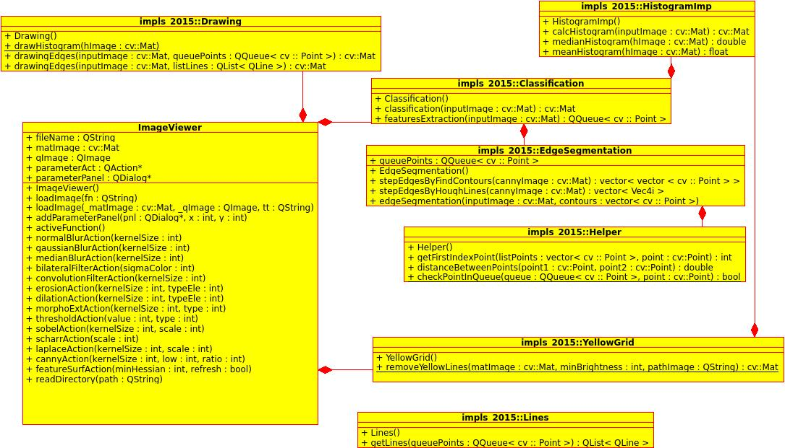
  - Supporting classes:
    - Drawing class
      - drawingHistogram(cv::Mat hImage)
        - Signification: drawing the histogram for an histogram image
        - Parameters:
          - hImage: the histogram of an image
      - drawingEdges(cv::Mat inputImage, Qqueue<cv::Point> queuePoints)
        - Signification: drawing the step edges from a queue of points
        - Parameters:
          - inputImage: the input image
          - queuePoints: queue of points which represented the edge
      - drawingEdges(cv::Mat inputImage, QList<QLine> listLines)
        - Signification: drawing the step edges from a set of lines
        - Parameters:
          - inputImage: the input image
          - listLines: the list of line which construct the edge
    - HistogramImp class
      - calcHistogram(cv::Mat inputImage)
        - Signification: calculate the histogram (on gray scale mode) of an image
        - Parameters:
          - inputImage: the input image which need to calculate the histogram.
      - meanHistogram(cv::Mat hImage)
        - Signification: calculate the mean of an histogram
        - Parameters:
          - hImage: the histogram of image
      - medianHistogram(cv::Mat hImage)
        - Signification: calculate the median of image
        - Parameters:
          - hImage: the histogram of image
    - Helper class
      - getFirstIndexPoint(vector<cv::Point> listPoints, cv::Point point)
        - Signification: get the first index of a point in a list of points
        - Parameters:
          - listPoints: list of points
          - point: the point need to get the index in list of points
      - distanceBetweenPoints(cv::Point point1, cv::Point point2)
        - Signification: calculate the distance between two points
        - Parameters:
          - point1: the first point
          - point2: the second point
      - checkPointInQueue(QQueue<cv::Point> queue, cv::Point point)
        - Signification: check the existing of a point in a queue
        - Parameters:
          - queue: the queue of points
          - point: the point need to check the existing in queue.
  - Remove the yellow grid – the YellowGrid class
Method: removeYellowLines(cv::Mat matImage, int minBrightness, Qstring pathImage)
    - Signification: removing the yellow gird in the image
    - Parameters:
      - matImage: the input image
      - minBrigthtness: minimum brightness to detect the points in grid
      - pathImage: the file path of the input image
  - Preprocessing image and feature extraction: the class
    - EdgeSegmentation class
      - stepEdgesByFindContours(cv::Mat cannyImage)
        - Signification: find the step edges using finContours technique.
        - Parameters:
          - cannyImage: the image after apply the Canny algorithm
      - stepEdgesByHoughLines(cv::Mat cannyImage)
        - Signification: find the step edges using Houngh Lines
        - Parameters:
          - cannyImage: the image after apply the Canny algorithm
      - edgeSegmentation(cv::Mat inputMat, vector<cv::Point> contours)
        - Signification: segment an edge which was represented by a list of points
        - Parameters:
          - inputMat: the input image
          - contours: list of points which represent the edge
    - Classification class
      - classification(cv::Mat inputImage)
        - Signification: classification the image
        - Parameters:
          - inputImage: the input image
      - featureExtraction(cv::Mat inputImage)
        - Signification: extract the features of the image
        - Parameters:
          - inputImage: the input image
  - Pairwise geometric histogram
- Continued...

