Pm

L2 distance
descriptor

Ps'
extract
Ps

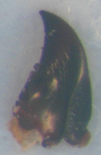
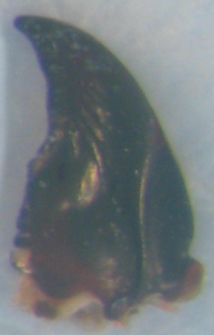
scene
model

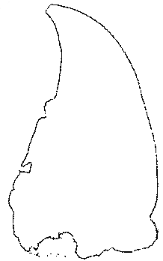
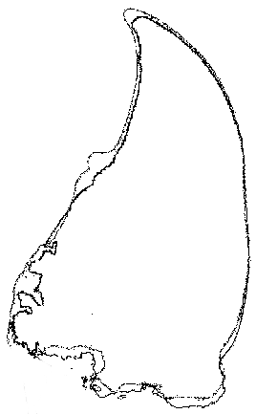

Determine estimated
landmarks

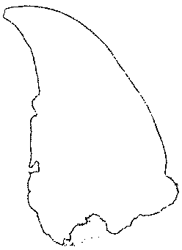

Segmentation
Registration
Localising estimated landmarks

Start

Model's segmentation
Segmentation
PCA
Sort the segmentations
by y-coordinate and take
a sub-set of points
Rotate and translate
the scene to the model's
position
angle < 1.5
End
True
False

Start

Segmentation
True
PCA
angle < 1.5
False
End

