Select c.courseName, g.groupName, s.room

From course c, group g, session s

Where s.date between (? AND ?) AND s.instructorID =?

Select groupName, studentCode,

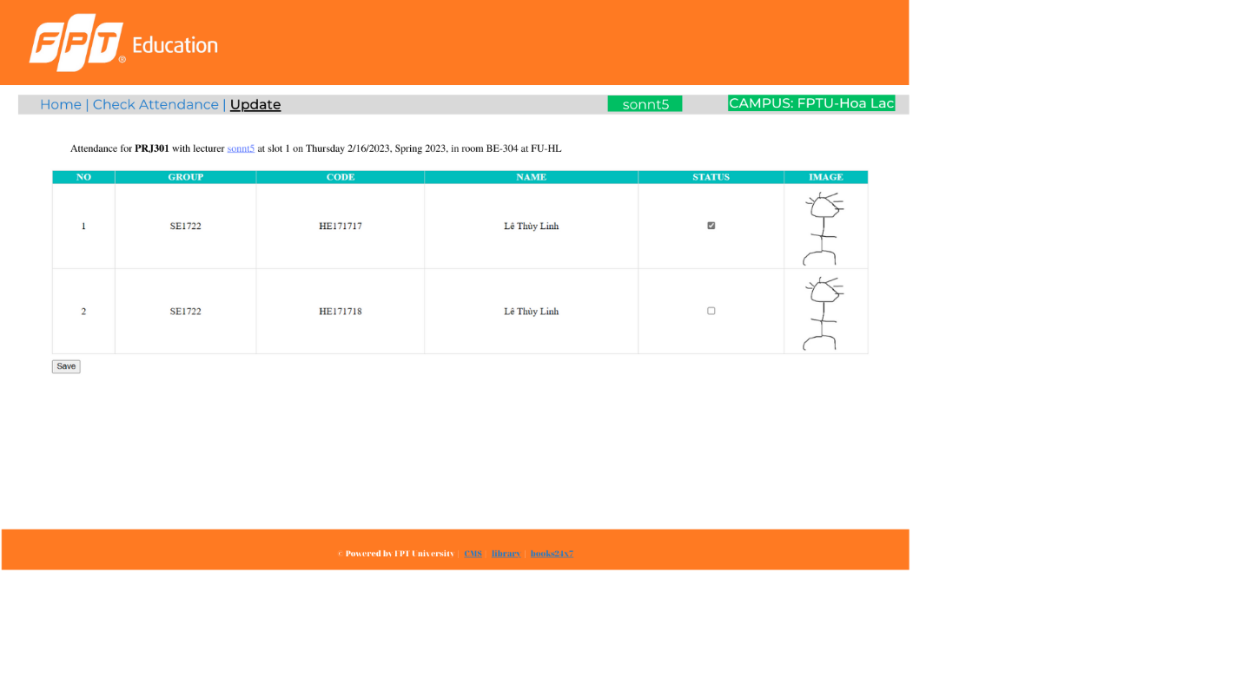

Course

Instructor

Student

Group

Session

Enroll

CheckAttendance

take

CourseID

StudentCode

InstructorID

SessionID

Status

Comment

RecordedTime

Manage

Join

TimeSlot

StudentCode

At

GroupID

1

1

1

1

N

N

N

N

N

N

N

1

Student

Phone

Username

Password

FatherPhone

SurName

MotherJob

Major

Gender

MiddleName

PlaceOfIssue

Nationality

HealthIssue

Curriculum

Peoples

DOB

DateOfIssue

Email

GivenName

Address

IDCard

MotherPhone

MotherName

FatherName

FatherJob

PlaceOfBirth

StudentCode

Course

CourseName

StudentsTask

Department

decisionNo

noCredit

NumOfSlot

TimeAllocation

degreeLevel

Decription

isApproved

note

Tools

ScoringScale

MinAvgToPass

CourseID

Group

GroupName

Term

GroupID

Instructor

MiddleName

Nationality

GivenName

Password

UserName

Email

DOB

Address

Phone

InstructorID

SurName

Gender

Session

Room

Date

SessionID

TimeSlot

SlotNum

Time

SlotID

StartTime

EndTime

