**F. Software User’s Manual**  
**1. Installation Guide**  
**1.1 Setting up environment at server side**

The following software must be installed into the server machine for user to run website smoothly as well as be able to check product effectively:

* + 1. **Hardware requirements**
* Here is our minimum hardware recommendation:
  + CPU: Quad core 2GHz+ CPU
  + RAM: 2GB or more of RAM
  + Minimum database space: 10GB
    1. **Software requirements**

The server or its components (core server, language servers) require a computer with a supported operating system. The server requires a compatible web browser and the Java Development Kit (JDK). You can either use Oracle Java SE 8 JDK x64 or IBM Java 8 SDK 64-bit.

**1.2 Deployment at server side**

**1.2.1 Prepare deployment package**  
**1.2.2 Configure Server before deploy**  
**1.2.3 Deploy web application on server**  
**1.3 Setting up the environment at client side**  
**1.3.1 Setting up for computer**

**2. User Guide**

**2.1 For User:**

**2.1.2 Login**

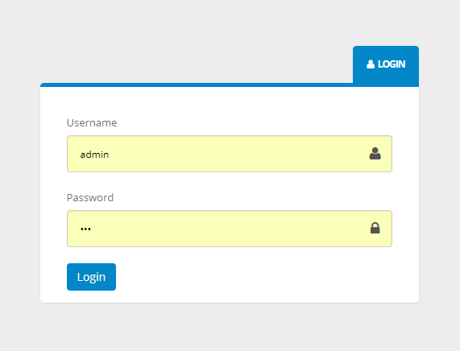

When you access to our website, you will see this login form. Please type your username and password then click on “Login” button.

**2.1.2 Logout**

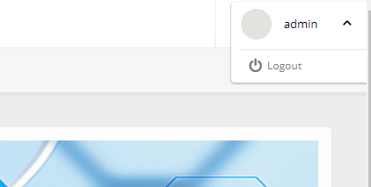

If you don’t want to be use this site anymore, you can logout of our system by clicking in “${username}” pop up button, choosing “Logout option”

**2.1.3 View mission schedule**

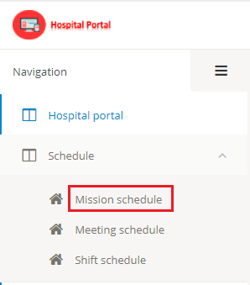

If you want to view mission schedule, please click “Schedule” on menu bar and then choose “Mission schedule” option.

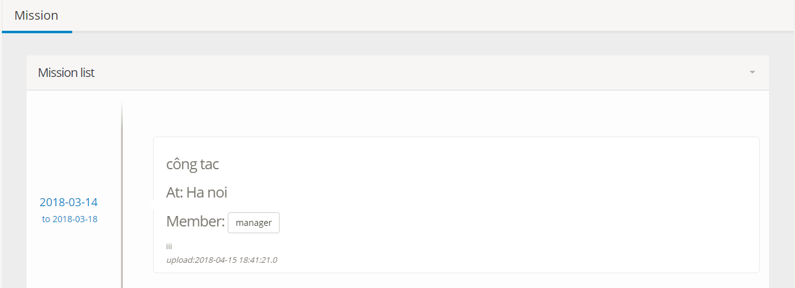

Mission list will show nearby.

**2.1.4 View meeting schedule**

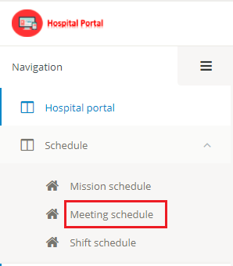

If you want to view meeting schedule, please click “Schedule” on menu bar and then choose “Meeting schedule” option.

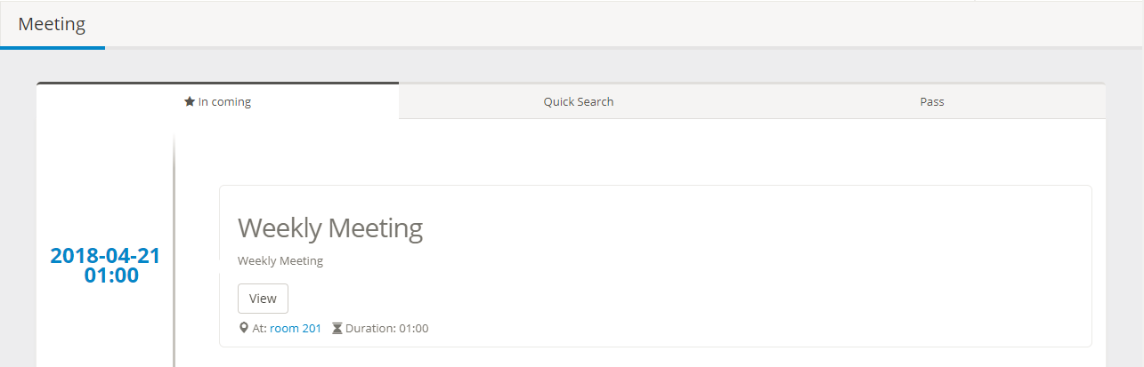

Meeting list will show nearby.

**2.1.5 View shift schedule**

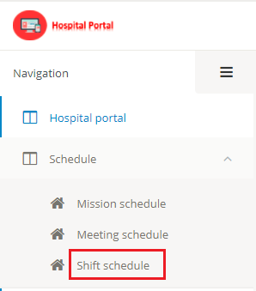

If you want to view shift schedule, please click “Schedule” on menu bar and then choose “Shift schedule” option.

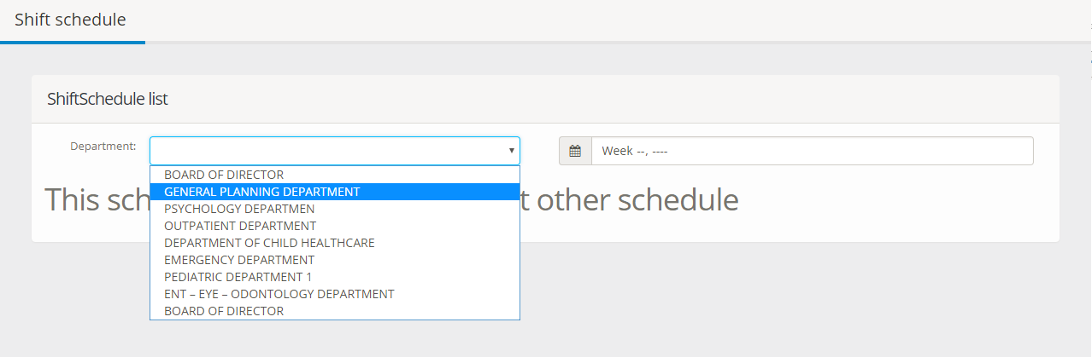

Second choose department to view shift schedule.

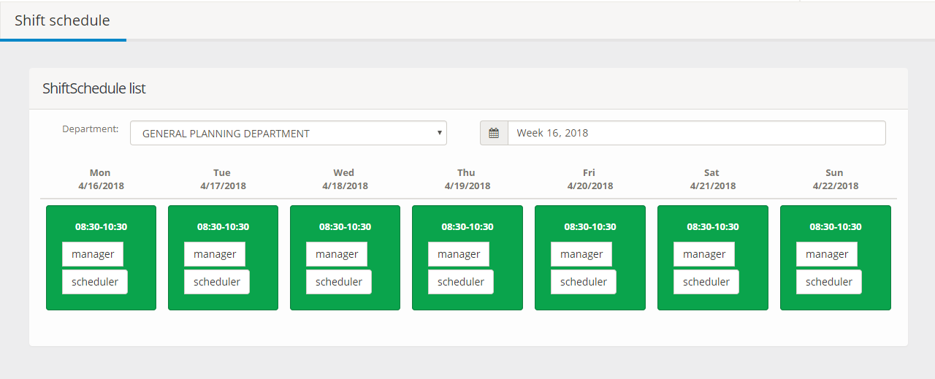

Then choose week, the shift schedule will show below

**2.2 For Scheduler:**

**2.2.1 Create/Update mission schedule**

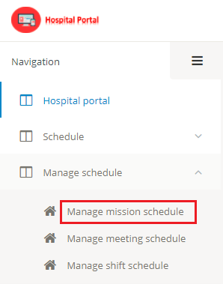

If you want to manage mission schedule, please click “Manage schedule” on menu bar and then choose “Manage mission schedule” option.

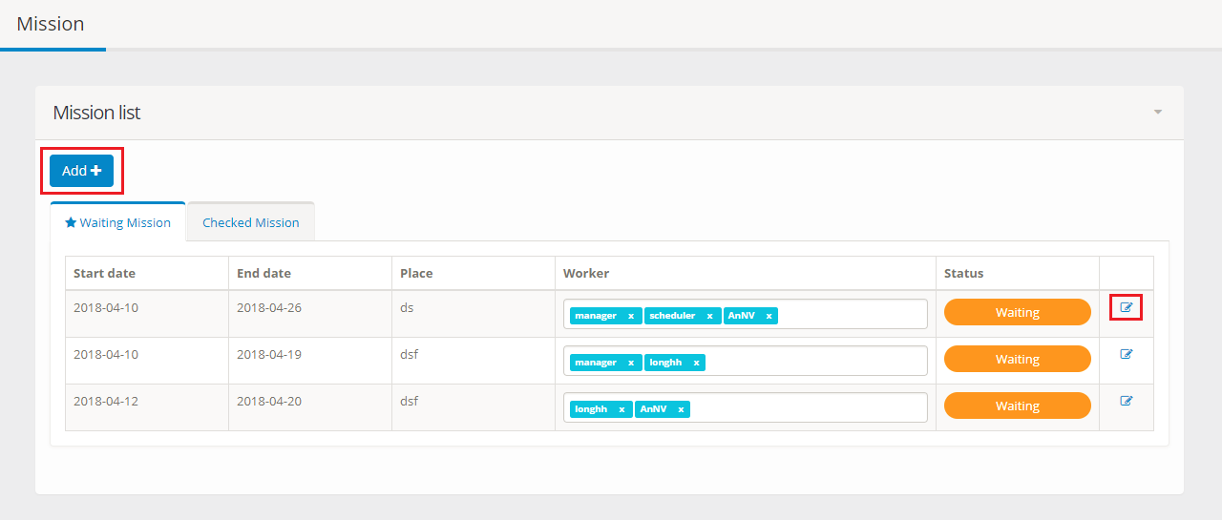

Click “Add” button on upper left corner of manage mission page to create new mission.

Click “View” icon on the right to update mission.

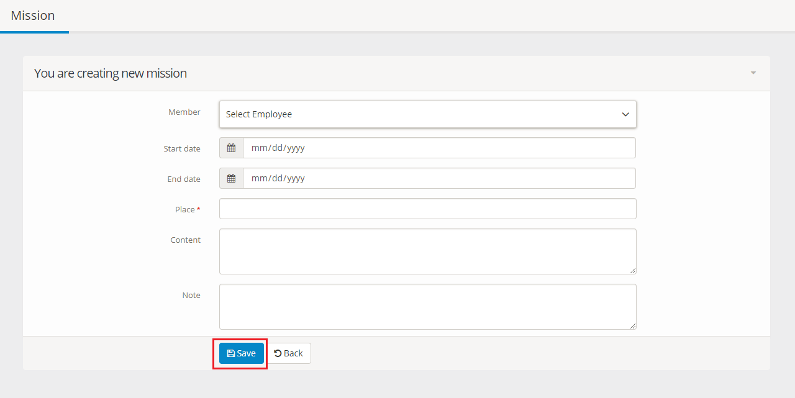

Please fill in all text box and click “Save” button

**2.2.2 Create/Update meeting schedule**

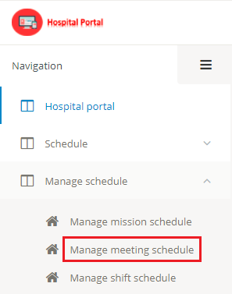

If you want to manage meeting schedule, please click “Manage schedule” on menu bar and then choose “Manage meeting schedule” option.

**2.2.3 Create shift schedule**

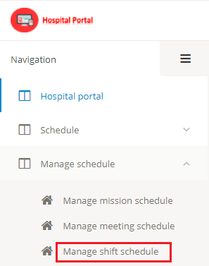

If you want to manage shift schedule, please click “Manage schedule” on menu bar and then choose “Manage meeting schedule” option.

**2.3 For Manager:**

**2.3.1 Create/Update notification**

If you want to manager notification, please click “Notification” on menu bar

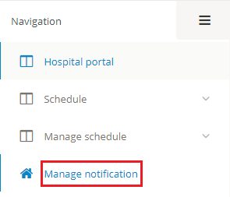

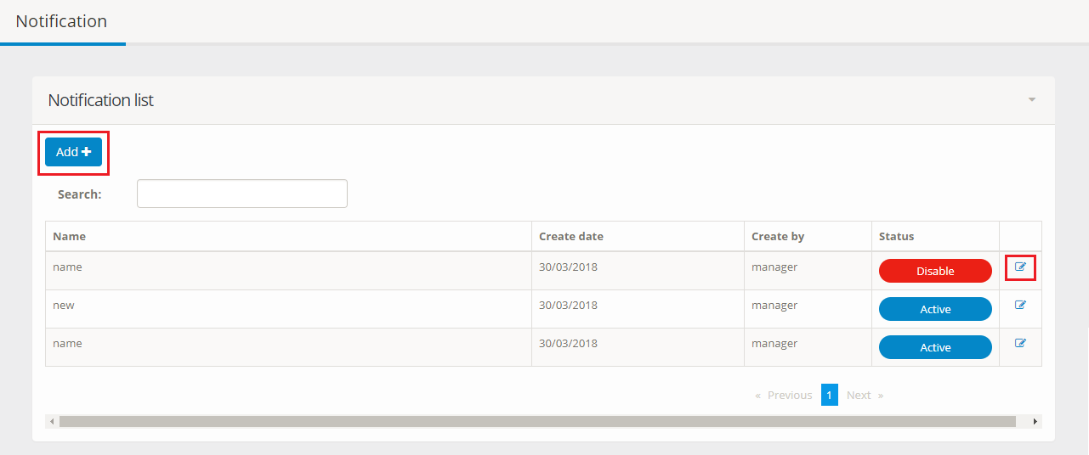

Click “Add” button on upper left corner of notification page to create new notification.

Click “View” icon on the right to update notification.

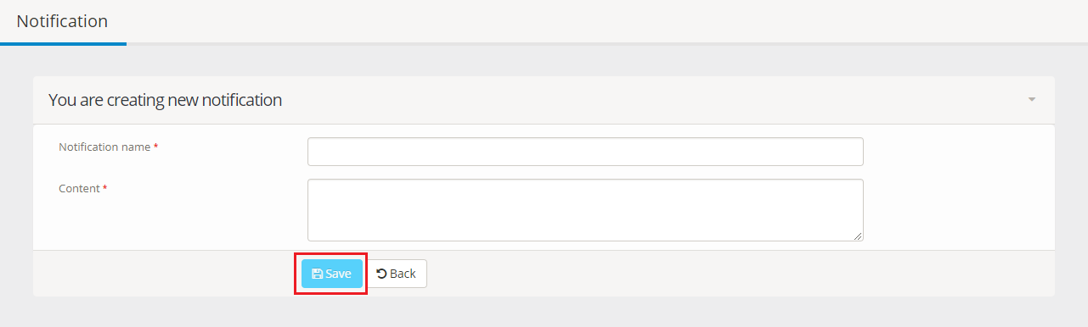

Please fill in all text box and click “Save” button

**G. Appendix**