📘 Buckeye-Marketplace User Guide

1. Getting Started: Account & Login
Creating an Account: Click the "Sign Up" button on the landing page. Enter your OSU email and create a password.
Logging In: Use your credentials on the Login page. The system uses secure JWT authentication to keep your session active.
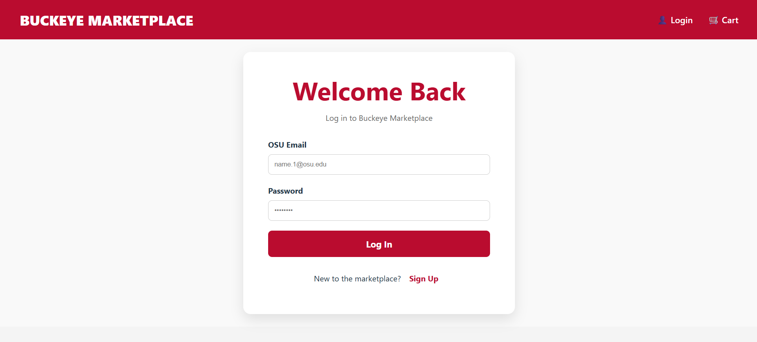

2. Browsing Products
The Marketplace: Upon logging in, you will see the Product Grid. You can scroll through items like textbooks, electronics, and dorm gear.
Search and Filter: Use the search bar at the top to find specific items (e.g., "Hibbeler Dynamics") or filter by category.
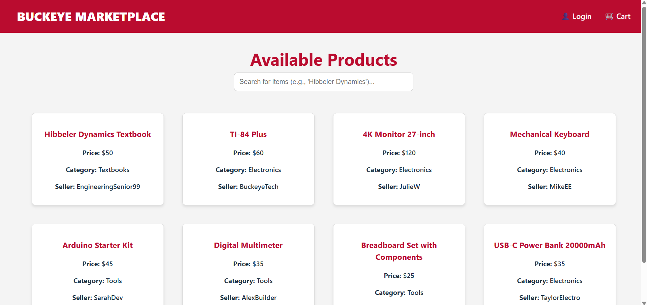

3. Adding Items to Cart
Selection: Click on a product card to see the Product Detail View.
The Action: Click the "Add to Cart" or "Add to Tracker" button. A notification will confirm the item has been added.
Screenshot Tip: Take a screenshot of the Product Detail View with the "Add" button highlighted.
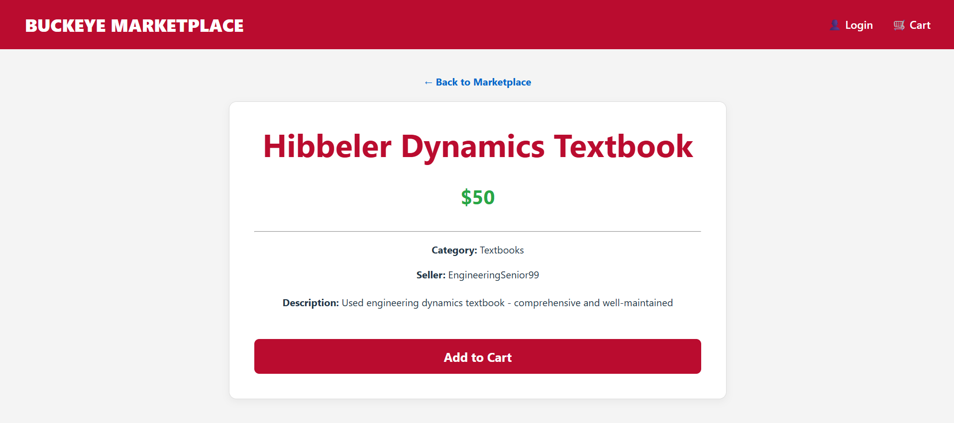

4. Placing an Order
Reviewing Cart: Click the shopping cart icon in the navigation bar to see your selected items.
Checkout: Verify your items and click "Place Order." For this marketplace, this sends a notification to the seller or saves the list to your tracker.
Screenshot Tip: Capture the Cart/Checkout page showing at least one item ready for order.
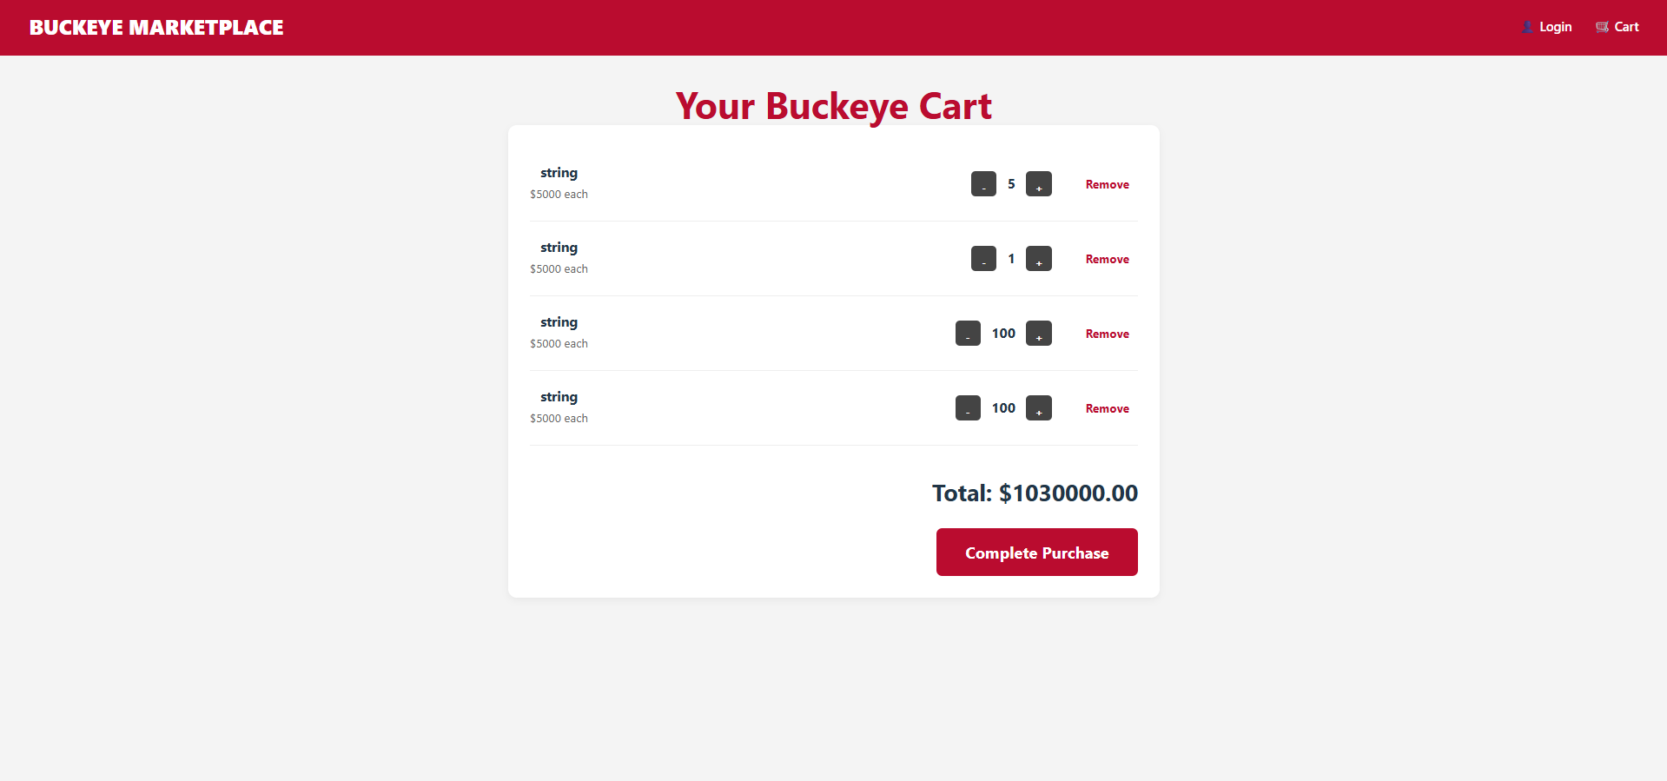

5. Viewing Order History
User Profile: Navigate to your "Account" or "Profile" section.
History: Click on "Order History" or "My Postings" to see a list of past transactions and their current status (e.g., Pending, Completed).
Screenshot Tip: Show the "Order History" table or list view from your user dashboard.

const addToCart = () => {
fetch('http://localhost:5000/api/cart', {
method: 'POST',
headers: { 'Content-Type': 'application/json' },
body: JSON.stringify({
productId: id, // Ensure ID is an integer
quantity: 1
})
})
.then(async res => {
if(res.ok) {
alert(`${product.title} added to cart!`);
} else {
const errorText = await res.text();
console.error("Server Response:", errorText);
alert("Failed to add to cart. Check console for details.");
}
})
.catch(err => alert("Error: Could not reach backend."));
};

using Microsoft.EntityFrameworkCore;
using backend;

var builder = WebApplication.CreateBuilder(args);

// 1. Define ONE CORS policy
builder.Services.AddCors(options =>
{
options.AddPolicy("AllowReact", policy =>
{
policy.AllowAnyOrigin()
.AllowAnyMethod()
.AllowAnyHeader();
});
});

builder.Services.AddEndpointsApiExplorer();
builder.Services.AddSwaggerGen();
builder.Services.AddControllers();

// Configure the SQLite database for Buckeye-Marketplace
builder.Services.AddDbContext<AppDbContext>(options =>
options.UseSqlite("Data Source=buckeye_marketplace.db"));

var app = builder.Build();

// 2. Use the CORS policy (Must be BEFORE MapControllers)
app.UseCors("AllowReact");

if (app.Environment.IsDevelopment())
{
app.UseSwagger();
app.UseSwaggerUI();
}

app.UseAuthorization();
app.MapControllers();

// ... WeatherForecast code ...

app.Run();

app.MapGet("/weatherforecast", () =>
{
var summaries = new[] { "Freezing", "Bracing", "Chilly", "Cool", "Mild", "Warm", "Balmy", "Hot", "Sweltering", "Scorching" };
var forecast = Enumerable.Range(1, 5).Select(index =>
new WeatherForecast
(
DateOnly.FromDateTime(DateTime.Now.AddDays(index)),
Random.Shared.Next(-20, 55),
summaries[Random.Shared.Next(summaries.Length)]
))
.ToArray();
return forecast;
})
.WithName("GetWeatherForecast")
.WithOpenApi();

app.Run();

record WeatherForecast(DateOnly Date, int TemperatureC, string? Summary)
{
public int TemperatureF => 32 + (int)(TemperatureC / 0.5556);
}

import React, { useState, useEffect } from 'react';
import { BrowserRouter, Routes, Route, Link, useParams, useNavigate } from 'react-router-dom'
import './App.css'
import { CartProvider, useCart } from './context/CartContext';

const ProductCard = ({ product }) => (
<Link to={`/product/${product.id}`} style={{ textDecoration: 'none', color: 'inherit' }}>
<div style={{
border: '1px solid #ddd',
borderRadius: '8px',
padding: '16px',
margin: '12px',
width: '280px',
boxShadow: '0 4px 6px rgba(0,0,0,0.1)',
cursor: 'pointer',
transition: 'transform 0.2s',
backgroundColor: 'white'
}}
onMouseEnter={(e) => e.currentTarget.style.transform = 'scale(1.03)'}
onMouseLeave={(e) => e.currentTarget.style.transform = 'scale(1)'}
>
<h3 style={{ color: '#ba0c2f' }}>{product.title}</h3>
<p><strong>Price:</strong> ${product.price}</p>
<p><strong>Category:</strong> {product.category}</p>
<p><strong>Seller:</strong> {product.sellerName}</p>
</div>
</Link>
)

function ProductList() {
const [products, setProducts] = useState([])
const [loading, setLoading] = useState(true)
const [searchTerm, setSearchTerm] = useState("");

useEffect(() => {
fetch('http://localhost:5000/api/products')
.then(response => response.json())
.then(data => {
setProducts(data)
setLoading(false)
})
.catch(error => {
console.error('Error fetching products:', error)
setLoading(false)
})
}, [])

// Filter products based on the search term
const filteredProducts = products.filter((product) =>
product.title.toLowerCase().includes(searchTerm.toLowerCase())
);

return (
<div style={{ padding: '40px', textAlign: 'center' }}>
<h1 style={{ marginBottom: '10px', fontSize: '2.5rem' }}>Available Products</h1>

{/* Search Bar UI */}
<div className="search-container" style={{ marginBottom: '40px', textAlign: 'center' }}>
<input
type="text"
placeholder="Search for items (e.g., 'Hibbeler Dynamics')..."
value={searchTerm}
onChange={(e) => setSearchTerm(e.target.value)}
style={{
padding: '12px',
width: '100%',
maxWidth: '400px',
borderRadius: '8px',
border: '1px solid #ccc',
fontSize: '16px'
}}
/>
</div>

{loading ? (
<p>Loading products...</p>
) : filteredProducts.length === 0 ? (
<h2>No products match your search.</h2>
) : (
<div style={{
display: 'flex',
flexWrap: 'wrap',
justifyContent: 'center',
gap: '20px'
}}>
{/* Mapping through filteredProducts instead of products */}
{filteredProducts.map((product) => (
<ProductCard key={product.id} product={product} />
))}
</div>
)}
</div>
)
}

function ProductDetail() {
const { id } = useParams();
const { addToCart } = useCart(); // Access the central function from CartContext
const [product, setProduct] = useState(null);
const [loading, setLoading] = useState(true);

// Keep the useEffect to load the specific product details for this page
useEffect(() => {
fetch(`http://localhost:5000/api/products/${id}`)
.then(response => response.json())
.then(data => {
setProduct(data);
setLoading(false);
})
.catch(error => {
console.error('Error fetching product:', error);
setLoading(false);
});
}, [id]);

// Integrated handler that uses the Context function
const handleAddToCart = () => {
if (product) {
// This triggers the axios.post logic inside CartContext.jsx to your .NET backend
addToCart(product);
alert(`${product.title} added to cart!`);
}
};

if (loading) return <div style={{ padding: '40px' }}><p>Loading product details...</p></div>;
if (!product) return <div style={{ padding: '40px' }}><p>Product not found</p></div>;

return (
<div style={{ padding: '40px', maxWidth: '800px', margin: '0 auto' }}>
<Link to="/" style={{ color: '#0066cc', textDecoration: 'none', fontWeight: 'bold' }}>
← Back to Marketplace
</Link>

<div style={{
border: '1px solid #ddd',
borderRadius: '12px',
padding: '40px',
marginTop: '20px',
backgroundColor: 'white',
boxShadow: '0 4px 12px rgba(0,0,0,0.05)'
}}>
<h1 style={{ color: '#ba0c2f' }}>{product.title}</h1>
<p style={{ fontSize: '32px', color: '#28a745', fontWeight: 'bold' }}>${product.price}</p>
<hr />
<p><strong>Category:</strong> {product.category}</p>
<p><strong>Seller:</strong> {product.sellerName}</p>
<p style={{ marginTop: '20px', lineHeight: '1.6' }}><strong>Description:</strong> {product.description}</p>

{/* The button now triggers the integrated handleAddToCart logic */}
<button
onClick={handleAddToCart}
style={{
backgroundColor: '#ba0c2f',
color: 'white',
padding: '15px',
border: 'none',
borderRadius: '8px',
fontSize: '20px',
cursor: 'pointer',
marginTop: '30px',
width: '100%',
fontWeight: 'bold'
}}
>
Add to Cart
</button>
</div>
</div>
);
}

function ShoppingCart() {
// 1. Pull everything we need from the Central Context
const { cart, loading, updateQuantity, removeFromCart } = useCart();

if (loading) return <div style={{ padding: '40px' }}><p>Loading your Buckeye Cart...</p></div>;

// 2. Ensure we are working with an array (handling potential nulls)
const items = cart || [];

// 3. Calculate total price using the items from context
// Inside ShoppingCart function in App.jsx
const totalPrice = items.reduce((sum, item) => sum + (item.price * item.quantity), 0);

return (
<div style={{ padding: '40px', maxWidth: '900px', margin: '0 auto' }}>
<h1>Your Buckeye Cart</h1>

{items.length === 0 ? (
<div style={{ textAlign: 'center', marginTop: '50px' }}>
<p style={{ fontSize: '1.2rem' }}>Your cart is empty.</p>
<Link to="/" style={{ color: '#ba0c2f', fontWeight: 'bold' }}>Start Shopping</Link>
</div>
) : (
<div style={{ backgroundColor: 'white', padding: '30px', borderRadius: '12px', boxShadow: '0 4px 10px rgba(0,0,0,0.05)' }}>
{items.map((item) => (
<div key={item.id} style={{ display: 'flex', justifyContent: 'space-between', borderBottom: '1px solid #eee', padding: '20px 0', alignItems: 'center' }}>
<div>
<h3 style={{ margin: 0 }}>{item.product?.title}</h3>
<p style={{ color: '#666', margin: '5px 0' }}>${item.product?.price} each</p>
</div>

<div style={{ display: 'flex', alignItems: 'center', gap: '15px' }}>
{/* 4. Use context updateQuantity: handles both + and - */}
<button
onClick={() => updateQuantity(item.id, item.quantity - 1)}
style={{ width: '35px', height: '35px', cursor: 'pointer' }}
>-</button>

<span style={{ fontSize: '1.2rem', fontWeight: 'bold' }}>{item.quantity}</span>

<button
onClick={() => updateQuantity(item.id, item.quantity + 1)}
style={{ width: '35px', height: '35px', cursor: 'pointer' }}
>+</button>

{/* 5. Use context removeFromCart */}
<button
onClick={() => removeFromCart(item.id)}
style={{ marginLeft: '20px', color: '#ba0c2f', border: 'none', background: 'none', cursor: 'pointer', fontWeight: 'bold' }}
>
Remove
</button>
</div>
</div>
))}

<div style={{ marginTop: '40px', textAlign: 'right' }}>
<h2 style={{ fontSize: '2rem' }}>Total: ${totalPrice.toFixed(2)}</h2>
<button
onClick={() => alert("Checkout system coming soon!")}
style={{ backgroundColor: '#ba0c2f', color: 'white', padding: '18px 40px', border: 'none', borderRadius: '8px', fontSize: '22px', cursor: 'pointer', fontWeight: 'bold' }}
>
Complete Purchase
</button>
</div>
</div>
)}
</div>
);
}

function LoginPage() {
const [isLogin, setIsLogin] = useState(true); // Toggle state
const [email, setEmail] = useState('');
const [password, setPassword] = useState('');
const [confirmPassword, setConfirmPassword] = useState('');
const navigate = useNavigate();

const handleAuth = (e) => {
e.preventDefault();
if (isLogin) {
// Login Logic
if (email && password) {
alert(`Welcome back!`);
navigate('/');
} else {
alert("Please enter both your OSU email and password.");
}
} else {
// Sign Up Logic
if (email && password && password === confirmPassword) {
alert(`Account created for ${email}!`);
setIsLogin(true); // Switch to login after signing up
} else {
alert("Please ensure all fields are filled and passwords match.");
}
}
};

return (
<div style={{
display: 'flex', justifyContent: 'center', alignItems: 'center',
minHeight: '80vh', backgroundColor: '#f9f9f9'
}}>
<div style={{
backgroundColor: 'white', padding: '50px', borderRadius: '15px',
boxShadow: '0 10px 25px rgba(0,0,0,0.1)', width: '100%',
maxWidth: '450px', textAlign: 'center'
}}>
{/* Title changes based on state */}
<h1 style={{ color: '#ba0c2f', marginBottom: '10px' }}>
{isLogin ? "Welcome Back" : "Create Account"}
</h1>
<p style={{ color: '#666', marginBottom: '30px' }}>
{isLogin ? "Log in to Buckeye Marketplace" : "Sign up with your OSU email"}
</p>

<form onSubmit={handleAuth}>
<div style={{ textAlign: 'left', marginBottom: '20px' }}>
<label style={{ fontWeight: 'bold', display: 'block', marginBottom: '8px' }}>OSU Email</label>
<input
type="text" placeholder="name.1@osu.edu" value={email}
onChange={(e) => setEmail(e.target.value)}
style={{ width: '100%', padding: '12px', borderRadius: '8px', border: '1px solid #ccc', boxSizing: 'border-box' }}
/>
</div>

<div style={{ textAlign: 'left', marginBottom: '20px' }}>
<label style={{ fontWeight: 'bold', display: 'block', marginBottom: '8px' }}>Password</label>
<input
type="password" placeholder="••••••••" value={password}
onChange={(e) => setPassword(e.target.value)}
style={{ width: '100%', padding: '12px', borderRadius: '8px', border: '1px solid #ccc', boxSizing: 'border-box' }}
/>
</div>

{/* Show Confirm Password only if signing up */}
{!isLogin && (
<div style={{ textAlign: 'left', marginBottom: '30px' }}>
<label style={{ fontWeight: 'bold', display: 'block', marginBottom: '8px' }}>Confirm Password</label>
<input
type="password" placeholder="••••••••" value={confirmPassword}
onChange={(e) => setConfirmPassword(e.target.value)}
style={{ width: '100%', padding: '12px', borderRadius: '8px', border: '1px solid #ccc', boxSizing: 'border-box' }}
/>
</div>
)}

<button type="submit" style={{
backgroundColor: '#ba0c2f', color: 'white', border: 'none',
padding: '15px', borderRadius: '8px', cursor: 'pointer',
width: '100%', fontWeight: 'bold', fontSize: '18px'
}}>
{isLogin ? "Log In" : "Sign Up"}
</button>
</form>

{/* Toggle Link */}
<div style={{ marginTop: '20px' }}>
<span>{isLogin ? "New to the marketplace?" : "Already have an account?"}</span>
<button
onClick={() => setIsLogin(!isLogin)}
style={{ background: 'none', border: 'none', color: '#ba0c2f', cursor: 'pointer', fontWeight: 'bold', marginLeft: '5px' }}
>
{isLogin ? "Sign Up" : "Log In"}
</button>
</div>
</div>
</div>
);
}

function App() {
return (
<CartProvider>
<BrowserRouter>
<nav style={{
display: 'flex',
justifyContent: 'space-between',
alignItems: 'center',
padding: '0 40px',
background: '#ba0c2f',
color: 'white',
height: '80px',
boxShadow: '0 2px 10px rgba(0,0,0,0.1)'
}}>
<Link to="/" style={{ color: 'white', fontWeight: '900', textDecoration: 'none', fontSize: '1.8rem' }}>
BUCKEYE MARKETPLACE
</Link>
<div style={{ display: 'flex', gap: '30px' }}>
<Link to="/login" style={{ color: 'white', textDecoration: 'none', fontSize: '1.1rem', display: 'flex', alignItems: 'center' }}>
👤 Login
</Link>
<Link to="/cart" style={{ color: 'white', textDecoration: 'none', fontSize: '1.1rem', display: 'flex', alignItems: 'center' }}>
🛒 Cart
</Link>
</div>
</nav>

<div style={{ backgroundColor: '#f4f4f4', minHeight: 'calc(100vh - 80px)' }}>
<Routes>
<Route path="/" element={<ProductList />} />
<Route path="/product/:id" element={<ProductDetail />} />
<Route path="/cart" element={<ShoppingCart />} />
<Route path="/login" element={<LoginPage />} />
</Routes>
</div>
</BrowserRouter>
</CartProvider>
);
}

export default App

import React, { createContext, useState, useContext, useEffect } from 'react';
import axios from 'axios';

const CartContext = createContext();

// Centralized API URL (Addressing Professor's coaching note on hardcoded URLs)
const API_URL = 'http://localhost:5000/api/Cart';

export const CartProvider = ({ children }) => {
const [cart, setCart] = useState([]);
const [loading, setLoading] = useState(false);

// 1. Fetch Cart from Database on Load
const fetchCart = async () => {
setLoading(true);
try {
const response = await axios.get(API_URL);
// The API returns { items: [...] }, so we set the items array
setCart(response.data.items || []);
} catch (error) {
console.error("Error fetching cart:", error);
} finally {
setLoading(false);
}
};

useEffect(() => {
fetchCart();
}, []);

// 2. Add to Cart (POST)
const addToCart = async (product) => {
try {
await axios.post(API_URL, {
productId: product.id,
title: product.title, // Add this line
price: product.price, // Add this line
quantity: 1,
userId: "default-user" // Add this to match your controller logic
});
fetchCart();
} catch (error) {
console.error("Error adding to cart:", error);
}
};

// 3. Remove Single Item (DELETE)
const removeFromCart = async (cartItemId) => {
try {
await axios.delete(`${API_URL}/${cartItemId}`);
fetchCart(); // Refresh cart from DB after removing
} catch (error) {
console.error("Error removing item:", error);
}
};

// 4. Update Quantity (PUT) - New feature required by rubric
const updateQuantity = async (cartItemId, newQuantity) => {
// Prevent quantity from dropping below 1 via the API
if (newQuantity < 1) {
return removeFromCart(cartItemId);
}

try {
// Sending as an object { quantity: X } to match .NET DTO expectations
await axios.put(`${API_URL}/${cartItemId}`, {
quantity: newQuantity
});

// Refresh the global cart state from the database
fetchCart();
} catch (error) {
console.error("Error updating quantity:", error);
}
};

// 5. Clear Cart (DELETE /clear)
const clearCart = async () => {
try {
await axios.delete(`${API_URL}/clear`);
setCart([]);
} catch (error) {
console.error("Error clearing cart:", error);
}
};

return (
<CartContext.Provider value={{
cart,
loading,
addToCart,
removeFromCart,
updateQuantity,
clearCart
}}>
{children}
</CartContext.Provider>
);
};

export const useCart = () => useContext(CartContext);

using System;
using System.Collections.Generic;
using System.Linq;
using Microsoft.AspNetCore.Mvc;
using backend.Models;

namespace backend.Controllers
{
[ApiController]
[Route("api/[controller]")]
public class ProductsController : ControllerBase
{
private static readonly List<Product> _products = new()
{
new Product
{
Id = 1,
Title = "Hibbeler Dynamics Textbook",
Description = "Used engineering dynamics textbook - comprehensive and well-maintained",
Price = 50m,
Category = "Textbooks",
SellerName = "EngineeringSenior99",
PostedDate = DateTime.UtcNow.AddDays(-10),
ImageUrl = "https://picsum.photos/200",
Condition = "Like New"
},
new Product
{
Id = 2,
Title = "TI-84 Plus",
Description = "Graphing calculator perfect for engineering coursework",
Price = 60m,
Category = "Electronics",
SellerName = "BuckeyeTech",
PostedDate = DateTime.UtcNow.AddDays(-8),
ImageUrl = "https://picsum.photos/200",
Condition = "Like New"
},
new Product
{
Id = 3,
Title = "4K Monitor 27-inch",
Description = "Ultra HD monitor - ideal for CAD and design work",
Price = 120m,
Category = "Electronics",
SellerName = "JulieW",
PostedDate = DateTime.UtcNow.AddDays(-5),
ImageUrl = "https://picsum.photos/200",
Condition = "Used - Good"
},
new Product
{
Id = 4,
Title = "Mechanical Keyboard",
Description = "RGB mechanical keyboard with hot-swap switches",
Price = 40m,
Category = "Electronics",
SellerName = "MikeEE",
PostedDate = DateTime.UtcNow.AddDays(-12),
ImageUrl = "https://picsum.photos/200",
Condition = "Like New"
},
new Product
{
Id = 5,
Title = "Arduino Starter Kit",
Description = "Complete Arduino starter kit with sensors and components",
Price = 45m,
Category = "Tools",
SellerName = "SarahDev",
PostedDate = DateTime.UtcNow.AddDays(-4),
ImageUrl = "https://picsum.photos/200",
Condition = "New"
},
new Product
{
Id = 6,
Title = "Digital Multimeter",
Description = "Professional grade multimeter for electronics testing",
Price = 35m,
Category = "Tools",
SellerName = "AlexBuilder",
PostedDate = DateTime.UtcNow.AddDays(-2),
ImageUrl = "https://picsum.photos/200",
Condition = "Used - Good"
},
new Product
{
Id = 7,
Title = "Breadboard Set with Components",
Description = "Prototyping breadboards with resistors, capacitors, and wires",
Price = 25m,
Category = "Tools",
SellerName = "ChrisTools",
PostedDate = DateTime.UtcNow.AddDays(-6),
ImageUrl = "https://picsum.photos/200",
Condition = "New"
},
new Product
{
Id = 8,
Title = "USB-C Power Bank 20000mAh",
Description = "High-capacity power bank with fast charging support",
Price = 35m,
Category = "Electronics",
SellerName = "TaylorElectro",
PostedDate = DateTime.UtcNow.AddDays(-1),
ImageUrl = "https://picsum.photos/200",
Condition = "Like New"
}
};

[HttpGet]
public ActionResult<IEnumerable<Product>> GetAll()
{
return Ok(_products);
}

[HttpGet("{id}")]
public ActionResult<Product> GetById(int id)
{
var product = _products.FirstOrDefault(p => p.Id == id);
if (product == null)
{
return NotFound();
}
return Ok(product);
}
}
}

