**Analysis ToolPak**

The Analysis ToolPak is an Excel add-in program for statistics and engineering analysis.

**Installing the Analysis ToolPak**

I recommend the latest versions of Microsoft Office (2010 or 2013)

1. Open an Excel File

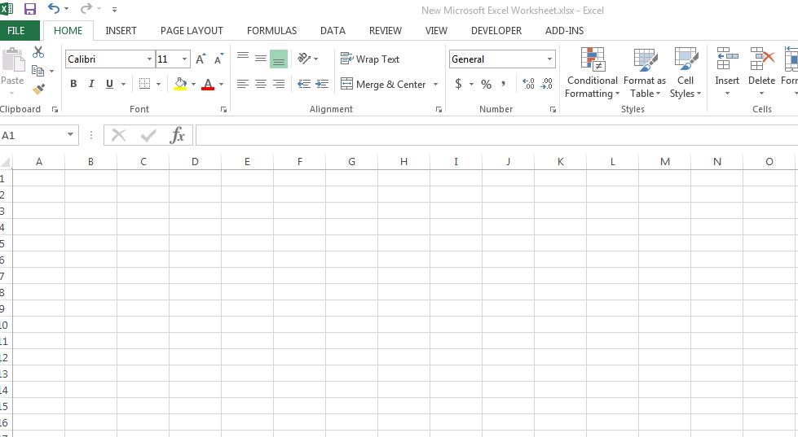

1. Click File

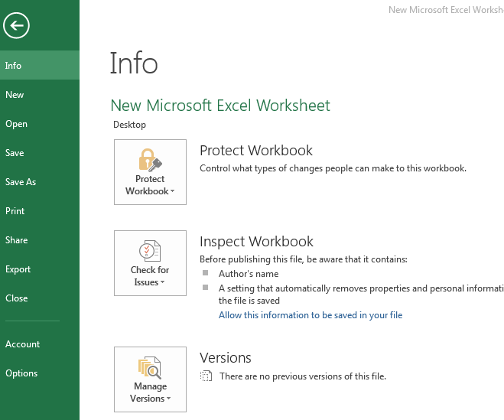

1. Click Options

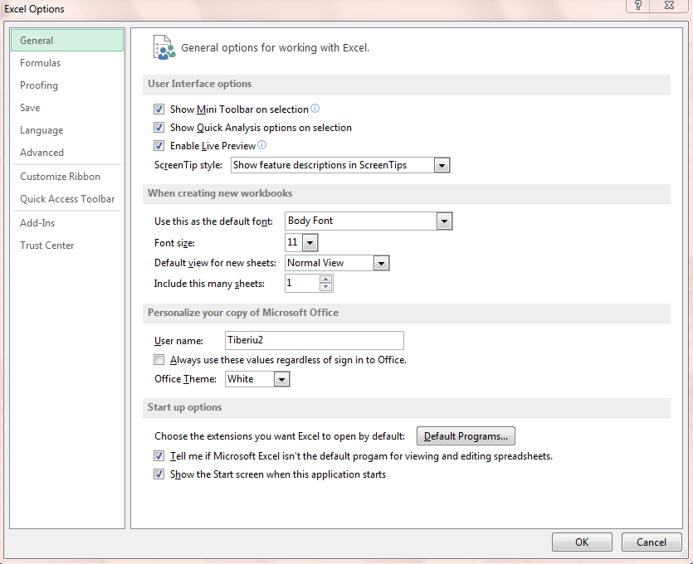

1. Click Add-Ins

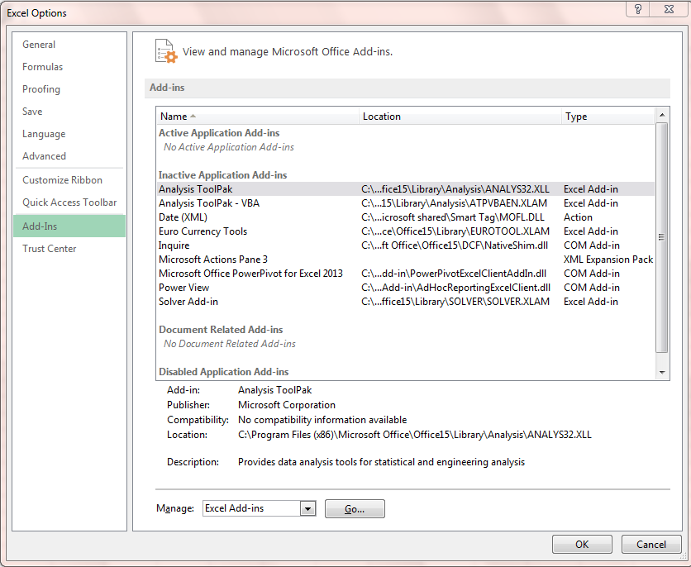

1. Select Analysis ToolPak
2. Click Go
3. Select Analysis ToolPak

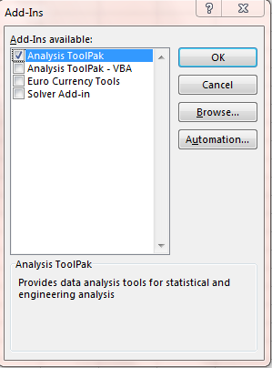

1. Click OK

The Analysis ToolPak is now installed

1. Go to Data

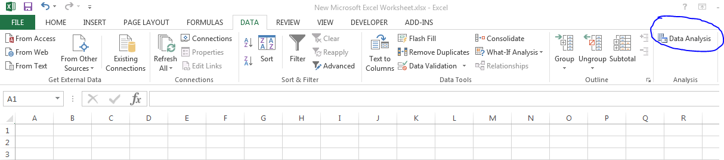

1. Data Analysis ToolPak is in the right corner. Click it

