Overview

Essential features of the Blue Box system
The BlueBox is the central element of the BlueBox system. The BlueBox system is a modular measuring and control system. The BlueBox is connected to sensors and actuators using CAN (Controller Area Network) technology.
The BlueBox is equipped with the usual interfaces for data processing and communication.
- Due to its modular design, the BlueBox system can handle almost all measuring and control functions.
- A total of over 200 sensors and actuators can be connected to a BlueBox. The connection is made via sensor modules1 and actuator modules2 (output modules).
- In addition to sensors and actuators from our own product range, we also integrate products from almost all other manufacturers.
- The sensor and actuator modules can be placed decentrally in bus or star architecture2 over distances of up to 1000 meters (optionally even longer).
- Measurement data transmission and communication via Ethernet, Internet, mobile radio (HSPA), telephone line (ISDN, analog)3, EMC or Modbus (RS-232 / RS-485), current outputs (4 - 20 mA).
- In the mobile use of the BlueBox it is possible to connect a GPS for continuous position determination.
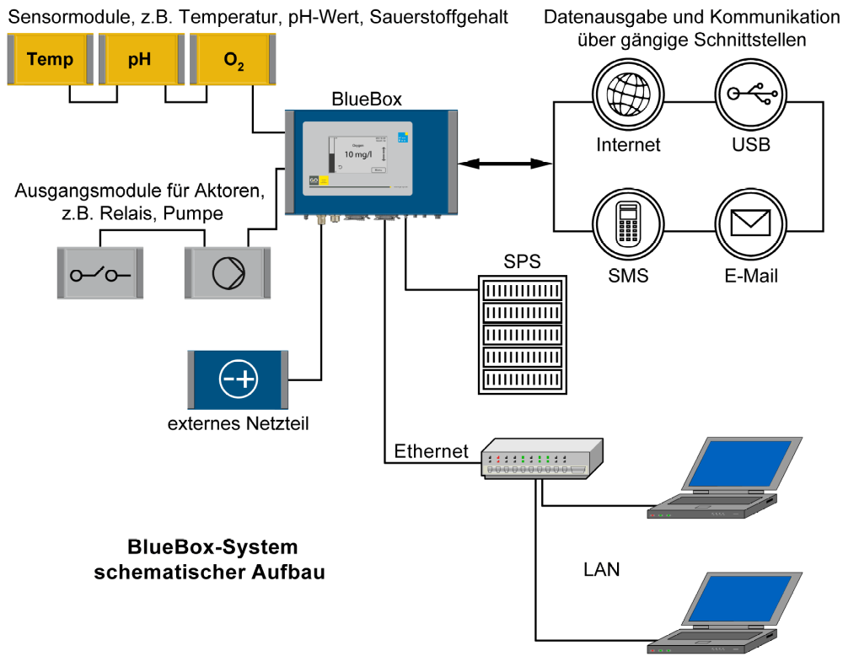
¹ Several sensors / actuators can be connected to a module.
² A star architecture is only possible with a repeater (see 5 Connection to a CAN repeater).
³ optional

Technical specifications BlueBox T4
Computer | PC 104, 200 MHz to 500 MHz  Operating system: Embedded Linux®  Memory: 256 MB
Display | Touchpanel 480 x 272 pixels; colored
Memory | Industrial CompactFlash card | 256 MB; 512 MB; 2 GB
Mechanical data | Housing dimensions | 280 mm x 170 mm x 90 mm (W x L x H)
Mechanical data | Weight | approx. 2.5 kg
Mechanical data | IP protection (housing) | IP65
Mechanical data | Aluminum die-cast housing, powder coated
Mechanical data | Color | RAL 5010
Power Supply | Rated Voltage | 24 VDC (18 V - 28 V)
Power Supply | Rated Power | T4: 10 W
Power Supply | additionally max. 1.85 A via the output to the modules
Power Supply | additionally optional 12 VDC / 6 W for power supply via serial connection
Interfaces | 1x CAN
Interfaces | 2x relay output | Contact load 48 V / 0.5 A
Interfaces | 1x Ethernet 10 or 100 Mbit / s
Interfaces | 1x RS-232 or RS-485 (half-duplex) | optional with 12 VDC power supply
Interfaces | 2x current output 4 mA - 20 mA
Interfaces | 2x pulse / digital input | Switching current approx. 6 mA; Measuring range up to 20 kHz; Debounced up to 100 Hz
Modem (opt) | Modem HSPA or modem ISDN / analog
Environmental conditions | Ambient temperature:  Storage:  Operation  Avoid direct sunlight | -10 ° C to + 50 ° C  -20 ° C to +45 ° C
Environmental conditions | Relative humidity: ≤ 90% (annual average)
In order to protect the device and to ensure the perfect functioning of the device, the stated environmental conditions must be strictly adhered to!
* Some modules have a narrowed input range, resulting in an input voltage tolerance of ± 10%.

Instructions for operation
If the memory space of the CompactFlash card is fully occupied, sensor data will be deleted day by day to create space for new sensor data. Sensory data consist of the measured values1 and the log files of the sensors (sensor protocol, calibration protocol and system protocol)
- The oldest data is deleted first.
The operating system2 and the firmware3 of the BlueBox require a memory space of approx. 45 MB.
A measured value occupies 8 - 12 bytes (16 - 20 bytes with GPS data).
A spectrometer extinction spectrum occupies 1540 bytes (1548 with GPS data).
- Example: BlueBox, CompactFlash card with 256 MB, 1 sensor, 1 spectrometer. At a measuring interval of one minute, approx. 0.5 MB for the sensor and approx. 64 MB per month for the spectrometer on the CompactFlash card. It starts erasing old sensory data after about 3 months.
- Example: BlueBox, CompactFlash card with 256 MB, 5 sensors, 1 spectrometer. At a measuring interval of two minutes, approx. 1.25 MB for the sensors and approx. 32 MB for the spectrometer on the CompactFlash card. It starts erasing old sensory data after about 5.7 months.
It is advisable to select the measuring interval as large as possible.

Safety instructions and warnings
Please read the operating instructions carefully before commissioning the BlueBox. Keep them handy. Never pass on the BlueBox to anyone else without instruction. The manufacturer is not liable for improper or non-application.
This device is designed according to the low voltage directive and the safety regulations for electronic measuring devices.
The faultless function and operational safety of the device can only be guaranteed if the general safety precautions and the special safety instructions in this operating manual are observed during use.
- Before connecting the BlueBox to the power supply, ensure that the operating voltage indicated on the blue box matches the mains voltage (details of the areas of the power supply).
- The proper functioning and operational safety of the device can only be ensured under the climatic conditions specified in chapter "1.2 Technical data" in this manual.
- If the device is transported from a cold to a warm environment, condensation may cause a malfunction of the device function. In this case, the device temperature must be adjusted to the room temperature before restarting.
- Maintenance and repair work may only be carried out by a qualified specialist authorized by GO Systemelektronik.
If it can be assumed that the device can no longer be operated safely, it must be put out of operation and secured by means of marking before further commissioning.
The safety of the user may be impaired by the device if, for example:
- shows visible damage,
- no longer works as prescribed,
- stored for a long time under unsuitable conditions,
- difficult transport conditions.
In case of doubt, the manufacturer "GO Systemelektronik GmbH" should be notified and the device may be sent for repair or maintenance.

