COMP-3948
Assignment 1 – AirBnB Price Predictive Modeling
Linh Hoang
Introduction
This project focuses on building an Ordinary Least Regression (OLS) model to predict Airbnb listing prices. After extensive feature exploration, the final model was selected using Recursive Feature Elimination (RFE) feature selection combined with engineered polynomial terms and interaction features (e.g., squared capacity variables, city × capacity interactions, room type × bedrooms, etc.). This approach allowed the model to capture non-linear effects and localized pricing patterns across different cities and listing types, while still keeping the model structure linear and explainable.
The final selected feature set for the best model included core listing attributes (e.g., accommodates, bedrooms, bathrooms, cleaning fee), host reputation metrics (response rate, identity verification), neighborhood average pricing, room type indicators, property type grouping, and curated interaction terms that significantly improved predictive power.
To ensure the model’s generalizability and robustness, the training process ran 100 randomized train/test iterations, and each iteration used 5-fold cross-validation on the training portion. All predictors and the target variable were standardized (z-scaled) to stabilize coefficient estimation and allow different magnitude features to contribute proportionately.
Model performance was evaluated using RMSE, R², adjusted R², AIC, BIC, and residual error diagnostics. In addition, performance was broken down by price segments to understand where the model performs well (e.g., budget listings) versus where prices are inherently harder to predict (e.g., high-tier luxury listings). The best model configuration was selected based on the lowest out-of-sample RMSE, and its coefficients and scaler statistics were exported for use in production to generate predictions for new listings on unseen data.

Exploratory Data Analysis
Overview of the dataset: 51879 rows x 150 columns
An overview of the target – ‘price’ shows that the average price is only around $160, and the standard deviation of 168 signals that the there are many outliers, especially in the higher end of the price range above $500.
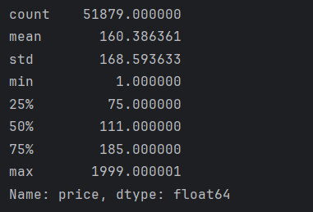
The number of outliers identified is 3582:
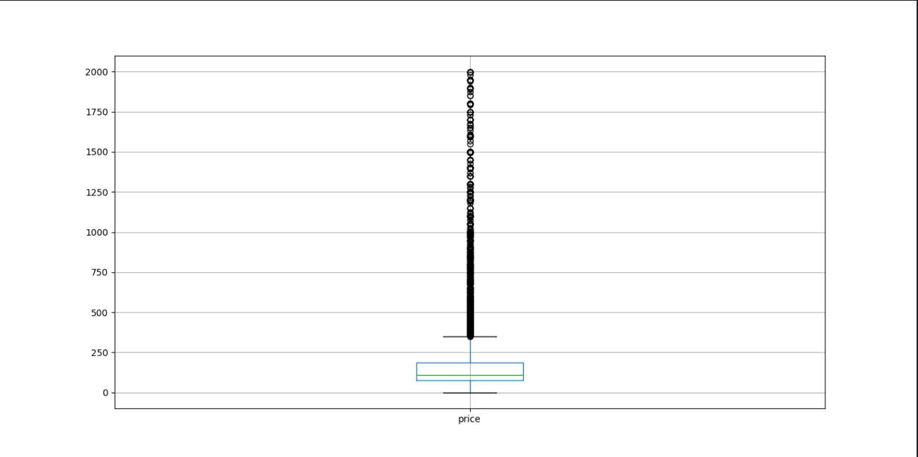
One of the major issues with this dataset is that there are many missing values:
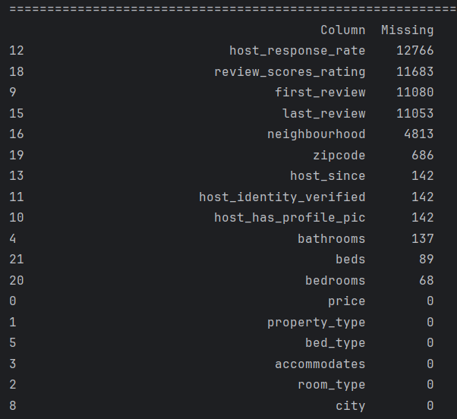

In addition, there are disproportionately many categorical columns, and some have too many categories to make use of traditional encoding approach. For example, the number of unique neighbourhoods is 598 and the photo below show the summary of the property_type column:

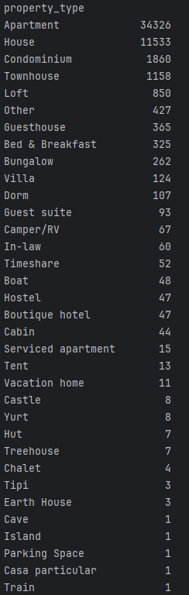

Data Processing
For missing values, Numeric Columns are imputed/filled in with the mean value of such columns, whereas Categorical Columns are imputed with most frequent values (or Modes).
For categorical columns, the ‘property_type’ column’s categories are grouped into more meaningful bins/groups to help reduce the dimensionality of the dataset when encoded:
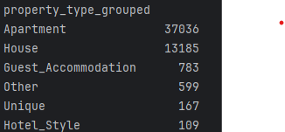
With the ‘neighbourhood’ column having 598 categories, it is more meaningful to compute the average price per neighbourhood that can help the model make more accurate predictions, and also help reduce the dimensions the dataset by dropping ‘zipcode’, as the former offers more concrete meaning.

Feature Selection Summary
After processing the dataset, three selection methods combined with three types of scaling are used to select the most significant/relevant features for OLS models. Overall, standardization method (using Standard Scaling) offers more consistent and better initial evaluation metrics than the others, and Recursive Feature Selection (RFE) is more competitive in performance than f_regression for Forward Feature Selection method and Outlier Clipping method.
Belows are the graphical summaries of these methods.
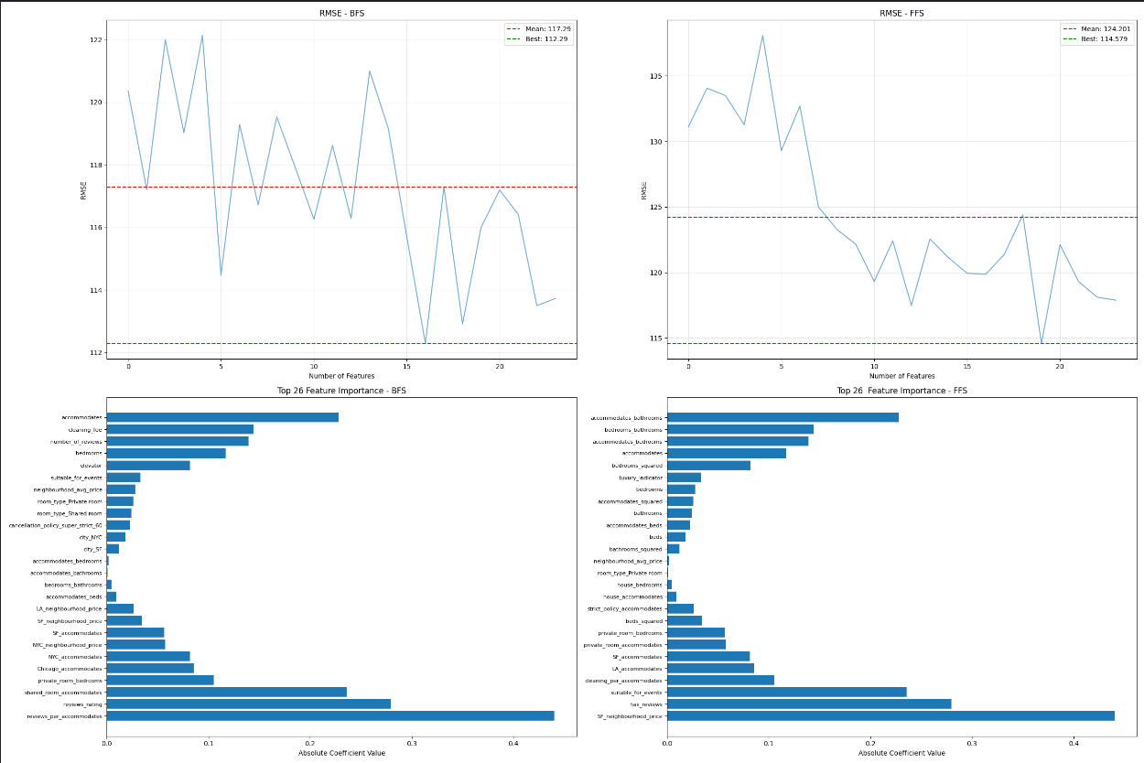
Standardization – Standard Scaling

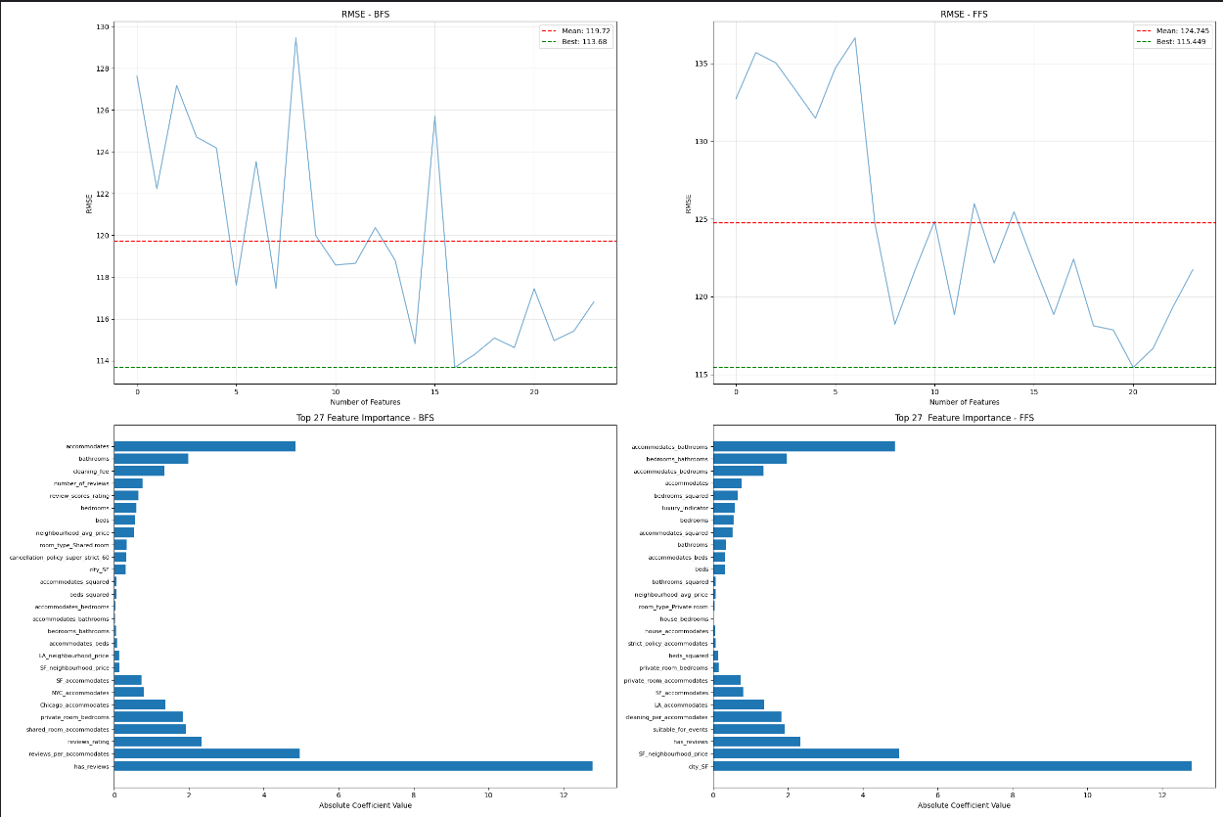
Min Max Scaling

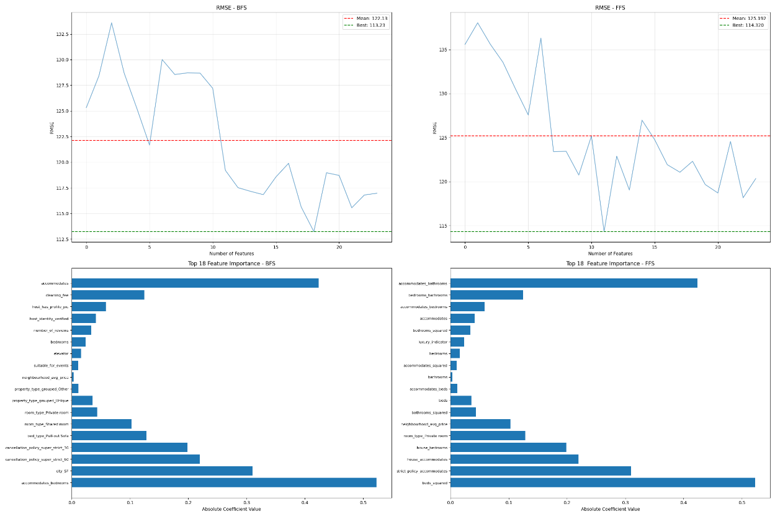
Interquartile Normalization – Robust Scaling

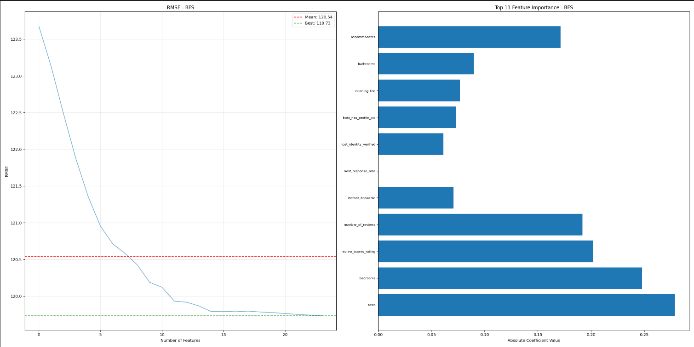
Outlier Clipping at price $1700, Standardization

Extensive Feature Engineering
Beyond the original listing attributes provided (e.g., accommodates, bathrooms, cleaning fee, room type, city, property type), extensive feature engineering was performed to capture non-linear effects and localized pricing behaviours that helps achieve the best performance model: reduce root mean squared error (RMSE) by 2 unit and R-squared score by over 6 percent (see model comparison table below).
First, polynomial terms were created for core continuous variables (e.g., accommodates², bedrooms², bathrooms², beds²) to model diminishing or increasing marginal returns on price as capacity scales.
Second, key interaction features were added to reflect relationships between size and configuration (e.g., accommodates × bedrooms, accommodates × bathrooms, bedrooms × bathrooms), and to capture market segmentation based on geography. City-specific interactions were generated for both capacity and neighbourhood pricing (e.g., LA_neighbourhood_price, NYC_accommodates), allowing the model to learn how the same feature behaves differently in different markets.
Additional domain-specific interactions were included for room types (e.g., private_room_accommodates), property types (e.g., house_bedrooms), and cancellation policies. Host-related predictors such as verified_response_rate and has_reviews were engineered to quantify trust and responsiveness. A luxury_indicator feature was also constructed to capture premium listings that combine larger spatial attributes with high neighbourhood pricing.
Here is an overview of the model trained on these features that achieved the best performance metrics: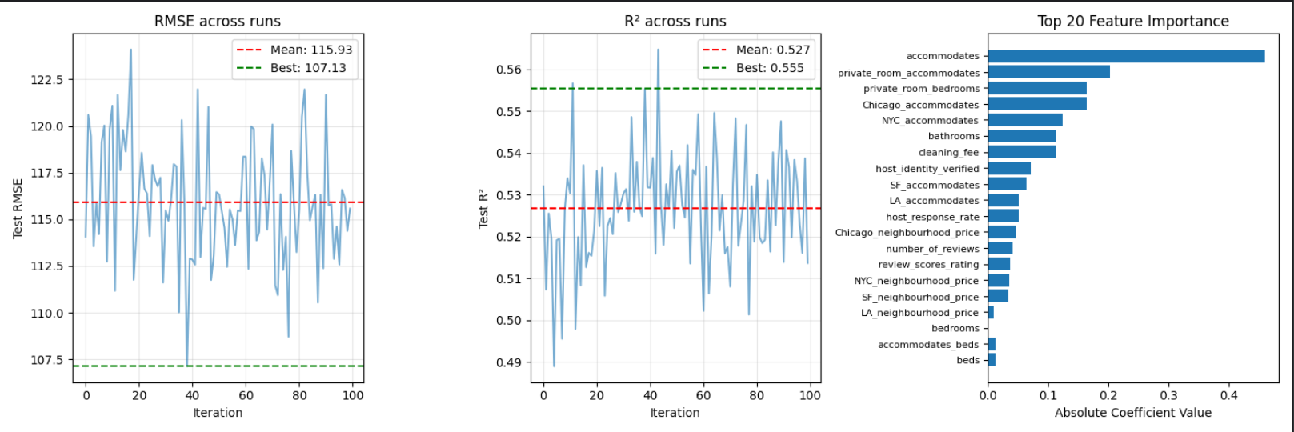

Correlations between predictor variables and target
These graphs below illustrate how the selected variables correlate to the target. Even though some do not show a clear correlation, others show a clear relationship with the target.
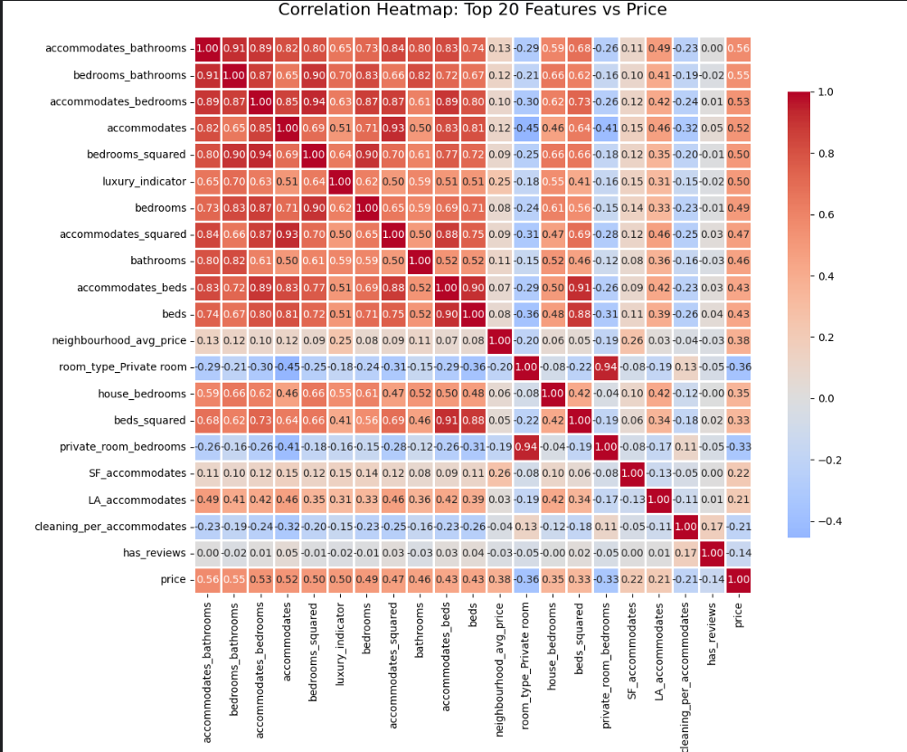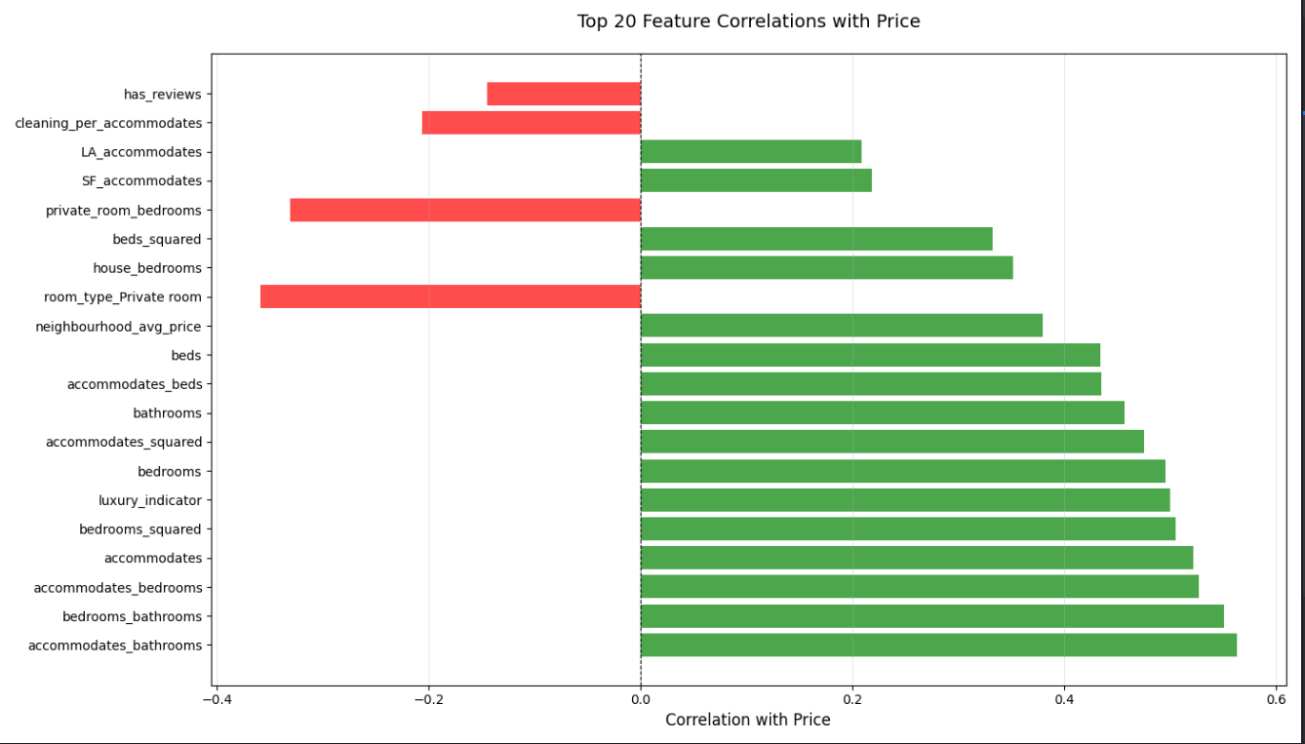
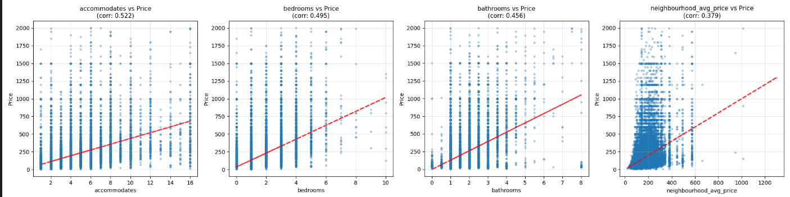
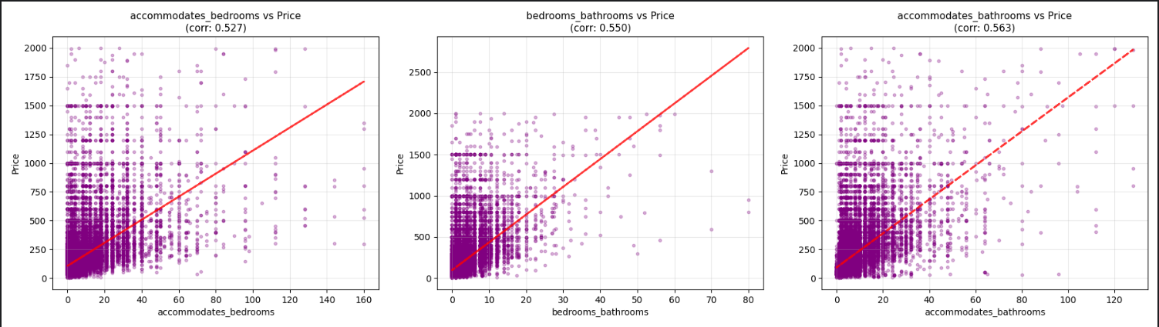
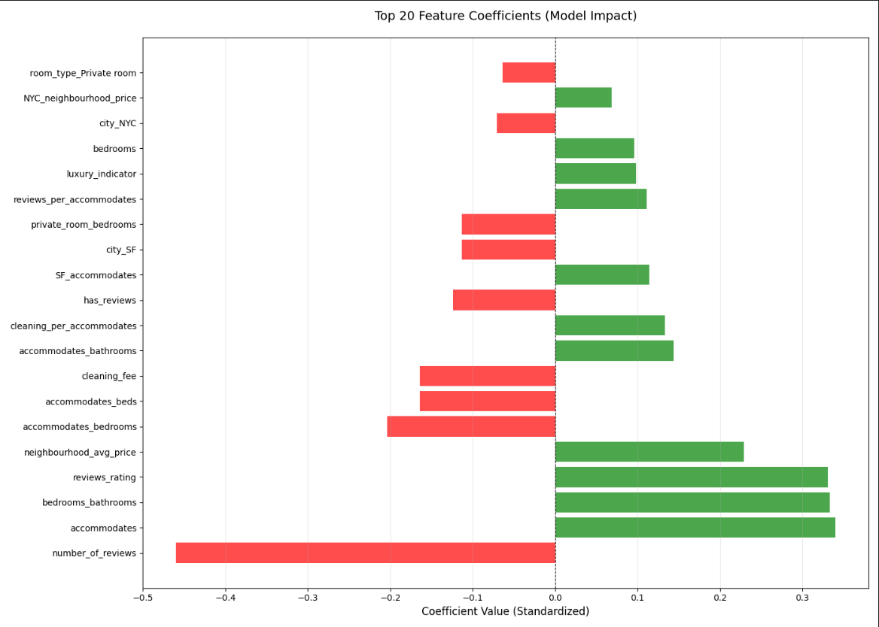

Model Comparison
 | Model A – Simple BFS with full Dataset | Model B – BFS with refined Dataset | Model C – Outlier Clipping | Model D – BFS with Feature interaction and polynomial
Variables | 'accommodates', 'bathrooms',  'cleaning_fee', 'number_of_reviews',  'review_scores_rating', 'bedrooms',  'beds',  'elevator',  'suitable_for_events', 'neighbourhood_avg_price' 'room_type_Private room', 'room_type_Shared room',  'cancellation_policy_super_strict_60',  'city_Chicago',  'city_LA' | 'accommodates', 'bathrooms', 'cleaning_fee', 'host_identity_verified',  'host_response_rate', 'number_of_reviews', 'review_scores_rating',  'bedrooms',  'beds', 'neighbourhood_avg_price’ 'property_type_grouped_House'  'property_type_grouped_Other',  'room_type_Private room', 'room_type_Shared room', 'bed_type_Real Bed',  'cancellation_policy_moderate''cancellation_policy_strict',  'cancellation_policy_super_strict_60',  'city_Chicago',  'city_LA',  'city_NYC',  'city_SF' | 'accommodates', 'bathrooms', 'cleaning_fee', 'review_scores_rating' 'bedrooms',  'beds',  'elevator', 'neighbourhood_avg_price',  'room_type_Private room', 'room_type_Shared room' | 'accommodates', 'bathrooms', 'cleaning_fee', 'host_identity_verified', 'number_of_reviews', 'review_scores_rating', 'bedrooms', 'beds', 'neighbourhood_avg_price', 'property_type_grouped_Other', 'room_type_Private room', 'room_type_Shared room', 'cancellation_policy_strict', 'cancellation_policy_super_strict_60', 'city_NYC', 'city_SF', 'accommodates_squared', 'bedrooms_squared', 'beds_squared', 'accommodates_bedrooms', 'accommodates_bathrooms', 'bedrooms_bathrooms', 'accommodates_beds', 'LA_neighbourhood_price', 'SF_neighbourhood_price', 'NYC_neighbourhood_price', 'LA_accommodates', 'SF_accommodates', 'NYC_accommodates', 'Chicago_accommodates', 'private_room_bedrooms', 'shared_room_accommodates', 'house_bedrooms', 'reviews_rating', 'reviews_per_accommodates', 'has_reviews', 'cleaning_per_accommodates', 'verified_response_rate', 'luxury_indicator'
# Vars | 15 | 23 | 10 | 39
Avg R2 | 0.4840 (+/-0.0035) | 0.4840 (+/-0.0034) | 0.4684 (+/- 0.0033) | 0.5226 (+/- 0.0032)
Avg Adj R2 | 0.4856 | 0.4856 | 0.4691 | 0.5262
Avg AIC | 76075.6483 | 76078.7844 | 73877.9121 | 87603.0295
Avg BIC | 76211.0580 | 76214.1941 | 73970.5254 | 87948.7311
Avg Train RMSE (+/- SD) | 119.0677 (+/-0.8759) | 119.1129 (+/-0.8075) | 122.8776 (+/- 0.8436) | 116.4186 (+/- 0.7526)
Avg. Test RMSE | 118.6185 (+/-3.0305) | 118.4481 (+/-2.8166) | 122.9543 (+/- 3.4814) | 115.9289 (+/- 3.2001)
Avg. Test R2 | 0.4838 (+/-0.0119) | 0.4839 (+/-0.0120) | 0.4674 (+/- 0.0133) | 0.5267 (+/- 0.0133)
Best RMSE | 111.4975 | 109.2244 | 116.3490 | 107.1255
Best R2 | 0.5206 | 0.4947 | 0.4819 | 0.5553

Summary
The model selected for production is the best performance model – Model D, and the following graphs illustrate its predictive performance on the whole dataset. Overall, it is able to make relatively close predictions on price range below $300 because there is less variance, which can be seen in the plot of actual vs predicted prices and its residuals plot which show lower residuals on the price range. The performance is also supported by distribution of residual with a mean error of -0.15 which is very close to zero error.
