Table of Contents
Feature Transformations 1
Transformations for Linearization 1
Square Root Transform: y = $x$ + b 1
Inverse Transform: y = 1/x + b 5
Negative Inverse Transform: y = 1/-x + b 5
Squared Transform: y = $x2$ + b 6
Log Transform: y = log(x) 7
Negative Log Transform: y = -log(x) 8
Exponential of Negative Transform: y = exp(-x) 9
Choosing a Transformation 10
Multi-dimensional Transformations 15

Feature Transformations
This document differs discusses how features, rather than y, can be transformed to help build linear models.

Transformations for Linearization
Linearization straightens relationships between x and y. Smoothing by transforming predictor variables (features) may sometimes make it easier to develop linear models. The disadvantage of linearization is that model coefficients of transformed variables have reduced interpretability.

Remember, when choosing treatments and features always evaluate the model with test data over multiple runs and compare the average model performance metrics to other models.

When evaluating model performance, there is no need to transform the feature back to it’s original format since y is the outcome that is being evaluated.

Square Root Transform: y = $\sqrt{x}$ + b

This section will examine plots and models before and after a square root transformation.

Example 1: Before Transformation
This example shows a typical curve at the left of Figure 1 which may benefit from a square root transformation. OLS with untreated data can lead to uneven error residuals during modeling (see the right of Figure 1).

Figure 1: X versus y before transformation (left) and $\hat{y}$ – y (right)
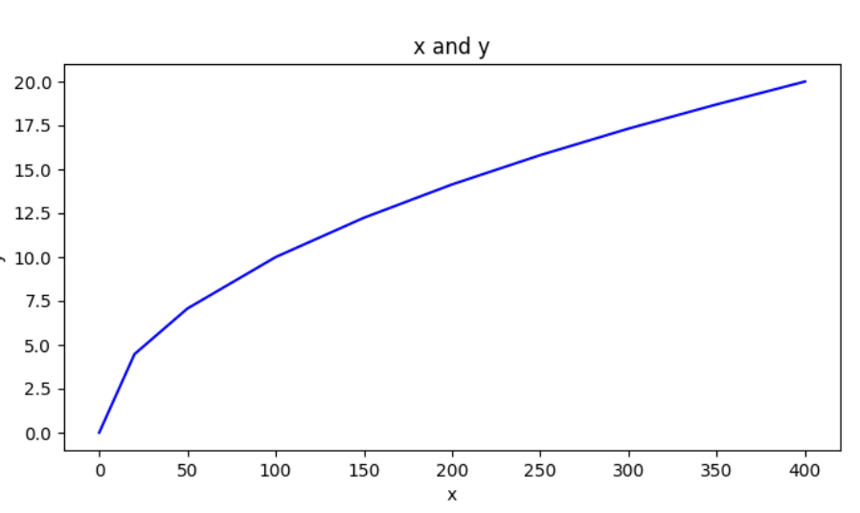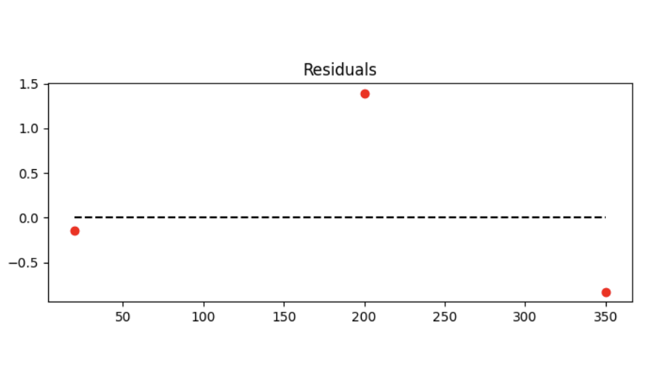

When creating a model with the untreated data, the fit is still quite decent. $R^{2}$=0.910 and RMSE is 0.93874.
OLS Regression Results
==============================================================================
Dep. Variable: y R-squared: 0.910
Model: OLS Adj. R-squared: 0.892
Method: Least Squares F-statistic: 50.73
Date: Prob (F-statistic): 0.000846
Time: 17:24:34 Log-Likelihood: -14.390
No. Observations: 7 AIC: 32.78
Df Residuals: 5 BIC: 32.67
Df Model: 1
Covariance Type: nonrobust
==============================================================================
coef std err t P>|t| [0.025 0.975]
------------------------------------------------------------------------------
const 3.7074 1.414 2.623 0.047 0.073 7.341
x 0.0452 0.006 7.123 0.001 0.029 0.062
==============================================================================
RMSE: 0.93874

Here is the original code.
import matplotlib.pyplot as plt
from sklearn.metrics import mean_squared_error
import pandas as pd
import statsmodels.api as sm
import numpy as np
from sklearn.model_selection import train_test_split

#------------------------------------------------
# Shows plot of x vs. y.
#------------------------------------------------
def showXandYplot(x,y, xtitle, title):
plt.figure(figsize=(8, 4))
plt.plot(x,y,color='blue')
plt.title(title)
plt.xlabel(xtitle)
plt.ylabel('y')
plt.show()

#------------------------------------------------
# Shows plot of actual vs. predicted and RMSE.
#------------------------------------------------
def showResidualPlotAndRMSE(x, y, predictions):
xmax = max(x)
xmin = min(x)
residuals = y - predictions

plt.figure(figsize=(8, 3))
plt.title('x and y')
plt.plot([xmin,xmax],[0,0],'--',color='black')
plt.title("Residuals")
plt.scatter(x,residuals,color='red')
plt.show()

# Calculate RMSE
mse = mean_squared_error(y,predictions)
rmse = np.sqrt(mse)
print("RMSE: " + str(rmse))

# Section A: Define the raw data.
x = [0, 20, 50, 100,150,200,250,300,350,400]
y = [0.0, 4.47, 7.07, 10.0, 12.24, 14.14, 15.81, 17.32, 18.70, 20.0]
print(y)

showXandYplot(x,y, 'x', 'x and y')

# Convert to DataFrame
dfX = pd.DataFrame({"x": x})
dfY = pd.DataFrame({"y": y})

#------------------------------------------------
# Add train/test split here
#------------------------------------------------
X_train, X_test, y_train, y_test = train_test_split(
dfX, dfY, test_size=0.3, random_state=42
)

# Add constant for statsmodels
X_train = sm.add_constant(X_train)
X_test = sm.add_constant(X_test)

# Fit model on training data
model = sm.OLS(y_train, X_train).fit()

# Predict on test data
predictions = model.predict(X_test)

# Output results
print(model.summary())
showResidualPlotAndRMSE(list(X_test['x']), list(y_test['y']), predictions)

After applying a square root transformation to X notice how the line is flattened at the left of Figure 2. The residuals at the right are also much closer to zero.

Figure 2: y = $\sqrt{x}$ (left) and $\hat{y}$ – y (right)
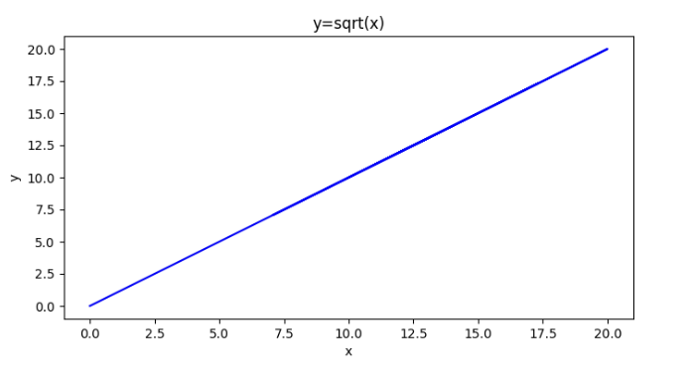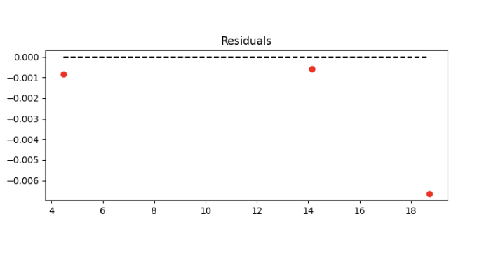
$R^{2}$ becomes 1.00 and the RMSE becomes 0.0027 which is much smaller than 1.66 when the data is not treated.
OLS Regression Results
==============================================================================
Dep. Variable: y R-squared: 1.000
Model: OLS Adj. R-squared: 1.000
Method: Least Squares F-statistic: 3.975e+07
Date: Prob (F-statistic): 4.49e-28
Time: 20:38:22 Log-Likelihood: 44.646
No. Observations: 10 AIC: -85.29
Df Residuals: 8 BIC: -84.69
Df Model: 1
Covariance Type: nonrobust
==============================================================================
coef std err t P>|t| [0.025 0.975]
------------------------------------------------------------------------------
const -0.0008 0.002 -0.359 0.729 -0.006 0.004
xt 0.9999 0.000 6304.457 0.000 1.000 1.000
==============================================================================
RMSE: 0.0038717048461445343
To build this example, append this code at the end of the current example.
# Section B: Transform and plot graph with transformed x.
X_train['xt'] = np.sqrt(X_train['x'])
X_test['xt'] = np.sqrt(X_test['x'])
showXandYplot(X_train['xt'] ,y_train, 'x', 'y=sqrt(x)')

# Build model with transformed x.
model_t = sm.OLS(y_train, X_train[['const', 'xt']]).fit()
predictions_t = model_t.predict(X_test[['const', 'xt']])
print(model_t.summary())
showResidualPlotAndRMSE(X_test['xt'],y_test['y'],predictions_t)

Inverse Transform: y = 1/x + b

When you see a curve like the one at the top left of Figure 3, you may be able to provide some linearization by transforming x with a negative inversion.

Figure 3: y =x (left) and y= 1/x + b (right0
Curved (Before) | Linearized (After)
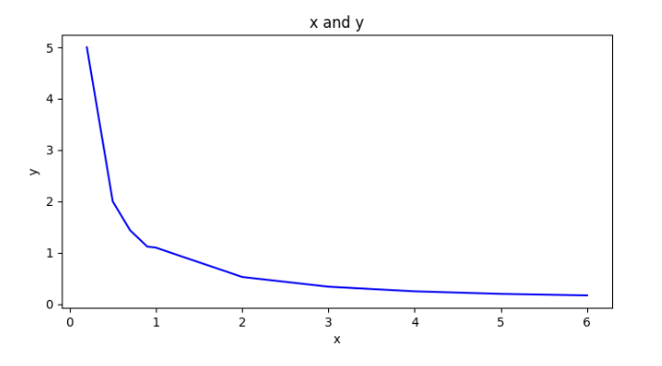 | 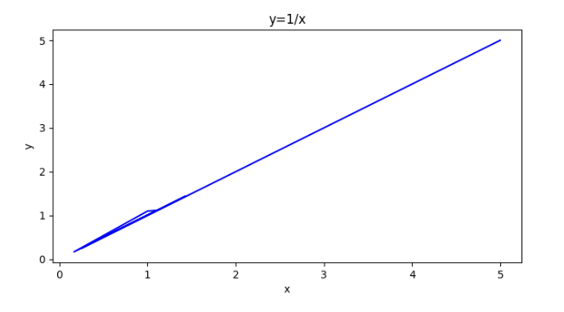
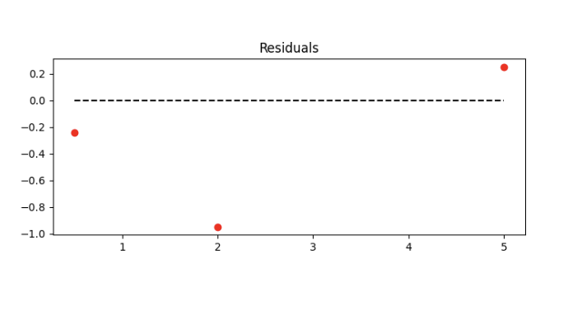 | 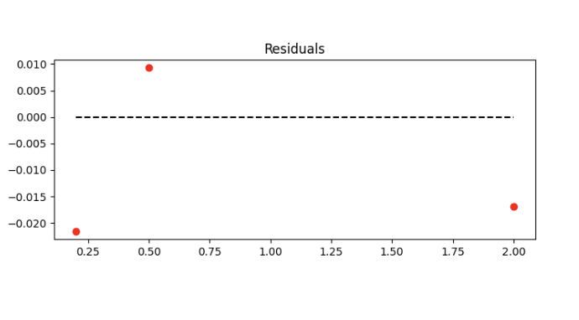
$R^{2}= 0.421$ RMSE $=$RMSE: 0.5826 | $R^{2}= 1$ RMSE $=$ 0.01667

Example 2: Inverse Transformation (1/x)
This example examines the statistical relationship between x and y and the error residuals for y=f(x) before and after the transformation. Replace the highlighted code in section A of Example 1 with this code.
# Section A: Define the raw data.
x = [0.2, 0.5, 0.7, 0.9,1,2,3,4,5,6]
y = [5.0, 2.0, 1.44, 1.12, 1.1, 0.53, 0.34, 0.25, 0.2, 0.17]

Then replace this highlighted code in section B of Example 1 to transform it:
# Section B: Transform and plot graph with transformed x.
X_train['xt'] = 1/X_train['x']
X_test['xt'] = 1/X_test['x']
showXandYplot(X_train['xt'] ,y_train, 'x', 'y=1/x')

Negative Inverse Transform: y = 1/-x + b
When you see a curve like the one at the top left of Figure 4, you may be able to enable some linearization by transforming x with a negative inversion.

Figure 4: Negative Inversion y = 1/-x + b
Curved (Before) | Linearized (After)
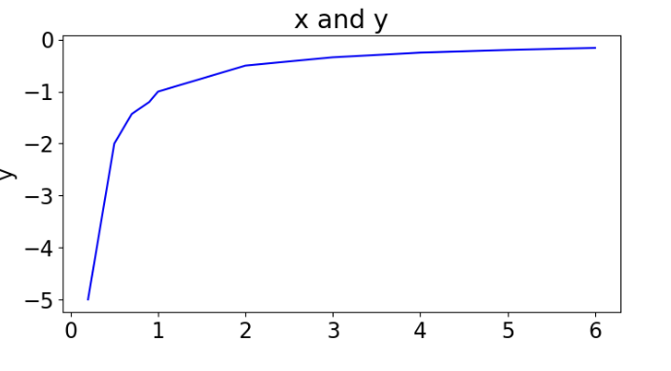 | 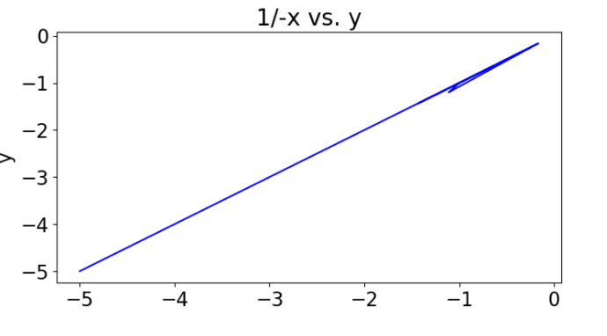
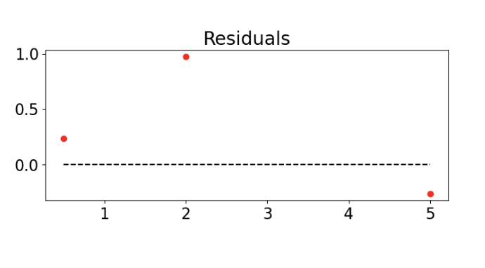 | 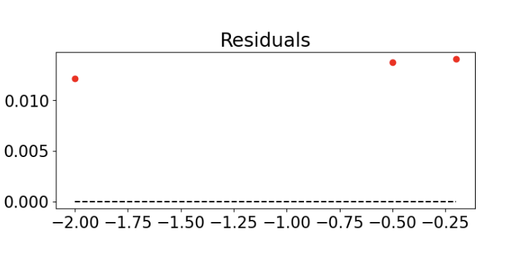

This example examines the statistical relationship between x and y and the error residuals for y=f(x) before and after the transformation. Replace the highlighted code in section A of Example 1 with this code.
# Section A: Define the raw data.
x = [0.2, 0.5, 0.7, 0.9,1,2,3,4,5,6]
y = [-5.0, -2.0, -1.43, -1.2, -1.0, -0.5, -0.34, -0.25, -0.2, -0.16]

Then replace this highlighted code in section B of Example 1to transform it:
# Section B: Transform and plot graph with transformed x.
X_train['xt'] = 1/-X_train['x']
X_test['xt'] = 1/-X_test['x']
showXandYplot(X_train['xt'] ,y_train, 'x', '1/-x vs. y')

Squared Transform: y = $x^{2}$ + b
When you see a curve like the one at the top left of Figure 5, you may be able to enable some linearization by squaring x.

Figure 5: Square Transformation
Curved (Before) | Linearized (After)
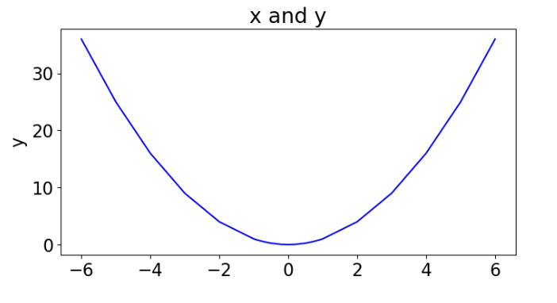 | 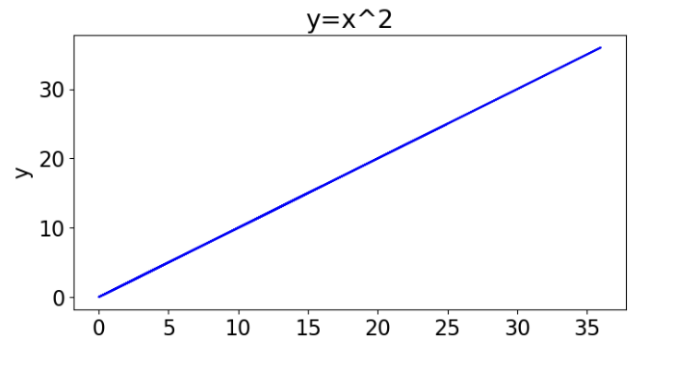
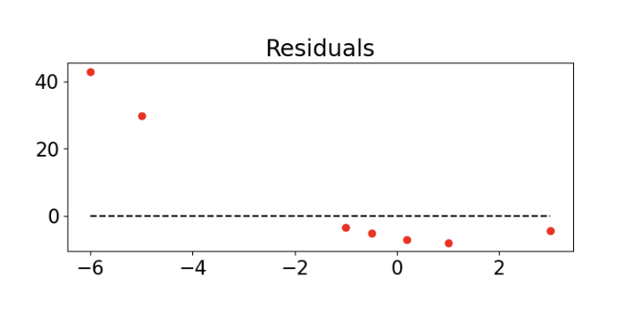 | 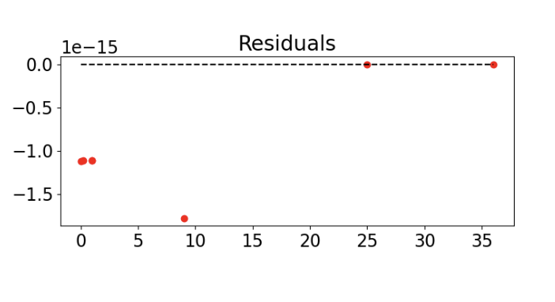
$R^{2}= 0.346$ RMSE = 20.39 | $$R^{2}= 1. RMSE = 0$$

Example 3: Squared Transformation
This example examines the statistical relationship between x and y and the error residuals for y=f(x) before and after the transformation. Replace the highlighted code in section A of Example 1 with this code.
# Section A: Define the raw data.
x = [-6,-5,-4,-3,-2,-1,-0.9,-0.7,-0.5,-0.2,0,0.2,0.5,0.7,0.9,1,2,3,4,5,6]
y = [36, 25, 16, 9, 4, 1, 0.81, 0.49, 0.25, 0.04,
0, 0.04, 0.25, 0.49, 0.81, 1, 4, 9, 16, 25, 36]

Then replace this highlighted code in section B of Example 1to transform it:
# Section B: Transform and plot graph with transformed x.
X_train['xt'] = X_train['x']*X_train['x']
X_test['xt'] = X_test['x']*X_test['x']
showXandYplot(X_train['xt'] ,y_train, 'x', 'y=x^2')

Log Transform: y = log(x)

When you see a curve like the one at the top left of Figure 6, you may be able to enable some linearization by taking the log of x.

Figure 6: Log(x) Transformation
Curved (Before) | Linearized (After)
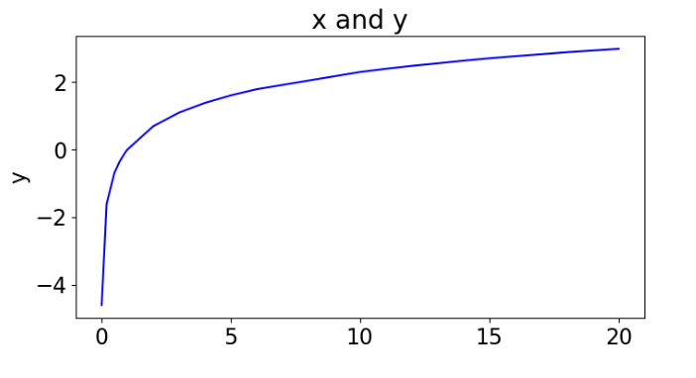 | 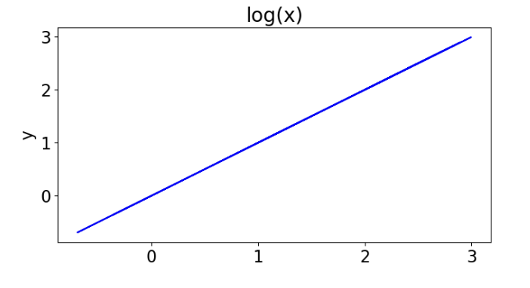
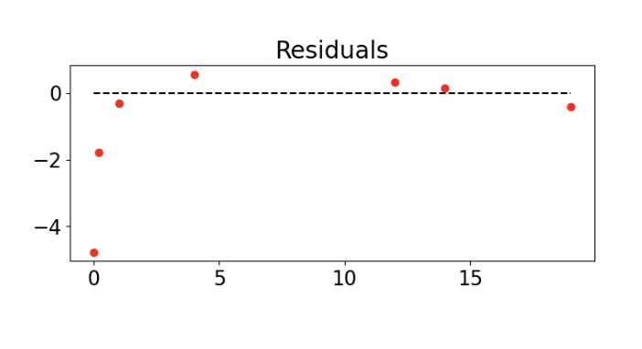 | 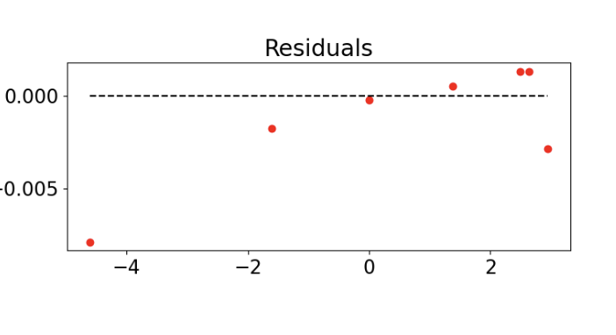
$R^{2}= 0.856$ RMSE= 1.9496 | $R^{2}= 1.$ RMSE=0.00332

Example 4: log(x) Transformation
This example examines the statistical relationship between x and y and the error residuals for y=f(x) before and after the transformation. Replace the highlighted code in section A of Example 1 with this code.
# Section A: Define the raw data.
x = [0.01, 0.2, 0.5, 0.7, 0.9,1,2,3,4,5,6,10,11,12,13,14,15,16,17,18,19,20]
y = [-4.61, -1.61, -0.693, -0.357, -0.1054, 0.0, 0.6931, 1.099, 1.3862, 1.6094,
1.792, 2.303, 2.398, 2.48491, 2.56, 2.6390, 2.71, 2.772, 2.83, 2.89,
2.94, 2.99]

Then replace this highlighted code in section B of Example 1to transform it:
# Section B: Transform and plot graph with transformed x.
X_train['xt'] = np.log(X_train['x'])
X_test['xt'] = np.log(X_test['x'])
showXandYplot(X_train['xt'] ,y_train, 'x', 'log(x)')

Negative Log Transform: y = -log(x)

Example 5: Negative Log Transformation
When you see a curve like the one at the top left of Figure 7 you may be able to enable some linearization by taking the negative log of x.

Figure 7: Negative Log Transform -log(x)
Curved (Before) | Linearized (After)
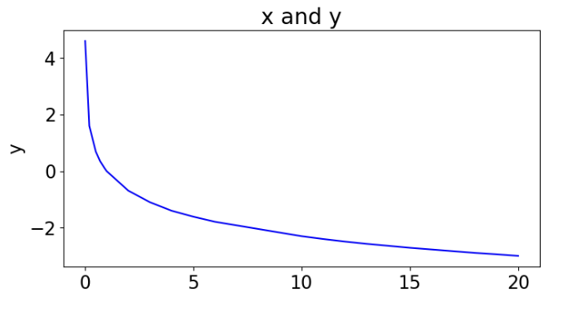 | 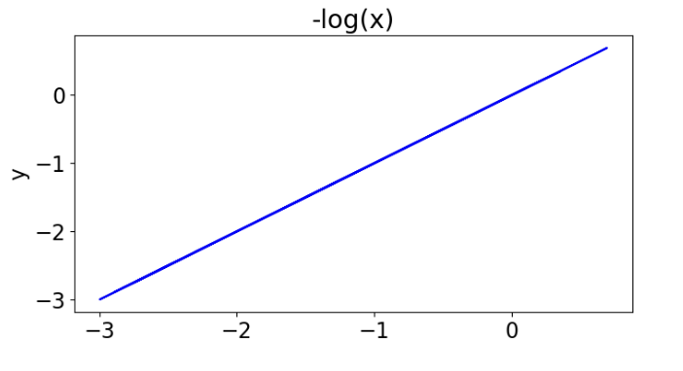
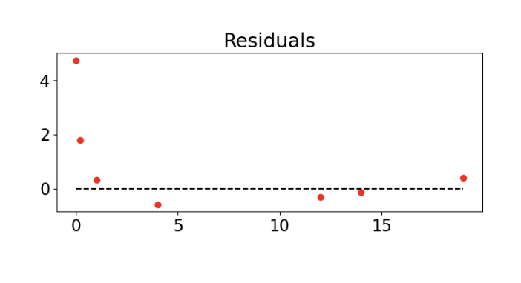 | 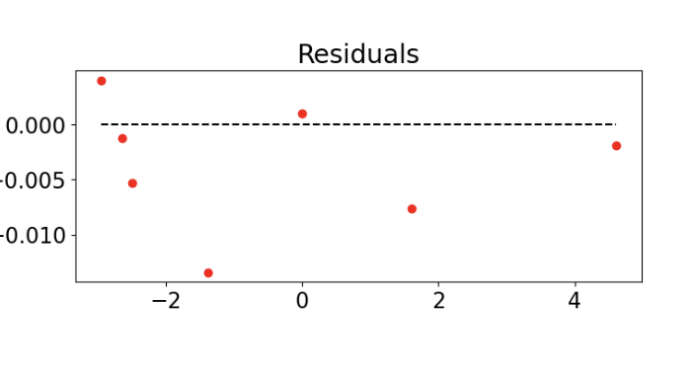
$R^{2}= 0.857$ RMSE = 1.9455 | $R^{2}= 1.$ RMSE = 0.0064

This example examines the statistical relationship between x and y and the error residuals for y=f(x) before and after the transformation. Replace the highlighted code in section A of Example 1 with this code.
# Section A: Define the raw data.
x = [0.01, 0.2, 0.5, 0.7, 0.9,1,2,3,4,5,6,10,11,12,13,14,15,16,17,18,19,20]
y = [4.60, 1.60, 0.69, 0.35, 0.11, 0.0, -0.69, -1.1, -1.4, -1.61, -1.79, -2.3, -2.4,
-2.49, -2.57, -2.64, -2.71, -2.77, -2.83, -2.89, -2.94, -2.996]

Exercise 1 (2 marks)
When you transform a feature of a model do you need to transform the feature back to the original format? Explain why or why not.
there is no need to transform the feature back to it’s original format since y is the outcome that is being evaluated.

Exercise 2 (4 marks)
Show the code needed to perform the transformation needed to flatten the curve in Example 5.
import numpy as np
import pandas as pd
from matplotlib import pyplot as plt
from sklearn.model_selection import train_test_split
import statsmodels.api as sm
from plot import show_X_y
from plot import show_residual_rmse
# Section A: Define the raw data.
x = [0.01, 0.2, 0.5, 0.7, 0.9,1,2,3,4,5,6,10,11,12,13,14,15,16,17,18,19,20]
y = [4.60, 1.60, 0.69, 0.35, 0.11, 0.0, -0.69, -1.1, -1.4, -1.61, -1.79, -2.3, -2.4,
-2.49, -2.57, -2.64, -2.71, -2.77, -2.83, -2.89, -2.94, -2.996]
df_X = pd.DataFrame({'x': x})
df_y = pd.DataFrame({'y': y})
X_train, X_test, y_train, y_test = train_test_split(
df_X, df_y, test_size=0.3, random_state=42
)
X_train = sm.add_constant(X_train)
X_test = sm.add_constant(X_test)
model = sm.OLS(y_train, X_train).fit()
y_pred = model.predict(X_test)
# Log Transform
X_train['xt'] = np.log(X_train['x'])
X_test['xt'] = np.log(X_test['x'])
model_t = sm.OLS(y_train, X_train[['const', 'xt']]).fit()
y_pred_t = model_t.predict(X_test[['const', 'xt']])
plt.subplots(1, 2, figsize=(14, 3))
plt.subplot(1, 2, 1)
show_X_y(x, y, 'Original', xlab='X')
plt.subplot(1, 2, 2)
show_residual_rmse(X_test['x'], y_test['y'], y_pred)
plt.subplots(1, 2, figsize=(14, 3))
plt.subplot(1, 2, 1)
show_X_y(X_train['xt'], y_train, 'y=-log(X)', xlab='X')
plt.subplot(1, 2, 2)
show_residual_rmse(X_test['xt'], y_test['y'], y_pred_t)
plt.show()

Plot the graph after flattening the data. Show a screenshot of it here.
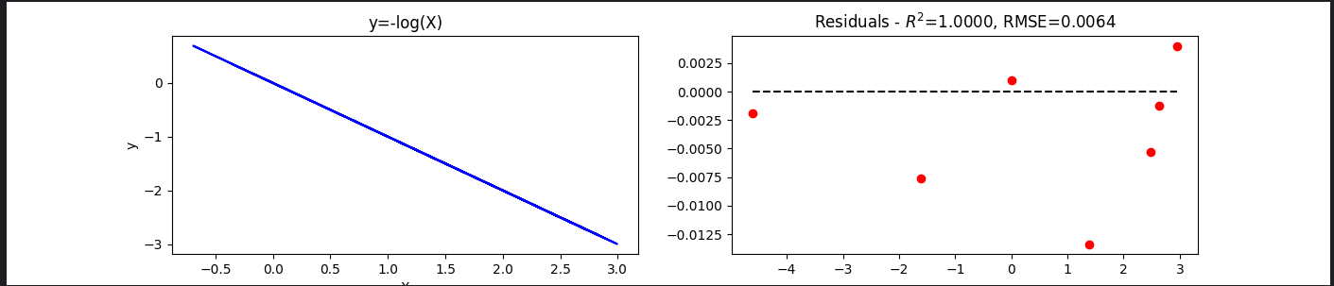

Exponential of Negative Transform: y = exp(-x)

Example 6: Exponential of Negative Transform
A curve like the following may be transformed to a straight line with exp(-x)

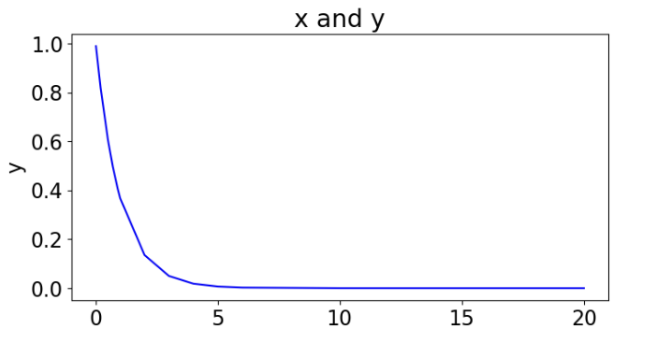
To build this example, replace the highlighted code in section A of Example 1 with this code.
# Section A: Define the raw data.
x = [0.01, 0.2, 0.5, 0.7, 0.9,1,2,3,4,5,6,10,11,12,13,14,15,16,17,18,19,20]
y = [0.99, 0.819, 0.6065, 0.4966, 0.40657, 0.368, 0.1353, 0.0498,
0.01831, 0.00674, 0.0025, 4.5399e-05, 1.670e-05, 6.1e-06,
2.260e-06, 8.3153e-07, 3.0590e-07, 1.12e-07, 4.14e-08,
1.52e-08, 5.60e-09, 2.061e-09]

Exercise 3 (4 marks)
Show the code needed to perform the transformation needed to flatten the curve in Example 6.
HINT: np.exp(-x)
import numpy as np
import pandas as pd
from matplotlib import pyplot as plt
from sklearn.model_selection import train_test_split
import statsmodels.api as sm
from plot import show_X_y
from plot import show_residual_rmse
# Section A: Define the raw data.
x = [0.01, 0.2, 0.5, 0.7, 0.9,1,2,3,4,5,6,10,11,12,13,14,15,16,17,18,19,20]
y = [0.99, 0.819, 0.6065, 0.4966, 0.40657, 0.368, 0.1353, 0.0498,
0.01831, 0.00674, 0.0025, 4.5399e-05, 1.670e-05, 6.1e-06,
2.260e-06, 8.3153e-07, 3.0590e-07, 1.12e-07, 4.14e-08,
1.52e-08, 5.60e-09, 2.061e-09]
df_X = pd.DataFrame({'x': x})
df_y = pd.DataFrame({'y': y})
X_train, X_test, y_train, y_test = train_test_split(
df_X, df_y, test_size=0.3, random_state=42
)
X_train = sm.add_constant(X_train)
X_test = sm.add_constant(X_test)
model = sm.OLS(y_train, X_train).fit()
y_pred = model.predict(X_test)
# Log Transform
X_train['xt'] = np.exp(-X_train['x'])
X_test['xt'] = np.exp(-X_test['x'])
model_t = sm.OLS(y_train, X_train[['const', 'xt']]).fit()
y_pred_t = model_t.predict(X_test[['const', 'xt']])
plt.subplots(1, 2, figsize=(14, 3))
plt.subplot(1, 2, 1)
show_X_y(x, y, 'Original', xlab='X')
plt.subplot(1, 2, 2)
show_residual_rmse(X_test['x'], y_test['y'], y_pred)
plt.subplots(1, 2, figsize=(14, 3))
plt.subplot(1, 2, 1)
show_X_y(X_train['xt'], y_train, 'y=-log(X)', xlab='X')
plt.subplot(1, 2, 2)
show_residual_rmse(X_test['xt'], y_test['y'], y_pred_t)
plt.show()

Plot the graph after flattening the data. Show a screenshot of it here.
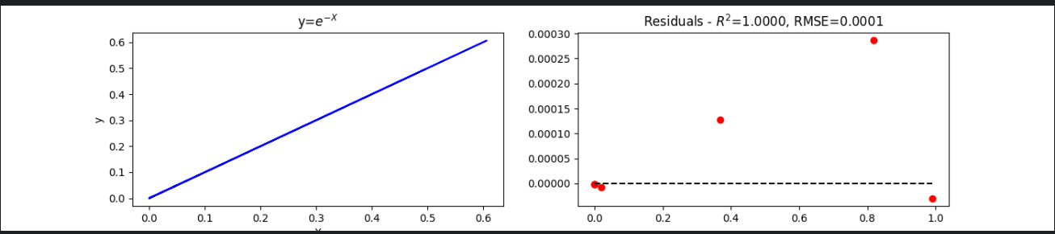

Choosing a Transformation
When learning about transformations it can be overwhelming to think of all transformation possibilities to enable the straightest line for linear regression. However, it is possible to loop through different transformations, perform regression with the transformed data and then choose the model that gives the lowest RMSE.

Example 7: Grid Searching for a Transformation
We are given the following data:
x = [0.1, 0.8, .99, 1.4, 2, 2.1, 2.4, 3.8]
y = [-2.303, -0.2231, -0.010050, 0.3364, 0.6931,
0.74194, 0.87547, 1.3350]

When we plot the data, we get the following curve:
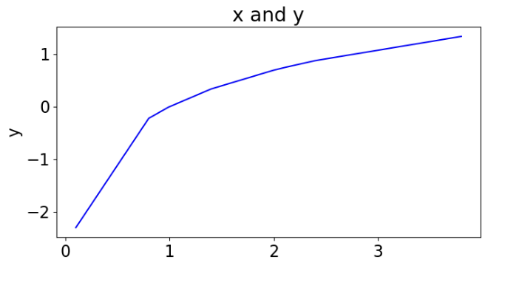
We can find the best fit by looping through different transformations, building a model with the transformed data and finding the model with the lowest RMSE.

The code implements a dictionary called transform_function. The dictionary stores anonymous functions which are accessible by a key which identifies the type of transformation. Basically, the anonymous function can take any number of inputs and return the results of an expression.

The output reveals the log transformation as the optimal transformation:
tran rmse
2 log 0.000029
0 sqrt 0.049589
4 neg_exp 0.088261
1 neg_inv 0.094556
3 exp 0.239458

Here is the code.
import matplotlib.pyplot as plt
from sklearn.metrics import mean_squared_error
import pandas as pd
import statsmodels.api as sm
import numpy as np
from sklearn.model_selection import train_test_split

#------------------------------------------------
# Shows plot of x vs. y.
#------------------------------------------------
def showXandYplot(x,y, xtitle, title):
plt.figure(figsize=(8, 4))
plt.plot(x,y,color='blue')
plt.title(title)
plt.xlabel(xtitle)
plt.ylabel('y')
plt.show()

#------------------------------------------------
# Shows plot of actual vs. predicted and RMSE.
#------------------------------------------------
def showResidualPlotAndRMSE(x, y, predictions):
xmax = max(x)
xmin = min(x)
residuals = y - predictions

plt.figure(figsize=(8, 3))
plt.title('x and y')
plt.plot([xmin,xmax],[0,0],'--',color='black')
plt.title("Residuals")
plt.scatter(x,residuals,color='red')
plt.show()

# Calculate RMSE
mse = mean_squared_error(y,predictions)
rmse = np.sqrt(mse)
print("RMSE: " + str(rmse))

# Section A: Define the raw data.
x = [0.1, 0.8, .99, 1.4, 2, 2.1, 2.4, 3.8]
y = [-2.303, -0.2231, -0.010050, 0.3364, 0.6931,
0.74194, 0.87547, 1.3350]

showXandYplot(x,y, 'x', 'x and y')

# Show raw x and y relationship
dfX = pd.DataFrame({"x": x})
dfY = pd.DataFrame({"y": y})
dfX = sm.add_constant(dfX)

# Show residuals from y(x)
model = sm.OLS(y, dfX).fit()
predictions = model.predict(dfX)
print(model.summary())
showResidualPlotAndRMSE(x,y,predictions)

x = [0.1, 0.8, .99, 1.4, 2, 2.1, 2.4, 3.8]
y = pd.Series([-2.303, -0.2231, -0.010050, 0.3364, 0.6931, 0.74194, 0.87547,
1.3350])
# Show raw x and y relationship
dfX = pd.DataFrame({"x": x})
dfX = sm.add_constant(dfX)
# split into train and test so that transforms are chosen on training data
X_train, X_test, y_train, y_test = train_test_split(dfX, y, test_size=0.3,
random_state=42)

transform_function = {
'sqrt': lambda x: np.sqrt(x),
'inv': lambda x: 1 / x,
'neg_inv': lambda x: -1 / x,
'sqr': lambda x: x * x,
'log': lambda x: np.log(x),
'neg_log': lambda x: -np.log(x),
'exp': lambda x: np.exp(x),
'neg_exp': lambda x: np.exp(-x),
}

# Pass a tuple of strings to test for trans. Refer to transform_function for the
# keywords.
def grid_search(dfX, y, trans):

dfTransformations = pd.DataFrame()
for tran in trans:
# Transform x
dfX['xt'] = transform_function[tran](dfX['x'])
model_t = sm.OLS(y, dfX[['const', 'xt']]).fit()
predictions_t = model_t.predict(dfX[['const', 'xt']])
# Calculate RMSE
mse = mean_squared_error(y, predictions_t)
rmse = np.sqrt(mse)
dfTransformations = dfTransformations._append({
"tran":tran, "rmse":rmse}, ignore_index=True)
dfTransformations = dfTransformations.sort_values(by=['rmse'])
print(dfTransformations)
bestTransform = dfTransformations.iloc[0]['tran']
return bestTransform

bestTransform = grid_search(X_train, y_train, ('sqrt', 'neg_inv', 'log', 'exp', 'neg_exp'))

def evaluateWithTestData(X_train, X_test, y_train, y_test, tran):
X_train['xt'] = transform_function[tran](X_train['x'])
model = sm.OLS(y_train, X_train[['const', 'xt']]).fit()

X_test['xt'] = transform_function[tran](X_test['x'])
predictions = model.predict(X_test[['const', 'xt']])
print(model.summary())
showResidualPlotAndRMSE(X_test['xt'], y_test, predictions)

evaluateWithTestData(X_train, X_test, y_train, y_test, bestTransform)

Exercise 4 (8 marks)
This exercise is based on the initial exercise at http://sciences.usca.edu/biology/zelmer/305/trans/.

Please use the abs.csv file that is located in the data sets folder. For this example, we are interested in predicting the concentration of protein (ug/L) given the absorption (450nm) see Figure 8.

Figure 8: Relationship between protein concentration (y) and protein absorbance (x) (Right) Error residuals (Left)
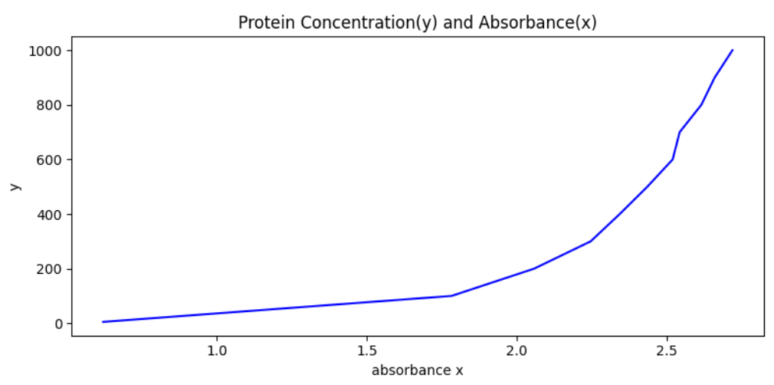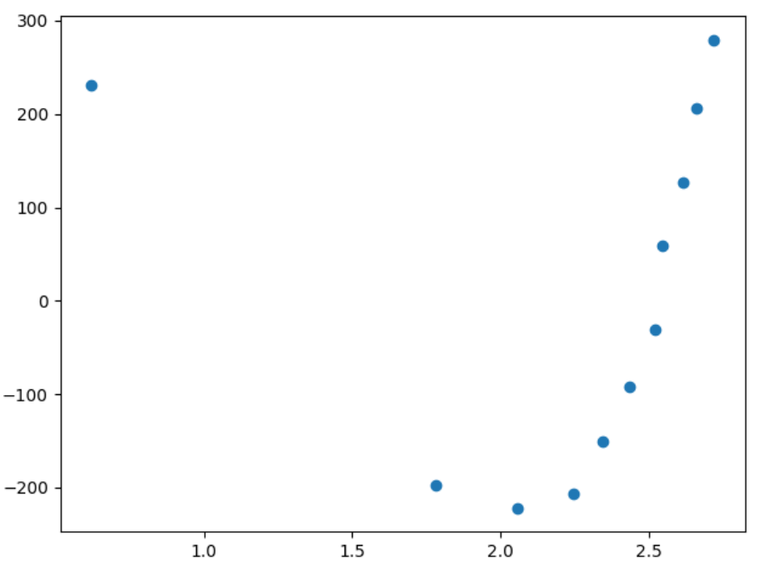
$R^{2}$=0.674 RMSE: 180.21998

The code to generate and evaluate our linear model is here:
import pandas as pd
import statsmodels.api as sm
import numpy as np
import matplotlib.pyplot as plt
#------------------------------------------------
# Shows plot of x vs. y.
#------------------------------------------------
def showXandYplot(x,y, xtitle, title):
plt.figure(figsize=(8, 4))
plt.plot(x,y,color='blue')
plt.title(title)
plt.xlabel(xtitle)
plt.ylabel('y')
plt.show()

PATH = "/Users/pm/Desktop/DayDocs/data/"
FILE = 'abs.csv'
df = pd.read_csv(PATH + FILE)

x = df[['abs(450nm)']] # absorbance
y = df[['ug/L']] # protein concentration
showXandYplot(x,y, 'absorbance x', 'Protein Concentration(y) and Absorbance(x)')

# Show raw x and y relationship
x = sm.add_constant(x)

# Show model.
model = sm.OLS(y, x).fit()
predictions = model.predict(x)
print(model.summary())

# Show RMSE.
preddf = pd.DataFrame({"predictions":predictions})
residuals = y['ug/L']-preddf['predictions']
resSq = [i**2 for i in residuals]
rmse = np.sqrt(np.sum(resSq)/len(resSq))
print("RMSE: " + str(rmse))

# Show the residual plot
plt.scatter(x['abs(450nm)'],residuals)
plt.show()

What kind of transformation should you apply to improve the results? Show the code that you need to transform x, build the model, compute the RMSE and plot the residuals.
import numpy as np
import pandas as pd
import statsmodels.api as sm
import matplotlib.pyplot as plt
from sklearn.metrics import mean_squared_error
from sklearn.model_selection import train_test_split
from lab.plot import show_X_y, show_residual_rmse
pd.set_option('display.max_columns', None)
pd.set_option('display.width', 1000)
path = r"C:\Users\linho\Desktop\CST\term3\pred_analytics\data\abs.csv"
df = pd.read_csv(path)
X = df[['abs(450nm)']]
y = df['ug/L']
show_X_y(X, y, 'absorbance x', 'Protein Concentration(y) and Absorbance(x)')
plt.show()
X = sm.add_constant(X)
model = sm.OLS(y, X).fit()
y_pred = model.predict(X)
print(model.summary())
pred_df = pd.DataFrame({'prediction': y_pred})
residuals = y - pred_df['prediction']
res_squared = [i**2 for i in residuals]
rmse = np.sqrt(np.sum(res_squared) / len(res_squared))
print(f'RMSE: {rmse:.4f}')
plt.scatter(X['abs(450nm)'], residuals)
plt.show()
# =======================================================
# Transform selection
# =======================================================
transform_func = {
'sqrt': lambda x: np.sqrt(x),
'inv': lambda x: 1 / x,
'neg_inv': lambda x: -1 / x,
'sqr': lambda x: x*x,
'log': lambda x: np.log(x),
'neg_log': lambda x: -np.log(x),
'exp': lambda x : np.exp(x),
'neg_exp': lambda x: np.exp(-x)
}
def grid_search(X, y, transform_func, col_name):
df_transform = pd.DataFrame()
for name, func in transform_func.items():
X['xt'] = func(X[col_name])
model = sm.OLS(y, X[['const', 'xt']]).fit()
y_pred = model.predict(X[['const', 'xt']])
rmse = np.sqrt(mean_squared_error(y, y_pred))
df_transform = df_transform._append({
'transform': name,
'rmse': rmse
}, ignore_index=True)
df_transform.sort_values(by=['rmse'], inplace=True)
print(df_transform)
return df_transform.iloc[0]['transform']
def evaluate(X_train, X_test, y_train, y_test,
transform_func, best_transform, col_name):
X_train['xt'] = transform_func[best_transform](X_train[col_name])
model = sm.OLS(y_train, X_train[['const', 'xt']]).fit()
X_test['xt'] = transform_func[best_transform](X_test[col_name])
y_pred = model.predict(X_test[['const', 'xt']])
print(model.summary())
show_residual_rmse(X_test['xt'], y_test, y_pred)
X_train, X_test, y_train, y_test = train_test_split(
X, y, test_size=0.3
)
best_transform = grid_search(X, y, transform_func, 'abs(450nm)')
# Evaluate based on train test split but the results
# depends closely on the splits, which is too small
# for them to be reliable
evaluate(X_train, X_test, y_train, y_test,
transform_func, best_transform, 'abs(450nm)')
plt.show()
# Evaluate based on the whole dataset, the result produced
# here is more suitable for comparison with the initial RMSE
X['xt'] = transform_func[best_transform](X['abs(450nm)'])
model_t = sm.OLS(y, X[['const', 'xt']]).fit()
y_pred_2 = model_t.predict(X[['const', 'xt']])
show_residual_rmse(X['xt'], y, y_pred_2)
plt.show()
print(model_t.summary())

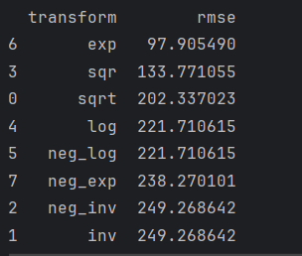 exp is selected for this transform

Show your residual plot after the transformation.
This plot is one of the many iterations run which show the “best” metrics which depends on the split of dataset.
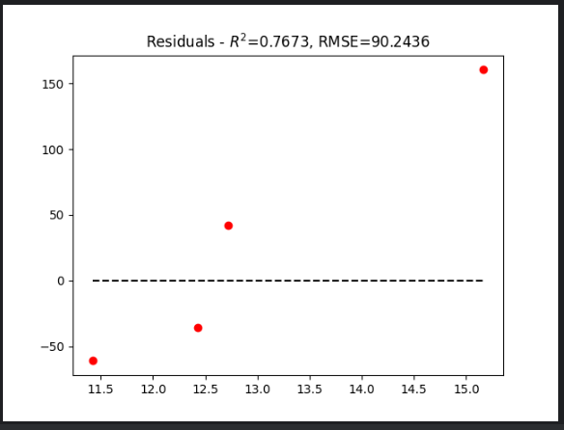

This is the evaluation plot for the whole dataset.
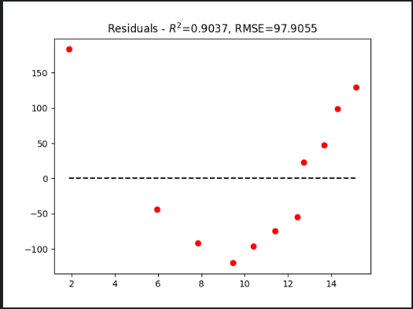

Show your model summary and RMSE after building the model with the transformation.
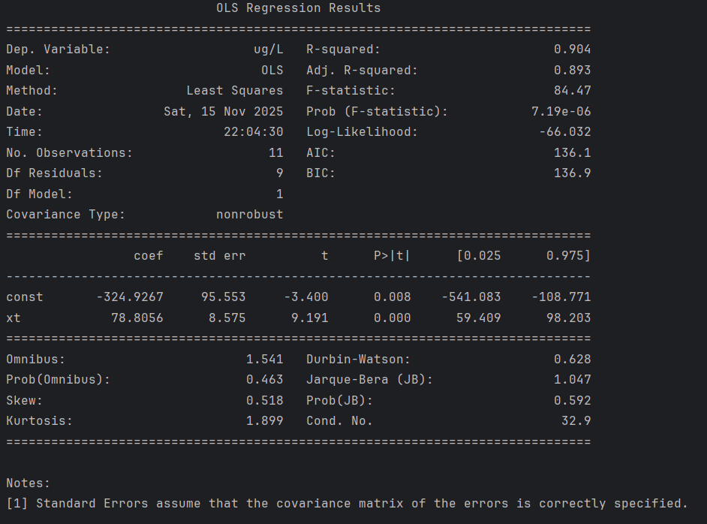

RMSE is included in the plot: RMSE = 90.2436

Multi-dimensional Transformations
We have been examining single variable transformations until now. However, we can sometimes transform our regression results to generate a better fit.

Example 8: The Wine Quality Data Set
The wine quality data set highlights a problem with poor fitting regression results. Notice how the residual errors were not evenly aligned with the actual values.
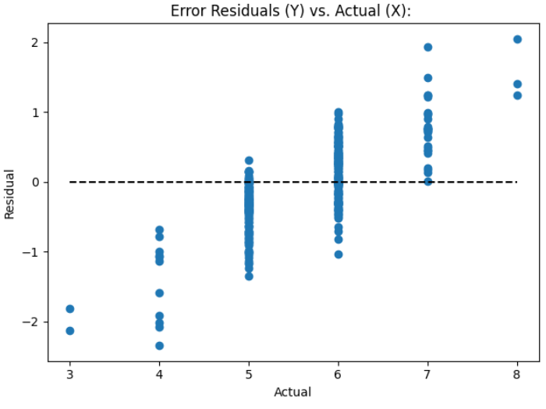

With the wine quality data set we saw that we did not obtain optimal results. Here is the model summary with all of the optimal parameters:
OLS Regression Results
==============================================================================
Dep. Variable: quality R-squared: 0.358
Model: OLS Adj. R-squared: 0.355
Method: Least Squares F-statistic: 141.8
Prob (F-statistic): 1.06e-119
Time: 08:48:28 Log-Likelihood: -1276.6
No. Observations: 1279 AIC: 2565.
Df Residuals: 1273 BIC: 2596.
Df Model: 5
Covariance Type: nonrobust
========================================================================================
coef std err t P>|t| [0.025 0.975]
----------------------------------------------------------------------------------------
const 3.0105 0.226 13.298 0.000 2.566 3.455
volatile acidity -1.2105 0.107 -11.337 0.000 -1.420 -1.001
chlorides -1.7655 0.433 -4.082 0.000 -2.614 -0.917
total sulfur dioxide -0.0022 0.001 -3.859 0.000 -0.003 -0.001
sulphates 0.8949 0.120 7.439 0.000 0.659 1.131
alcohol 0.2827 0.019 15.207 0.000 0.246 0.319
==============================================================================
Omnibus: 14.372 Durbin-Watson: 2.100

The Root Mean Squared Error is 0.6259157889490549

import pandas as pd
from sklearn.model_selection import train_test_split
from sklearn.linear_model import LinearRegression
from sklearn import metrics
import statsmodels.api as sm
import numpy as np

PATH = "/Users/pm/Desktop/DayDocs/data/"
CSV_DATA = "winequality.csv"
dataset = pd.read_csv(PATH + CSV_DATA, sep=',')

# Show all columns.
pd.set_option('display.max_columns', None)

# Increase number of columns that display on one line.
pd.set_option('display.width', 1000)
print(dataset.head())
print(dataset.describe())
X = dataset[[ 'volatile acidity', 'chlorides', 'total sulfur dioxide',
'sulphates','alcohol']]

# Adding an intercept *** This is requried ***. Don't forget this step.
# The intercept centers the error residuals around zero
# which helps to avoid over-fitting.
X = sm.add_constant(X)

y = dataset['quality']

X_train, X_test, y_train, y_test = train_test_split(X, y, test_size=0.2, random_state=0)

model = sm.OLS(y_train, X_train).fit()
predictions = model.predict(X_test) # make the predictions by the model

print(model.summary())

print('Root Mean Squared Error:', np.sqrt(metrics.mean_squared_error(y_test, predictions)))

import matplotlib.pyplot as plt
def plotResidualsVsActual(y_test, predictions):
residuals = y_test - predictions
plt.scatter(y_test, residuals, label='Residuals vs Actual')
plt.xlabel("Actual")
plt.ylabel("Residual")
plt.title('Error Residuals (Y) vs. Actual (X): ')
plt.plot([y_test.min(), y_test.max()], [0, 0], 'k--')
plt.show()

plotResidualsVsActual(y_test, predictions)

Example 9: Grid Searching X Values
This example grid searches transformations of individual X attributes in the wine quality data set to offer better results. Originally we had an RMSE of 0.6259.

Searching on two attributes shows in this case that the improvement is negligible:
**** Column Name: alcohol
{'sqrt': 0.6246185433785854, 'neg_inv': 0.6212272747168763, 'log': 0.6234011647858946, 'exp': 0.6568550003042516, 'neg_exp': 0.6170300267846759}

**** Column Name: volatile acidity
{'sqrt': 0.6253887685549827, 'neg_inv': 0.6239767541541097, 'log': 0.6247868038556254, 'exp': 0.6259879786279715, 'neg_exp': 0.6253890585262681}

Here is the code:
import pandas as pd
from sklearn.model_selection import train_test_split
from sklearn import metrics
import statsmodels.api as sm
import numpy as np
from sklearn.metrics import mean_squared_error

PATH = "/Users/pm/Desktop/DayDocs/data/"
CSV_DATA = "winequality.csv"
dataset = pd.read_csv(PATH + CSV_DATA, sep=',')

# Show all columns.
pd.set_option('display.max_columns', None)

# Increase number of columns that display on one line.
pd.set_option('display.width', 1000)
print(dataset.head())
print(dataset.describe())
X = dataset[[ 'volatile acidity', 'chlorides', 'total sulfur dioxide',
'sulphates','alcohol']]

def buildModelAndShowRMSE(X, y):
X_train, X_test, y_train, y_test = train_test_split(X, y, test_size=0.2, random_state=0)
model = sm.OLS(y_train, X_train).fit()
predictions = model.predict(X_test) # make the predictions by the model
print('Root Mean Squared Error:', np.sqrt(metrics.mean_squared_error(y_test, predictions)))

# Adding an intercept *** This is requried ***. Don't forget this step.
# The intercept centers the error residuals around zero
# which helps to avoid over-fitting.
X = sm.add_constant(X)
y = dataset['quality']

def grid_search(X, y, columnName, trans):
print("\n**** Column Name: " + columnName)
trans_func = {
'sqrt': lambda x: np.sqrt(x),
'inv': lambda x: 1 / x,
'neg_inv': lambda x: -1 / x,
'sqr': lambda x: x * x,
'log': lambda x: np.log(x),
'neg_log': lambda x: -np.log(x),
'exp': lambda x: np.exp(x),
'neg_exp': lambda x: np.exp(-x),
}
rmses = {}
for tran in trans:
# Create copy to prevent overwrites to reference.
dfX = X.copy()

# Transform data.
dfX['xt'] = trans_func[tran](dfX[columnName])

del dfX[columnName] # Drop temporary column.

X_train, X_test, y_train, y_test = train_test_split(dfX, y, test_size=0.2, random_state=0)

model_t = sm.OLS(y_train, X_train).fit()
predictions_t = model_t.predict(X_test)

# Calculate RMSE
mse = mean_squared_error(y_test, predictions_t)
rmse = np.sqrt(mse)
rmses[tran] = float(rmse)
print(rmses)
return rmses
rmses = grid_search(X, y, "alcohol", ('sqrt', 'neg_inv', 'log', 'exp', 'neg_exp'))
rmses = grid_search(X, y, "volatile acidity", ('sqrt', 'neg_inv', 'log', 'exp', 'neg_exp'))

