Table of Contents
Target Variable Transformations for Linear Models 1
Quantile-Quantile (Q-Q) Plots 1
Correcting Non-Normally Distributed Residuals 5
Box Cox Transformation 5
Log Transform 12

Target Variable Transformations for Linear Models
This document discusses ways to transform y_train to potentially improve linear models.
Linear regression models assume the residuals (actual – predicted values) are normally distributed and that they have constant variance (homoscedasticity). This document discusses some treatments which on occasion may help to improve results when the residuals are not normally distributed.

Quantile-Quantile (Q-Q) Plots
Quantile-Quantile (QQ) plots provide a visual check to determine if the residuals are normally distributed. The Q-Q plots appear at the right in Figure 1. Deviation from the straight line suggests that the residuals are not normally distributed. Closer alignment with the straight line suggests that the residuals are more normally distributed.
Figure 1: Observing deviant and aligned residual distributes
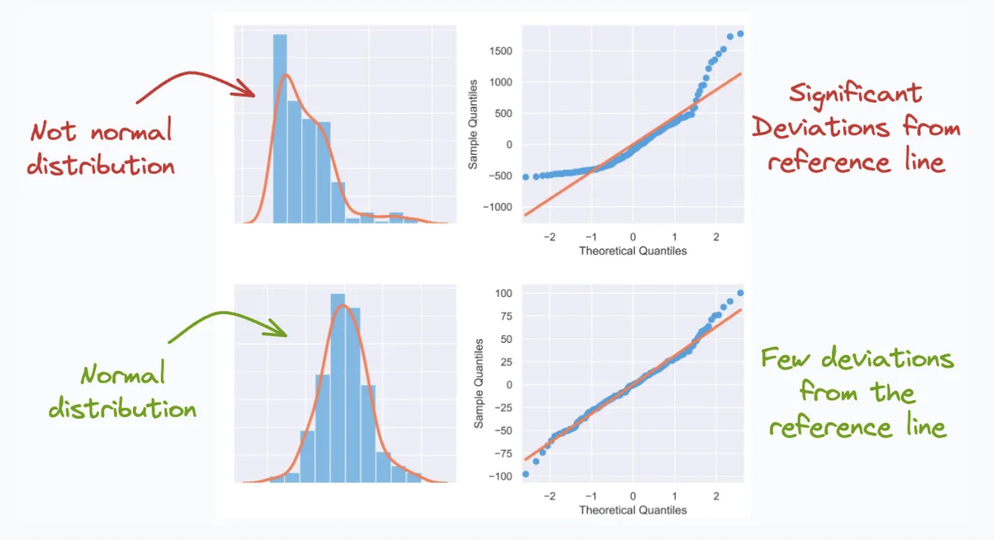
Figure 2 describes how the Q-Q plot is created to represent adherence to normality.

Figure 2: How Q-Q Plots are created.
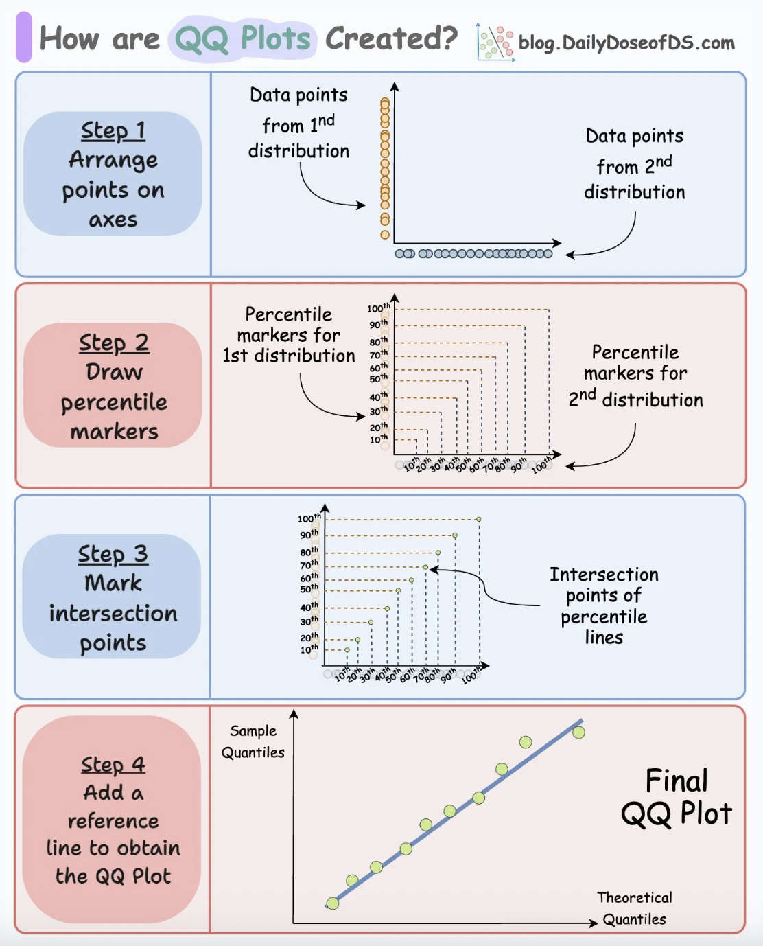
Figure 1 and Figure 2 taken from https://blog.dailydoseofds.com/p/how-are-qq-plots-created.
I actually prefer to draw a histogram of the residuals over Q-Q plots. However, if you prefer Q-Q Plots or read documentation which uses them, Figure 3 explains how to interpret them. The main takeaway is if the data strays wildly from the straight line then the residuals are not normally distributed.
Figure 3: Interpreting Q-Q Plots
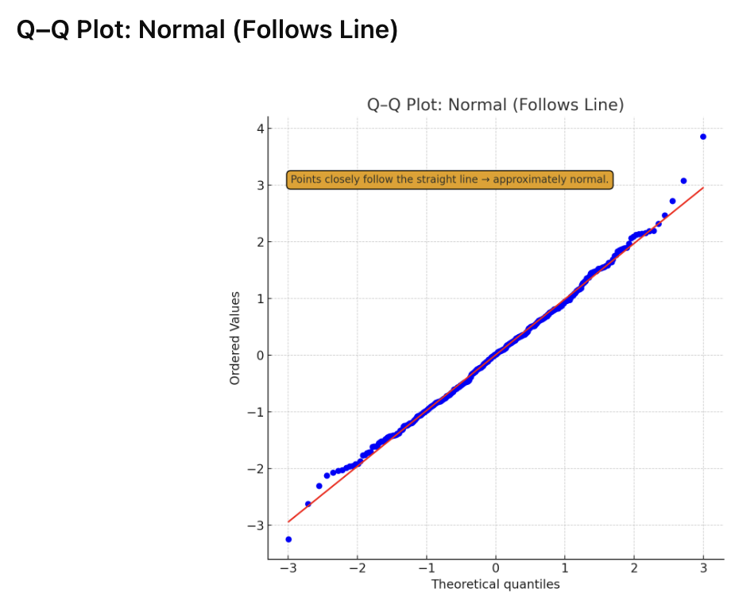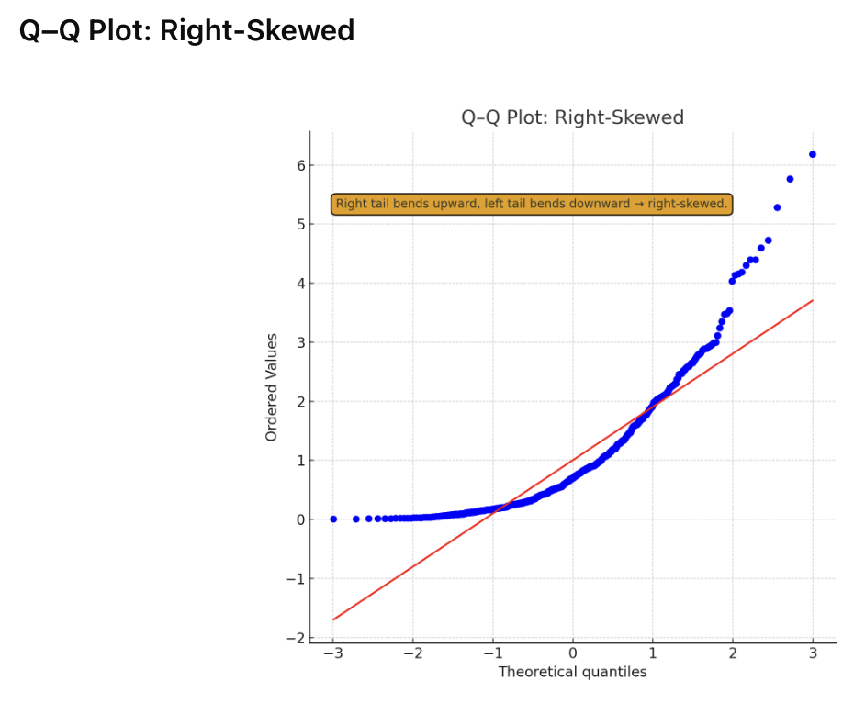
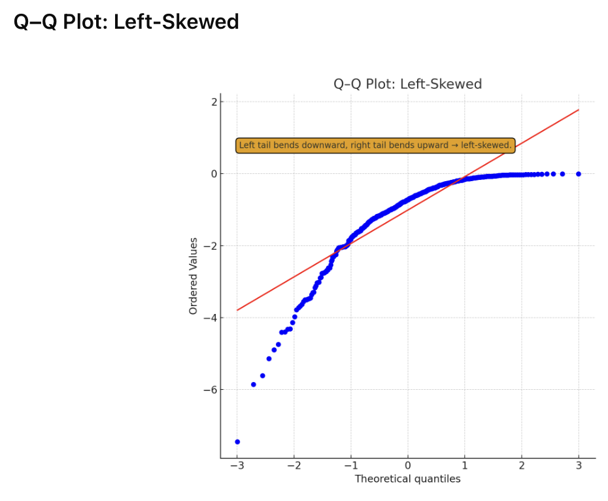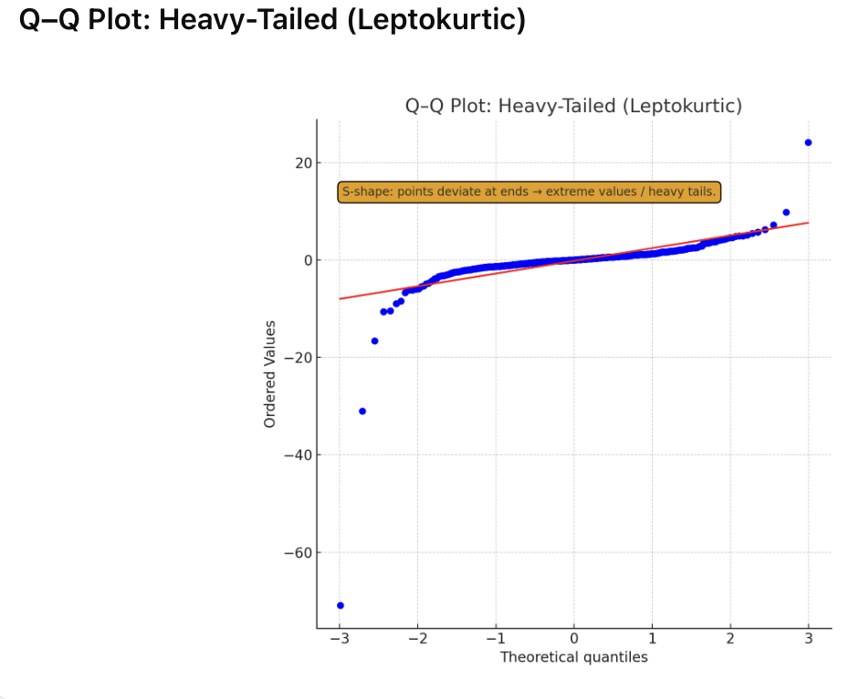

Example 1: Visualizing Predicted vs Residual Values
This example shows how to plot predicted vs residual values and a Q-Q plot. (See Figure 4).

Figure 4: Plotting predicted vs residual values and observing the Q-Q Plot.
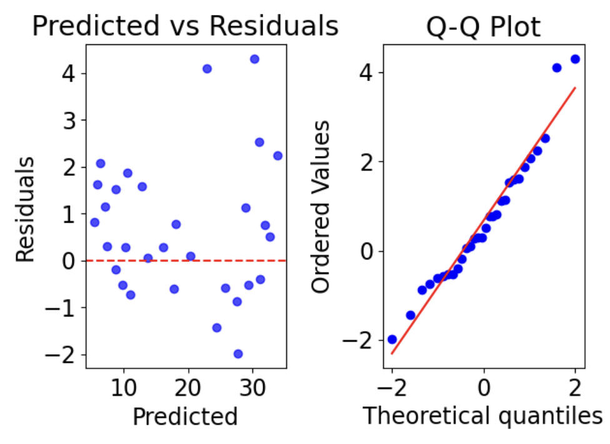
Here is the code to draw the diagrams shown in Figure 4:
import numpy as np
import matplotlib.pyplot as plt
import scipy.stats as stats
from sklearn.linear_model import LinearRegression
from sklearn.model_selection import train_test_split

# create synthetic data
np.random.seed(42)
X = np.random.rand(100, 1) * 10
y = 3 * X.squeeze() + 5 + np.random.randn(100) * 2

# split to train test
X_train, X_test, y_train, y_test = train_test_split(X, y, test_size=0.3, random_state=42)

model = LinearRegression().fit(X_train, y_train)
y_pred = model.predict(X_test)

# Calculate residual error
residuals = y_test - y_pred

# Left: Predicted vs Residuals
plt.rcParams['font.size'] = 17
plt.subplot(1, 2, 1)
plt.scatter(y_pred, residuals, color="blue", alpha=0.7)
plt.axhline(y=0, color="red", linestyle="--")
plt.title("Predicted vs Residuals")
plt.xlabel("Predicted")
plt.ylabel("Residuals")

# Right: Q-Q Plot of Residuals
plt.subplot(1, 2, 2)
stats.probplot(residuals, dist="norm", plot=plt)
plt.title("Q-Q Plot")
plt.tight_layout()
plt.show()

Exercise 1 (2 marks)
Examine the Q-Q plot and Figure 4 which suggest slight skewness. Try to guess which way the residuals are skewed and then plot a histogram for them to verify. Show a screenshot of the histogram for the data in Example 1 and state how it is skewed here.
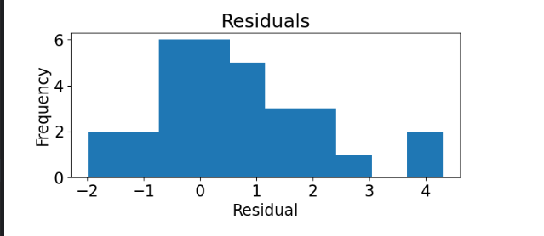

Correcting Non-Normally Distributed Residuals
When residuals are not normally distributed, a transform of y_train may help. Transforms may include a Box-Cox transformation or log(y + c) transform (common for income, price, counts). Other methods which may help could also involve a non-linear model which will be discussed next term.

Box Cox Transformation
Box–Cox transforms can improve a model when:
- the target is positive and strongly skewed.
- variance grows with the mean (heteroscedastic).
- using a linear model that can’t handle nonlinear targets.
The Box-Cox transformation is defined as:
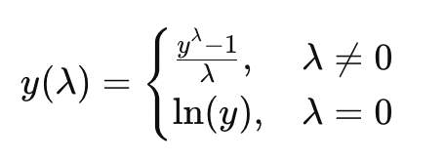
($λ$ is estimated from the data to maximize normality)

For Box Cox transforms to work properly, all values must be positive but the data may be shifted. Box Cox transforms work particularly well on right-skewed distributions (e.g., income, price, sales).
Example 2: Comparing Box Cox Transform with Original Data
This example demonstrates how the Box Cox method can transform y values so they are more normally distributed (see Figure 5).

Figure 5: Value distribution before and after Box Cox transform.
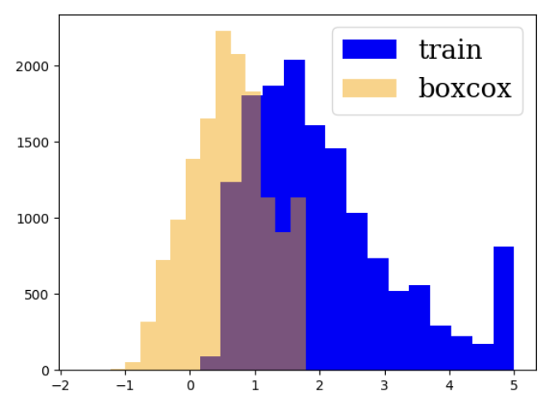
Here is the code:
from sklearn.datasets import fetch_california_housing
from sklearn.model_selection import train_test_split
from scipy.stats import boxcox

# Load data
X, y = fetch_california_housing(return_X_y=True, as_frame=True)
y = y.values

# Train/test split
X_train, X_test, y_train, y_test = train_test_split(X, y, test_size=0.3, random_state=0)

# Shift to make data positive. Boxcox requires that this be positive.
y_min = y_train.min()
if y_min <= 0:
y_shift = y_min - 0.000001
else:
y_shift = 0
y_train_shifted = y_train - y_shift

# Box-Cox transform
y_train_bc, lam = boxcox(y_train_shifted)

import matplotlib.pyplot as plt
plt.hist(y_train, color='blue', bins=15, label='train')
plt.hist(y_train_bc, color='orange', bins=15, alpha=0.5, label='boxcox' )
plt.legend(prop={'family': 'serif', 'size': 20})
plt.show()

Exercise 2 (1 mark)
What is the lambda value for Example 2?
lambda value: 0.12434861022133184

Exercise 3 (4 marks)
Given the following y values:
y = np.array([1.2, 1.5, 1.8, 2.0, 2.3, 2.5, 2.9, 3.0, 3.1, 3.3,
4.0, 4.5, 5.2, 6.8, 8.5, 10.2, 12.0, 15.5, 20.0, 25.0])
Transform this data using a box cox transform. Show a histogram both of the y values before the transform and after the transform.
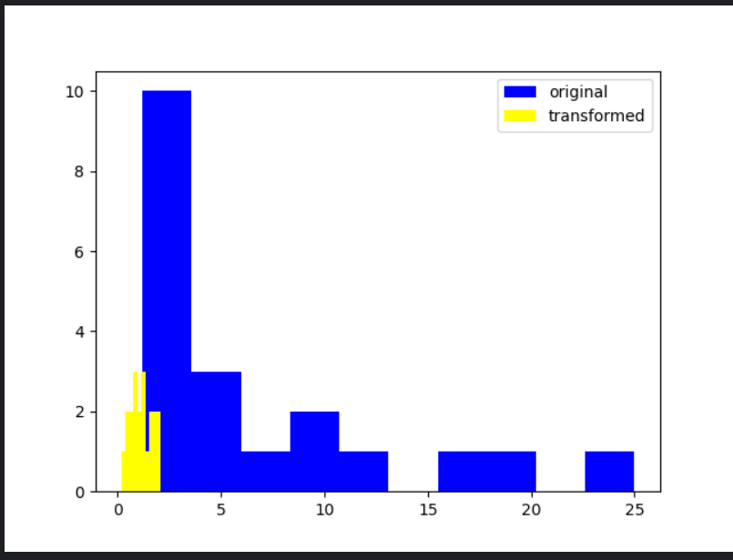

Manually calculate the box cox value for y=1.2. Show enough of your calculation to demonstrate a good understanding of how the transform is made.
lambda =-0.2868
y(lambda) = (1.2^( -0.2868) - 1) / -0.2868 = 0.17763678572

Example 3: Improving results with a Box Cox Transform
Here is a case where a Box Cox transform improves results. The data is skewed to the right but the Box Cox transform helps to normalize it.

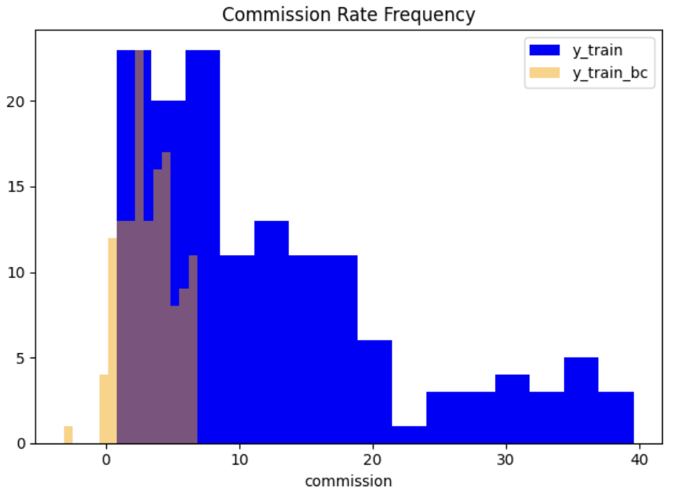
The actual versus predicted values appear to be a much better it after the Box Cox transform.

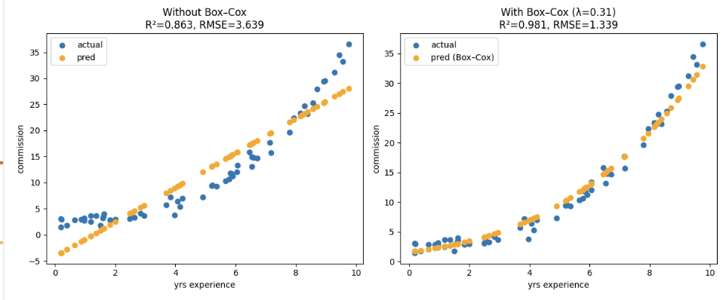
Here is the code:
import numpy as np
import matplotlib.pyplot as plt
import pandas as pd
from sklearn.linear_model import LinearRegression
from sklearn.metrics import mean_squared_error, r2_score
from scipy.stats import boxcox
from scipy.special import inv_boxcox
from sklearn.model_selection import train_test_split

from get_path import getPath

FILE = "commission_vs_experience.csv"
df = pd.read_csv(getPath() + FILE)
X = df[['years_experience']]
y = df[['commission']]

X_train, X_test, y_train, y_test = train_test_split(X, y,
test_size=0.3, random_state=42)

# Model A - plain linear regression
model_plain = LinearRegression().fit(X_train, y_train)
y_pred_plain = model_plain.predict(X_test)
r2_plain = r2_score(y_test, y_pred_plain)
rmse_plain = np.sqrt(mean_squared_error(y_test, y_pred_plain))

# Model B - Box–Cox on target column.
# Ensure y is positive
OFFSET = 0.000001 # Make very small increment for case when y is 0.
# Shift to make data positive.
y_min = y_train['commission'].min()
if y_min <= 0:
y_shift = y_min - OFFSET
else:
y_shift = 0
y_train_shifted = y_train['commission'] - y_shift

y_train_bc, lam = boxcox(y_train_shifted)
model_bc = LinearRegression().fit(X_train, y_train_bc)

# Compare distributions of plain target and box cox transformed target.
plt.hist(y_train['commission'], bins=15, label="y_train", color="blue")
plt.hist(y_train_bc, bins=15, label="y_train_bc", color="orange", alpha=0.5)
plt.xlabel("commission")
plt.legend()
plt.title("Commission Rate Frequency")
plt.tight_layout()
plt.show()

# Predict and inverse-transform
y_pred_bc = model_bc.predict(X_test)

# Do inverse transform to get data back to original scale.
y_pred_bc = np.maximum(y_pred_bc, -1/lam + OFFSET)
y_pred_boxcox = inv_boxcox(y_pred_bc, lam) + y_train['commission'].min() - OFFSET

r2_bc = r2_score(y_test, y_pred_boxcox)
rmse_bc = np.sqrt(mean_squared_error(y_test, y_pred_boxcox))

# Compare predicted vs. actual side by side.
plt.figure(figsize=(12,5))
plt.subplot(1,2,1)
plt.scatter(X_test, y_test, label="actual")
plt.scatter(X_test, y_pred_plain, color="orange", label="pred")
plt.title(f"Without Box–Cox\nR²={r2_plain:.3f}, RMSE={rmse_plain:.3f}")
plt.xlabel("yrs experience"); plt.ylabel("commission"); plt.legend()

plt.subplot(1,2,2)
plt.scatter(X_test, y_test, label="actual")
plt.scatter(X_test, y_pred_boxcox, color="orange", label="pred (Box–Cox)")
plt.title(f"With Box–Cox (λ={lam:.2f})\nR²={r2_bc:.3f}, RMSE={rmse_bc:.3f}")
plt.xlabel("yrs experience"); plt.ylabel("commission"); plt.legend()

plt.tight_layout()
plt.show()

Exercise 4 (1 mark)
The RMSE is calculated with actual size data. What function is used to transform the data back to original size?
inv_boxcox

Exercise 5 (3 marks)
Show the Q-Q plot before and after the Box Cox transform in Example 3. Show a screen shot of the plot before and after.
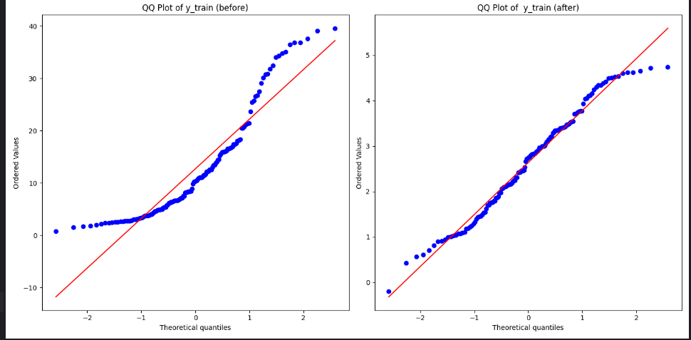

Exercise 6 (3 marks)
Show the predicted versus residual plot before and after the Box Cox transform.
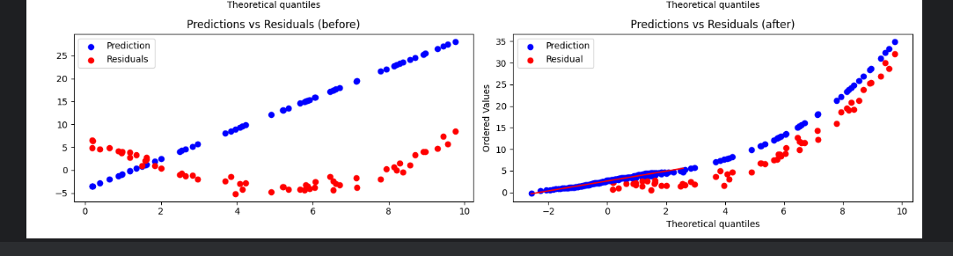

Example 4: Comparing Plain Linear Regression Model with Box Cox Transformed Model
This example provides a Box Cox transform for the California house price data set. Figure 6 shows how well predictions align with actual values before and after the transform. While the predicted values are more evenly aligned with the actual values after the transform, the distance between actual and predicted values after the transform is much bigger.

Figure 6: Before and After the Box Cox transform.
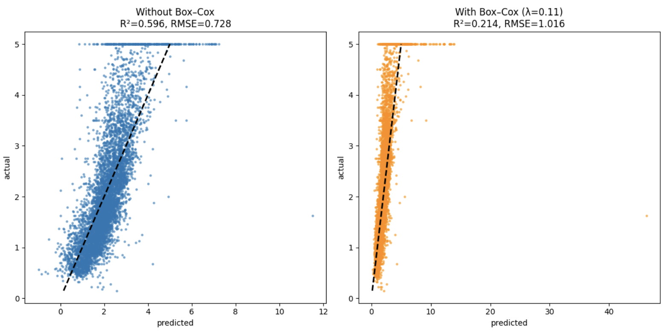 | 
The points will typically form an oval shape around the diagonal — predictions are biased toward the mean, especially for skewed targets. | The points tend to cluster closer to the diagonal. Extreme values and residuals become more symmetric. Unfortunately, the average distance between actual and predicted values is greater.

Here is the code:
import numpy as np
import matplotlib.pyplot as plt
from sklearn.datasets import fetch_california_housing
from sklearn.model_selection import train_test_split
from sklearn.linear_model import LinearRegression
from sklearn.metrics import r2_score, mean_squared_error
from scipy.stats import boxcox
from scipy.special import inv_boxcox

X, y = fetch_california_housing(return_X_y=True, as_frame=True)
y = y.values
X_train, X_test, y_train, y_test = train_test_split(X, y,
test_size=0.3, random_state=42)

# Model A: Regular Linear Regression (no Box–Cox)
model_plain = LinearRegression()
model_plain.fit(X_train, y_train)
y_pred = model_plain.predict(X_test)

r2_plain = r2_score(y_test, y_pred)
rmse_plain = np.sqrt(mean_squared_error(y_test, y_pred))

# Model B: Linear Regression with Box–Cox-transformed target

# Box–Cox requires strictly positive y
# Shift to make data positive.
OFFSET = 0.000001
y_min = y_train.min()
if y_min <= 0:
y_shift = y_min - OFFSET
else:
y_shift = 0
y_train_shifted = y_train - y_shift

# Box-Cox transform
y_train_bc, lambda_ = boxcox(y_train_shifted)

model_bc = LinearRegression()
model_bc.fit(X_train, y_train_bc)

# Predict and inverse-transform
y_pred_bc = model_bc.predict(X_test)
y_pred_boxcox = inv_boxcox(y_pred_bc, lambda_) + y_shift

r2_bc = r2_score(y_test, y_pred_boxcox)
rmse_bc = np.sqrt(mean_squared_error(y_test, y_pred_boxcox))

# Plot side-by-side comparison
plt.subplots(1, 2, figsize=(12, 6))
plt.subplot(1, 2, 1) # First Plot (row, col, graph num)
plt.rcParams['font.size'] = 20

# without Box–Cox
plt.scatter(y_pred, y_test, s=5, alpha=0.5)
# black line
plt.plot([y_test.min(), y_test.max()], [y_test.min(), y_test.max()], color="black")

plt.xlabel("predicted")
plt.ylabel("actual")
plt.title(f"Without Box–Cox\nR²={r2_plain:.3f}, RMSE={rmse_plain:.3f}")

# With Box–Cox
plt.subplot(1, 2, 2) # 2nd Plot (row, col, graph num)
plt.scatter(y_pred_boxcox, y_test, s=5, alpha=0.5, color="orange")
# black line
plt.plot([y_test.min(), y_test.max()], [y_test.min(), y_test.max()], color="black")
plt.xlabel("predicted")
plt.ylabel("actual")
plt.title(f"With Box–Cox (λ={lambda_:.2f})\nR²={r2_bc:.3f}, RMSE={rmse_bc:.3f}")

plt.tight_layout()
plt.show()

Exercise 7 (6 marks)
Show the residual and Q-Q plots before and after the Box Cox transform.
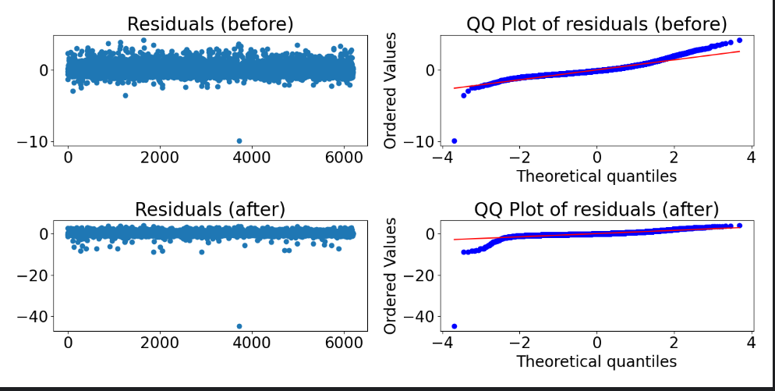

Exercise 8 (3 marks)
Show a histogram of the y_train before and after the Box Cox transform.
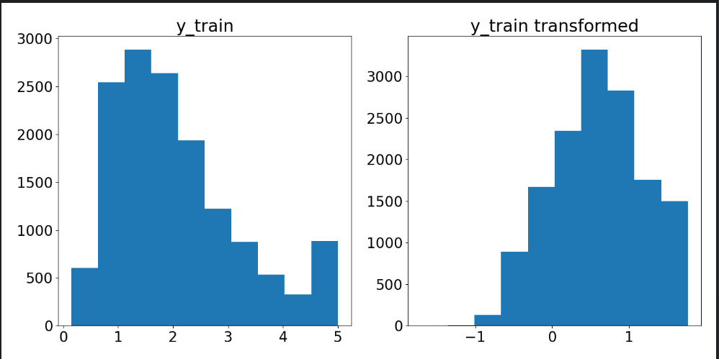

Exercise 9 (1 mark)
In your opinion, does the Box Cox transform improve results? How does it improve results and/or how does it make them worse?
Based on the values of both R-squared and RMSE, this transformation using Box Cox actually makes the predictions worse, r2_bc = 0.2137 compared to 0.6 for r2_plain, and rmse_bc = 1.02 compared to 0.73 for rmse_plain. This signals that the transformation might have made the model overfit the train data and it is not able to generalize on actual data

Log Transform
Log transforms may help linear models by compressing extremely large values and by stretching small values, which helps:
- Reduce skewness (make data more symmetric normal shape)
- Stabilize variance (reduce heteroskedasticity)
- Make multiplicative relationships linear (so linear regression fits better).

Example 5: Comparing Models with Log Transform
This example shows how a log transform can improve linear model results.
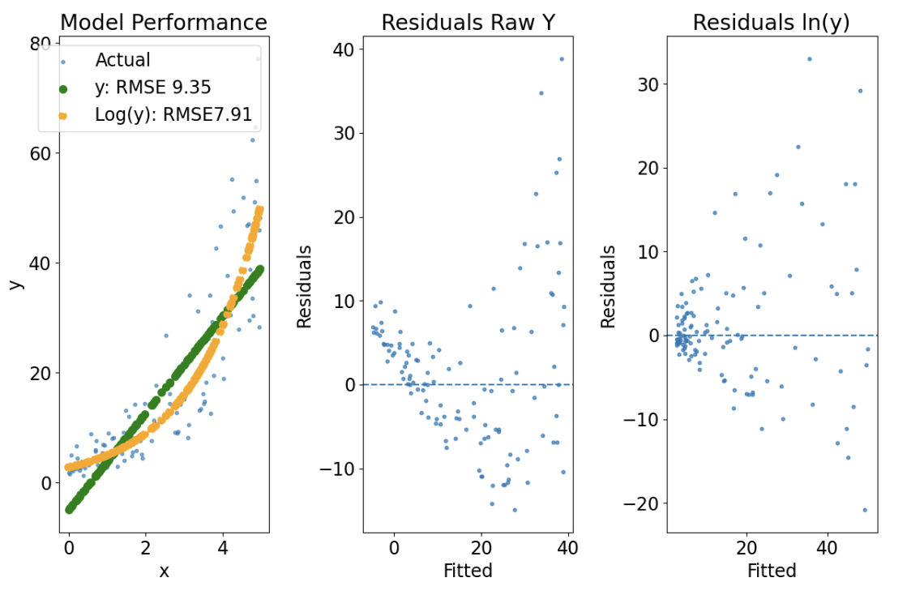

import numpy as np
import matplotlib.pyplot as plt
from sklearn.linear_model import LinearRegression
from sklearn.metrics import mean_squared_error, r2_score, mean_absolute_error
from sklearn.model_selection import train_test_split

def getSyntheticData():
np.random.seed(123)
n = 400
x = np.linspace(0, 5, n)
a_true, b_true, sigma = 1.0, 0.6, 0.35
eps = np.random.randn(n) * sigma
y = np.exp(a_true + b_true * x + eps)
X = x.reshape(-1, 1)
# --- train/test split added (minimal change) ---
X_train, X_test, y_train, y_test = train_test_split(
X, y, test_size=0.3, random_state=42
)
return X_train, X_test, y_train, y_test

X_train, X_test, y_train, y_test = getSyntheticData()

# Model A: OLS on y.
ols = LinearRegression().fit(X_train, y_train)
yhat_ols = ols.predict(X_test) # predict on X_test only

# Negative y not allowed during log transform.
def shiftYtrain(y_train):
shift = 0.0
min_y = np.min(y_train) # use training data only
OFFSET = 0.0000001
if min_y <= 0:
shift = -min_y + OFFSET
y_for_log_train = y_train + shift
return y_for_log_train, shift

y_for_log_train, shift = shiftYtrain(y_train)

# Model B: OLS on log(y) (with shift if needed).
logy = np.log(y_for_log_train)
log_model = LinearRegression().fit(X_train, logy)
logyhat = log_model.predict(X_test) # predict on X_test only
yhat_log_shifted = np.exp(logyhat)
yhat_log = yhat_log_shifted - shift # back to original scale

# Metrics on original scale
def showMetrics(y_true, y_pred, title):
rmse = np.sqrt(mean_squared_error(y_true, y_pred))
rmse = round(rmse, 2)
r2 = r2_score(y_true, y_pred)
r2 = round(r2, 2)
print("\n" + title + " RMSE: " + str(rmse))
print(title + " R^2: " + str(r2))
return rmse, r2

rmse, r2 = showMetrics(y_test, yhat_ols, "y")
rmse_log, r2_log = showMetrics(y_test, yhat_log, "Log(y)")

rmseStr = "y: RMSE " + str(round(rmse, 2))
rmseLogStr = "Log(y): RMSE" + str(round(rmse_log, 2))

plt.figure(figsize=(12, 8))
plt.rcParams['font.size'] = 17

# Model performance
plt.subplot(1,3,1)
plt.scatter(X_test, y_test, s=10, alpha=0.6, label="Actual") # minimal change

plt.scatter(X_test, yhat_ols, lw=2, label=rmseStr, color="green")
plt.scatter(X_test, yhat_log, lw=2, linestyle="--", color="orange",
label=rmseLogStr)
plt.title("Model Performance")
plt.xlabel("x");
plt.ylabel("y");
plt.legend()

# Residuals vs fitted (OLS)
plt.subplot(1,3,2)
plt.scatter(yhat_ols, y_test - yhat_ols, s=10, alpha=0.7)
plt.axhline(0, linestyle="--")
plt.title("Residuals Raw Y")
plt.xlabel("Fitted");
plt.ylabel("Residuals")

# Residuals vs fitted (log model back-transformed)
plt.subplot(1,3,3)
plt.scatter(yhat_log, y_test - yhat_log, s=10, alpha=0.7)
plt.axhline(0, linestyle="--")
plt.title("Residuals ln(y)")
plt.xlabel("Fitted")
plt.ylabel("Residuals")

plt.tight_layout()
plt.show()

Exercise 10 (1 mark)
When a linear model is created with a log transform on y, is the test data transformed?
no

Exercise 11 (1 mark)
How is the data converted back to the original size when calculating the RMSE?
y_pred_orig = np.exp(y_pred_log) - shift

Exercise 12 (4 marks)
Show the histogram of the y train data in Example 5 before and after the transform:
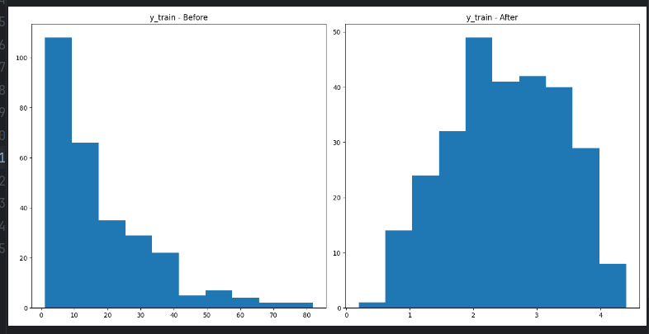

Describe the distribution of y train before the log transform:
Before: right skewed
After: Normal distribution with mean around 2.5

Exercise 13 (2 marks)
Perform linear regression with the raw_material_prices.csv to predict y and y transformed with a log transform. Compare RSME’s of the linear models before and after the transform:
Normal=527.3226 | Log=400.0011

Exercise 14 (4 marks)
Draw predicted versus actual plots for the data used in Exercise 13 before and after the transform. Show your plots here.
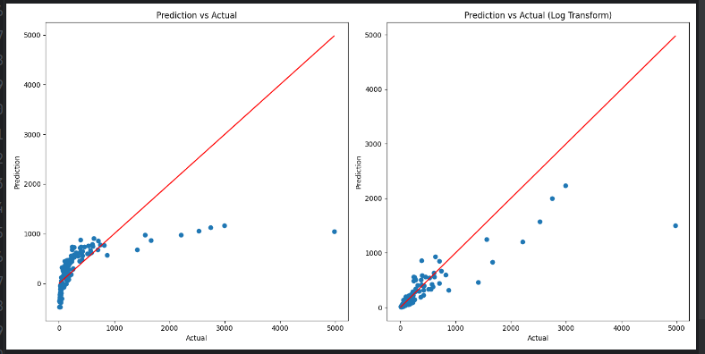import numpy as np
import pandas as pd
from matplotlib import pyplot as plt
from sklearn.linear_model import LinearRegression
from sklearn.metrics import mean_squared_error
from sklearn.model_selection import train_test_split
pd.set_option('display.max_columns', None)
pd.set_option('display.width', 1000)
path = r"C:\Users\linho\Desktop\CST\term3\pred_analytics\data\raw_material_prices.csv"
df = pd.read_csv(path)
X = df[['feature_strength', 'market_score']]
y = df['price']
print(y.describe())
X_train, X_test, y_train, y_test = train_test_split(
X, y, test_size=0.25
)
offset = 1e-6
y_min = y.min()
if y_min <= 0:
y_shift = y_min - offset
else:
y_shift = 0
y_train_shifted = y_train - y_shift
y_train_logged = np.log(y_train_shifted)
model_normal = LinearRegression().fit(X_train, y_train)
model_log = LinearRegression().fit(X_train, y_train_logged)
y_pred = model_normal.predict(X_test)
y_pred_log = model_log.predict(X_test)
y_pred_orig = np.exp(y_pred_log) + offset
rmse = np.sqrt(mean_squared_error(y_test, y_pred))
rmse_log = np.sqrt(mean_squared_error(y_test, y_pred_orig))
print(f"RMSE\nNormal={rmse:.4f} | Log={rmse_log:.4f}")
plt.subplots(1, 2, figsize=(14, 7))
plt.subplot(1, 2, 1)
plt.scatter(y_test, y_pred)
plt.plot([y_test.min(), y_test.max()], [y_test.min(), y_test.max()],
color='red')
plt.title('Prediction vs Actual')
plt.xlabel('Actual')
plt.ylabel('Prediction')
plt.subplot(1, 2, 2)
plt.scatter(y_test, y_pred_orig)
plt.plot([y_test.min(), y_test.max()], [y_test.min(), y_test.max()],
color='red')
plt.title('Prediction vs Actual (Log Transform)')
plt.xlabel('Actual')
plt.ylabel('Prediction')
plt.tight_layout()
plt.show()

Exercise 15 (3 marks)
Show your code for Exercise 13 and Exercise 14 here:

