Table of Contents
Data Formatting and Visualization Tips Continued 1
Converting Strings to Numbers 1
Line Graphs 2
Scatter Plots 3
Bar Plots 5
Grouped Bar Plots 6
Frequency Histograms 6
Statistical Measures Introduction 7
Slope 7
Equation of a Straight Line 9
Normal Distribution 11
Z-Score 11
Student’s t-Distribution 13
Mean and Deviation 15
Sample Mean 15
Sample Standard Deviation 15
Standard Error 15
The Empirical Rule and Chebyshev’s Theorem 16
Empirical Rule 16
Chebyshev’s Theorem 16
Confidence Intervals 17
Now we can calculate SE using Standard Error 18

Data Formatting Tips Continued and Visualization Introduction

Converting Strings to Numbers
When you need to convert strings to numbers you can with int() and float().

Example 1: Converting Strings to Numbers
This example demonstrates how to convert string values to a whole number and a floating-point number.
unformattedInt = '233'
wholeNumber = int(unformattedInt)
print(wholeNumber)

unformattedFloat = '12.99'
print(unformattedFloat)
floatNumber = float(unformattedFloat)

print(wholeNumber + floatNumber)
The output verifies that the conversions from strings to numbers has been successful:
﻿233
12.99
245.99

Line Graphs
This section will discuss some basic but essential ways to visualize statistical data. We will then apply these techniques towards exploratory data analysis to help understand the potential and limitations of a data set. You may want to refer back to this document – if you do be sure to use the table of contents and side bar navigation to find the resources that you need from it.

Example 2: Line Graphs
This example demonstrates how to plot two different lines that show changes to population for Connecticut and Colorado. Notice how the legend labels, titles, axis labels and line styles are set – you may want to refer back to this example to see how these features are implemented. This is the output:
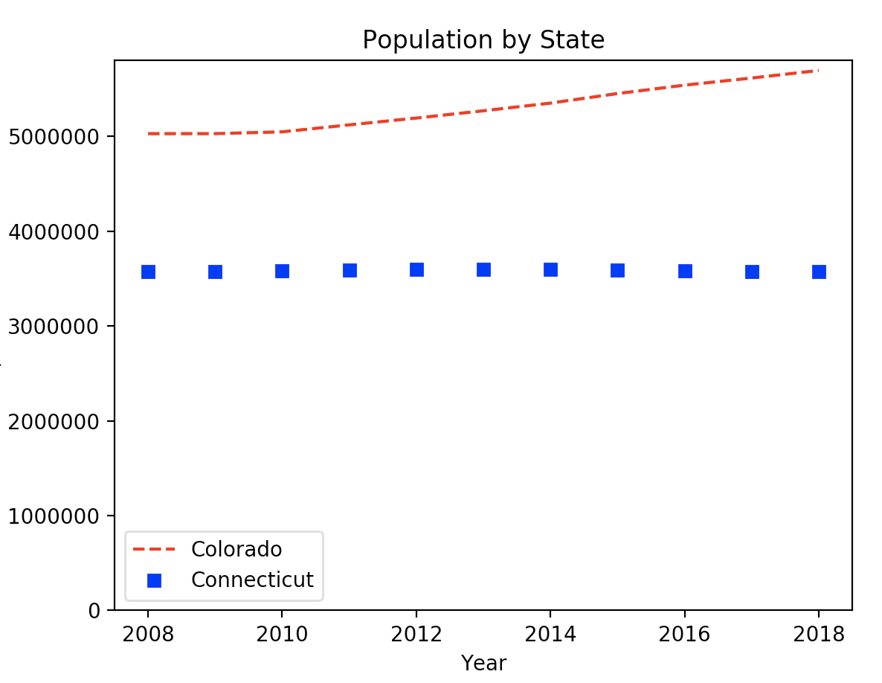

Here is the code:
import numpy as np
import matplotlib.pyplot as plt
years = [2008,2009,2010,2011,2012,2013,2014,2015,2016,2017,2018]
colorado = [5029196,5029316,5048281,5121771,5193721,5270482,5351218,5452107,
5540921,5615902,5695564]
connecticut = [3574097,3574147,3579125,3588023,3594395,3594915,3594783,3587509,
3578674,3573880,3572665]
# red dashes, blue squares and green triangles
plt.plot(years, colorado, "--", color='red', label="Colorado")
plt.plot(years,connecticut, "s", color='blue', label="Connecticut")
# legend
# https://matplotlib.org/users/legend_guide.html
plt.ylim(ymin=0) # Set's y axis start to 0.
plt.legend(loc=0)
plt.xlabel("Year")
plt.ylabel("Population")
plt.title('Population by State')
plt.show()

Exercise 1 (2 marks)
See if you can figure out how to adjust your code in Example 2 to include a third line for Delaware. The population Delaware between 2008 and 2018 is included in this array.

delaware = [897934,897934,899595,907316,915188,923638,932596,941413,949216,
957078,967171]

You can make the line a straight line by not including a style parameter. “--" and “s” were used as style parameters previously. Try not including a style parameter to draw a solid line which is the default. Or if you prefer to add line formatting, you can look up linestyle at https://matplotlib.org/3.1.1/api/_as_gen/matplotlib.lines.Line2D.html#matplotlib.lines.Line2D

Figure out how to make the legend appear at the center left of the graph. See https://matplotlib.org/3.1.1/api/_as_gen/matplotlib.pyplot.legend.html to look up location code.

Show your revised program here:

Show a screenshot of your chart with three lines in it here:

Scatter Plots
Scatter plots show how one variable is correlated to another for multiple samples.

Example 3: Simple Scatter Plot
Figure 1 shows a simplified scatter plot which illustrates how the level of bacteria A growth is related to time in days for six different samples.

Figure 1: Bacteria A growth over time
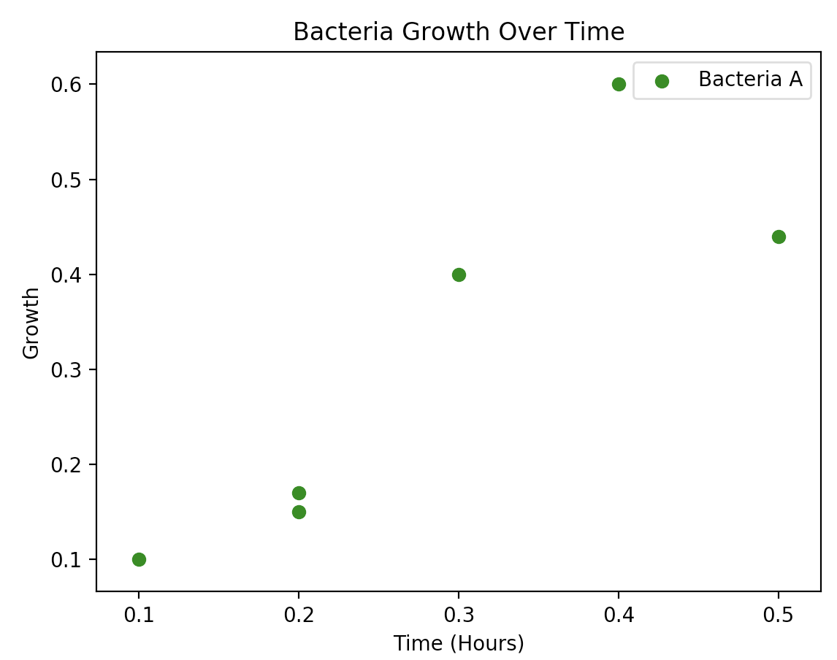
This is the code that is needed to draw the scatter plot. Notice how the x and y values are supplied as arrays to the scatter() function to provide data for the graph. Also notice how the axis, title and legend items are labelled.

import matplotlib.pyplot as plt
# Plot scatter of x and y coordinates.
time_X = [0.1, 0.2, 0.3, 0.4, 0.5, 0.2]
growth_Y = [0.1, 0.15, 0.4, 0.6, 0.44, 0.17]
plt.scatter(time_X, growth_Y, color='green', label='Bacteria A')
# Add a legend, axis labels, and title.
plt.legend()
plt.xlabel("Time (Hours)")
plt.ylabel("Growth")
plt.title('Bacteria Growth Over Time')
plt.show()

Exercise 2 (2 marks)
Draw a scatter plot that looks exactly like the following one.
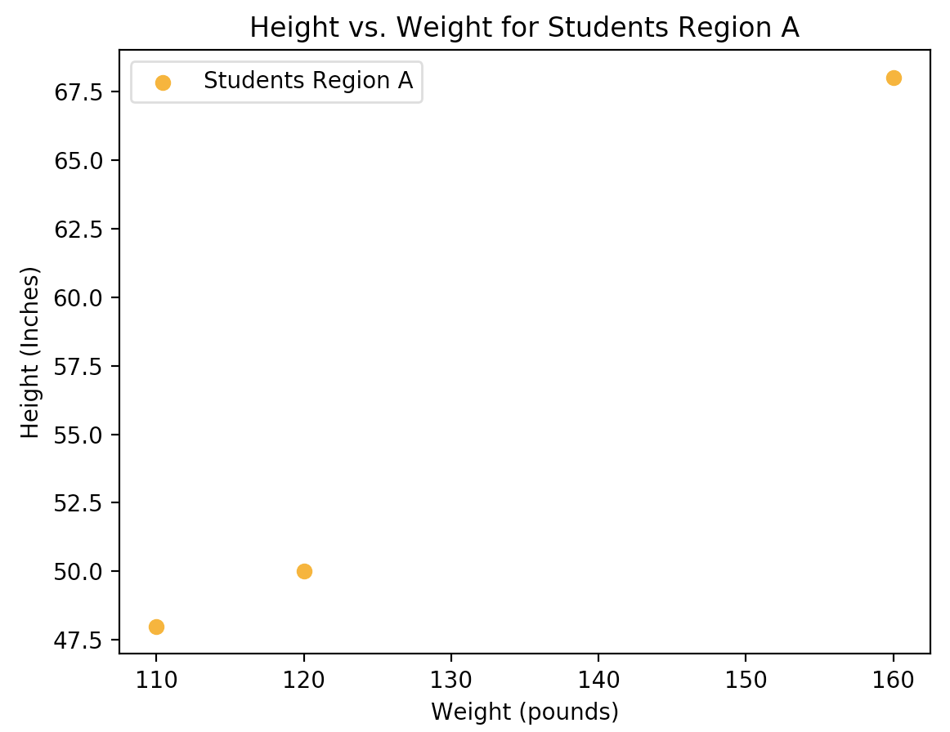
These are the data arrays:

pounds = [120, 110, 160]
inches = [50, 48, 68]

Show your program here:

Exercise 3 (2 marks)
Starting with your solution from Exercise 2, add in code to plot a second scatter group as shown in Figure 2. Keep your new code above the plt.show() instruction.

Figure 2: Comparing Height and Weight Correlations of Two Sample Groups
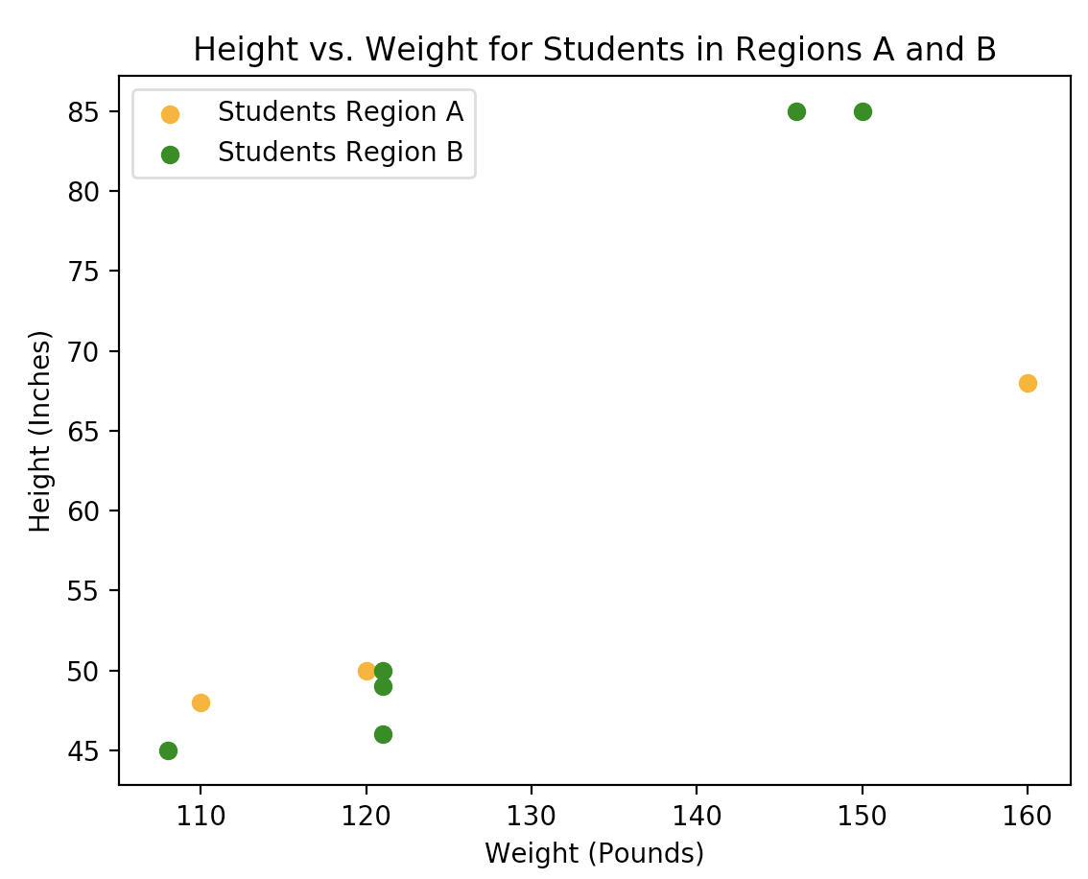
These are the data sets:
poundsA = [120, 110, 160]
inchesA = [50, 48, 68]
poundsB = [121, 108, 150, 121, 121, 146]
inchesB = [49, 45, 85, 46, 50, 85]

Show your program here:

Bar Plots
Bar plot documentation can be viewed here:
https://matplotlib.org/3.1.0/api/_as_gen/matplotlib.pyplot.bar.html

Example 4: Bar Plots
This example shows how to create a basic bar plot.
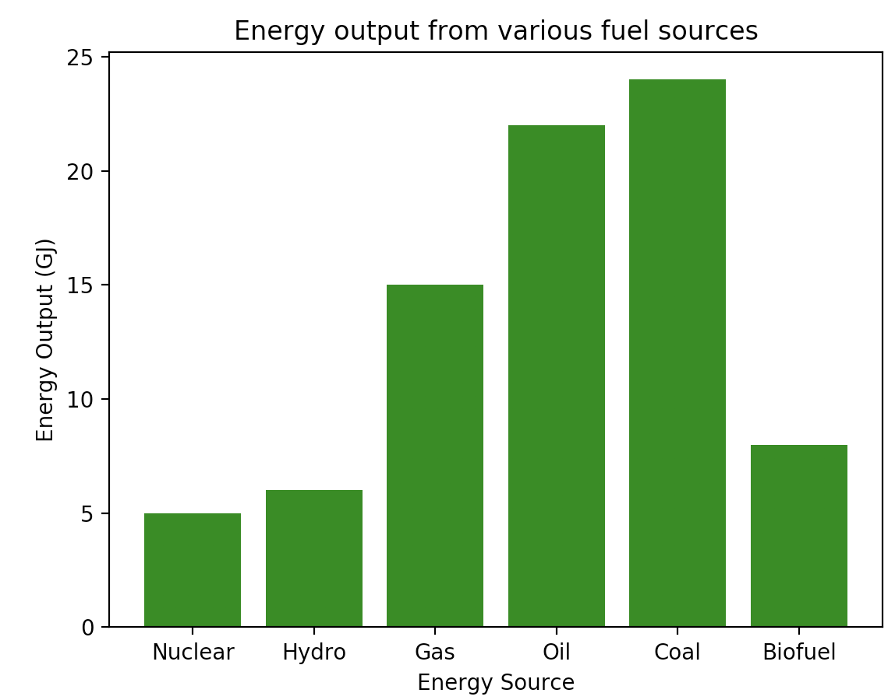
import matplotlib.pyplot as plt
x = ['Nuclear', 'Hydro', 'Gas', 'Oil', 'Coal', 'Biofuel']
energy = [5, 6, 15, 22, 24, 8]
plt.bar(x, energy, color='green')
plt.xlabel("Energy Source")
plt.ylabel("Energy Output (GJ)")
plt.title("Energy output from various fuel sources")
plt.xticks(x, x)
plt.show()

Grouped Bar Plots
Example 5: Grouped Bar Plots
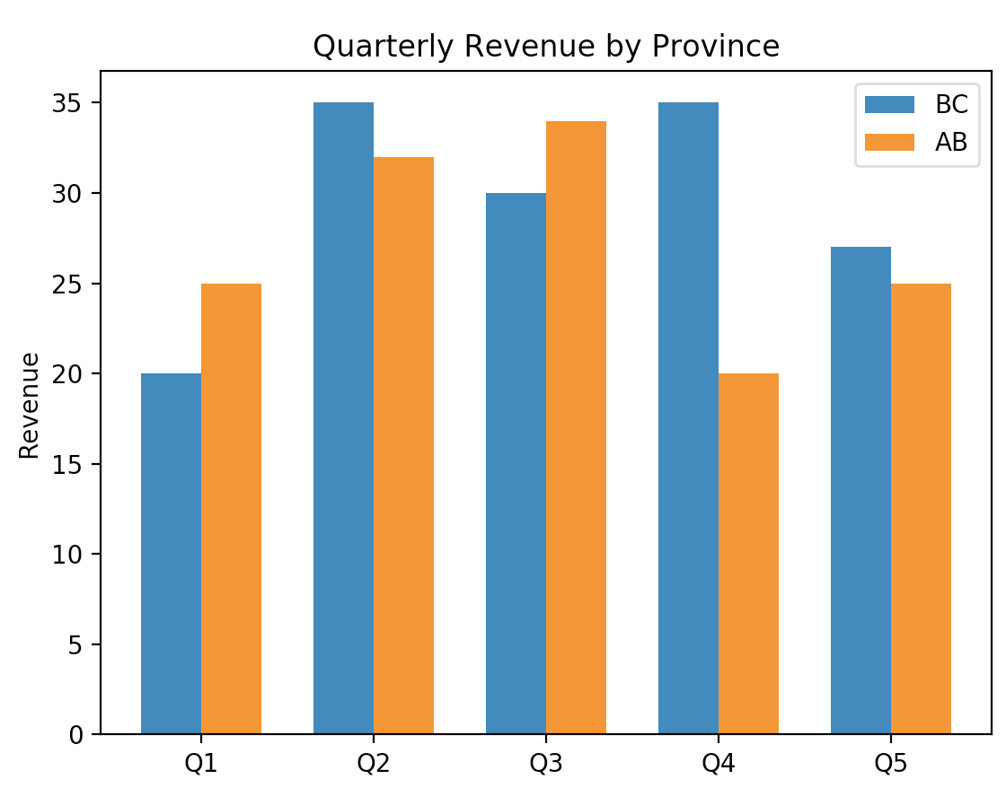
import matplotlib.pyplot as plt
import numpy as np
NUM_MEANS = 5
NUM_GROUPS = 2
bc_means = [20, 35, 30, 35, 27]
alberta_means = [25, 32, 34, 20, 25]
# This generates indices from 0 to 4 in a format that is accepted for
# plotting bar charts.
ind = np.arange(NUM_MEANS)
print(ind)
width = 0.35
plt.bar(ind, bc_means, width, label='BC')
plt.bar(ind + width, alberta_means, width, label='AB')
plt.ylabel('Revenue')
plt.title('Quarterly Revenue by Province')
plt.xticks(ind + width / NUM_GROUPS, ('Q1', 'Q2', 'Q3', 'Q4', 'Q5'))
plt.legend(loc='best')
plt.show()

Exercise 4 (2 marks)
Modify the code in Example 5 to show groupings for BC, Alberta and Saskatchewan but for the first four quarters only. Customize the color of the bars. You may need to reduce the width to make the bars fit together.

saskatchewan_means = [18, 28, 32, 24, 31]

Show your code here:
Show a screenshot of your graph here:

Frequency Histograms
Having tables with precise frequency and ranges is helpful. However, many numbers in a summary report can be overwhelming so histograms offer a quick but effective overview of frequency, range and distribution.

Example 6: Histogram Introduction
When examining a histogram of the mother age we can observe a distribution that looks a bit like a normal distribution with a peak around 24 years of age. Some other spikes may also be significant.
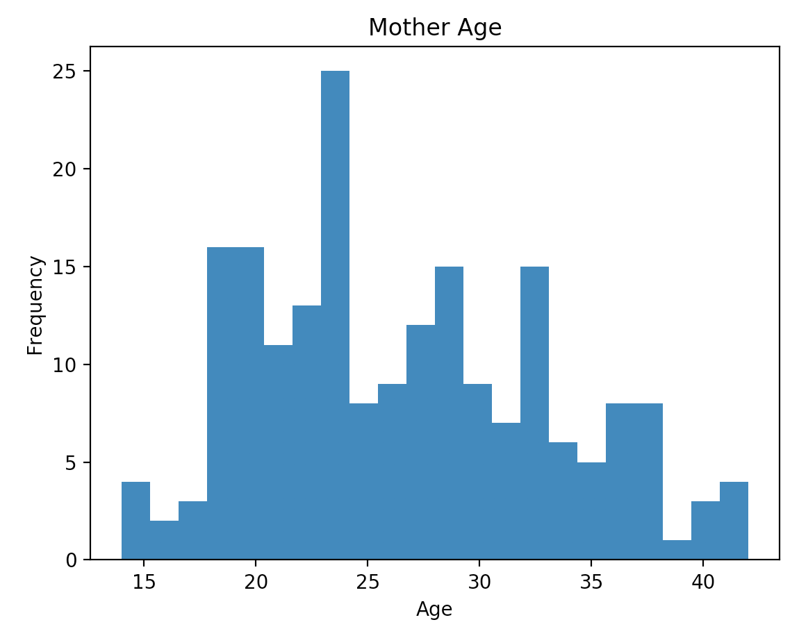
Here is the code used to generate the histogram for the Mother’s age.
import pandas as pd
import matplotlib.pyplot as plt

# Import data into a DataFrame.
path = "/Users/pm/Desktop/DayDocs/data/babysamp-98.txt"
df = pd.read_csv(path, sep='\t')
# Show all columns.
pd.set_option('display.max_columns', None)

# Increase number of columns that display on one line.
pd.set_option('display.width', 1000)

plt.hist(df["MomAge"], bins=22)
plt.xlabel("Age")
plt.ylabel("Frequency")
plt.title('Mother Age')

plt.show()

Statistical Measures Introduction
This course is mainly about different forms of regression and data modeling which is a foundational topic for many predictive algorithms including machine learning algorithms. To prepare we need to cover some basic math and statistics theory. The topics may seem disjoint initially but very soon they will become useful within the predictive modeling cycle.

Slope
Slope helps to describe the relationship between one variable such as y and another variable such as x. For this case, slope is the change in y divided by the change in x.

Equation 1: Slope
Slope $= \frac{Change in Y}{Change in X}=\frac{∆y}{∆x}=\frac{y_{1}-y_{0} }{x_{1}-x_{0}}$

Figure 3 shows four general cases where the slope is rising, falling, zero and undefined.

Figure 3: Slope Scenarios
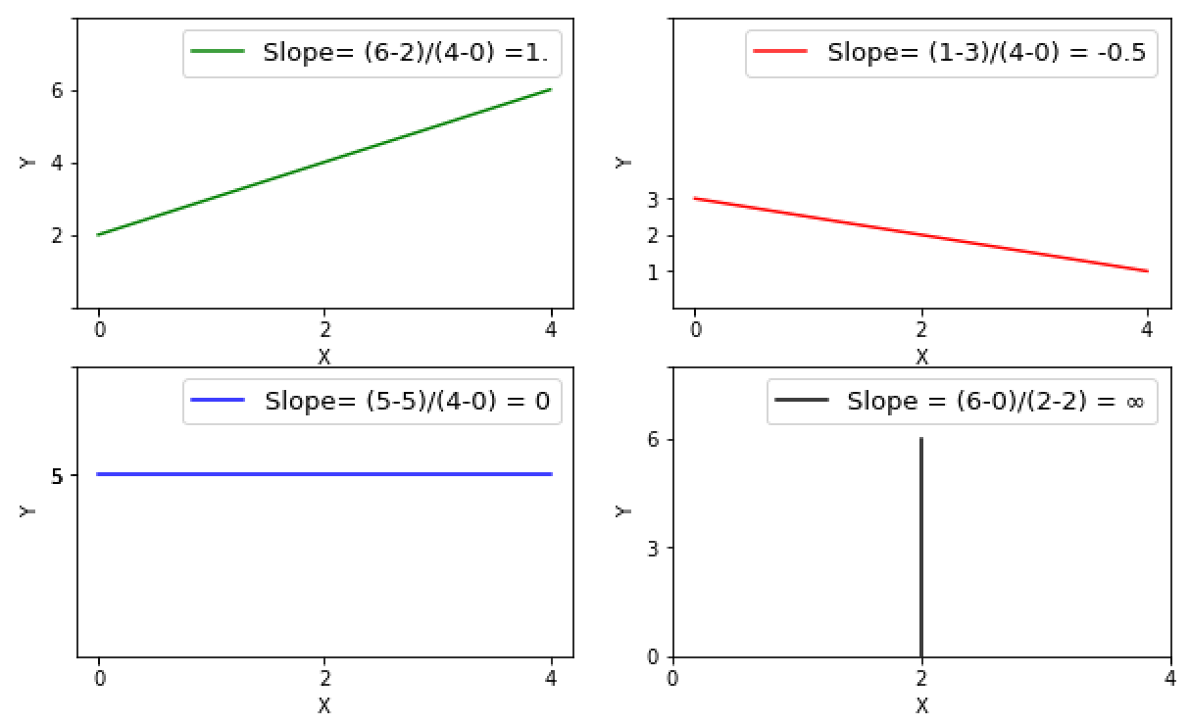
To calculate the slope of the green line in Figure 3 use the equation slope $= \frac{rise}{run}=\frac{y_{1}-y_{0}}{x_{1}-x_{0}}$ $=\frac{6-2}{4-0}$ = $\frac{4}{4}$= 1.

Exercise 5 (1 mark)
What is the slope of the following line?
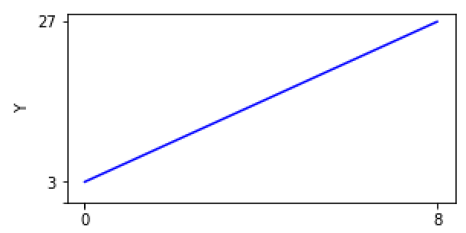
Show your calculation and result here (refer to Equation 1).

Exercise 6 (1 mark)
What is the slope of the following line?
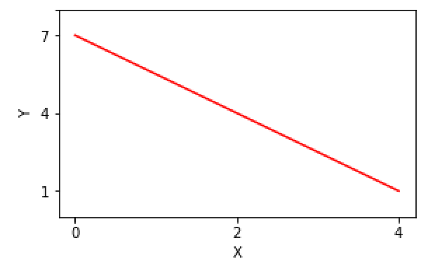
Show your calculation by hand here (don’t just put the answer):

Equation of a Straight Line
The equation of a straight line describes the slope and the intercept.

Figure 4: Slope and Intercept of a Straight Line
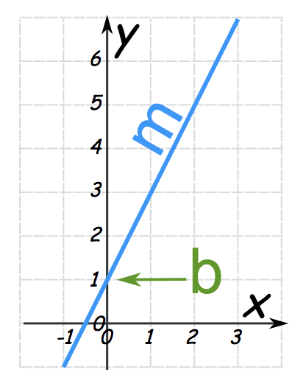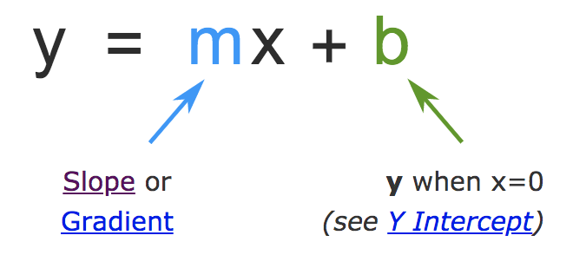
Equation 2: Equation of a Straight Line
y = mx + b
Exercise 7 (1 mark)
- What is the y-intercept for the green line in Figure 3?

- What is the y-intercept for the red line in Figure 3?

Example 7: Determining the Equation of the Straight Line
This example shows how to calculate a straight-line equation. In Figure 4, the y intercept, b, is at 1 when x = 0. The slope $=m$ $= \frac{rise}{run}=\frac{y_{1}-y_{0}}{x_{1}-x_{0}}$ $=\frac{7-1}{3-0}$ = $\frac{6}{3}$= 2.

Putting this information in equation form gives us the following equation for the line:
y = mx + b = 2x + 1

Exercise 8 (0.5 marks)
What is the equation of the straight line for the green line in Figure 3?

Exercise 9 (0.5 marks)
What is the equation of the straight line for the red line in Figure 3?

Example 8: Calculating the Value of y when x is Known.
In Example 7, we determined that y = 2x + 1. If we are asked what is y when x = 2 we can predict the result by plugging 2 into the value of x within the equation. What is y when x = 2?

y = 2$∙($2) + 1 = 4 + 1 = 5

Exercise 10 (2 marks)
Given the linear equation y = 3x + 2:

- What is the expected value of y when x = 3?

- What is the expected value of y when x = 0?

- What is the expected value of y when x = -1?

- What is the slope and what is the intercept?

Exercise 11 (2 marks)
Draw a graph which represents the equation discussed in Exercise 10. Show the graph for the range where -2 $≤$ x $≤$ 4. You can draw it by hand, you can use excel – be resourceful but do not spend too much time figuring out how to draw the graph. (We will cover graphing in Python soon) Show your graph here:

Exercise 12 (1 mark)
What is the predicted value of y when x = 8 for the green line in Figure 3? Show your calculations here.

Exercise 13 (1 mark)
What is the predicted value of y when x = - 5 for the red line in Figure 3? Show your calculations here.

Normal Distribution
The normal distribution describes a natural dispersion of samples symmetrically about the mean. The entire area under the curve accounts for 100% of all sample occurrences. Samples cluster closer to the mean so the normal distribution is characterized by a bell-shaped curve (see Figure 5).

Central Limit Theorem
The Central Limit Theorem (CLT) says the mean of independent random samples whose distributions are unknown becomes closer to the population mean as the sample size increases. Sample sizes of 30 or more is considered to be sufficient enough for the CLT to hold.

Z-Score
The standard normal distribution is a normal distribution where the population mean, $μ$, is zero. A Z-value is a unit along the horizontal axis of the standard normal distribution. The Z-score helps to identify the percentage of samples that are expected to fit within a specific range of the normal distribution. In other words, the Z score identifies the expected area under the curve for the standard normal distribution. Figure 5 shows 39.4% of the samples in a standard normal distribution exist when 0 $≤$ z $≤$ 1.25. The look up table allows us to reference the percentage by cross-referencing 1.2 on the vertical axis and 0.05 on the horizontal axis.

Figure 5: Area under the curve for 0 $≤$ z $≤$ 1.25
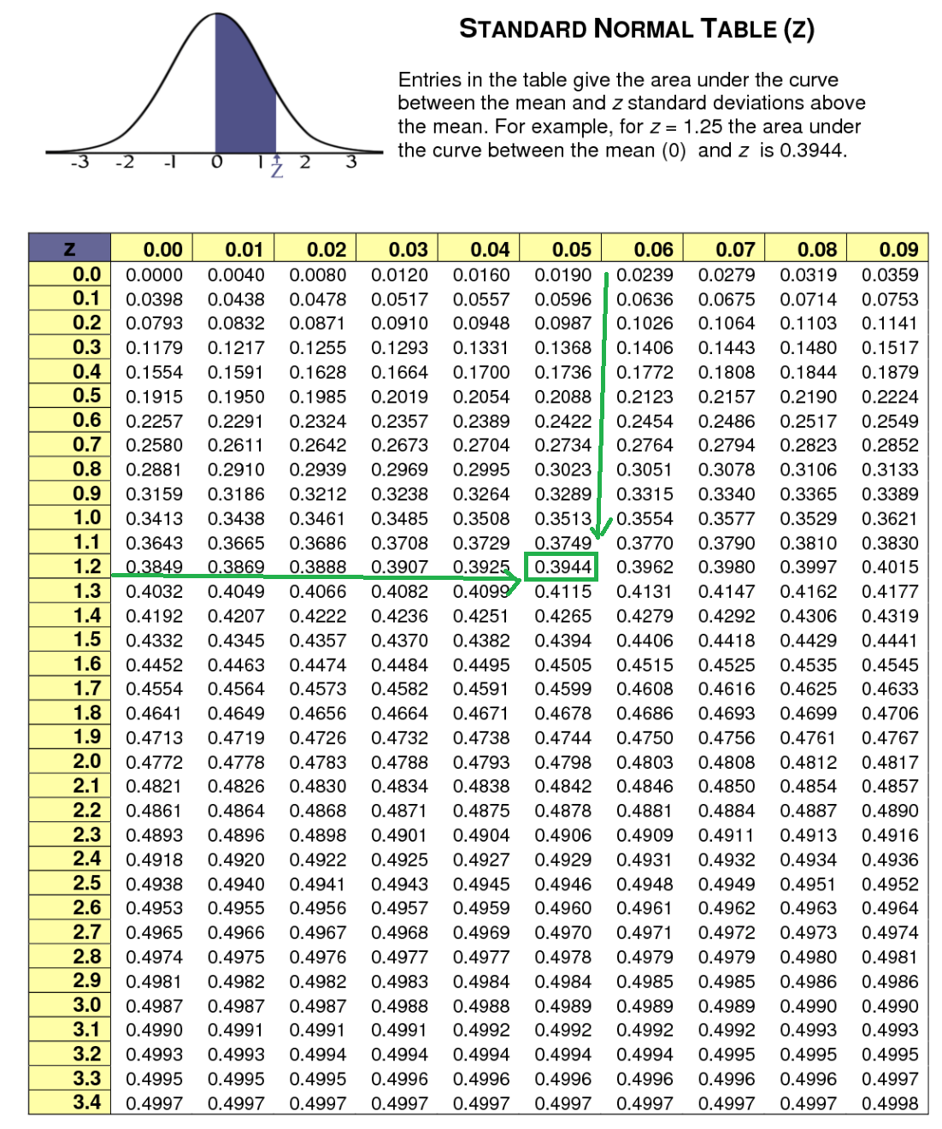

Exercise 14 (1 mark)
What percentage of samples are found in a standard normal distribution for -1.25 $≤$ z $≤$ 0?

Exercise 15 (1 mark)
What percentage of samples are found in a standard normal distribution for 1.25 $≤$ z?

Exercise 16 (1 mark)
What percentage of samples are found in a standard normal distribution for -1.25 $≤$ z $≤$ 1.25?

Exercise 17 (1 mark)
What percentage of samples are found in a standard normal distribution for 0 $≤$ z $≤$ 2.17?

Exercise 18 (1 mark)
What percentage of samples are found in a standard normal distribution for -1.96 $≤$ z $≤$ 1.96?

Student’s t-Distribution
When working with samples of less than 30 we often have incomplete information about the distribution so we use a Student’s t-distribution to approximate statistics. The t-distribution is a less accurate approximation of the normal distribution. The t-distribution is like a normal distribution but the t-distribution is shorter with fatter tails to account for error. Figure 6 compares the standard normal distribution with the Student t-distribution.

Figure 6: Standard Normal Distribution Versus the Student t-Distribution

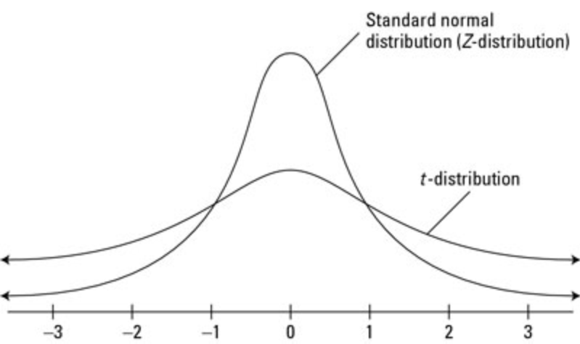

The t-value is determined with a lookup value. Since accuracy is compromised with lower sample sizes, degrees of freedom are used to penalize the estimate. Figure 7 shows that 95% of the samples within a t-distribution can be found where -2.228 $≤$ t $≤$ 2.228 for 10 degrees of freedom when n=11 samples exist. Since we are dealing with a two-tail distribution each tail area outside the 95% range is described with $∝$ = 0.025.

Equation 3: Degrees of Freedom
Degrees of freedom = $ν$ = sample size – 1 = n – 1. ($ν$ is pronounced as nu).

Figure 7: t-value look up for 95% of distribution (two-tailed) and 10 degrees of freedom
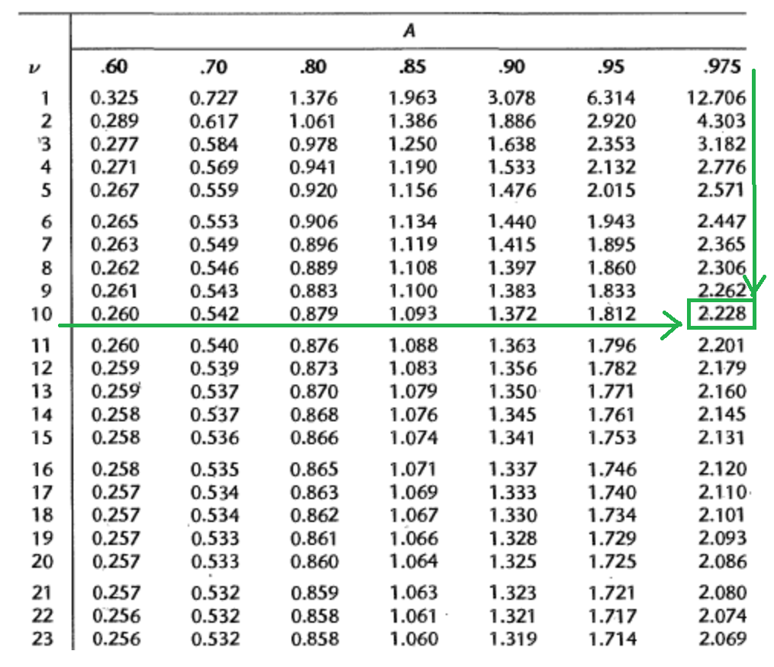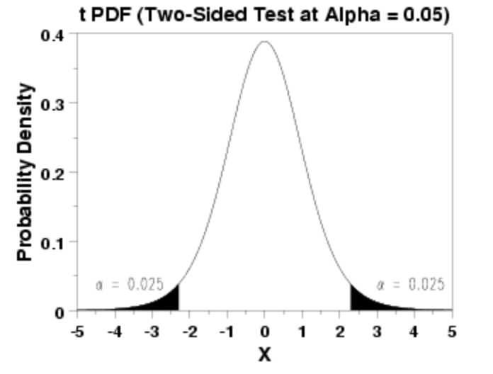

Exercise 19 (1 mark)
Given a sample size of 20, what is the range of t for 90% of the distribution when $α$=0.05 at each tail?

Exercise 20 (1 mark)
Given a sample size of 14, what is the t-value for 90% of the one-tailed t-distribution when $α$=0.1 at the right tail and t $≥ -∞$?

Exercise 21 (1 mark)
Does the distribution with the dashed line in Figure 8 have higher or lower degrees of freedom than the distribution with the solid line?

Figure 8: T-Distributions for different degrees of freedom
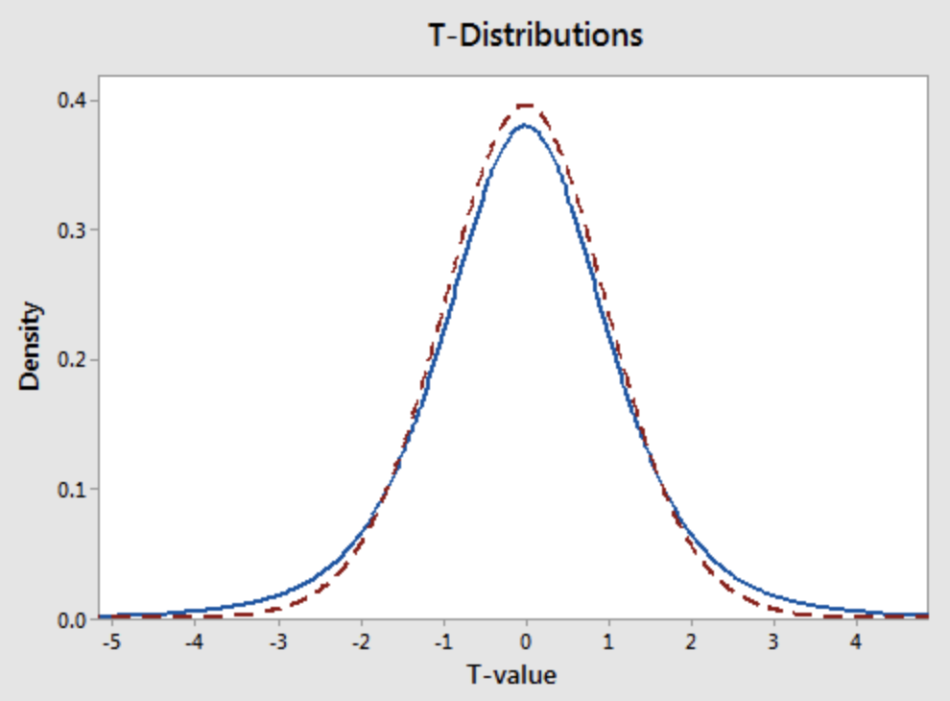
Exercise 22 (1 mark)
Which T-distribution (dashed or solid) in Figure 8 is closer to a standard normal distribution?

Exercise 23 (1 mark)
What is the value of n when degrees of freedom, $ν$, is 21?

Mean and Deviation
To help understand our distributions better we often need to examine the mean (average) and standard deviation (dispersion about the mean). The population mean is represented by the character $μ$ and the population deviation is represented by $σ$. Often though we do not know the true mean or standard deviation so we must use estimates.

Sample Mean
The sample mean, $\overline{x}$, is the average sample value. Where n is the sample size.

Equation 4: Sample Mean
$\overline{x}$ = $\frac{\sum_{i=1}^{n}{x_{i}}}{n}$

Sample Standard Deviation
The sample standard deviation, s, represents the average dispersion of samples about the sample mean.

Equation 5: Sample Standard Deviation
s = $\sqrt{\frac{1}{n-1}∙\sum_{i=1}^{n}{{(x_{i}-\overline{x})}^{2}}}$

Standard Error
The standard error is an estimate of how far the sample mean is likely to be from the population mean.

Equation 6: Standard Error When Standard Deviation Known
The standard error is the standard deviation divided by the square root of the sample size n.
Where:
- the population standard deviation, $σ$, is known – this is the preferred scenario.
- n is the sample size.
SE = $\frac{σ}{\sqrt{n}}$
Equation 7: Standard Error When Standard Deviation Not Known
When the population standard deviation is not known the equation uses the standard deviation estimate, s, from the sample. The estimate is less accurate.

SE = $\frac{s}{\sqrt{n}}$

Exercise 24 (1 mark)
Without performing any calculations examine the equations to answer this question. Does the standard error increase or decrease as the sample size increases?

The Empirical Rule and Chebyshev’s Theorem
While you do not need to know the empirical rule or Chebyshev’s theorem I am mentioning it here to emphasize the importance of standard deviation. Basically, these theorems allow us to make fairly accurate conclusions about the dispersion of samples when sample or population standard deviations are known.

Empirical Rule
The Empirical rule states that for a normal distribution, 99.7% of sample values are within 3 standard deviations $σ$ of the mean $μ$. 95% sample values are within 2 standard deviations of the mean. 68% of sample values are within 1 standard deviation of the mean (see Figure 9).

Figure 9: Empirical Rule
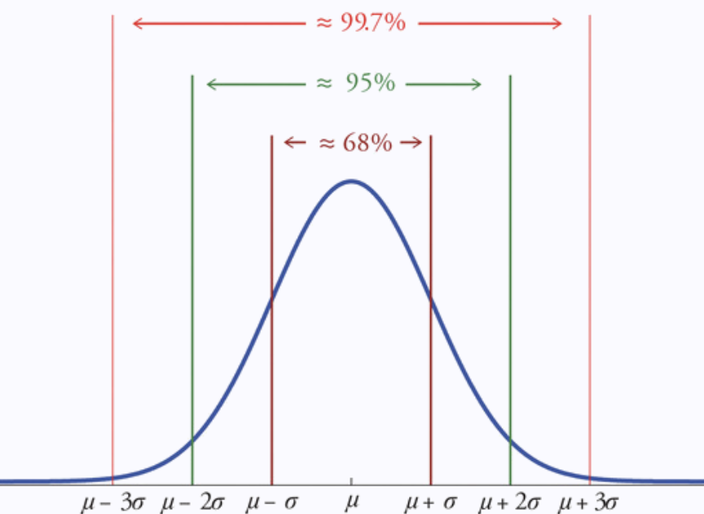
For a live demonstration of this natural normally distributed occurrence see https://www.youtube.com/watch?v=Vo9Esp1yaC8

Chebyshev’s Theorem
Chebyshev’s theorem describes data ranges for any type of distribution for two or more standard deviations from the mean.

For any numerical data set:
- at least 3/4 of the data lie within two standard deviations of the mean, that is, in the interval with endpoints $\overline{x}$ ± 2s for samples and with endpoints μ±2σ for populations;
- at least 8/9 of the data lie within three standard deviations of the mean, that is, in the interval with endpoints $\overline{x}$ ± 3s for samples and with endpoints μ±3σ for populations;
- at least 1 $-\frac{1}{k^{2}}$ of the data lie within k standard deviations of the mean, that is, in the interval with endpoints $\overline{x}$ ± ks for samples and with endpoints μ±kσ for populations, where k is any positive whole number that is greater than 1 .

Figure 10: Chebyshev’s Theorem
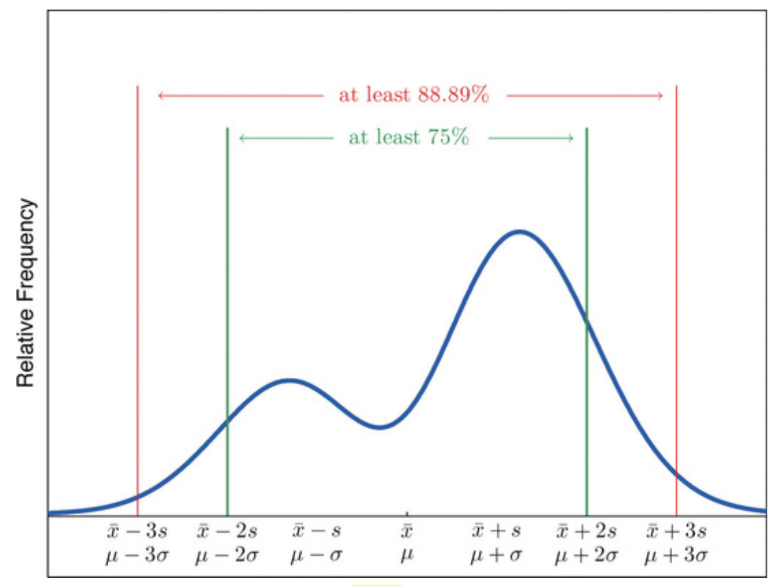
You do not need to memorize the empirical rule or Chebyshev’s theorem but you need to have confidence that distributions and their patterns of variance offer reliable characteristics for predictive algorithms.

Confidence Intervals
A confidence interval is a range of values that contains an expected value with a weighted level of confidence. Understanding confidence intervals will be very useful for us when validating predictive models and their components.

Equation 8: Confidence Interval for the Sample Mean for Normal Distributions
When computing the confidence interval for a sample mean we are really stating a percentage of confidence that the sample mean, $\overline{x}$, is $±$ some value from the true population mean.

Note: The confidence interval for the sample mean is not the same as estimating the range for 95% of all sample values.

When working with normal distributions, for sample sizes of n that are less than 30, we use the t distribution which is flatter and has fatter tails to account for the error:

C.I. = $\overline{x}$ $±$ $t_{\frac{∝}{2}, df=n-1}∙SE$

For sample sizes of n that are greater than 30, we use the z distribution to calculate the confidence interval which is:

C.I. =$\overline{x}$ $±$ $z_{\frac{∝}{2}}∙SE$

Example 9: Confidence Interval for a Sample Mean
This example is taken from https://www.mathsisfun.com/data/confidence-interval.html. We measure the heights of 40 randomly chosen men, and get a mean height of 175cm. We also know the population standard deviation, $σ$, of men's heights is 20cm. The 95% Confidence Interval for the mean is calculated in the following manner:

$\overline{x}$ = 175
n = 40
$σ$ = 20

Now we can calculate SE using Standard Error
The standard error is an estimate of how far the sample mean is likely to be from the population mean.

Equation 6.
SE = $\frac{}{\sqrt{n}}$ = $\frac{20}{\sqrt{40}}$ = 3.162

$$α=1-0.95=0.05=5\%$$
Since we are looking at a two-tailed region the alpha value is split in half.
$$\frac{∝}{2} = \frac{0.5}{2}=0.025$$

Since we have n > 30 we can use the normal distribution. Therefore, we look up the z value. According to the z table:

$z_{0.025}$ = 1.96 (See Figure 11)

Figure 11: Z-table reference for Two-Tailed 95% confidence interval
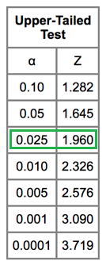

We can now calculate the confidence interval:
$\overline{x}$ $±$ $z_{\frac{∝}{2}}∙SE$ = 175 ± 1.96$∙$3.162 = 175 ± 6.2 cm

The 95% confidence interval for the true mean is identified with the dashed green line in Figure 12.

Figure 12: Confidence Interval for the True Mean
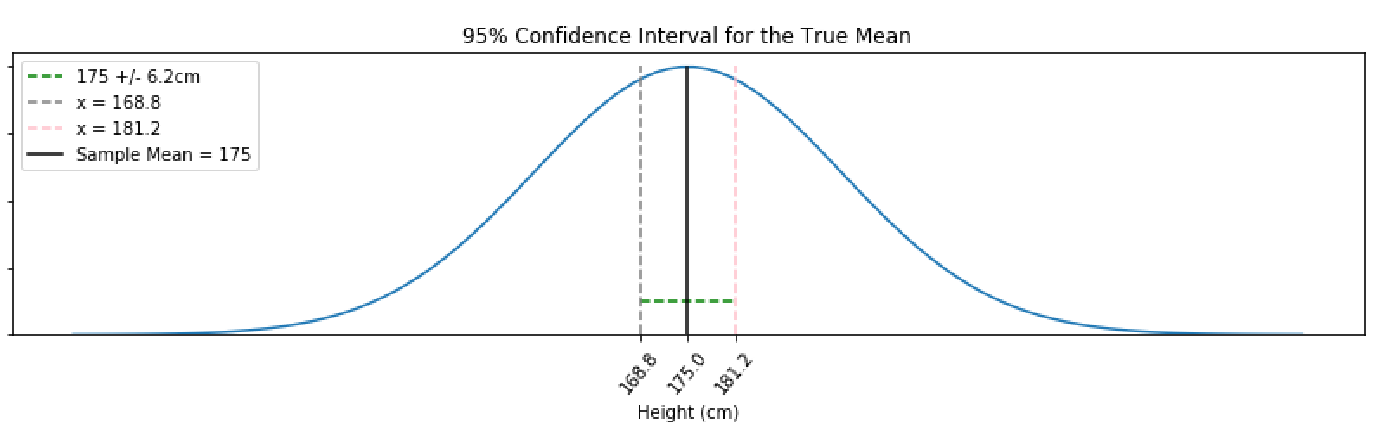
Conclusion: We can now say that we are 95% confident that the sample mean of 175cm is ± 6.2 cm from the true population mean. In other words, 168.8 $≤$ $\overline{x}$ $≤$ 181.2.

Exercise 25 (2 marks)
A sample of size n = 100 produced the sample mean of $\overline{x}$= 16. Assuming the
population standard deviation σ = 3, compute a 95% confidence interval for the population mean
µ.

Example 10: Confidence Intervals Continued
This confidence interval example is taken from:
https://www.khanacademy.org/math/statistics-probability/confidence-intervals-one-sample/old-confidence-interval-videos/v/small-sample-size-confidence-intervals

Seven patient’s blood pressures have been measured after having been given a new drug for 3 months. They had blood pressure increases of 1.5, 2.9, 0.9, 3.9, 3.2, 2.1 and 1.9. Construct a 95% confidence interval for the true expected blood pressure increase for all patients in the population.

We know the sample mean, $\overline{x}= \frac{1.5+2.9+0.9+3.9+3.2+2.1+1.9}{7} =$2.3429

s = $\sqrt{\frac{1}{N-1}∙\sum_{i=1}^{N}{{(x_{i}-\overline{x})}^{2}}}=\sqrt{\frac{1}{7-1}∙\sum_{i=1}^{7}{{(x_{i}-\overline{x})}^{2}}}$
s = $\sqrt{\begin{aligned}\frac{1}{6} ∙( {\left(1.5-2.3429\right)}^{2}+{\left(2.9-2.3429\right)}^{2}+{\left(0.9-2.3429\right)}^{2}+{\left(3.9-2.3429\right)}^{2}+ \\ {( 3.2-2.3429)}^{2}+ {( 2.1-2.3429)}^{2}+ {( 1.9-2.3429)}^{2})\end{aligned}}$
s = 1.04220462

SE = $\frac{s}{\sqrt{n}}$ = $\frac{1.0422}{\sqrt{7}}$ = 0.3939

Since we have less than 30 samples we need to use the t-distribution. Looking up the 95% confidence interval for n-1 degrees of freedom gives us a t value of 2.447.
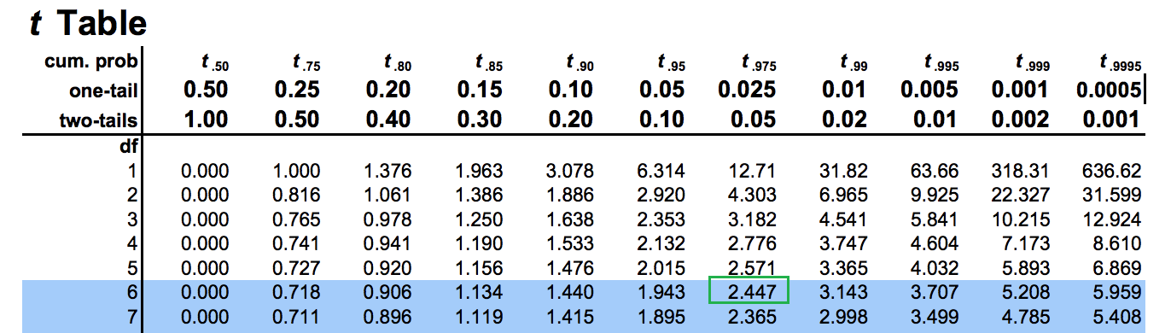

Our confidence interval is therefore:
C.I. = $\overline{x}$ $±$ $t_{\frac{∝}{2}, df=n-1}∙SE$ = 2.3429 $±$ 2.447$∙$0.3939 = 2.3429$±$0.9638733

Conclusion:
We are 95% confident that the true population mean increase in blood pressure due to the medication is between 1.3790267 and 3.3067733.

Exercise 26 (2 marks)
- A simple random sample of prices for a certain fruit in 9 different shops has produced the following values; 2.5 2.1 1.8 2.1 2.3 2.2 2.2 2.0 1.9
The sample standard deviation is:

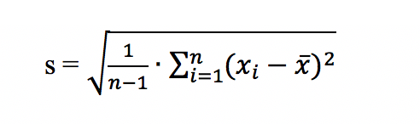
Calculating this manually in Excel gives:

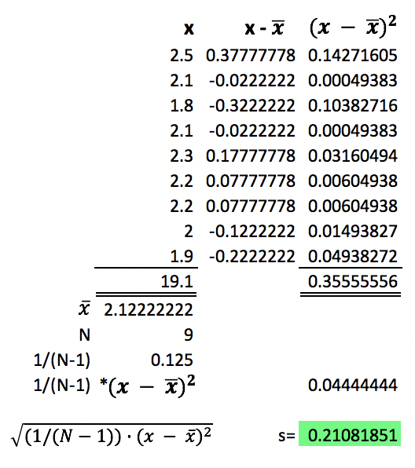

Compute the 99% confidence interval here. Show your calculations here:

