Table of Contents
Displaying Multiple Graphs 1
Scatter Matrix 4
Correlation Heatmap 6
Querying DataFrames with SQL 7
Filtering (WHERE clause) 8
Sorting 9
Descending Sort 9
Sorting on Multiple Columns 9
Filtering on a List of Values 10
IS NULL / IS NOT NULL 10
Selecting Unique Rows 10
Alias Columns 11
Arithmetic Operators ( + - * / ) 11
LIKE 12
Aggregate (Summary) Functions 13
Including Detail with Summaries 13
Filtering Summary Queries 14
duckdb: An Easier Alternative to SQL Alchemy 15

Note:
You are encouraged to work with others and you can discuss your solutions verbally as well but DO NOT SHARE COPIES of YOUR WORK ELECTONICALLY OR IN ANY OTHER FORM.

Displaying Multiple Graphs
During exploratory data analysis (EDA) and reporting you will often need to present summaries about many variables. You can adjust graphics output so more than one chart appears in the same row (See Figure 1).

Figure 1: Plotting Multiple Charts in One Row
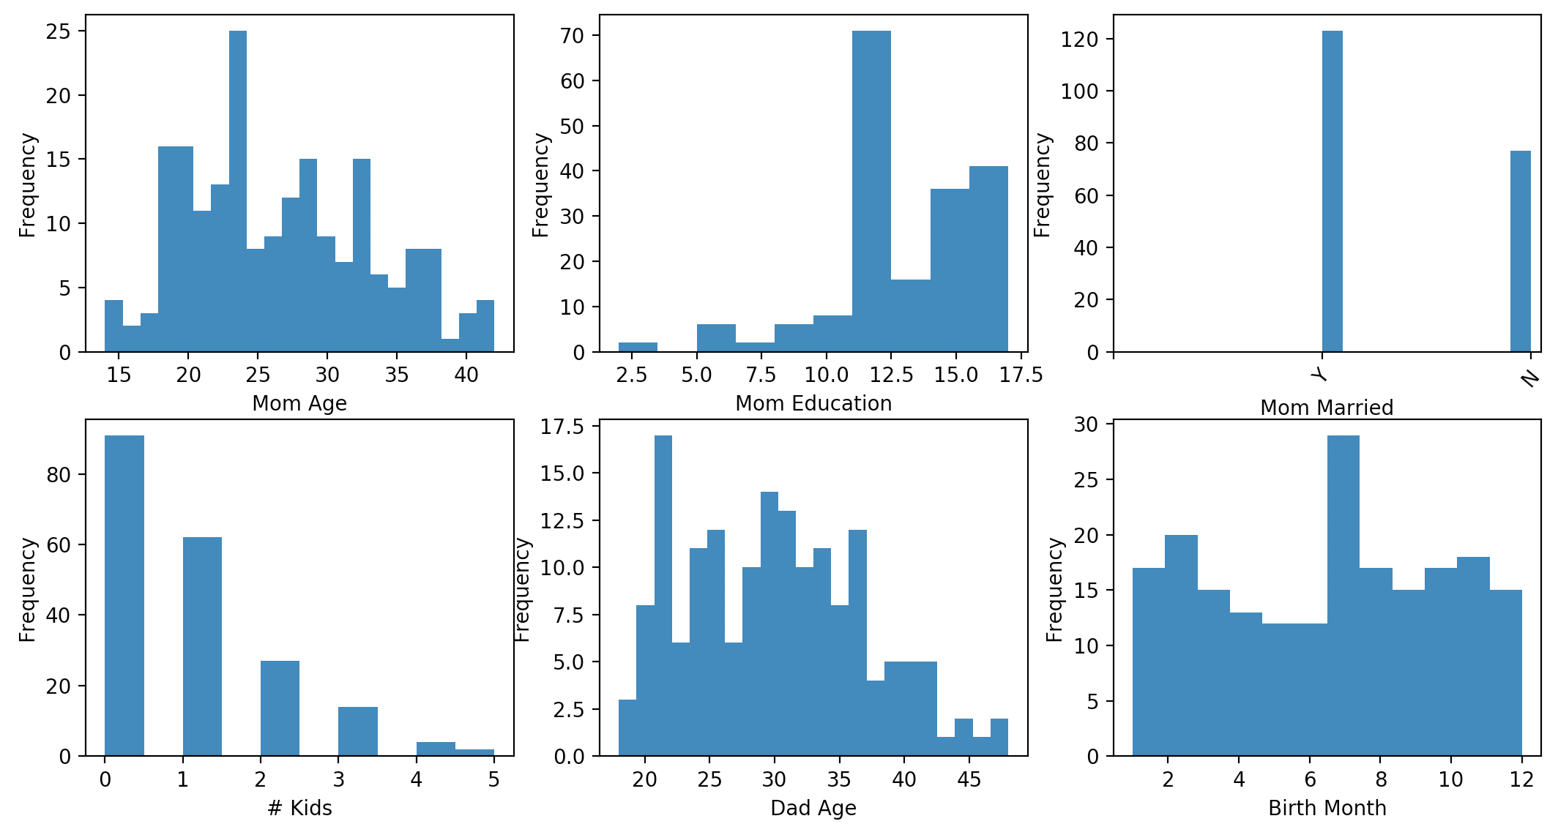
Example 1: Drawing Multiple Graphs on One Line
This example shows how to output multiple graphs in the same row-column layout as Figure 1. Placing the following line before instructions to draw all graphs allows you to control the size of each of the graphs. I have not perfected the sizing so I use the width and height parameters in the figsize attribute as relative measures and experiment with them until getting the proper size.

# This line allows us to set the figure size supposedly in inches.
# When rendered in the IDE the output often does not translate to inches.
plt.subplots(nrows=2, ncols=3, figsize=(3,4))

Placing a line like this one above each chart sets the position of the chart in the matrix. The first two parameters represent the number of rows and columns of the output. The final number is the position in the matrix where charts are rendered in a clock-wise manner. I find the syntax to be a bit odd but it works. Each time you plot a new chart in the series you state the number of rows and columns in the series as well as the position of the current plot within it.

plt.subplot(2, 3, 1) # Specfies total rows, columns and image #
# where images are drawn clockwise.

import pandas as pd
import matplotlib.pyplot as plt

# Import data into a DataFrame.
path = "/Users/pm/Desktop/DayDocs/data/babysamp-98.txt"
df = pd.read_csv(path, skiprows=1,
sep='\t',
names=('MomAge', 'DadAge', 'MomEduc', 'MomMarital', 'numlive',
"dobmm", 'gestation', 'sex', 'weight', 'prenatalstart',
'orig.id', 'preemie'))

# Show all columns.
pd.set_option('display.max_columns', None)

# Increase number of columns that display on one line.
pd.set_option('display.width', 1000)
# This line allows us to set the figure size supposedly in inches.
# When rendered in the IDE the output often does not translate to inches.
plt.subplots(nrows=2, ncols=3, figsize=(14,7))

plt.subplot(2, 3, 1) # Specfies total rows, columns and image #
# where images are drawn clockwise.
plt.hist(df["MomAge"], bins=22)
plt.xlabel("Mom Age")
plt.ylabel("Frequency")
#plt.title('Mother Age')

plt.subplot(2, 3, 2)
plt.hist(df["MomEduc"], bins=10)
plt.xlabel("Mom Education")
plt.ylabel("Frequency")

# 1 is married
# 2 is unmarried
plt.subplot(2, 3, 3)
plt.hist(df["MomMarital"], bins=10)
t11 = ['', 'Y', 'N']
plt.xticks(range(len(t11)), t11, rotation=50)

#plt.xticks(['Mar', '2'], rotation=50)
plt.xlabel("Mom Married")
plt.ylabel("Frequency")

# 1 is married. 2 is unmarried.
plt.subplot(2, 3, 4)
plt.hist(df["numlive"], bins=10)
plt.xlabel("# Kids")
plt.ylabel("Frequency")

plt.subplot(2, 3, 5) # of rows, # of columns, # plots.
plt.hist(df["DadAge"], bins=22)
plt.xlabel("Dad Age")
plt.ylabel("Frequency")

plt.subplot(2, 3, 6)
plt.hist(df["dobmm"], bins=12)
plt.xlabel("Birth Month")
plt.ylabel("Frequency")

plt.show()

Exercise 1 (2 marks)
Starting with the following code;
﻿import pandas as pd
import matplotlib.pyplot as plt

# Import data into a DataFrame.

path = "/Users/pm/Desktop/DayDocs/data/bodyfat.txt"
df = pd.read_csv(path, skiprows=1,
sep='\t',
names=('Density', 'Pct.BF', 'Age', 'Weight', 'Height',
'Neck', 'Chest', 'Abdomen', 'Waist', 'Hip', 'Thigh',
'Ankle', 'Knee', 'Bicep', 'Forearm', 'Wrist'))
Make the following histograms by drawing 2 per row with 10 bins each.
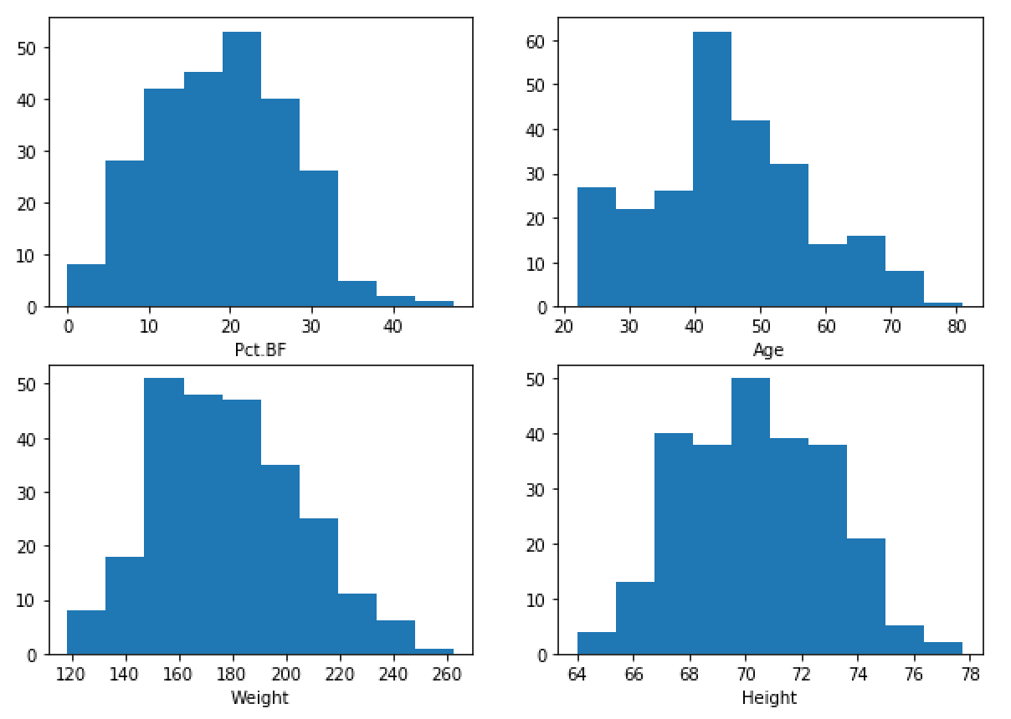
Show your code here:
import pandas as pd
import matplotlib.pyplot as plt
path = r"C:\Users\linho\Desktop\CST\term3\pred_analytics\data\bodyfat.txt"
df = pd.read_csv(path, sep='\t')
plt.subplots(nrows=2, ncols=2, figsize=(14, 8))
plt.subplot(2, 2, 1)
plt.hist(df['Pct.BF'], bins=10)
plt.xlabel('Pct.BF')
plt.subplot(2, 2, 2)
plt.hist(df['Age'])
plt.xlabel('Age')
plt.subplot(2, 2, 3)
plt.hist(df['Weight'])
plt.xlabel('Weight')
plt.subplot(2, 2, 4)
plt.hist(df['Height'])
plt.xlabel('Height')
plt.show()

Scatter Matrix
Scatter matrices are helpful for showing correlation between variable pairs. The red outline in Figure 2 indicates very little correlation. The green outline suggests very high correlation between waist and abdomen. Density seems to be negatively correlated to many of the variables as outlined in red. Age does not seem correlated with many weights and measurements as outlined in yellow. There does appear to be a strong correlation between abdomen size and waist as outlined in green. 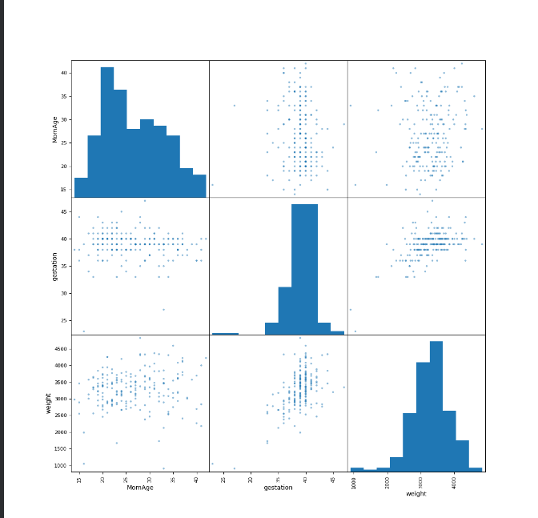

Figure 2: Scatter Matrix
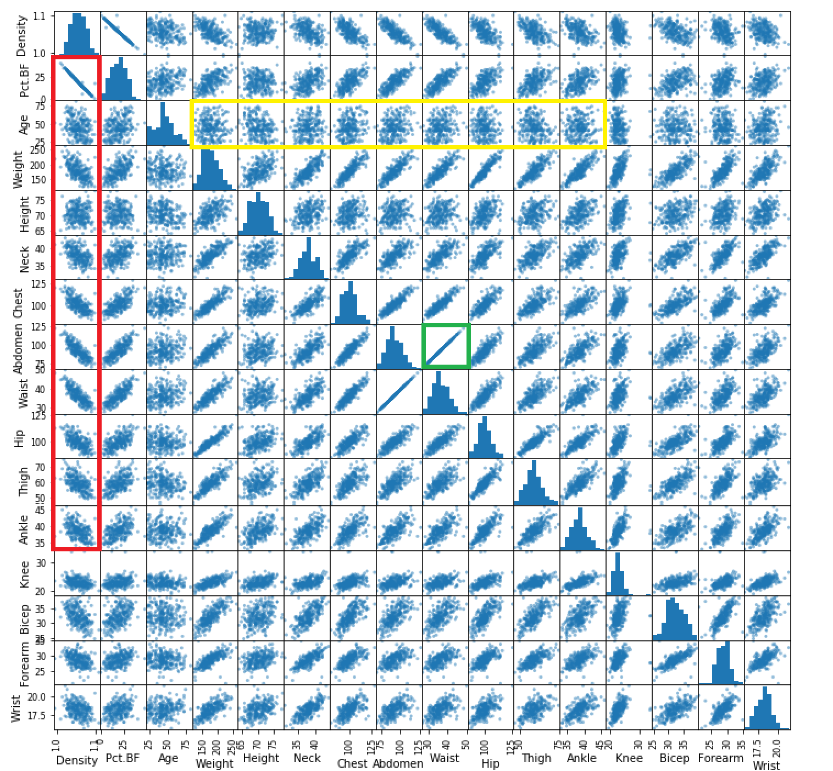
Here is the code:

﻿import pandas as pd
import matplotlib.pyplot as plt
from pandas.plotting import scatter_matrix

# Import data into a DataFrame.
path = "C:\\datasets\\bodyfat.txt"
df = pd.read_csv(path, skiprows=1,
sep='\t',
names=('Density', 'Pct.BF', 'Age', 'Weight', 'Height',
'Neck', 'Chest','Abdomen', 'Waist', 'Hip', 'Thigh',
'Ankle', 'Knee', 'Bicep',
'Forearm',
'Wrist'))
scatter_matrix(df, figsize=(12,12))
plt.show()

Exercise 2 (3 marks)`
It is not possible to run a scatter matrix non-numeric data and some categorical variables. To isolate the numeric data, use the sample from babysamp-98.txt file to create a sub-DataFrame with MomAge, gestation and weight columns only. Then draw a scatter matrix with this subset. Show your program here:
import pandas as pd
import matplotlib.pyplot as plt
from pandas.plotting import scatter_matrix
path = r"C:\Users\linho\Desktop\CST\term3\pred_analytics\data\babysamp-98.txt"
df = pd.read_csv(path, sep='\t')
sub_df = df[['MomAge', 'gestation', 'weight']]
scatter_matrix(sub_df, figsize=(12, 12))
plt.show()

Show a screenshot of your scatter matrix here:

Are there any visible trends (or lack of trends) that appear in terms of correlation?
There seems a correlation between gestation and weight, the other two factors do not show any correlations

Correlation Heatmap
Another way to show correlation is with the correlation heat map. The correlation heatmap offers a more condensed view of correlation between variables but it does not show the distribution of correlation.

Example 2: Correlation Heatmap
This example demonstrates how to draw a correlation heatmap with the body fat sample.
﻿import numpy as np
import seaborn as sns
import matplotlib.pylab as plt
from string import ascii_letters
import numpy as np
import pandas as pd
import seaborn as sns

# Import data into a DataFrame.
path = "/users/pm/desktop/daydocs/data/bodyfat.txt"
df = pd.read_csv(path, skiprows=1,
sep='\t',
names=('Density', 'Pct.BF', 'Age', 'Weight', 'Height',
'Neck', 'Chest','Abdomen', 'Waist', 'Hip', 'Thigh',
'Ankle', 'Knee', 'Bicep',
'Forearm',
'Wrist'))
# Compute the correlation matrix
corr = df.corr()

# plot the heatmap

sns.set(rc = {'figure.figsize':(6,4)})
sns.heatmap(corr[['Weight']],
linewidths=0.1, vmin=-1, vmax=1,
cmap="YlGnBu")
plt.show()

Exercise 3 (3 marks)
As mentioned previously, it is not possible to run a scatter matrix non-numeric data and some categorical variables. To isolate the numeric data, use the sample from babysamp-98.txt file to create a sub-DataFrame with MomAge, gestation and weight columns only.

Choose a continuous numeric variable, other than weight, and then draw a correlation heatpmap with it. Show your program here:
import numpy as np
import seaborn as sns
import matplotlib.pylab as plt
import pandas as pd
from string import ascii_letters
path = r"C:\Users\linho\Desktop\CST\term3\pred_analytics\data\babysamp-98.txt"
df = pd.read_csv(path, sep='\t')
sub_df = df[['MomAge', 'gestation', 'weight']]
# compute correlation matrix
corr = sub_df.corr()
# plot heatmap
sns.set_theme(rc={'figure.figsize': (6, 4)})
sns.heatmap(corr[['gestation']],
linewidths=0.1, vmin=-1, vmax=1,
cmap='YlGnBu')
plt.show()

Show a screenshot of your correlation heatmap here:
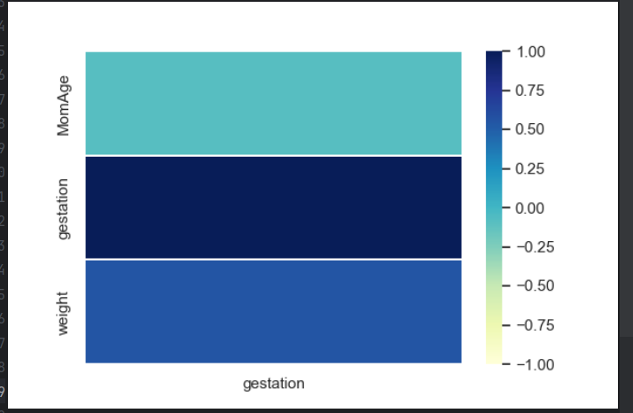

Querying DataFrames with SQL
When working with large amounts of data, it is really important that you have the ability to quickly and easily query the data. Last day, we discussed how to use the pandas methods to query DataFrames. You can use these pandas methods especially if you like them. I also want to show SQLAlchemy which provides an alternative API to query your data frames.

Example 3: Retail SQL
To demonstrate different ways of querying the data run the following script to create an Inventory table and to display its contents.
import pandas as pd
from sqlalchemy import create_engine

# The data file path and file name need to be configured.
PATH = "/Users/pm/Desktop/DayDocs/data/"
CSV_DATA = "retailerDB.csv"
df = pd.read_csv(PATH + CSV_DATA)

# Placed query in this function to enable code re-usuability.
def showQueryResult(sql):
# This code creates an in-memory table called 'Inventory'.
engine = create_engine('sqlite://', echo=False)
connection = engine.connect()
df.to_sql(name = 'Inventory', con=connection, if_exists='replace', index=False)

# This code performs the query.
queryResult = pd.read_sql(sql, connection)
return queryResult

# Read all rows from the table.
SQL = "SELECT * FROM Inventory"
results = showQueryResult(SQL)
print(results)
The output from running this query is:
productID productName vendor quantity price stockDate
0 1 Wonder Bar Cadbury 11.0 1.11 2020-10-01
1 2 Too too Toucan Inc. 22.0 2.22 2020-10-02
2 3 Fork Silverware Inc. 44.0 4.44 2020-10-04
3 4 Fork Waterford Corp. 34.0 5.31 2020-10-04
4 5 Futon Sleep Country NaN 4.32 2020-10-05
5 6 Coffee Crisp Cadbury 9.0 1.32 2020-10-06

Exercise 4 (1 mark)
This question may seem trivial once you know how to do it but I am asking so you do not miss it. In Example 3, the DataFrame is referred to as Inventory. Then, the Inventory table is referred to in the SQL statement. However, we could have created a virtual table with any name. For this exercise, change the virtual table name from Inventory to RetailInventory in both places where it is referenced and verify that the code still works. Show your code here:
import pandas as pd
from sqlalchemy import create_engine
path = r'C:\Users\linho\Desktop\CST\term3\pred_analytics\data'
csv_data = r'\retailerDB.csv'
df = pd.read_csv(path + csv_data)
def show_query_result(sql):
# Create an in-memory table called 'Inventory'
engine = create_engine('sqlite://', echo=False)
connection = engine.connect()
df.to_sql(name='RetailInventory', con=connection,
if_exists='replace', index=False)
# execute query
query_result = pd.read_sql(sql, connection)
return query_result
SQL = 'SELECT * FROM RetailInventory'
results = show_query_result(SQL)
print(results)

Filtering (WHERE clause)
WHERE classes allow us to select a subset of rows with conditional filtering.

Example 4: Filtering with a WHERE clause
To build this example. replace the SQL declaration in Example 3 with the following:
SQL = "SELECT * FROM Inventory WHERE vendor == 'Cadbury'"
The output is:
productID productName vendor quantity price stockDate
0 1 Wonder Bar Cadbury 11.0 1.11 2020-10-01
1 6 Coffee Crisp Cadbury 9.0 1.32 2020-10-06

Exercise 5: (1 mark)
Starting with Example 3, modify the SQL to select all rows from the DataFrame where the price is greater than or equal to 4. Show your SQL statement here:
SQL = 'SELECT * FROM RetailInventory WHERE price >= 4'

Show your output here:
productID productName vendor quantity price stockDate
0 3 Fork Silverware Inc. 44.0 4.44 2020-10-04
1 4 Fork Waterford Corp. 34.0 5.31 2020-10-04
2 5 Futon Sleep Country NaN 4.32 2020-10-05

Sorting
The ORDER BY command beside an attribute forces the SELECT statement to retrieve data in a sorted sequence by the designated attribute. For example, the following query displays products sequenced according to their quantity in stock:
SQL = "SELECT productID, quantity, price FROM Inventory ORDER BY quantity"
The output is:
productID quantity price
0 5 NaN 4.32
1 6 9.0 1.32
2 1 11.0 1.11
3 2 22.0 2.22
4 4 34.0 5.31
5 3 44.0 4.44

Exercise 6 (1 mark)
Starting with Example 3, sort the DataFrame by productName. Show your SQL statement here:
SQL = 'SELECT * FROM RetailInventory WHERE price >= 4 ORDER BY productName'
Show your output here:
productID productName vendor quantity price stockDate
0 3 Fork Silverware Inc. 44.0 4.44 2020-10-04
1 4 Fork Waterford Corp. 34.0 5.31 2020-10-04
2 5 Futon Sleep Country NaN 4.32 2020-10-05

Descending Sort
To sort items in descending order, use the DESC clause after the sort column. The query;
SQL = "SELECT productID, quantity, price FROM Inventory ORDER BY quantity DESC"
Generates the output;
productID quantity price
0 3 44.0 4.44
1 4 34.0 5.31
2 2 22.0 2.22
3 1 11.0 1.11
4 6 9.0 1.32
5 5 NaN 4.32

Sorting on Multiple Columns
To group items, you can sort on one column and then another with a comma separated list of columns. The query below sorts by vendor and then by productName;
SQL = "SELECT productName, vendor, price FROM Inventory ORDER BY \
vendor, productName"
The output is;
productName vendor price
0 Coffee Crisp Cadbury 1.32
1 Wonder Bar Cadbury 1.11
2 Fork Silverware Inc. 4.44
3 Futon Sleep Country 4.32
4 Too too Toucan Inc. 2.22
5 Fork Waterford Corp. 5.31

Exercise 7 (1 mark)
Write a SELECT statement to select all items from the Inventory table and order the items by productName and then quantity. Show productName, vendor, quantity and price columns in your query:
SQL = ("SELECT productName, vendor, quantity, price FROM RetailInventory"
" ORDER BY productName, quantity")

Filtering on a List of Values
To filter a query against a list of values you may use the IN clause before the list:
SQL="SELECT DISTINCT productID, productName FROM Inventory WHERE productID IN(1, 3)"

The output is;
productID productName
0 1 Wonder Bar
1 3 Fork

Exercise 8 (1 mark)
Write a statement to retrieve all products except products that are sold by Cadbury and Waterford Corp. Use an IN statement.
SQL = ("SELECT * FROM RetailInventory "
"WHERE productName NOT IN ('Cadbury', 'Waterford Corp')")

IS NULL / IS NOT NULL
It is possible to check for NULL values in the WHERE clause. This statement only pulls records with empty values for the designated attribute.
SQL = "SELECT * FROM Inventory WHERE quantity IS NULL"
The output from running this statement is:
productID productName vendor quantity price stockDate
0 5 Futon Sleep Country None 4.32 2020-10-05

IS NOT NULL obviously retrieves items that only have values so;
SQL = "SELECT * FROM Inventory WHERE quantity IS NOT NULL"
retrieves;
productID productName vendor quantity price stockDate
0 1 Wonder Bar Cadbury 11.0 1.11 2020-10-01
1 2 Too too Toucan Inc. 22.0 2.22 2020-10-02
2 3 Fork Silverware Inc. 44.0 4.44 2020-10-04
3 4 Fork Waterford Corp. 34.0 5.31 2020-10-04
4 6 Coffee Crisp Cadbury 9.0 1.32 2020-10-06

Selecting Unique Rows
Distinct ensures that each row in the query is unique. For the following query;
SQL = "SELECT DISTINCT vendor FROM Inventory"
Cadbury only appears once:
vendor
0 Cadbury
1 Toucan Inc.
2 Silverware Inc.
3 Waterford Corp.
4 Sleep Country
Without DISTINCT in the following query;
SQL = "SELECT vendor FROM Inventory"
Cadbury would appear twice:
vendor
0 Cadbury
1 Toucan Inc.
2 Silverware Inc.
3 Waterford Corp.
4 Sleep Country
5 Cadbury

Alias Columns
When generating new information in a query you may assign a new name to your columns. The new name is called an alias.

Example 5: Alias
This example shows how to combine the productName and vendor to create a new alias column called ProductVendor: To build this example. replace the SQL declaration in Example 3 with the following:

SQL = "SELECT productName || '-' || vendor AS ProductVendor FROM Inventory"
The output is:
ProductVendor
0 Wonder Bar-Cadbury
1 Too too-Toucan Inc.
2 Fork-Silverware Inc.
3 Fork-Waterford Corp.
4 Futon-Sleep Country
5 Coffee Crisp-Cadbury

Arithmetic Operators ( + - * / )
You can perform mathematical operations (+-*/) in your select statements. Here is an example which calculates the dollar value of each product in stock. Notice that the total value is calculated during the query by multiplying quantity times price. A new column with the alias name total is generated to display the calculation result:
SQL = "SELECT quantity, price, quantity * price AS total FROM Inventory"
The output is:
quantity price total
0 11.0 1.11 12.21
1 22.0 2.22 48.84
2 44.0 4.44 195.36
3 34.0 5.31 180.54
4 NaN 4.32 NaN
5 9.0 1.32 11.88

Exercise 9 (1 mark)
Query the Inventory table to show the productName, price, and after tax price with an alias column named afterTaxPrice. Assume that the tax rate is 7%:
SQL = ("SELECT productName, price, price + price*0.07 AS afterTaxPrice FROM RetailInventory")

LIKE
The LIKE command is used to finding matching string patterns. The LIKE command is used in combination with regular expression symbols which are summarized in the following table;
% | Any string of zero or more characters
_ | Any single character
[ ] | Any single character within the specified range (for example, [a-f]) or set (for example, [abcdef])
[^] | Any single character not within the specified range (for example, [^a - f]) or set (for example, [^abcdef])

Here are some examples;
- LIKE 'Mc%' searches for all names that begin with the letters "Mc" (eg. McBadden).
- LIKE '%inger' searches for all names that end with the letters "inger" (eg. Ringer, Stringer).
- LIKE '%en%' searches for all names that have the letters "en" (eg. Bennet, Green, McBadden).
- LIKE '_heryl' searches for all six-letter names ending with the letters "heryl" (eg. Cheryl, Sheryl).
- LIKE '[CK]ars[eo]n' searches for Carsen, Karsen, Carson, and Karson (eg. Carson).
- LIKE '[M-Z]inger' searches for all names ending with the letters "inger" that begin with any single letter from M to Z (eg. Ringer).
- LIKE 'M[^c]%' searches for all names beginning with the letter M that don't have the letter c as the second letter (eg. MacFeather).

When used with the Inventory table, the query;
SQL = "SELECT * FROM Inventory WHERE productName LIKE '%on%'"
Retrieves productName values which have the substring ‘on’ in it;
productID productName vendor quantity price stockDate
0 1 Wonder Bar Cadbury 11.0 1.11 2020-10-01
1 5 Futon Sleep Country NaN 4.32 2020-10-05

Exercise 10 (1 mark)
Show the query needed to display vendor and productName values where the vendor name ends with ‘ry’:
SQL = ("SELECT vendor, productName from RetailInventory WHERE vendor LIKE '%ry'")

Exercise 11 (1 mark)
Show the query needed to output productName values that begin with ‘F’:
SQL = ("SELECT productName from RetailInventory WHERE productName LIKE 'F%'")

Aggregate (Summary) Functions
Aggregates are summaries. Here is a list of common aggregate functions that can be found in most database platforms:

Function Description
AVG Gets the average of numeric value.
COUNT Gets distinct count.
MAX Gets maximum value.
MIN Gets minimum value.
SUM Gets combined total,

Example 6: Summary Query
This example shows how a summary query could be used to calculate the dollar total value of inventory.
SQL = "SELECT SUM(quantity*price) AS InventoryValue FROM Inventory"
results = showQueryResult(SQL)
print(results.iloc[0]['InventoryValue'])
The output is:
448.83000000000004

Exercise 12 (1 mark)
Show the code needed to calculate and display the maximum price for all products in inventory.
SQL = "SELECT MAX(price) AS MaxPrice FROM RetailInventory"
results = show_query_result(SQL)
print(results.iloc[0]['MaxPrice'])

Including Detail with Summaries
A challenge with summary queries is by default they only show the numeric summary values. If you need to detail you must include them in the GROUP BY clause.

Example 7: GROUP BY
For example, if you are trying to show the total number of product types stocked per vendor, you need to create a grouping column for vendor to include this column in the SELECT clause. If you add this code to the end of Example 3.
SQL = "SELECT vendor, COUNT(productName) AS TotalProductTypes FROM Inventory \
GROUP BY vendor"
results = showQueryResult(SQL)
print(results)
When the code is run, the following counts of total product types sold by vendor is displayed.
vendor TotalProductTypes
0 Cadbury 2
1 Silverware Inc. 1
2 Sleep Country 1
3 Toucan Inc. 1
4 Waterford Corp. 1

Exercise 13 (2 marks)
Write a statement to show the projected revenue for each vendor where revenue is price * quantity. Note that a GROUP BY clause is needed because Cadbury has two products. Show your code here:
SQL = ("SELECT vendor, price*quantity AS ProjectedRev "
"FROM RetailInventory GROUP BY vendor")

Exercise 14 (2 marks)
Write a statement to show the minimum price for each product. Note that a GROUP BY clause is needed to show productName. Also note that there are two types of forks in the inventory. Your output should appear as shown below with the productName in the output:
productName minPrice
0 Coffee Crisp 1.32
1 Fork 4.44
2 Futon 4.32
3 Too too 2.22
4 Wonder Bar 1.11
Show your code here:
SQL = ("SELECT productName, MIN(price) AS minPrice "
"FROM RetailInventory GROUP BY productName")

Filtering Summary Queries
A HAVING clause is needed to filter rows using columns that are contained a GROUP BY clause. A HAVING clause can contain summary or grouping columns.

Example 8: Filtering Summary Queries
Notice here that the query only retrieves vendors as long as at least twenty of their items are in stock:
SQL = "SELECT vendor, SUM(quantity) AS TotalItemsStocked FROM Inventory \
GROUP BY vendor HAVING SUM(quantity) > 20"
results = showQueryResult(SQL)
print(results)

The output from this is:
vendor TotalItemsStocked
0 Silverware Inc. 44.0
1 Toucan Inc. 22.0
2 Waterford Corp. 34.0

Exercise 15 (1 mark)
Write a summary query to display the total quantities stocked for Cadbury and for Waterford Corp. Cadbury should have 20 items listed Waterford should have 34.
SQL = ("SELECT vendor, SUM(quantity) AS TotalItemsStocked FROM RetailInventory"
" GROUP BY vendor HAVING vendor IN ('Cadbury', 'Waterford Corp.')")

Exercise 16 (2 marks)
A 15% of sale is being held for Silverware Inc. and Waterford Corp. products only. Write a summary query which shows the total inventory revenue potential (price*0.85*quantity) for Silverware Inc. and Waterford Corp. products only.

Show the vendor name in one column and the total revenue in the other for Silverware Inc. and Waterford Corp. There should only be two rows of output for this query.

Show your code here:
SQL = ("SELECT vendor, (price*0.85*quantity) as TotalRevenue FROM "
"RetailInventory GROUP BY vendor "
"HAVING vendor IN ('Silverware Inc.', 'Waterford Corp.')")

duckdb: An Easier Alternative to SQL Alchemy
SQL Alchemy appears to be the more popular framework for running SQL queries against the dataframe. duckdb is easier to use though.

Example 9: Querying a data frame with duckdb.
With duckdb a virtual connection is not needed as long as the query contains the original dataframe name.
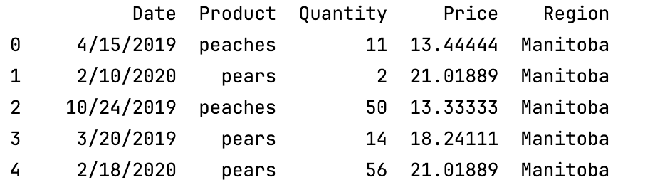

Here is the code:
import pandas as pd
import duckdb

# Show all columns.
pd.set_option('display.max_columns', None)
# Increase number of columns that display on one line.
pd.set_option('display.width', 1000)

mydf = pd.read_csv('/users/patmcgee/desktop/daydocs/data/fruit.csv')
# .df() turns it to dataframe
queryDf = duckdb.sql("SELECT * FROM mydf WHERE Region ='Manitoba'").df()
print(queryDf)

Exercise 17 (3 marks)
Write duckdb code to perform the same query as Exercise 16. Show your entire program here:
import pandas as pd
import duckdb
path = r"C:\Users\linho\Desktop\CST\term3\pred_analytics\data\retailerDB.csv"
pd.set_option('display.max_columns', None)
pd.set_option('display.width', 1000)
mydf = pd.read_csv(path)
SQL = ("SELECT vendor, (price*0.85*quantity) AS TotalRevenue FROM mydf "
"GROUP BY (vendor, price, quantity) "
"HAVING vendor IN ('Silverware Inc.', 'Waterford Corp.')")
query_df = duckdb.sql(SQL).df()
print(query_df)

