Table of Contents
Submission Instructions 1
Least Squares Regression 1
Slope and Intercept 1
Assumptions of Least Squares Regression 2
Analysis of the Variance (ANOVA) 5
Degrees of Freedom 6
Coefficient of Determination 10
Adjusted Coefficient of Determination 11
Train and Test Data 11
Target and Predictor Variables 11
Preventing Randomization During Test-Train Split 13
Checking Your Work 15

Note:
You are encouraged to work with others and you can discuss your solutions verbally as well but DO NOT SHARE COPIES of YOUR WORK ELECTONICALLY OR IN ANY OTHER FORM. Keep good karma with your career network and protect your reputation – do not plagiarize.

Submission Instructions
Please do not submit pdf files.

For this lesson only, unless otherwise requested, please submit:
- This document with your answers in it.
- The excel spreadsheet that is requested in exercises 1, 2 and 3

Least Squares Regression
Least squares regression offers a method to generate a best fit line through a scatter of data. The best fit line can then be used to make predictions about a target variable given a set of predictor variables. You do not need to prove or memorize the equations used to calculate and analyze least squares regression but it is important to understand how to use them.

Slope and Intercept
The least squares equation is described with the help of m, the slope, and b, the intercept. These values are calculated with the following equations:

Equation 1: Slope $=m= \frac{n\left(\sum{xy}\right)-\left(\sum{x}\right)*(\sum{y})}{n\left(\sum{x^{2}}\right)-{(\sum{x})}^{2}}$
Equation 2: Y intercept $=b= \frac{\sum{y}-m(\sum{x})}{n}$

Assumptions of Least Squares Regression
Proper least squares regression requires the residuals (error) and response variables to be:

- Homoscedastic
Homoscedasticity refers to an even spread whereas heteroscedasticity is a broadening spread (see Figure 1). The diagram on the left is homoscedastic since the relationship between x and y is evenly spread. The diagram on the right demonstrates heteroscedasticity since the relationship between x and y disperses outward.

Figure 1: Homoscedasticity versus. Heteroscedasticity

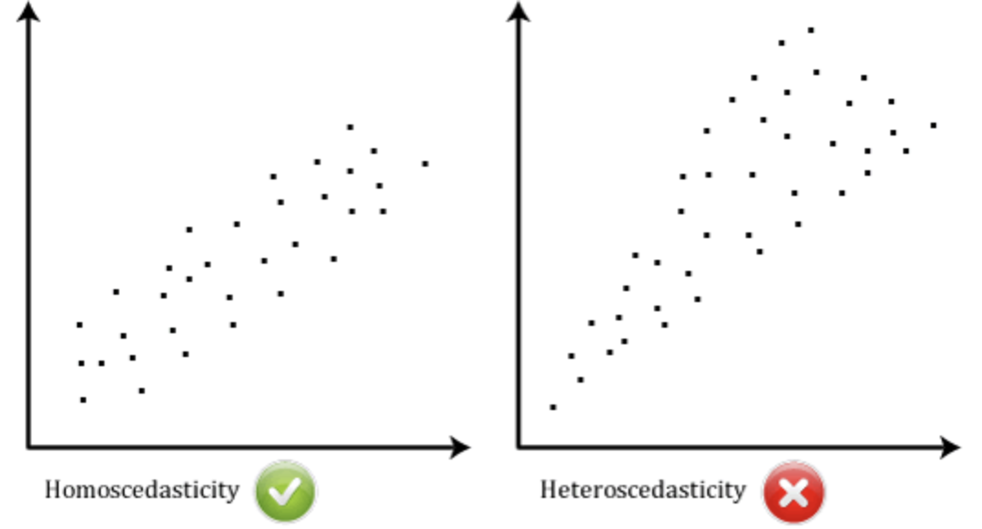

- Normally distributed
With the classic normal distribution samples are evenly spread symmetrically about the mean. The highest sample concentration is at the mean (see Figure 2). Residual errors are also distributed normally about the mean.

Figure 2: Normal spread of target variables and residual errors.
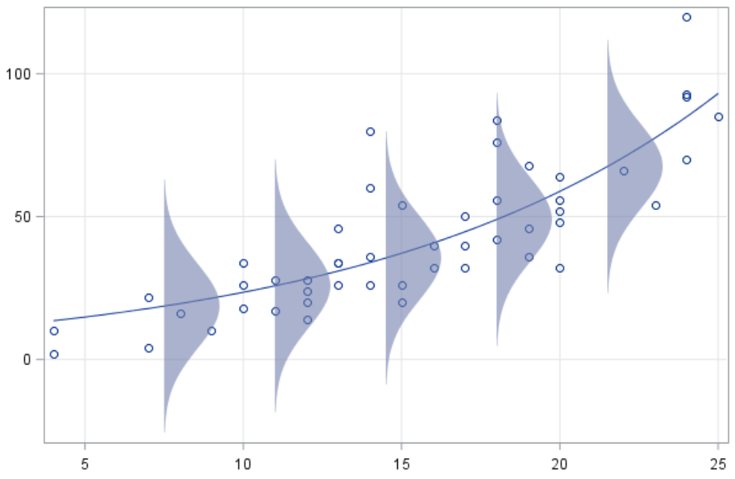

Example 1: Simple Least Squares Regression
Figure 3 shows five bacteria samples with growth (y) in grams per day (x). This example demonstrates how you can use least squares regression to generate the best fitting line equation to predict levels of bacteria growth (y) over time.

Note: Usually a much larger sample set is needed but only five samples have been included here to make it easier to explain the calculations manually.

Figure 3: Sample Data points
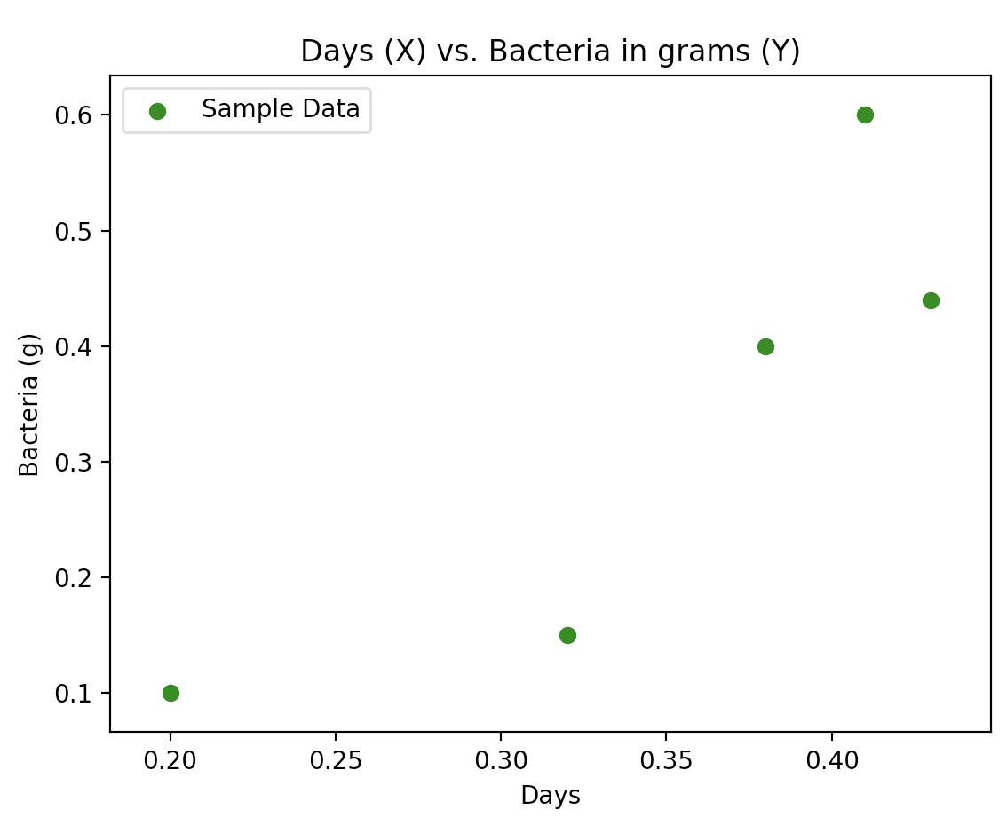 | x (days)  0.20  0.32  0.38  0.41  0.43 | y  (bacteria)  0.10  0.15  0.40  0.60  0.44
`
If we plug the values of x and y into Equation 1 we get the slope and Equation 2 gives the y-intercept when x = 0 (see Figure 4). Some other calculations have been included in Figure 4 for later.

Figure 4: Calculating the slope and intercept for x and y
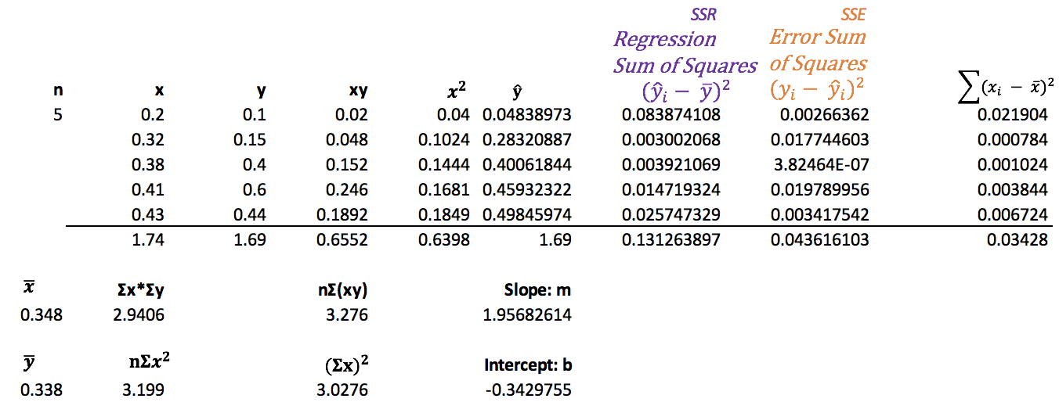
Average x $=\overline{x}=\frac{\sum{x}}{n}$ $=\frac{1.74}{5}=$0.348
Average y $=\overline{y}=\frac{\sum{y}}{n}$ $=\frac{1.69}{5}=$0.338

Now that we have calculated values for m and b we can say the equation generated is:

Predicted bacteria in grams $\hat{y}$ $=1.9568∙(x) days-0.3430$
$\hat{y}$ $=1.9568∙x-0.3430$

Explaining the equation in simpler terms, we could say bacteria appears to grow 1.96 times each day. The intercept of -0.3430 does not make as much sense since it is not possible to have a negative growth amount.

If we plug in different values for days (x) into the straight-line equation that is generated through least squares regression we can obtain predicted levels ($\hat{y}$) of bacteria (see Figure 5). The blue line is our prediction line.

Figure 5: Predicting y using the straight-line equation.
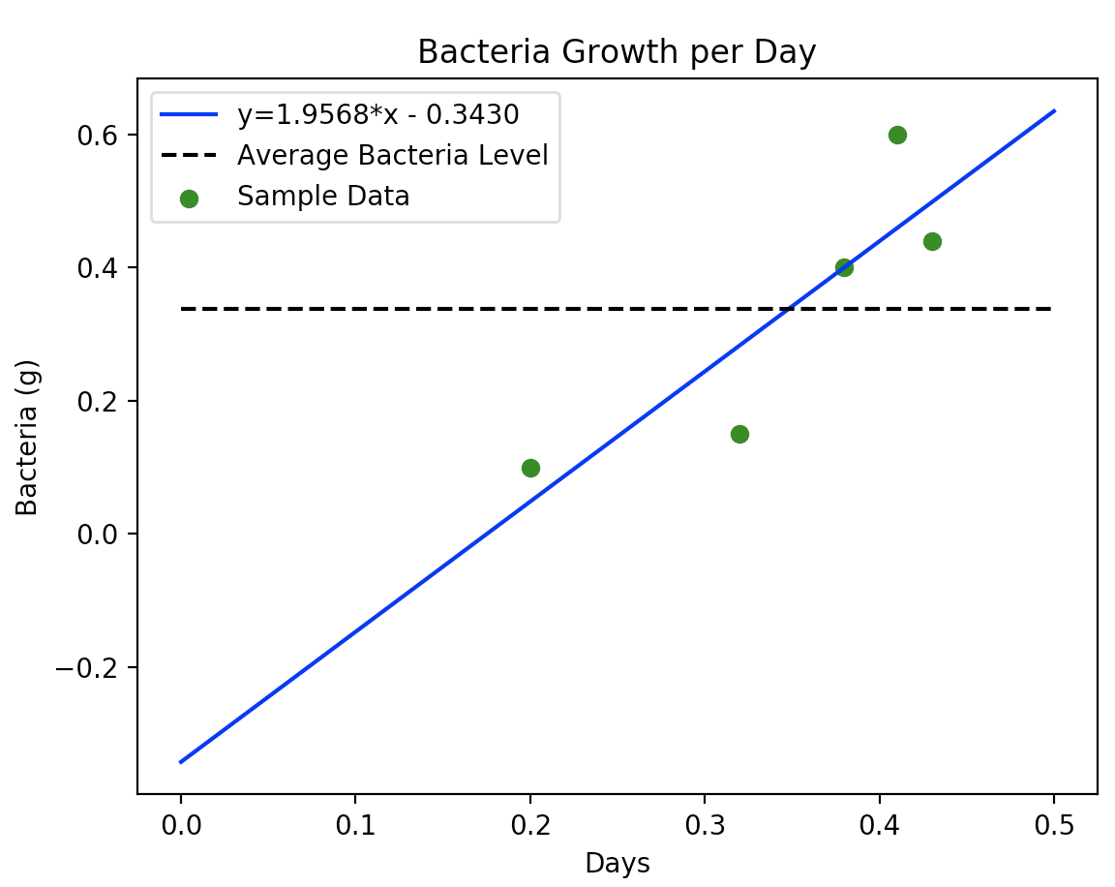 | 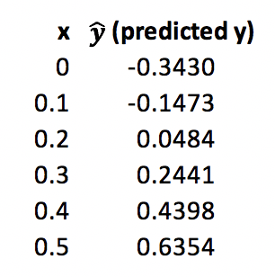
Here is the code used to draw the graph in Figure 5.
import matplotlib.pyplot as plt
# Plot scatter of actual values.
daysX = [0.2, 0.32, 0.38, 0.41, 0.43]
bacteriaY = [0.1, 0.15, 0.4, 0.6, 0.44]
plt.scatter(daysX, bacteriaY, color='green', label='Sample Data')
# Plot prediction line.
daysX2 = [0, 0.1, 0.2, 0.3, 0.4, 0.5]
bacteriaY2 = [-0.3430, -0.1473, 0.0484, 0.2441, 0.4398, 0.6354]
plt.plot(daysX2, bacteriaY2, color='blue', label='y=1.9568*x - 0.3430')
# Show average
x3 = [0, 0.5]
y3 = [0.338, 0.338]
plt.plot(x3, y3, '--', color='Black', label='Average Bacteria Level')
# Add a legend, axis labels, and title.
plt.legend()
plt.xlabel("Days")
plt.ylabel("Bacteria (g)")
plt.title('Bacteria Growth per Day')
plt.show()

Exercise 1 (15 marks)
Using Excel, set up a spreadsheet similar to Figure 4 to manually implement least squares regression to calculate the intercept and slope of a model that predicts the y value given the following data set.

﻿ x = [0.19, 0.28, 0.35, 0.37, 0.2, 0.16]
y = [0.13, 0.12, 0.35, 0.34, 0.36, 0.9]

Upload your spreadsheet with this document when you submit your answers for Lesson Week 2 (6 marks)

Show your slope here:
-1.17015
Show your intercept here:
0.668955
Show your least squares regression model here: (4 marks)
y = -1.17015x + 0.66895
Using your model make predictions for x = [0.13, 0.22, 0.33] (5 marks)
$\hat{y}=[$0.516836, 0.411522, 0.282806]

Analysis of the Variance (ANOVA)
When using different forms of regression, we can use ANOVA to *help* determine the reliability of the prediction model in terms of variance. A high variance is undesirable since predicted values are further away from actual values. Variance is often described with comparisons that are relative to these three measures:

y = actual value
$\hat{y}$= predicted value
$\overline{y}$ = mean

The total variance (SST) is composed of the variance explained by the predictive model (SSR) and the error variance (SSE). Variance is often summarized with these three equations.

Equation 3: SSR | Regression Sum of Squares: Variance explained by model. | $$\sum_{i=1}^{n}{{(\hat{y_{i}}-\overline{y})}^{2}}$$
Equation 4: SSE | Error Sum of Squares: Unexplained variance. | $$\sum_{i=1}^{n}{{(y_{i}-\hat{y_{i}})}^{2}}$$
Equation 5: SST | Total Sum of Squares: Total variance of sample. | $$\sum_{i=1}^{n}{{\left(y_{i}-\overline{y}\right)}^{2}}$$  = SSR + SSE
The total sum of squares, SST, in Figure 6 represents the variance between the actual values of the target variable and overall average in absence of a model. This total variance can then be split into SSR and SSE components. The green section in Figure 6 shows the SSR variance component which is the variance between the predicted value and the overall average. In other words, the green section represents the variance explained by the model. The red section of Figure 6 highlights the unexplained variance between the estimated and actual value. Higher amounts of green versus red are preferred.

Figure 6: Analysis of Variance for Least Squares Regression
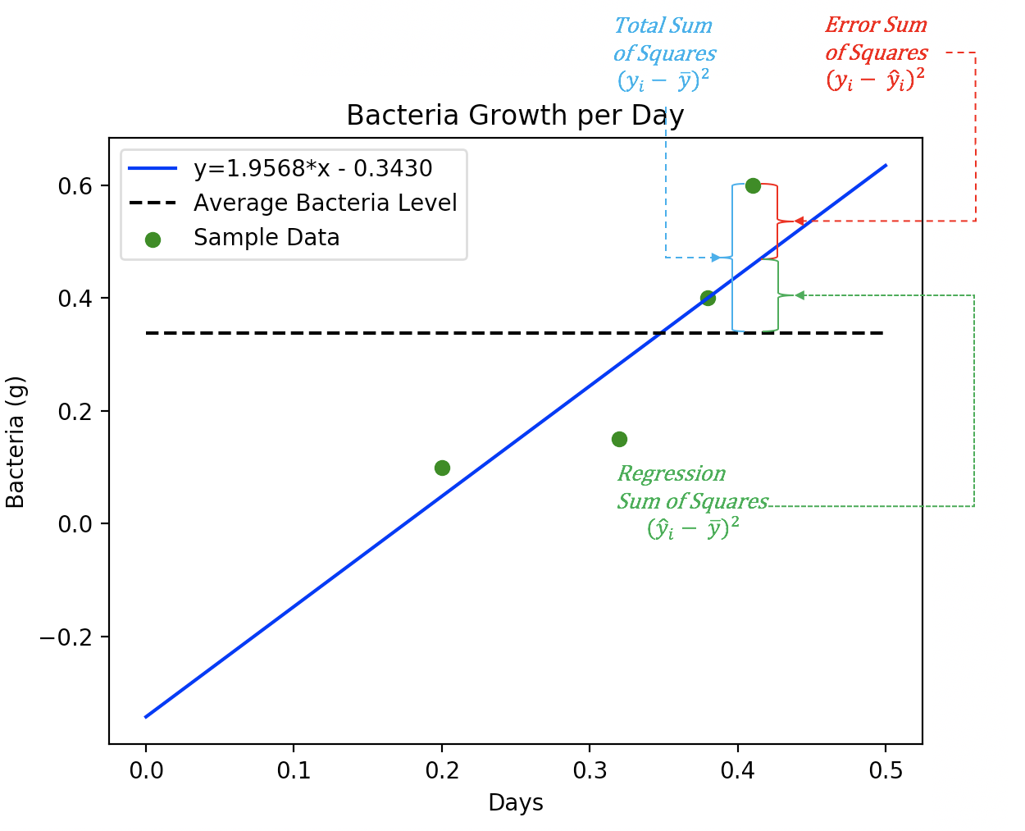

Degrees of Freedom
We use degrees of freedom to account for a reduced sample size and the number of predictor variables. Small sample sizes and higher numbers of predictor variables make the model less reliable.

Model DF: Total Number of Variables
Having too many variables can lead to overfitting which in turn leads to unreliable results. The model DF adds a penalty for each predictor variable used in the model. For Example 1 we have one predictor variable, x, so the model DF is 1.

Model DF = # of model parameters = 1
(Does not include intercept)

Error DF:
The error DF represents the variance which is not explained by the model.

Error DF = N – Model DF – 1
(Includes the intercept)

F Statistic
The F Statistic is the ratio mean square of the variance explained by the model divided by model degrees of freedom over the mean square of the error residuals divided by error DF.
Equation 6: $F=\frac{{MS}_{model}}{{MS}_{error}}$ $=\frac{\frac{SSRegression}{Model DF}}{\frac{SSE}{Error DF}}$

A higher proportion of explained variance over unexplained variance is obviously desirable so a large F statistic is preferred. Notice how the degrees of freedom can shift the placement of the F statistic.

Null Hypothesis, $H_{0}$, for Slope Coefficients
For least squares regression the F statistic is used to validate the null hypothesis, $H_{0}$ that the slope coefficients do not help to predict the target outcome. A rejection of $H_{0}$ is desired. The rejection of the null hypothesis suggests that the slope coefficients are not zero and are therefore helpful in predicting outcomes. For example, the prediction line:

y = mx + b is only useful if m $≠$ 0.

The F statistic distribution is right skewed. F values in the red-shaded $∝$region is desirable since it indicates a rejection of $H_{0}$ (see Figure 7).

Figure 7: F-distribution
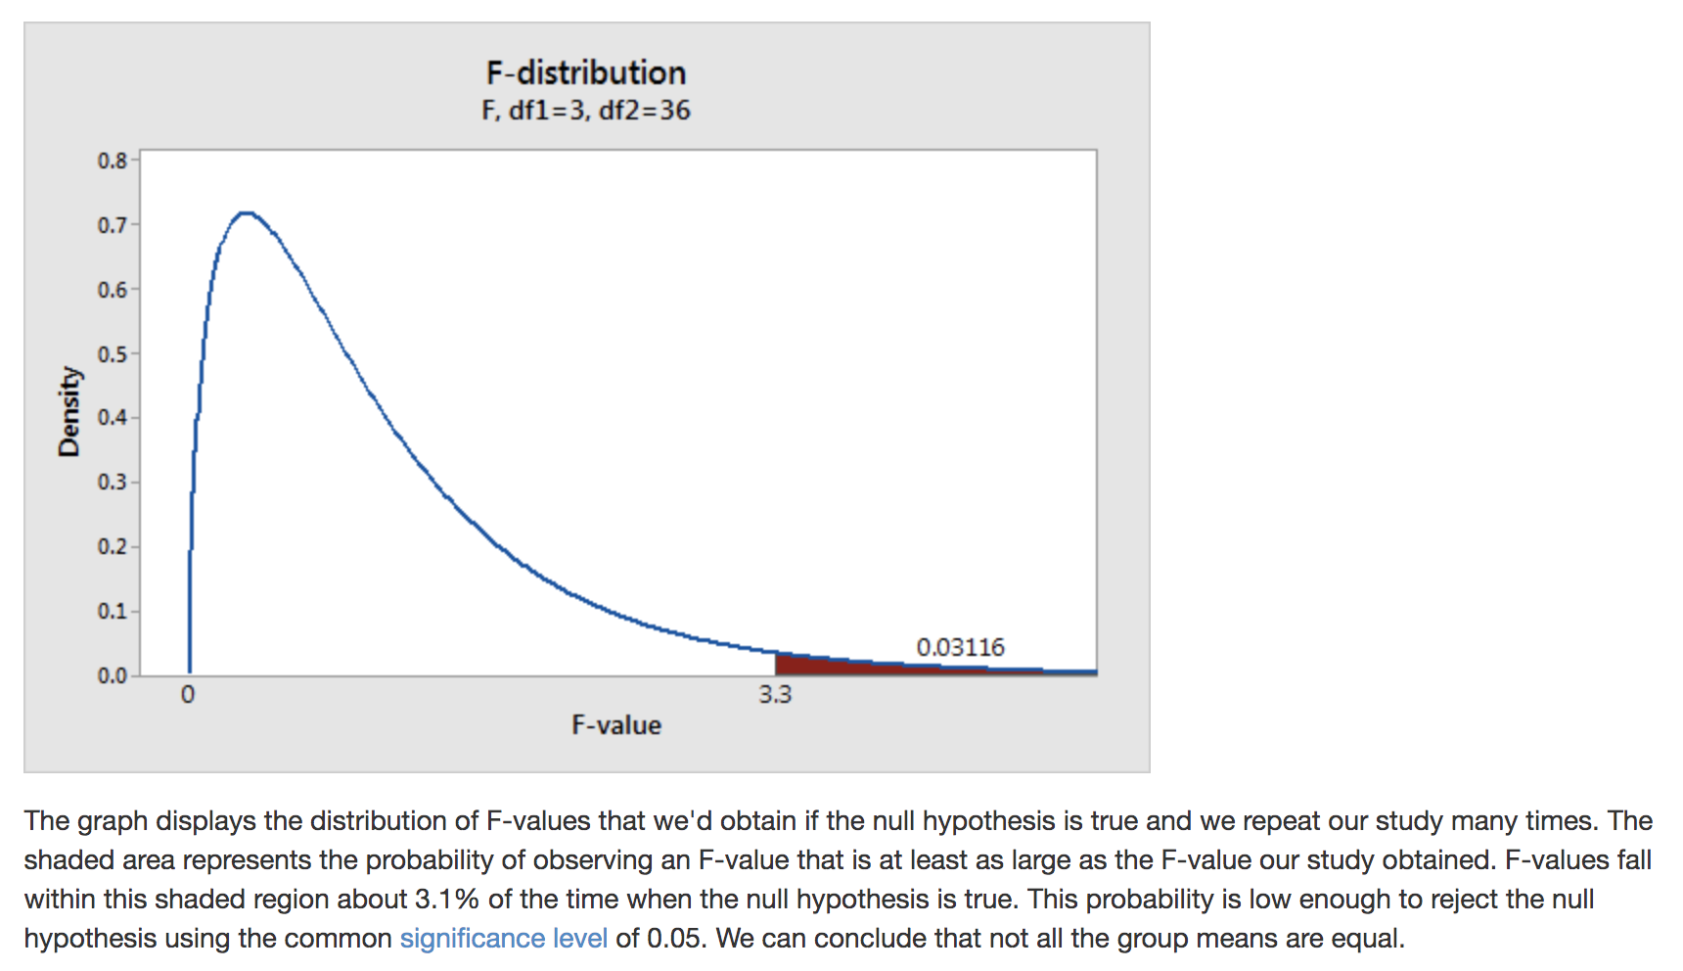

Example 2: Validating the Slope Coefficient When $α$ = 0.05
This example demonstrates how to validate the slope coefficient of our model with an $α$ region of 5% for the F-Statistic.

Null hypothesis = $H_{0}$ = slope, m, is equal to zero. (Undesirable)
Alternate hypothesis = $H_{1}$ = slope, m, is not equal to zero. (Desirable)

To calculate the F-statistic for Example 1, we need calculations for SSR and SSE (see Figure 8) as well as the degrees of freedom components that were calculated earlier.

Figure 8: Manually Calculating SSR and SSE
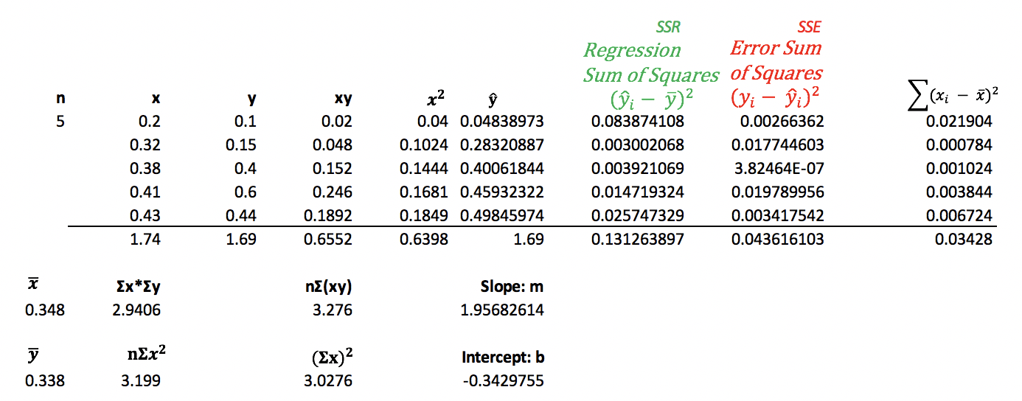

$F=\frac{{MS}_{model}}{{MS}_{error}}$ $=\frac{\frac{SSRegression}{Model DF}}{\frac{SSE}{Error DF}}$ $=\frac{\frac{0.13126}{1}}{\frac{0.043616103}{3}}$ $=\frac{\frac{0.13126}{1}}{\frac{0.043616103}{3}}=9.0286$

We can then check the F statistic tables online for the confidence interval to determine if there is a chance that $H_{0}$ is accepted. When looking up the F statistic, the error df is used for the row of the F statistic table and the model df is used for the column of the F Statistic table.

The F Statistic table lookup for $α=0.05$ with the model df = 1 and error df = 3 suggests that F should be 10.128. Since our calculated value of F is 9.0286 we cannot reject the null hypothesis. It appears that there is more than a 5% chance that our model will not enable better predictions than the average.

Figure 9: F Statistic $∝=0.05, df error=3, df model=1$ vs. Model F
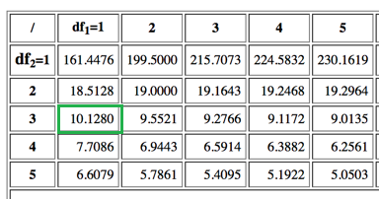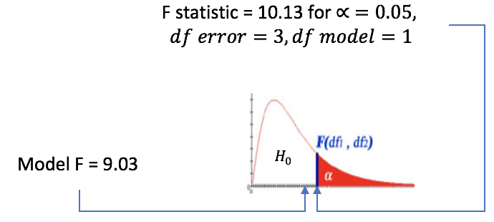

Conclusion:
We cannot reject the null hypothesis when $α$ = 0.05. Therefore, we cannot prove that m is not zero. In other words, we have failed to confidently establish a relationship between the x and y within this range.

Example 3: Validating the Slope Coefficient When $α$ = 0.10
Continuing on from Example 2, we will test the slope coefficient where $α$ = 10%.

Null hypothesis = $H_{0}$ = slope, m, is equal to zero. (Undesirable)
Alternate hypothesis = $H_{1}$ = slope, m, is not equal to zero. (Desirable)

Figure 10: F Statistic $∝=0.10, df error=3, df model=1$ vs. Model F
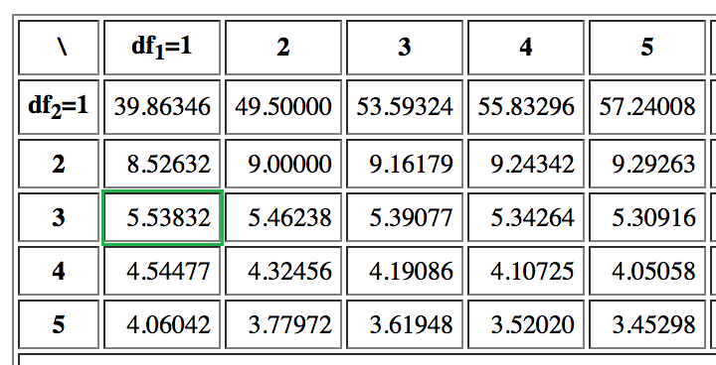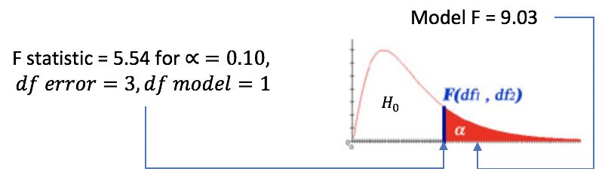
(Not drawn to scale)
Conclusion:

In F Statistic table lookup for $α=0.10$ when the model df = 1 and error df = 3, the F statistic is 5.53832. Our model generates a value for F of 9.0286 so the model’s F statistic is well into the $α$ region. We can therefore reject the null hypothesis since our F value is statistically significant. For a one-tailed confidence interval of 10% it appears that the slope coefficients offer a better prediction than the average target variable.

Exercise 2 (5 marks)
Using your Excel spreadsheet from Exercise 1, calculate the regression sum of squares value. The output should be presented in a manner that is similar to the output that is presented in Figure 8. Show a screenshot of your regression sum of squares value here:
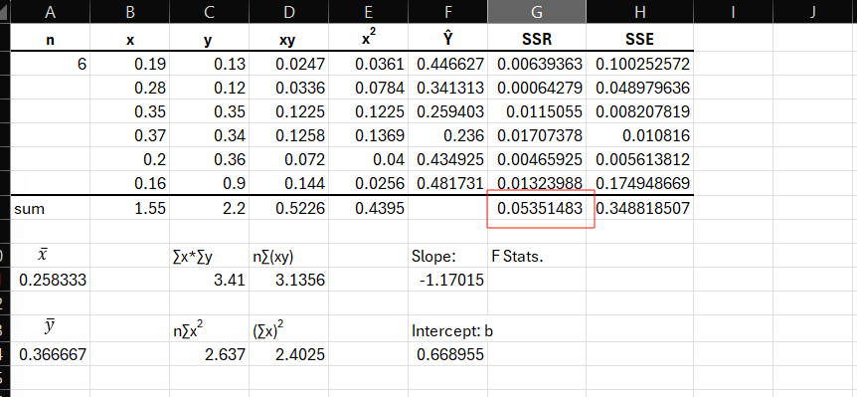
Exercise 3 (5 marks)
Using your Excel spreadsheet from Exercise 1, calculate the error sum of squares value. The output should be presented in a manner that is similar to the output that is presented in Figure 8. Show a screenshot of your error sum of squares value here:
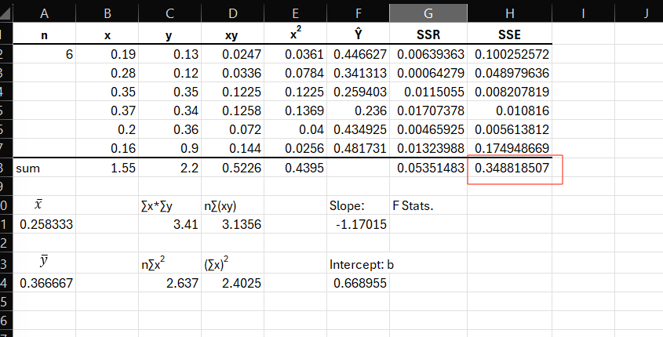

Exercise 4 (1 mark)
What is the model degrees of freedom value for Exercise 1?
Model DF = 1 since it has one variable, x

Exercise 5 (1 mark)
What is the error degrees of freedom value for Exercise 1?
Error DF = N – Model DF – 1 = 6 – 1 – 1 = 4

Exercise 6 (3 marks)
Show the calculations for the F-statistic for Exercise 1.
$F=\frac{{MS}_{model}}{{MS}_{error}}$ $=\frac{\frac{SSRegression}{Model DF}}{\frac{SSE}{Error DF}}$ = $\frac{\frac{0.0535}{1}}{\frac{0.3488}{4}}=0.61366957$

Exercise 7 (2 marks)
Write statements for the null hypothesis and alternate hypothesis for the slope coefficient of your model here:
Null Hypothesis = H₀ = slope, m, is equal to zero.
Alternate Hypothesis = H₁ = slope, m is not equal to zero.

Exercise 8 (1 mark)
What is the F-value given the error and model degrees of freedom for Exercise 1 where $α$ = 0.05?
7.7086

Exercise 9 (1 mark)
Based on the outcome in Exercise 8 do you conclude by rejecting or failing to reject the null hypothesis? Please state your conclusion clearly.
Since our calculated F statistics value is 0.6137, which is substantially smaller than 7.70865 when $α=0.05,$therefore we cannot reject the null hypothesis. It appears that there is more than a 5% chance that our model will not enable better predictions than the average.

Exercise 10 (2 marks)
What is the F-value given the error and model degrees of freedom for Exercise 1 where $α$ = 0.1? What does this result imply?
4.54477. This result indicates the same conclusion as above.

Exercise 11 (2 marks)
Based on the outcome in Exercise 10 do you conclude by rejecting or failing to reject the null hypothesis? Please state your conclusion clearly.
Since our calculated F statistics value is 0.6137, which is still smaller than 4.5447 when $α=0.1,$therefore we cannot reject the null hypothesis. For a one-tail confidence interval of 10 %, it appears that the slope coefficient cannot offer a prediction better than the average target variable by a large margin.

Coefficient of Determination
The coefficient of determination, $R^{2}$, is the proportion of variability accounted for by the model. Ideally, we want this number as high as possible (close to 1). A value of 1 suggests perfect positive or negative correlation. However, we need to be careful about overfitting the model to the sample (more on this soon).

Equation 7: Coefficient of Determination = $R^{2}$= $\frac{SSR}{SST}=1- \frac{SSE}{SST}$
For Example 1, $R^{2}$=$\frac{SSR}{SST}=\frac{SSR}{SSR+SSE}=\frac{0.13126}{0.13126+0.043616103}=0.75056$

Exercise 12 (4 marks)
Manually show the calculations for the coefficient of determination for Exercise 1.
R² = $\frac{SSR}{SST}= \frac{0.053515}{0.314818507+0.053515}=0.133011166$

Is the correlation relatively high or low? Explain.
This coefficient of determination is low because it is far from 1.

Adjusted Coefficient of Determination
Too many predictor variables can lead to a model that is overfit (heavily biased) based on the sample. An overfitted model may perform well with the current data but it will on average perform more poorly with a different data set.

The adjusted coefficient of determination, $R_{adj}^{2}$ , is often used to describe the variability of a model instead of $R^{2}$ for because $R_{adj}^{2}$ is lowered when more prediction variables are included in the model. In other words, $R_{adj}^{2}$ helps to reduce bias by adding a penalty for an increased number of prediction variables.

To calculate the adjusted coefficient of determination we use the following variables:
$R^{2}$ = The coefficient of determination.
p = Number of predictors.
N = Sample size.

Equation 8: $R_{adj}^{2}$ = 1 - $\frac{(1- R^{2})(N-1)}{N-p-1}$
For Example 1,
$R_{adj}^{2}$ = 1 - $\frac{(1- R^{2})(N-1)}{N-p-1}$ = 1 - $\frac{(1- 0.75056)(5-1)}{5-1-1}$ = 0.6674

Exercise 13 (2 marks)
Manually show the calculations for $R_{adj}^{2}$ based on your result for Exercise 12.
$R_{adj}^{2}$ = 1 - $\frac{(1- R^{2})(N-1)}{N-p-1}$ = 1 - $\frac{(1- 0.133011166)(6-1)}{6-1-1}$ = -0.08373604

Train and Test Data
Predictive models are developed with existing data. The model development step is called training. Part of the validation process though involves checking the model’s predictions with known results. To help avoid adding model bias from the current data set (overfitting), a portion of existing data is kept out of the training data set so the model’s performance can be evaluated with it later. This reserve of data for model validation is called test data. Several techniques exist for allocating test and training data. We will use a simple split technique to get started but we will examine other splitting algorithms later.

Target and Predictor Variables
Predictive models are developed to predict outcomes. The variable being predicted is called a target variable. The target variable is represented with the name y. Variables that are used to estimate the target variable are called predictor variables and they are often represented with the name x.

Example 4: Generating Test and Training Data
This example will demonstrate how to randomly split the data set into 60% training data and 40% test data. Say we had the following data set.

Figure 11: Scatter Plot of Five Separate Bacteria Samples
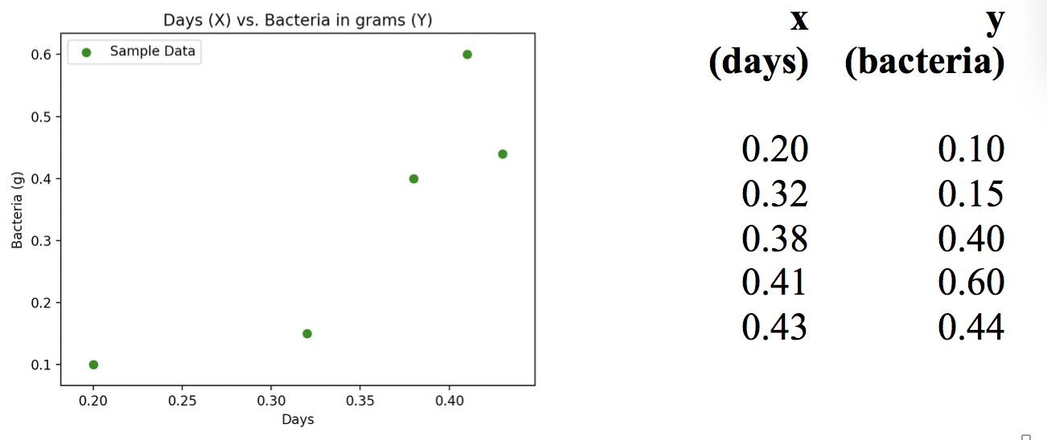
To randomly split the data into 60% training data and 40% test data we can use the following code. The existing data is stored in the variables that are highlighted in yellow. The variables that are generated and populated with data after the train_test_split() function runs are highlighted in green.
import pandas as pd
from sklearn.model_selection import train_test_split

# Create DataFrame.
dataSet = {'days': [0.2, 0.32, 0.38, 0.41, 0.43],
'growth': [0.1, 0.15, 0.4, 0.6, 0.44] }
df = pd.DataFrame(dataSet, columns= ['days', 'growth'])

# Store x and y values.
X = df['days']
target = df['growth']

# Create training set with 60% of data and test set with 40% of data.
X_train, X_test, y_train, y_test = train_test_split(
X, target, train_size = 0.6
)
The output after the split shows how the data from the original sample set is divided into test and training data sets.
X_train | y_train | X_test | y_test
﻿﻿0.38  0.43  0.32 | ﻿ 0.40  0.44  0.15 | ﻿﻿ 0.20  0.41 | ﻿ 0.1  0.6
Exercise 14 (2 marks)
Run the code in Example 4 again but this time use a 80% train / 20% test split. Print out the values for X_train, X_test, y_train and y_test. Show a screenshot of your output here:
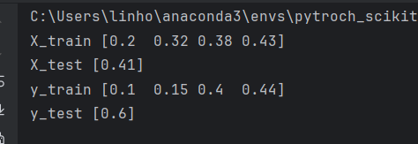
How does your output in this exercise differ when compared to the output from Example 4?
There are more values for train sets, and fewer values for test sets.

Preventing Randomization During Test-Train Split
Sometimes when documenting a model after it is developed you will want to ensure the test and train data is consistent during multiple runs. You can prevent randomization with by setting the random_state parameter to zero in the train_test_split() function:

X_train, X_test, y_train, y_test = train_test_split(X, y, test_size=0.2,
random_state=0)

Example 5: Simple Linear Regression
Now that we have discussed training and test data in Example 4, this current example shows how the train and test can be used to create a model and to validate it. For this case, a simple best fit line using least squares regression will be generated to fit through the scattering of samples that are shown in Figure 11.

Calculating the Root Mean Square Error (RMSE) – Average Deviation from the Actual Value
While also demonstrating test and train data, we are going to also calculate the root mean square error RMSE which describes the average deviation between the actual and predicted target value. Root MSE is $σ$ of residuals.

Equation 9: Root Mean Square Error
The formula for RMSE is:

$\sqrt{\frac{{\sum{(y actual - y predicted)}}^{2}}{number of samples}}$ = $\sqrt{\frac{{\sum{(y- \hat{y})}}^{2}}{n}}$

Do not be discouraged by the math. We really are just focusing on how the train and test data are used. Also, the RMSE measure of variance to help understand the effectiveness of our model. A lower RMSE is preferred because it means our prediction is closer to the actual result.

Example 6: Automating Regression with Test and Train Data
This code sample introduces automated regression with Python. This example is quite incomplete but we will expand on this next day.
import pandas as pd
from sklearn.model_selection import train_test_split
from statsmodels.formula.api import ols
from sklearn import metrics
import math

def performSimpleRegression():
# Initialize collection of X & Y pairs like those used in example 5.
data = [[0.2,0.1],[0.32,0.15],[0.38,0.4],[0.41,0.6],[0.43,0.44]]

# Create data frame.
dfSample = pd.DataFrame(data, columns = ['X', 'target'])

# Create training set with 60% of data and test set with 40% of data.
X_train, X_test, y_train, y_test = train_test_split(
dfSample['X'], dfSample['target'], train_size = 0.6
)

# Create DataFrame with test data.
dataTrain = {"X":X_train, "target":y_train}
dfTrain = pd.DataFrame(dataTrain, columns = ['X', 'target'])

# Generate model to predict target using X.
model = ols('target ~ X', data=dfTrain).fit()
y_prediction = model.predict(X_test)

# Present X_test, y_test, y_predict and error sum of squares.
data = {"X_test":X_test, "y_test":y_test, "y_prediction":y_prediction}
dfResult = pd.DataFrame(data, columns = ['X_test', 'y_test', 'y_prediction'])
dfResult['y_test - y_pred'] =(dfResult['y_test']-dfResult['y_prediction'])
dfResult['(y_test - y_pred)^2']=(dfResult['y_test']-dfResult['y_prediction'])**2

# Present X_test, y_test, y_predict and error sum of squares.
print(dfResult)

# Manually calculate the deviation between actual and predicted values.
rmse = math.sqrt(dfResult['(y_test - y_pred)^2'].sum()/len(dfResult))
print("RMSE is average deviation between actual and predicted values: "
+ str(rmse))

# Show faster way to calculate deviation between actual and predicted values.
rmse2 = math.sqrt(metrics.mean_squared_error(y_test, y_prediction))
print("The automated root mean square error calculation is: " + str(rmse2))

performSimpleRegression()
The output shows known values from our test set beside the predicted y value. Results from the root mean square error calculation are also shown. A lower deviation between the actual and predicted value is desirable.

When we inspect our output, we can see the first predicted y value is close to the actual y_test value. However, the second predicted y value is relatively far away from the actual y_test value. This deviation may be a problem. We can look at the RMSE to understand the overall average deviation from the actual and predicted values.
﻿ X_test y_test y_prediction y_test - y_pred (y_test - y_pred)^2
2 0.38 0.40 0.441602 -0.041602 0.001731
1 0.32 0.15 0.330719 -0.180719 0.032659

RMSE is the deviation between actual and predicted values: 0.1311295925504966
The automated root mean square error calculation is: 0.1311295925504966

Exercise 15 (2 marks)
Run the linear regression again but adjust the code so it uses an 80% train - 20% test split. Show the output here:
X_test y_test y_pred y_test - y_pred (y_test - y_pred)^2
0 0.2 0.1 -0.220507 0.320507 0.102725
RMSE is average deviation between actual and predicted values: 0.3205072463768118
The automated root mean square error calculation: 0.3205072463768118

Does the RMSE go up or down? Explain why you think it changed the way that it did.
For my run of dataset split, the RMSE went down, possibly because there were more data for training, but this is really insignificant to make concrete conclusion here.

Checking Your Work
You can actually check to verify that your manual calculations match the model summary that is generated by Python
Example 7: Checking your manual calculations with Python
The model summary that displays when running this code will match the metrics which were manually calculated for the data set that was presented in Example 1. It is really satisfying to see the numbers match up. Note that no split is used for this example since all samples were used for the calculations.
import pandas as pd
from statsmodels.formula.api import ols

def performSimpleRegression():
# Initialize collection of X & Y pairs like those used in example 5.
data = [[0.2, 0.1], [0.32, 0.15], [0.38, 0.4], [0.41, 0.6], [0.43, 0.44]]

# Create data frame.
dfSample = pd.DataFrame(data, columns=['X', 'target'])

# Build model with all samples.
model = ols('target ~ X', data=dfSample).fit()

# Show model summary.
print(model.summary())

print("\nMake prediction")
xsample = dfSample['X']
print("X=" + str(xsample))
predictions = model.predict(dfSample['X'])
print("yhats=" + str(predictions))

performSimpleRegression()

Exercise 16 (3 marks)
If you are considering a career as a software developer, I want to emphasize how important it is to be comfortable using the IDE debugger and to be able to step through your code. To answer this question, take a screenshot of your environment while halted at the line of code shown below and while the data frame is displayed. Also be sure to add your first name to the screenshot to get the mark.
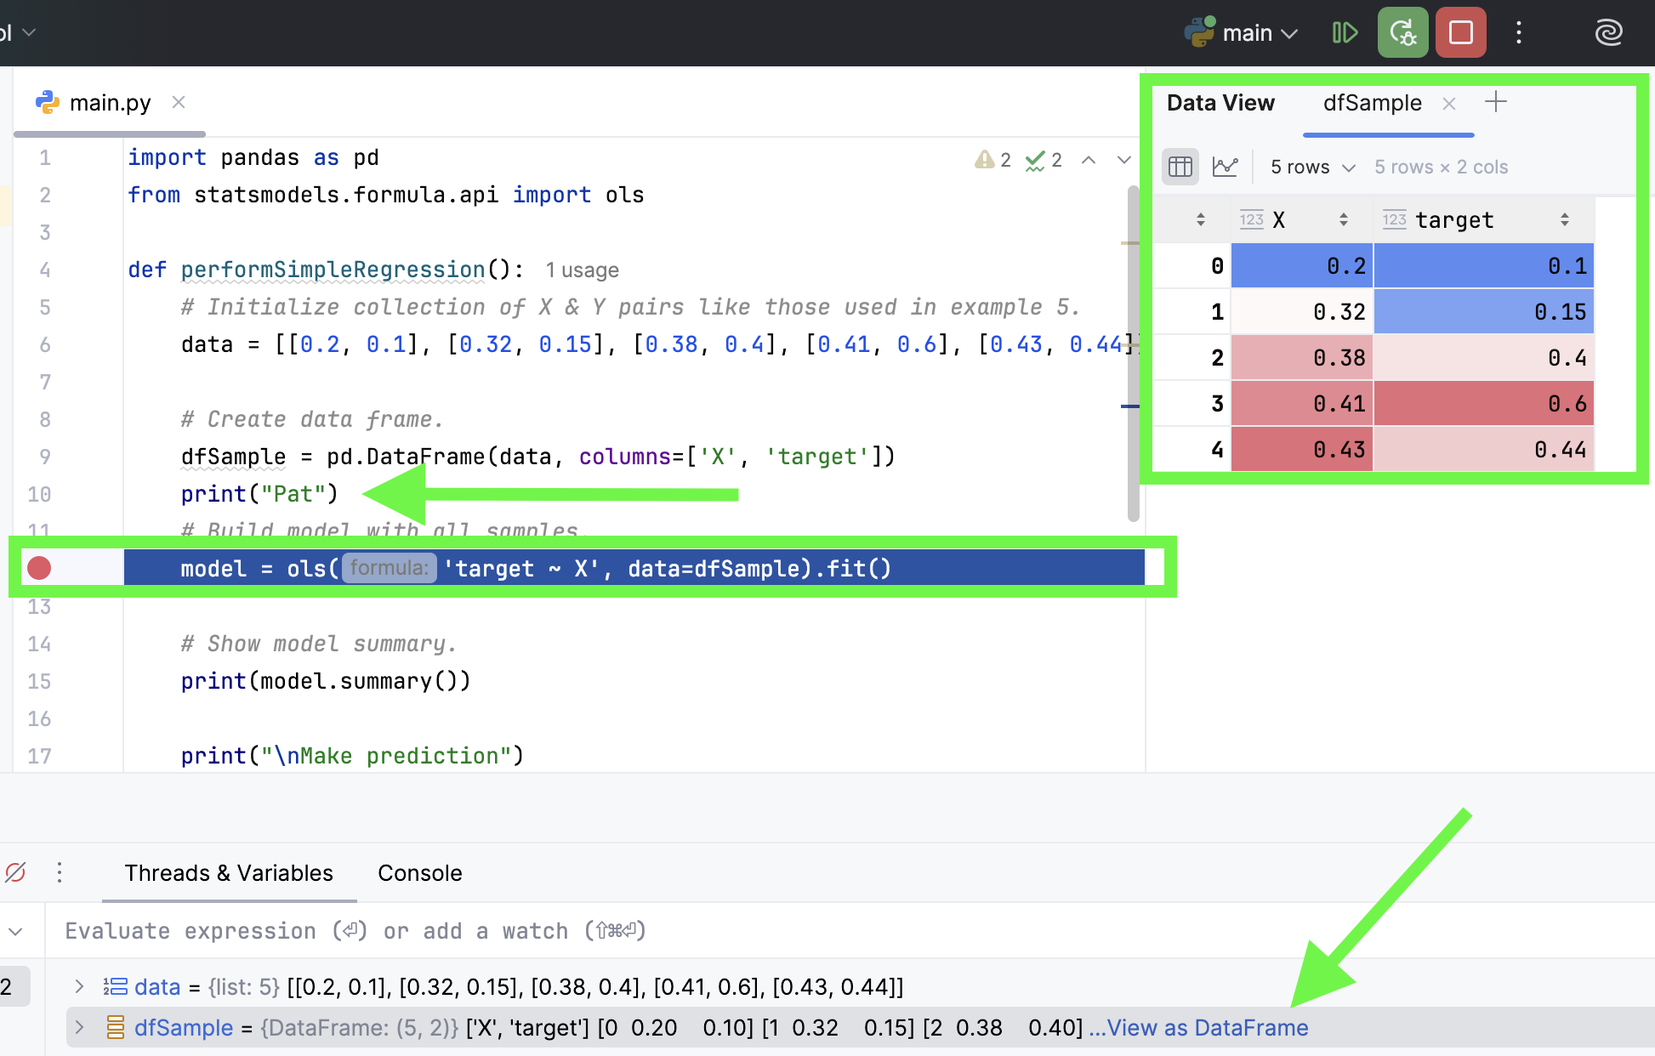
The screenshot should show the IDE while halted with the data frame visible in the debugger and with your name present like in the screenshot above. Show your screenshot here:
