Table of Contents
Other Regression Statistics in the Model Output 1
Conditional Number (Collinearity) 2
Omnibus Test (Normality Goodness of Fit) 2
Handling Missing Data 2
Techniques for Imputing During Linear Regression 3
Imputing by Mean, Median or Mode 3
Regression imputation 3
Nearest neighbors imputation 3
Imputation Case Study 3
Dummy Variables for Categorical and Ordinal Variables 6
Creating Binary Dummy Variables 6
get_dummies() 7
Binning Categories 9
Appendix: carPrices.py 11

Other Regression Statistics in the Model Output
When developing OLS models, you will have noticed some other statistics at the end of the OLS regression model output (refer to Table 1).

Table 1: Additional Model Output Statistics
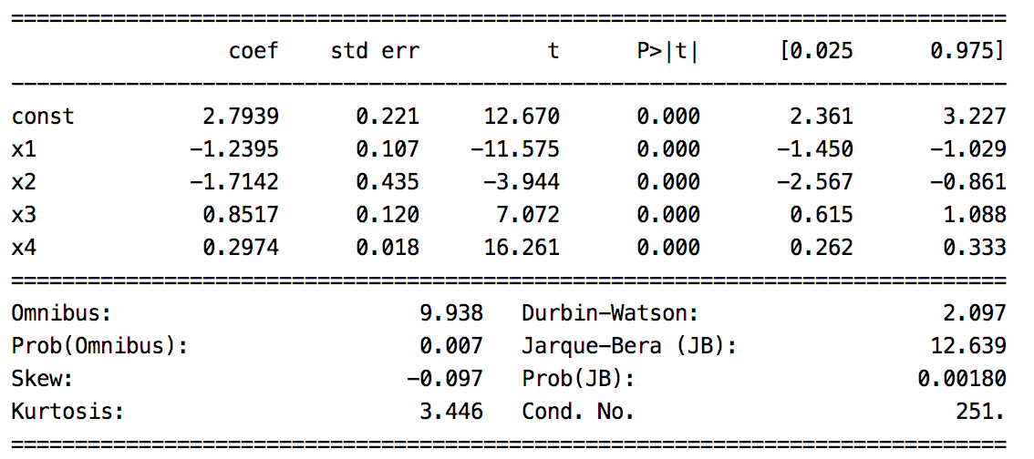
I will provide a brief summary of these statistics in this section.

Durbin Watson Test (Error residual independence)
The Durbin Watson test indicates whether or not the error residuals are independent of each other. Ideally the model has accounted for as much explainable variance as possible so the residual errors are independent of each other. Table 2 explains how to interpret the different Durbin-Watson ranges. A Durbin-Watson value around 2 is desirable.

Table 2: Ranges for Durbin-Watson
Range | Interpretation
0 to 2 | A positive correlation exists among residuals.
Around 2  (Around 2 is ideal) | Error residuals are independent (which is preferred).
2 to 4 | A negative autocorrelation

Jarque-Bera (Model normality)
The Jarque–Bera test is a goodness-of-fit test of whether a model has the skewness and kurtosis matching a normal distribution. The null hypothesis, $H_{0}$, suggests that the distribution is normal where the Kurtosis, or height, is approximately 3 and skewness is 0. When the p-value > 0.05 accept the null hypothesis. With samples below 2000, JB is prone to rejecting the null hypothesis. For the case presented in Table 1, normality is rejected.

Conditional Number (Collinearity)
The conditional number measures likelihood for collinearity or unwanted interdependence between predictor variables. Ideally predictor variables are independent. High interdependence means higher variance in results from our model.

Linear regression models are prone to higher amounts of collinearity. If the models have high collinearity this should be documented and explained to a subject matter expert who is familiar with the model variables and the goals of the model. Sometimes high collinearity is acceptable. For example, SAT and LSAT scores on college entrance exams are highly correlated. Both indicate that the applicant is prepared for a rigorous academic program. Collinearity, could be high for these predictor variables yet we may still want both variables in the model.

Other times, high collinearity may be unacceptable. For example, a stock portfolio may rely on a complex relationship between sectors. A portfolio model may be incorrectly constructed under the assumption that oil and housing prices rise together yet an unexpected change in one of these sectors could have a detrimental effect on the prediction.

Omnibus Test (Normality Goodness of Fit)
The Omnibus tests examines the model for goodness of fit with a normal distribution.

$H_{0}:$It is normally distributed.

Since the p-value is small in Table 1 we would reject the null hypothesis.

Handling Missing Data
Often, when you prepare your data for modeling you will need to handle missing values because the algorithms require numbers. You can handle missing values in many ways and none of them are ideal.

- You can remove the outlying rows but this practice is almost never recommended. Sometimes the data is missing for a reason. Removing items can produce a bias in the model. A case where removing data may make sense could be when only 10 or 20% of the attributes are present for a particular column of a data set.

- You can impute data for missing values. Imputing may not necessarily improve the model either and this practice can introduce bias to your model.

In spite of this challenge, keeping the data and imputing missing values is most common.

Techniques for Imputing During Linear Regression
This section suggests ways that you may impute content. You may create other methods to impute values as well or you may build a method for imputing that uses a hybrid of techniques.
For now, you may keep your imputing methods simple but they could become very advanced if needed.

Often imputing techniques do not offer much lift in the regression results. On the other hand, I have occasionally experienced significant performance gains through imputing. In any case, the topic is a necessary one and it can make a positive difference when done properly.

Imputing by Mean, Median or Mode
For linear regression algorithms you can impute missing values by providing the sample mean, median or mode. This technique can be implemented quickly but it also reduces the model variance. Be wary that bias and inaccuracy may result.

Regression imputation
Missing values can be predicted with simple OLS models based on other variables. This preserves relationships among variables in the imputation model. This technique can become complex if predictor variables are also missing data.

Nearest neighbors imputation
Nearest neighbours imputation involves selecting the missing value from one or more samples which have similar values for other variables.

Imputation Case Study
When inspecting the babysamp-98.txt file we can see several missing values exist.
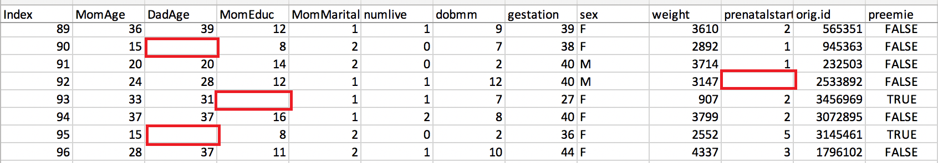
Sometimes opening the file and finding all columns with missing values is not so simple so you can use the describe() command to generate a numerical summary of non-null counts.

print(df.describe()) # View counts that highlight missing values.

When inspecting descriptive statistics for numeric data in the set we can see that DadAge, MomEduc and prenatalstart have missing values (see Table 3) since their row counts are lower than 200.

Table 3: Using describe() to find missing values
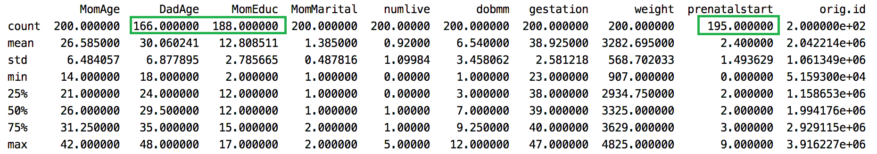

Example 1: Imputing with Mean, Median and Mode
Sometimes values are missing for a reason. In this case the Father’s age is missing and the Mother’s education level is missing. These values could be missing perhaps because the Father is absent or the Mother is not willing to report her education level. Or the person collecting the data may have recorded the data differently than others who collect or interpret data. We can speculate but the fact that data is missing could be relevant to our model.

This example demonstrates how to not only create columns with imputed values, another column is created to indicate if the value was imputed. In the end, for every missing value two other columns are created. Notice how m_ column indicates if the value in the imp_ column is imputed or not (refer to Table 4). Also note that the original column is retained.

Table 4: Imputed Values for DadAge
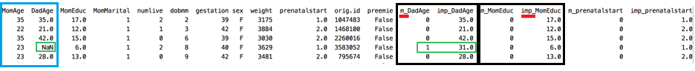

In the end, you can use either m_ or imp_ columns in your regression – or both. For this case the new predictors do not offer useful performance gain but the technique can sometimes be extremely useful. Here is the code to impute the values and perform the regression.
import pandas as pd
import numpy as np
from sklearn.model_selection import train_test_split
import statsmodels.api as sm
from sklearn import metrics

# Import data into a DataFrame.
path = "/Users/pm/Desktop/DayDocs/PythonForDataAnalytics/workingData/babysamp-98.txt"
df = pd.read_table(path, skiprows=1,
delim_whitespace=True,
names=('MomAge', 'DadAge', 'MomEduc', 'MomMarital', 'numlive',
"dobmm", 'gestation', 'sex', 'weight', 'prenatalstart',
'orig.id', 'preemie'))
# Show all columns.
pd.set_option('display.max_columns', None)
pd.set_option('display.width', 1000)
print(df.head()) # View a snapshot of the data.
print(df.describe()) # View stats including counts which highlight missing values.

def convertNAcellsToNum(colName, df, measureType):
# Create two new column names based on original column name.
indicatorColName = 'm_' + colName # Tracks whether imputed.
imputedColName = 'imp_' + colName # Stores original & imputed data.

# Get mean or median depending on preference.
imputedValue = 0
if(measureType=="median"):
imputedValue = df[colName].median()
elif(measureType=="mode"):
imputedValue = float(df[colName].mode())
else:
imputedValue = df[colName].mean()

# Populate new columns with data.
imputedColumn = []
indictorColumn = []
for i in range(len(df)):
isImputed = False

# mi_OriginalName column stores imputed & original data.
if(np.isnan(df.loc[i][colName])):
isImputed = True
imputedColumn.append(imputedValue)
else:
imputedColumn.append(df.loc[i][colName])

# mi_OriginalName column tracks if is imputed (1) or not (0).
if(isImputed):
indictorColumn.append(1)
else:
indictorColumn.append(0)

# Append new columns to dataframe but always keep original column.
df[indicatorColName] = indictorColumn
df[imputedColName] = imputedColumn
return df

df = convertNAcellsToNum('DadAge', df, "mode")
df = convertNAcellsToNum('MomEduc', df, "mean")
df = convertNAcellsToNum('prenatalstart', df, "median")
print(df.head(10))

# You can include both the indicator 'm' and imputed 'imp' columns in your model.
# Sometimes both columns boost regression performance and sometimes they do not.
X = df[[ 'gestation', 'm_DadAge', 'imp_DadAge', 'm_prenatalstart', 'imp_prenatalstart',
'm_MomEduc', 'imp_MomEduc']].values

# Adding an intercept *** This is requried ***. Don't forget this step.
X = sm.add_constant(X)
y = df['weight'].values
X_train, X_test, y_train, y_test = train_test_split(X, y, test_size=0.2, random_state=0)

# Build and evaluate model.
model = sm.OLS(y_train, X_train).fit()
predictions = model.predict(X_test) # make the predictions by the model
print(model.summary())
print('Root Mean Squared Error:', np.sqrt(metrics.mean_squared_error(y_test, predictions)))
The output shows the m_ and imp_ columns for DadAge as shown in Table 4.

Dummy Variables for Categorical and Ordinal Variables
Regression analysis treats all independent (X) variables in the analysis as numerical. Numerical variables are interval or ratio scale variables whose values are directly comparable, e.g. ‘10 is twice as much as 5’, or ‘3 minus 1 equals 2’. Often, however, you might want to include an attribute or nominal scale variable such as ‘Product Brand’ or ‘Type of Defect’ in your study. Say you have three types of defects, numbered ‘1’, ‘2’ and ‘3’. In this case, ‘3 minus 1’ doesn’t mean anything. The numbers here are used to indicate or identify the levels of ‘Defect Type’ and do not have intrinsic meaning of their own. Dummy variables are created in this situation to ‘trick’ the regression algorithm into correctly analyzing attribute variables. The dummy variables act like ‘switches’ that turn various parameters on and off in an equation.

Creating Binary Dummy Variables
Example 2: Creating Binary Dummy Variables
For this example, we are creating binary dummy columns which have either 0 or 1 as values. Notice that the columns begin with m_ + the original name. The sex column contains either M or F but we need it to be 0 or 1 respectively. The preemie column contains False or True but again our regression algorithm requires 0 or 1 respectively (see Table 5).

Table 5: Imputed Binary Values Are Usually Always Either 0 or 1
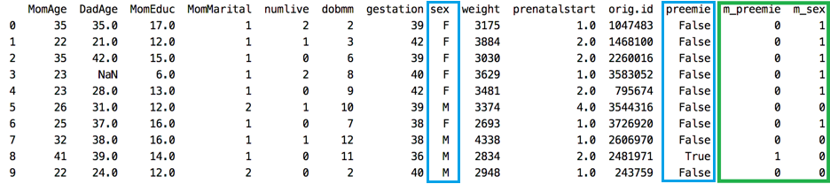
Here is the code used to generate the output in Table 5:
import pandas as pd
import numpy as np
from sklearn.model_selection import train_test_split
import statsmodels.api as sm
from sklearn import metrics

# Import data into a DataFrame.
path = "/Users/pm/Desktop/DayDocs/PythonForDataAnalytics/workingData/babysamp-98.txt"
df = pd.read_table(path, skiprows=1,
delim_whitespace=True,
names=('MomAge', 'DadAge', 'MomEduc', 'MomMarital', 'numlive',
"dobmm", 'gestation', 'sex', 'weight', 'prenatalstart',
'orig.id', 'preemie'))
# Show all columns.
pd.set_option('display.max_columns', None)
pd.set_option('display.width', 1000)
print(df.head()) # View a snapshot of the data.
print(df.describe()) # View stats including counts which highlight missing values.

def createBinaryDummyVar(df, colName, val0, val1):
imputedColName = "m_" + colName
imputedCol = []

for i in range(len(df)):
if(df.loc[i][colName]==val0):
imputedCol.append(0)
else:
imputedCol.append(1)
df[imputedColName] = imputedCol
return df

df = createBinaryDummyVar(df, "preemie", False, True)
df = createBinaryDummyVar(df, "sex", "M", "F")
print(df.head(10))
The output generates the new DataFrame structure that is presented in Table 5.

get_dummies()
The get_dummies() method automates the generation of dummy variables.

Example 3: A Faster Way to Create Dummy Variables from Categories
This example demonstrates how to use get_dummies() to quickly convert ‘sex’ and ‘preemie’ columns into numeric dummy variable columns (refer to Table 6). This code is much easier to implement than the code in Example 2.

Table 6: Auto-Generated Dummy Variable Columns
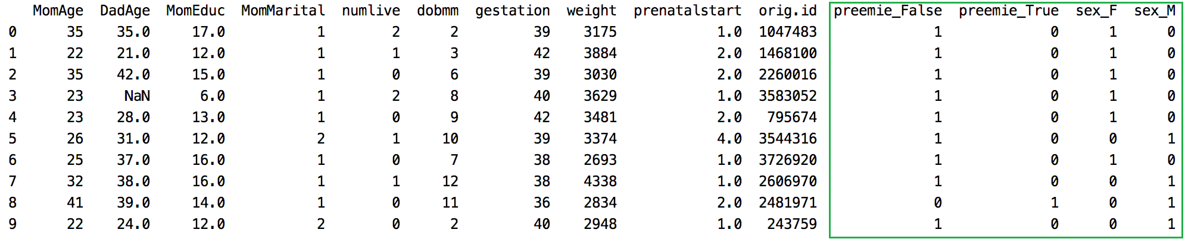
Here is the code:
import pandas as pd
import numpy as np
from sklearn.model_selection import train_test_split
import statsmodels.api as sm
from sklearn import metrics
# Import data into a DataFrame.
path = "/Users/pm/Desktop/DayDocs/PythonForDataAnalytics/workingData/babysamp-98.txt"
df = pd.read_table(path, skiprows=1,
delim_whitespace=True,
names=('MomAge', 'DadAge', 'MomEduc', 'MomMarital', 'numlive',
"dobmm", 'gestation', 'sex', 'weight', 'prenatalstart',
'orig.id', 'preemie'))
# Show all columns.
pd.set_option('display.max_columns', None)
pd.set_option('display.width', 1000)
print(df.head()) # View a snapshot of the data.
print(df.describe()) # View stats including counts which highlight missing values.
df = pd.get_dummies(df, columns=['preemie', 'sex'],dtype=int)
print(df.head(10))

The results show the DataFrame that is shown in Table 6.

Example 4: Auto-Generated Dummy Variable Columns with Retained Original Columns
On its own, the get_dummies() method removes the original column from the DataFrame. An adjustment can be made to retain the original column to maintain explanatory ability in the DataFrame. This example shows how to adjust the code in Example 3 to also retain the original sex and preemie columns after adding dummy variable columns. Generally, you do not want to delete original columns from your DataFrame since you will often want to refer back to the original data structure. Using this technique is quick, simple and extremely informative.

Table 7: Using get_dummies() and retaining the original Columns
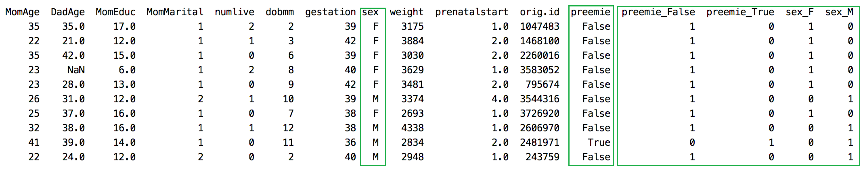
To build this replace the get_dummies() instruction in Example 3 with these three lines.
tempDf = df[['preemie', 'sex']] # Isolate columns
dummyDf = pd.get_dummies(tempDf, columns=['preemie', 'sex'], dtype=int) # Get dummies
df = pd.concat(([df, dummyDf]), axis=1) # Join dummy df with original df
The output shows the original columns along with the dummy variable columns (see Table 7).

Binning Categories
You may find that a variable like MomAge is insignificant on its own but if you bin it within clusters of 10 years the variables created may become significant. The DataFrame’s cut() function allows you to quickly split ordinal data into bins. Table 8 shows ages for Mom’s and Dad’s split into separate sub-groups. The sub-groups are labeled with bin notation. dadAgeBin_(27,37] refers to ages 28 to 87 inclusively. The round bracket on the left does not include the number that it precedes. Table 8 shows separate bins that have been created for Mother and Father age groups.

Table 8: Bin Categories for MomAge and DadAge
import pandas as pd

# Import data into a DataFrame.
path = "/Users/pm/Desktop/DayDocs/PythonForDataAnalytics/workingData/babysamp-98.txt"
df = pd.read_table(path, skiprows=1,
delim_whitespace=True,
names=('MomAge', 'DadAge', 'MomEduc', 'MomMarital', 'numlive',
"dobmm", 'gestation', 'sex', 'weight', 'prenatalstart',
'orig.id', 'preemie'))
# Show all columns.
pd.set_option('display.max_columns', None)
pd.set_option('display.width', 1000)
print(df.head()) # View a snapshot of the data.
print(df.describe()) # View stats including counts which highlight missing values.

#print("\nbinned_statistic for median : \n", stats.binned_statistic(df['DadAge'].values, bins = 4))
df['dadAgeBin'] = pd.cut(x=df['DadAge'], bins=[17, 27, 37, 48])
df['momAgeBin'] = pd.cut(x=df['MomAge'], bins=[13,23,33,42])

tempDf = df[['dadAgeBin','momAgeBin','sex']] # Isolate columns
# Get dummies
dummyDf = pd.get_dummies(tempDf, columns=['dadAgeBin','momAgeBin','sex'], dtype=int)
df = pd.concat(([df, dummyDf]), axis=1) # Join dummy df with original
print(df)
The output from running this example generates the content shown in Table 8.

Exercise 1 (4 marks)
Using the carPrice.py script (in the appendix), create dummy variables for transmission and fuel type2 columns. Show a snapshot of the data frame head after the changes:
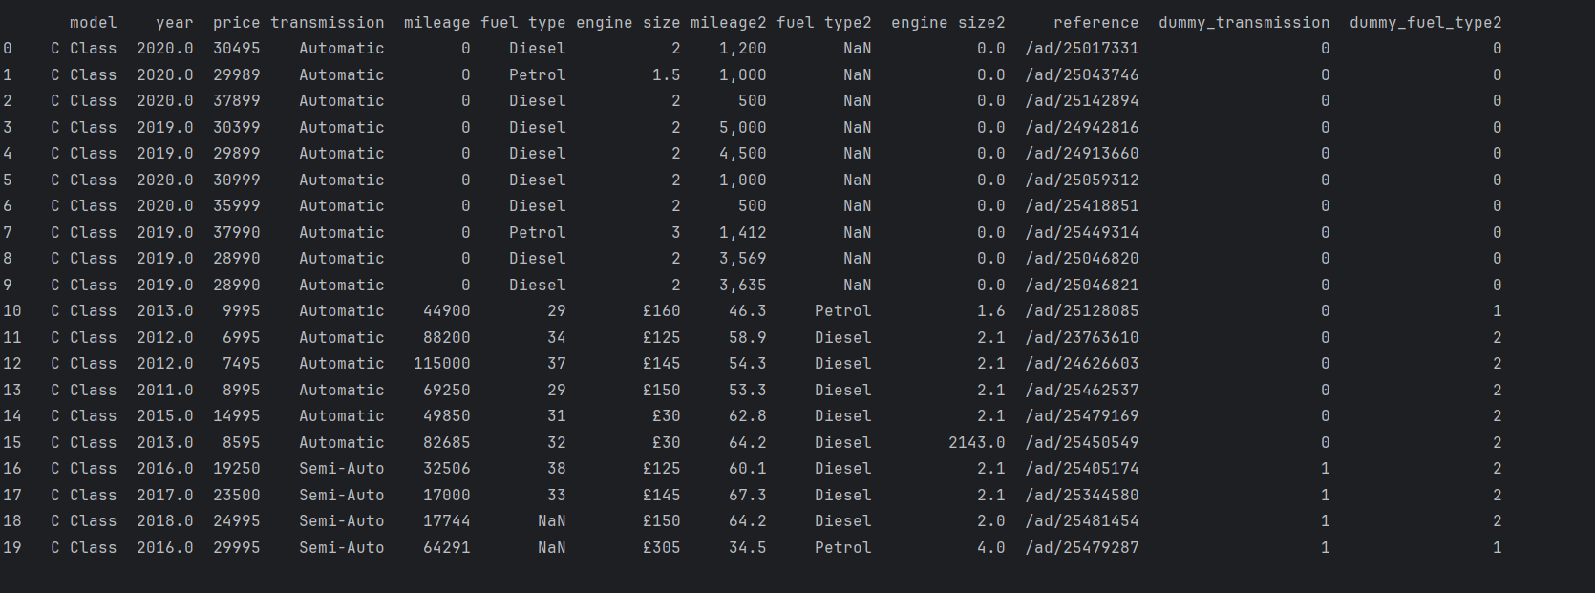

Do the transmission and ‘fuel type2’ columns still exist in the data frame after the changes or were they deleted?
yes, I retained them as recommended

Show the lines of code used to create the dummy variables here:
# get the unique values from each column
transmission = pd.unique(df['transmission'])
fuel_type2 = pd.unique(df['fuel type2'])
# create mapping dict
transmissions = {val: i for i, val in enumerate(transmission)}
fuel_type2 = {val: i for i, val in enumerate(fuel_type2)}
# map each matching key to a value of int in the columns
transmission_mapped = df['transmission'].map(transmissions)
fuel_type2_mapped = df['fuel type2'].map(fuel_type2)
# create two new columns for dummy variables
df['dummy_transmission'] = transmission_mapped
df['dummy_fuel_type2'] = fuel_type2_mapped

Exercise 2 (4 marks)
Add the new columns from Exercise 1 to your least square regression model. Show your new model summary output after running the program with the changes.
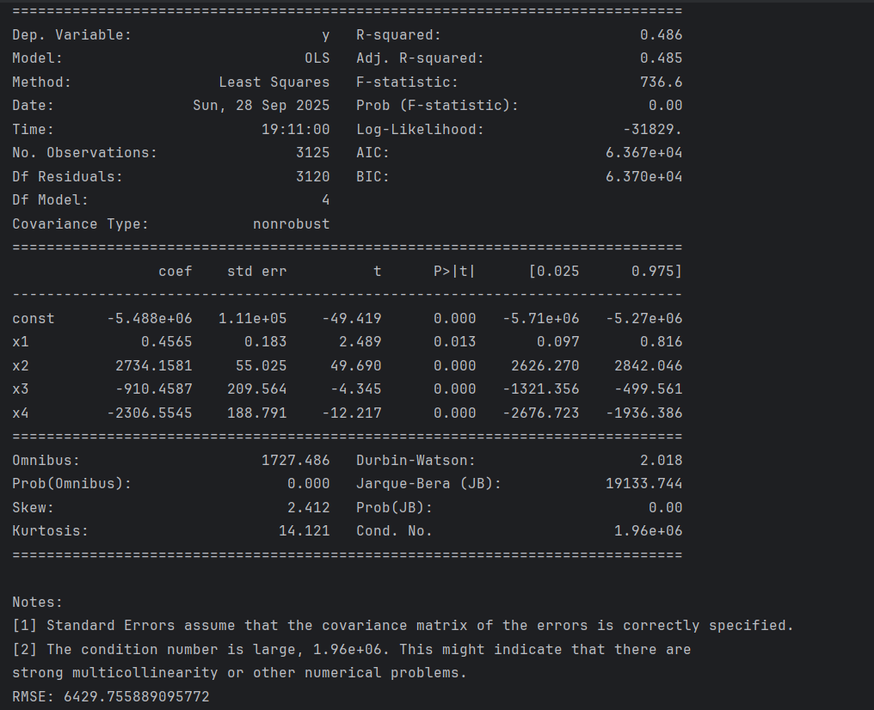

Do the regression results improve with the dummy variables?
It seems slightly improved in terms of RMSE, however colinearlity also increases due to higher Conditional number values,

Which variables are insignificant now in the new model with the inclusion of the dummy variables? Please list the actual variable names.
x1 continues to contribute insignificantly before and after adding dummy variable columns, which is engine size2.

Show code revisions needed to include the dummy variables in your model here:
X = df[['engine size2', 'year', 'dummy_transmission', 'dummy_fuel_type2']].values
X = sm.add_constant(X)
y = df['price'].values
X_train, X_test, y_train, y_test = train_test_split(
X, y, test_size=0.2,
)
model = sm.OLS(y_train, X_train).fit()
y_pred = model.predict(X_test)
print("\n\n==========================================================================================")
print(model.summary())
print(f'RMSE: {np.sqrt(mean_squared_error(y_test, y_pred))}')

Exercise 3 (4 marks)
Create separate bin columns for the years 2020, 2019, 2018, 2017, 2016, 2015, 2014, 2013 and anything less than 2013 in its own bin. Show the code used to create the 8 new bins.

df['year_binned'] = df['year'].where(df['year'] > 2013, '2013_before')
dummy_bins = pd.get_dummies(df['year_binned'], prefix="year", dtype=int)
df = pd.concat([df, dummy_bins], axis=1)

Show a screenshot of the data frame after making the 8 bins.
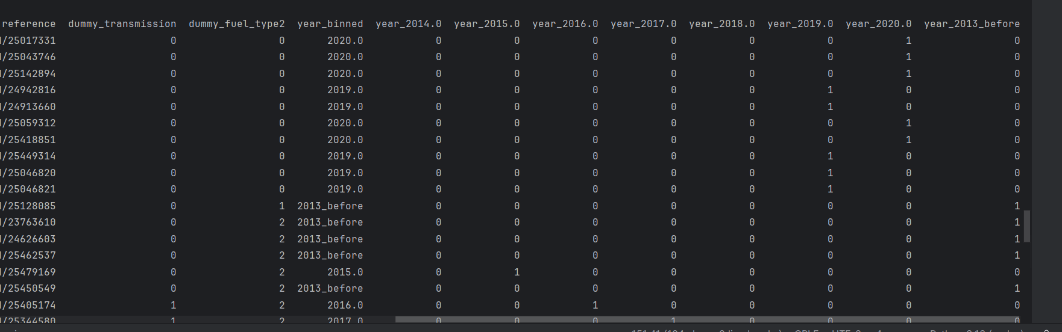

Include the bins in your data model and run the program again. Show the model summary here:
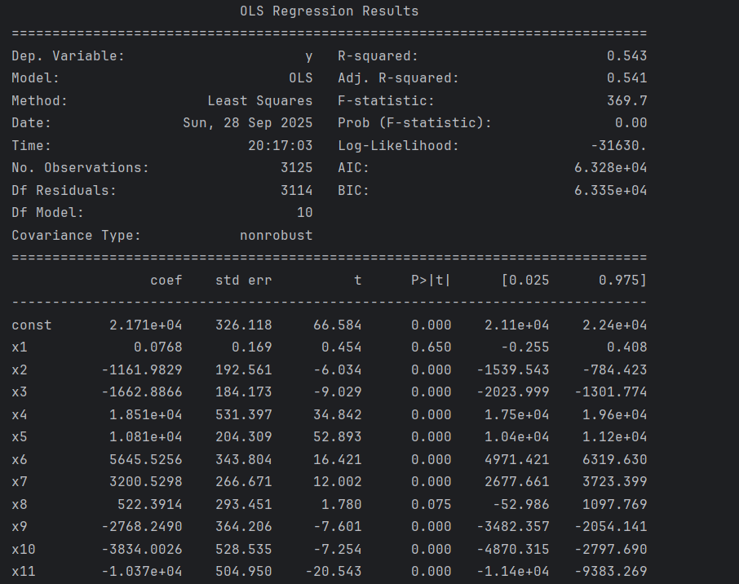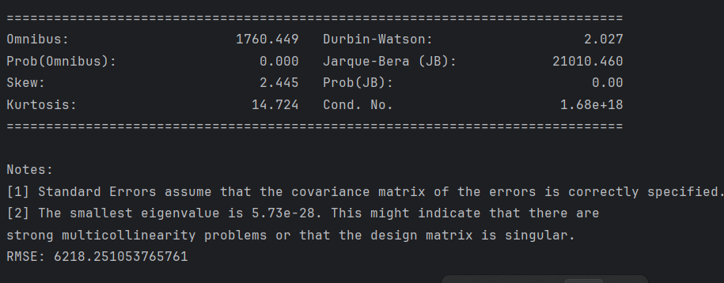

Are any of the bins insignificant and if so which ones?
year_2016.0 should be removed as p value is high, and probably engine size2 as mentioned before due to its small coefficient value.

Exercise 4 (8 marks)
Choose your best performing model from the exercises above. You do not have the most amazing model. Create model production code using your model for car prices (Table 9 shows what model production code is.).

Table 9: Explanation of Model Production Code
Based on the equation that is generated from the model summary.

We can then implement the equation in model production code. In model production code the model is already defined so there is no fitting or training needed.

Include your model production code for the car price model here. Please ensure the script runs from start to finish without error.
def predictCarPrice(true_price, transmission, fuel_type2, year_2020=0,
year_2019=0, year_2018=0, year_2017=0, year_2015=0,
year_2014=0, year_2013_before=0):
pred_price = (2.171e+04 -1161.9829*transmission -1662.8866*fuel_type2
+ 1.851e+04*year_2020 + 1.081e+04*year_2019 + 5645.5256*year_2018 +
3200.5298*year_2017 -2768.2490*year_2015 -3834.0026*year_2014
-1.037e+04*year_2013_before)
print(f'Actual price: {true_price} | Predicted price: {pred_price}')
print(predictCarPrice(30495, 0, 0, year_2020=1))
print(predictCarPrice(24500, 0, 2, year_2017=1))
print(predictCarPrice(14495, 2, 1, year_2015=1))

Actual price: 30495 | Predicted price: 40220.0
Actual price: 24500 | Predicted price: 21584.7566
Actual price: 14495 | Predicted price: 14954.8986

Appendix: carPrices.py
from statsmodels.tsa.seasonal import seasonal_decompose
import pandas as pd
import matplotlib.pyplot as plt
import seaborn as sns
import numpy as np

# Import Data
PATH = "/Users/pm/Desktop/DayDocs/data/"
FILE = "carPrice.csv"
df = pd.read_csv(PATH + FILE)

# Enable the display of all columns.
pd.set_option('display.max_columns', None)
pd.set_option('display.width', 1000)

#---------------------------------------------
# Generate quick views of data.
def viewQuickStats():
print("\n*** Show contents of the file.")
print(df.head())

print("\n*** Show the description for all columns.")
print(df.info())

print("\n*** Describe numeric values.")
print(df.describe())

print("\n*** Showing frequencies.")

# Show frequencies.
print(df['model'].value_counts())
print("")
print(df['transmission'].value_counts())
print("")
print(df['fuel type'].value_counts())
print("")
print(df['engine size'].value_counts())
print("")
print(df['fuel type2'].value_counts())
print("")
print(df['year'].value_counts())
print("")

#---------------------------------------------
# Fix the price column.
for i in range(0, len(df)):
priceStr = str(df.iloc[i]['price'])
priceStr = priceStr.replace("£", "")
riceStr = priceStr.replace("-", "")
priceStr = priceStr.replace(",", "")
df.at[i,'price'] = priceStr

# Convert column to number.
df['price'] = pd.to_numeric(df['price'])

#---------------------------------------------
# Fix the price column.
averageYear = df['year'].mean()
for i in range(0, len(df)):
year = df.iloc[i]['year']

if(np.isnan(year)):
df.at[i, 'year'] = averageYear

#---------------------------------------------
# Fix the engine size2 column.
for i in range(0, len(df)):
try:
engineSize2 = df.loc[i]['engine size2']
if(pd.isna(engineSize2)):
df.at[i,'engine size2'] = "0"

except Exception as e:
error = str(e)
print(error)

df['engine size2'] = pd.to_numeric(df['engine size2'])
df['mileage2'].value_counts()
viewQuickStats()

#---------------------------------------------
# Fix the mileage column.
for i in range(0, len(df)):
mileageStr = str(df.iloc[i]['mileage'])
mileageStr = mileageStr.replace(",", "")
df.at[i, 'mileage'] = mileageStr
try:
if(not mileageStr.isnumeric()):
df.at[i, 'mileage'] = "0"
except Exception as e:
error = str(e)
print(error)

df['mileage'] = pd.to_numeric(df['mileage'])
viewQuickStats()

# Compute the correlation matrix
corr = df.corr()
# plot the heatmap
sns.heatmap(corr,
xticklabels=corr.columns,
yticklabels=corr.columns)
plt.show()

from sklearn.linear_model import LinearRegression
X = df[['engine size2', 'year']].values

from sklearn.model_selection import train_test_split
from sklearn.linear_model import LinearRegression
from sklearn import metrics
import statsmodels.api as sm
# Adding an intercept *** This is requried ***. Don't forget this step.
# The intercept centers the error residuals around zero
# which helps to avoid over-fitting.
X = sm.add_constant(X)

y = df['price'].values

X_train, X_test, y_train, y_test = train_test_split(X, y, test_size=0.2, random_state=0)

model = sm.OLS(y_train, X_train).fit()
predictions = model.predict(X_test) # make the predictions by the model

print(model.summary())

print('Root Mean Squared Error:',
np.sqrt(metrics.mean_squared_error(y_test, predictions)))

