Table of Contents
Cross Fold Validation 1
Logistic Regression 5
Logistic Regression – How it works 5
Logistic Model Introduction 6
Model Evaluation and Confusion Matrices 9
Accuracy Score 10
Precision, Recall, F-Score 11
F1-Score 12
Multinomial Logistic Regression 13

Cross Fold Validation
Cross-fold validation helps to determine the model reliability by testing the model features with random data over multiple runs.

Please see https://machinelearningmastery.com/k-fold-cross-validation/

Example 1: Selecting Different Test and Train Sets over Multiple Runs
This example is not completely practical on its own but it demonstrates how the selection of test and train data can be randomized during each run to enable a more robust way to test the X-feature set.
# scikit-learn k-fold cross-validation
from numpy import array
from sklearn.model_selection import KFold

# data sample
data = array([0.1, 0.2, 0.3, 0.4, 0.5, 0.6])

# prepare cross validation
kfold = KFold(n_splits=3, shuffle=True)

# enumerate splits
for train, test in kfold.split(data):
print('train: %s, test: %s' % (data[train], data[test]))
The randomized training and test sets are:
train: [0.1 0.4 0.5 0.6], test: [0.2 0.3]
train: [0.2 0.3 0.4 0.6], test: [0.1 0.5]
train: [0.1 0.2 0.3 0.5], test: [0.4 0.6]

Example 2: Traditional Test Train Split
This example shows how we can train our model and evaluate it with the test set like we have been doing up until now. The problem is though that the evaluation works for one run only. The results may not be stable.
import pandas as pd
from sklearn.model_selection import train_test_split
from sklearn.linear_model import LinearRegression
from sklearn import metrics
import statsmodels.api as sm
import numpy as np

PATH = "/Users/pm/Desktop/DayDocs/data/"
CSV_DATA = "winequality.csv"
dataset = pd.read_csv(PATH + CSV_DATA)
# Show all columns.
pd.set_option('display.max_columns', None)

# Increase number of columns that display on one line.
pd.set_option('display.width', 1000)
print(dataset.head())
print(dataset.describe())

# PART B
X = dataset[[ 'volatile acidity',
'chlorides', 'total sulfur dioxide', 'sulphates','alcohol']]

# Adding an intercept *** This is requried ***. Don't forget this step.
# The intercept centers the error residuals around zero
# which helps to avoid over-fitting.
X = sm.add_constant(X)
y = dataset['quality']

X_train, X_test, y_train, y_test = train_test_split(X, y,
test_size=0.2)

model = sm.OLS(y_train, X_train).fit()
predictions = model.predict(X_test) # make the predictions by the model

print(model.summary())

print('Root Mean Squared Error:',
np.sqrt(metrics.mean_squared_error(y_test, predictions)))

Here is the output:
OLS Regression Results
==============================================================================
Dep. Variable: quality R-squared: 0.352
Model: OLS Adj. R-squared: 0.349
Method: Least Squares F-statistic: 138.1
Prob (F-statistic): 3.99e-117
Log-Likelihood: -1273.3
No. Observations: 1279 AIC: 2559.
Df Residuals: 1273 BIC: 2590.
Df Model: 5
Covariance Type: nonrobust
========================================================================================
coef std err t P>|t| [0.025 0.975]
----------------------------------------------------------------------------------------
const 2.8377 0.230 12.350 0.000 2.387 3.288
volatile acidity -1.1594 0.109 -10.617 0.000 -1.374 -0.945
chlorides -1.6541 0.442 -3.739 0.000 -2.522 -0.786
total sulfur dioxide -0.0021 0.001 -3.691 0.000 -0.003 -0.001
sulphates 0.9593 0.121 7.957 0.000 0.723 1.196
alcohol 0.2898 0.019 15.538 0.000 0.253 0.326
==============================================================================
Omnibus: 17.801 Durbin-Watson: 2.032
Prob(Omnibus): 0.000 Jarque-Bera (JB): 25.138
Skew: -0.146 Prob(JB): 3.48e-06
Kurtosis: 3.622 Cond. No. 1.39e+03
==============================================================================
Notes:
[1] Standard Errors assume that the covariance matrix of the errors is correctly specified.
[2] The condition number is large, 1.39e+03. This might indicate that there are
strong multicollinearity or other numerical problems.
Root Mean Squared Error: 0.63217891937099

Cross fold validation offers an opportunity to ensure that we test our model’s X feature set with all data. Measuring performance with all available data will help to provide a more responsive model.
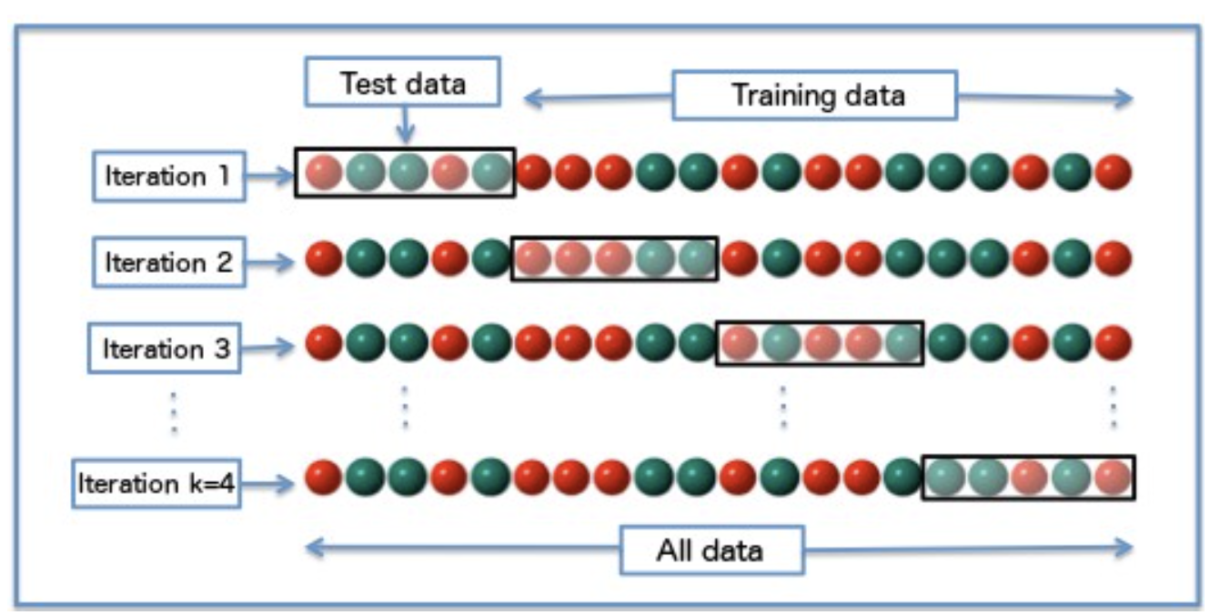
https://medium.com/@johnnaujoks/adventures-in-cross-validation-techniques-with-linear-regression-models-75f4e30471

Example 3: Cross Fold Validation
This code ensures that we use all data to test our model. The closeness of the root mean square error results during each of the four iterations suggest that the model is stable.

RMSE: 0.6637059850004006
RMSE: 0.6400068280725355
RMSE: 0.6617156733878725
Average rmse: 0.6551428288202695

To build this example, replace part B of Example 2 with the following code.

X = dataset[[
'chlorides', 'total sulfur dioxide']]

# Adding an intercept *** This is requried ***. Don't forget this step.
# The intercept centers the error residuals around zero
# which helps to avoid over-fitting.
X = sm.add_constant(X)
y = dataset[['quality']]

from sklearn.model_selection import KFold
kfold = KFold(n_splits=3, shuffle=True)

from sklearn.metrics import mean_squared_error
import numpy as np

rmses = []
for train_index, test_index in kfold.split(X):
# use index lists to isolate rows for train and test sets.
# Get rows filtered by index and all columns.
# X.loc[row number array, all columns]
X_train = X.loc[X.index.intersection(train_index), :]
X_test = X.loc[X.index.intersection(test_index), :]
y_train = y.loc[y.index.intersection(train_index), :]
y_test = y.loc[y.index.intersection(test_index), :]

# build model
model = LinearRegression()
model.fit(X_train,y_train)

predictions = model.predict(X_test)
mse = mean_squared_error(predictions, y_test)
rmse = np.sqrt(mse)
print("RMSE: " + str(rmse))
rmses.append(rmse)

avgRMSE = np.mean(rmses)
print("Average rmse: " + str(avgRMSE))

Exercise 1 (4 marks)
Build a linear regression model to predict home prices with the USA_Housing.csv file. This time though use cross fold regression over 5 folds. Show the average RMSE for all 5 folds. Show your code here:
import pandas as pd
import numpy as np
from sklearn.metrics import mean_squared_error
from sklearn.model_selection import KFold, train_test_split
from sklearn.linear_model import LinearRegression
import statsmodels.api as sm
path = r"C:\Users\linho\Desktop\CST\term3\pred_analytics\data\USA_Housing.csv"
dataset = pd.read_csv(path)
pd.set_option('display.max_columns', None)
pd.set_option("display.width", 1000)
print(dataset.head())
print(dataset.describe())
# Extract only numeric columns
X = dataset[["Avg. Area Income", "Avg. Area House Age",
"Avg. Area Number of Rooms", "Avg. Area Number of Bedrooms",
"Area Population"]]
X = sm.add_constant(X)
y = dataset['Price']
# split dataset
X_train, X_test, y_train, y_test = train_test_split(X, y, test_size=0.2)
model = sm.OLS(y_train, X_train).fit()
y_pred = model.predict(X_test)
print(model.summary())
# Based on p value, removing Avg. Area Number of Bedrooms from X
X = dataset[["Avg. Area Income", "Avg. Area House Age",
"Avg. Area Number of Rooms", "Area Population"]]
X = sm.add_constant(X)
# resplit dataset
X_train, X_test, y_train, y_test = train_test_split(
X, y, test_size=0.2
)
model1 = sm.OLS(y_train, X_train).fit()
y_pred = model1.predict(X_test)
print("\n\n===========================================================================")
print(" ************************ OLS Model 1 *************************\n")
print(model1.summary())
print(f"RMSE: {np.sqrt(mean_squared_error(y_test, y_pred))}")
### We'll use this updated dataset for training a LinearRegression model
### since all p values are 0.
print("\n\n********************* LINEAR REGRESSION MODEL *************************\n")
X = dataset[["Avg. Area Income", "Avg. Area House Age",
"Avg. Area Number of Rooms", "Area Population"]]
y = dataset[['Price']]
rmses = []
kfold = KFold(n_splits=5, shuffle=True)
for train_idx, test_idx in kfold.split(X):
X_train = X.loc[train_idx, :]
X_test = X.loc[test_idx, :]
y_train = y.loc[train_idx, :]
y_test = y.loc[test_idx, :]
lr_model = LinearRegression()
# train model
lr_model.fit(X_train, y_train)
# make predictions
y_pred = lr_model.predict(X_test)
# calculate loss
mse = mean_squared_error(y_test, y_pred)
rmse = np.sqrt(mse)
rmses.append(rmse)
print(f"RMSE: {rmse}")
avgRMSE = np.average(rmses)
print(f"Average RMSE: {avgRMSE}")

Show the individual RMSE values and the average RMSE value here:
RMSE: 101377.83831956924
RMSE: 97751.2521104523
RMSE: 103436.32583472083
RMSE: 103651.8405976382
RMSE: 99754.5585278345
Average RMSE: 101194.36307804301

Logistic Regression
Logistic regression is a fundamental algorithm for making classifications. Unlike least squares regression, logistic regression does not predict continuous numeric variables such as the sale price of a home. Logistic regression is suitable for making predictions for the following problems:

- If an email is spam.
- If fraud has occurred.
- If a person has contracted a specific illness.
- Whether a user will respond to a marketing campaign.
Logistic regression models predict probabilities that range between 0 and 1. The classification is then assigned based on the probability weighting. For example, if the predicted probability that the email message is spam is 0.15 then the predicted classification is 0. If the predicted probability that an email is 0.8 then the classification is 1.

Logistic regression, can be extended to predict classifications for more than two classes. For example:

- Whether a movie is rated 1, 2, 3, 4, or 5 stars.
- Whether a spruce tree is a white, red or black spruce tree.
Logistic regression is a foundation for many advanced classification algorithms.

Logistic Regression – How it works
We will not proof out the formula for logistic regression in this course but it can be proven. In simple terms though, logistic regression is a linear regression equation, $b_{0}+b_{1}$x, inside a sigmoid function where

Equation 1: Sigmoid Function
Sigmoid = $\frac{1}{e^{-x}}$

Equation 2: Logistic Regression Function
p = $\frac{1}{1+ e^{-(b_{0}+b_{1}x)}}$

The sigmoid function restricts all y values to a range between 0 and 1(see Figure 3). Figure 3 shows the classic S-shape for a sigmoid function where 0 $<y<1.$ In other words, for all possible values of x, y is always greater than 0 and less than 1.
Figure 3: Classic Sigmoid S-Shape With 0 $<y<$ 1
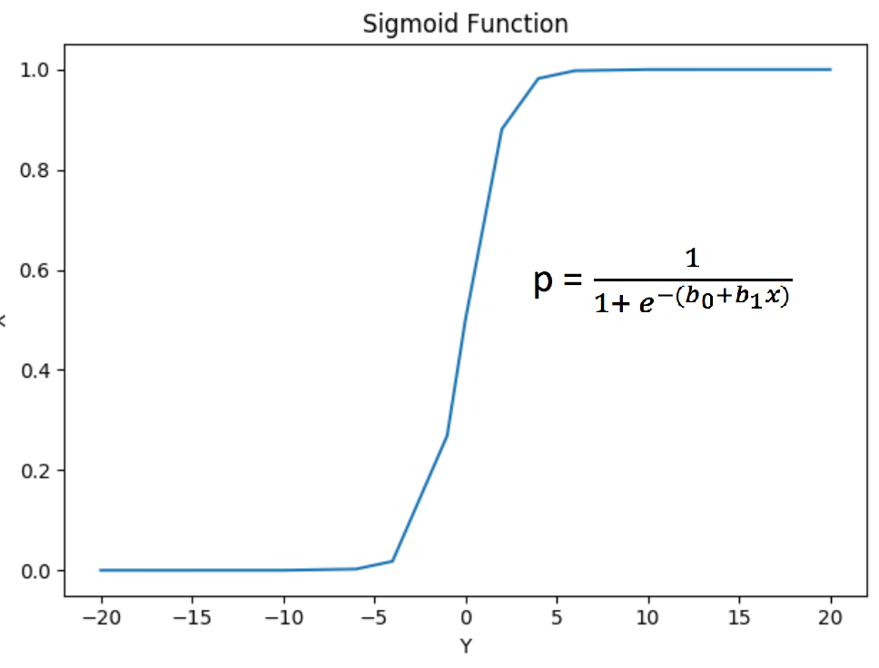 | import matplotlib.pyplot as plt  import numpy as np  x = np.array([-20,-10,-6,-4,  -1,0,2,4,6,10,20])  y = probability = 1/(1+np.exp(-x))  plt.plot(x, y)  plt.title('Sigmoid Function')  plt.xlabel("Y")  plt.ylabel("X")  plt.show()

Logistic Model Introduction
This section introduces basic logistic model regression and validation techniques.

Determining Significant Predictor Variables
To avoid overfitting, it is important not to make the model too complex. With the logistic regression a chi-square test is used to determine which sample features help to generate the best model.

A chi-square test determines if the predictor variables are significant where chi > 3.8 is significant.

test = SelectKBest(score_func=chi2, k=3)
chiScores = test.fit(X, y) # Summarize scores
np.set_printoptions(precision=3)

Example 4: Finding Significant Predictor Variables
This example shows the initial stages of model development for a model which predicts whether a college applicant will be admitted to a college. The sample features include GMAT and GPA scores as well as years of work experience.

The output identifies the gmat and work_experience variables as the significant predictors since their chi scores are greater than 3.8.
Predictor variables: ['gmat', 'gpa', 'work_experience']
Predictor Chi-Square Scores: [123.062 3.307 21.457]

Here is the code that performs the chi square test.
import pandas as pd
import numpy as np

# Setup data.
candidates = {'gmat': [780,750,690,710,680,730,690,720,
740,690,610,690,710,680,770,610,580,650,540,590,620,
600,550,550,570,670,660,580,650,660,640,620,660,660,
680,650,670,580,590,690],
'gpa': [4,3.9,3.3,3.7,3.9,3.7,2.3,3.3,
3.3,1.7,2.7,3.7,3.7,3.3,3.3,3,2.7,3.7,2.7,2.3,
3.3,2,2.3,2.7,3,3.3,3.7,2.3,3.7,3.3,3,2.7,4,
3.3,3.3,2.3,2.7,3.3,1.7,3.7],
'work_experience': [3,4,3,5,4,6,1,4,5,
1,3,5,6,4,3,1,4,6,2,3,2,1,4,1,2,6,4,2,6,5,1,2,4,6,
5,1,2,1,4,5],
'admitted': [1,1,1,1,1,1,0,1,1,0,0,1,
1,1,1,0,0,1,0,0,0,0,0,0,0,1,1,0,1,1,0,0,1,1,1,0,0,
0,0,1]}

df = pd.DataFrame(candidates,columns= ['gmat', 'gpa',
'work_experience','admitted'])
print(df)

# Separate into x and y values.
predictorVariables = ['gmat', 'gpa','work_experience']
X = df[predictorVariables]
y = df['admitted']

# Import the necessary libraries first
from sklearn.feature_selection import SelectKBest
from sklearn.feature_selection import chi2
# You imported the libraries to run the experiments. Now, let's see it in action.

# Show chi-square scores for each feature.
# There is 1 degree freedom since 1 predictor during feature evaluation.
# Generally, >=3.8 is good)
test = SelectKBest(score_func=chi2, k=3)
chiScores = test.fit(X, y) # Summarize scores
np.set_printoptions(precision=3)

print("\nPredictor variables: " + str(predictorVariables))
print("Predictor Chi-Square Scores: " + str(chiScores.scores_))

# Another technique for showing the most statistically
# significant variables involves the get_support() function.
cols = chiScores.get_support(indices=True)
print(cols)
features = X.columns[cols]
print(np.array(features))

Exercise 2 (3 marks)
The following code reads in the data set for predicting employee turnover.
import pandas as pd
import numpy as np

# Show all columns.
pd.set_option('display.max_columns', None)
pd.set_option('display.width', 1000)

FOLDER_PATH = '/users/pm/desktop/daydocs/data/'
FILE = 'employee_turnover.csv'
df = pd.read_csv(FOLDER_PATH + FILE)
print(df)

# Separate into x and y values.
predictorVariables = list(df.keys())
predictorVariables.remove('turnover')
print(predictorVariables)

# Create X and y values.
X = df[predictorVariables]
y = df['turnover']

Determine which X features are significant for logistic regression.

Note: 5e+01 = ${5∙10}^{1}$ = $5∙$10 = 50
9.881e+00 = 9.881${∙10}^{0}$= $9.881∙$1 = 9.881
1.653e-01 = 1.653${∙10}^{-1}$ = 1.653$∙$0.1 = 0.1653

Show the variables which are significant here:
{'experience': 83.73533151091576,
'age': 4.223674148179527,
'industry': 9.881477586136974,
'way': 4.695920023406387}

Implementing Logistic Regression
The code to implement logistic regression is very similar to the code that is needed to implement linear regression. First data is split into test and train sets. Then the logistic regression model is fit with the training data. Predictions are then made with the test data.

Example 5: Logistic Regression Introduction
This example continues on from Example 4. Since it was determined in Example 4 that GPA was not statistically significant, the predictor DataFrame is built only with the significant predictor variables. Once the model has been fit and is used to make predictions, the predictions are printed. The test data that is used to make the predictions is selected randomly so for this case the first student will be admitted to College but the one after will not and so on.

[1 0 1 1 1 0 1 1 0 1]

To build this example, add the following code to Example 4.
from sklearn.model_selection import train_test_split
from sklearn.linear_model import LogisticRegression

# Re-assign X with significant columns only after chi-square test.
X = df[['gmat', 'work_experience']]

# Split data.
X_train,X_test,y_train,y_test = train_test_split(X, y, test_size=0.25,
random_state=0)

# Build logistic regression model and make predictions.
logisticModel = LogisticRegression(fit_intercept=True, solver='liblinear',
random_state=0)
logisticModel.fit(X_train,y_train)
y_pred=logisticModel.predict(X_test)
print(y_pred)

Exercise 3 (3 marks)
Starting with the solution from Exercise 2, add code to perform logistic regression to predict employee turnover. Show your working program here:
def predict_employee_turnover():
df = pd.read_csv(path)
print(df.head())
predictor_vars = list(df.keys())
predictor_vars.remove('turnover')
# print(predictor_vars)
# construct features and label
X = df[predictor_vars]
y = df['turnover']
# Ex 2
### Naive Way
# selector = SelectKBest(score_func=chi2)
# chi_scores = selector.fit(X, y)
# # print(chi_scores.scores_)
#
# all_chi_score_df = pd.DataFrame(chi_scores.scores_).T
# all_chi_score_df.columns = predictor_vars
#
# result = all_chi_score_df[all_chi_score_df >= 3.8].dropna(axis=1)
# print(all_chi_score_df)
# print('\n*** Significant Variables ***\n')
# print(result)
### More efficient way using zip()
selector = SelectKBest(score_func=chi2, k=4)
selector.fit(X, y)
chi_scores = dict(zip(predictor_vars, selector.scores_))
significant_vars = {var:score.item() for var,score in chi_scores.items() if score >= 3.8}
print(significant_vars)
print("\n\n=========== LOGISTIC REGRESSION ==============")
predictor_vars = significant_vars.keys();
X = df[predictor_vars]
y = df['turnover']
# split dataset
X_train, X_test, y_train, y_test = train_test_split(
X, y, test_size=0.2
)
# instantiate model
logistic_model = LogisticRegression(fit_intercept=True, solver='liblinear')
logistic_model.fit(X_train, y_train)
y_pred = logistic_model.predict(X_test)
print(f"y_test: {y_test.values}")
print(f"y_pred: {y_pred}")
print(f"Accuracy: {np.sum((y_test == y_pred)) / len(y_test)}")
predict_employee_turnover()

Show your predictions here:
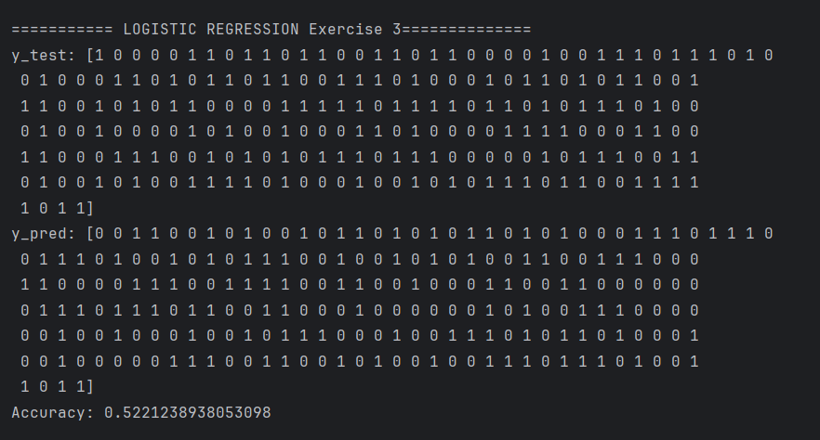

Model Evaluation and Confusion Matrices
There are many methods for evaluating the effectiveness of a logistic regression model. We will start with two of the most basic methods which are accuracy score and confusion matrices.

Confusion Matrices
With many classification algorithms, a confusion matrix compares actual versus predicted values. For this example, our target prediction is admission acceptance. The actual response row values are mapped with predicted response column values. The best possible outcome is to have all values in the diagonal from the top left to the bottom right where admissions rejections and acceptances are accurately predicted.

For our college admissions example, the 8 correct predictions exist in the diagonal but two incorrect predictions exist at the top right of Figure 4.

Figure 4: Confusion Matrix
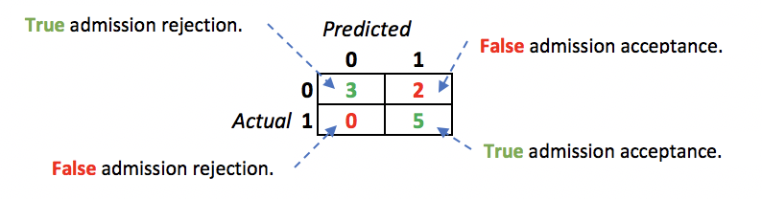
The matrix accounts for all predictions in our test set.

Printing out our actual test and predicted values shows a clear breakdown of where differences between actual and predicted values occur:

Figure 5: Comparing Actual and Predicted Values
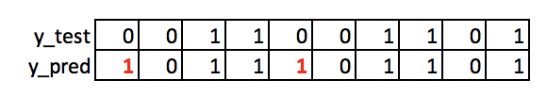

Accuracy Score
Based on the results in the confusion matrix in Figure 4, since 8 out of 10 predictions are correct we can say accuracy score is 8/10 = 80%.

Example 6: Accuracy Score and the Confusion Matrix
This code example generates the accuracy scores and confusion matrices for the results of logistic regression for the college admissions example in Example 5.

# Show confusion matrix and accuracy scores.
from sklearn import metrics
cm = pd.crosstab(y_test, y_pred, rownames=['Actual'], colnames=['Predicted'])
print('\nAccuracy: ',metrics.accuracy_score(y_test, y_pred))
print("\nConfusion Matrix")
print(cm)

Exercise 4 (1 mark)
What is the accuracy of logistic regression with the following confusion matrix?
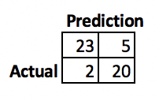
43/50 = 0.86 or 86%

Exercise 5 (2 marks)
Manually create a confusion matrix for the following set:
Actual | 1 | 0 | 1 | 1 | 0
Predicted | 1 | 1 | 0 | 1 | 1

Show your confusion matrix output here:
Actual |  | Predicted
 | 0 | 0 | 2
 | 1 | 1 | 2
 |  | 0 | 1

Exercise 6 (1 mark)
What is the accuracy rate for the confusion matrix that is drawn in Exercise 5?
2/5 = 0.4 or 40%

Exercise 7 (6 marks)
Starting with your solution from Exercise 3, add in code to evaluate the success of the logistic regression. (Do not be concerned that the score will likely be slightly worse than a random guess). Show the entire program here (you will need it later):
import pandas as pd
from sklearn.model_selection import train_test_split
from sklearn.linear_model import LogisticRegression
from sklearn.feature_selection import SelectKBest, chi2
from sklearn import metrics
PATH = r"C:\Users\linho\Desktop\CST\term3\pred_analytics\data\employee_turnover.csv"
def predict_employee_turnover():
df = pd.read_csv(PATH)
predictor_vars = [col for col in df.keys() if col != 'turnover']
# print(predictor_vars)
# Construct features and label
X = df[predictor_vars]
y = df['turnover']
# evaluate predictors
selector = SelectKBest(score_func=chi2)
selector.fit(X, y)
chi_scores = dict(zip(predictor_vars, selector.scores_))
# extract only significant predictors, i.e chi scores > 3.8
sig_predictors = {pred:score.item() for pred,score in chi_scores.items() if score >= 3.8}
X = df[sig_predictors.keys()]
# split dataset
X_train, X_test, y_train, y_test = train_test_split(
X, y, test_size=0.2
)
# instantiate logistic model
logistic_model = LogisticRegression(fit_intercept=True, solver='liblinear')
logistic_model.fit(X_train, y_train)
# make predictions
y_pred = logistic_model.predict(X_test)
# retrieve accuracy
acc = metrics.accuracy_score(y_test, y_pred)
# create confusion matrix
conf_mat = pd.crosstab(y_test, y_pred,
rownames=['Actual'], colnames=['Predicted'])
print(f'Accuracy: {acc:.2f}')
print(f'Confusion Matrix: {conf_mat}')
predict_employee_turnover()

Show the accuracy score here:
Accuracy: 0.50
Show the confusion matrix here:
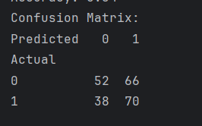

Precision, Recall, F-Score
In addition to validating a model with an accuracy score and confusion matrix, we have other measures to obtain a clearer understanding of model reliability. When making predictions for large data sets, the accuracy score of a classifier model may be really high but it may still have difficulty identifying positive candidates.

Precision
Precision measures the ratio of relevant results over all results retrieved. For example, if you did a search for books on growing plants 7 out of 8 results are relevant then the precision rate is 7/8.

The precision is the ratio of true positive results over the sum of true and false positive results:
$\frac{tp}{(tp+fp)}$ For our college admissions example, precision = $\frac{5}{5+2}$ = 0.714

Recall
The recall score rates the ability of the classifier to find all the positive samples. A low recall rate indicates that a significant number of positive responses where missed by the model. For a marketing campaign, a low recall rate means that a large amount of potential revenue has been overlooked. The recall ratio is:

$\frac{tp}{(tp+fn)}$ For the college admissions example, recall = $\frac{5}{0+5}$ = 1

F1-Score
A high F-score is as a weighted mean of the precision and recall scores. The F-score is at its best value at 1 and worst at 0.

F1 Score = $2∙\frac{Recall∙Precision}{(Recall + Precision)}$ = $2∙\frac{1∙0.714}{(1 + 0.714)}$= 0.8331

Example 7: Calculating Precision, Recall and F1 for College Admission
This example shows how to calculate the precision, recall and F1 scores for the college admissions example.
True Negative: 3
False Negative: 0
False Positive: 2
True Positive: 5

Precision: 0.714
Recall: 1.0
F1: 0.833

Starting with the solution for Example 6 add this code to show the precision, recall and F1 scores:
TN = cm[0][0] # = 3 True Negative (Col 0, Row 0)
FN = cm[0][1] # = 0 False Negative (Col 0, Row 1)
FP = cm[1][0] # = 2 False Positive (Col 1, Row 0)
TP = cm[1][1] # = 5 True Positive (Col 1, Row 1)

print("")
print("True Negative: " + str(TN))
print("False Negative: " + str(FN))
print("False Positive: " + str(FP))
print("True Positive: " + str(TP))

precision = (TP/(FP + TP))
print("\nPrecision: " + str(round(precision, 3)))

recall = (TP/(TP + FN))
print("Recall: " + str(round(recall,3)))

F1 = 2*((precision*recall)/(precision+recall))
print("F1: " + str(round(F1,3)))

Exercise 8 (8 marks)
Given the following confusion matrix, manually calculate the accuracy score, precision score, recall score and f1-score:
 |  | Predicted
Actual |  | 0 | 1
 | 0 | 32 | 10
 | 1 | 3 | 15
Show your accuracy score here (please include the calculations):
(32+15)/60 = 0.78
Show your precision score here (please include the calculations):
15 / (15 + 10) = 0.6
Show your recall score here(please include the calculations):
15 / (15 + 3) = 0.83
Show your f1-score here (please include the calculations):
2 * (0.6*0.83) / (0.6 + 0.83) = 0.70

Exercise 9 (4 marks)
Starting with your solution for Exercise 7, show your precision, recall and F1 scores for the employee turnover example. Show your full program here:
import pandas as pd
from sklearn.model_selection import train_test_split
from sklearn.linear_model import LogisticRegression
from sklearn.feature_selection import SelectKBest, chi2
from sklearn import metrics
PATH = r"C:\Users\linho\Desktop\CST\term3\pred_analytics\data\employee_turnover.csv"
def predict_employee_turnover():
df = pd.read_csv(PATH)
predictor_vars = [col for col in df.keys() if col != 'turnover']
# print(predictor_vars)
# Construct features and label
X = df[predictor_vars]
y = df['turnover']
# evaluate predictors
selector = SelectKBest(score_func=chi2)
selector.fit(X, y)
chi_scores = dict(zip(predictor_vars, selector.scores_))
# extract only significant predictors, i.e chi scores > 3.8
sig_predictors = {pred:score.item() for pred,score in chi_scores.items() if score >= 3.8}
X = df[sig_predictors.keys()]
# split dataset
X_train, X_test, y_train, y_test = train_test_split(
X, y, test_size=0.2
)
# instantiate logistic model
logistic_model = LogisticRegression(fit_intercept=True, solver='liblinear')
logistic_model.fit(X_train, y_train)
# make predictions
y_pred = logistic_model.predict(X_test)
# retrieve accuracy
acc = metrics.accuracy_score(y_test, y_pred)
# create confusion matrix
conf_mat = pd.crosstab(y_test, y_pred,
rownames=['Actual'], colnames=['Predicted'])
print(f'Accuracy: {acc:.2f}')
print(f'Confusion Matrix: \n{conf_mat}')
### Precision and Recall
TN = conf_mat[0][0]
FN = conf_mat[0][1]
FP = conf_mat[1][0]
TP = conf_mat[1][1]
print(f'\nTrue Neg: {TN}')
print(f'False Neg: {FN}')
print(f'False Pos: {FP}')
print(f'True Pos: {TP}')
precision = TP / (TP + FP)
recall = TP / (TP + FN)
F1 = 2 * (precision * recall) / (precision + recall)
print(f'Precision: {precision}')
print(f'Recall: {recall}')
print(f'F1: {F1}')
predict_employee_turnover()

Show your output here:
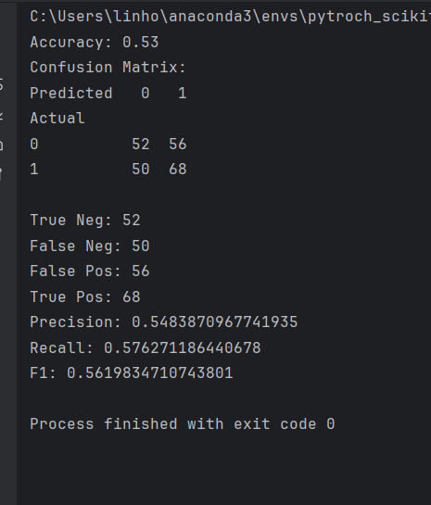

Multinomial Logistic Regression
Multinomial regression allows you to make predictions about more than two classes.

Example 8: Multinomial Regression
This example is based on a multinomial (multi-class) logistic regression tutorial at:
https://chrisalbon.com/machine_learning/naive_bayes/multinomial_logistic_regression/

The goal of this regression is to predict three types of iris flowers: 'setosa', 'versicolor', 'virginica'.


The features are:
- sepal length (cm)
- sepal width (cm)
- petal length (cm)
- petal width (cm)
Here is the code – the explanation for how it works is in the comments:
# Load libraries
from sklearn.linear_model import LogisticRegression
from sklearn import datasets
from sklearn.model_selection import train_test_split
import pandas as pd

# Load data from sklearn library.
iris = datasets.load_iris()
X = iris.data
y = iris.target

# Split data.
X_train,X_test,y_train,y_test = train_test_split(
X, y, test_size=0.25,random_state=0)

# Create one-vs-rest logistic regression object
clf = LogisticRegression(
random_state=0,
multi_class='multinomial', solver='newton-cg')

# Train model
model = clf.fit(X_train, y_train)

# Predict class
y_pred = model.predict(X_test)
print(y_pred)

# View predicted probabilities
y_prob = model.predict_proba(X_test)
print(y_prob)

The output shows the output of the predict() function and the output from the predict_proba() function. Both functions show different representations of the same prediction. predict() shows the predicted classification and predict_proba() shows the predicted probabilities that the flower sample belongs to each class.
[2 1 0 2 0 2 0 1 1 1 2 1 1 1 1 0 1 1 0 0 2 1 0 0 2 0 0 1 1 0 2 1 0 2 2 1 0 2]

[[1.16880555e-04 5.59187205e-02 9.43964399e-01]
[1.26300606e-02 9.60286533e-01 2.70834062e-02]
[9.84395848e-01 1.56041129e-02 3.88424453e-08]
…
[4.79722754e-02 8.80300074e-01 7.17276509e-02]
[9.44684299e-01 5.53153076e-02 3.93764290e-07]
[5.99607426e-04 3.11162157e-01 6.88238236e-01]]

Exercise 10 (1 mark)
Which Iris flower class (0, 1, or 2) is predicted with this set of probabilities?
[5.99607426e-04 3.11162157e-01 6.88238236e-01]
2
Exercise 11 (1 mark)
What is the sum of all probabilities for each sample?
1

Example 9: Evaluating Precision, Recall and F1 Scores for Multinomial Logistic Regression
We can measure the accuracy. Add this code to Example 8
# Show precision, recall and F1 scores for all classes.
from sklearn import metrics
precision = metrics.precision_score(y_test, y_pred, average=None)
recall = metrics.recall_score( y_test, y_pred, average=None)
f1 = metrics.f1_score( y_test, y_pred, average=None)

print("Precision: " + str(precision))
print("Recall: " + str(recall))
print("F1: " + str(f1))

We can see the model does well to make predictions for each of the scores. Remember, recall is the ability to get all. Precision measures the relevancy of the results for the targeted class. F1 is a weighted average of the precision and recall scores. s

Predicted 0 1 2
Actual
0 13 0 0
1 0 15 1
2 0 0 9

Precision: [1. 1. 0.9]
Recall: [1. 0.9375 1. ]
F1: [1. 0.96774194 0.94736842]

Exercise 12
Starting with the following code, perform logistic regression to predict the glass type.
# Load libraries
from sklearn.linear_model import LogisticRegression
from sklearn import datasets
from sklearn.model_selection import train_test_split
import pandas as pd

PATH = '/users/pm/desktop/daydocs/data/'
FILE = 'glass.csv'
df = pd.read_csv(PATH + FILE)

# Show DataFrame contents.
print(df.head())

# Get X values and remove target column.
# Make copy to avoid over-writing.
X = df.copy()
del X['Type']

# Get y values
y = df['Type']

Exercise a) 4 marks show your code to perform logistic regression with a 75/25 test train split.
# split dataset
X_train, X_test, y_train, y_test = train_test_split(
X, y, test_size=0.25
)
# instantiate logistic model
logistic_model = LogisticRegression(solver='newton-cg')
logistic_model.fit(X_train, y_train)

Exercise b) 6 marks
Generate the accuracy, precision, recall and f1 scores for each class type. Show your code here:
# Precision, recall, f1 and accuracy
acc = metrics.accuracy_score(y_test, y_pred)
precision = metrics.precision_score(y_test, y_pred, average=None)
recall = metrics.recall_score(y_test, y_pred, average=None)
f1 = metrics.f1_score(y_test, y_pred, average=None)

Show your accuracy, precision, recall and f1 scores here:
Accuracy: 0.59
Precision: [0.57142857 0.56521739 0. 1. 1. 0.57142857]
Recall: [0.8 0.61904762 0. 0.25 0.5 0.66666667]
F1: [0.66666667 0.59090909 0. 0.4 0.66666667 0.61538462]
Which glass type has the highest precision score?
3 and 4
Which glass type has the highest recall score?
0

