Table of Contents
Scaling 1
Comparing MinMax, Standard and Robust Scalers 9
Cross Fold Validation 9
Note about Reshaping Data 14
Converting Data Back to the Original Scale 14
Saving and Reusing Scalers 15

Scaling
Without scaling the weighting of various features during model building and use may be disproportionate to other features. You will sometimes notice that improvements can be made to your logistic regression and linear regression models if the data is scaled. Many machine learning algorithms perform better or converge faster when all features are sized on a relatively similar scale.

Example 1: Unscaled Data
In this example which uses the computer purchase data set. A problem with the unscaled data is evident when performing basic logistic regression. The significant predictors for a computer purchase are age and estimated salary. The range of numbers for estimated salary is much larger than age. When creating a logistic regression without scaling the model fails to predict any computer purchases:

Accuracy: 0.68

Actual | Predicted 0  0 68  1 32

Even though salary and age distributions are somewhat shaped the same, the right image in
Figure 1 highlights the difference in magnitude which likely is causing unbalanced weights in the model.

Figure 1: Salary and Age Distributions Without Scaling
Salary No Scaling | Age No Scaling | Together Before Scale
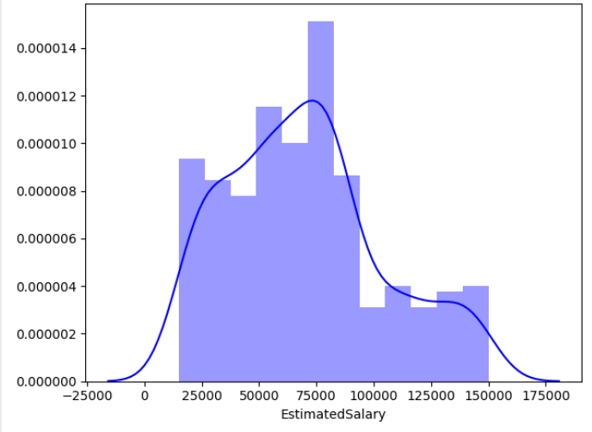 | 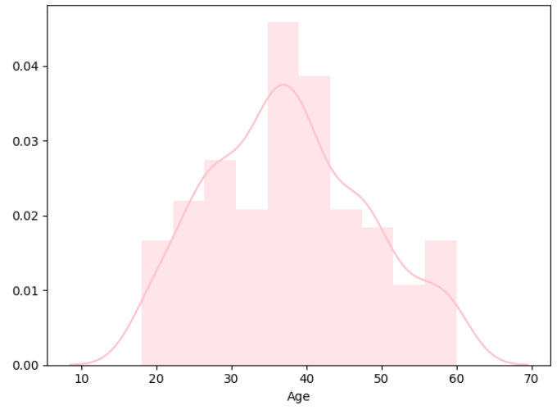 | 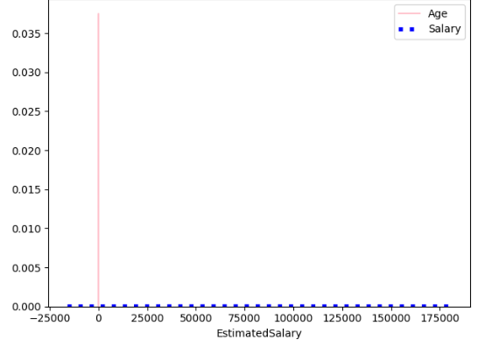

Here is the code which makes the prediction using age and salary without scaling:
import pandas as pd
from sklearn.model_selection import train_test_split
from sklearn.linear_model import LogisticRegression
from sklearn import metrics

PATH = "/Users/pm/Desktop/DayDocs/data/"
CSV_DATA = "computerPurchase.csv"
df = pd.read_csv(PATH + CSV_DATA)

# Separate into x and y values.
X = df[["Age", "EstimatedSalary"]]
y = df['Purchased']

## SECTION A ########################################
# Split data.
X_train, X_test, y_train, y_test = train_test_split(
X, y, test_size=0.25)
## SECTION A ########################################

## SECTION B ########################################
# Perform logistic regression.
logisticModel = LogisticRegression(fit_intercept=True, solver='liblinear')

# Fit the model.
logisticModel.fit(X_train, y_train)
y_pred = logisticModel.predict(X_test)
## SECTION B ########################################

# Show confusion matrix and accuracy scores.
cm = pd.crosstab(y_test, y_pred, rownames=['Actual'], colnames=['Predicted'])

print('\nAccuracy: ',metrics.accuracy_score(y_test, y_pred))
print("\nConfusion Matrix")
print(cm)

To correct the problem described above we will look at three scaling algorithms:

- MinMaxScaler
- StandardScaler
- RobustScaler

MinMax Scaler
MinMaxScaler preserves the shape of the original distribution. It does not meaningfully change the information embedded in the original data. MinMaxScaler essentially restricts the range between 0 and 1 (or -1 to 1 if there are negative values). If the distribution is not Gaussian (normal) or the standard deviation is very small, the min-max scaler is usually recommended.

The equation for MinMaxScaler is: $\frac{x_{i}-min⁡(x)}{\max\left(x\right)-min⁡(x)}$

Table 1 highlights predictor values and accuracy results without and with MinMaxScaler.

Table 1: Computer Purchase Prediction Accuracy Without and With MinMaxScaler
No Scaling | MinMaxScaler
Accuracy: 0.68  Predicted 0  Actual  0 68  1 32 | Accuracy: 0.89  Predicted 0 1  Actual  0 67 1  1 10 22
Age EstimatedSalary  mean 37.66 69742.50  std 10.48 34096.96  min 18.00 15000.00  25% 29.75 43000.00  50% 37.00 70000.00  75% 46.00 88000.00  max 60.00 150000.00 | Age Salary  mean 0.47 0.41  std 0.25 0.25  min 0.00 0.00  25% 0.28 0.21  50% 0.45 0.41  75% 0.67 0.54  max 1.00 1.00

The second diagram from the right in Figure 2 highlights an enormous imbalance between magnitude for age and salary. The diagram at the very right though shows how MinMaxScaler produces distributions that maintain the original shape while sizing each predictor on a similar scale.

Figure 2: Before and After MinMaxScaler
Salary No Scaling | Age No Scaling | Together Before Scale | MinMaxScaler
 |  |  | 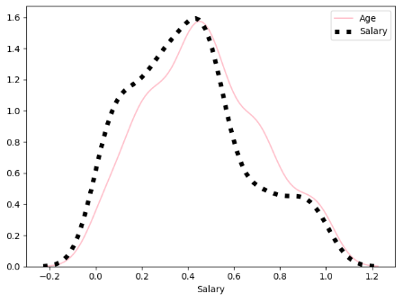

Example 2: Manually Applying the MinMaxScaler
Here is a sample calculation which applies MinMaxScaler to an estimated salary value of 57,000.

Salary = 57,000
Min. = 15,000
Max. = 150,000

MinMaxScaler = $\frac{x_{i}-min⁡(x)}{\max\left(x\right)-min⁡(x)} = \frac{57,000-15,000}{150,000-15,000}$ = $\frac{42,000}{135,000}$ = 0.3111

Exercise 1 (1 mark)
Show the MinMaxScaler calculation for age of 19. Please show your calculations. Examine the unscaled and scaled data set from Example 1 and Example 2 to check your work.
$\frac{x_{i}-min⁡(x)}{\max\left(x\right)-min⁡(x)}$ = $\frac{19-18}{60- 18}=\frac{1}{42}$ = = 0.0238

Exercise 2 (1 mark)
Show the MinMaxScaler calculation for a salary of 70,000.
$\frac{x_{i}-\min\left(x\right)}{\max\left(x\right)-\min\left(x\right)}= \frac{70000-15000}{150000-15000}=\frac{55000}{135000}=$0.4074

Example 3: Enabling MinMaxScaler for the Computer Purchase Model
To enable MinMaxScaler in the computer purchase model, replace the code which splits the data into test and training sets in Example 1 with this version. Note that the scaler is fit with the training data. Also, since y is binary a scaler is not built for y.
## SECTION A ########################################
from sklearn.preprocessing import MinMaxScaler
X_train, X_test, y_train, y_test = train_test_split(
X, y, test_size=0.25)

sc_x = MinMaxScaler()
X_train_scaled = sc_x.fit_transform(X_train) # Fit and transform X.
X_test_scaled = sc_x.transform(X_test) # Transform X.
## SECTION A ########################################

## SECTION B ########################################
# Perform logistic regression.
logisticModel = LogisticRegression(fit_intercept=True,
solver='liblinear')
# Fit the model.
logisticModel.fit(X_train_scaled, y_train)
y_pred = logisticModel.predict(X_test_scaled)
## SECTION B ########################################

Exercise 3 (4 marks)
Compare the output for Example 1 with the output of Example 3. Show the outputs here:
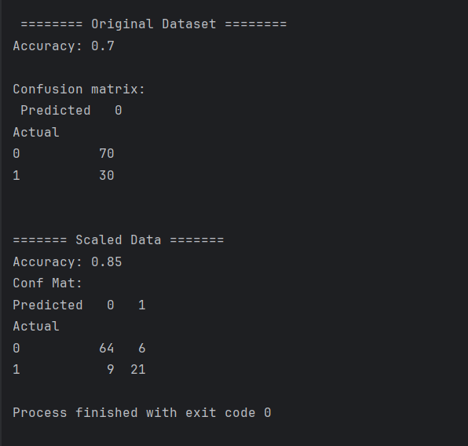

Which model is better?
Model with scaled dataset

StandardScaler
Deep learning algorithms often call for zero mean and unit variance. Regression-type algorithms also benefit from normally distributed data with small sample sizes. The StandardScaler algorithm outputs something very close to a normal distribution by changing the values so the distribution standard deviation from the mean equals one. StandardScaler does distort the relative distances between the feature values which may not be desirable in many cases.

Example 4: StandardScaler
The StandardScaler() class calculates the standard deviation with zero degrees of freedom instead of using the usual value of 1. The sd equation becomes:

${sd}_{0 degrees freedom }$= $\sqrt{\frac{\sum_{0}^{n}{{(x-\overline{x})}^{2}}}{n}}$
Scaled value = (x-$\overline{x}$)/${sd}_{0 degrees freedom }$

This code sample shows how to calculate the scaled values that are generated through a StandardScaler calculation.

*** Showing automated results:
The first unscaled salary in the list is: 19000
$19,000 scaled using StandardScaler() is: -1.4900462352132775
*** Showing manually calculated results:
sd with 0 degrees of freedom automated: 34054.3124104716
sd with 0 degrees of freedom manually: 34054.3124104716
$19,000 scaled manually is: -1.4900462352132775

Here is the code needed to calculate this value:
import pandas as pd
PATH = "/Users/pm/Desktop/DayDocs/data/"
CSV_DATA = "computerPurchase.csv"
df = pd.read_csv(PATH + CSV_DATA)

# Separate into x and y values.
X = df[["Age", "EstimatedSalary"]]
y = df['Purchased']

# Split data.
from sklearn.preprocessing import StandardScaler
import numpy as np

def showAutomatedScalerResults(X):
sc_x = StandardScaler()
X_Scale = sc_x.fit_transform(X)
salary = X.iloc[0][1]
scaledSalary = X_Scale[0][1] # Get first scaled salary.
print("The first unscaled salary in the list is: " + str(salary))
print("$19,000 scaled using StandardScaler() is: " + str(scaledSalary))

def getSD_with_zeroDegreesFreedom(X):
mean = X['EstimatedSalary'].mean()

# StandardScaler calculates the standard deviation with zero degrees of freedom.
s1 = df['EstimatedSalary'].std(ddof=0)
print("sd with 0 degrees of freedom automated: " + str(s1))

# This is the same calculation manually. (**2 squares the result)
s2 = np.sqrt(np.sum(((X['EstimatedSalary'] - mean) ** 2)) / (len(X)))
print("sd with 0 degrees of freedom manually: " + str(s2))

return s1

print("*** Showing automated results: ")
showAutomatedScalerResults(X)

print("\n*** Showing manually calculated results: ")
sd = getSD_with_zeroDegreesFreedom(X)
mean = df['EstimatedSalary'].mean()
scaled = (19000 - mean) / sd

print("$19,000 scaled manually is: " + str(scaled))

Example 5: Using StandarScaler()
As you can see in Figure 3, the output from scaling is a transformation which creates similarly sized and shaped distributions for both predictor variables.

Figure 3: Comparing Distributions Before and After StandardScaler
Salary No Scaling | Age No Scaling | Together Before Scale | StandardScaled
 |  |  | 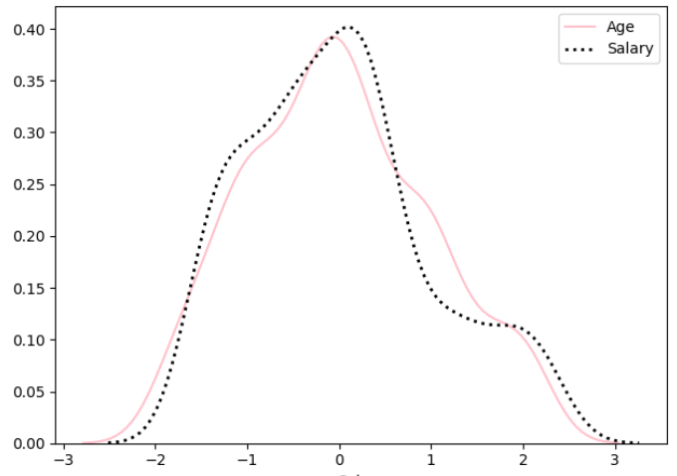

To enable StandardScaler, replace both references to MinMaxScaler in Example 3Example 1 with StandardScaler.

RobustScaler
RobustScaler transforms the feature vector by subtracting the median and then dividing by the interquartile range (75% value — 25% value). RobustScaler users less data so it reduces the influence of outliers.

RobustScaler = $\frac{x_{i}-median}{Q_{3}\left(x\right)-Q_{1}\left(x\right) }$ = $\frac{x_{i}-Q_{2}\left(x\right)}{Q_{3}\left(x\right)-Q_{1}\left(x\right) }$

Here are the results without and with scaling:

No Scaling | RobustScaler
Accuracy: 0.68  Predicted 0  Actual  0 68  1 32 | Accuracy: 0.9  Predicted 0 1  Actual  0 66 2  1 8 24
Age EstimatedSalary  mean 37.66 69742.50  std 10.48 34096.96  min 18.00 15000.00  25% 29.75 43000.00  50% 37.00 70000.00  75% 46.00 88000.00  max 60.00 150000.00 | Age EsitmatedSalary  mean 0.04 -0.01  std 0.65 0.76  min -1.17 -1.22  25% -0.45 -0.60  50% 0.00 0.00  75% 0.55 0.40  max 1.42 1.78
For this case, the distributions do not change much since there are no significant outliers.
Salary No Scaling | Age No Scaling | Together Before Scale | RobustScaler
 |  |  | 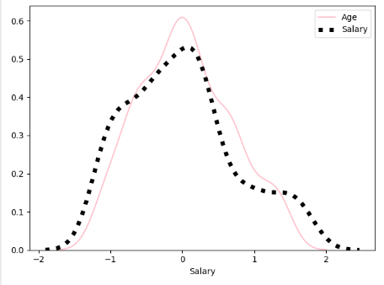

Here is a sample RobustScaler calculation for salary:

Salary = 57,000
$Q_{1}$(x) = 43,000 $Q_{2}$(x) = 88,000

$\frac{x_{i}-median}{Q_{3}\left(x\right)-Q_{1}\left(x\right) }$ = $\frac{x_{i}-Q_{2}\left(x\right)}{Q_{3}\left(x\right)-Q_{1}\left(x\right) }$ =

RobustScaler = $\frac{x- Q_{2}(x)}{Q_{3}\left(x\right) - Q_{1}\left(x\right)}$ = $\frac{57,000-70,000}{88,000-43,000}$ = $\frac{14000}{45000}$ = -0.29

Example 6: RobustScaler
To enable the RobustScaler replace the test/train split code in Example 3 with this version.
from sklearn.preprocessing import RobustScaler
sc_x = RobustScaler()
X_Scale = sc_x.fit_transform(X)

# Split data.
X_train, X_test, y_train, y_test = train_test_split(
X_Scale, y, test_size=0.25, random_state=0)

Exercise 4 (1 mark)
Show the RobustScaler calculation for age of 19. Please show your calculations. Examine the unscaled data in Example 1 and the scaled data set in Example 6 to check your work.
$\frac{x- Q_{2}(x)}{Q_{3}\left(x\right) - Q_{1}\left(x\right)}$ = $\frac{19-37.0}{46.0-29.75}$ = $\frac{-18}{16.25}= -1.1077$

Exercise 5 (1 mark)
Show the RobustScaler calculation for a salary of 15,000. Examine the unscaled data in Example 1 and the scaled data set in Example 6 to check your work.
$\frac{x- Q_{2}(x)}{Q_{3}\left(x\right) - Q_{1}\left(x\right)}$ = $\frac{1500-70,000}{88,000-43,000}$ = $\frac{-55000}{45000}= -1.3043$

Comparing MinMax, Standard and Robust Scalers

- Use MinMaxScaler as the default if you are transforming a feature. It is non-distorting.
- Use RobustScaler if you have outliers and want to reduce their influence. However, you might be better off removing the outliers, instead.
- Use StandardScaler if you need a relatively normal distribution.

Cross Fold Validation
Cross fold validation is a common procedure for splitting data. There are several variations of cross fold validation. Today we will look at a simple implementation which splits the dataset into k groups while holding back data from each group for testing.

Example 7: Cross Fold Validation Introduction
This example demonstrates how cross fold validation splits the data into different data folds.
# scikit-learn k-fold cross-validation
from numpy import array
from sklearn.model_selection import KFold

# data sample
data = array([0.1, 0.2, 0.3, 0.4, 0.5, 0.6])

# splits data into 3 randomized folds
kfold = KFold(n_splits=3, shuffle=True)

# enumerate splits
for train, test in kfold.split(data):
print('train: %s, test: %s' % (data[train], data[test]))

The output shows how three separate random folds are created:
train: [0.1 0.3 0.5 0.6], test: [0.2 0.4]
train: [0.1 0.2 0.4 0.5], test: [0.3 0.6]
train: [0.2 0.3 0.4 0.6], test: [0.1 0.5]

Exercise 6 (2 marks)
What happens to the test sets if you change the number of folds to 4? Based on this observation what can you say about the importance of choosing a suitable number of splits?
the test sets don’t have equal length due to inconsistent splits because 6/4 is not an integer, so 2 samples get 2 and 2 gets 1. So we need to select a suitable split number so that both training and test sets have equal number of datapoints in each dataset.

Example 8: Cross Fold Validation for Logistic Regression
This example shows how to perform iterative cross fold validation for a logistic regression model for predicting purchase responses to a marketing campaign for computers. The output shows modest but arguably stable fluctuations in accuracy and effectiveness.
***K-fold: 1  Accuracy: 0.7686567164179104  Confusion Matrix  Predicted 0 1  Actual  0 75 6  1 25 28 | ***K-fold: 2  Accuracy: 0.8270676691729323  Confusion Matrix  Predicted 0 1  Actual  0 85 4  1 19 25 | ***K-fold: 3  Accuracy: 0.8421052631578947  Confusion Matrix  Predicted 0 1  Actual  0 82 5  1 16 30

An overall average accuracy and standard deviation help to identify the accuracy and stability of results across all folds:
Accuracy and Standard Deviation For All Folds:
*********************************************
Average accuracy: 0.8126098829162457
Accuracy std: 0.031680098296742884

Here is the code:
import pandas as pd
from sklearn.model_selection import train_test_split
from sklearn.linear_model import LogisticRegression
from sklearn import metrics
from sklearn.preprocessing import StandardScaler

PATH = "/users/patmcgee/desktop/daydocs/data/"
CSV_DATA = "computerPurchase.csv"
df = pd.read_csv(PATH + CSV_DATA, sep=',')

import numpy as np
from sklearn.model_selection import KFold

# prepare cross validation with three folds and 1 as a random seed.
kfold = KFold(n_splits=3, shuffle=True)
accuracyList = []
foldCount = 0

def getTestAndTrainData(trainIndexes, testIndexes, df):
dfTrain = df.iloc[trainIndexes, :] # Gets all rows with train indexes.
dfTest = df.iloc[testIndexes, :]
X_train = dfTrain[['EstimatedSalary', 'Age']]
X_test = dfTest[['EstimatedSalary', 'Age']]
y_train = dfTrain[['Purchased']]
y_test = dfTest[['Purchased']]
return X_train, X_test, y_train, y_test

for trainIdx, testIdx in kfold.split(df):
X_train, X_test, y_train, y_test = \
getTestAndTrainData(trainIdx, testIdx, df)

# Recommended to only fit on training data.
# Scaling only needed for X since y ranges between 0 and 1.

scalerX = StandardScaler()
X_train_scaled = scalerX.fit_transform(X_train) # Fit and transform.
X_test_scaled = scalerX.transform(X_test) # Transform only.

# Perform logistic regression.
logisticModel = LogisticRegression(fit_intercept=True, solver='liblinear')

# Fit the model.
logisticModel.fit(X_train_scaled, y_train)
y_pred = logisticModel.predict(X_test_scaled)
y_prob = logisticModel.predict_proba(X_test_scaled)

# Show confusion matrix and accuracy scores.
y_test_array = np.array(y_test['Purchased'])
cm = pd.crosstab(y_test_array, y_pred, rownames=['Actual'],
colnames=['Predicted'])

print("\n***K-fold: " + str(foldCount))
foldCount += 1
accuracy = metrics.accuracy_score(y_test, y_pred)
accuracyList.append(accuracy)

print('\nAccuracy: ', accuracy)
print("\nConfusion Matrix")
print(cm)

from sklearn.metrics import classification_report, roc_auc_score
print(classification_report(y_test, y_pred))

from sklearn.metrics import precision_score
precision = precision_score(y_test, y_pred)
print('Precision: {0:0.2f}'.format(precision))

# calculate scores
auc = roc_auc_score(y_test, y_prob[:, 1], )
print('Logistic: ROC AUC=%.3f' % (auc))
print("\nAccuracy and Standard Deviation For All Folds:")
print("*********************************************")
print("Average accuracy: " + str(np.mean(accuracyList)))
print("Accuracy std: " + str(np.std(accuracyList)))

Exercise 7 (6 marks)
Run the code for Example 8. Each time though, adjust the code to use either MinMaxScaler, StandardScaler and RobustScaler. You can make the adjustment in the highlighted section of the code. Record your results in Table 2 that follows the code.

Table 2: Comparing Scaler Results
Scale Type | Average  Accuracy | Accuracy Std | Average  Precision | Precision  Std | Average  Recall | Recall  Std
MinMax Scaler | 0.8200 | 0.0307 | 0.8333 | 0.0863 | 0.7750 | 0.1684
Standard Scaler | 0.8450 | 0.0154 | 0.8427 | 0.0187 | 0.8141 | 0.1094
Robust Scaler | 0.8400 | 0.0155 | 0.8393 | 0.0196 | 0.8063 | 0.1227

Exercise 8 (2 marks)
Does any scaler in Table 2 stand out as one that enables a better model? Does any scaler produce sub-optimal results? Please explain.
Standard Scaler and Robust Scaler are both competive but no much difference, MinMax scaler seems to have a lower recall score and higher standard deviation of all metrics.

Example 9: Linear Regression without Scaling
Scaling can improve the results of linear regression as well. Without scaling, when performing linear regression with the sklearn wine dataset for predicting quality, the RMSE is 0.3723. Here is the model summary.

OLS Regression Results
==============================================================================
Dep. Variable: target R-squared: 0.914
Model: OLS Adj. R-squared: 0.909
Method: Least Squares F-statistic: 176.6
Prob (F-statistic): 5.88e-67
Time: 17:03:08 Log-Likelihood: 7.5102
No. Observations: 142 AIC: 2.980
Df Residuals: 133 BIC: 29.58
Df Model: 8
Covariance Type: nonrobust
================================================================================================
coef std err t P>|t| [0.025 0.975]
------------------------------------------------------------------------------------------------
const 2.0788 0.213 9.768 0.000 1.658 2.500
alcalinity_of_ash 0.0307 0.007 4.538 0.000 0.017 0.044
total_phenols 0.2225 0.068 3.277 0.001 0.088 0.357
flavanoids -0.5359 0.054 -9.833 0.000 -0.644 -0.428
nonflavanoid_phenols -0.4999 0.198 -2.519 0.013 -0.892 -0.107
proanthocyanins 0.1138 0.046 2.461 0.015 0.022 0.205
color_intensity 0.0469 0.012 4.048 0.000 0.024 0.070
od280/od315_of_diluted_wines -0.3130 0.054 -5.783 0.000 -0.420 -0.206
proline -0.0008 9.52e-05 -8.305 0.000 -0.001 -0.001

Here is the full application:
import pandas as pd
import numpy as np
from sklearn import datasets
from sklearn.model_selection import train_test_split
import statsmodels.api as sm
import numpy as np
from sklearn import metrics

wine = datasets.load_wine()
dataset = pd.DataFrame(
data=np.c_[wine['data'], wine['target']],
columns=wine['feature_names'] + ['target']
)

# Create copy to prevent overwrite.
X = dataset.copy()
del X['target'] # Remove target variable
del X['hue'] # Remove unwanted features
del X['ash']
del X['magnesium']
del X['malic_acid']
del X['alcohol']

y = dataset['target']

# Adding an intercept *** This is requried ***. Don't forget this step.
X = sm.add_constant(X)
X_train, X_test, y_train, y_test = train_test_split(X, y, test_size=0.2)

model = sm.OLS(y_train, X_train).fit()
predictions = model.predict(X_test) # make the predictions by the model

print(model.summary())
print('Root Mean Squared Error:', np.sqrt(metrics.mean_squared_error(y_test, predictions)))

Example 10: Linear Regression with Scaling
This example shows how scaling data can sometimes improve the results of linear regression. For this case, the difference is mildly better but for some cases and machine learning algorithms the improvement can be quite dramatic.

Note that when scaling data for logistic regression the y values were not scaled since they already range between 0 and 1. However, for linear regression the y values are scaled along with the X features so all features are normalized.

Note about Reshaping Data

This is awkward, however the scaling transformation functions require an array of feature arrays as inputs. In other words, when y is in a DataFrame format:

y_train
161 2.0
92 1.0
94 1.0
174 2.0

We get the error:
Reshape your data either using array.reshape(-1, 1) …

We need to convert the data to the following format:

array([[2.],
[1.],
[1.],
[2.],
[0.],
[0.],…

We can convert the data with the following code:
yReshaped = np.array(y_train).reshape(-1,1)
y_train_scaled = sc_y.fit_transform(yReshaped)

Converting Data Back to the Original Scale
Since RMSE describes the average dispersion of predicted values away from the actual values, the scaled predictions need to be transformed back to the original scale so the RMSE score is comparable to models without scaling.
predictions = sc_y.inverse_transform(np.array(unscaledPredictions).reshape(-1,1))
print('Root Mean Squared Error:',
np.sqrt(metrics.mean_squared_error(y_test, predictions)))

To build this example, replace these instructions
model = sm.OLS(y_train, X_train).fit()
predictions = model.predict(X_test) # make the predictions by the model

in Example 9 with the following code:
from sklearn.preprocessing import RobustScaler
sc_x = RobustScaler()
X_train_scaled = sc_x.fit_transform(X_train)
X_test_scaled = sc_x.transform(X_test)

# Create y scaler. Only scale y_train since evaluation
# will use the actual size y_test.
sc_y = RobustScaler()
y_train_scaled = sc_y.fit_transform(np.array(y_train).reshape(-1,1))

model = sm.OLS(y_train_scaled, X_train_scaled).fit()
scaledPredictions = model.predict(X_test_scaled) # make predictions

# Rescale predictions back to actual size range.
predictions = sc_y.inverse_transform(np.array(scaledPredictions).reshape(-1,1))

Exercise 9 (1 mark)
Compare the RMSE results for Example 9 and Example 10. Which outcome is better and why?
Model example 10 shows a slightly better result as the RMSE is lower

Saving and Reusing Scalers
To save on time and to be consistent, production code does not include training code. However, to build the scaler it must be trained. The following code can be included to save the scaler to a binary file that uses the pickle format.

from pickle import dump, load
dump(sc_x, open('sc_x.pkl', 'wb'))

When the scaler is needed in production it can then be loaded.

loaded_scalerX = load(open('sc_x.pkl', 'rb'))

Example 11: Saving and Reusing Scalers
This example provides an overly simplified view of how to train the scaler, save it and then load it to make predictions. Normally though the scaler would be loaded by production code that is stored in a separate class or file.
import pandas as pd
import numpy as np
from sklearn import datasets
from sklearn.model_selection import train_test_split
import statsmodels.api as sm
import numpy as np
from sklearn import metrics

wine = datasets.load_wine()
dataset = pd.DataFrame(
data=np.c_[wine['data'], wine['target']],
columns=wine['feature_names'] + ['target']
)

# Create copy to prevent overwrite.
X = dataset.copy()
del X['target'] # Remove target variable
del X['hue'] # Remove unwanted features
del X['ash']
del X['magnesium']
del X['malic_acid']
del X['alcohol']

y = dataset['target']

# Adding an intercept *** This is requried ***. Don't forget this step.
X = sm.add_constant(X)
X_train, X_test, y_train, y_test = train_test_split(X, y, test_size=0.2)

from sklearn.preprocessing import RobustScaler
sc_x = RobustScaler()
X_train_scaled = sc_x.fit_transform(X_train)

# Create y scaler. Only scale y_train since evaluation
# will use the actual size y_test.
sc_y = RobustScaler()
y_train_scaled = sc_y.fit_transform(np.array(y_train).reshape(-1,1))

# Save the fitted scalers.
from pickle import dump, load
dump(sc_x, open('sc_x.pkl', 'wb'))
dump(sc_y, open('sc_y.pkl', 'wb'))

# Build model with training data.
model = sm.OLS(y_train_scaled, X_train_scaled).fit()

# Load the scalers.
loaded_scalerX = load(open('sc_x.pkl', 'rb'))
loaded_scalery = load(open('sc_y.pkl', 'rb'))

X_test_scaled = loaded_scalerX.transform(X_test)
scaledPredictions = model.predict(X_test_scaled) # make predictions

# Rescale predictions back to actual size range.
predictions = loaded_scalery.inverse_transform(
np.array(scaledPredictions).reshape(-1,1))

print(model.summary())
print('Root Mean Squared Error:',
np.sqrt(metrics.mean_squared_error(y_test, predictions)))

Exercise 10 (4 marks)
You can use the binary pickle format to save and load models as well. Modify the code in Example 11 to save the trained model and then load it to make the prediction. Show your revised code as text here:
import pandas as pd
import numpy as np
import statsmodels.api as sm
from sklearn.preprocessing import RobustScaler
from sklearn import metrics
from sklearn import datasets
from sklearn.model_selection import train_test_split
from pickle import dump, load
pd.set_option("display.max_columns", None)
pd.set_option("display.width", 1000)
wine = datasets.load_wine()
df = pd.DataFrame(data=np.c_[wine['data'], wine['target']],
columns=wine['feature_names'] + ['target'])
print(df.head())
X = df[['alcalinity_of_ash', 'total_phenols', 'flavanoids',
'nonflavanoid_phenols', 'proanthocyanins', 'color_intensity',
'od280/od315_of_diluted_wines', 'proline']]
y = df['target']
X = sm.add_constant(X)
# split dataset
X_train, X_test, y_train, y_test = train_test_split(
X, y, test_size=0.2
)
sc_X = RobustScaler()
# scale features
X_train_scaled = sc_X.fit_transform(X_train)
X_test_scaled = sc_X.fit_transform(X_test)
# scale target
sc_y = RobustScaler()
y_train_scaled = sc_y.fit_transform(np.array(y_train).reshape(-1, 1))
model = sm.OLS(y_train_scaled, X_train_scaled).fit()
y_pred_scaled = model.predict(X_test_scaled)
# rescale predictions back to actual size range
y_pred = sc_y.inverse_transform(np.array(y_pred_scaled).reshape(-1, 1))
print(model.summary())
print(f"RMSE: {np.sqrt(metrics.mean_squared_error(y_test, y_pred))}")
####################################################################
### Saving and Loading models
# save scalers
dump(model, open('ols_model.pkl', 'wb'))
# load scalers
loaded_model = load(open('ols_model.pkl', 'rb'))
y_pred_loaded = loaded_model.predict(X_test_scaled)
y_pred = sc_y.inverse_transform(np.array(y_pred_loaded).reshape(-1, 1))
print(f"RMSE from loaded model: {np.sqrt(metrics.mean_squared_error(y_test, y_pred))}")

RMSE: 0.4790788621458605
RMSE from loaded model: 0.4790788621458605

