Table of Contents
ROC Curves and Precision Recall Curves 1
True Positive Rate (TPR) 1
False Positive Rate (FPR) 1
Automated Feature Selection 3
Backward Feature Elimination 3
Selecting Features with the Chi-Square Test 8
Forward Feature Selection 11

ROC Curves and Precision Recall Curves
ROC stands for the Receiver Operating Characteristic curve, or ROC curve. ROC Curves summarize the trade-off between the true positive and false positive rates of a model using different probability cut-offs. ROC curves are appropriate when the observations are balanced between each class.

True Positive Rate (TPR)
The true positive rate summarizes how well the model identifies all actual positive outcomes.
True Positive Rate (Recall) = $\frac{tp}{tp+fn}$

False Positive Rate (FPR)
The false positive rate, or false alarm rate, summarizes how often positive predictions are made for actual negative outcomes.
False Positive Rate (False Alarm Rate) = $\frac{fp}{fp+tn}$
Exercise 1 (2 marks)
Given the following confusion matrix, what is the true positive rate? What is the false positive rate? Please show your calculations.
Actual |  | Predicted
 |  | 0 | 1
 | 0 | 15 | 5
 | 1 | 10 | 20

TPR = 20/(20 + 10) = 0.6667
FPR = 5 / (5 + 15) = 0.25

Exercise 2 (2 marks)
Given the following confusion matrix, what is the true positive rate? What is the false positive rate? Please show your calculations.

Actual |  | Predicted
 |  | 0 | 1
 | 0 | 20 | 15
 | 1 | 5 | 10
TPR = 10 / (10 + 5) = 0.6667
FPR = 15 / (15 + 20) = 0.4286

Exercise 3 (1 mark)
Do the confusion matrices presented in Exercise 1and Exercise 2 rely on probability cut-off in any way? What is the default probability cut-off (threshold) for logistic regression during binary classification?
Confused about the first part as to what indication given here to answer the question?

Default cut-off is 0.5 for binary classfication with logistic regression.

Figure 1 shows both poor and desirable ROC curves. When the true and false positive rates are calculated, samples are sequenced by placing the most probable positive target candidates the left. Having the most probable targets at the left ensures the lowest estimated false positive rate and the highest true positive rate early on. As the prediction probability cut-off is reduced towards the right the tpr/fpr ratio is reduced. The straight line represents a one-to-one ratio of the true positive rate over the false positive rate. In other words, a curve over the dashed line indicates the model’s ability to beat a random guess. When the data and model have been prepared properly, an area under the curve value close to 1 is the best scenario.

Figure 1: Poor and Desirable ROC Curves
Poor AUC=0.482 |  | Good AUC = 0.98
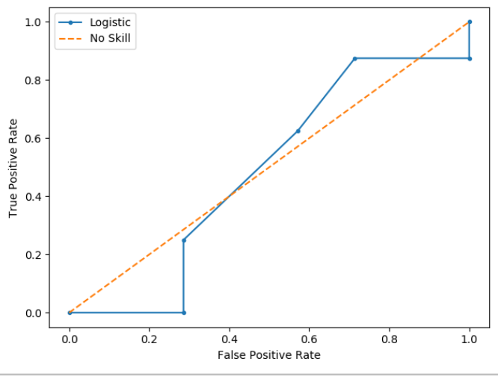 | Predicted  0 2 5  1 1 7 | 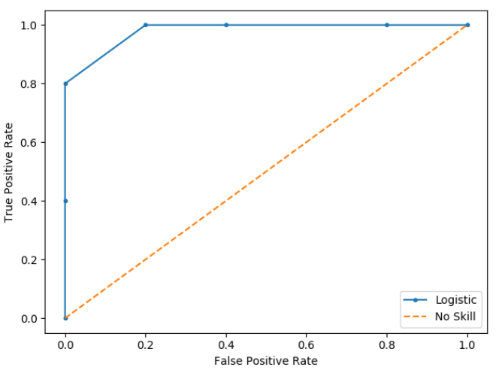 | Predicted  0 3 2  1 0 5

This video by Josh Stormer offers an excellent description of how ROC curves work.
https://www.youtube.com/watch?v=4jRBRDbJemM

Example 1: Simple ROC Curve
The ROC curve in Figure 2 shows how cut-off affects true and false positive rates.

Figure 2: ROC Curve with Cut-off and True Positive Count Information
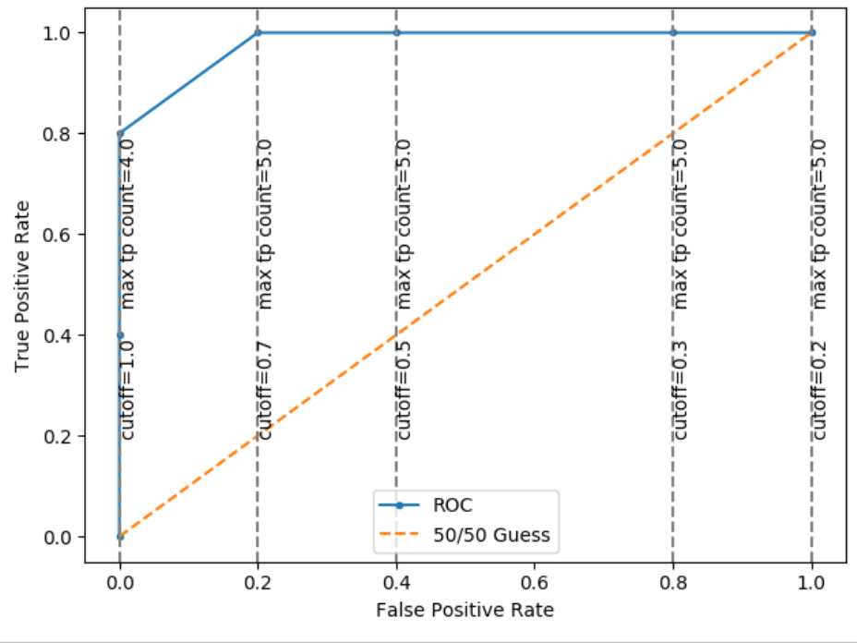

Automated Feature Selection
In this section we will look at common algorithms for feature selection with logistic regression.

Backward Feature Elimination
Backward feature elimination begins by starting with a model which contains all existing features. When the model is trained and tested, the least significant variable is dropped.

Backward feature elimination is implemented with sklearn through Recursive Feature Elimination (RFE).

Example 2: Using Recursive Feature Elimination (Backward Feature Elimination)
This example shows how to use the RFE library for backward feature elimination. The code starts with all features for logistic regression with a divorce Divorce.csv file to identify the top 8 features to predict divorce.

# Create the object of the model
model = LogisticRegression()

# Specify the number of features to select
rfe = RFE(model, n_features_to_select = 8)

# fit the model
rfe = rfe.fit(X, y)

The output is:
FEATUERS SELECTED
[False False True False False True False False False False False False
False False False False True True False False False False False False
False True False False False False False False False False False False
False False True True False False False False False False False False
True False False False False False]

RANKING OF FEATURES
[13 9 1 28 24 1 47 38 33 41 29 27 32 17 8 26 1 1 6 5 31 44 42 37
25 1 30 2 15 11 3 19 22 12 36 18 43 14 1 1 16 23 20 7 45 40 34 35
1 21 46 4 10 39]

The eight most significant features that are identified by backwards feature elimination correspond to the following survey questions:
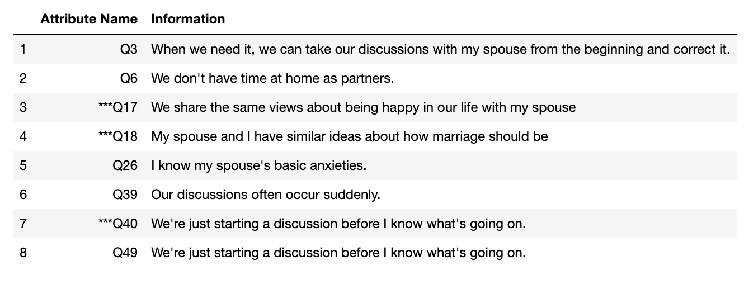
Here is the code.

# Importing required libraries:
import warnings
warnings.simplefilter(action="ignore", category=FutureWarning)
import numpy as np
import matplotlib.pyplot as plt
import pandas as pd
from sklearn import metrics
from sklearn.model_selection import train_test_split
from sklearn.linear_model import LogisticRegression
from sklearn.feature_selection import RFE

# Read the data:
PATH = '/users/pm/desktop/daydocs/data/'
df = pd.read_csv(PATH + "Divorce.csv", header = 0)

# Seperate the target and independent variable
X = df.copy() # Create separate copy to prevent unwanted tampering of data.
del X['Divorce'] # Delete target variable.

# Target variable
y = df['Divorce']

# Create the object of the model
model = LogisticRegression()

# Specify the number of features to select
rfe = RFE(model, n_features_to_select = 8)

# fit the model
rfe = rfe.fit(X, y)

# Please uncomment the following lines to see the result
print('\n\nFEATURES SELECTED\n\n')
print(rfe.support_)

# Show top features.
for i in range(0, len(X.keys())):
if(rfe.support_[i]):
print(X.keys()[i])

Example 3: Logistic Regression with Selected Features
Since the most significant features have been identified in Example 2, the following code uses the significant features in the classification. Here is the output that results:

Confusion Matrix
Predicted 0 1
Actual
0 22 0
1 1 20

Recall: 0.9523809523809523
Precision: 1.0
F1: 0.975609756097561
Accuracy: 0.9767441860465116

To enable the logistic regression and model evaluation, add this code to Example 2.
from sklearn.metrics import precision_score, recall_score, f1_score, accuracy_score
def buildAndEvaluateClassifier(features, X, y):
# Re-assign X with significant columns only after chi-square test.
X = X[features]

# Split data.
X_train, X_test, y_train, y_test = train_test_split(X, y, test_size=0.25, random_state=0)

# Perform logistic regression.
logisticModel = LogisticRegression(fit_intercept=True, solver='liblinear', random_state=0)

# Fit the model.
logisticModel.fit(X_train, y_train)
y_pred = logisticModel.predict(X_test)
# print(y_pred)

# Show accuracy scores.
print('Results without scaling:')

# Show confusion matrix
cm = pd.crosstab(y_test, y_pred, rownames=['Actual'], colnames=['Predicted'])
print("\nConfusion Matrix")
print(cm)

print("Recall: " + str(recall_score(y_test, y_pred)))
print("Precision: " + str(precision_score(y_test, y_pred)))
print("F1: " + str(f1_score(y_test, y_pred)))
print("Accuracy: " + str(accuracy_score(y_test, y_pred)))
features = ['Q3', 'Q6', 'Q17', 'Q18', 'Q26', 'Q39', 'Q40', 'Q49']
buildAndEvaluateClassifier(features, X, y)

Exercise 4 (6 marks)
This following creates dummy variables to generate a very large number of columns. Here is the code which prepares the data:
from sklearn.model_selection import train_test_split
from sklearn.preprocessing import StandardScaler, MinMaxScaler
from sklearn.metrics import roc_auc_score
import matplotlib.pyplot as plt
import pandas as pd
import numpy as np

PATH = "/Users/pm/Desktop/DayDocs/data/"
CSV_DATA = "bank-additional-full.csv"
df = pd.read_csv(PATH + CSV_DATA,
skiprows=1, # Don't include header row as part of data.
encoding="ISO-8859-1", sep=';',
names=(
"age", "job", "marital", "education", "default", "housing", "loan", "contact",
"month", "day_of_week", "duration", "campaign", "pdays", "previous", "poutcome",
"emp.var.rate", "cons.price.idx", "cons.conf.idx", "euribor3m", "nr.employed", "y"))
pd.set_option('display.max_columns', None)
pd.set_option('display.width', 1000)

print(df.head())
print(df.describe().transpose())
print(df.info())

targetList = []
for i in range(0, len(df)):
if (df.loc[i]['y'] == 'yes'):
targetList.append(1)
else:
targetList.append(0)
df['target'] = targetList

tempDf = df[["job", "marital", "education", "default","housing", "loan", "contact", "month", "day_of_week", "poutcome"]] # Isolate columns
dummyDf = pd.get_dummies(tempDf, columns=["job", "marital", "education", "default",
"housing", "loan", "contact", "month", "day_of_week", "poutcome"]) # Get dummies
df = pd.concat(([df, dummyDf]), axis=1) # Join dummy df with original df

X = df[[
"age", "duration", "campaign", "pdays", "previous", "emp.var.rate", "cons.price.idx",
"cons.conf.idx", "euribor3m", "nr.employed", "job_admin.", "job_blue-collar",
"job_entrepreneur", "job_housemaid", "job_management", "job_retired",
"job_self-employed", "job_services", "job_student", "job_technician", "job_unemployed",
"job_unknown", "marital_divorced", "marital_married", "marital_single",
"marital_unknown", "education_basic.4y", "education_basic.6y", "education_basic.9y",
"education_high.school", "education_illiterate", "education_professional.course",
"education_university.degree", "education_unknown", "default_no",
"default_unknown", "default_yes", "housing_no", "housing_unknown", "housing_yes",
"loan_no", "loan_unknown", "loan_yes", "contact_cellular", "contact_telephone",
"month_apr", "month_aug", "month_dec", "month_jul", "month_jun", "month_mar",
"month_may", "month_nov", "month_oct", "month_sep", "day_of_week_fri",
"day_of_week_mon", "day_of_week_thu", "day_of_week_tue", "day_of_week_wed",
"poutcome_failure", "poutcome_nonexistent", "poutcome_success", ]]
y = df[['target']]
print(X.head())

Note: To make exercise work without the following solver must be set when defining the logistic regression model. Also, it will help to specify 15 features explicitly.
# Create the object of the model
model = LogisticRegression(solver='liblinear')
# Specify the number of features to select
rfe = RFE(estimator=model, n_features_to_select=15)

Which top 15 features are identified by RFE?
Selected Features
['previous' 'euribor3m' 'job_retired' 'job_student' 'default_no'
'contact_telephone' 'month_apr' 'month_aug' 'month_mar' 'month_may'
'month_nov' 'day_of_week_mon' 'poutcome_failure' 'poutcome_nonexistent'
'poutcome_success']

Automate the column selection with RFE to identify the top 15 most significant features. Show your full program here:
def select_features_rfe(model, X, y, num_features):
rfe = RFE(model, n_features_to_select=num_features)
rfe.fit(X, y)
print("\n\n============================================================")
print("Selected Features")
# use the mask returned by RFE to apply on the column names array
selected_features = X.keys()[rfe.support_ == True]
print(selected_features.values)
logistic_model = LogisticRegression(solver='liblinear')
select_features_rfe(logistic_model, X, y, num_features=15)

Selecting Features with the Chi-Square Test
When logistic regression was introduced, the chi-square test was used to identify significant predictor values. A chi-square score of 3.8 or greater indicates that the feature is significant.

Example 4: Identifying the Top Predictor Columns with the Chi-Square Test
This next example continues from the initial sample provided in Exercise 4. In this example, a chi-square test is performed to select the top features which enable the best performing model. Ideally, before modelling the insignificant columns would be removed. These are the selected columns and corresponding chi-square scores below:

chi-square score feature
26 4.315471 education_basic.4y
52 5.160439 month_nov
57 6.281413 day_of_week_thu
20 8.742603 job_unemployed
…
53 763.644573 month_oct
50 842.916583 month_mar
8 890.685536 euribor3m
62 3982.548056 poutcome_success

To implement feature selection with the chi-square test, add this code to the end of the script that is provided for Exercise 4.
from sklearn.linear_model import LogisticRegression
# Show chi-square scores for each feature.
# There is 1 degree freedom since 1 predictor during feature evaluation.
# Generally, >=3.8 is good)
from sklearn.feature_selection import chi2
from sklearn.feature_selection import SelectKBest
test = SelectKBest(score_func=chi2, k=15)

# Use scaled data to fit KBest
XScaled = MinMaxScaler().fit_transform(X)
chiScores = test.fit(XScaled, y) # Summarize scores
np.set_printoptions(precision=3)

# Search here for insignificant features.
print("\nPredictor Chi-Square Scores: " + str(chiScores.scores_))

# Create a sorted list of the top features.
dfFeatures = pd.DataFrame()
for i in range(0, len(chiScores.scores_)):
headers = list(X.keys())
featureObject = {"feature":headers[i], "chi-square score":chiScores.scores_[i]}
dfFeatures = dfFeatures.append(featureObject, ignore_index=True)

print("\nTop Features")
dfFeatures = dfFeatures.sort_values(by=['chi-square score'], ascending=False)
print(dfFeatures.tail(40))

Example 5: Logistic Regression with Chi-Square Selected Features
This example uses the chi-square selected features to build and evaluate the logistic regression model for predicting responses to a bank marketing campaign.

Results suggest that the model has trouble identifying the target variable. However, only 10% of the values in the data set indicate a positive response so 41% recall is actually decent.

Recall: 0.41450777202072536
Precision: 0.6779661016949152
F1: 0.5144694533762058
Accuracy: 0.912013207730407

Here is the code:
from sklearn.metrics import precision_score, recall_score, f1_score, accuracy_score
def buildAndEvaluateClassifier(features, X, y):
# Re-assign X with significant columns only after chi-square test.
X = X[features]

# Split data.
X_train, X_test, y_train, y_test = train_test_split(X, y, test_size=0.25)

# Perform logistic regression.
logisticModel = LogisticRegression(fit_intercept=True, solver='liblinear')

# Fit the model.
logisticModel.fit(X_train, y_train)
y_pred = logisticModel.predict(X_test)
y_prob = logisticModel.predict_proba(X_test)
# print(y_pred)

# Show accuracy scores.
print('Results without scaling:')

print("Recall: " + str(recall_score(y_test, y_pred)))
print("Precision: " + str(precision_score(y_test, y_pred)))
print("F1: " + str(f1_score(y_test, y_pred)))
print("Accuracy: " + str(accuracy_score(y_test, y_pred)))
return X_test, y_test, y_pred, y_prob

X_test, y_test, y_pred, y_prob =\
buildAndEvaluateClassifier(dfFeatures['feature'], X, y)

Exercise 5 (4 marks)
Add this code to the end of Example 4 to display the confusion matrix and ROC curve.
from sklearn.metrics import roc_curve
from sklearn.metrics import roc_auc_score

auc = roc_auc_score(y_test, y_prob[:, 1],)
print('Logistic: ROC AUC=%.3f' % (auc))

# calculate roc curves
lr_fpr, lr_tpr, _ = roc_curve(y_test, y_prob[:, 1])
plt.plot(lr_fpr, lr_tpr, marker='.', label='Logistic')
plt.plot([0,1], [0,1], '--', label='No Skill')
plt.xlabel('False Positive Rate')
plt.ylabel('True Positive Rate')
plt.legend()
plt.show()

print(df['target'].value_counts())

Exercise 6 (4 marks)
Modify Example 5 to only perform logistic regression with the top 15 features that are identified with the chi square test. Show your ROC curve for 15-features selected by chi-square here:
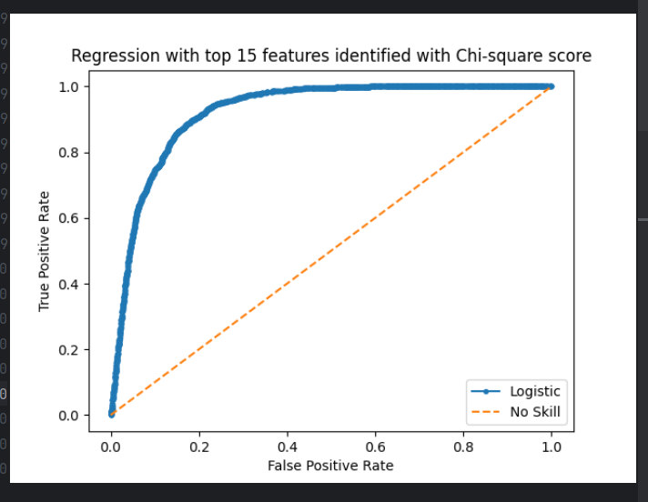

Exercise 7 (8 marks)
Perform logistic regression for the bank-additional-full.csv dataset but this time use the top 15 features that were identified by using RFE instead of chi-square scores. In a table, compare precision, recall, accuracy, f1 and AUC scores for the two models from this exercise and from Exercise 6. Show your table here:
Feature Selection Method | Recall | Precision | F1 | Accuracy | ROC AUC
Chi-square | 0.2899 | 0.6511 | 0.4011 | 0.8988 | 0.9219
RFE | 0.1944 | 0.6888 | 0.3032 | 0.8982 | 0.7844

Based on the table that you generated in the last step, what conclusions can you make about the performance of chi-square versus RFE for an 15-feature set?
In general, the metrics indicate chi-square model performs better than RFE on a 15 top features dataset.

Forward Feature Selection

Forward feature selection is another process that is used to find the optimal feature set for a model. Forward feature selection starts by finding the single best feature. Then it adds the next best feature. Additional features are added incrementally in the same manner.

Example 6: Forward Feature Selection
This example shows how to implement forward feature selection with the Divorce.csv dataset. It is interesting to note that even though the Divorce.csv dataset has 54 features only the following 8 features were selected. (See Figure 3 for detail about the selected features).

['Q9', 'Q11', 'Q15', 'Q17', 'Q18', 'Q19', 'Q20', 'Q40']

When backward feature elimination (RFE) was used, questions Q17, Q18 and Q40 were also selected. However, overall the forward and backward selected feature sets are quite different.

Figure 3: Selected Forward Feature Detail
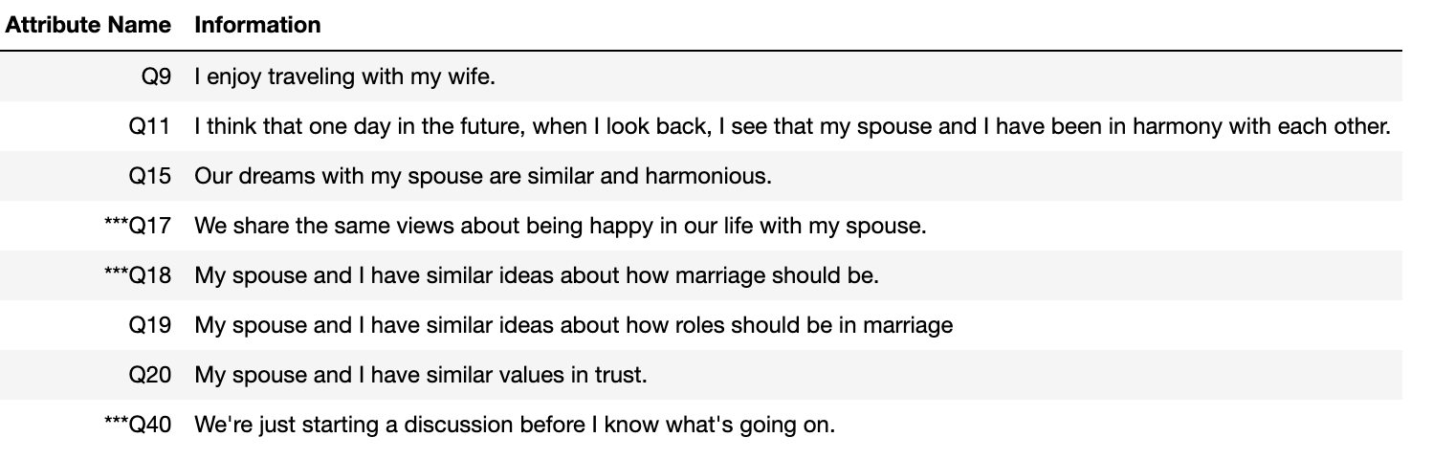
Here is the code.
import pandas as pd
from sklearn.feature_selection import f_regression

# Read the data:
df = pd.read_csv("/users/pm/desktop/daydocs/data/Divorce.csv", header=0)

# Seperate the target and independent variable
X = df.copy() # Create separate copy to prevent unwanted tampering of data.
del X['Divorce'] # Delete target variable.

# Target variable
y = df['Divorce']

# f_regression is a scoring function to be used in a feature selection procedure
# f_regression will compute the correlation between each regressor and the target
ffs = f_regression(X, y)

variable = []
for i in range(0, len(X.columns) - 1):
if ffs[0][i] >= 700:
variable.append(X.columns[i])

print(variable)

Exercise 8 (10 marks)
Use forward feature selection to identify the top features in the bank-additional-full.csv dataset. What features are most significant?
['duration', 'pdays', 'previous', 'emp.var.rate', 'cons.price.idx', 'euribor3m', 'nr.employed', 'contact_cellular', 'contact_telephone', 'month_mar', 'month_oct', 'poutcome_nonexistent']

In the following table identify the top features that are selected using the following methods:
Chi Square | RFE (Backwards elimination) | Forward selection
poutcome_success  euribor3m  month_mar  month_oct  month_sep  contact_telephone  emp.var.rate  nr.employed  previous  duration  job_student  job_retired  month_may  default_unknown  contact_cellular | ['previous' 'euribor3m' 'job_retired' 'job_student' 'default_no'  'contact_telephone' 'month_apr' 'month_aug' 'month_mar' 'month_may'  'month_nov' 'day_of_week_mon' 'poutcome_failure' 'poutcome_nonexistent'  'poutcome_success'] | ['duration', 'pdays', 'previous', 'emp.var.rate', 'cons.price.idx', 'euribor3m', 'nr.employed', 'contact_cellular', 'contact_telephone', 'month_mar', 'month_oct', 'poutcome_nonexistent']

Build a model for the bank-additional-full.csv with the top forward features. Generate the precision, recall, f1, accuracy and auc_scores. Compare your scores here for the different models.

 | Chi Square | RFE (Backwards elimination) | Forward selection
Precision | 0.6511 | 0.1944 | 0.6299
Recall | 0.2899 | 0.6888 | 0.3805
F1 | 0.4011 | 0.3032 | 0.4745
Accuracy | 0.8988 | 0.8982 | 0.9040
AUC | 0.9219 | 0.7844 | 0.9236

