Table of Contents
Forward Feature Selection for Linear Regression 1
SMOTE 5
Cumulative Gains and Lift Charts 9
Cumulative Gains Chart Shapes 11
Plotting Cumulative Gains and Lift Charts 12

Forward Feature Selection for Linear Regression

Example 1: Finding Significant Features with Forward Feature Selection for Linear Regression.
This example uses forward feature selection to estimate the most optimal features for linear regression with the wine quality data set. Forward feature selection returns an F-statistic value. Higher F-statistics imply that corresponding features are better for modeling.

feature ffs
3 residual sugar 0.301184
5 free sulfur dioxide 4.108502
8 pH 5.340462
0 fixed acidity 24.960038
4 chlorides 26.985608
7 density 50.405223
6 total sulfur dioxide 56.657818
2 citric acid 86.257726
9 sulphates 107.740433
1 volatile acidity 287.444450
10 alcohol 468.267011
Here is the code:

import pandas as pd
from sklearn.feature_selection import f_regression

# Read the data:
df = pd.read_csv("/users/pm/desktop/daydocs/data/winequality.csv")

# Seperate the target and independent variable
X = df.copy() # Create separate copy to prevent unwanted tampering of data.
del X['quality'] # Delete target variable.

# Target variable
y = df['quality']

# f_regression returns F statistic for each feature.
ffs = f_regression(X, y)

featuresDf = pd.DataFrame()
for i in range(0, len(X.columns)):
featuresDf = featuresDf._append({"feature":X.columns[i],
"ffs":ffs[0][i]}, ignore_index=True)
featuresDf = featuresDf.sort_values(by=['ffs'])
print(featuresDf)

Example 2: Linear Regression with Forward Selected Features
This example demonstrates how to implement linear regression with the top five features that were selected in Example 1. The model summary suggests that four of the five features are significant.
OLS Regression Results
==============================================================================
Dep. Variable: quality R-squared: 0.349
Model: OLS Adj. R-squared: 0.347
Method: Least Squares F-statistic: 136.7
Prob (F-statistic): 3.75e-116
Time: 12:56:57 Log-Likelihood: -1284.8
No. Observations: 1279 AIC: 2582.
Df Residuals: 1273 BIC: 2613.
Df Model: 5
Covariance Type: nonrobust
==============================================================================
coef std err t P>|t| [0.025 0.975]
------------------------------------------------------------------------------
const 2.8425 0.228 12.482 0.000 2.396 3.289
x1 0.3012 0.018 16.597 0.000 0.266 0.337
x2 -1.2908 0.124 -10.418 0.000 -1.534 -1.048
x3 0.7004 0.113 6.215 0.000 0.479 0.922
x4 -0.0445 0.116 -0.382 0.703 -0.273 0.184
x5 -0.0021 0.001 -3.672 0.000 -0.003 -0.001
==============================================================================
Omnibus: 16.445 Durbin-Watson: 2.094
Prob(Omnibus): 0.000 Jarque-Bera (JB): 22.347
Skew: -0.147 Prob(JB): 1.40e-05
Kurtosis: 3.577 Cond. No. 764.
==============================================================================
Notes:
[1] Standard Errors assume that the covariance matrix of the errors is correctly specified.
Root Mean Squared Error: 0.6280028145853614

To build this solution, start with the code in Example 1 and add the following code:
from sklearn.model_selection import train_test_split
from sklearn import metrics
import statsmodels.api as sm
import numpy as np

# Now we can build our model with forward selected features.
X = df[['alcohol', 'volatile acidity', 'sulphates',
'citric acid', 'total sulfur dioxide']]

# Adding an intercept *** This is requried ***. Don't forget this step.
# The intercept centers the error residuals around zero
# which helps to avoid over-fitting.
X = sm.add_constant(X)

X_train, X_test, y_train, y_test = train_test_split(X, y, test_size=0.2, random_state=0)

model = sm.OLS(y_train, X_train).fit()
predictions = model.predict(X_test) # make the predictions by the model

print(model.summary())

print('Root Mean Squared Error:', np.sqrt(metrics.mean_squared_error(y_test, predictions)))

Example 3: Feature Selection with RFE
This example demonstrates how to use RFE to select features for a linear regression model for predicting wine quality. It is interesting to note that a different feature set is selected by RFE than by forward feature selection:
RFE | Forward Feature Selection
volatile acidity  chlorides  density  pH  sulphates | 6 total sulfur dioxide 56.657818  2 citric acid 86.257726  9 sulphates 107.740433  1 volatile acidity 287.444450  10 alcohol 468.267011

import pandas as pd
from sklearn.feature_selection import RFE
from sklearn.linear_model import LinearRegression
# Read the data:
df = pd.read_csv("/users/pm/desktop/daydocs/data/winequality.csv")

# Seperate the target and independent variable
X = df.copy() # Create separate copy to prevent unwanted tampering of data.
del X['quality'] # Delete target variable.

# Target variable
y = df['quality']

# Create the object of the model
model = LinearRegression()

# Specify the number of features to select
rfe = RFE(model, n_features_to_select=5)

# fit the model
rfe = rfe.fit(X, y)
# Please uncomment the following lines to see the result
print('\n\nFEATUERS SELECTED\n\n')
print(rfe.support_)

columns = list(X.keys())
for i in range(0, len(columns)):
if(rfe.support_[i]):
print(columns[i])

Exercise 1 (4 marks)
Perform recursive feature elimination to find the top predictor variables for linear regression to predict housing price. See USA_Housing.csv. Show the top features.
This analysis is not useful since the dataset has only 6 feature columns, of which only 5 are suitable for RFE, and 1 label column. So the top features really depend on the specified value for ‘n_features_to_select’ parameter which cannot exceed 5.

Here is the output for both types of scaling for different numbers of top features, since there dataset is small, there seems no difference between either methods.

1 FEATURE SELECTED
=================================================
STD SCALER
[ True False False False False]
Avg. Area Income
=================================================
MM SCALER
[ True False False False False]
Avg. Area Income
=================================================

2 FEATURE SELECTED
=================================================
STD SCALER
[ True True False False False]
Avg. Area Income
Avg. Area House Age
=================================================
MM SCALER
[ True True False False False]
Avg. Area Income
Avg. Area House Age
=================================================

3 FEATURE SELECTED
=================================================
STD SCALER
[ True True False False True]
Avg. Area Income
Avg. Area House Age
Area Population
=================================================
MM SCALER
[ True True False False True]
Avg. Area Income
Avg. Area House Age
Area Population
=================================================

4 FEATURE SELECTED
=================================================
STD SCALER
[ True True True False True]
Avg. Area Income
Avg. Area House Age
Avg. Area Number of Rooms
Area Population
=================================================
MM SCALER
[ True True True False True]
Avg. Area Income
Avg. Area House Age
Avg. Area Number of Rooms
Area Population
=================================================

5 FEATURE SELECTED
=================================================
STD SCALER
[ True True True True True]
Avg. Area Income
Avg. Area House Age
Avg. Area Number of Rooms
Avg. Area Number of Bedrooms
Area Population
=================================================
MM SCALER
[ True True True True True]
Avg. Area Income
Avg. Area House Age
Avg. Area Number of Rooms
Avg. Area Number of Bedrooms
Area Population
=================================================

Perform linear regression with the top features that you identified. Show the model summary here:
1 FEATURES SELECTED
========================================================================
************** STD Fit *********************
Avg. Area Income
************** MinMax Fit *********************
Avg. Area Income
----------------------------------------------------------------------------
Model 1 Coef: [[0.63391577]]
Model 1 Intercept: [-0.00825937]
Model 1 R-squared: 0.4345552419438472
Model 1 RMSE: 0.7597138823355574
----------------------------------------------------------------------------
Model 2 Coef: [[0.78575309]]
Model 2 Intercept: [0.0530449]
Model 2 R-squared: 0.3733252765389943
Model 2 RMSE: 0.11147653070826394
========================================================================

2 FEATURES SELECTED
========================================================================
************** STD Fit *********************
Avg. Area Income
Avg. Area House Age
************** MinMax Fit *********************
Avg. Area Income
Avg. Area House Age
----------------------------------------------------------------------------
Model 1 Coef: [[0.63389578 0.45325509]]
Model 1 Intercept: [-0.00423996]
Model 1 R-squared: 0.6465876394080736
Model 1 RMSE: 0.6005738416183036
----------------------------------------------------------------------------
Model 2 Coef: [[0.77872167 0.44685516]]
Model 2 Intercept: [-0.16223464]
Model 2 R-squared: 0.5988995764763759
Model 2 RMSE: 0.09109768720172272
========================================================================

3 FEATURES SELECTED
========================================================================
************** STD Fit *********************
Avg. Area Income
Avg. Area House Age
Area Population
************** MinMax Fit *********************
Avg. Area Income
Avg. Area House Age
Area Population
----------------------------------------------------------------------------
Model 1 Coef: [[0.65238314 0.461083 0.42806293]]
Model 1 Intercept: [0.00030386]
Model 1 R-squared: 0.8058757315681163
Model 1 RMSE: 0.43770733741601225
----------------------------------------------------------------------------
Model 2 Coef: [[0.77864746 0.46600884 0.42866176]]
Model 2 Intercept: [-0.39243805]
Model 2 R-squared: 0.8002233742164947
Model 2 RMSE: 0.0652982098627386
========================================================================

4 FEATURES SELECTED
========================================================================
************** STD Fit *********************
Avg. Area Income
Avg. Area House Age
Avg. Area Number of Rooms
Area Population
************** MinMax Fit *********************
Avg. Area Income
Avg. Area House Age
Avg. Area Number of Rooms
Area Population
----------------------------------------------------------------------------
Model 1 Coef: [[0.65426145 0.46607104 0.34006645 0.42782496]]
Model 1 Intercept: [-0.00017506]
Model 1 R-squared: 0.9130224239223927
Model 1 RMSE: 0.2899769308078784
----------------------------------------------------------------------------
Model 2 Coef: [[0.78975234 0.46756849 0.37255079 0.43628797]]
Model 2 Intercept: [-0.58912004]
Model 2 R-squared: 0.9151119738122148
Model 2 RMSE: 0.04075972663564323
========================================================================

5 FEATURES SELECTED
========================================================================
************** STD Fit *********************
Avg. Area Income
Avg. Area House Age
Avg. Area Number of Rooms
Avg. Area Number of Bedrooms
Area Population
************** MinMax Fit *********************
Avg. Area Income
Avg. Area House Age
Avg. Area Number of Rooms
Avg. Area Number of Bedrooms
Area Population
----------------------------------------------------------------------------
Model 1 Coef: [[0.64970855 0.46742771 0.34811055 0.00359345 0.429965 ]]
Model 1 Intercept: [0.00297733]
Model 1 R-squared: 0.9147252318586704
Model 1 RMSE: 0.2946611968132542
----------------------------------------------------------------------------
Model 2 Coef: [[0.78613967 0.46580648 0.37269563 0.00262872 0.43245435]]
Model 2 Intercept: [-0.58479044]
Model 2 R-squared: 0.9191898868990869
Model 2 RMSE: 0.040620016463549125
========================================================================

Show the RMSE here:
Please refer to the output above as I tried to run different models with different scaling so I printed out the metrics in each iteration for summary so it’s included there.

But overall, it seems MinMax Scaling achieves better RMSE score with more features (> 4), while Standard Scaling has better R squared score with fewer features (< 4)

Exercise 2 (4 marks)
Perform forward feature selection to find the top predictor variables for linear regression to predict housing price. See USA_Housing.csv. Show the top features.
*** MinMaxScaler
feature ffs_fstat
0 Avg. Area Income 3462.564948
1 Avg. Area House Age 1287.169756
4 Area Population 1001.408749
2 Avg. Area Number of Rooms 634.632191
3 Avg. Area Number of Bedrooms 150.677576

Perform linear regression with the top features that you identified. Show the model summary here:
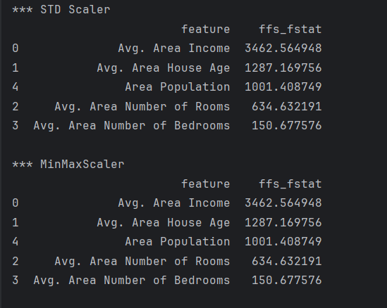

Show the RMSE here:
*************** 3 TOP FEATURES *****************
Coef: [[8.78341957e-06 6.77815936e-02 4.89236698e-02 1.00072013e-03
6.14472711e-06]]
Intercept: [-1.07996874]
R-squared: 0.9156813553899679
RMSE: 0.04217230237106924
========================================================================

*************** 4 TOP FEATURES *****************
Coef: [[8.83349440e-06 6.77154519e-02 4.89812611e-02 2.28045443e-04
6.23246256e-06]]
Intercept: [-1.08368324]
R-squared: 0.9199960569422199
RMSE: 0.041385191205133946
========================================================================

*************** 5 TOP FEATURES *****************
Coef: [[8.79137701e-06 6.72209752e-02 4.92525259e-02 1.11293213e-03
6.18967044e-06]]
Intercept: [-1.08135028]
R-squared: 0.9131196785775985
RMSE: 0.0409535951873075
========================================================================

Exercise 3 (4 marks)
Compare the scores for Exercise 1 and Exercise 2. How are the features different?
The number of feeatures is too small for this comparison to be useful since there is no essential difference of feature rankings.

Does the model summary indicate if any of the RFE or forward selected features are insignificant?
No. based on the output the model, it seems that it will perform better if all 5 features are included.

SMOTE
SMOTE corrects an imbalance from under-sampling the majority class and an over-sampling the minority class. SMOTE stands for Synthetic Minority Over-sampling Technique.

Example 4: Underrepresented Data
This example demonstrates the problem with classification models when a target class is underrepresented. When examining the risk of a stroke, Figure 1 demonstrates how the original dataset underrepresents stroke cases.

Figure 1: Underrepresentation of Stroke Cases
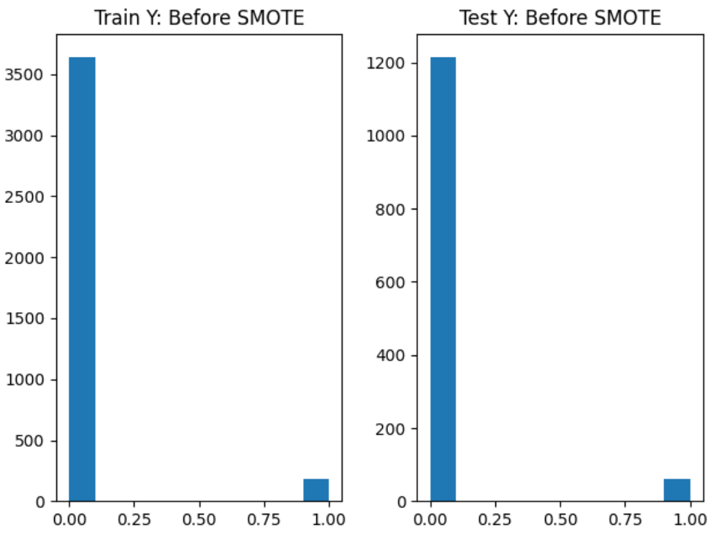

When the target class is underrepresented, the logistic regression model is unable to train properly. Prior to implementing SMOTE, the model incorrectly assumes that a stroke never occurs. As a result, the model accuracy is deceptively high but the precision and recall scores are extremely poor.

***Before SMOTE
[[1210 0]
[ 68 0]]

Precision: 0.0
Recall: 0.0
Accuracy: 0.94679186228482

Here is the code which examines the data set and builds the classifier with the imbalanced dataset.
import pandas as pd
import matplotlib.pyplot as plt
from sklearn.metrics import confusion_matrix,\
precision_score, recall_score, accuracy_score
from sklearn.model_selection import train_test_split
from sklearn.linear_model import LogisticRegression
import numpy as np

PATH = '/users/pm/desktop/daydocs/data/'
FILE = 'healthcare-dataset-stroke-data.csv'

data = pd.read_csv(PATH + FILE)

def showYPlots(y_train, y_test, title):
print("\n ***" + title)
plt.subplots(1,2)

plt.subplot(1,2 ,1)
plt.hist(y_train)
plt.title("Train Y: " + title)

plt.subplot(1,2, 2)
plt.hist(y_test)
plt.title("Test Y: " + title)
plt.show()

def evaluate_model(X_test, y_test, y_train, model, title):
showYPlots(y_train, y_test, title)

preds = model.predict(X_test)
cm = confusion_matrix(y_test, preds)
print(cm)
precision = precision_score(y_test, preds, average='binary')
print("Precision: " + str(precision))

recall = recall_score(y_test, preds, average='binary')
print("Recall: " + str(recall))

accuracy = accuracy_score(y_test, preds)
print("Accuracy: " + str(accuracy))

# Inspect data.
pd.set_option('display.max_columns', None)
pd.set_option('display.width', 1000)
print(data.head())
print(data.describe())

# Impute missing bmi values with average BMI value.
averageBMI = np.mean(data['bmi'])
data['bmi'] = data['bmi'].replace(np.nan, averageBMI)
print(data.describe())

X = data[['age','hypertension','heart_disease','avg_glucose_level','bmi']]
y = data['stroke']

# Split the data into train and test sets.
X_train, X_test, y_train, y_test = train_test_split(X, y)

# Build logistic regressor and evaluate model.
clf = LogisticRegression(solver='newton-cg', max_iter=1000)
clf.fit(X_train, y_train)
evaluate_model(X_test, y_test, y_train, clf, "Before SMOTE")

Example 5: Implementing SMOTE
SMOTE allows us to resample the training set to provide a more balanced class representation in the training set (see Figure 2).

NOTE: SMOTE is never used on the test set so we can evaluate the model during regular circumstances.

Figure 2: Equal Class Representation in the Training Set After SMOTE.
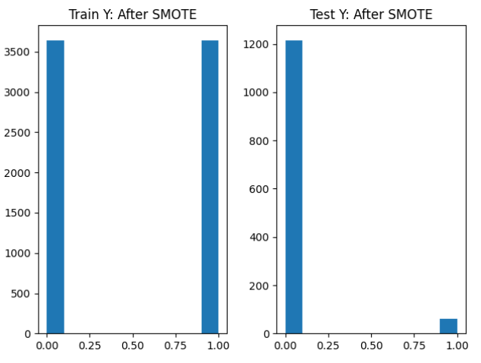

The accuracy in our model falls once trained with SMOTE resampling but the precision and recall scores rise dramatically once we have more stroke samples to fit the model. Even when false positives occur medical professionals can run other tests to determine the likelihood of a stroke. The ability to detect true positives is far better and the model may even save lives.

***After SMOTE
[[911 299]
[ 24 44]]

Precision: 0.1282798833819242
Recall: 0.6470588235294118
Accuracy: 0.7472613458528952

Example 6: Implementing SMOTE
Implementing SMOTE is easy. To install the required package, run this command:

pip install imblearn

To build and evaluate the logistic regression model with data that is resampled with SMOTE, add this code to the end of Example 4.
from imblearn.over_sampling import SMOTE
smt = SMOTE()
X_train_SMOTE, y_train_SMOTE = SMOTE().fit_resample(X_train, y_train)

clf2 = LogisticRegression(solver='newton-cg', max_iter=1000)
clf2.fit(X_train_SMOTE, y_train_SMOTE)
evaluate_model(X_test, y_test, y_train_SMOTE, clf2, "After SMOTE")

Exercise 4 (8 marks)
Implement SMOTE to perform logistic regression to determine if a candidate has coronary heart disease (TenYearCHD) using the framingham_v2.csv data set. Show your complete program here:
def show_y_plots(y_train, y_test, title):
print(f"\n*** {title}")
plt.subplots(1, 2)
plt.subplot(1, 2, 1)
plt.hist(y_train)
plt.title(f"y_train {title}")
plt.subplot(1, 2, 2)
plt.hist(y_test)
plt.title(f"y_test {title}")
plt.show()
def evaluate_model(X_test, y_test, y_train, model, title):
show_y_plots(y_train, y_test, title)
y_pred = model.predict(X_test)
cm = confusion_matrix(y_test, y_pred)
print(cm)
precision = precision_score(y_test, y_pred, average='binary')
recall = recall_score(y_test, y_pred, average='binary')
accuracy = accuracy_score(y_test, y_pred)
print(f"Precision: {precision}")
print(f"Recall: {recall}")
print(f"Accuracy: {accuracy}")
path = r"C:\Users\linho\Desktop\CST\term3\pred_analytics\data\framingham_v2.csv"
df = pd.read_csv(path)
print(df.head())
print(df.describe())
X = df.copy()
del X['TenYearCHD']
y = df['TenYearCHD']
X_train, X_test, y_train, y_test = train_test_split(
X, y, test_size=0.2
)
clf1 = LogisticRegression(solver='newton-cg', max_iter=1000)
clf2 = LogisticRegression(solver='newton-cg', max_iter=1000)
smote = SMOTE()
X_train_SMOTE, y_train_SMOTE = smote.fit_resample(X_train, y_train)
clf1.fit(X_train, y_train)
clf2.fit(X_train_SMOTE, y_train_SMOTE)
evaluate_model(X_test, y_test, y_train, clf1, "Before SMOTE")
evaluate_model(X_test, y_test, y_train_SMOTE, clf2, "After SMOTE")

Show a screenshot which displays the confusion matrices, precision and recall scores before and after SMOTE is implemented.
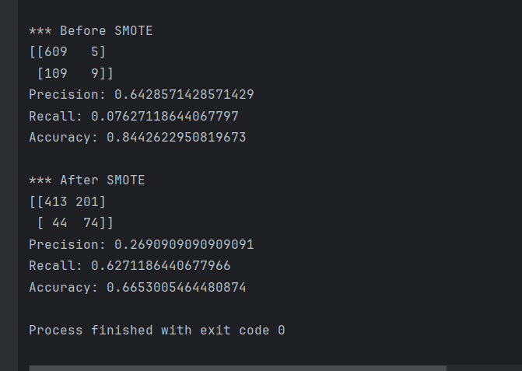

Show screenshots of a bar plots that shows the training Y values before and after SMOTE is implemented.
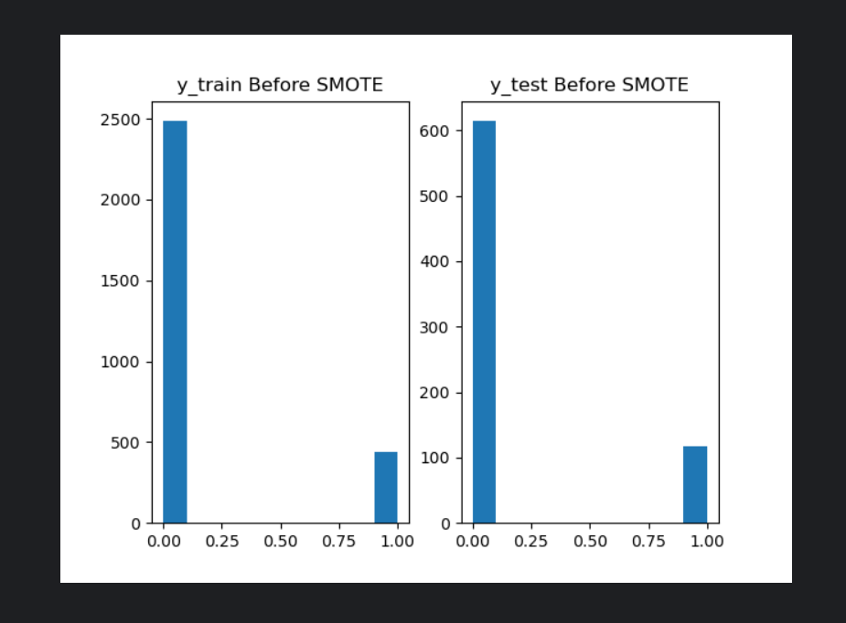
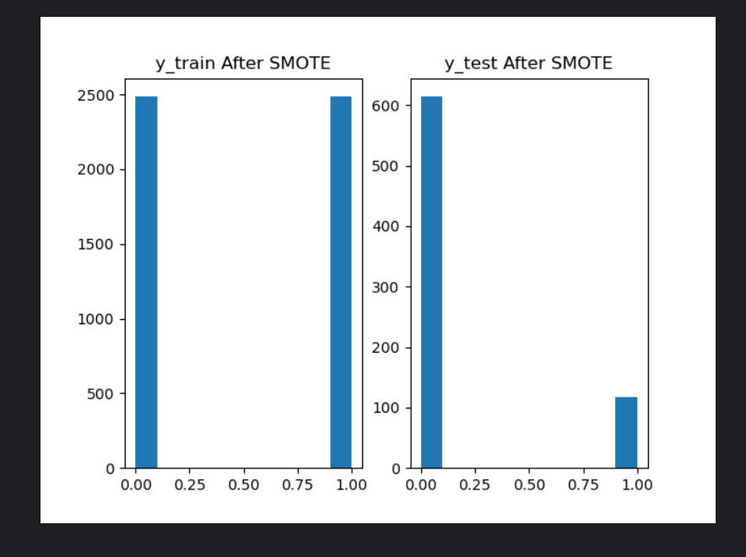

This document is not for marks. However, I think and hope you will find the content to be useful.

Great models do not always need to be highly accurate. Even if overall accuracy, precision and recall are not great, being able to identify highly likely candidates can still offer a huge amount of value. Cumulative gains and lift charts help to understand how to differentiate probable candidates from more neutral or strongly negative candidates.

Cumulative Gains and Lift Charts
Cumulative gains and lift charts are visual aids to help monitor model performance. These charts target the most likely candidates first while showing the diminishing returns of the model. This section is based on the example that is posted at

http://www2.cs.uregina.ca/~dbd/cs831/notes/lift_chart/lift_chart.html

The example presents a company mail-out campaign. Each mail-out costs $1. You want to contact 100,000 people and that will cost $100,000. You predict 20,000 will respond with your model. Without a model you predict that you would only reach 10,000 out of 100,000 people. You rank the customers into 10 groups in order of their likelihood to respond. The most likely candidates are listed first. In the first bucket the campaign acquires 6,000 out of 20,000 potential responses which is 30% of the total responses. The baseline random guess without a model suggests that you will only reach 10% of the potential customers each bucket. The expected lift is 30/10 = 3. Table 1 shows the % cumulative gain and lift calculations.

Table 1: Cumulative Gains and Lift Calculations
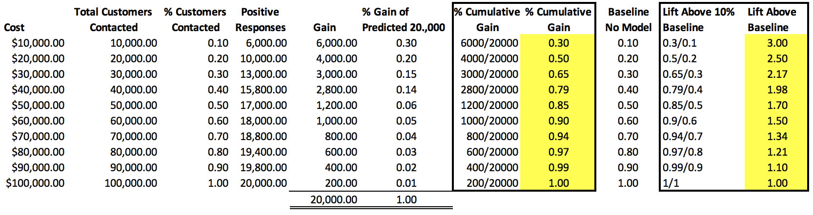
Cumulative gain for the model for first 10,000 contacted
= $\sum{\frac{Number of Successes}{Total Possible Successes}}$ = $\sum{\frac{6000}{20000}}$ = 0.3

For this baseline without a model, we estimate a 1 in 10 chance of a successful response. So if 10,000 people are contacted we expect only 1,000 candidates to response. The baseline model gain is 0.1 in this case.

The cumulative gain for the first 10,000 contacted without a model is
= $\sum{\frac{Number of Successes}{Total Possible Successes}}$ = $\sum{\frac{1000}{10000}}$ = 0.1

Exercise 5 (1 mark)
When using a model, how many successful responses occur between candidate 10,000 to 20,000?
4000

Exercise 6 (1 mark)
When not using a model, how many successful responses occur between candidate 10,000 to 20,000?
1000

Exercise 7 (1 mark)
When using a model, how many successful responses occur between candidate 20,000 to 30,000?
3000

Exercise 8 (1 mark)
When not using a model, how many successful responses occur between candidate 20,000 to 30,000?
1000

Exercise 9 (1 mark)
What is the % cumulative gain when using a model when contacting the first 20,000 customers?
0.5

Exercise 10 (1 mark)
What is the % cumulative gain when not using a model when contacting the first 20,000 customers?
0.20

Exercise 11 (1 mark)
What is the % cumulative gain when using a model when contacting the first 30,000 customers?
0.65

Exercise 12 (1 mark)
What is the % cumulative gain when not using a model when contacting the first 30,000 customers?
0.3

Exercise 13 (1 mark)
Show a screenshot of the cumulative gains chart from Figure 3 with the following two items highlighted:
- The total positive response rate for the model after 20% of the customers are contacted.
- The total positive response rate for the baseline (random guess) model after 20% of the customers are contacted.

Show the screenshot here:
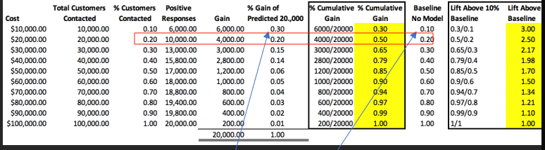

Exercise 14 (2 marks)
Show a screenshot of the cumulative gains chart from Figure 3 with the following two items highlighted:
- The total positive response rate for the model after 50% of the customers are contacted.
- The total positive response rate for the baseline (random guess) model after 50% of the customers are contacted.

Show the screenshot here:
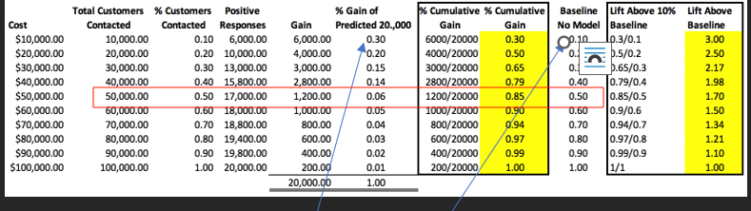

Figure 3: Anticipated Cumulative Gains and Lift for Each Bucket of Target Respondents
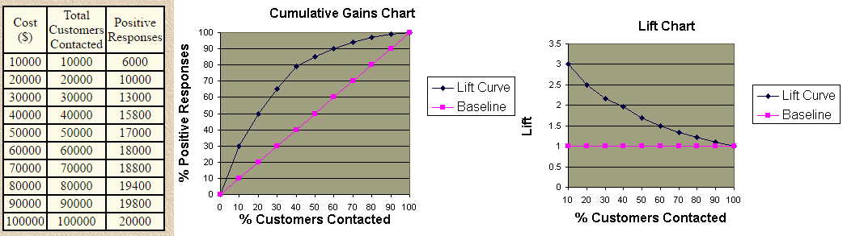

Lift = $\frac{Cumulative Gain Model}{Cumulative Gain Baseline}$ For the first 10,000 people approached Lift = $\frac{0.3}{0.1}$ = 3 .

Exercise 15 (1 mark)
Show the calculations needed to determine the lift for the first 20,000 people contacted.
0.5/0.2 = 2.5

Exercise 16 (1 mark)
Take a screenshot of the lift chart in Figure 3 with the value that is computed in Exercise 15 highlighted.
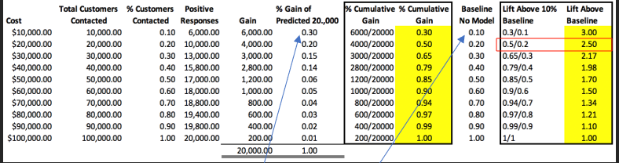

Cumulative Gains Chart Shapes
Figure 4 shows a summary of desirable and undesirable cumulative gains curve shapes.

Figure 4: Cumulative Gains Shapes
Good. | Too perfect. | Overfit. | Worthless.
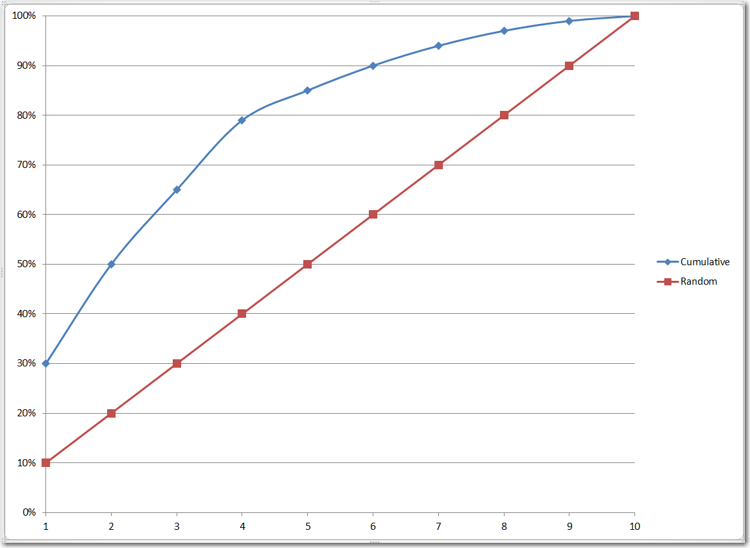 | 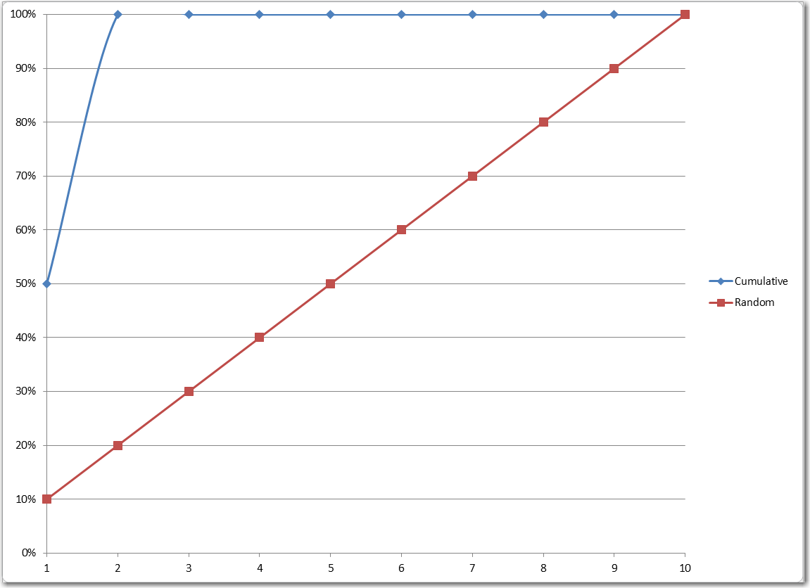 | 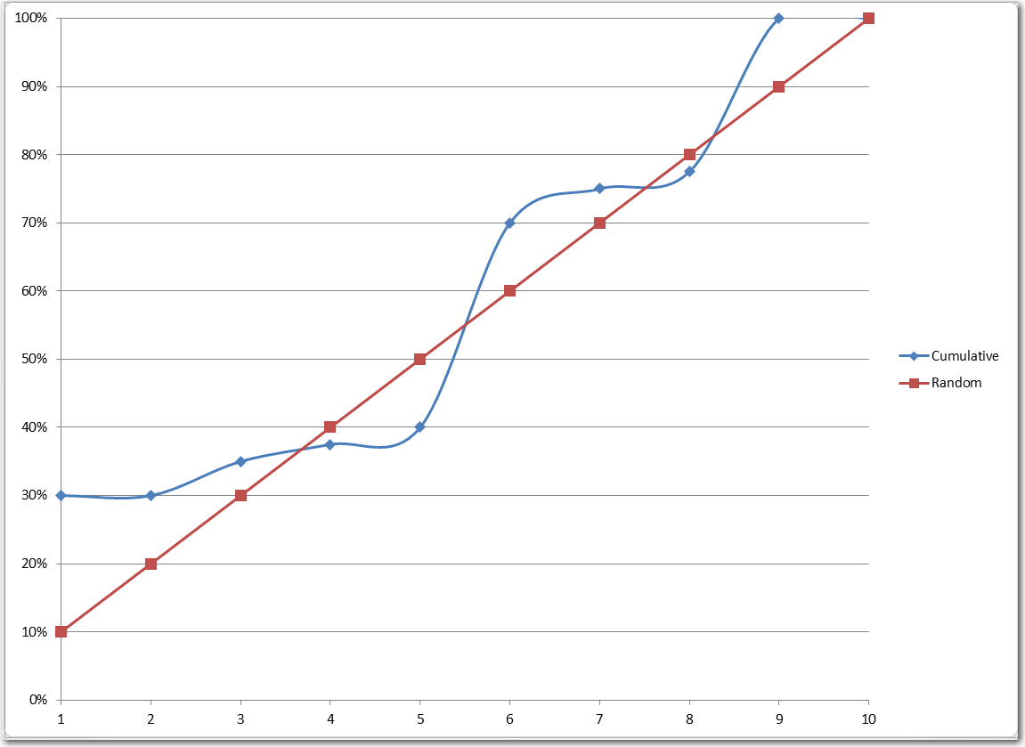 | 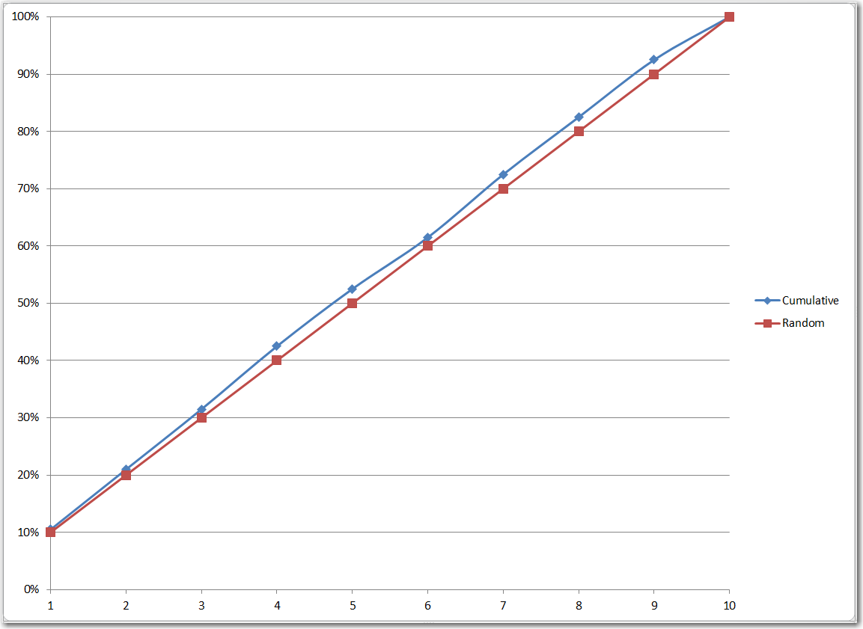

Plotting Cumulative Gains and Lift Charts
Cumulative gains and lift curves can be drawn with:
# The magic happens here
import matplotlib.pyplot as plt
import scikitplot as skplt
skplt.metrics.plot_cumulative_gain(y_test, predicted_probas)
skplt.metrics.plot_lift_curve(y_test, predicted_probas)
plt.show()

Example 7: Cumulative Gains Chart
This example shows how to automate the process of drawing a cumulative gains chart for a model which predicts whether a breast cancer growth is benign (harmless) or not. The cumulative gains chart in Figure 5 indicates that about most of the potential malignant (harmful) cases can be identified within the first 40% of all samples. Almost all benign samples can be identified within the first 65% of all samples.

Figure 5: Cumulative Gains and Lift Charts Compared with the Confusion Matrix
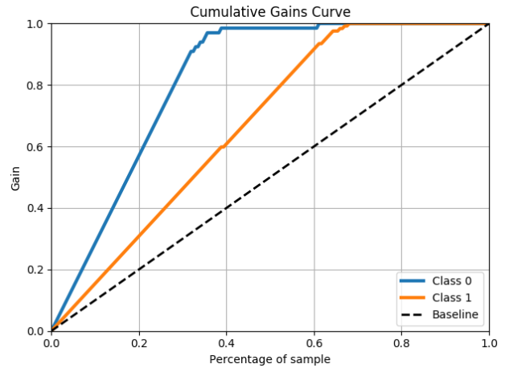 | 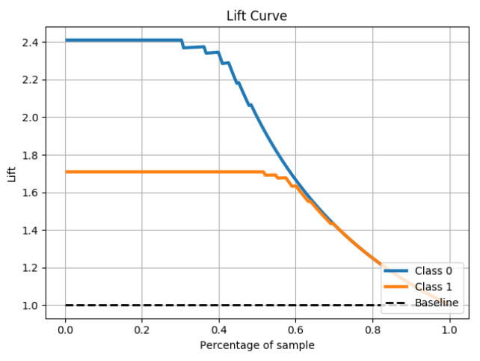 | Predicted 0 1  Actual  0 74 5  1 3 106
Here is the code that is used to draw the cumulative gains chart:
# The usual train-test split mumbo-jumbo
from sklearn.datasets import load_breast_cancer
from sklearn.linear_model import LogisticRegression
from sklearn.model_selection import train_test_split
import pandas as pd
X, y = load_breast_cancer(return_X_y=True)
X_train, X_test, y_train, y_test = train_test_split(X, y,
test_size=0.33)
clf = LogisticRegression(
random_state=0, multi_class='multinomial', solver='newton-cg')

clf.fit(X_train, y_train)
predicted_probas = clf.predict_proba(X_test)
y_pred = clf.predict(X_test);

# The magic happens here
import matplotlib.pyplot as plt
import scikitplot as skplt
skplt.metrics.plot_cumulative_gain(y_test, predicted_probas)
skplt.metrics.plot_lift_curve(y_test, predicted_probas)
plt.show()

# Show confusion matrix and accuracy scores.
cm = pd.crosstab(y_test, y_pred,
rownames=['Actual'],
colnames=['Predicted'])
print(cm)

