Table of Contents
PCA for Dimension Reduction 1
Linear Regression with PCA 4
Other Resources 11

PCA for Dimension Reduction
An important benefit of PCA is dimension reduction for data sets with large numbers of features. Not only does PCA eliminate complex multicollinearity issues, it also improves processing speed with the dimension reduction.

Example 1: MNIST
This example uses PCA to reduce the MINST data set which contains hand-written numbers. The reduced data is then used to build a logistic model to predict the numbers. Download the MNIST files from the data sets folder:

- t10k-images-idx3-ubyte.gz
- t10k-labels-idx1-ubyte.gz

The data set contains 28x28 gray scale images which are stored in arrays of integers. Each image array contains 784 elements. Data ranges from 0 to 256. Figure 1 displays the contents for a sample image on the left along with a rendering of the grey scale pixels on the right.

Figure 1: Numeric and Graphic Representation of Gray Scale Image
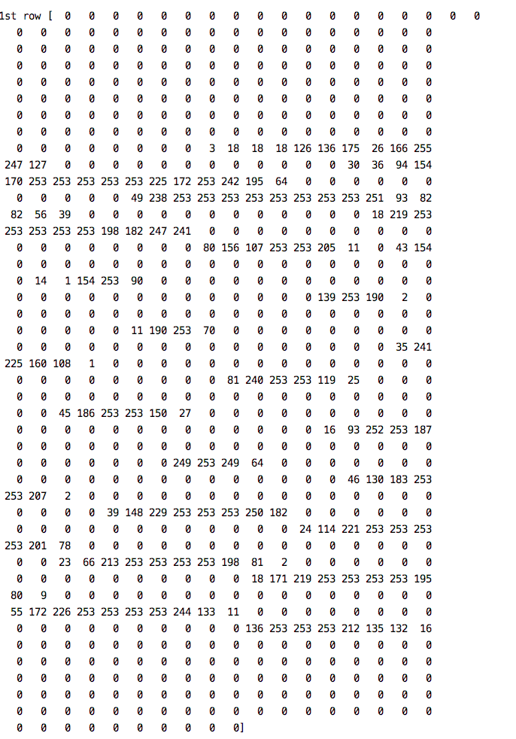 | 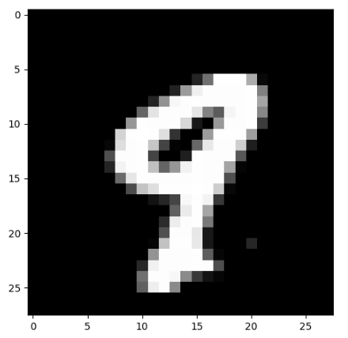

Here is the code:
from mlxtend.data import loadlocal_mnist
from sklearn.metrics import classification_report

PATH = getPath() # Set your folder path here.
X, y = loadlocal_mnist(
images_path= PATH + 'mnist_images',
labels_path= PATH + 'mnist_labels')

#/Users/patmcgee/Desktop/DayDocs/data/t10k-labels-idx1-ubyte
print('Dimensions: %s x %s' % (X.shape[0], X.shape[1]))
print('\n1st row', X[0])

# Split the data.
from sklearn.model_selection import train_test_split
# test_size: what proportion of original data is used for test set
train_img, test_img, train_lbl, test_lbl = train_test_split( X,
y,
test_size=1/7.0,
random_state=0)
# Show image.
print("Image size: ")
print(train_img[0].shape)

import matplotlib.pyplot as plt
import numpy as np
first_image = train_img[0]
first_image = np.array(first_image, dtype='float')
print(len(first_image))
pixels = first_image.reshape((28, 28))
plt.imshow(pixels, cmap='gray')
plt.show()

from sklearn.preprocessing import StandardScaler
scaler = StandardScaler()

# Fit on training set only.
scaler.fit(train_img)

# Apply transform to both the training set and the test set.
train_img = scaler.transform(train_img)
test_img = scaler.transform(test_img)

from sklearn.decomposition import PCA
# Make an instance of the PCA.
pca = PCA(.95)
pca.fit(train_img)

# Data is transformed with PCA.
train_img = pca.transform(train_img)
test_img = pca.transform(test_img)

from sklearn.linear_model import LogisticRegression

# all parameters not specified are set to their defaults
# default solver is incredibly slow which is why it was changed to 'lbfgs'
logisticRegr = LogisticRegression(solver = 'lbfgs', max_iter=1000)
logisticRegr.fit(train_img, train_lbl)
y_pred = logisticRegr.predict(test_img)
score = logisticRegr.score(test_img, test_lbl)
print(score)

# Show confusion matrix and accuracy scores.
import pandas as pd
cm = pd.crosstab(test_lbl, y_pred, rownames=['Actual'],
colnames=['Predicted'])

print("\n*** Confusion Matrix")
print(cm)

print("\n*** Classification Report")
print(classification_report(test_lbl, y_pred))

The output from running this code shows the result of an accurate predictive model.
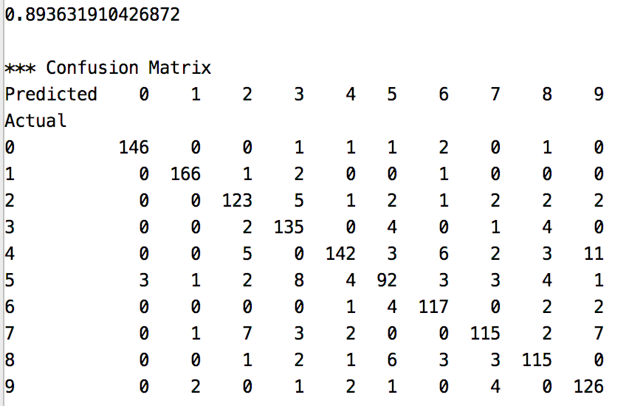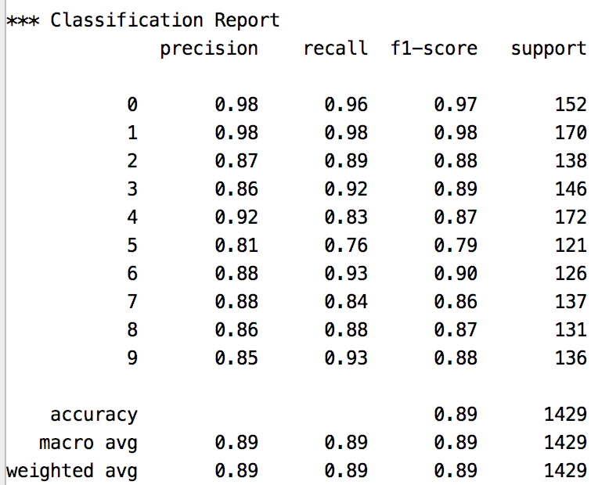

Exercise 1 (2 marks)
Read through the code and figure out how to show the second and third images in the training data. Show the images here.
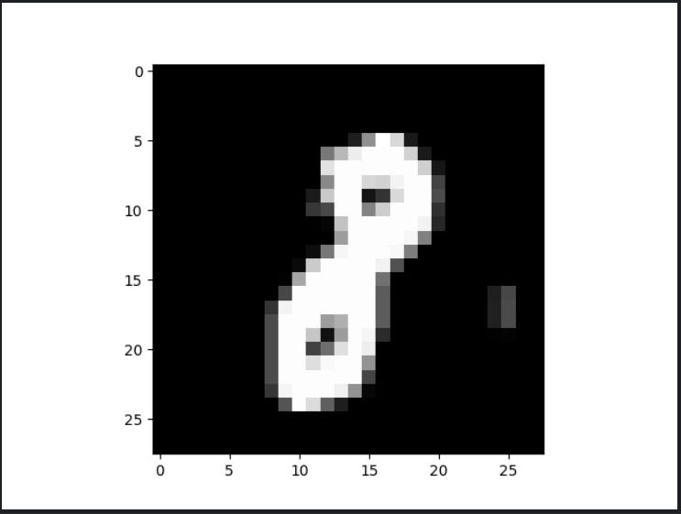
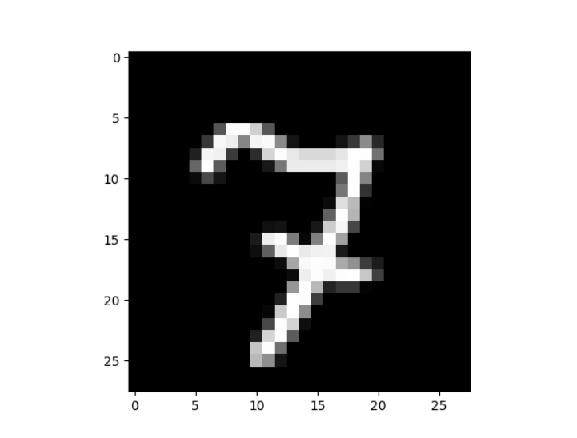

Linear Regression with PCA
As you may have guessed, PCA can be used to create reduced data sets which can be used in linear regression. The selected components can be used as variables in the regression.

Example 2: Linear Regression with Principal Components
This example uses PCA to help perform linear regression to estimate the salary of a baseball hitters. For more detail, please see http://www.science.smith.edu/~jcrouser/SDS293/labs/lab11-py.html Table 1shows preliminary statistics about the predictor and target variables.

Table 1: Predictor and Target Variable Statistics
# Column Non-Null Count Dtype  --- ------ -------------- -----  0 AtBat 263 non-null int64  1 Hits 263 non-null int64  2 HmRun 263 non-null int64  3 Runs 263 non-null int64  4 RBI 263 non-null int64  5 Walks 263 non-null int64  6 Years 263 non-null int64  7 CAtBat 263 non-null int64  8 CHits 263 non-null int64  9 CHmRun 263 non-null int64  10 CRuns 263 non-null int64  11 CRBI 263 non-null int64  12 CWalks 263 non-null int64  13 League 263 non-null object  14 Division 263 non-null object  15 PutOuts 263 non-null int64  16 Assists 263 non-null int64  17 Errors 263 non-null int64  18 Salary 263 non-null float64  19 NewLeague 263 non-null object |  | Salary statistics:  count 263.000000  mean 535.925882  std 451.118681  min 67.500000  25% 190.000000  50% 425.000000  75% 750.000000  max 2460.000000

To build this example download the Hitters.csv file from the Datasets folder at the Learning Hub. I am using a version which has been modified from the original. Here is the code:
import pandas as pd
import numpy as np
from sklearn import model_selection
from sklearn.decomposition import PCA
from sklearn.linear_model import LinearRegression
from sklearn.metrics import mean_squared_error
from statsmodels.stats.outliers_influence import variance_inflation_factor
from sklearn.preprocessing import StandardScaler
PATH = getPath() # Set your folder path here.
CSV_DATA = "Hitters.csv"

# Drop null values.
df = pd.read_csv(PATH + CSV_DATA).dropna()
df.info()

dummies = pd.get_dummies(df[['League', 'Division', 'NewLeague']], dtype=int)

y = df.Salary

print("\nSalary stats: ")
print(y.describe())

# Drop the column with the independent variable (Salary),
# and columns for which we created dummy variables.
X_ = df.drop(['Salary', 'League', 'Division', 'NewLeague'], axis=1).astype('float64')

# Define the feature set X.
X = pd.concat([X_, dummies[['League_N', 'Division_W', 'NewLeague_N']]], axis=1)

# Calculate and show VIF Scores for original data.
vif = pd.DataFrame()
vif["VIF Factor"] = [variance_inflation_factor(X.values, i) for i in range(X.shape[1])]
vif["features"] = X.columns
print("\nOriginal VIF Scores")
print(vif)

# Standardize the data.
X_scaled = StandardScaler().fit_transform(X)

# Split into training and test sets
X_train, X_test , y_train, y_test = model_selection.train_test_split(X_scaled, y,
test_size=0.25, random_state=1)

# Transform the data using PCA for first 80% of variance.
pca = PCA(.8)
X_reduced_train = pca.fit_transform(X_train)
X_reduced_test = pca.transform(X_test)

print("\nPrincipal Components")
print(pca.components_)

print("\nExplained variance: ")
print(pca.explained_variance_)

# Train regression model on training data
model = LinearRegression()
model.fit(X_reduced_train, y_train)

# Prediction with test data
pred = model.predict(X_reduced_test)
print()

# Show stats about the regression.
mse = mean_squared_error(y_test, pred)
RMSE = np.sqrt(mse)
print("\nRMSE: " + str(RMSE))

print("\nModel Coefficients")
print(model.coef_)

print("\nModel Intercept")
print(model.intercept_)

from sklearn.metrics import r2_score
print("\nr2_score",r2_score(y_test,pred))

# For each principal component, calculate the VIF and save in dataframe
vif = pd.DataFrame()

# Show the VIF score for the principal components.
print()
vif["VIF Factor"] = [variance_inflation_factor(X_reduced_train, i) for i in range(X_reduced_train.shape[1])]
print(vif)

While not amazing, the output shows a reasonably decent goodness of fit. The correlation is $\sqrt{0.4122}$ = 0.6420 which is decent.
Explained variance:
[7.77597646 4.18461023 2.08996888 1.51498738]

RMSE: 362.53224118763626

Model Coefficients
[ 99.33549424 -38.1317022 27.85002734 -29.67678236]

Model Intercept
532.6254517766497

r2_score 0.4122990272060483

VIF Factor
0 1.0
1 1.0
2 1.0
3 1.0

Exercise 2 (2 marks)
Which features of the data set are transformed by the coordinates of each principal component?
all of them, each corresponds to one element of the row inside the PC’s list of lists (4 here)

Exercise 3 (4 marks)
Run the regression in Example 2 again but with enough principal components to account for 90% of the variance. How many principal components are used? Do the RMSE and $R^{2}$ scores improve much when compared to the original example output? Explain if you think the additional principal components are worthwhile.
PC are 7. Both RMSE and R2 scores improve slightly and if we aim for best performance, then this should be ok since all PCs’ VIF scores are still 1.

Exercise 4
Perform linear regression using PCA to estimate the sale price of a home using the USA Housing data set. Starter code is provided for you below.

NOTE:
This exercise is not intended to be an exhaustive exercise in any way. You do not need to create dummy or binned variables. You do not need to find the optimal variable combination for your model. Just build a crude model with the starter code provided. Also use Example 2 as a guide to complete this section.

Starting with the following code, perform a linear regression using PCA. You do not need to create dummy variables, binned variables or any other variables
import pandas as pd

PATH = getPath() # Set your folder path here.
CSV_DATA = "USA_Housing.csv"
df = pd.read_csv(PATH + CSV_DATA)

# Show all columns.
pd.set_option('display.max_columns', None)
pd.set_option('display.width', 1000)
df2 = df._get_numeric_data()

X = df2.copy()
X.drop(['Price'], inplace=True, axis=1)
y = df2.copy()
y = y[['Price']]

  - What is the average housing price? The price standard deviation? The max price? The min price? (2 marks)
- mean 1.232073e+06
- std 3.531176e+05
- min 1.593866e+04
- 25% 9.975771e+05
- 50% 1.232669e+06
- 75% 1.471210e+06
- max 2.469066e+06

  - What are the VIF scores of the original features? Do they suggest multi-collinearity? (2 marks)
- Original Data VIF
- VIF Score Feature
- 0 29.650899 Avg. Area Income
- 1 27.447775 Avg. Area House Age
- 2 45.257291 Avg. Area Number of Rooms
- 3 14.537873 Avg. Area Number of Bedrooms
- 4 12.825450 Area Population
this shows a lot of multi-colinearity

  - What are the VIF scores of the principal components in the model? (1 mark)
- VIF Factor
- 0 1.0
- 1 1.0
- 2 1.0
- 3 1.0

  - What is your $R^{2}$ value and your RMSE? (2 marks)
R2 score: 0.8753
RMSE: 124469.3363

  - Show the principal components here. You may use: (2 marks)
print("\nPrincipal Components")
print(pca.components_)

Principal Componenets:
[[ 4.65644967e-02 -2.67387231e-02 6.97212831e-01 7.12272587e-01
-6.06532637e-02]
[-3.27620108e-02 -6.75720369e-01 3.98618827e-02 3.74581412e-04
7.35349933e-01]
[-5.05988123e-03 7.36122941e-01 3.91944681e-02 4.69980868e-02
6.74056664e-01]
[ 9.97943241e-01 -1.78482233e-02 -5.17521816e-02 -1.26232254e-02
3.08722228e-02]]

Example 3: PCA for Modelling with Spectroscopic Readings
This example demonstrates how to use PCA with logistic regression to determine the amount of lactose concentration in milk. In this study, 9 different lactose concentration amounts were used. Spectroscopic readings which record light wave lengths for 600 separate points were taken for each sample.

PCA enables an enormous reduction of features so that classification is permitted through logistic regression.
https://nirpyresearch.com/classification-nir-spectra-principal-component-analysis-python/

In this example, enough principal components are selected to explain 95% of the variance.

import pandas as pd
from sklearn.decomposition import PCA
from sklearn.preprocessing import StandardScaler
from sklearn.metrics import classification_report
import pandas as pd
from sklearn.model_selection import train_test_split
from sklearn.linear_model import LogisticRegression

PATH = getPath() # Set your folder path here.
df = pd.read_csv(PATH + "milk.csv")

# Split the data at the start to hold back a test set.
train, test = train_test_split(df, test_size=0.2)

X_train = train.copy()
X_test = test.copy()
del X_train['labels']
del X_test['labels']
del X_train['dates']
del X_test['dates']

y_train = train['labels']
y_test = test['labels']

# Scale X values.
xscaler = StandardScaler()
Xtrain_scaled = xscaler.fit_transform(X_train)
Xtest_scaled = xscaler.transform(X_test)

# Generate PCA components.
pca = PCA(0.95)

# Always fit PCA with train data. Then transform the train data.
X_reduced_train = pca.fit_transform(Xtrain_scaled)

# Transform test data with PCA
X_reduced_test = pca.transform(Xtest_scaled)

print("\nPrincipal Components")
print(pca.components_)

print("\nExplained variance: ")
print(pca.explained_variance_)

# Train regression model on training data
model = LogisticRegression(solver='liblinear')
model.fit(X_reduced_train, y_train)

# Predict with test data.
preds = model.predict(X_reduced_test)

report = classification_report(y_test, preds)
print(report)

The results that are generated show a highly accurate model for each of the nine categories.
precision recall f1-score support
1 1.00 1.00 1.00 12
2 0.86 0.86 0.86 7
3 0.70 0.70 0.70 10
4 0.55 0.67 0.60 9
5 1.00 0.77 0.87 13
6 0.83 0.91 0.87 11
7 0.88 0.54 0.67 13
8 0.64 1.00 0.78 7
9 0.89 1.00 0.94 8
accuracy 0.81 90
macro avg 0.82 0.83 0.81 90
weighted avg 0.83 0.81 0.81 90

Exercise 5 (2 marks)
How many components are used to transform the feature set when 95% of the variance is explained by PCA?
3

Exercise 6 (2 marks)
How many components are used to transform the feature set when 80% of the variance is explained by PCA?
2

Exercise 7 (2 marks)
Show the classification report that is generated when modelling with PCA while explaining 80% of the variance.
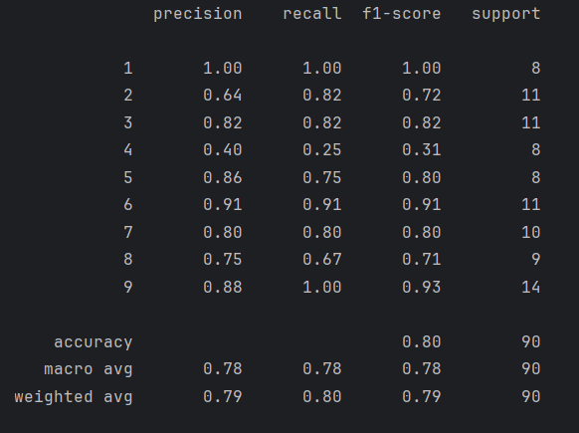

Exercise 8 (8 marks)
In code, plot scree and cumulative variance graphs. Show your graphs here;
