Table of Contents
PCA Introduction 1
Multicollinearity 1
Controlling Multicollinearity 1
Principal Components Analysis (PCA) 2
Predictor Correlation 2
Eigen Decomposition 3
Eigenvectors 3
Eigen Values 3
Choosing Components 5
Kaiser’s Stopping Rule 5
Scree and Cumulative Variance Plots 5
PCA for Dimension Reduction 7

PCA Introduction
Principal component analysis is not an intuitive topic. Do not be discouraged if you have difficulty understanding it initially. PCA has a coolness factor that is worth obtaining so for your sake try to stay on top of this topic – the technique is a slick one.

PCA lets you reduce data sets with 100’s or 1000’s of features down to three or four features. You end up with a very fast way to compress data and build models with these new reduced features. PCA also removes all multicollinearity between predictor variables. You can also use PCA to shrink huge unlabeled feature sets such as sets of images for regression.

Multicollinearity
Ideally predictor variables should be independent of each other so they are non-correlated. However, this usually is not the case. Problems with multicollinearity occur when one predictor is highly correlated with another. Moderate multicollinearity may not be problematic. If you notice wide fluctuations in predictor significance when adding and removing variables this is an indicator of problematic multicollinearity. Volatile coefficients can lead to an unreliable model and higher prediction variance.

Controlling Multicollinearity
Some simple ways to control multicollinearity are to:
- Avoid creating dummy variables for every category.
- Drop variables.
- Obtain more data.
Other ways to remedy multicollinearity include:
- Mean-centering (scaling) the predictor variables.
- Standardizing the independent (predictor) variables.
- Using principal component analysis regression.

Variance Inflation Factor (VIF)
Multicollinearity can be detected using a variance inflation factor (VIF) score. The VIF score is calculated for a particular variable $x_{k}$ by a linear model based on all other independent variables. VIF increases with a higher goodness of fit.

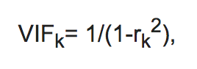
Table 1 suggests guidelines for interpreting VIF scores. These are rules of thumb and they are not absolute. As mentioned earlier, if the data being modelled follows the same collinearity pattern as the predictors then the model may be fine.

Table 1: Suggested Rules for Multicollinearity
VIF Score | Suggested Interpretation
1 | No multicollinearity
1 to 5 | Moderate collinearity
5+ | High collinearity

Principal Components Analysis (PCA)
For large feature data multicollinearity may be difficult to tame. However, principal component analysis (PCA) can reduce overfitting and multicollinearity through dimension reduction. Predictive models which use PCA are also usually faster due to the dimension reduction. PCA uses linear algebra which performs an orthogonal transformation to re-orient the coordinate system of the predictor variables. I will not cover the math behind PCA but this is a great article which helps to explain the theory and math.

https://plot.ly/python/v3/ipython-notebooks/principal-component-analysis/

PCA does not require normally distributed data. However, usually before performing PCA, the data should be standardized on a -1 to 1 distribution which is centered at 0.

Predictor Correlation
To understand the collinearity in the predictor variables covariance and correlation are examined.

Covariance
Covariance measures how variables relate to each other. If two variables are independent their covariance is 0. The covariance between two features is calculated as follows:
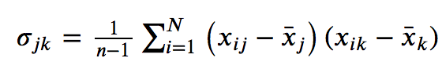

Correlation
Correlation is the scaled version of covariance and correlation ranges between -1 and 1. When the covariance matrix is built with standardized data it is the same is the correlation matrix.

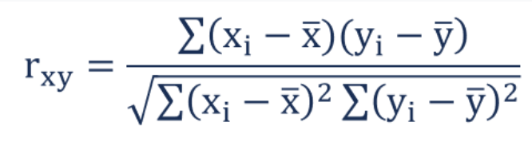

Eigen Decomposition
To determine how to apply PCA, Eigen decomposition is then performed. Eigen decomposition involves generating Eigenvectors and Eigenvalues from the covariance matrix.

Eigenvectors
Eigenvectors are vectors of direction weights. These vectors are used to transform the original feature coordinates. We will examine Eigenvectors more in Example 1.

Eigen Values
An Eigenvalue tells us how much variance is explained by each Eigenvector. The Eigenvectors with the highest explanatory values are selected first.

Example 1: Eigenvectors and Eigenvalues
This example introduces Eigenvectors and Eigenvalues. For this case, Eigen decomposition is applied to understand the covariance and correlation between predictor variables in the Iris flower dataset.
from sklearn.preprocessing import StandardScaler
from sklearn import datasets
import numpy as np

# Load iris data set and apply standard scaler.
iris = datasets.load_iris()
X = iris.data
featureNames = ['sepal length (cm)', 'sepal width (cm)', 'petal length (cm)', 'petal width (cm)']
y = iris.target
X_std = StandardScaler().fit_transform(X)

print(featureNames)

# Generate covariance matrix to show bivariate relationships.
cov_mat = np.cov(np.transpose(X_std))
print('\nCovariance matrix: \n%s' %cov_mat)

# When data is standardized, the covariance matrix is same as the
# correlation matrix.
cor_mat = np.corrcoef(np.transpose(X_std))
print('\nCorrelation matrix: \n%s' %cor_mat)

# Perform an Eigen decomposition on the covariance matrix:
eig_vals, eig_vecs = np.linalg.eig(cov_mat)
print('\nEigenvectors \n%s' %eig_vecs)
print('\nEigenvalues \n%s' %eig_vals).
The covariance matrix uses standardized data so the matrix values are the same as the correlation matrix. The covariance and correlation matrices also explain the relationships between predictor variables. For example, if you look at the output below you will notice that sepal length has a correlation of -0.1184 with sepal width.

The covariance matrix is used to generate the Eigenvector. Try to think of the Eigenvectors as vectors of direction for generating the new feature coordinates. Each Eigenvector is a principal component. The Eigenvalue represents the magnitude (weighting) of the related Eigenvector.
Covariance matrix:
sepal l sepal w petal l petal w
sepal l [[ 1.00671141 -0.11835884 0.87760447 0.82343066]
sepal w [-0.11835884 1.00671141 -0.43131554 -0.36858315]
petal l [ 0.87760447 -0.43131554 1.00671141 0.96932762]
petal w [ 0.82343066 -0.36858315 0.96932762 1.00671141]]

Correlation matrix:
sepal l sepal w petal l petal w
sepal l [[ 1. -0.11756978 0.87175378 0.81794113]
sepal w [-0.11756978 1. -0.4284401 -0.36612593]
petal l [ 0.87175378 -0.4284401 1. 0.96286543]
petal w [ 0.81794113 -0.36612593 0.96286543 1. ]]

Eigenvectors
[[ 0.52106591 -0.37741762 -0.71956635 0.26128628]
[-0.26934744 -0.92329566 0.24438178 -0.12350962]
[ 0.5804131 -0.02449161 0.14212637 -0.80144925]
[ 0.56485654 -0.06694199 0.63427274 0.52359713]]

Eigenvalues
[2.93808505 0.9201649 0.14774182 0.02085386]

Eigenvalues shown above weight the amount of variance between variables accounted for by each Eigenvector. The first Eigenvector (principal component) accounts for 73% of the variance between features.

$\frac{2.93808505}{2.93808505+0.9201649+0.14774182+0.0208538}$ = 0.72962%

Exercise 1 (1 mark)
How much does sepal length correlate to petal length?
0.81794113
Exercise 2 (1 mark)
How does sepal length correlate to petal width?
highly positively correlated

Exercise 3 (2 marks)
How much variance does the second Eigenvector account for?
0.22850761726368932 or 22.85%

Exercise 4 (1 mark)
According to the Eigenvalues, how much cumulative variance is accounted for by the first two Eigenvectors?
.72962 + 0.2285 = 0.9547 or 95.47%

Exercise 5 (1 mark)
How much cumulative variance is accounted for by the first three Eigenvectors? In addition to showing your answer, please show your calculation or code used to generate the answer.
print(sum([2.93808505, 0.9201649, 0.14774182]) /
sum([2.93808505, 0.9201649, 0.14774182, 0.02085386]))

0.9948212914235801

Choosing Components
When building a model with principal components, the method of component selection must be chosen. There is no perfect solution but it is important to select the first components which represent the highest amount of variance. Often, you might select components which explain the first 80% of the variance.

Kaiser’s Stopping Rule
Kaiser’s Stopping rule suggests that we choose Eigenvalues scoring greater than 1.

Scree and Cumulative Variance Plots
Scree and cumulative variance plots also help identify where gains from principal components diminish. (Scree means rock debris that has fallen down a mountain). Instead of using Kaiser’s Stopping rule, you may select the components which account for the most variance until gains flatten. See Figure 1.

Figure 1: Scree and Cumulative Variance Plots
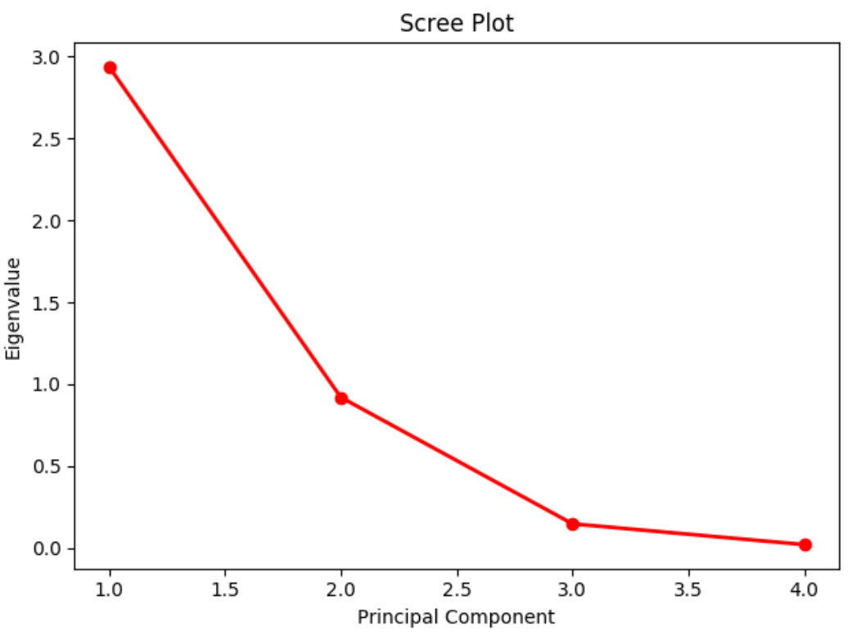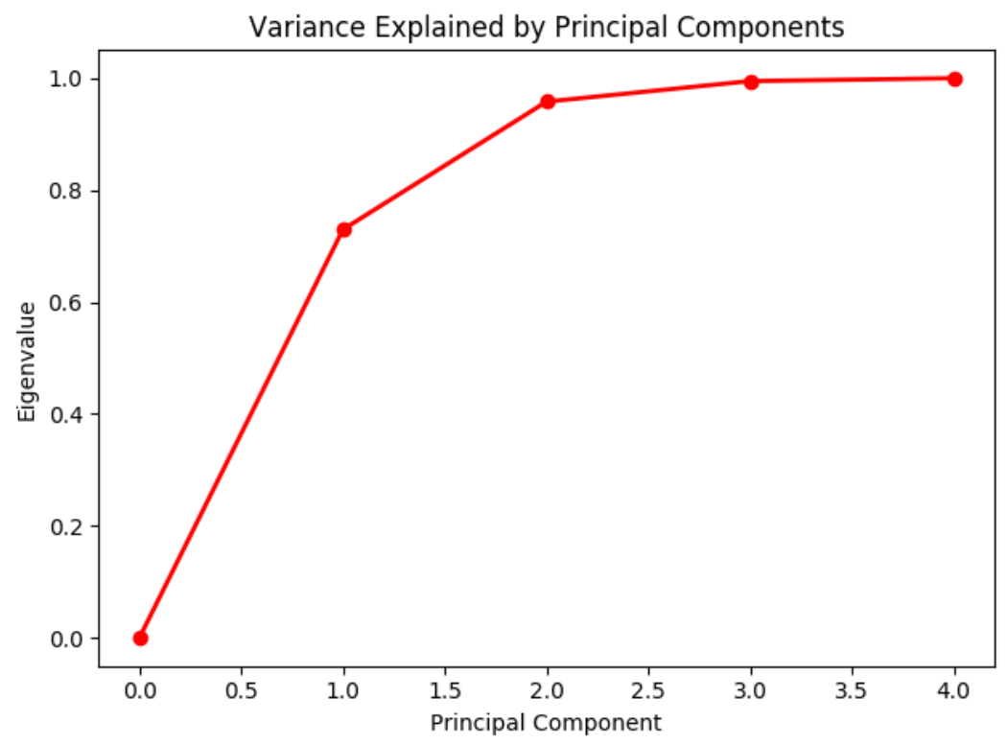
Example 2: Drawing Scree and Cumulative Variance Plots
This code sample shows how to draw the curves in Figure 1. To build this example, start with the code in Example 1. Then add this code after.
import matplotlib.pyplot as plt

# Show the scree plot.
plt.plot([1,2,3,4], eig_vals, 'ro-', linewidth=2)
plt.title('Scree Plot')
plt.xlabel('Principal Component')
plt.ylabel('Eigenvalue')
plt.show()

# Calculate cumulative values.
sumEigenvalues = eig_vals.sum()
cumulativeValues = []
cumulativeSum = 0
for i in range(0,len(eig_vals)+1):
cumulativeValues.append(cumulativeSum)
if(i<len(eig_vals)):
cumulativeSum += eig_vals[i] / sumEigenvalues

# Show cumulative variance plot.
import matplotlib.pyplot as plt
plt.plot([0,1,2,3,4], cumulativeValues, 'ro-', linewidth=2)
plt.title('Variance Explained by Principal Components')
plt.xlabel('Principal Component')
plt.ylabel('Eigenvalue')
plt.show()

Exercise 6 (1 mark)
Which principal components in Example 1 are recommended by Kaiser’s stopping rule and why?
The first because its eigenvalue is greater than 1.

Exercise 7 (1 mark)
Which components do the scree and cumulative variance plots in Figure 1 suggest using?
the first three

Exercise 8 (1 mark)
Imagine you have variance accounted for by five principal components where the Eigenvalues are: [3.3, 2.2, 0.5, 0.08, 0.05]

Which components do Kaiser’s Stopping rule recommend?
first and second

PCA for Dimension Reduction
Principal components can be used to transform high width feature sets to low width feature sets. For example, a feature set containing 656 attributes might be reduced to a feature set of 12 components with the help of a PCA transformation.

Example 3: PCA with Iris DataSet
This example shows a simplified view of how principal components could reduce the number of features used in a logistic regression model from four to two. For this case, the Iris dataset is used and the goal of the model is to classify flowers into Virginica, Setosa and Versicolor classes. For more detail see:
https://plot.ly/python/v3/ipython-notebooks/principal-component-analysis/

The Eigenvectors calculated in Example 1 are actually our principal components that can be used in the dimension reduction. In this current example we will use the principal components to transform the standardized X values. We can then fit the logistic model on the scaled data.

As you can see from the output from our logistic regression we are able to generate our logistic model and the results of the logistic regression are quite decent.

*** Intercept:
[-1.58589278 -0.99583449 -2.01859188]

*** Model Coefficients:
[[-2.39890719 0.94546703]
[ 0.23032071 -1.08212721]
[ 2.30527623 0.0260823 ]]

*** Confusion Matrix
Predicted 0 1 2
Actual
0 13 0 0
1 0 10 6
2 0 0 9

*** Classification Report
precision recall f1-score support
0 1.00 1.00 1.00 13
1 1.00 0.62 0.77 16
2 0.60 1.00 0.75 9
accuracy 0.84 38
macro avg 0.87 0.88 0.84 38
weighted avg 0.91 0.84 0.84 38
*** Explained Variance
[3.0863862 0.98414798]

Here is the code that generates the output above. You will also notice that the code also prints out the principal Eigenvectors and Eigenvalues which we generated in Example 1.
from sklearn.preprocessing import StandardScaler
from sklearn import datasets
import numpy as np

# Load iris data set and apply standard scaler.
iris = datasets.load_iris()
X = iris.data
featureNames = ['sepal length (cm)', 'sepal width (cm)', 'petal length (cm)', 'petal width (cm)']
y = iris.target
X_std = StandardScaler().fit_transform(X)

print(featureNames)

# Generate covariance matrix to show bivariate relationships.
cov_mat = np.cov(np.transpose(X_std))
print('\nCovariance matrix: \n%s' % cov_mat)

# When data is standardized, the covariance matrix is same as the
# correlation matrix.
cor_mat = np.corrcoef(np.transpose(X_std))
print('\nCorrelation matrix: \n%s' % cor_mat)

# Perform an Eigen decomposition on the covariance matrix:
eig_vals, eig_vecs = np.linalg.eig(cov_mat)
print('\nEigenvectors \n%s' % eig_vecs)
print('\nEigenvalues \n%s' % eig_vals)

#######
# Show the scree plot.
from sklearn.preprocessing import StandardScaler
from sklearn.decomposition import PCA as sklearnPCA
from sklearn.model_selection import train_test_split
from sklearn.linear_model import LogisticRegression
from sklearn.metrics import classification_report
from sklearn import datasets
import numpy as np
import pandas as pd

# Load iris data set and apply standard scaler.
iris = datasets.load_iris()
X = iris.data
y = iris.target
X_std = StandardScaler().fit_transform(X)

# Split x and y into test and training.
X_train, X_test, y_train, y_test = train_test_split(
X_std, y, test_size=0.25, random_state=0)

# Create principal components. (Use only 2 significant eigen vectors)
sklearn_pca = sklearnPCA(n_components=2)

# Transform the data.
X_train = sklearn_pca.fit_transform(X_train)

# Transform test data.
X_test = sklearn_pca.transform(X_test)

# Perform logistic regression.
logisticModel = LogisticRegression(fit_intercept=True, random_state=0,
solver='liblinear')
logisticModel.fit(X_train, y_train)

# Generate predictions.
y_pred = logisticModel.predict(X_test)

# Show model coefficients and intercept.
print("\n*** Intercept: ")
print(logisticModel.intercept_)

print("\n*** Model Coefficients: ")
print(logisticModel.coef_)

# Show confusion matrix and accuracy scores.
cm = pd.crosstab(y_test, y_pred, rownames=['Actual'],
colnames=['Predicted'])

print("\n*** Confusion Matrix")
print(cm)

# Show accuracy.
from sklearn.metrics import accuracy_score
accuracy = accuracy_score(y_test, y_pred)
print("Accuracy: " + str(accuracy))

Example 4: PCA Transformation
To help understand the PCA transformation, we will look at the manual calculations for the PCA transform. After considering options from Example 1, two Eigenvectors (or principal components) have been selected. The left of Table 2 shows Iris feature values after a StandardScaler has been applied. The right shows the first two principal components that were generated in Example 1.

Table 2: StandardScaled X Values and Selected Components
StandardardScaled X Values (Sepal length, Sepal width, Petal length, Petal width) | Principal Components (Eigenvectors)
[-9.0068e-01, 1.0190e+00, -1.3402e+00, -1.3154e+00],  [-1.1430e+00, -1.3198e-01, -1.3402e+00, -1.3154e+00],  [-1.3853e+00, 3.2841e-01, -1.3971e+00, -1.3154e+00], | [[ 0.52106591 ,-0.37741762],  [-0.26934744, -0.92329566],  [ 0.5804131, -0.02449161],  [ 0.56485654, -0.06694199]]

Now we will use the two principal components to transform the original scaled data for the first row of X-values:

[-9.0068e-01, 1.0190e+00, -1.3402e+00, -1.3154e+00] * |  | [[ 0.52106591 ,-0.37741762],  [-0.26934744, -0.92329566],  [ 0.5804131, -0.02449161],  [ 0.56485654, -0.06694199]]
=  [-9.0068e-01 * 0.52106591 +  1.0190e+00 * -0.26934744 +  -1.3402e+00 * 0.5804131 +  -1.3154e+00 * 0.56485654 ] + | [-9.0068e-01 * -0.37741762 +  1.0190e+00 * -0.92329566 +  -1.3402e+00 * -0.02449161 +  -1.3154e+00 * -0.06694199 ]
Our transformed X values are:

[-2.26470281, -0.48002659]

We will now use the PCA transformed variables to fit and test the logistic model.

Exercise 9 (1 mark)
Explain how the final result of [-2.26470281, -0.48002659] is a dimension reduction.
it’s matrix multiplication M[1x4] x N[4x2] = Q[1x2], so the final shape is 1x2 or two features

Exercise 10 (2 marks)
Using the selected two principal components above, perform a PCA transformation for this standardized feature set:

[-1.1430e+00, -1.3198e-01, -1.3402e+00, -1.3154e+00]

Show your calculations and result here (you can use Python for the calculation if you want but if you do please show your code and output):
pca_mat = [[ 0.52106591 ,-0.37741762],
[-0.26934744, -0.92329566],
[ 0.5804131, -0.02449161],
[ 0.56485654, -0.06694199]]
feature = [-1.1430e+00, -1.3198e-01, -1.3402e+00, -1.3154e+00]
result = np.matmul(feature, pca_mat)
print(f"\nPCA:\n {result}")

[-2.08091179 0.67412405]

Exercise 11 (2 marks)
Using the selected two principal components above, perform a PCA transformation for this standardized feature set:

[-1.3853e+00, 3.2841e-01, -1.3971e+00, -1.3154e+00]

Show your calculations and result here (you can use Python for the calculation if you want but if you do please show your code and output):
feature2 = [-1.3853e+00, 3.2841e-01, -1.3971e+00, -1.3154e+00]
print(np.matmul(feature2, pca_mat))
[-2.36419643 0.34188982]

Exercise 12 (4 marks)
To observe the multicollinearity scores of the principal components in our model, add this code to the end of the program in Example 3.
# For each X, calculate VIF and save in dataframe
from statsmodels.stats.outliers_influence import variance_inflation_factor
vif = pd.DataFrame()
vif["VIF Factor for Components"] = \
[variance_inflation_factor(X_train, i) for i in range(X_train.shape[1])]
print(vif)
Show the output that appears after running the code.
VIF Factor for Components
0 1.0
1 1.0
How can the VIF scores be interpreted?
There is no multicolinearity between the two principal components
Originally our feature set contained sepal length, sepal width, petal length, and petal width. How many features appear in the training data and why?
Two because the training features has been transformed/reduced using PCA.

