Table of Contents
Monte Carlo Simulations Continued 1
Normal Distribution 1
Uniform Distributions 4
Gamma Distribution 5
Choosing a Distribution 6
Kolmogorov Smirnov Test for Identical Distributions 7
D value for Distance Between Distributions 7
Generating Random Data with the Estimated Distribution 10
Approximating the Distribution 11

Monte Carlo Simulations Continued
As discussed earlier, Monte Carlo simulations are often done to perform a risk / reward analysis with random values from known distributions. During the last session, you were asked to perform an analysis for long-term revenue gain/loss potential in Excel.
https://www.youtube.com/watch?v=HwVBi--mE4M

When generating random numbers for Monte Carlo simulations it is helpful when they can be generated using a reasonably close matching distribution. We will use probability distributions to create some simple Monte Carlo simulations in Python.

Normal Distribution
One of the most common distributions that you will use is the Normal distribution. Figure 1 shows a typical Normal distribution curve.

Figure 1: Typical Normal Distribution
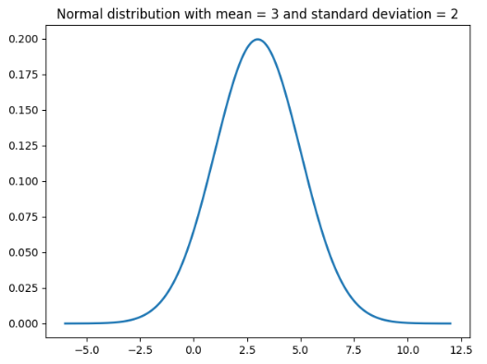

To enable the same randomized generation of normally distributed samples you can use the norm.rvs() function from scipy.stats.
randomNums = norm.rvs(loc = mean,
scale = standardDev,
size = NUM_SIMULATIONS)

Example 1: Monte Carlo Simulation (Calculating Risk of Loss)
This code performs the exact same risk analysis that is presented in the Youtube video at https://www.youtube.com/watch?v=HwVBi--mE4M

The example presented used a normal distribution to generate values for fixed cost, variable cost and revenue. The output generates results which align nicely with the results from the spreadsheet in the video:
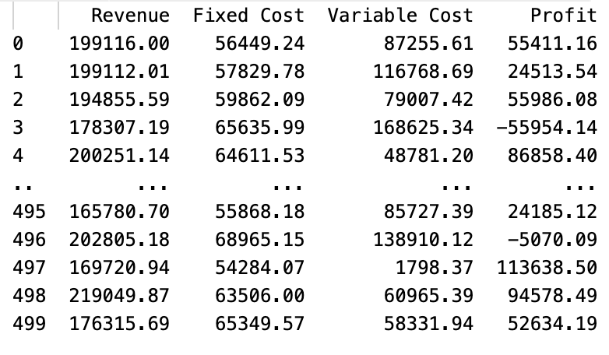
[500 rows x 4 columns]
Profit Mean: 37693.30245999999
Profit SD: 41887.843872224614
Profit Min: -81628.67
Profit Max: 160689.87
Risk of loss: 0.192

Here is the full program which includes the normal sample set generation:
NUM_SIMULATIONS = 500

# Define revenue, fixed and variable cost parameters.
REV_EXPECTED = 194000
REV_SD = 15000

FC_EXPECTED = 60000
FC_SD = 4000

VC_EXPECTED = 100000
VC_SD = 40000

# Generate random numbers from a normal distribution.
from scipy.stats import norm
def generateRandomNumbers(mean, standardDev):
randomNums = norm.rvs(loc = mean,
scale = standardDev,
size = NUM_SIMULATIONS)
return randomNums

revenues = generateRandomNumbers(REV_EXPECTED, REV_SD)
fixedCosts = generateRandomNumbers(FC_EXPECTED, FC_SD)
variableCosts = generateRandomNumbers(VC_EXPECTED, VC_SD)

profits = []

import pandas as pd
df = pd.DataFrame(columns = ['Revenue', 'Fixed Cost',
'Variable Cost', 'Profit'])

for i in range(0, NUM_SIMULATIONS):
profit = revenues[i] - fixedCosts[i] - variableCosts[i]

dictionary = {'Revenue': round(revenues[i],2),
'Fixed Cost': round(fixedCosts[i],2),
'Variable Cost':round(variableCosts[i],2),
'Profit': round(profit,2)}
df = df._append(dictionary, ignore_index=True)

# Show the data frame which contains results from
# all 500 trials.
print(df)

# Calculate profit summaries.
print("Profit Mean: " + str(df['Profit'].mean()))
print("Profit SD: " + str(df['Profit'].std()))
print("Profit Min: " + str(df['Profit'].min()))
print("Profit Max: " + str(df['Profit'].max()))

# Calculate the risk of incurring a loss.
dfLoss = df[(df['Profit']<0)]
totalLosses = dfLoss['Profit'].count()
riskOfLoss = totalLosses/NUM_SIMULATIONS
print("Risk of loss: " + str(riskOfLoss))

Exercise 1 (4 marks)
A bank machine downtown is visited by customers throughout an 8-hour business day. The typical number of customers arriving per hour during business hours to use the bank machine is normally distributed. An average of 23 customers visit the machine each hour. The standard deviation is 7. The bank machine can usually service about 30 people per hour without too much of a line up if at all. The wait times become uncomfortably long if more than 30 people want to use the machine during that hour. Create a Monte Carlo simulation to determine how many times during a business week when more than 30 customers want to use the machine per hour.

Show your code here:
from scipy.stats import norm
import numpy as np
WAIT_AVG = 23
WAIT_SD = 7
TOTAL_HOURS = 40
sim_runs = norm.rvs(loc=WAIT_AVG, scale=WAIT_SD, size=TOTAL_HOURS)
print(np.round(sim_runs, 0))
print(f"Number of times more than 30 customers waiting: {(sim_runs > 30).sum()}")

Show your output here:
[22. 29. 23. 37. 25. 27. 39. 30. 24. 21. 23. 26. 28. 23. 22. 26. 33. 21.
25. 33. 16. 20. 18. 16. 24. 37. 22. 25. 29. 23. 17. 36. 14. 25. 33. 33.
11. 32. 18. 22.]

Number of times more than 30 customers waiting: 9

Uniform Distributions
All values within a Uniform distribution have evenly distributed probabilities. The probability density function is:

p(x) = $\frac{1}{b-a}$ where (a$≤x≤b)$

To generate values for a uniform distribution we can set the random.uniform() function from numpy:

x = np.random.uniform(LOW, HIGH, SAMPLESET_SIZE)

Example 2: Downtown Uniform Distribution
This example shows how to generate three sample sets of 1200 values that are evenly distributed between 0 and 20.

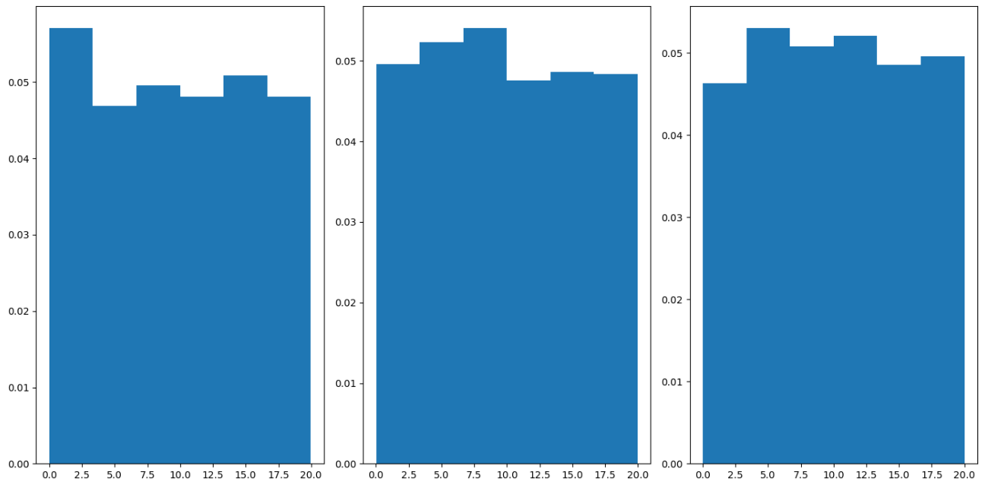
Here is the code which implements random uniform number generation:
import numpy as np
import matplotlib.pyplot as plt
LOW = 0
HIGH = 20
SIZE = 1200
NUM_SIMULATIONS = 3

plt.subplots(nrows=1, ncols=3, figsize=(14,7))
# Sets default font size globally

for i in range(1,NUM_SIMULATIONS + 1):
# Randomize data
x = np.random.uniform(LOW, HIGH, SIZE)

plt.subplot(1, 3, i)

plt.hist(x, 6, density=True)
plt.xlabel('X')
plt.ylabel('Frequency')
plt.rcParams.update({'font.size': 40})
plt.show()

Exercise 2: (4 marks)
Create a simulation for a prize wheel to determine how many contestants out of 100 will go bankrupt when they spin it. There are 24 equally probable options. The bankrupt option can be chosen twice. Run the simulation 5 times and calculate the average numbers of bankrupt contestants.



Show your code here:
import numpy as np
import matplotlib.pyplot as plt
SIZE = 100
LOW = 0
HIGH = 24
SIMS = 5
# bankrupt position on the wheel
BANKRUPT = [11, 23]
avgs = []
for i in range(SIMS):
spins = np.random.randint(LOW, HIGH, SIZE)
# count bankrupts
bankrupts = np.sum(np.isin(spins, BANKRUPT))
print(f"Number of bankrupts: {bankrupts}")
print(f"Bankrupt rate: {bankrupts/SIZE:.2f}")
avgs.append(bankrupts)
plt.hist(avgs)
plt.xlabel('Number of Bankrupts')
plt.ylabel('Frequency')
plt.title("Distribution over 5 simulations")
plt.show()

Show the bankrupt rate that you calculated here:
Number of bankrupts: 13
Bankrupt rate: 0.13
Number of bankrupts: 6
Bankrupt rate: 0.06
Number of bankrupts: 6
Bankrupt rate: 0.06
Number of bankrupts: 8
Bankrupt rate: 0.08
Number of bankrupts: 6
Bankrupt rate: 0.06

Gamma Distribution
The Gamma distribution offers other possibilities for data generation. For example, it could be used model visitor behavior at a typical website. The majority of users are going to visit one page and leave the site quickly. A few are going to click another link and browse a little bit more. Only a handful of visitors will remain at the site for an extended period (see Figure 2).

Figure 2: Gamma Distribution
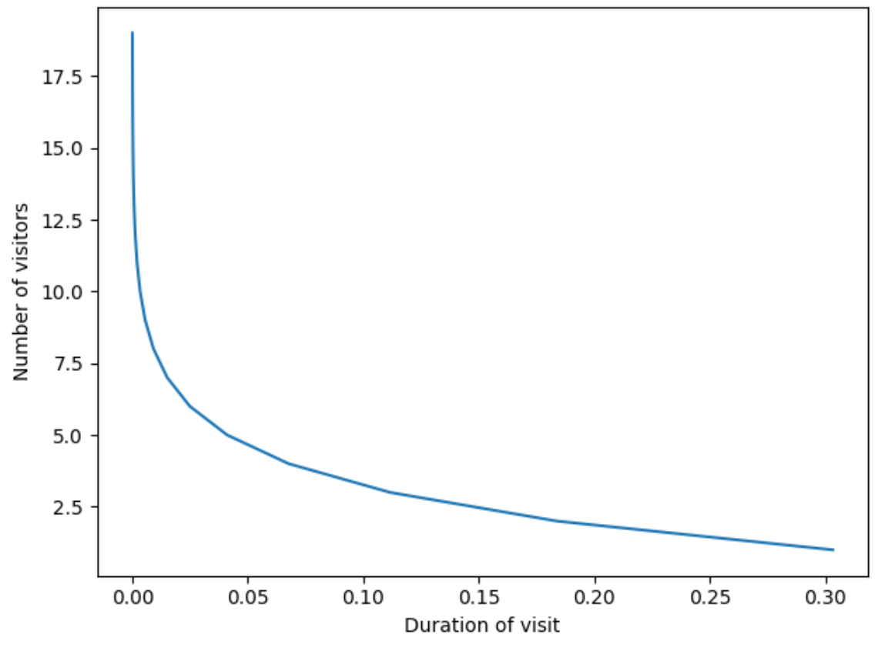

The gamma function from scipy.stats receives a shape parameter which defines the minimum number of events. The scale parameter defines a rate of decay.

Example 3: Gamma Distribution Implementation
Here is the code which maps out the duration of visits for 20 different people who visit a web site.
from scipy.stats import gamma
import numpy as np
shape = 1 # Minimum number of events.
scale = 2 # Poisson rate of events.

Gamma = gamma(a = shape, scale = scale)

x = np.arange(1,20)

import matplotlib.pyplot as plt
plt.plot(Gamma.pdf(x), x)
plt.xlabel("Duration of visit")
plt.ylabel("Number of visitors")
plt.show()

Choosing a Distribution
When performing Monte Carlo simulations, it is often important to determine which distribution is needed to generate the data required. Or, you may have existing data and you might want to know what distribution it belongs to. Or, if you cannot find the identical distribution you can also try to find the smallest distance between distributions and choose the distribution that matches most closely.

Based on my own experience, it is very likely that you will not find an identical distribution but usually you can find a reasonable approximation.

Kolmogorov Smirnov Test for Identical Distributions
It is possible to determine the distribution with a Kolmogorov Smirnov test for identifying identical distributions. The Kolmogorov Smirnov test compares actual samples with random samples from a specific data set. The null hypothesis is:

$H_{o}:The distributions are the same.$

A large p-value in this case is desirable. When the null hypothesis is rejected, the distribution that has the lowest D value is likely the distribution with the better goodness-of-fit.

D value for Distance Between Distributions
Unfortunately, it is usually difficult to find a perfectly matching distribution so when approximating distributions if you cannot pass the K-S identical distribution test you can try to find a relative approximation which offers the least distance between distributions. When a K-S test fails to find identical distributions, choosing a distribution where the D value is closer to zero may provide a reasonable alternative.

Example 4: Grid Searching for the Appropriate Distribution
This example shows how to grid search the age values in the Titanic data set to determine the best fitting distribution for ages (see Figure 3).

Figure 3: Age Distribution for the Titanic
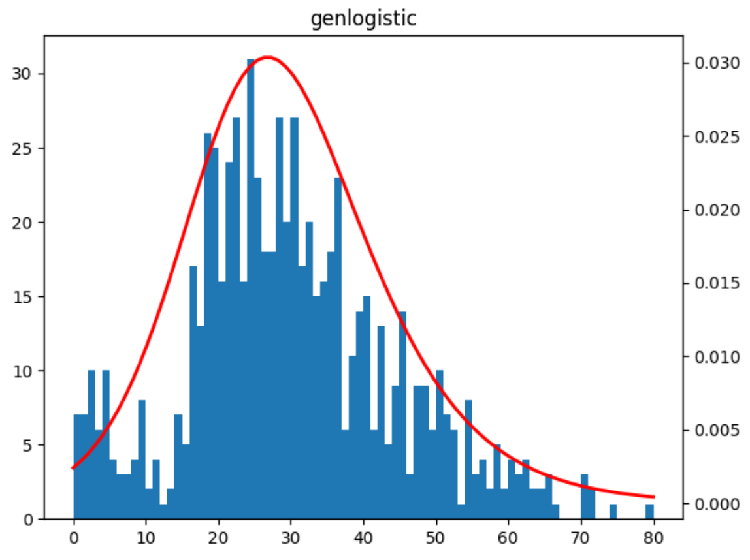
The Komolgorov Smirnov test is used to find the most likely fit. In the end, the genlogistic test offers the best match.
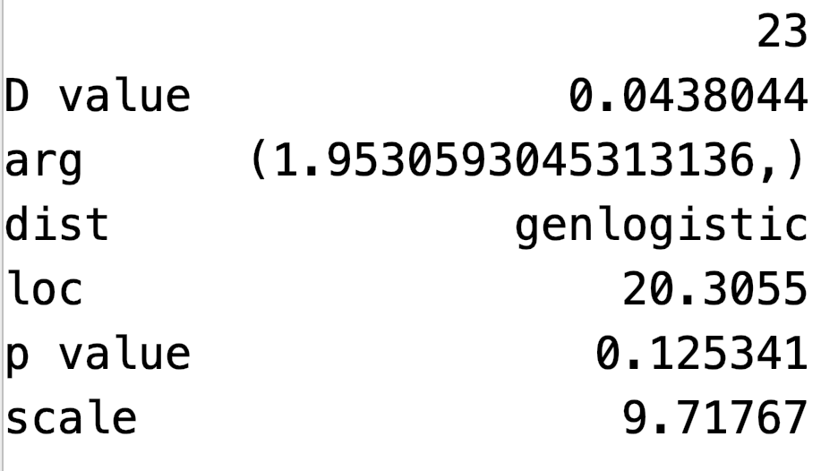

Here is the code which grid searches different distributions in the scipy.stats library. (Note there are many more distributions in the library but I have included enough to find a decent match)
import pandas as pd
import matplotlib.pyplot as plt
import numpy as np
import scipy.stats
from scipy.stats import kstest

pd.set_option('display.max_columns', None)
pd.set_option('display.width', 1000)

# Load samples.
import seaborn
dataset = seaborn.load_dataset('titanic')
# Drop the null values.
samples = dataset.age.dropna()

# High p-values are preferred and low D scores (closer to 0)
# are preferred. loc==mean / scale==sd
def runKolmogorovSmirnovTest(dist, loc, arg,
scale, samples):
d, pvalue = kstest(samples.tolist(),
lambda x: dist.cdf(x,
loc=loc, scale=scale, *arg),
alternative="two-sided")
print("D value: " + str(d))
print("p value: " + str(pvalue))
dict = {"dist": dist.name, "D value": d, "p value": pvalue,
"loc":loc, "scale":scale, "arg":arg}
return dict

def fit_and_plot(dist, samples, df):
print("\n*** " + dist.name + " ***")

# Fit the distribution as best as possible
# to existing data.
params = dist.fit(samples)
arg = params[:-2]
loc = params[-2] # Like mean/median
scale = params[-1] # Like standard deviation or spread

# Generate 'x' values between 0 and 80.
x = np.linspace(0, 80, 80)

# Run test to see if generated data aligns properly
# to the sample data.
distDandP = runKolmogorovSmirnovTest(dist, loc, arg, scale, samples)
df = df._append(distDandP, ignore_index=True)

# Plot the test and actual values together.
_, ax = plt.subplots(1, 1)
plt.hist(samples, bins=80, range=(0, 80))
ax2 = ax.twinx()
ax2.plot(x, dist.pdf(x, loc=loc, scale=scale, *arg),
'-', color="r", lw=2)
plt.title(dist.name)
plt.show()
return df

distributions = [
scipy.stats.norm,
scipy.stats.gamma,
scipy.stats.chi2,
scipy.stats.wald,
scipy.stats.uniform,
scipy.stats.norm,
scipy.stats.t,
scipy.stats.chi,
scipy.stats.dgamma,
scipy.stats.ncx2,
scipy.stats.burr,
scipy.stats.bradford,
scipy.stats.crystalball,
scipy.stats.exponnorm,
scipy.stats.pearson3,
scipy.stats.exponpow,
scipy.stats.invgauss,
scipy.stats.argus,
scipy.stats.gennorm,
scipy.stats.expon,
scipy.stats.gengamma,
scipy.stats.genextreme,
scipy.stats.genexpon,
scipy.stats.genlogistic]

dfDistribution = pd.DataFrame()
# Grid search the continuous distributions.
for i in range(0, len(distributions)):
dfDistribution = fit_and_plot(distributions[i], samples, dfDistribution)

dfDistribution = dfDistribution.sort_values(by=['D value'])
print(dfDistribution.T) #

Generating Random Data with the Estimated Distribution
Once we have estimated the best distribution we can then use it to generate random data for our simulations.

Example 5: Generating Random Data
Since we determined that genlogistic is an appropriate estimated distribution for ages in Example 4, we can then generate random data with the genlogistic distribution. The generated sample needs to be truncated since ages cannot be younger than 0. The general shape of the sample distribution is a decent match with the ages in the original set that was presented in Example 4.

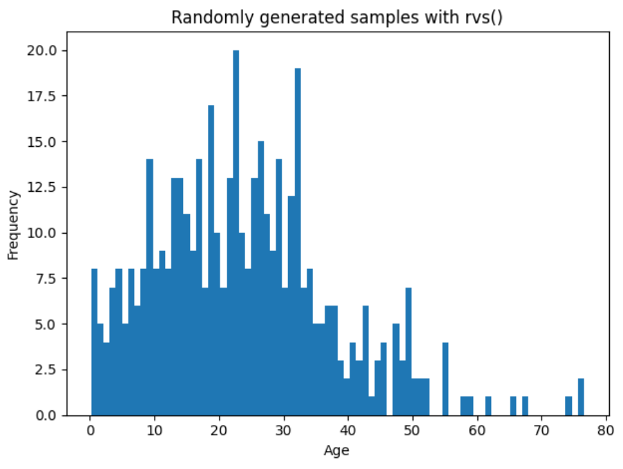

The following code uses location, scale and distribution type values from Example 4 along with the rvs() function to generate 500 random samples. The approximation is not perfect but this is a decent initial set of data to work with for a random simulation.
import scipy.stats
NUM_SIMULATIONS = 500

loc = 20.30555
scale = 9.717675

randomSamples = scipy.stats.genlogistic.rvs(
c=1, # This is the number of array dimensions.
size=NUM_SIMULATIONS, loc=loc, scale=scale)

# Get samples greater than 0 since age cannot be negative.
truncatedSamples = [i for i in randomSamples if i >= 0]

import matplotlib.pyplot as plt
plt.hist(truncatedSamples, bins=80)
plt.title("Randomly generated samples with rvs()")
plt.xlabel("Age")
plt.ylabel("Frequency")
plt.show()

Approximating the Distribution
When grid searching the distribution, it is usually difficult to find an identical distribution. When a match cannot be found, you can try to find a best approximation by finding the distribution where the D value is closest to zero.

Example 6: Approximating the Distribution
When trying to find the closest match for the daily minimum temperatures set, the ncx2 distribution appears with the lowest D value.

D value: 0.9516167331184288
p value: 0.0

Unfortunately, the graph of the ncx2 distribution does not indicate a good fit. However, the next lowest D value of 0.9972 is yielded by the genlogistic distribution which appears to have a better fit.
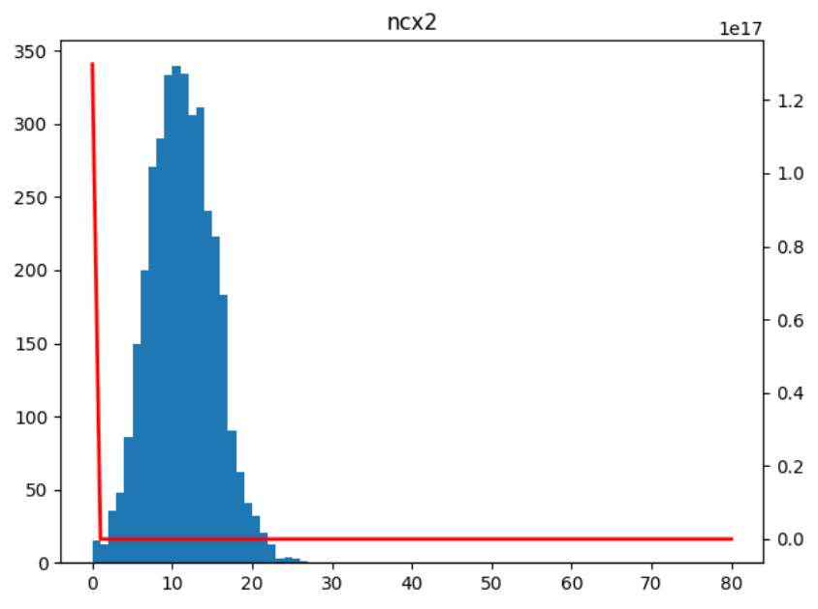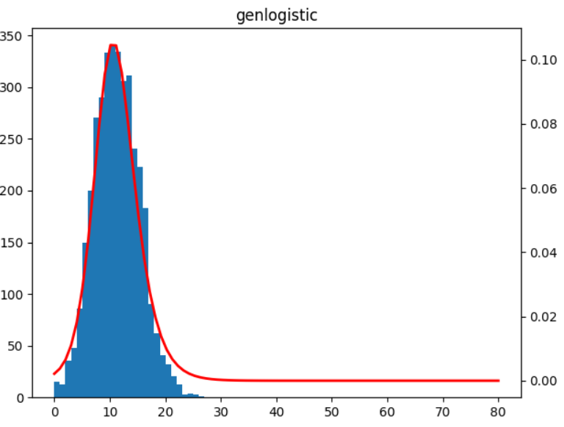
Given the D values, it may be more convenient to approximate the distribution with a normal distribution which has statistics that are a close match to the genlogistic distribution.

D value: 0.9998981456822233
p value: 0.0

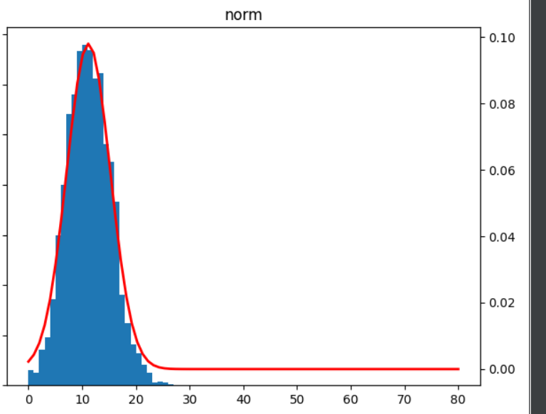
To build this example, replace the section of code in Example 4 where the samples are loaded and defined with this version.
# Load samples.
PATH = '/users/pm/desktop/daydocs/data/'
FILE = 'daily-min-temperatures.csv'
df = pd.read_csv(PATH + FILE)
samples = np.array(df[['Temp']])

Exercise 3 (8 marks)
Use the following code to load the drug sales data.
# Load samples.
PATH = '/users/pm/desktop/daydocs/data/'
FILE = 'drugSales.csv'
df = pd.read_csv(PATH + FILE)
samples = np.array(df[['value']])

Find the best approximation for the drug sales data. An identical match likely will not be found. Show the distribution name and the corresponding p-value and D value.
*** norm ***
D value: [0.10900499]
p value: [0.01447674]

*** gamma ***
D value: [0.05507349]
p value: [0.54745082]

*** chi2 ***
D value: [0.05506894]
p value: [0.54755705]

*** wald ***
D value: [0.08006796]
p value: [0.13846383]

*** uniform ***
D value: [0.33083944]
p value: [2.13021108e-20]

*** norm ***
D value: [0.10900499]
p value: [0.01447674]

*** t ***
D value: [0.10900473]
p value: [0.01447708]

*** chi ***
D value: [0.03080554]
p value: [0.98711156]

*** dgamma ***
D value: [0.12150692]
p value: [0.00440429]

*** ncx2 ***
D value: [0.07139497]
p value: [0.23789777]

*** burr ***
D value: [0.07792803]
p value: [0.15918281]

*** bradford ***
D value: [0.17355183]
p value: [7.6360532e-06]

*** crystalball ***
D value: [0.109005]
p value: [0.01447672]

*** exponnorm ***
D value: [0.07272729]
p value: [0.21983169]

*** pearson3 ***
D value: [0.05506965]
p value: [0.54754036]

*** exponpow ***
D value: [0.03856488]
p value: [0.91033827]

*** invgauss ***
D value: [0.06816451]
p value: [0.28625834]

*** argus ***
D value: [0.30288861]
p value: [4.21615754e-17]

*** gennorm ***
D value: [0.12816918]
p value: [0.00221531]

*** expon ***
D value: [0.08222531]
p value: [0.11984059]

*** gengamma ***
D value: [0.07340871]
p value: [0.21100404]

*** genextreme ***
D value: [0.06763594]
p value: [0.29479808]

*** genexpon ***
D value: [0.06587204]
p value: [0.32458623]

*** genlogistic ***
D value: [0.08107011]
p value: [0.12954026]

Show a plot of the cumulative density function with the samples.
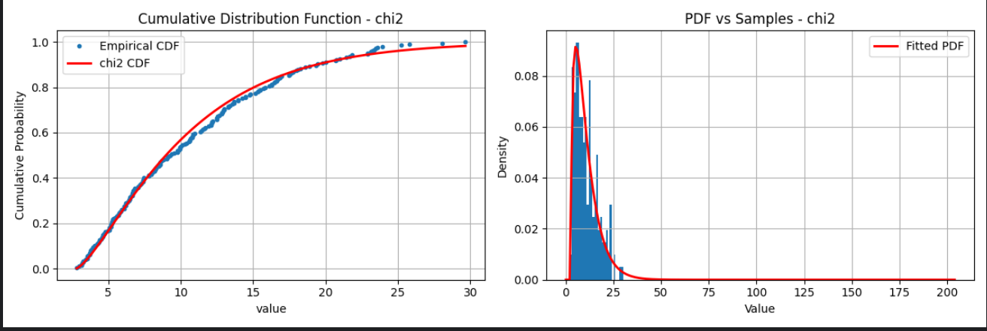

Show the p-value and D values for the normal function.
*** norm ***
D value: [0.10900499]
p value: [0.01447674]

Show a plot of the cumulative density function for the normal distribution with the samples.
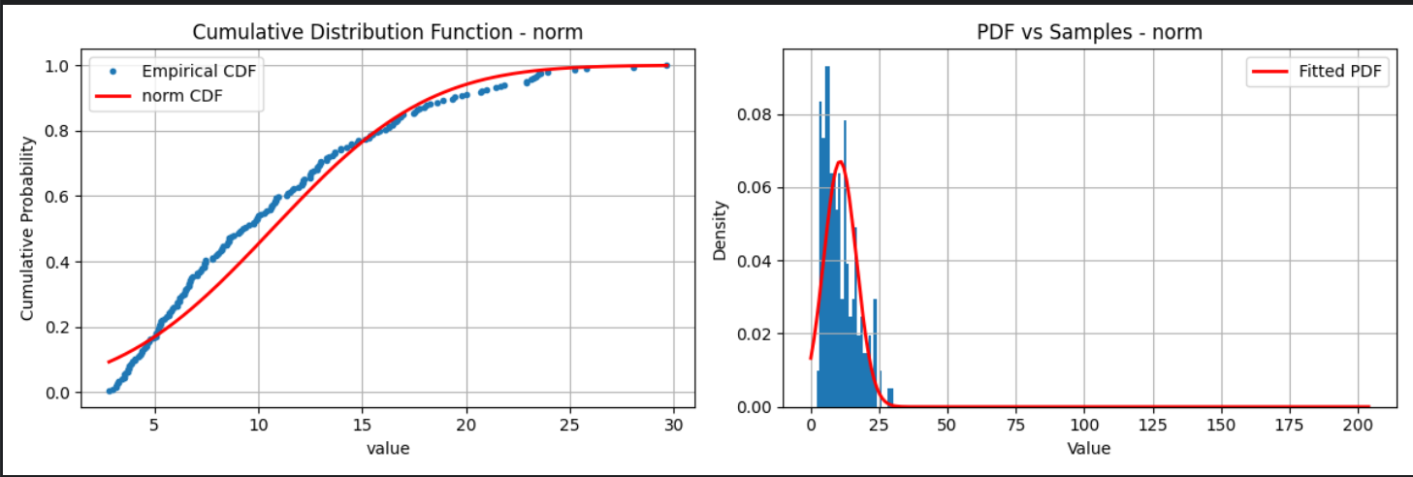

Approximating any Distribution with a Normal Distribution
When building data models we often make the assumption that the distributions are normally distributed when actually they are not. However, the normal distribution can be often used to generate a reasonable approximation of the actual distribution.

Example 7: Approximating any Distribution with a Normal Distribution
This example shows how the normal distribution can be used to approximate the distribution for ages in the titanic data set. A genlogistic distribution would actually be better but the normal distribution performs reasonably well. When comparing the randomly generated set with the actual the general shape, tails and average are reasonably estimated.

Actual Age Samples with Approximated Normal Distribution in Red | Randomly Generated Age Samples with Approximated Normal Distribution
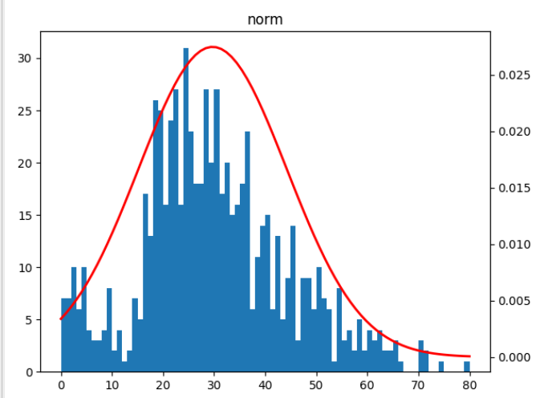 | 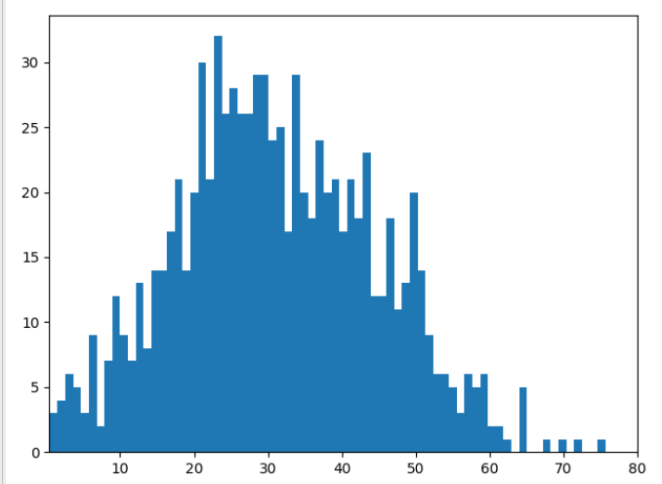
This code fits the normal distribution for random sample generation and then generates the samples for display.
# This is not as good as with genlogistic but is a somewhat reasonable alternative approach.
import pandas as pd
import matplotlib.pyplot as plt
import numpy as np
import scipy.stats
from scipy.stats import kstest

pd.set_option('display.max_columns', None)
pd.set_option('display.width', 1000)

# Load samples.
import seaborn
dataset = seaborn.load_dataset('titanic')
# Drop the null values.
samples = dataset.age.dropna()

# High p-values are preferred and low D scores (closer to 0)
# are preferred.
def runKolmogorovSmirnovTest(dist, loc, arg,
scale, samples):
d, pvalue = kstest(samples.tolist(),
lambda x: dist.cdf(x,
loc=loc, scale=scale, *arg),
alternative="two-sided")
print("D value: " + str(d))
print("p value: " + str(pvalue))
dict = {"dist": dist.name, "D value": d, "p value": pvalue,
"loc":loc, "scale":scale, "arg":arg}
return dict

def fit_and_plot(dist, samples, df):
print("\n*** " + dist.name + " ***")

# Fit the distribution as best as possible
# to existing data.
params = dist.fit(samples)
arg = params[:-2]
loc = params[-2]
scale = params[-1]

# Generate 'x' values between 0 and 80.
x = np.linspace(0, 80, 80)

# Run test to see if generated data aligns properly
# to the sample data.
distDandP = runKolmogorovSmirnovTest(dist, loc, arg, scale, samples)
df = df._append(distDandP, ignore_index=True)

# Plot the test and actual values together.
_, ax = plt.subplots(1, 1)
plt.hist(samples, bins=80, range=(0, 80))
ax2 = ax.twinx()
ax2.plot(x, dist.pdf(x, loc=loc, scale=scale, *arg),
'-', color="r", lw=2)
plt.title(dist.name)
plt.show()
return df

distributions = [
scipy.stats.norm,]

dfDistribution = pd.DataFrame()
# Grid search the continuous distributions.
for i in range(0, len(distributions)):
dfDistribution = fit_and_plot(distributions[i], samples, dfDistribution)

meanAges = np.mean(samples)
ageSD = np.std(samples)
minAge = np.min(samples)
maxAge = np.max(samples)
totalAges= len(dataset)

dfDistribution = dfDistribution.sort_values(by=['D value'])
print(dfDistribution.T) #
NUM_SIMULATIONS = totalAges

# Generate random samples.
randomNums = scipy.stats.norm.rvs(loc = meanAges,
scale = ageSD,
size = NUM_SIMULATIONS)
plt.xlim([minAge, maxAge])

# Show random samples in a histogram.
plt.hist(randomNums, bins=80)
plt.show()

