Table of Contents
A/B Testing Continuous Outcomes 1
Type 1 and Type 2 Errors 1
Preventing Type 1 and Type 2 Errors with Hypothesis Testing 1
Step 1. Choose the statistic that is to be measured. 2
Step 2. Define the hypothesis test. 2
Step 2. Calculate the Effect Size 2
Step 3. Calculate the Number of Samples Needed 3
Step 4. Perform the Test 3
A/B Testing Binary Outcomes 5
Sample Standard Deviation for Binary Outcomes 5
Determine Total Samples Needed 6
Calculate the Z Score for Binary Outcomes 7
Hypothesis Testing Binary Outcomes 8
Hypothesis Test Conclusion 10
Monte Carlo Simulations 11

A/B Testing Continuous Outcomes
A/B testing involves testing whether or not one scenario performs better than another. For example, you could test whether visitors to a website purchase more if the page has a red background or a pink background. Or you might test if potential blood donors respond better to blood donor request message 1 or blood donor request message 2.

Type 1 and Type 2 Errors
If we are not careful we may incorrectly interpret the results from our testing. A type 1 error occurs when we incorrectly conclude that samples are from distribution B when they are actually from distribution A. Type 2 errors occur when we incorrectly conclude that a sample is from distribution A when it is actually from distribution B (see Figure 1).

Figure 1: Type I and Type II Errors
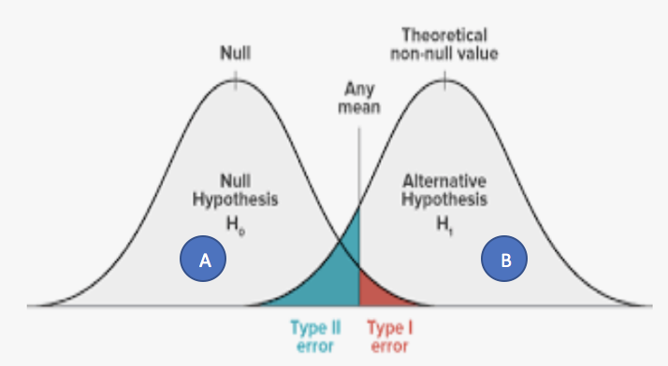

Preventing Type 1 and Type 2 Errors with Hypothesis Testing
At this point you might be thinking “Wow this is potentially a serious problem! How can I avoid type A and type B errors?!!” Thankfully we can create a hypothesis test to help prevent these mistakes. To do this, we create a T-test for the means of two independent sample sets. The general design of the test is:

$H_{0}:$ Change makes no difference. New sample is from same distribution. (p-value $≥$ 0.05)
$H_{1}$: Change makes a difference. Sample is from different distribution. (p-value < 0.05)

Tips:
When designing your hypothesis tests:
- Define a clear hypothesis.
- Design a test for one metric only.

Example 1: A/B Testing Strawberry Cake Advertising
 | A restaurant wants to sell more strawberry cakes to groups of customers. The owners wonder if their new menu card entices more groups to buy strawberry cake. The current mean number of dessert-eating customers is 123 groups per day with a standard deviation $σ$= 20. The restaurant wants the new mean to be 140 per day with a standard deviation of $σ$=20.

This section will explain how to determine if the observations from A/B testing validate the hypothesis that more customers are buying desserts because of the new table card.

Step 1. Choose the statistic that is to be measured.
First, identify the one statistic that we want to measure. For this case, the total number of customer groups that are purchasing desserts per day is the statistic to be measured.

Step 2. Define the hypothesis test.
The next step involves defining the hypothesis. For our case, the tests are;

$H_{0}$=The new table card makes no difference to the number of groups ordering dessert each day.
$H_{1}$=The new table card increases the number of groups ordering dessert each day from an average of 123 to 140.

Step 2. Calculate the Effect Size
Next, we need to calculate the effect size. The effect size helps us to identify an adequate minimum number of samples for the hypothesis test. For our case, we want the effect to help us evaluate whether or not the average strawberry cake desserts ordered increases to 140 from 123 per day. The effect size is calculated with Cohen’s d formula:

d = $\frac{{mean}_{a}- {mean}_{b}}{\sqrt{\frac{{var}_{1}+{var}_{2}}{2}}}$

For our example;

d = $\frac{{mean}_{a}- {mean}_{b}}{\sqrt{\frac{{var}_{1}+{var}_{2}}{2}}}$ = $\frac{123- 140}{\sqrt{\frac{σ_{1}^{2}+ σ_{2}^{2}}{2}}}$ = $\frac{-17}{\sqrt{\frac{{20}^{2}+ {20}^{2}}{2}}}$ = $\frac{-17}{\sqrt{\frac{400+400}{2}}}$ = $\frac{-17}{\sqrt{\frac{400+400}{2}}}$ = -0.85

We can now use Cohen’s d value as a parameter in the next step.

Step 3. Calculate the Number of Samples Needed
Once you have the effect size, you can use it as a parameter to calculate the appropriate number of samples needed to detect such a change between both groups. Running the following code outputs a result that indicates that 23 separate days are needed for testing with the new cards since we are testing the average numbers of groups that order dessert per day.
from statsmodels.stats.power import TTestIndPower
effect = -0.85 # Obtained from previous step.
alpha = 0.05 # Enable 95% confidence for two tail test.
power = 0.8 # One minus the probability of a type II error.
# Limits possibility of type II error to 20%.
analysis = TTestIndPower()
numSamplesNeeded = analysis.solve_power(effect, power=power, alpha=alpha)
print(numSamplesNeeded)

Step 4. Perform the Test
The next step involves performing the test. This can be done using 23 observations from days when the old table card is used and with 23 observations from days when the new card is used. It happens that the variance for both distributions is the same but we will treat the variances as if they are independent so equal_var is set to False.

testResult = stats.ttest_ind(new_menu_sales, old_menu_sales, equal_var=False)

Here is the full program.
from scipy import stats
old_menu_sales = [101, 110, 115, 136, 140, 108,
80, 89, 131, 98, 121, 117, 106,
141, 119, 153, 184, 127, 103,
139, 130, 146, 130]

new_menu_sales = [158, 145, 134, 130, 113, 135,
163, 128, 166, 154, 143, 147, 132,
132, 136, 99, 163, 106, 143, 168, 136,
123, 159]

testResult = stats.ttest_ind(new_menu_sales,
old_menu_sales, equal_var=False)

import numpy as np
print("Hypothesis test p-value: " + str(testResult))
print("New sales mean: " + str( np.mean(new_menu_sales)))
print("New sales std: " + str(np.std(new_menu_sales)))

The output shows a p value of 0.009. Therefore, we can reject the null hypothesis which suggests the new card makes no difference. In other words, we can conclude that the new card likely does help to obtain more orders of strawberry cake dessert. The higher number of dessert purchases after using the new card appears to be the result of having the new card:
Hypothesis test p-value:
Ttest_indResult(statistic=2.7250996310490008, pvalue=0.009307319110185647)

New sales mean: 139.69565217391303
New sales std: 18.425961794515096

Exercise 1 (8 marks)
The government of Canada recently shut-down gym class in high school due to COVID-19 cases. Prior to the shut-down it appeared that an average of 10 new cases per day were linked to high school across the country. After the shut-down it appears that the cases linked to high school had dropped to 5 new cases per day. The standard deviation in both cases appears to be around 4.5 before and after the shut-down. Treat the standard deviations as if they are from separate distributions. The government is facing requests to lift these restrictions on gym class so it wants to verify if the shut-down has been effective statistically.

You are to create the following test:

$H_{0}$=The shut-down makes no difference to the number of new COVID cases linked to high school per day.

$H_{1}$=The shut-down has helped to reduce the number of new COVID cases linked to high school per day.

Calculate Cohen’s d value for this case. Show your calculations here:
mean_a = 10
mean_b = 5
std = 4.5
cohen_val = (mean_a - mean_b) / (np.sqrt((std**2 + std**2) / 2))
print(cohen_val)

1.1111111111111112

Using the effect size that is obtained in the last step, calculate an adequate number of sample days that are needed to compare COVID case counts before and after the shut-down. The government only wants to allow for a 5% probability of a type 2 error. Show your code here:
import math
import numpy as np
from statsmodels.stats.power import TTestIndPower
mean_a = 10
mean_b = 5
std = 4.5
cohen_val = (mean_a - mean_b) / (np.sqrt((std**2 + std**2) / 2))
print(cohen_val)
alpha = 0.05
power = 0.95
analysis = TTestIndPower()
test_days_needed = analysis.solve_power(cohen_val, power=power, alpha=alpha)
print(f"Number of test days: {math.ceil(test_days_needed)}")

Show the optimal number of sample days here:
Number of test days: 22.06036069274869

Exercise 2 (4 marks)
We happen to have 30 samples of new case counts from before and after the gym shut-down.

Case counts linked to high school before gym class shut down:
[10, 11, 6, 18, 11, 9, 13, 9, 3, 12, 3, 13, 14, 4, 12, 8, 18, 17, 15, 18, 6, 1, 13, 9, 11, 15, 11, 7, 12, 14]

Case counts linked to high school after gym class shut down:
[ 5, 7, 3, 12, 0, 7, 0, 8, 9, 5, 5, 2, 2, 2, 4, 6, 6, 7, 1, 6, 10, 1, 0, 2, 2, 4, 5, 1, 4, 3]

Using only the number of samples that are recommended in Exercise 1, determine if the cases appear to accept or reject the null hypothesis. Show your code here:
import math
import numpy as np
from statsmodels.stats.power import TTestIndPower
from scipy import stats
mean_a = 10
mean_b = 5
std = 4.5
cohen_val = (mean_a - mean_b) / (np.sqrt((std**2 + std**2) / 2))
print(cohen_val)
alpha = 0.05
power = 0.95
analysis = TTestIndPower()
test_days_needed = analysis.solve_power(cohen_val, power=power, alpha=alpha)
print(f"Number of test days: {math.ceil(test_days_needed)}")
before = [10, 11, 6, 18, 11, 9, 13, 9, 3, 12, 3, 13, 14, 4, 12,
8, 18, 17, 15, 18, 6, 1, 13, 9, 11, 15, 11, 7, 12, 14]
after = [ 5, 7, 3, 12, 0, 7, 0, 8, 9, 5, 5, 2, 2, 2, 4,
6, 6, 7, 1, 6, 10, 1, 0, 2, 2, 4, 5, 1, 4, 3]
test_result = stats.ttest_ind(before, after, equal_var=False)
print(f"Hypothesis test summary: {test_result}")
print(f"New Covid cases mean: {np.mean(after)}")
print(f"New Covid cases std: {np.std(after)}")

Show your p-value and state whether the closing of gym class appears to reduce the COVID cases or not.
Hypothesis test summary: TtestResult(statistic=np.float64(6.394792279873922), pvalue=np.float64(4.962902221102939e-08), df=np.float64(50.87028926179464))
New Covid cases mean: 4.3
New Covid cases std: 3.0457620830699605

p-value is extremely small, 0.000000049629 so the null hypothesis is rejected or yes, it is effective in preventing Covid infection when shutting down gym class.

A/B Testing Binary Outcomes
The setup for A/B testing binary outcomes is similar to testing continuous outcomes as previously demonstrated in Example 1.

Example 2: Binary A/B test
A youtuber runs two separate channels to obtain subscribers. After examining different campaigns for each channel, it appears the signup rates are generally normally distributed. In other words, the percentage of subscribers for all trials are centred around an average with relatively equal dispersion on both sides. Channel B appears to be better at gaining subscribers (see Figure 2) but the youtuber wants to be confident that this actually is the case.

Sample Standard Deviation for Binary Outcomes
For this case, the youtuber has 2000 samples of new viewers for each channel. For binary outcomes such as subscriber conversion, sample standard deviation for channel A is calculated as:

$\sqrt{\frac{P_{A}∙(1-P_{A})}{n}}$
${Probability}_{A}$ = $\frac{X_{A}}{n_{A}}$ = $\frac{250 new viewers clicked subscribe}{2000}$ = 0.125

Channel A: Sample standard deviation =$\sqrt{\frac{0.125*(1-0.125)}{2000}}$ $≅$ 0.007

Figure 2: Subscriber rates for channels A and B.
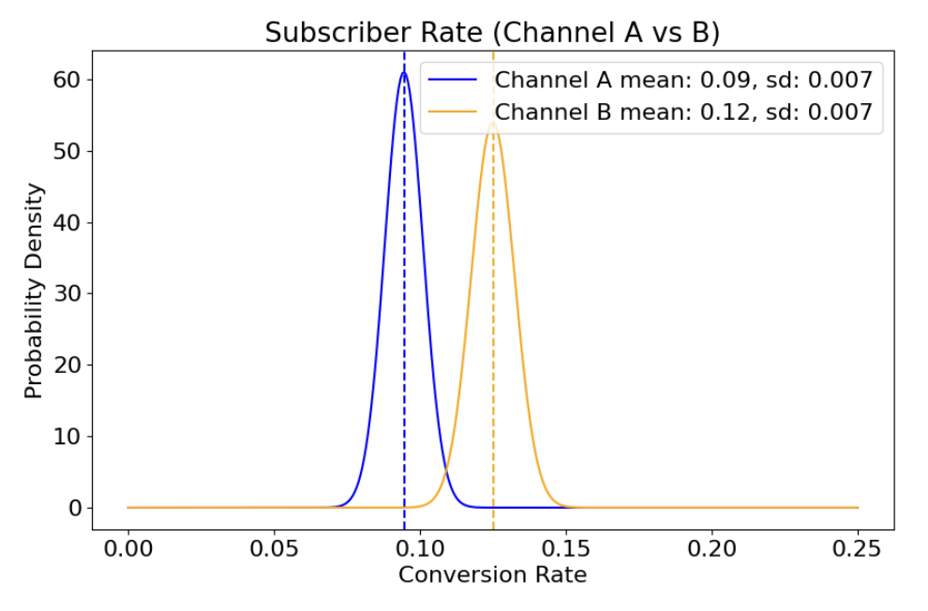
Exercise 3 (2 marks)
Show the calculation for the sample standard deviation for group B.
This is confusing based on your code output: pA=0.095, pB=0.125, pooled=0.110. So you want std for pA?

print(pA * (1 - pA) / 2000) = 4.2784875e-05

Exercise 4 (2 marks)
A higher standard deviation in a normally distributed population leads to a flatter curve.

- True b) False

Determine Total Samples Needed
Before conducting a test to determine if the difference in subscribe rates is significant, the youtuber needs to know if enough samples exist in both data sets.

This test generates recommends sample sizes to minimize type 1 errors to 5% and type 2 errors to 20%.

from statsmodels.stats.power import NormalIndPower
from statsmodels.stats.proportion import proportion_effectsize
import numpy as np

# Ratio of 1 says both samples have same count.
# Ratio of 0.5 says B has half the samples of A.
def min_n_two_prop(p1, p2, alpha=0.05, power=0.80, ratio=1.0):
# Cohen’s effect says how big difference is between two groups in standard units
eff = proportion_effectsize(p1, p2) # Cohen's h for proportions
analysis = NormalIndPower()

# Alpha split over two tails so 0.025 at each tail.
n_a = analysis.solve_power(effect_size=eff, alpha=alpha, power=power,
ratio=ratio, alternative='two-sided')
return int(np.ceil(n_a))

# Detect lift from 9% to 12% with 5% alpha, 80% power
p1, p2 = 0.09, 0.12
nA = min_n_two_prop(p1, p2, alpha=0.05, power=0.80, ratio=1.0)
nB = nA # equal sizes
print(f"Required per group: A={nA}, B={nB}, total={nA+nB}")

The output shows:
Required per group: A=1632, B=1632, total=3264

Since both groups have 2000 samples each, a test can be conducted with relative confidence for minimizing type 1 and type 2 errors.

Calculate the Z Score for Binary Outcomes

The Z score tells us how far apart the distributions are. If the Z value yields a small p-value then we can be confident that the distributions are different. The setup for A/B testing binary outcomes is similar to testing continuous outcomes as previously demonstrated.

A p-value less than 0.05 would allow us to confidently conclude that channel B is performing better than channel A for obtaining subscribers.

z =$\frac{Observed difference between groups}{Random noise}$ = $\frac{{Probility}_{B}- {Probility}_{A}}{Standard Error}$

$P_{pooled}$ is the combined conversion rate assuming there is no real difference between groups A and B.

$P_{pooled}= \frac{x_{a}+ x_{b}}{n_{a}+ n_{b}}$ where x is total conversions and n is total samples.
$= \frac{189+250}{2000+2000}$ = 0.10975

SE = random noise during sampling = $\sqrt{P_{pooled}∙(1-P_{pooled})∙(\frac{1}{n_{a}}+ \frac{1}{n_{b}})}$

= $\sqrt{0.10975*\left(1-0.10975\right)*(\frac{1}{2000}+ \frac{1}{2000})}$ = 0.00988458

${Probability}_{A}$ = $\frac{X_{A}}{n_{A}}$ = $\frac{250 new viewers clicked subscribe}{2000}$ = 0.125

${Probability}_{B}$ = $\frac{X_{B}}{n_{B}}$ = $\frac{189 new viewers clicked subscribe}{2000}$ = 0.0945

Z = $\frac{{Probility}_{B}- {Probility}_{A}}{Standard Error}$ $=\frac{0.125-0.0945}{0.00988458}$ = 3.08561416

Hypothesis Testing Binary Outcomes
The null hypothesis is that both channels are equally effective at obtaining new subscribers.

We have calculated Z to represent the distance between distributions. The hypothesis test says if -z < p-value < +z there is no difference between distributions.

The p value is the probability of being in the tail region. This is a two tailed test so p = 2*0.00104 = 0.00208

Figure 3: Z table
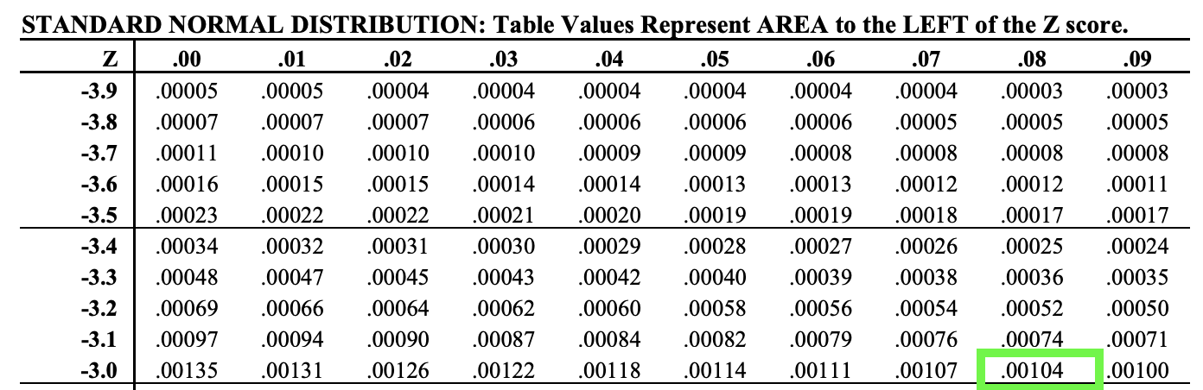

$H_{0}$is not rejected if the p-value appears between the tails. $H_{1}$ occurs if p-values appear in either tail (see Figure 4).

Figure 4: $H_{0}$ is not rejected if the p-value appears between the tails. $H_{1}$ occurs if p-values appear in either tail.
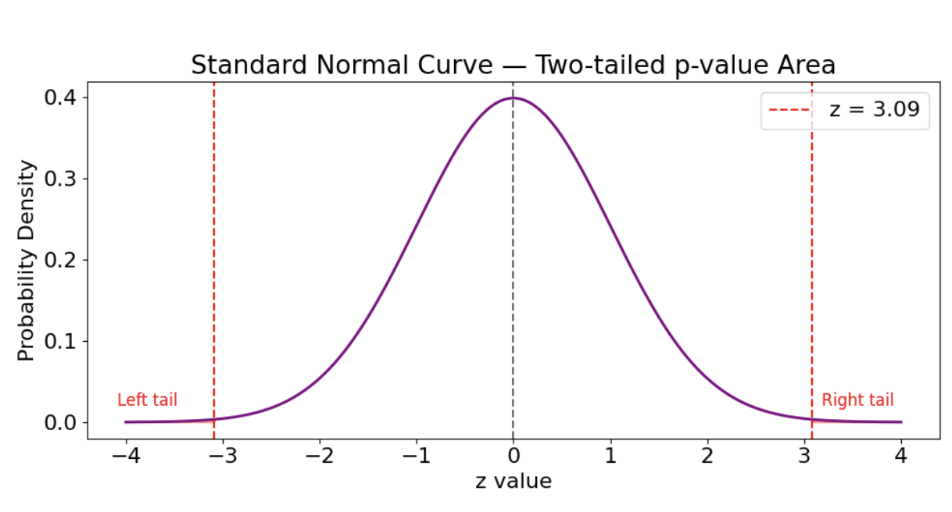

Here is code which automates the calculations for the p-value:
import numpy as np
import matplotlib.pyplot as plt
from scipy.stats import norm
from statsmodels.stats.proportion import proportions_ztest

TOTAL_SAMPLES = 2000

# Generate some fake data
np.random.seed(41)
channelA = np.random.binomial(1, 0.10, TOTAL_SAMPLES)
channelB = np.random.binomial(1, 0.13, TOTAL_SAMPLES)

# Get stats for both channels
xA, nA = channelA.sum(), len(channelA)
xB, nB = channelB.sum(), len(channelB)
pA, pB = xA/nA, xB/nB
p_pool = (xA + xB) / (nA + nB)

# Get standard error
se = np.sqrt(p_pool * (1 - p_pool) * (1/nA + 1/nB))

# Calculate z
z_stat = (pB - pA) / se

# Note we are getting the combined alphas at both ends.
# So multiply by 2.
# Note there will be some slight rounding differences.

p_val = 2 * (1 - norm.cdf(abs(z_stat)))

print(f"pA={pA:.3f}, pB={pB:.3f}, pooled={p_pool:.3f}")
print(f"z={z_stat:.2f}, p={p_val:.4f}")

Hypothesis Test Conclusion
Since the p-value is 0.0208 which is less than 0.05, the youtuber can conclude that channel B is better at generating more subscribers.
Exercise 5 (8 marks)
Here is code to generate a new test data set:
import numpy as np
from scipy.stats import norm
from statsmodels.stats.proportion import proportions_ztest

TOTAL_SAMPLES = 1000
# Generate some fake data
np.random.seed(22)
channelA = np.random.binomial(1, 0.10, TOTAL_SAMPLES)
channelB = np.random.binomial(1, 0.14, TOTAL_SAMPLES)

This generates a sample mean of 0.09 and 0.13 for channels A and B. Ignoring the need for a sufficient sample size, calculate the z value and p value and assume your goal is to determine if channel B and A are any different with 95% confidence. What is the Z value and what is the p value? You may use code to generate this result.
z=3.2224, p=0.0013

Show the calculation of the Z value by hand to demonstrate enough understanding of how the calculation is made.
$P_{pooled}= \frac{x_{a}+ x_{b}}{n_{a}+ n_{b}}$ where x is total conversions and n is total samples.
$= \frac{87+132}{2000}$ = 0.1095

SE = random noise during sampling = $\sqrt{P_{pooled}∙(1-P_{pooled})∙(\frac{1}{n_{a}}+ \frac{1}{n_{b}})}$

= $\sqrt{0.1095*\left(1-0.1095\right)*(\frac{1}{1000}+ \frac{1}{1000})}$ = 0.01396493823

${Probability}_{A}$ = $\frac{X_{A}}{n_{A}}$ = $\frac{87 new viewers clicked subscribe}{1000}$ = 0.087

${Probability}_{B}$ = $\frac{X_{B}}{n_{B}}$ = $\frac{132 new viewers clicked subscribe}{1000}$ = 0.132

Z = $\frac{{Probility}_{B}- {Probility}_{A}}{Standard Error}$ $=\frac{0.132-0.087}{0.01396493823}$ = 3.22235582133

Exercise 6 (3 marks)
Using the information Exercise 5, calculate proper sample sizes which allow for testing for a 95% confidence interval and show the proper sizes for each sample assuming they are the same.
Required per group: A=954, B=954, total=1908

Based on sample size calculations, can you conclude with 95% confidence of avoiding a type 1 error that Channel B is performing better at obtaining subscribers?
yes since p-value = 0.0013 < 0.05.

Monte Carlo Simulations
Monte Carlo simulations allow us to perform risk analysis by using randomly selected variable values. Monte Carlo simulations assume the variables fall within a specific distribution.

Exercise 7 (12 marks)
This video explains how to implement a Monte Carlo simulation with Excel.
https://www.youtube.com/watch?v=HwVBi--mE4M

For this exercise, complete the simulation and upload your spreadsheet with the word document to the drop box for this lesson.

During the lesson we will examine how to implement Monte Carlo simulations for different distributions with Python.

