Table of Contents
Data Loader 1
Convolutional Neural Networks (CNN’s) 5
Filters (Kernels) 7
Stride 7
Padding 8
Pooling 8
Calculating the Flattened Length of a Convolutional Layer Output 11
Introduction to Recurrent Neural Networks (RNNs) 14
Sequential Data 15
Learning Sequences 15
Hidden State 16

Data Loader
A DataLoader is a helper that feeds your data to the model in batches, optionally shuffles it, and loads it efficiently.

Example 1: Dataloader
This example creates a DataLoader. The DataLoader is initialized with torch tensors:
# Make x,y tensors from scalled data
train_dataset = TensorDataset(X_train_sc, y_train_sc)
test_dataset = TensorDataset(X_test_sc, y_test_sc)

# Create data loader
train_loader = DataLoader(train_dataset, batch_size=16, shuffle=True)
test_loader = DataLoader(test_dataset, batch_size=16, shuffle=False)

Then in the training loop, the training loader automatically splits the data into batches:
for xb, yb in train_loader:

In the evaluation area within the training loop, the test loader also splits the data into batches for evaluation:

for xb, yb in test_loader:

Here is the code:
import torch
from torch.utils.data import DataLoader, TensorDataset
import torch.nn as nn
from sklearn.preprocessing import StandardScaler
import numpy as np

# Make sample data
def generateData():
torch.manual_seed(0)

X = torch.linspace(0, 10, steps=100).unsqueeze(1) # shape (100, 1)
y = 2 * X + 1 + 0.1 * torch.randn_like(X) # add tiny noise
return X, y

def getData(train_ratio=0.8):
X, y = generateData()

n = len(X)
n_train = int(n * train_ratio)

# Split (no shuffle for reproducibility)
X_train, X_test = X[:n_train], X[n_train:]
y_train, y_test = y[:n_train], y[n_train:]

# Convert to numpy for sklearn
X_train_np = X_train.numpy()
X_test_np = X_test.numpy()
y_train_np = y_train.numpy()
y_test_np = y_test.numpy()

# Fit scalers on TRAIN ONLY
x_scaler = StandardScaler()
y_scaler = StandardScaler()

X_train_sc = x_scaler.fit_transform(X_train_np)
y_train_sc = y_scaler.fit_transform(y_train_np)

# Transform test using same scalers
X_test_sc = x_scaler.transform(X_test_np)
y_test_sc = y_scaler.transform(y_test_np)

# Back to torch tensors
X_train_t = torch.from_numpy(X_train_sc).float()
y_train_t = torch.from_numpy(y_train_sc).float()
X_test_t = torch.from_numpy(X_test_sc).float()
y_test_t = torch.from_numpy(y_test_sc).float()

return X_train, y_train, X_test, y_test, X_train_t, y_train_t, X_test_t, y_test_t, x_scaler, y_scaler

(X_train, y_train, X_test, y_test,
X_train_sc, y_train_sc, X_test_sc, y_test_sc,
x_scaler, y_scaler) = getData(train_ratio=0.8)

# Make x,y tensors
train_dataset = TensorDataset(X_train_sc, y_train_sc)
test_dataset = TensorDataset(X_test_sc, y_test_sc)

# Create data loader
train_loader = DataLoader(train_dataset, batch_size=16, shuffle=True)
test_loader = DataLoader(test_dataset, batch_size=16, shuffle=False)

# Define simple model
model = nn.Linear(1, 1)
loss_fn = nn.MSELoss()
optimizer = torch.optim.SGD(model.parameters(), lr=0.01)

# Train
for epoch in range(50):
model.train()
train_loss = 0.0

for xb, yb in train_loader:
optimizer.zero_grad()
preds = model(xb)
loss = loss_fn(preds, yb)
loss.backward()
optimizer.step()
train_loss += loss.item()

# Evaluate
model.eval()
test_loss = 0.0
with torch.no_grad():
for xb, yb in test_loader:
preds = model(xb)
loss = loss_fn(preds, yb)
test_loss += loss.item()

if (epoch + 1) % 10 == 0:
print(f"Epoch {epoch+1:3d} | train loss = {train_loss:.4f} | test loss = {test_loss:.4f}")

# Make predictions
model.eval()
with torch.no_grad():
preds_test_n = model(X_test_sc).numpy() # normalized predictions
preds_test = y_scaler.inverse_transform(preds_test_n)

# Show actual vs predicted
print("\n x actual predicted")
for i in range(0, len(X_test), max(1, len(X_test)//5)):
print(f"{X_test[i].item():5.2f} {y_test[i].item():8.3f} {preds_test[i,0]:8.3f}")

Exercise 1 (2 mark2)
The purpose of this exercise is to show that the TensorDataset loads torch tensors for scaled X and scaled y. While not overly complicated awareness here is the goal. Show a screenshot of X_train_sc in the Threads and Variables window while halted with the debugger beside dataset.
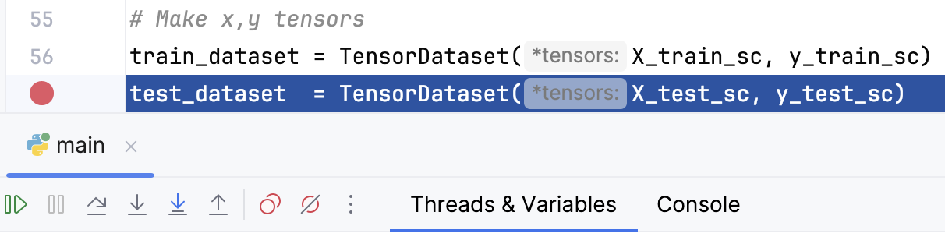
Show your screenshot here.
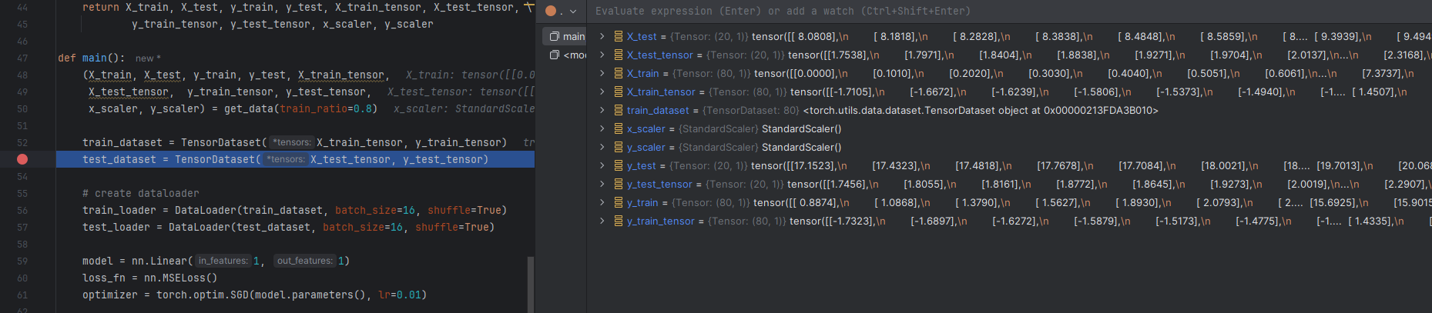

Exercise 2 (1 mark)
Replace the batch loop header in Example 1 with this code:
batch_num = 0
for xb, yb in train_loader:
print("len(xb): ", len(xb))
print("batch num: ", batch_num)
batch_num += 1
Show a screenshot of the new output that is printed by these new instructions for the first epoch:
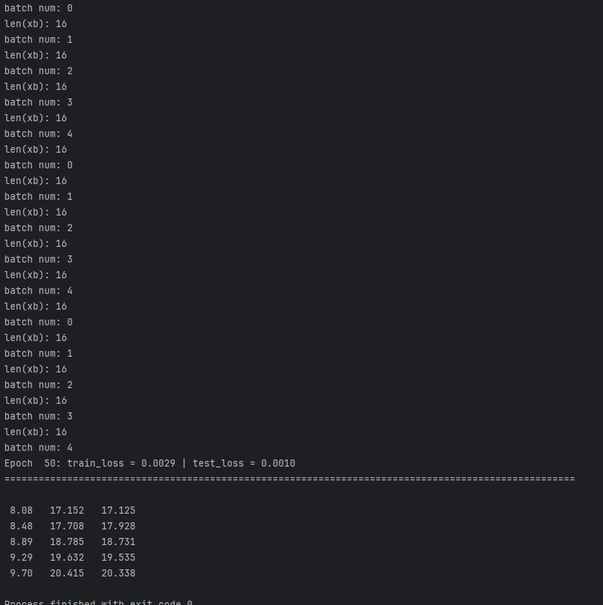
How many samples exist in the train dataset?
80
How many samples exist in each batch?
16
How many batches are created each epoch?
5
Show the instruction that initializes a DataLoader object for the train dataset.
train_dataset = TensorDataset(X_train_tensor, y_train_tensor)

Exercise 3 (2 marks)
Show the changes needed to print the loop output in this format:
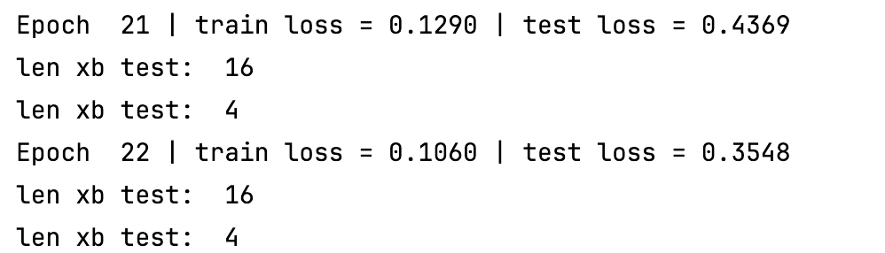
Explain why 16 and 4 appear each epoch:
each standard batch size is 16, however, the number of samples in test dataset is 20 % 16 = 4, that’s why the last batch has only 4 samples.

That’s enough for now. The DataLoader will appear in many future PyTorch examples.

Convolutional Neural Networks (CNN’s)
Convolutional neural networks (CNNs) are well suited for image classification and object detection. CNNs preserve the two-dimensional layout of an image which allows them to learn spatial patterns more effectively than MLPs. MLPs treat input data as a single one-dimensional vector. CNNs typically use far fewer parameters than MLPs because they share weights across the image. MLPs on the other hand need many more parameters to represent visual patterns. As a result, CNNs can achieve similar or better performance than MLPs with lower computational cost.
A typical CNN is built from three main kinds of layers:
- convolutional layers - uses learned filters to extract features and produce feature maps.
- pooling layers - reduces the spatial size of feature maps with downs sampling.
- fully connected layer - learns with flattened features for classification or identification. (This portion of the network is similar to an MLP like we have seen before.)
Figure 1 shows the relationship between convolutional, pooling and fully connected layers.

Figure 1: Feature Pooling and Classification Activities of a Convolutional Neural Network
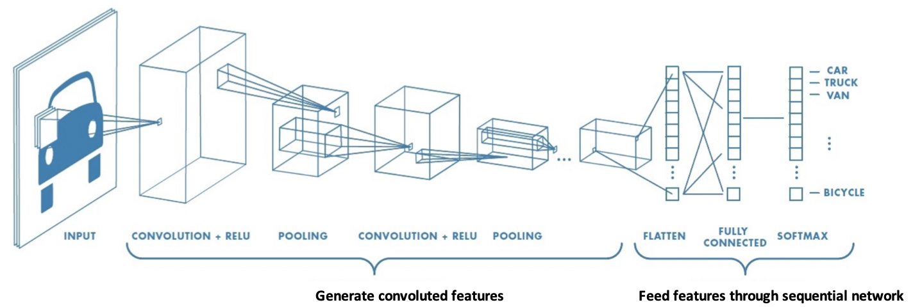
Figure 2 shows how nine pixels of an image can be convolved to produce one element of a feature map. A 3x3 kernel filter slides over the image to perform a convolving operation. Notice how the feature map is much smaller than the original image.

Figure 2: Producing One Feature Map Value from a 3×3 Convolution Kernel
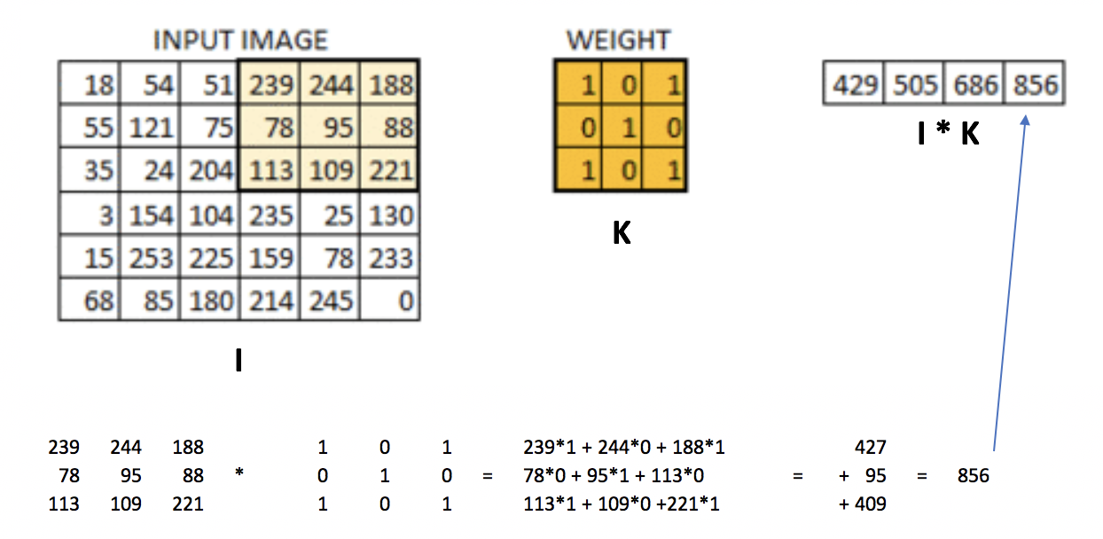
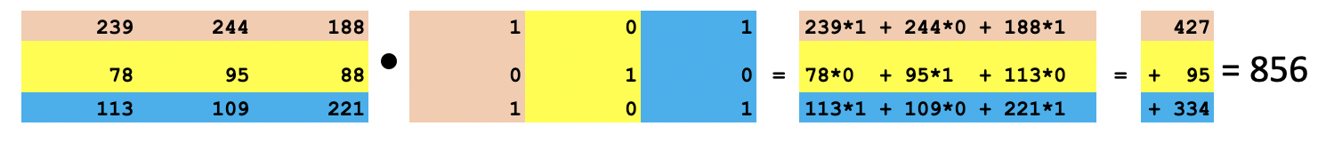
Convolving with a filter creates a feature map like the one at the right in Figure 3.

Figure 3: Real Image vs. Convolved Image (Feature Map)
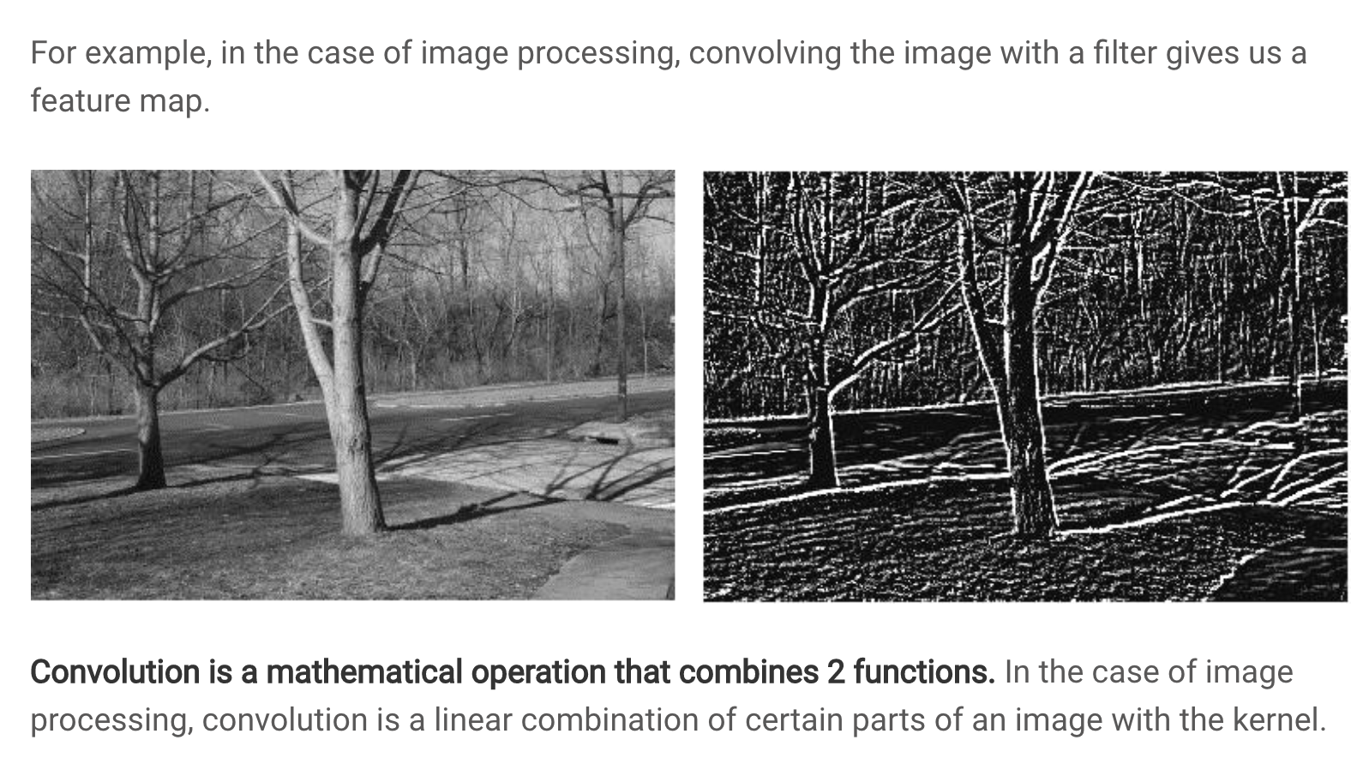

Filters (Kernels)
The filters (kernels) are made from trainable parameters. They are updated during training using backpropagation and with an optimizer such as gradient descent. Typical kernel sizes include 1×1, 3×3, 5×5, and 7×7 (with smaller sizes being the most common). It is rare for modern CNNs to use kernels larger than 7×7, since multiple smaller kernels can be stacked to capture multiple patterns of the image.

Stride
As shown in Figure 2, the weight matrix (filter kernel) is applied to subsections of the image. In this example, the subsections are selected by shifting a window horizontally across the image one pixel at a time and then down one pixel at a time. This stride of 1×1 produces a convolved feature map that is 4×4 pixels for this case. Smaller strides result in larger feature maps and preserve more spatial detail, while larger strides reduce the spatial size and detail.

Figure 4 shows how a convolved feature map is created using a stride of 2x2 pixels. The filter is first applied to the top-left subsection of the image. The window is then shifted two pixels to the right, and the new subsection is multiplied element-wise by the filter and summed to produce the next output value. The filter continues to slide across the image in steps of two pixels horizontally and vertically. Larger strides result in fewer filter applications and therefore produce a smaller feature map compared to using a stride of 1.

Figure 4: Creating a Convolved Image with a 2x2 Stride
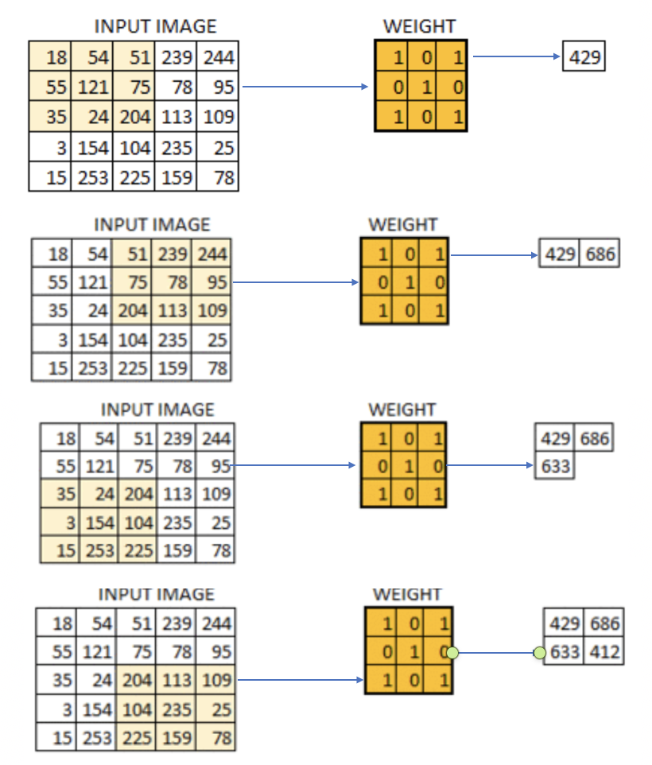
Exercise 4 (3 marks)
Show the step-by-step calculation for applying the filter to the top-right section of the image to obtain the value 686 (see Figure 4).
51*1 + 239*0 + 244*1 + 75*0 + 78*1 + 95*0 + 204*1 + 133*0 + 109*1

Exercise 5 (4 marks)
Mark the following sentence true or false.
a) Increasing the stride leads to a higher rate of image down sampling. i) True ii) False
b) Higher rates of image down sampling preserve more image detail than lower rates of down sampling. i) True ii) False
c) Increasing the kernel size, while keeping stride and padding fixed, reduces the spatial size of the output feature map. i) True ii) False
d) The kernel is the matrix of weights that slides over the input in a CNN. i) True ii) False

Padding
As discussed, using a stride greater than one reduces the size of the convolved image. To lower the reduction amount, we can add padding around the border of the image, typically by inserting zeros. Padding also helps the filter to have more focus on the pixels near the edges of the image (see Figure 5).

Figure 5: Padding an Image
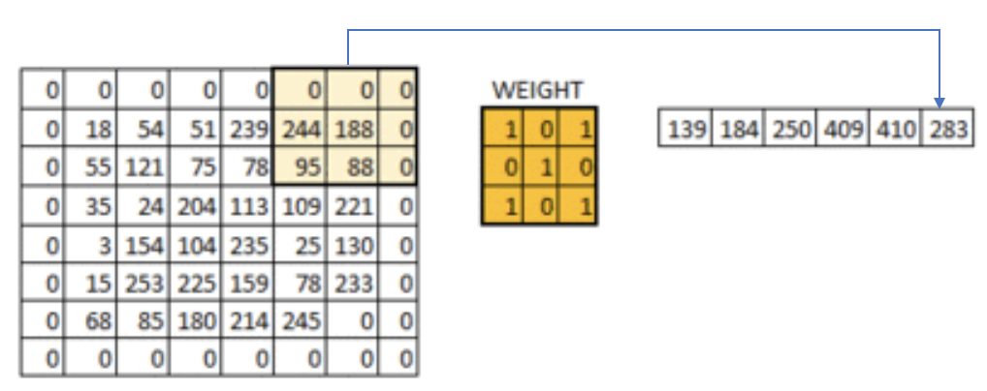

Pooling
The pooling layer reduces the size of a feature map by sliding a small window (e.g., 2×2) over it and replacing each region with a single summary value, such as the maximum (see Figure 6). This reduction is performed using a fixed algorithmic operation and it does not involve any learned parameters.

Figure 6: Showing pooled elements.
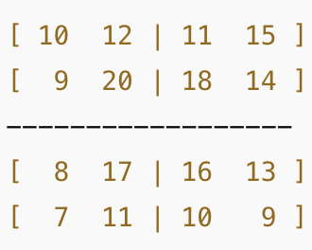 | Taking the maximum from each cell gives:
 | 20 | 18
 | 17 | 16

Example 2: Training a CNN introduction
This example uses the CIFAR image dataset which has 10 different classes of images. CNNs need all input images to be the same size so they can be processed together in the network. Images of different sizes are prepared so they are a uniform size at training time. The CIFAR dataset already fixes this by storing every image in a 32 pixels wide by 32 pixels high format (see Table 1).

Table 1: CIFAR Image dataset
Image labels include:  0:'airplane',  1:'automobile',  2:'bird',  3:'cat', | 4:'deer',  5: 'dog',  6:'frog', | 7:'horse', 8:'ship', 9:'truck'. | The image dimensions are 3 channel RGB, 32 width, 32 height.  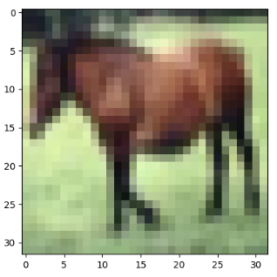

This code loads the data and prepares the convolutional, pooling and fully connected layers. Then it moves the data through these layers during training.

A data loader has been used to help prepare the data and to manage the batching in a memory efficient way.

Only 4 epochs are used for training to help save time but 20 epochs is recommended.

When the training is finished, the weights and bias are saved in a pth file.

Some of the exercises and discussion that follow will help to explain the parameters of the program.
import torch
import torch.nn as nn
import torch.optim as optim
import torchvision

# Load the CIFAR-10 test dataset
transform = torchvision.transforms.Compose([torchvision.transforms.ToTensor()])

# Load the datasets
trainset = torchvision.datasets.CIFAR10(root='./data', train=True,
download=True, transform=transform)
testset = torchvision.datasets.CIFAR10(root='./data', train=False,
download=True, transform=transform)

# Show one example image from the training set
import matplotlib.pyplot as plt
plt.imshow(trainset.data[7])
plt.show()

print("Showing dimensions of image data.")
img, label = trainset[7]
print(img.shape)

# DataLoader creates mini-batches and shuffles the data each epoch
batch_size = 32
trainloader = torch.utils.data.DataLoader(trainset, batch_size=batch_size, shuffle=True)
testloader = torch.utils.data.DataLoader(testset, batch_size=batch_size, shuffle=True)

# Define the CNN model
class CIFAR10Model(nn.Module):
def __init__(self):
super().__init__()
# First convolutional layer: input channels=3 (RGB), output channels=36
self.conv1 = nn.Conv2d(3, 36, kernel_size=(3,3), stride=1, padding=1)
self.act1 = nn.ReLU()
self.drop1 = nn.Dropout(0.3)

# Second convolutional layer: 36 -> 36 channels
self.conv2 = nn.Conv2d(36, 36, kernel_size=(3,3), stride=1, padding=1)
self.act2 = nn.ReLU()
self.pool2 = nn.MaxPool2d(kernel_size=(2, 2))

# Flatten layer
self.flat = nn.Flatten()

# Fully connected layer (UPDATED size)
self.fc3 = nn.Linear(9216, 512) # 36 * 16 * 16 = 9216
# 36 output from conv2
# 16=32 image W/2 pool,16=32 image H/2 pool
self.act3 = nn.ReLU()
self.drop3 = nn.Dropout(0.5)

# Output layer: 10 outputs for 10 classes
self.fc4 = nn.Linear(512, 10)

def forward(self, x):
x = self.act1(self.conv1(x))
x = self.drop1(x)

x = self.act2(self.conv2(x))
x = self.pool2(x)

x = self.flat(x)

x = self.act3(self.fc3(x))
x = self.drop3(x)

x = self.fc4(x)
return x

model = CIFAR10Model()
loss_fn = nn.CrossEntropyLoss()
optimizer = optim.SGD(model.parameters(), lr=0.001, momentum=0.9)

n_epochs = 4 # Should really be set to 20.
for epoch in range(n_epochs):
for inputs, labels in trainloader:
# forward, backward, and then weight update
y_pred = model(inputs)
loss = loss_fn(y_pred, labels)
optimizer.zero_grad()
loss.backward()
optimizer.step()

acc = 0
count = 0
for inputs, labels in testloader:
y_pred = model(inputs)
acc += (torch.argmax(y_pred, 1) == labels).float().sum()
count += len(labels)
acc /= count
print("Epoch %d: model accuracy %.2f%%" % (epoch, acc*100))

torch.save(model.state_dict(), "cifar10model.pth")

Calculating the Flattened Length of a Convolutional Layer Output
The CNN is a bit complicated so I will try to break it down as simply as I can. When designing a CNN, it helps to understand the output length calculation from the convolutional layer since this value is needed for the fully connected layer.

input channels = Number of channels (in this case there are 3 RGB color channels).
# Note: This is not referring to pixels.

output channels = # of filters (kernels) = # of feature maps

Flattened length = Output height × Output width × Total feature maps

(Where Output height and Output width are the sizes after all convolution and pooling
layers.)

Before pooling:
Feature map W = floor((input width – kernel sz + 2*padding)/stride) + 1
Feature map H = floor((input height – kernel sz + 2*padding)/stride) +1
Feature map W = floor((input width – kernel sz + 2*padding)/stride) + 1
Feature map W = ((32 - 3 + 2*1) / 1) + 1 = (31/1) + 1 = 32

Feature map H = floor((input height – kernel sz + 2*padding)/stride)+ 1
Feature map H = ((32 - 3 + 2*1) / 1) + 1 = (31/1) + 1 = 32

Output from the first convolutional layer is 36x32x32.

Output from the second convolutional layer before pooling is 36x32x32.
After pooling width = 32/2 = 16
After pooling height = 32/2 = 16

The Flattened length = After pooling height × After pooling width × Total Feature Maps
= 16 x 16 x 36 = 9216

Example 3: Performing Inference with a Trained CNN
This code performs inference to classify an image. First it defines the same network as Example 2. Then it loads the weights and biases from the pth file that was saved in Example 2. For this example, I loaded a horse image. The code in Figure 7 transforms the image to the (32x32) size that is required by the network.

Figure 7: Transforming the image to the size required by the network.
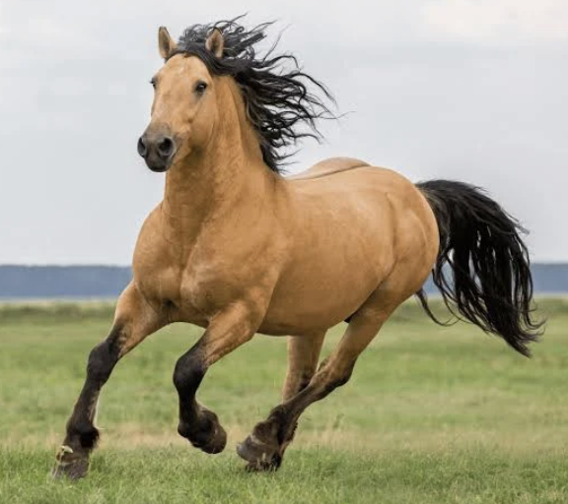 | transform = torchvision.transforms.Compose([  torchvision.transforms.Resize((32, 32)),  torchvision.transforms.ToTensor()  ])  img = Image.open("test.png").convert("RGB")  x = transform(img).unsqueeze(0) # shape: (1, 3, 32, 32)

The classification in this case is successful:

Predicted class: horse

Here is the full program.
classes = (
"airplane", "automobile", "bird", "cat", "deer",
"dog", "frog", "horse", "ship", "truck"
)
import torch
import torch.nn as nn
import torchvision
from PIL import Image

# Recreate the model class (MUST match training)
class CIFAR10Model(nn.Module):
def __init__(self):
super().__init__()
self.conv1 = nn.Conv2d(3, 36, kernel_size=3, stride=1, padding=1)
self.act1 = nn.ReLU()
self.drop1 = nn.Dropout(0.3)

self.conv2 = nn.Conv2d(36, 36, kernel_size=3, stride=1, padding=1)
self.act2 = nn.ReLU()
self.pool2 = nn.MaxPool2d(kernel_size=2)

self.flat = nn.Flatten()

self.fc3 = nn.Linear(36 * 16 * 16, 512)
self.act3 = nn.ReLU()
self.drop3 = nn.Dropout(0.5)

self.fc4 = nn.Linear(512, 10)

def forward(self, x):
x = self.act1(self.conv1(x))
x = self.drop1(x)
x = self.act2(self.conv2(x))
x = self.pool2(x)
x = self.flat(x)
x = self.act3(self.fc3(x))
x = self.drop3(x)
x = self.fc4(x)
return x

# Load model
model = CIFAR10Model()
model.load_state_dict(torch.load("cifar10model.pth", map_location="cpu"))
model.eval()

transform = torchvision.transforms.Compose([
torchvision.transforms.Resize((32, 32)),
torchvision.transforms.ToTensor()
])

img = Image.open("test.png").convert("RGB")
x = transform(img).unsqueeze(0) # shape: (1, 3, 32, 32)

with torch.no_grad():
outputs = model(x)
predicted_class = torch.argmax(outputs, dim=1).item()

print("Predicted class:", classes[predicted_class])

Exercise 6 (1 mark)
Both the convolutional layer and pooling layer down sample the image data. How is the convolutional layer different than the pooling layer?
convolution layers does dot product or element wise multiplication for kernels and inputs, while pooling layers perform downsampling using max operation most commonly

Exercise 7 (2 marks)
In Example 2, if you changed conv1 to Conv2d(3, 64, ...) and conv2 to Conv2d(64, 64, ...), what would the new flattened length be after pooling? Show the calculation.
16*16*64 = 16384
If the input images were 3×32×64 instead of 3×32×32, and everything else stayed the same, what would the flattened length be after pooling in Example 2? (Assume the pooling halves both height and width using floor.)
16 * 32 * 32

Exercise 8 (1 mark)
Which operation most directly reduces spatial size in this network?
- a) ReLU
- b) MaxPool2d
- c) Dropout
- d) Flatten

Introduction to Recurrent Neural Networks (RNNs)

This initial discussion about RNNs is based on the video at https://www.youtube.com/watch?v=LHXXI4-IEns

Sequential Data
Recurrent neural networks help to explain sequential data. For example, when trying to predict the direction of a moving ball, it is difficult to know with only the current position. Figure 8 shows a snapshot of the ball at its current position.

Figure 8: Current Snapshot of a Ball

To improve your accuracy, you need to know where the ball has been. Figure 9 shows several snapshots of the ball’s historical positions in succession.

Figure 9: Sequence of Ball Positions

Sequence data can be obtained and stored in many different ways. For example, audio files contain wave data which is sequential.
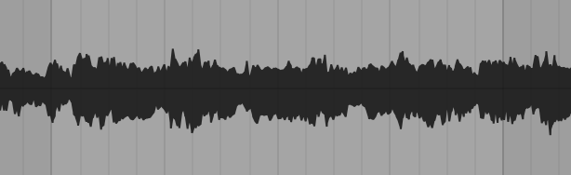

Words also follow a sequence. If you only read the words “the beach” you have no context about why “the beach” is mentioned. A more complete sentence with leading words provides more detail.
Remy and Nebula went to the beach.

In all sequential cases if we understand what occurred earlier, we can better understand the current context.

Learning Sequences
Learning sequences can help with understanding by providing earlier context. For example, if you were asked to list the letters of the alphabet you could very quickly recall the letters in a typical order. If you were asked to list the letters of the alphabet in reverse order you would probably pause and walk through those steps more slowly. However, an alternate sequence can be learned to make the task easier.

Hidden State
RNN’s include a hidden state to reference previous inputs. Figure 10 shows 5 steps to understand the meaning behind “What time is it?”. At the first step, the word “what” is read. At the second step, the word “time” is read and “what” is contained in a hidden state. In the third step, “is” is read and the previous two words are stored in the hidden state. By step 5, the representation of the initial states is proportionally weighted less. The problem is though, as the RNN processes more steps it has difficulty retaining information from previous steps. Short term memory and vanishing gradients can often make it challenging for RNN’s to model with sequential data.

Figure 10: Tracking Hidden States with RNN’s
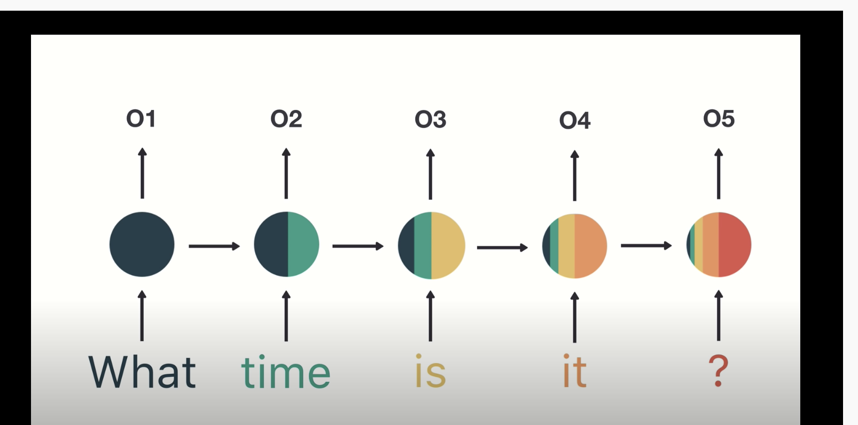

Example 4: RNN Example
This example loads time series data going back to t-20. Table 2 shows lagged values of y

Table 2: y and lagged values of y.
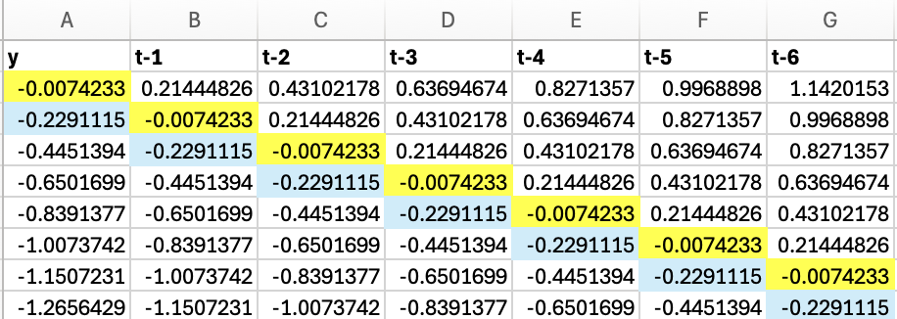 … 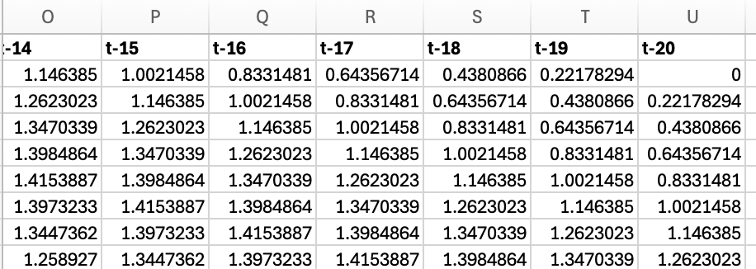

A model is then built to predict the next steps in the pattern based on past steps.
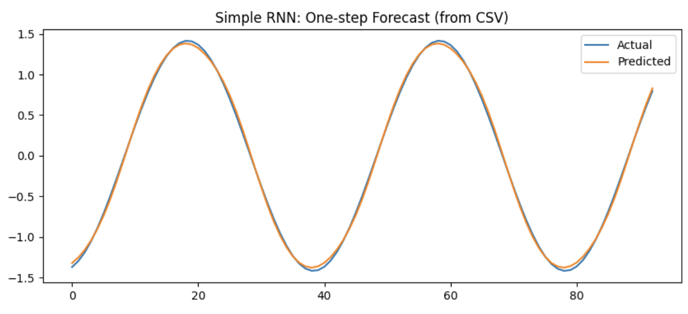 | Epoch 01 | train MSE = 1.1271  Epoch 02 | train MSE = 0.8130  Epoch 03 | train MSE = 0.5447  Epoch 04 | train MSE = 0.2537  Epoch 05 | train MSE = 0.0956  Epoch 06 | train MSE = 0.0279  Epoch 07 | train MSE = 0.0109  Epoch 08 | train MSE = 0.0077  Epoch 09 | train MSE = 0.0058  Epoch 10 | train MSE = 0.0047  MSE: 0.06350933842674134
Here is the code:

import numpy as np
import torch
import torch.nn as nn
from torch.utils.data import DataLoader, TensorDataset
import matplotlib.pyplot as plt
import pandas as pd

from get_path import getPath

df = pd.read_csv(getPath() + "sine_wave_data.csv")

lag_cols = [c for c in df.columns if c.startswith("t-")]
lag_cols = sorted(lag_cols, key=lambda s: int(s.split("-")[1])) # t-1, t-2,... ,t-20

print("Columns in CSV:", list(df.columns))
print("Using feature columns:", lag_cols)

# Create arrays
y = df["y"].values.astype(np.float32) # (N,)
X = df[lag_cols].values.astype(np.float32) # (N, 20)

# RNN expects (batch, seq_len, input_size)
# Basically puts data in a matrix by adding one
# more set of square brackets
X = X[..., np.newaxis] # (N, 20, 1)

# Convert to torch tensors
X = torch.tensor(X) # (N, 20, 1)
Y = torch.tensor(y).unsqueeze(-1) # (N, 1)

print("X shape:", X.shape)
print("Y shape:", Y.shape)

# Train / test split
TRAIN_SPLIT = 0.8
split = int(len(X) * TRAIN_SPLIT)

X_train = X[:split]
y_train = Y[:split]
X_test = X[split:]
y_test = Y[split:]

train_ds = TensorDataset(X_train, y_train)
test_ds = TensorDataset(X_test, y_test)

train_loader = DataLoader(train_ds, batch_size=32, shuffle=True)
test_loader = DataLoader(test_ds, batch_size=32, shuffle=False)

# Define a simple RNN model
class SimpleRNN(nn.Module):
def __init__(self, hidden_size=32):
super().__init__()
self.rnn = nn.RNN(
input_size=1, # total features per time step
# 20 time steps but only one number each
hidden_size=hidden_size, # size of RNN’s internal memory
batch_first=True
)
self.fc = nn.Linear(hidden_size, 1)

def forward(self, x):
out, _ = self.rnn(x) # out: (batch, seq_len, hidden)
last = out[:, -1, :] # last time step: (batch, hidden)
pred = self.fc(last) # (batch, 1)
return pred

model = SimpleRNN(hidden_size=32)

# Train
loss_fn = nn.MSELoss()
optimizer = torch.optim.Adam(model.parameters(), lr=1e-3)

EPOCHS = 10
for epoch in range(1, EPOCHS + 1):
model.train()
total = 0.0

for xb, yb in train_loader:

pred = model(xb)
loss = loss_fn(pred, yb)

optimizer.zero_grad()
loss.backward()
optimizer.step()

total += loss.item() * xb.size(0)

train_mse = total / len(train_loader.dataset)
print(f"Epoch {epoch:02d} | train MSE = {train_mse:.4f}")

# Predict + plot
model.eval()
preds = []
targets = []

with torch.no_grad():
for xb, yb in test_loader:
pred = model(xb).cpu().numpy()
preds.append(pred)
targets.append(yb.numpy())

preds = np.vstack(preds).squeeze()
targets = np.vstack(targets).squeeze()

plt.figure(figsize=(10, 4))
plt.plot(targets, label="Actual")
plt.plot(preds, label="Predicted")
plt.title("Simple RNN: One-step Forecast (from CSV)")
plt.legend()
plt.show()
from sklearn.metrics import mean_squared_error
mse = mean_squared_error(targets, preds)
print("MSE: ", np.sqrt(mse))

Exercise 9 (2 marks)
Double the size for the hidden state in Example 4. Show the training MSE’s and final RMSE.
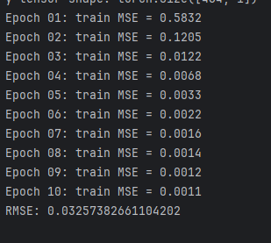
Does the RMSE improve? Explain why? If uncertain about the change try running the code multiple times.
yes, because the model has more neurons to learn about the data patterns better

Exercise 10 (4 marks)
Replace the data loading code in Example 3 with this code which references Nvidia open price percent changes from one trading day to the next.
# Load dataframe
df = pd.read_csv(getPath() + "NVDA_AMD_OpenPrices.csv")

print("Columns in CSV:", list(df.columns))

# Use ONLY NVDA_Ot-1 and NVDA_Ot-2 to predict NVDA_Open
feature_cols = ["NVDA_Ot-1", "NVDA_Ot-2"]
target_col = "NVDA_Open"

# Create arrays
y = df[target_col].values.astype(np.float32) # (N,)
X = df[feature_cols].values.astype(np.float32) # (N, 2)

# RNN expects (batch, seq_len, input_size)
# We treat the 2 lags as 2 time steps, each with 1 feature
X = X[..., np.newaxis] # (N, 2, 1)

# Convert to torch tensors
X = torch.tensor(X) # (N, 2, 1)
Y = torch.tensor(y).unsqueeze(-1) # (N, 1)

# Train / test split
TRAIN_SPLIT = 0.99
split = int(len(X) * TRAIN_SPLIT)

X_train = X[:split]
y_train = Y[:split]
X_test = X[split:]
y_test = Y[split:]

train_ds = TensorDataset(X_train, y_train)
test_ds = TensorDataset(X_test, y_test)

train_loader = DataLoader(train_ds, batch_size=32, shuffle=True)
test_loader = DataLoader(test_ds, batch_size=32, shuffle=False)

Run the model. Show the predicted versus actual plot which will be somewhat flat.
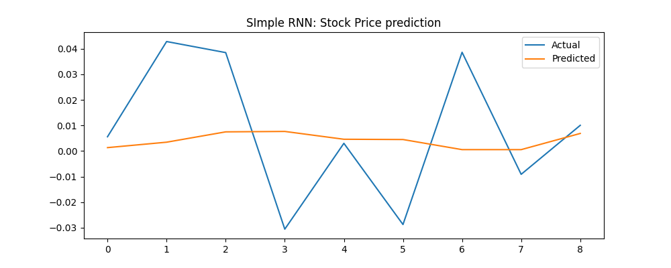

How well does the model do for the entire prediction period?
not well

How well does the model do for the next step ahead?
not well either

Exercise 11 (1 mark)
Which type of data is best suited for RNNs?
a) Tabular data
b) Sequential data (e.g., time series, text, speech)
c) Image classification tasks
d) Independent observations with no time dependency

Exercise 12 (1 mark)
How does an RNN maintain memory of past inputs?
a) It stores all previous inputs in a separate memory unit
b) It uses hidden states that are passed from one time step to the next
c) It concatenates all inputs before processing
d) It only considers the last input at each time step

Exercise 13 (1 mark)
Why isn’t train_test_split() used in this case?
because it doesn’t preserve the order of data inputs

Exercise 14 (1 mark)
What is the main limitation of standard RNNs when handling long sequences?
a) They require too many neurons
b) They struggle with vanishing or exploding gradients
c) They cannot process numerical data
d) They require CNN layers to function

Exercise 15 (1 mark)
Why do RNNs share weights across time steps?
a) To reduce memory usage
b) To ensure consistency in learning from sequential data
c) To allow RNNs to process images
d) To make the model train faster

