Table of Contents
Long Short-Term Memory Networks (LSTMs) 1
Multifeatured LSTM 6
Multifeatured Recursive Neural Network (RNN) 11
LSTM for Text Generation 11

Long Short-Term Memory Networks (LSTMs)

An LSTM (Long Short-Term Memory) network is a type of recurrent neural network that learns from sequences, like text, audio, or time series data. It reads inputs one step at a time (for example, one character at a time) and keeps a “memory” of what it has seen so far. That memory helps it predict what should come next.

LSTMs were developed to overcome problems of vanishing hidden state with RNN’s. LSTMs use virtual gates which perform operations to learn what to store in memory.
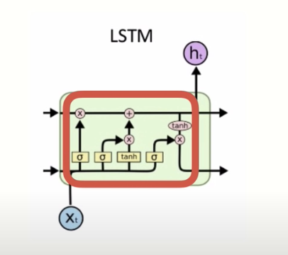

LSTMs are computationally more expensive than RNN’s but LSTMs can offer significant improvement to manage context about sequences. As a result, LSTMs can be very slow to train.

Example 1: LSTM for Time Series
This script loads a sine wave dataset to demonstrate how an LSTM can learn a sequence. The data set contains actual and pre-made lagged features. The data is scaled and used to train a simple LSTM-based neural network to predict the next values in the sequence.

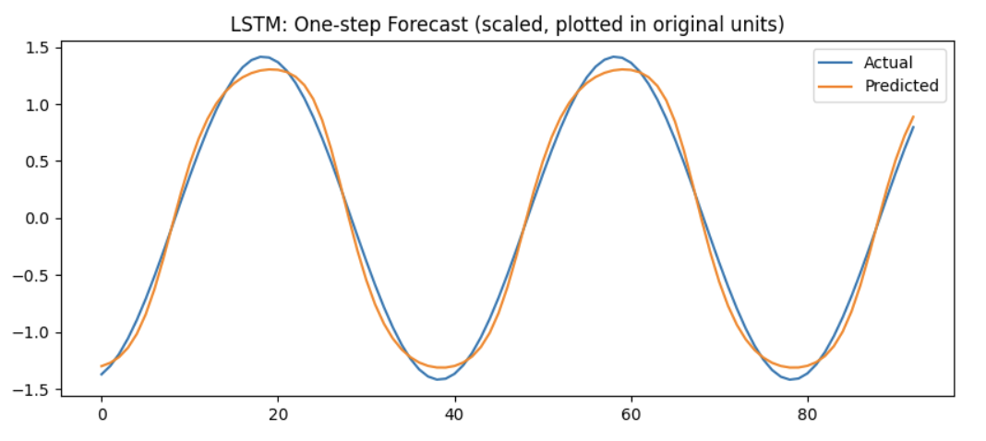
RMSE: 0.07169405003338482

Here is the code:
import matplotlib.pyplot as plt
import numpy as np
import pandas as pd
import torch
import torch.nn as nn
import torch.optim as optim
from torch.utils.data import DataLoader, TensorDataset
from sklearn.preprocessing import StandardScaler

from get_path import getPath

df = pd.read_csv(getPath() + "sine_wave_data.csv")

# Gets all existing columns with ‘t-‘ in header such as t-1, t-2, t-3.
lag_cols = [c for c in df.columns if c.startswith("t-")]

print("Columns in CSV:", list(df.columns))
print("Using feature columns:", lag_cols)

# Where N = # rows.
# Create arrays
y = df["y"].values.astype(np.float32) # (N,)
X = df[lag_cols].values.astype(np.float32) # (N, 20)

# Basically X in a matrix by adding one more set of square brackets
X = X[..., np.newaxis] # (N, 20, 1)

print("X shape:", X.shape)
print("Y shape:", y.shape)

# Train / test split
TRAIN_SPLIT = 0.8
split = int(len(X) * TRAIN_SPLIT)

X_train = X[:split]
y_train = y[:split]
X_test = X[split:]
y_test = y[split:]

# Scale
scalerX = StandardScaler()
scalerY = StandardScaler()

# StandardScaler expects numpy arrays
X_train_np = X_train.reshape(X_train.shape[0], -1) # (Ntrain, 20)
X_test_np = X_test.reshape(X_test.shape[0], -1) # (Ntest, 20)
y_train_np = y_train.reshape(-1, 1) # (Ntrain, 1)
y_test_np = y_test.reshape(-1, 1) # (Ntest, 1)

scalerX.fit(X_train_np)
scalerY.fit(y_train_np)

X_train_scaled = scalerX.transform(X_train_np)
X_test_scaled = scalerX.transform(X_test_np)

y_train_scaled = scalerY.transform(y_train_np)

# Put scaled data into torch tensors.
# (rows, lags, 1 feature)
X_train = torch.tensor(X_train_scaled, dtype=torch.float32).unsqueeze(-1)
# (rows, lags, 1 feature)
X_test = torch.tensor(X_test_scaled, dtype=torch.float32).unsqueeze(-1)
y_train = torch.tensor(y_train_scaled, dtype=torch.float32) # (Ntrain, 1)
y_test = torch.tensor(y_test_np, dtype=torch.float32) # (Ntest, 1)

train_ds = TensorDataset(X_train, y_train)
test_ds = TensorDataset(X_test, y_test)

train_loader = DataLoader(train_ds, batch_size=32, shuffle=False)
test_loader = DataLoader(test_ds, batch_size=32, shuffle=False)

# Define a simple LSTM model
class AirModel(nn.Module):
def __init__(self, hidden_size=32):
super().__init__()
self.lstm = nn.LSTM(
input_size=1, # total features per time step
# 20 time steps but only one number each
hidden_size=hidden_size, # size of LSTM’s internal memory
batch_first=True
)
self.fc = nn.Linear(hidden_size, 1)

def forward(self, x):
out, _ = self.lstm(x) # out: (batch, seq_len, hidden)
last = out[:, -1, :] # last time step: (batch, hidden)
pred = self.fc(last) # (batch, 1)
return pred

model = AirModel(hidden_size=32)

# Train
loss_fn = nn.MSELoss()
optimizer = torch.optim.Adam(model.parameters(), lr=1e-3)

EPOCHS = 10
for epoch in range(1, EPOCHS + 1):
model.train()
total = 0.0

for xb, yb in train_loader:
pred = model(xb)
loss = loss_fn(pred, yb)

optimizer.zero_grad()
loss.backward()
optimizer.step()

total += loss.item() * xb.size(0)

train_mse = total / len(train_loader.dataset)
print(f"Epoch {epoch:02d} | train MSE = {train_mse:.4f}")

# Predict
model.eval()
preds = []
targets = []

with torch.no_grad():
for xb, yb in test_loader:
pred = model(xb).numpy()
preds.append(pred)
targets.append(yb.numpy())

preds = np.vstack(preds).squeeze()
targets = np.vstack(targets).squeeze()

# Inverse transform for plotting in original units
preds_orig = scalerY.inverse_transform(preds.reshape(-1, 1)).squeeze()

plt.figure(figsize=(10, 4))
plt.plot(targets, label="Actual")
plt.plot(preds_orig, label="Predicted")
plt.title("LSTM Forecast")
plt.legend()
plt.show()

from sklearn.metrics import mean_squared_error
mse = mean_squared_error(targets, preds_orig)
rmse = np.sqrt(mse)
print("RMSE: ", rmse)

Exercise 1 (3 marks)
Change the data loading code in Example 1 to the following.
df = pd.read_csv(getPath() + "DailyDelhiClimateTest.csv")

for i in range(1, 21):
df['t-' + str(i)] = df['meantemp'].shift(i)
df = df.dropna()

Also, change the train split to 97%
TRAIN_SPLIT = 0.97

As well, adjust the reference for y.
y = df["meantemp"].values.astype(np.float32)

Show the RMSE. Run the code multiple times and choose an RMSE that represents the general average of the runs where hidden_size = 64

Show the RMSE. Run the code multiple times and choose an RMSE that represents the general average of the runs where hidden_size = 256

Do the results generally improve with a higher_size? Why or why not?

Note: The predictions forecast is flat compared to the actual data. Also, the most accurate predictions will be the earlier steps in the forecast. This limitation is a common situation for most multistep time series forecasts.

Exercise 2 (1 mark)
How does an LSTM improve upon a standard RNN?
a) It replaces fully connected layers with convolutional layers
b) It introduces gating mechanisms to prevent vanishing gradients
c) It processes only the last element of a sequence
d) It requires fewer training samples

Exercise 3 (1 mark)
What is the main advantage of LSTMs over standard RNNs?
a) They are faster to train
b) They handle long-term dependencies better by preventing vanishing gradients
c) They use fewer parameters
d) They work better with small datasets

Exercise 4 (1 mark)
Which of the following is NOT a limitation of LSTMs?
a) High computational cost compared to standard RNNs
b) Struggles with very long sequences due to memory constraints
c) Inability to learn sequential dependencies
d) Requires more hyperparameter tuning than traditional RNNs

Multifeatured LSTM
Example 2: Multifeatured LSTM
This example demonstrates how to build an LSTM with three lagged input features: mean temperature, humidity, and wind speed.

Figure 1: LSTM predicted versus actual.
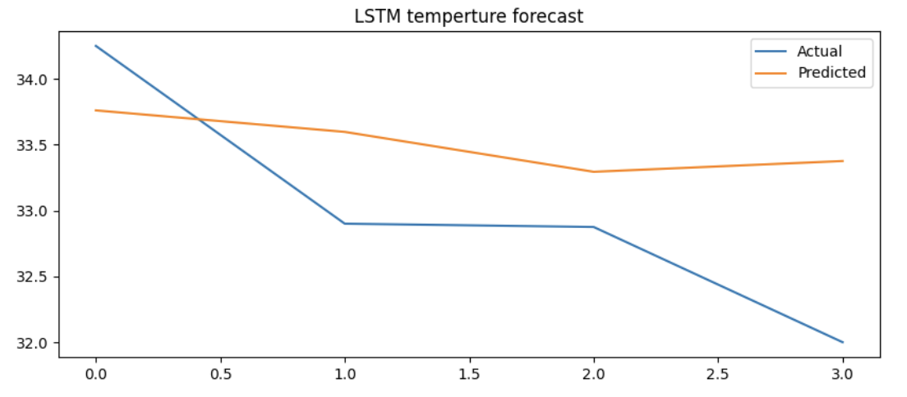

import matplotlib.pyplot as plt
import numpy as np
import pandas as pd
import torch
import torch.nn as nn
from torch.utils.data import DataLoader, TensorDataset
from sklearn.preprocessing import StandardScaler
from get_path import getPath

pd.set_option('display.max_columns', None)
pd.set_option('display.width', 1000)

def createLagFeatures(df, base_cols, total_lags):
lag_cols = []

for i in range(1, total_lags + 1):
for col in base_cols:
new_col = f"t-{i}_{col}"
df[new_col] = df[col].shift(i)
lag_cols.append(new_col)

df = df.dropna()
return df, lag_cols

def splitData(X, y):
# Train / test split
TRAIN_SPLIT = 0.97
split = int(len(X) * TRAIN_SPLIT)

X_train = X[:split]
y_train = y[:split]
X_test = X[split:]
y_test = y[split:]
return X_train, y_train, X_test, y_test

df = pd.read_csv(getPath() + "DailyDelhiClimateTest.csv")
originalFeatures = ['meantemp', 'humidity', 'wind_speed']
TOTAL_LAGS = 5
TOTAL_FEATURES = len(originalFeatures)
df, lag_cols = createLagFeatures(df, originalFeatures, TOTAL_LAGS)

# Convert df to numpy arrays for X and y
y = df["meantemp"].values.astype(np.float32)
X = df[lag_cols]
X = X.values.astype(np.float32)

X_train, y_train, X_test, y_test = splitData(X, y)

NUM_ROWS = X.shape[0]

# Convert to numpy
X = df[lag_cols].values.astype(np.float32)
y = df["meantemp"].values.astype(np.float32)

# Split while still 2D
X_train, y_train, X_test, y_test = splitData(X, y)

# Scale (2D format)
sc_x = StandardScaler()
X_train_scaled = sc_x.fit_transform(X_train)
X_test_scaled = sc_x.transform(X_test)

# LSTM needs 3D format.
# (rows, sequence_length, num features)
X_train_scaled = X_train_scaled.reshape(X_train_scaled.shape[0],
TOTAL_LAGS, TOTAL_FEATURES)
X_test_scaled = X_test_scaled.reshape(X_test_scaled.shape[0],
TOTAL_LAGS, TOTAL_FEATURES)

# Must convert list to 2D array for matrix multiplication during scaling.
y_train_reshaped = y_train.reshape(-1, 1)

# Scale y_train
scalerY = StandardScaler()
scalerY.fit(y_train_reshaped)
y_train_scaled = scalerY.transform(y_train_reshaped)

# Put data into torch tensors.
X_train = torch.tensor(X_train_scaled, dtype=torch.float32)
X_test = torch.tensor(X_test_scaled, dtype=torch.float32)
y_train = torch.tensor(y_train_scaled, dtype=torch.float32) # (Rows, 1)
y_test = torch.tensor(y_test, dtype=torch.float32) # (Rows, 1)

train_ds = TensorDataset(X_train, y_train)
test_ds = TensorDataset(X_test, y_test)

train_loader = DataLoader(train_ds, batch_size=32, shuffle=False)
test_loader = DataLoader(test_ds, batch_size=32, shuffle=False)

# Define a simple LSTM model
class AirModel(nn.Module):

def __init__(self, hidden_size=128):
super().__init__()
self.lstm = nn.LSTM(
input_size=3, # total features per time step
hidden_size=hidden_size, # size of LSTM’s internal memory
batch_first=True
)
self.fc = nn.Linear(hidden_size, 1)

def forward(self, x):
out, _ = self.lstm(x) # out: (batch, seq_len, hidden)
last = out[:, -1, :] # last time step: (batch, hidden)
pred = self.fc(last) # (batch, 1)
return pred

model = AirModel(hidden_size=64)

# Train
loss_fn = nn.MSELoss()
optimizer = torch.optim.Adam(model.parameters(), lr=1e-3)

EPOCHS = 1500
for epoch in range(1, EPOCHS + 1):
model.train()
total = 0.0

for xb, yb in train_loader:
pred = model(xb)
loss = loss_fn(pred, yb)

optimizer.zero_grad()
loss.backward()
optimizer.step()

total += loss.item() * xb.size(0)

train_mse = total / len(train_loader.dataset)
print(f"Epoch {epoch:02d} | train MSE = {train_mse:.4f}")

# Predict
model.eval()
preds = []
targets = []

with torch.no_grad():
for xb, yb in test_loader:
pred = model(xb).numpy()
preds.append(pred)
targets.append(yb.numpy())

# Concatenate batches.
preds = np.concatenate(preds, axis=0).ravel()
targets = np.concatenate(targets, axis=0).ravel()

# Inverse transform for plotting in original units
preds_orig = scalerY.inverse_transform(preds.reshape(-1, 1)).squeeze()

plt.figure(figsize=(10, 4))
plt.plot(targets, label="Actual")
plt.plot(preds_orig, label="Predicted")
plt.title("LSTM temperture forecast")
plt.legend()
plt.show()

from sklearn.metrics import mean_squared_error
mse = mean_squared_error(targets, preds_orig)
rmse = np.sqrt(mse)
print("RMSE: ", rmse)

Exercise 5 (2 marks)
The data set used in Example 2 is the same data set that is used in Exercise 1. Example 2 uses three lagged features in the model whereas Exercise 1 uses only a single lagged feature. How does the general RMSE for Example 2 compare to the general RMSE for Exercise 1 when the hidden_state value = 64?

How does the general RMSE for Example 2 compare to the general RMSE for Exercise 1 when the hidden_state value = 256?

Exercise 6 (4 marks)
Modify Example 2 to use the product_daily_sales.csv. Change the model so it uses all features (lagged) to predict sales for product_0.

Show the RMSE and plot that results here. Be sure to adjust the title of the plot so it is correct.

Show the code changes that you made here:

Multifeatured Recursive Neural Network (RNN)
Example 3: Multifeatured RNN
Recursive neural networks can also include multiple features. To build the RNN, replace the neural network definition with this version:

Replace
self.lstm = nn.LSTM(
input_size=3, # total features per time step
hidden_size=hidden_size, # size of LSTM’s internal memory
batch_first=True
)

With;
self.rnn = nn.RNN(
input_size=3, # total features per time step
hidden_size=hidden_size, # size of RNN’s internal memory
batch_first=True
)

Also in the forward function replace:
out, _ = self.lstm(x)

With:
out, _ = self.rnn(x)

Exercise 7 (2 marks)
Train the RNN in Example 3 multiple times with a hidden state of 256. How does the general average RMSE that is obtained in this exercise compare to the general LSTM RMSE average that is obtained when the hidden_state is 256 in Exercise 5?

LSTM for Text Generation
Example 4: Minimal text generation
This program trains a small character-level LSTM neural network to predict the next character in a piece of text. First, it takes a short sample string and builds a vocabulary of all unique characters, assigning each character a numeric ID. For every sequence of 8 characters, the model learns to predict the very next character.

The model is actually weak but the simplicity makes it easier to understand.

During evaluation after training, when the following text is past to the model:
ello wor

The output is:
ello worlllllllllllllllllllllllllllllllllllllllllllllllll

import numpy as np
import torch
import torch.nn as nn
import torch.optim as optim
from torch.utils.data import DataLoader, TensorDataset

# Tiny sample text
text = "hello hello hello world!!!! "
text = text.lower()

# Build character vocabulary
chars = sorted(list(set(text)))
char_to_int = {c:i for i,c in enumerate(chars)}
int_to_char = {i:c for c,i in char_to_int.items()}
vocab_size = len(chars)

print("Vocab:", chars)
print("Vocab size:", vocab_size)

# Build sequences
seq_len = 8
X_list, y_list = [], []

for i in range(len(text) - seq_len):
seq_in = text[i:i+seq_len]
seq_out = text[i+seq_len]
X_list.append([char_to_int[c] for c in seq_in])
y_list.append(char_to_int[seq_out])

X = torch.tensor(X_list, dtype=torch.float32).unsqueeze(-1) # (N, seq_len, 1)
y = torch.tensor(y_list, dtype=torch.long) # (N,)

# Normalize inputs (simple scaling)
X = X / float(vocab_size)

dataset = TensorDataset(X, y)
loader = DataLoader(dataset, batch_size=32, shuffle=False)

# Define an LSTM model
class NextCharLSTM(nn.Module):
def __init__(self, hidden_size=64):
super().__init__()
self.lstm = nn.LSTM(
input_size=1,
hidden_size=hidden_size,
num_layers=1,
batch_first=True
)
self.fc = nn.Linear(hidden_size, vocab_size)

def forward(self, x):
out, _ = self.lstm(x) # out: (batch, seq_len, hidden_size)
last = out[:, -1, :] # take last time step: (batch, hidden_size)
logits = self.fc(last) # (batch, vocab_size)
return logits

model = NextCharLSTM(hidden_size=256)
loss_fn = nn.CrossEntropyLoss()
optimizer = optim.Adam(model.parameters(), lr=0.01)

# Train
epochs = 20
for epoch in range(1, epochs+1):
model.train()
total_loss = 0.0

for xb, yb in loader:
logits = model(xb)
loss = loss_fn(logits, yb)

optimizer.zero_grad()
loss.backward()
optimizer.step()

total_loss += loss.item()

avg_loss = total_loss / len(loader)
if epoch % 5 == 0 or epoch == 1:
print(f"Epoch {epoch}/{epochs} - loss: {avg_loss:.4f}")

# Generate text (simple demo)
def generate(seed, model, n_chars=60):
model.eval()
pattern = [char_to_int[c] for c in seed][-seq_len:]

out_text = seed
for _ in range(n_chars):
x = torch.tensor(pattern, dtype=torch.float32).view(1, seq_len, 1) / float(vocab_size)
with torch.no_grad():
logits = model(x)
next_id = int(torch.argmax(logits, dim=1).item())

out_text += int_to_char[next_id]
pattern.append(next_id)
pattern = pattern[1:]
return out_text

print("\nGenerated:")
# Input size must be 8.
print(generate(seed="ello wor", model=model, n_chars=60))

Exercise 8 (1 mark)
Modify the training string in Example 4 to be:
aaabbbcccdddeee
Change the prompt during evaluation to be:
print(generate(seed="abbbcccd", model=model, n_chars=60))
What is the output?
Exercise 9 (1 mark)
Run the code for Exercise 8 again but this time use 200 epochs for training. What is the output now?
How has the output changed?

Example 5: LSTM for text generation
This LSTM learns text sequences from Alice in Wonderland. This code trains an LSTM for text generation. I ran it in Google Colab with the GPU enabled. It took me about 30 minutes to train. This code is from Deep Learning with PyTorch by Adrian Lam.

Total Characters: 144343
Total Vocab: 44
Vocab: ['\n', ' ', '!', '"', "'", '(', ')', '*', ',', '-', '.', ':', ';', '?', '[', ']', '_', 'a', 'b', 'c', 'd', 'e', 'f', 'g', 'h', 'i', 'j', 'k', 'l', 'm', 'n', 'o', 'p', 'q', 'r', 's', 't', 'u', 'v', 'w', 'x', 'y', 'z', '\ufeff']
Total Patterns: 144243
import numpy as np
import torch
import torch.nn as nn
import torch.optim as optim
import torch.utils.data as data
import time

# load ascii text and covert to lowercase
filename = "/Users/patmcgee/Downloads/wonderland.txt"
raw_text = open(filename, 'r', encoding='utf-8').read()
raw_text = raw_text.lower()

# create mapping of unique chars to integers
chars = sorted(list(set(raw_text)))
char_to_int = dict((c, i) for i, c in enumerate(chars))

# summarize the loaded data
n_chars = len(raw_text)
n_vocab = len(chars)
print("Total Characters: ", n_chars)
print("Total Vocab: ", n_vocab)
print("Vocab: ", chars)

# prepare the dataset of input to output pairs encoded as integers
seq_length = 100
dataX = []
dataY = []
for i in range(0, n_chars - seq_length, 1):
seq_in = raw_text[i:i + seq_length]
seq_out = raw_text[i + seq_length]
dataX.append([char_to_int[char] for char in seq_in])
dataY.append(char_to_int[seq_out])
n_patterns = len(dataX)
print("Total Patterns: ", n_patterns)

# reshape X to be [samples, time steps, features]
X = torch.tensor(dataX, dtype=torch.float32).reshape(n_patterns, seq_length, 1)
X = X / float(n_vocab)
y = torch.tensor(dataY)

class CharModel(nn.Module):
def __init__(self):
super().__init__()
self.lstm = nn.LSTM(input_size=1, hidden_size=256, num_layers=2,
batch_first=True, dropout=0.2)
self.dropout = nn.Dropout(0.2)
self.linear = nn.Linear(256, n_vocab)
def forward(self, x):
x, _ = self.lstm(x)
# take only the last output
x = x[:, -1, :]
# produce output
x = self.linear(self.dropout(x))
return x

n_epochs = 40
batch_size = 128
model = CharModel()
device = torch.device("cuda:0" if torch.cuda.is_available() else "cpu")
model.to(device)

optimizer = optim.Adam(model.parameters())
loss_fn = nn.CrossEntropyLoss(reduction="sum")
loader = data.DataLoader(data.TensorDataset(X, y), shuffle=False, batch_size=batch_size)

best_model = None
best_loss = np.inf

best_model = None
best_loss = np.inf

for epoch in range(1, n_epochs + 1):
model.train()
running_loss = 0.0
start_time = time.time()

for batch_idx, (X_batch, y_batch) in enumerate(loader, 1):
y_pred = model(X_batch.to(device))
loss = loss_fn(y_pred, y_batch.to(device))

optimizer.zero_grad()
loss.backward()
optimizer.step()

running_loss += loss.item()

# Print batch progress every 50 batches
if batch_idx % 50 == 0 or batch_idx == len(loader):
print(f"Epoch [{epoch}/{n_epochs}] "
f"Batch [{batch_idx}/{len(loader)}] "
f"Loss: {loss.item():.4f}")

avg_train_loss = running_loss / len(loader)

# validation
model.eval()
val_loss = 0.0
with torch.no_grad():
for X_batch, y_batch in loader:
y_pred = model(X_batch.to(device))
val_loss += loss_fn(y_pred, y_batch.to(device)).item()

val_loss /= len(loader)

# Save best model
if val_loss < best_loss:
best_loss = val_loss
best_model = model.state_dict()
improved = " (best so far)"
else:
improved = ""

elapsed = time.time() - start_time

print(f"Epoch {epoch}/{n_epochs} "
f"- Train Loss: {avg_train_loss:.4f} "
f"- Val Loss: {val_loss:.4f} "
f"- Time: {elapsed:.1f}s{improved}")
print("-" * 60)

torch.save([best_model, char_to_int], "single-char.pth")

Example 6: Loading LSTM
This example, loads the model that was generated in Example 5. The prediction is not amazing – but it is not bad for a simple model.
Prompt: "r waist,'
the duchess said after a pause: 'the reason is, that i'm doubtful about
the temper of your"

Next character sequence:
pardon, she said to herself 'the mock turtle semark ' said alice. 'i don't know what i can tery moved and sead in the sea, the mobk turtle sead of the sout!' said the mock turtle an iertinner. 'i don't know what i can tery moved and sead when she sam to the peftoe of the garden, the mock turtle semarked, 'i don't know what i can tery moved and sead when she sam to the peftoe of the garden, the mock turtle semarked, 'i don't know what i can tery moved and sead when she sam to the peftoe of the garden, the mock turtle semarked, 'i don't know what i can tery moved and sead when she sam to the peftoe of the garden, the mock turtle semarked, 'i don't know what i can tery moved and sead when she sam to the peftoe of the garden, the mock turtle semarked, 'i don't know what i can tery moved and sead when she sam to the peftoe of the garden, the mock turtle semarked, 'i don't know what i can tery moved and sead when she sam to the peftoe of the garden, the mock turtle semarked, 'i don'
Done.

To run this code, first adjust depending on whether the code is running in a GPU or CPU environment.
import torch
import torch.nn as nn
import numpy as np

# Generation using the trained model
'''
# Use this line if running on CPU
best_model, char_to_int = torch.load("/Users/patmcgee/Desktop/DayDocs/2026/COMP4949/single-char.pth", map_location=torch.device('cpu'))
'''
# Use this line if running on GPU
best_model, char_to_int = torch.load("single-char.pth")

n_vocab = len(char_to_int)
int_to_char = dict((i, c) for c, i in char_to_int.items())
class CharModel(nn.Module):
def __init__(self):
super().__init__()
self.lstm = nn.LSTM(input_size=1, hidden_size=256, num_layers=2,
batch_first=True, dropout=0.2)
self.dropout = nn.Dropout(0.2)
self.linear = nn.Linear(256, n_vocab)
def forward(self, x):
x, _ = self.lstm(x)
# take only the last output
x = x[:, -1, :]
# produce output
x = self.linear(self.dropout(x))
return x

model = CharModel()
device = torch.device("cuda:0" if torch.cuda.is_available() else "cpu")
model.load_state_dict(best_model)

# randomly generate a prompt
filename = "/Users/patmcgee/Downloads/wonderland.txt"
seq_length = 100
raw_text = open(filename, 'r', encoding='utf-8').read()
raw_text = raw_text.lower()
start = np.random.randint(0, len(raw_text)-seq_length)
prompt = raw_text[start:start+seq_length]
pattern = [char_to_int[c] for c in prompt]

model.eval()
print('Prompt: "%s"' % prompt)

print("\n Next character sequence:")
with torch.no_grad():
for i in range(1000):
# format input array of int into PyTorch tensor
x = np.reshape(pattern, (1, len(pattern), 1)) / float(n_vocab)
x = torch.tensor(x, dtype=torch.float32)
# generate logits as output from the model
prediction = model(x.to(device))
# convert logits into one character
index = int(prediction.argmax())
result = int_to_char[index]
print(result, end="")
# append the new character into the prompt for the next iteration
pattern.append(index)
pattern = pattern[1:]
print()
print("Done.")

Exercise 10 (2 marks)
Run Example 6 but this time change the prompt to one that includes your first as part of the story. Show a screenshot of the output. Note, you must use all lower-case characters and no fancy punctuation for this to work.

Exercise 11 (1 mark)
Why is the Dropout layer used in the LSTM model?

Exercise 12 (1 mark)
How does an LSTM improve upon a standard RNN?
a) It replaces fully connected layers with convolutional layers
b) It introduces gating mechanisms to prevent vanishing gradients
c) It processes only the last element of a sequence
d) It requires fewer training samples

Exercise 13 (1 mark)
What is the main advantage of LSTMs over standard RNNs?
a) They are faster to train
b) They handle long-term dependencies better by preventing vanishing gradients
c) They use fewer parameters
d) They work better with small datasets

Exercise 14 (1 mark)
Which of the following is NOT a limitation of LSTMs?
a) High computational cost compared to standard RNNs
b) Struggles with very long sequences due to memory constraints
c) Inability to learn sequential dependencies
d) Requires more hyperparameter tuning than traditional RNNs

