Table of Contents
StratifiedKFold 1
Data Leakage 4
Pipeline for Data Preparation and Model Development 4
NumericalTransformer 5
OneHotEncoder 5
Preprocessor 6
Model Pipeline 7
Cross Fold Validation with a Pipeline 7
Holdout Validation (Unseen Data) 7
Fit and Save the Model 8
Loading and Applying the Binary 8
Viewing Features and Sample Data 12
Binning 13
Pipeline for Regression 17

StratifiedKFold
Until now, the content has used KFold for cross fold validation. When working with classification models you may also consider StratifiedKFold.

StratifiedKFold splits the data so that each fold preserves the class proportions of the target variable. Each train/test split has approximately the same class distribution as the full dataset. Stratified KFold also helps to prevent folds with too few or zero minority-class samples. With this adjustment, metrics like F1, recall, ROC-AUC often become more stable and reliable.

Note: StratifiedKFold is intended for classification models and cannot be used with regression
models.

Example 1: KFold only
This example shows the problem that is faced with KFold. With KFold, every fold will have a different proportion class label distributions both in train and test.

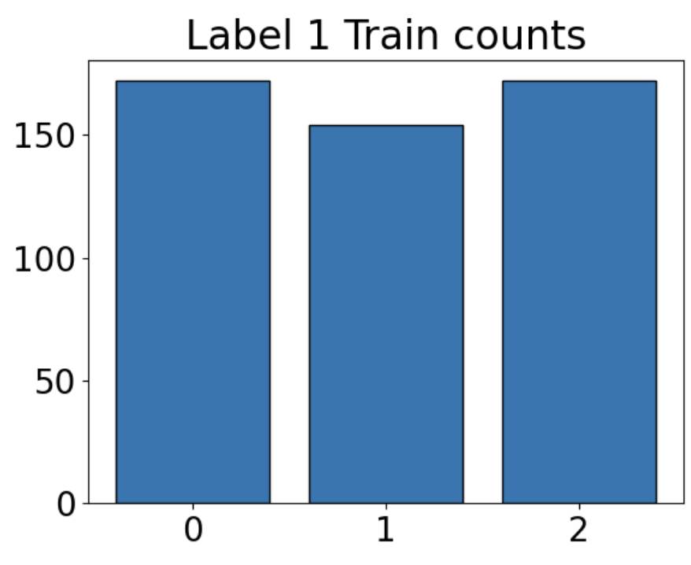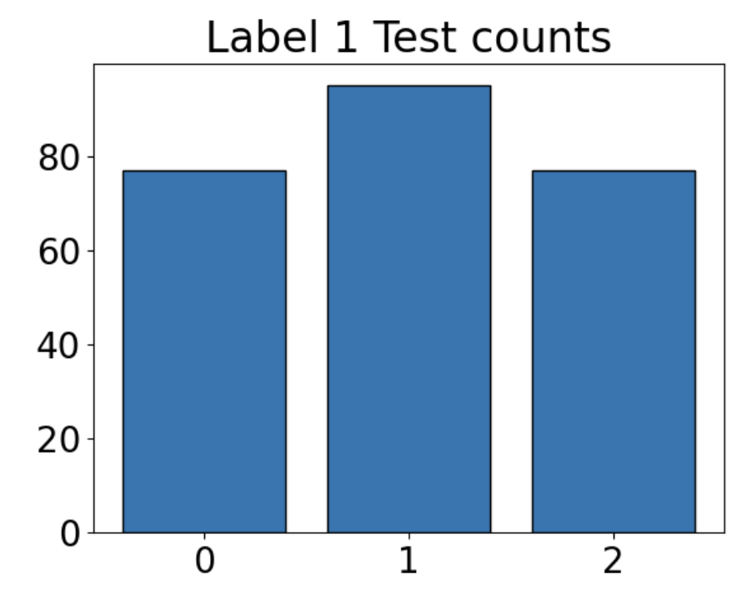

import pandas as pd
from sklearn.model_selection import KFold
from get_path import getPath
import matplotlib.pyplot as plt

PATH = getPath()
FILE = "healthcare-dataset-stroke-data.csv"
df = pd.read_csv(PATH + FILE)

y = df["stroke"] # Series
X = df.drop(columns=["stroke"]) # DataFrame

kfold = KFold(n_splits=3, shuffle=True)

trainCounts = []
testCounts = []

for train_idx, test_idx in kfold.split(X):
# Use positional indexing
X_train = X.iloc[train_idx]
X_test = X.iloc[test_idx]
y_train = y.iloc[train_idx]
y_test = y.iloc[test_idx]
trainCount = y_train.value_counts().get(1, 0)
trainCounts.append(trainCount)
testCount = y_test.value_counts().get(1, 0)
testCounts.append(testCount)

def plotLabelCounts(data, title):
#data.sort()
plt.rcParams.update({"font.size": 20})
plt.bar(['0', '1', '2'], data, edgecolor="black")
plt.xticks(['0', '1','2'])
plt.title("Label 1 " + title + " counts")
plt.show()

plotLabelCounts(trainCounts, "Train")
plotLabelCounts(testCounts, "Test")

Exercise 1 (2 marks)
Replace the kfold declaration with
sfold = StratifiedKFold(n_splits=3, shuffle=True)

Also, import StatifiedKFold:
from sklearn.model_selection import StratifiedKFold

Replace the cross fold header with:
for train_idx, test_idx in sfold.split(X, y):

Show the plot for train and test data of counts where label equals 1 for each fold when using StratifiedKFold:
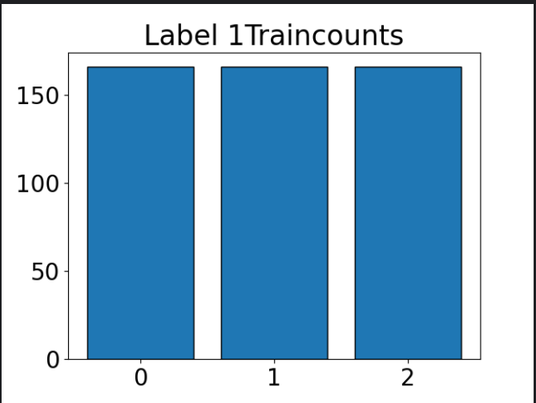
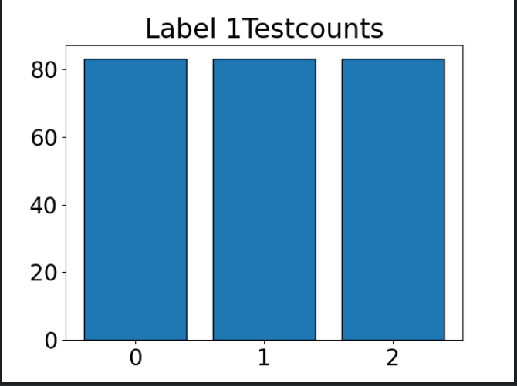

Explain how StratifiedKFold changed the allocation of label 1 values for Stroke at each fold:
StratifiedKfold ensures that the proportions of all labels are the same in each split, so the allocation of label 1 in each fold will be the same as its proportion in the whole dataset.

Exercise 2 (2 marks)
This code uses KFold to perform classification. The results are:

Average F1 score: 0.7328947368421052
F1 standard deviation: 0.09417951181262944

Here is the code:
import pandas as pd
from sklearn.linear_model import LogisticRegression
from sklearn.model_selection import KFold
from get_path import getPath
from sklearn.metrics import f1_score
import numpy as np

PATH = getPath()
FILE = "fluDiagnosis.csv"
df = pd.read_csv(PATH + FILE)

y = df["Diagnosed"] # Series
X = df.drop(columns=["Diagnosed"]) # DataFrame

kfold = KFold(n_splits=3, shuffle=True)

f1s = []
for train_idx, test_idx in kfold.split(X):
# Use positional indexing
X_train = X.iloc[train_idx]
X_test = X.iloc[test_idx]
y_train = y.iloc[train_idx]
y_test = y.iloc[test_idx]
model = LogisticRegression()
model.fit(X_train, y_train)
predictions = model.predict(X_test)
f1s.append(f1_score(y_test, predictions))

print("Average F1 score:", np.mean(f1s))
print("F1 standard deviation:", np.std(f1s))

Modify the code in this exercise to use StratifiedKFold. Show the new average F1 and F1 SD here:
Average F1: 0.7563
F1 Std: 0.0208

How does the average F1 and F1 SD compare with the KFold?
The average F1 score is higher with smaller standard deviation.

Tip: I actually did not find that the sample was large enough to observe much difference so I placed the crossfold loop inside another loop to iterate 100 times. Then I noticed that the F1 standard deviation was smaller for StratifiedKFold.

Exercise 3 (1 mark)
What type of models can use StratifiedKFold?
LogisticRegression models or models for classification

Data Leakage
Data leakage occurs when an object is trained with data that is used in its evaluation. A goal during training and evaluation should be to keep your training and test data sets separate. When objects like a scaler, imputer or model are fit using all of the data they are getting a preview of the very data that will be used to evaluate it. This preview can give the model an unfair advantage when it is being evaluated while training. As a result, the object may under-perform during production with unseen data.

Ideally it is better to fit your scaler and to fit your imputer on training data only. Fitting either the scaler or imputer on all of the available data may add some bias. I am guilty of fitting my imputer on all of the data. While fitting an imputer on all data often may not add significant bias, fitting the imputer with only the training data is a safer option for all situations.

Pipeline for Data Preparation and Model Development
I was not enthusiastic about using a Pipeline until recently when I was shown that fitting the imputer with all data is incorrect. However, waiting until training to eliminate null values during training means that dummy variable creation and binning can only happen during training. Fortunately, pipelines help to simplify this task.

Figure 1 shows how a valid flow for using a pipeline to prepare data, train and evaluate a model.

Figure 1: Model Fitting with Pipeline
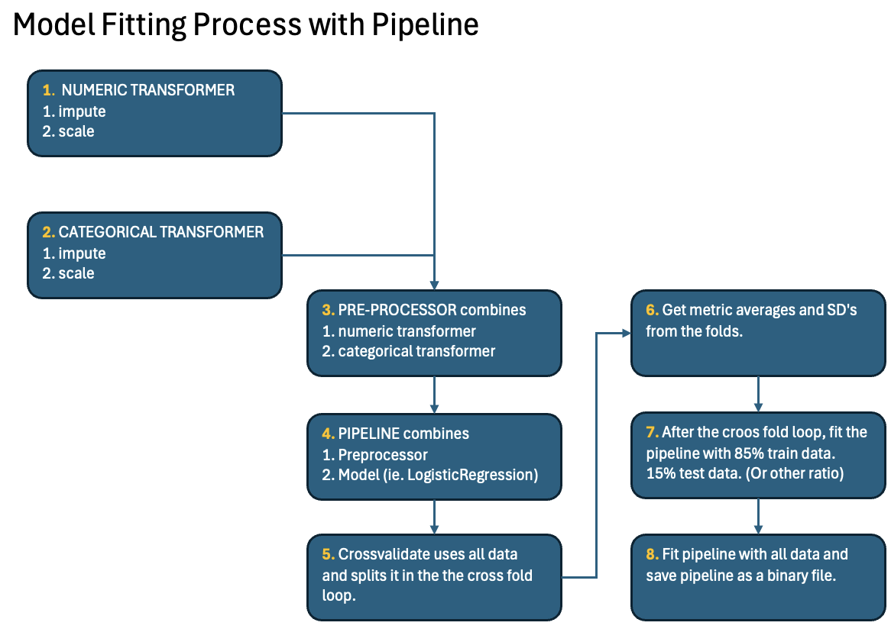

NumericalTransformer
The pipline will often start with data preprocessor. An important component of the Preprocessor is a numerical transformer. The numeric transformer uses a pipeline to prepare continuous variables with scaling and possibly binning.
numerical_transformer = Pipeline(steps=[
# ‘uniform’ weights neighbours equally. ‘distance’ weights closest more.
("imputer", KNNImputer(n_neighbors=3, weights="uniform")),
("scaler", StandardScaler())
])

OneHotEncoder
A OneHotEncoded class converts categories into dummy variables and this may be included in the data preprocessor. The handle_unknown ignore option causes the other related categories to all be treated as zero.
categorical_transformer = OneHotEncoder(  handle_unknown="ignore",  ) | Value  "A"  "B"  NaN | Encoding  [1, 0]  [0, 1]  [0, 0]

Instead, you may choose to use encoded_missing_value=-1 to create a separate column for the nan value.
OneHotEncoder(  handle_unknown="ignore",  encoded_missing_value=-1  ) | Value  "A"  "B"  NaN | Encoding  1 0 0  0 1 0  0 0 1

Preprocessor
These various data transformers for imputing ordinal and categorical column preparation can be combined by a single ColumnTransformer to make the data preprocessor.
def getPreprocessor(numerical_features, categorical_features):

#1 Preprocessing for continuous columns.
numerical_transformer = Pipeline(steps=[
("imputer", KNNImputer(n_neighbors=3, weights="uniform")),
("scaler", StandardScaler())
])
#2 Categorical: NO imputation; NaN becomes its own category.
categorical_transformer = OneHotEncoder(
handle_unknown="ignore",
# sparse_output say result is matrix (true) or dense array (false)
# matrix (true) is more memory efficient but may require extra conversions
# later to work with numPy and PyTorch. The default is ‘true’.
sparse_output=False
)
#3 Combine continuous and categorical columns.
preprocessor = ColumnTransformer(
transformers=[
("num", numerical_transformer, numerical_features),
("cat", categorical_transformer, categorical_features),
],
remainder="drop"
)
return preprocessor

When pipeline.fit() is called to fit the model later, implicitly the fit_transform() functions of the imputer and scaler within the preprocessor are invoked so you do not need to write this in code:

KNNImputer.fit_transform(...)
StandardScaler.fit_transform(...)

Exercise 4 (1 mark)
Based on the preprocessor code above, what two transformations are only applied to the continuous variables?
KKNImputer and StandardScaler
What transformation is only applied to the categorical data in this case?
OneHotEncoder

Model Pipeline
The model pipeline combines the column transformations and model.
def getPipeline(preprocessor):
pipeline = Pipeline(steps=[
("preprocessor", preprocessor),
("classifier", LogisticRegression(random_state=42))
])
return pipeline

Cross Fold Validation with a Pipeline
With a pipeline, the cross_validate() function receives the pipeline and data. There are other functions that can be used instead but I like cross_validate() because it generates multiple metrics for evaluation. Note that a classification model typically would use StratifiedKFold and the regression model would use KFold.
# For Classification  def crossFoldEvaluate(X, y, pipeline):  cv = StratifiedKFold(n_splits=3,  shuffle=True)  scores = cross_validate(  pipeline,  X, y,  cv=cv,  scoring={  "accuracy": "accuracy",  "f1": "f1",  "precision": "precision",  "recall": "recall",  }  )  return scores | # For Regression  def crossFoldEvaluateRegression(X, y,  pipeline):  cv = KFold(n_splits=3, shuffle=True)  scores = cross_validate(  pipeline,  X, y,  cv=cv,  scoring={  "rmse":  "neg_root_mean_squared_error",  "r2": "r2",  }  )  return scores

Holdout Validation (Unseen Data)
After the cross validate loop, the model should be refit with as much data as possible and evaluated with a holdout set. For this reason, train_test_split() can be used once again after the cross validate loop to create the train and test sets:
def performHoldoutEvaluation(X, y):
# Split data
X_train, X_test, y_train, y_test = train_test_split(
X, y,
test_size=0.3,
random_state=42,
stratify=y # ensure test/train have similar label proportions as population
)
pipeline.fit(X_train, y_train)
accuracy = pipeline.score(X_test, y_test)
print(f"Holdout Test Accuracy: {accuracy:.2f}")

Fit and Save the Model
A convenient feature of pipeline is that it generates only one binary which contains all information about the entire data preprocessor and the model pipeline.
def fitAndSaveFinalPipeline(X, y, preprocessor):
pipeline = getPipeline(preprocessor)
pipeline.fit(X, y)
joblib.dump(pipeline, "model_pipeline.joblib")
print("Saved model_pipeline.joblib")

Loading and Applying the Binary
Once the pipeline is saved, it can easily be loaded and applied to prepare the raw data and run it through the model.
# Load the binary & predict
loaded_pipeline = joblib.load("model_pipeline.joblib")

new_data = pd.DataFrame({
"age": [45],
"gender": ["Female"],
"city": ["Paris"]
})

prediction = loaded_pipeline.predict(new_data)

Example 2: Modelling and Evaluation Steps with a Pipeline
This example assembles all of the pipeline code discussed in this section to create a model with robust validation and efficient use of data. The outcome leads to safe tests that avoid data leakage.
import pandas as pd
import numpy as np
import joblib

from sklearn.model_selection import train_test_split, StratifiedKFold, cross_val_score, cross_validate
from sklearn.pipeline import Pipeline
from sklearn.compose import ColumnTransformer
from sklearn.impute import KNNImputer
from sklearn.preprocessing import OneHotEncoder, StandardScaler
from sklearn.linear_model import LogisticRegression

def getData():
data = {
"age": [
25, 34, 45, np.nan, 52, 41, 29, 60, 48, 33,
37, 55, 62, 44, 28, np.nan, 39, 47, 51, 31,
36, 58, 63, 42, 27, 49, 54, 35, np.nan, 46,
40, 59, 61, 32, 38
],
"gender": [
"Male", "Female", "Female", "Male", "Female",
"Male", "Male", "Female", "Male", "Female",
"Male", "Female", "Male", "Female", "Male",
np.nan, "Female", "Male", "Female", "Male",
"Female", "Male", "Female", "Male", "Female",
"Male", "Female", "Male", "Female", "Male",
"Female", "Male", "Female", "Male", "Female"
],
"city": [
"New York", "Paris", "London", "Toronto", "Paris",
"London", "New York", "Toronto", "Paris", "London",
"New York", "Paris", "Toronto", "London", "New York",
"Paris", "London", "Toronto", "Paris", "New York",
"London", "Toronto", "Paris", "New York", "London",
"Paris", "Toronto", "New York", "London", "Paris",
"Toronto", "New York", "Paris", "London", "Toronto"
],
"target": [
0, 1, 0, 1, 1, 0, 0, 1, 0, 1, 0, 1, 1, 0, 0, 1, 0, 1, 1, 0,
0, 1, 1, 0, 0, 1, 1, 0, 1, 0, 1, 1, 1, 0, 0
]
}
return pd.DataFrame(data)

def getVariableGroups():
numerical_features = ['age']
categorical_features = ['gender', 'city']
target = 'target'
return numerical_features, categorical_features, target

def getPreprocessor(numerical_features, categorical_features):
# Preprocessing for continuous columns.
numerical_transformer = Pipeline(steps=[
("imputer", KNNImputer(n_neighbors=3, weights="uniform")),
("scaler", StandardScaler())
])
# Categorical: NO imputation; NaN becomes its own category
categorical_transformer = OneHotEncoder(
handle_unknown="ignore",
sparse_output=False
)
preprocessor = ColumnTransformer(
transformers=[
("num", numerical_transformer, numerical_features),
("cat", categorical_transformer, categorical_features),
],
remainder="drop"
)
return preprocessor

def crossFoldEvaluate(X, y, preprocessor):
pipeline = getPipeline(preprocessor)

# Cross-fold evaluation (StratifiedKFold)
cv = StratifiedKFold(n_splits=3, shuffle=True, random_state=42)

# cross_validate lets you have multiple metrics like accuracy, F1, etc.
scores = cross_validate(
pipeline,
X, y,
cv=cv,
scoring={
"accuracy": "accuracy",
"f1": "f1",
"precision": "precision",
"recall": "recall",
}
)
return scores

def showCrossFoldResults(scores):
print("Accuracy:", scores["test_accuracy"])
print("F1: ", scores["test_f1"])
print("Precision", scores["test_precision"])
print("Recall: ", scores["test_recall"])

print("\nMean scores:")
print("Accuracy:", scores["test_accuracy"].mean())
print("F1: ", scores["test_f1"].mean())
print("Precision", scores["test_precision"].mean())
print("Recall: ", scores["test_recall"].mean())

def getPipeline(preprocessor):
pipeline = Pipeline(steps=[
("preprocessor", preprocessor),
("classifier", LogisticRegression(random_state=42))
])
return pipeline

def performHoldoutEvaluation(X, y, preprocessor):
pipeline = getPipeline(preprocessor)
# Split data
X_train, X_test, y_train, y_test = train_test_split(
X, y,
test_size=0.3,
random_state=42,
stratify=y
)
pipeline.fit(X_train, y_train)
accuracy = pipeline.score(X_test, y_test)
print(f"Holdout Test Accuracy: {accuracy:.2f}")

def fitAndSaveFinalPipeline(X, y, preprocessor):
pipeline = getPipeline(preprocessor)
pipeline.fit(X, y)
joblib.dump(pipeline, "model_pipeline.joblib")
print("Saved model_pipeline.joblib")

numerical_features, categorical_features, target = getVariableGroups()
preprocessor = getPreprocessor(numerical_features, categorical_features)

# Get X and y.
df = getData()
X = df[numerical_features + categorical_features]
y = df[target]

# Perform crossfold.
cvscores = crossFoldEvaluate(X, y, preprocessor)
showCrossFoldResults(cvscores)

# Evaluate model with train_test_split using all data.
performHoldoutEvaluation(X, y, preprocessor)

# Fit model with all data and save as a binary.xa
fitAndSaveFinalPipeline(X, y, preprocessor)

# Load the binary & predict
loaded_pipeline = joblib.load("model_pipeline.joblib")

new_data = pd.DataFrame({
"age": [45],
"gender": ["Female"],
"city": ["Paris"]
})

prediction = loaded_pipeline.predict(new_data)
probability = loaded_pipeline.predict_proba(new_data)

print("Prediction:", prediction)
print("Probabilities:", probability)

Exercise 5 (1 mark)
What does the stratify parameter located in the performHoldoutEvaluation() function do?
To ensure that proportions of the label remain relative the same in the splits as the whole dataset.

Exercise 6 (1 mark)
Would this stratify parameter exist in a regression (for continuous number modelling) as well?
- Yes
- b) No

How many rows of data are given to crossFoldEvaluate(), performHoldoutEvaluation() and fitAndSaveFinalPipeline()? Please ignore this part of the question.
NO RESPONSE REQUIRED HERE.

Viewing Features and Sample Data
Example 3: Viewing Features and Sample Data
Since it helps during debugging to inspect the features and sample data while debugging an app, this example shows how to track the after it is processed with a pipeline. This example adds code to the solution for Example 2 to show the feature names, scaled numeric data and dummy variables.

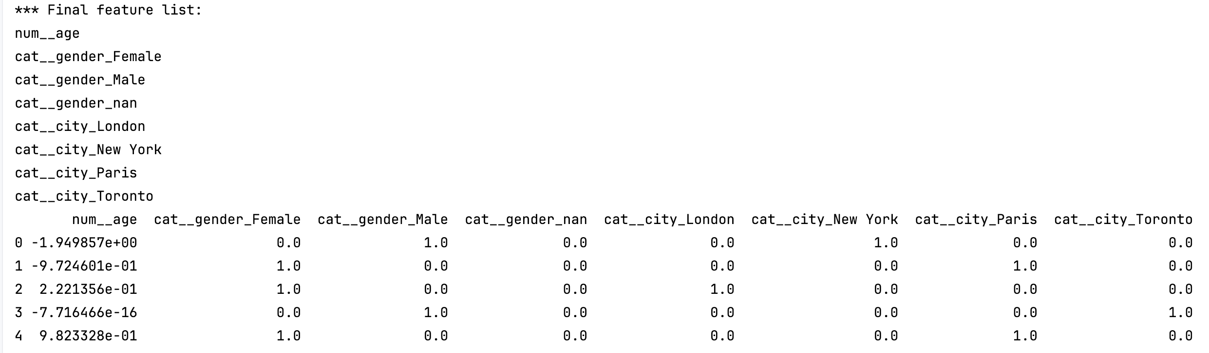

This code can be used after the preprocessor is fit. To build this example, add this function to Example 2.
def viewFeaturesAndSampleData(X, pipeline):
# Access the preprocessor from the fitted pipeline.
preprocessor = pipeline.named_steps["preprocessor"]

# Show all columns.
pd.set_option('display.max_columns', None)
pd.set_option('display.width', 1000)

# Get final feature names
feature_names = preprocessor.get_feature_names_out()

print("*** Final feature list:")
for name in feature_names:
print(name)

# Transform 3 rows of original X.
X_prepared = preprocessor.transform(X.head(3))

# Store transformed data in DataFrame for readability
X_prepared_df = pd.DataFrame(
X_prepared,
columns=feature_names
)
print(X_prepared_df)

Call the new function at the end of the performHoldoutEvaluation() function.
viewFeaturesAndSampleData(X, pipeline)

Exercise 7 (1 mark) Please ignore this exercise.
Based on your response in Error! Reference source not found., determine and state how you could extract the model from the pipeline. Hint: See getPipeline().
NO RESPONSE REQUIRED

Binning
When using a pipeline, binning is a slightly more a complicated transformation which involves multiple steps. There are many ways to bin - I personally want to be able to keep track of the column names that are generated so the approach here gives me some control for tracking the names.

Example 4: Binning
This example walks through steps that are required to perform binning. When finished the resulting dataset will appear.
Starting with the solution for Example 3, add this data series to the original data set to create an income_k column.
"income_k": [
45, 62, 58, 40, 80, 72, 50, 95, 66, 55,
60, 88, 105, 70, 48, 52, 63, 75, 82, 54,
57, 92, 110, 69, 46, 78, 86, 59, 61, 73,
68, 98, 102, 56, 64
],

Then add new references for the binned features:
def getVariableGroups():
numerical_features = ['age']
categorical_features = ['gender', 'city']
target = 'target'
binned_features = ["income_k"]
return numerical_features, categorical_features, target, binned_features

income_bin_feature_names_out() defines the new binned column names. bin_income_np() creates binned data in a manner that works for sklearn’s FunctionTransformer() function:
# *args param is needed to absorb arguments passed by sklearn’s FunctionTransformer.
def income_bin_feature_names_out(*args):
return np.array([
"income_k_(-inf,55]",
"income_k_(55,75]",
"income_k_(75,95]",
"income_k_(95,inf]"
])

# Creates output like [[0 1 0 0],
# [1 0 0 0],...]
def bin_income_np(X):
x = np.asarray(X, dtype=float).reshape(-1)

# Fixed bin edges → fixed indices
bins = [-np.inf, 55, 75, 95, np.inf]
bin_idx = np.digitize(x, bins[1:-1], right=True) # 0,1,2,3

# One-hot encode with fixed width = 4
one_hot = np.eye(len(bins) - 1, dtype=int)[bin_idx]
return one_hot

Then at the start of getPreprocessor() add this code block which references the two new bin helpers:
binned_transformer = Pipeline(steps=[
("imputer", KNNImputer(n_neighbors=3)),
("bin", FunctionTransformer(
bin_income_np,
validate=False,
feature_names_out=income_bin_feature_names_out
))
])

Also in getPreprocessor, a new transformer is to manage the income imputing so make the highlighted changes as shown:
def getPreprocessor(numerical_features, categorical_features, binned_features):
…
preprocessor = ColumnTransformer(
transformers=[
("num", numerical_transformer, numerical_features),
("income_bins", binned_transformer, binned_features),
("cat", categorical_transformer, categorical_features),
],
remainder="drop"
)
return preprocessor

Finally, modify the instructions for getting the variable groups and the data processor so they include consideration for the binned feature while preparing the data.
numerical_features, categorical_features, \
target, binned_features = getVariableGroups()
preprocessor = getPreprocessor(numerical_features,
categorical_features, binned_features)
# Get X and y.
df = getData()
X = df[numerical_features + categorical_features + binned_features]
y = df[target]

The final data set that is used to test the pipeline after it is loaded from the binary file also needs income data once the pipeline has been set up to perform income binning.
new_data = pd.DataFrame({
"age": [45], "gender": ["Female"], "income_k":[88], "city": ["Paris"] })

Exercise 8 (1 mark)
Why is income_bins located after num in the transformers array?
because imputation for missing values need to happen first before binning is done.

Example 5: Production code for the pipline
This example shows production code which prepares the data. Of course more modularization could be used to avoid the code duplication.
import joblib
import pandas as pd
import numpy as np

def bin_income_np(X):
s = pd.Series(np.asarray(X).reshape(-1))
cut = pd.cut(s, bins=[-np.inf, 55, 75, 95, np.inf])
dummies = pd.get_dummies(cut, dtype=int)
# lock column order (important)
cats = pd.IntervalIndex.from_breaks([-np.inf, 55, 75, 95, np.inf])
dummies = dummies.reindex(columns=cats, fill_value=0)
return dummies.to_numpy()

def income_bin_feature_names_out(*args):
return np.array([
"income_k_(-inf,55]",
"income_k_(55,75]",
"income_k_(75,95]",
"income_k_(95,inf]"
])

loaded_pipeline = joblib.load("model_pipeline.joblib")

new_data = pd.DataFrame({
"age": [45],
"gender": ["Female"],
"income_k":[88],
"city": ["Paris"]
})

prediction = loaded_pipeline.predict(new_data)
probability = loaded_pipeline.predict_proba(new_data)

print("Prediction:", prediction)
print("Probabilities:", probability)

Exercise 9 (4 marks)
Use the following new data column;
"days_since_last_purchase": [
5, 40, 18, 120, 12, 30, 75, 4, 22, 15,
35, 8, 2, 28, 90, 60, 20, 10, 6, 55,
80, 7, 3, 45, 100, 14, 9, 25, 17, 32,
11, 5, 1, 65, 19
]

To create the following bins and add them to the pipeline covered up to Example 4;

0–7 days are considered recent, those with activity 8–30 days ago are active, customers whose last purchase was 31–90 days ago are cooling, and those with no purchases for over 90 days are considered dormant.

Show a screenshot of the binned features and some other columns that appear when running viewFeaturesAndSampleData():
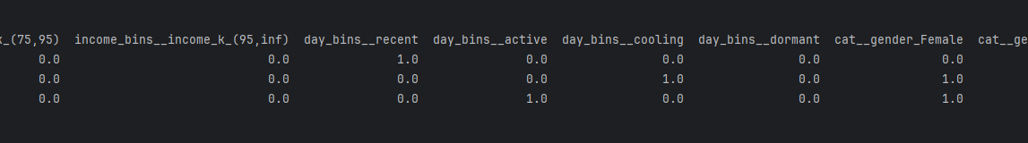

Exercise 10 (2 marks)
Show the updated production code which includes the new binned features from Exercise 9 as part of the pipeline.
import joblib
import pandas as pd
import numpy as np
def bin_income_np(X):
s = pd.Series(np.asarray(X).reshape(-1))
cut = pd.cut(s, bins=[-np.inf, 55, 75, 95, np.inf])
dummies = pd.get_dummies(cut, dtype=int)
# lock column order
cats = pd.IntervalIndex.from_breaks([-np.inf, 55, 75, 95, np.inf])
dummies = dummies.reindex(columns=cats, fill_value=0)
return dummies.to_numpy()
def bin_days_since_last_purchase(X):
x = np.asarray(X, dtype=int).reshape(-1)
bins = [0, 7, 30, 90, np.inf]
bin_idx = np.digitize(x, bins[1:-1], right=True)
one_hot = np.eye(len(bins)-1, dtype=int)[bin_idx]
return one_hot
def income_bin_feature_names_out(*args):
return np.array([
'income_k_(-inf,55]',
'income_k_(55,75]',
'income_k_(75,95]',
'income_k_(95,inf]'
])
def days_since_last_purchase_bin_names_out(*args):
return np.array([
'recent',
'active',
'cooling',
'dormant'
])
loaded_pipeline = joblib.load('model_pipeline.joblib')
new_data = pd.DataFrame({
'age': [45],
'gender': ['Female'],
'income_k': [88],
'days_since_last_purchase': [30],
'city': ["Paris"]
})
prediction = loaded_pipeline.predict(new_data)
probability = loaded_pipeline.predict_proba(new_data)
print(f'Prediction: {prediction}')
print(f'Probability: {probability}')

Exercise 11 (4 marks)
Continuing from Exercise 10, add this continuous data to the pipeline as well and modify the code accordingly.
"email_open_rate": [
0.35, 0.62, 0.48, np.nan, 0.81,
0.55, 0.40, 0.90, 0.60, 0.50,
np.nan, 0.72, 0.95, 0.58, 0.30,
np.nan, 0.65, 0.78, 0.82, 0.45,
0.52, 0.88, np.nan, 0.57, 0.33,
0.70, 0.76, 0.49, np.nan, 0.66,
0.61, 0.92, 0.97, 0.54, 0.59
]
Show a screenshot of the email_open_rate and some other columns that appear when running viewFeaturesAndSampleData():
Show a copy of the getPreprocessor() function after making the required changes and after ensuring your new model can be fit and run properly to make predictions:
I’m not sure what you are asking for changes in this function since we can treat this new feature as numerical and just add it to the list of numerical features and let the pipeline handle it accordingly.
def get_variable_groups():
numerical_features = ['age', 'email_open_rate']
categorical_features = ['gender', 'city']
target = 'target'
feature_income = ['income_k']
feature_day = ['days_since_last_purchase']
return numerical_features, categorical_features, target, feature_income, feature_day

Show an updated new_data dataframe which is accepted by the pipeline to make predictions:
new_data = pd.DataFrame({
'age': [45],
'gender': ['Female'],
'income_k': [88],
'days_since_last_purchase': [30],
'email_open_rate': [0.4],
'city': ['Paris']
})

Pipeline for Regression
Example 6: Pipeline for Regression
Similar to the classification example before, this example demonstrates how to perform regression with a pipeline. To keep it simple, I have not performed validation with a holdout test set and I have not fitted a final pipeline with all available data but those would be suitable steps in a production situation.
import pandas as pd
import numpy as np
import joblib

from sklearn.model_selection import train_test_split, KFold, cross_validate
from sklearn.pipeline import Pipeline
from sklearn.compose import ColumnTransformer
from sklearn.impute import KNNImputer
from sklearn.preprocessing import OneHotEncoder, StandardScaler
from sklearn.linear_model import LinearRegression
from sklearn.metrics import mean_squared_error, r2_score

# Create sample regression data
data = {
"sqft": [800, 900, 1000, 1100, np.nan, 1300, 1400],
"age": [20, 15, np.nan, 5, 30, 10, 8],
"city": ["A", "B", "A", "C", "B", "A", "C"],
"price": [200000, 220000, 250000, 270000, 230000, 300000, 320000]
}
df = pd.DataFrame(data)

numeric_features = ["sqft", "age"]
categorical_features = ["city"]
target = "price"

X = df[numeric_features + categorical_features]
y = df[target]

# Preprocessing pipelines
numeric_transformer = Pipeline(steps=[
("imputer", KNNImputer(n_neighbors=3)),
("scaler", StandardScaler())
])

categorical_transformer = OneHotEncoder(
handle_unknown="ignore",
sparse_output=False
)

preprocessor = ColumnTransformer(
transformers=[
("num", numeric_transformer, numeric_features),
("cat", categorical_transformer, categorical_features),
],
remainder="drop"
)

# Full regression pipeline
pipeline = Pipeline(steps=[
("preprocessor", preprocessor),
("regressor", LinearRegression())
])

# Use KFold for regression (StratifiedKFold is for classification)
cv = KFold(n_splits=3, shuffle=True, random_state=42)

# Not sure why older versions of sklearn do not offer
# neg_root_mean_squared_error but neg_root_mean_squared_error can be negated.
scores = cross_validate(
pipeline,
X, y,
cv=cv,
scoring={
"rmse": "neg_root_mean_squared_error",
"r2": "r2"
},
return_train_score=False
)

rmse_per_fold = -scores["test_rmse"] # make positive
r2_per_fold = scores["test_r2"]

print("RMSE per fold:", rmse_per_fold)
print("RMSE mean: ", rmse_per_fold.mean())
print("RMSE std: ", rmse_per_fold.std())

print("\nR² per fold: ", r2_per_fold)
print("R² mean: ", r2_per_fold.mean())

# Fit final model on all data and save
pipeline.fit(X, y)
joblib.dump(pipeline, "regression_pipeline.joblib")
print("\nSaved regression_pipeline.joblib")

# Load and predict on new data
loaded_pipeline = joblib.load("regression_pipeline.joblib")
new_data = pd.DataFrame({
"sqft": [1200],
"age": [12],
"city": ["B"]
})

predicted_price = loaded_pipeline.predict(new_data)
print("Predicted price:", predicted_price)

Exercise 12 (1 mark)
How is the type of cross_validate() function different for regression compared to classification?
I’m confused about this question. Are you asking about what metrics or estimators (Logistic vs Linear)?
According to its documentation: the cross_validate funtion returns:
Array of scores of the estimator for each run of the cross validation.
A dict of arrays containing the score/ time arrays for each scorer is returned

Exercise 13 (4 marks)
Add this new feature to the data in Example 6.
"property_type": ["Condo","Townhouse","Detached","Detached",np.nan,"Condo","Detached"]
The make adjustments to include this new feature in the pipeline. Show the updated code after making the change.
data = {
"sqft": [800, 900, 1000, 1100, np.nan, 1300, 1400],
"age": [20, 15, np.nan, 5, 30, 10, 8],
"city": ["A", "B", "A", "C", "B", "A", "C"],
"property_type": ["Condo","Townhouse","Detached","Detached",np.nan,"Condo","Detached"],
"price": [200000, 220000, 250000, 270000, 230000, 300000, 320000]
}
df = pd.DataFrame(data)
numeric_features = ['sqft', 'age']
categorical_features = ['city', 'property_type']
target = 'price'
X = df[numeric_features + categorical_features]
y = df[target]
numeric_transformer = Pipeline(steps=[
('imputer', KNNImputer(n_neighbors=3)),
('scaler', StandardScaler())
])
categorical_transformer = OneHotEncoder(
handle_unknown='ignore',
sparse_output=False,
drop='first'
)

