Table of Contents
Bagging 1
Bagged Classifier 1
Bagged Regressors 4
Grid Searching 6
Ensembles 8
Voting Regressor 11
Stacked Models 13
Stacking Regression 13
Stacking Classification 16

Bagging
Bagging involves averaging the predictions from the weak learners to generate a more stable result with less variance. ‘Bagging’ is a term that is derived from the terms “bootstrapping” and “aggregating”. Bootstrapping involves sampling with replacement. Weak learners of the same type are built with the bootstrapped data.

A random forest is a great example of a bagging algorithm since it combines many weak decision trees with random data. Other types of learners can be bagged as well.

Bagged Classifier
We have looked at bagging with random forests. We can perform bagging with other model types as well.

Example 1: Bagging
Next in this example, several stand-alone and bagged classifiers are compared. These classifiers include:
- KNeighborsClassifier()
- SVC()
- RidgeClassifier()

A more fair test would involve a more careful approach for exploring parameter values. To keep this example simple an in depth parameter explanation is avoided.

Bagging often offers a slight improvement in accuracy with generally less variance in most cases. Overall the KNeighborsClassifier appears to gain the most from bagging. (see Table 1). However, when bagging or not, RidgeClassifier scores already are superior to KNeighborsClassifier.

Table 1: Comparing Stand-Alone and Bagged Classifiers
*** KNeighborsClassifier ***  0.573170731707317  *** Bagged: KNeighborsClassifier ***  0.6036585365853658  *** SVC ***  0.6341463414634146 | *** Bagged: SVC ***  0.6463414634146342  *** RidgeClassifier ***  0.6158536585365854  *** Bagged: RidgeClassifier ***  0.6036585365853658

Here is the code for this sample:
import pandas as pd
from sklearn.preprocessing import StandardScaler
import warnings
from sklearn.tree import DecisionTreeClassifier
warnings.filterwarnings("ignore", category=RuntimeWarning)

# Get the housing data
df = pd.read_csv(getPath() + 'housing_classification.csv')
# Show all columns.
pd.set_option('display.max_columns', None)
pd.set_option('display.width', 1000)
print(df.head(5))

# Split into two sets
y = df['price']
X = df.drop('price', axis=1)

from sklearn.ensemble import BaggingClassifier
from sklearn.neighbors import KNeighborsClassifier
from sklearn.linear_model import RidgeClassifier
from sklearn.svm import SVC
from sklearn.metrics import f1_score, accuracy_score

# Create classifiers
knn = KNeighborsClassifier()
svc = SVC()
rg = RidgeClassifier(alpha=1.0)

# Build array of classifiers.
classifierArray = [knn, svc, rg]

def showStats(classifier, scores):
print(classifier + ": ", end="")
strMean = str(round(scores.mean(),2))

strStd = str(round(scores.std(),2))
print("Mean: " + strMean + " ", end="")
print("Std: " + strStd)

from sklearn.model_selection import train_test_split
X_train, X_test, y_train, y_test = train_test_split(X, y, test_size=0.30)

# KNN and SVC generally require scaling for better results.
scaler = StandardScaler()
X_train = scaler.fit_transform(X_train)
X_test = scaler.transform(X_test)

def evaluateModel(model, X_test, y_test, title):
print("*** " + title + " ***")
predictions = model.predict(X_test)
f1 = f1_score(y_test, predictions, average=None)
accuracy = accuracy_score(y_test, predictions)
print(accuracy)

# Search for the best classifier.
for clf in classifierArray:
modelType = clf.__class__.__name__

# Create and evaluate stand-alone model.
clfModel = clf.fit(X_train, y_train)
evaluateModel(clfModel, X_test, y_test, modelType)

# max_features means the maximum number of features to draw from X.
# max_samples sets the percentage of available data used for fitting.
bagging_clf = BaggingClassifier(clf, max_samples=0.4, max_features=6,
n_estimators=100, bootstrap=True)
baggedModel = bagging_clf.fit(X_train, y_train)
evaluateModel(baggedModel, X_test, y_test, "Bagged: " + modelType)

Exercise 1 (3 marks)
Modify Example 1 by importing the DecisionTreeClassifier class.
from sklearn.tree import DecisionTreeClassifier

Define the decision tree as shown here:
dt = DecisionTreeClassifier()

Modify the classifier array to also include your decision tree in the simple single and bagged model evaluation.

Finally change the number of estimators to 1000. Show the output for all models here after making the changes above in this exercise.
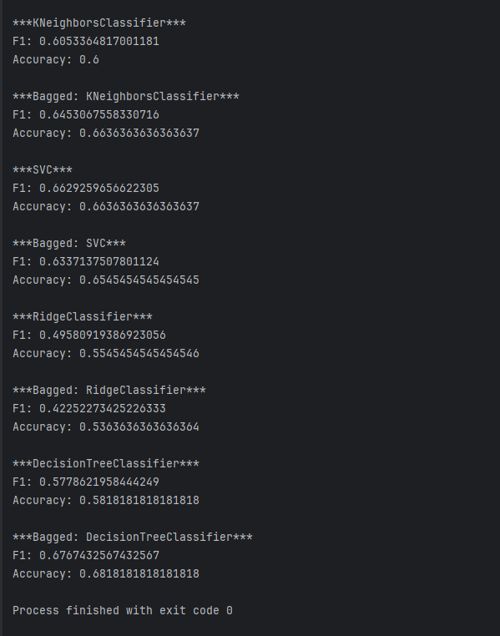

What bagged models appear to more often significantly beat the single version of the model for accuracy over multiple runs?
DecisionTree

Bagged Regressors
In addition to classification problems, you can use bagging to create an ensemble of regressors.

Example 2: Bagging with the KNeighboursRegressor
This example uses a bagged a KNeighborsRegressor model to predict wine quality. The results show that the single model tends to do more poorly with more variance than the bagged version:

****** Bagged Model
Mean RMSE: 0.6497
Std RMSE: 0.0283

****** Single Model
Mean RMSE: 0.6794
Std RMSE: 0.0294

For now, here is how to implement a basic ensemble for linear regression:
import warnings

from sklearn.neighbors import KNeighborsRegressor

warnings.filterwarnings("ignore", category=RuntimeWarning)

import pandas as pd
from sklearn.ensemble import BaggingRegressor
from sklearn.model_selection import train_test_split
import numpy as np
from sklearn.metrics import mean_squared_error
from sklearn.preprocessing import StandardScaler
from sklearn.tree import DecisionTreeRegressor

# Show all columns.
pd.set_option('display.max_columns', None)
pd.set_option('display.width', 1000)

# Load and prepare data.
FILE = 'winequality.csv'
dataset = pd.read_csv(getPath() + FILE)
print(dataset)
X = dataset.copy()
del X['quality']
y = dataset[['quality']]

def evaluateModel(model, X_test, y_test, title):
predictions = model.predict(X_test)
rmse = np.sqrt(mean_squared_error(y_test, predictions))
return rmse

# Repeat many times
N_RUNS = 200

rmse_ensemble = []
rmse_single = []

for run in range(N_RUNS):
# Create random split (different each run)
X_train, X_test, y_train, y_test = train_test_split(X, y, test_size=0.2)
scaler = StandardScaler()
X_train = scaler.fit_transform(X_train)
X_test = scaler.transform(X_test)

# Build linear regression ensemble (bagging)
ensembleModel = BaggingRegressor(
estimator=KNeighborsRegressor(n_neighbors=5),
max_features=4,
max_samples=0.5,
n_estimators=100
).fit(X_train, y_train)

rmse_ensemble.append(evaluateModel(ensembleModel, X_test, y_test, "Ensemble"))

# Build stand-alone model
model = KNeighborsRegressor(n_neighbors=5)
model.fit(X_train, y_train)

rmse_single.append(evaluateModel(model, X_test, y_test, "Single"))

rmse_ensemble = np.array(rmse_ensemble)
rmse_single = np.array(rmse_single)

print("\n==============================")
print("RMSE across many random splits")
print("==============================")

print("\n****** Bagged Model")
print("Mean RMSE:", round(rmse_ensemble.mean(), 4))
print("Std RMSE:", round(rmse_ensemble.std(), 4))

print("\n****** Single Model")
print("Mean RMSE:", round(rmse_single.mean(), 4))
print("Std RMSE:", round(rmse_single.std(), 4))

print("\nStd ratio (Single / Bagged):", round(rmse_single.std() / rmse_ensemble.std(), 3))

Grid Searching
With countless parameter combinations for ensembles and potential models it helps to be able to grid search different combinations to find the optimal combination.

Example 3: Grid Searching Bagging Regressor Parameters
This example actually shows that it is possible to reduce the variance with an ensemble. The optimal parameter combination is found through a manually implemented grid search.

Since the data split and sampling is random, the results will vary each run. However, it appears that an ensemble with a maximum of 4 features and 1200 estimators can out-perform a single stand alone model. Actually, several ensemble feature combinations appear to out-perform a single model which has an average RMSE of 81.257.
type rmse estimators features
10 Ensemble 61.086154 1200 4
12 Ensemble 66.889771 1400 3
8 Ensemble 75.444111 1200 3
14 Ensemble 80.646723 1400 4
4 Ensemble 83.016143 1000 3
2 Ensemble 93.618481 800 4
0 Ensemble 109.620029 800 3
6 Ensemble 128.580656 1000 4

13 Single 53.378910 None None
9 Single 67.236567 None None
11 Single 67.381451 None None
15 Single 69.263468 None None
5 Single 81.727743 None None
3 Single 85.892584 None None
1 Single 104.294314 None None
7 Single 120.881181 None None
Average Single RMSE 81.25702743302512

The code that performs the grid search is similar to the code in Example 2. This code however loops through different combinations of numbers of estimators and maximum features.

import pandas as pd
from sklearn.ensemble import BaggingRegressor

from sklearn.model_selection import train_test_split
import numpy as np
from sklearn.metrics import mean_squared_error
from sklearn.neighbors import KNeighborsRegressor
from sklearn.preprocessing import StandardScaler

# Show all columns.
pd.set_option('display.max_columns', None)
pd.set_option('display.width', 1000)

# Load and prepare data.

FILE = 'petrol_consumption.csv'
dataset = pd.read_csv(getPath() + FILE)
print(dataset)
X = dataset.copy()
del X['Petrol_Consumption']
y = dataset[['Petrol_Consumption']]

feature_combo_list = []
def evaluateModel(model, X_test, y_test, title, num_estimators, max_features):
print("\n****** " + title)
predictions = model.predict(X_test)
rmse = np.sqrt(mean_squared_error(y_test, predictions))

# Store statistics and add to list.
stats = {"type":title, "rmse":rmse,
"estimators":num_estimators, "features":max_features}
feature_combo_list.append(stats)
return rmse

num_estimator_list = [ 800, 1000, 1200, 1400]
max_features_list = [3, 4]

single_rmses=[]
for num_estimators in num_estimator_list:
for max_features in max_features_list:
# Create random split.
X_train, X_test, y_train, y_test = train_test_split(X, y, test_size=0.2)
scaler = StandardScaler()
X_train = scaler.fit_transform(X_train)
X_test = scaler.transform(X_test)

import numpy as np

# Build linear regression ensemble.
ensembleModel = BaggingRegressor(estimator=KNeighborsRegressor(),
max_features=max_features,
# Can be percent (float) or actual
# total of samples (int).
max_samples =0.5,
n_estimators=num_estimators).fit(X_train,
y_train.values.ravel())
evaluateModel(ensembleModel, X_test, y_test, "Ensemble",
num_estimators, max_features)

# Build stand alone linear regression model.
model = KNeighborsRegressor(n_neighbors=5)
model.fit(X_train, y_train)
rmse = evaluateModel(model, X_test, y_test, "Single", None, None)
single_rmses.append(rmse)

# Build data frame with dictionary objects.
dfStats = pd.DataFrame()
print(dfStats)
for combo in feature_combo_list:
dfStats = pd.concat([dfStats,
pd.DataFrame.from_records([combo])],
ignore_index=True)

# Sort and show all combinations.
# Show all rows
pd.set_option('display.max_rows', None)
dfStats = dfStats.sort_values(by=['type', 'rmse'])
print(dfStats)

print("Average Single RMSE " + str(np.mean(single_rmses)))

Exercise 2 (1 mark)
Why would it be redundant to use a Random Forest model in a bagged model?
because Random Forest is a type of bagged model per se. It’s a collection of different week learners == single decision trees combined together to create a forest

Ensembles
Ensembles allow you to average the predictions from multiple models to provide a more stable and accurate model.

eclf = EnsembleVoteClassifier(clfs=[ada_boost, grad_boost,
xgb_boost], voting='hard')

Hard voting chooses the majority of votes, soft voting averages the percentages of votes for each class (see Table 2).

Table 2: Calculations for hard voting and soft voting predictions.
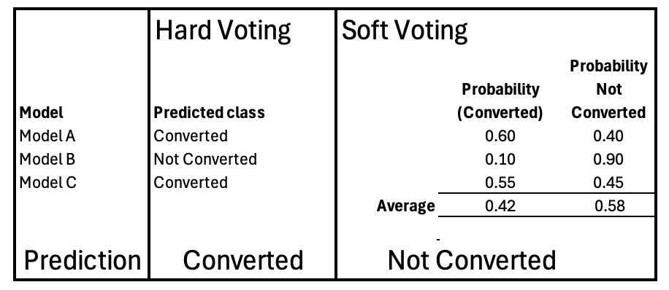
Ensemble voting classifiers often perform competitively even if they are not the single best model. By combining predictions from multiple diverse models, they reduce variance and produce more stable and robust results.

Example 4: Ensembles
This example demonstrates how to implement the EnsembleVoteClassifier. The boosting models do not require scaling but the data is scaled so additional models which require scaling can be added later. The validation implemented is not rigorous for ease of understanding. However, if you run the model multiple times, if accuracy was the desired metric, you would find that the ensemble vote classifier usually finishes somewhere as one of the top two models.
***AdaBoostClassifier***  precision recall f1-score support  0 0.66 0.50 0.57 54  1 0.47 0.67 0.55 57  2 0.83 0.66 0.74 53  accuracy 0.61 164  macro avg 0.65 0.61 0.62 164  weighted avg 0.65 0.61 0.62 164  ***GradientBoostingClassifier***  precision recall f1-score support  0 0.71 0.67 0.69 54  1 0.55 0.51 0.53 57  2 0.75 0.85 0.80 53  accuracy 0.67 164  macro avg 0.67 0.67 0.67 164  weighted avg 0.66 0.67 0.67 164 | ***XGBClassifier***  precision recall f1-score support  0 0.59 0.61 0.60 54  1 0.44 0.42 0.43 57  2 0.80 0.81 0.80 53  accuracy 0.61 164  macro avg 0.61 0.61 0.61 164  weighted avg 0.61 0.61 0.61 164  ***Ensemble Vote Classifier***  precision recall f1-score support  0 0.66 0.65 0.65 54  1 0.51 0.51 0.51 57  2 0.80 0.81 0.80 53  accuracy 0.65 164  macro avg 0.66 0.66 0.66 164  weighted avg 0.65 0.65 0.65 164

Here is the code:
import pandas as pd
from sklearn.metrics import classification_report
from sklearn.preprocessing import StandardScaler

# Get the housing data
df = pd.read_csv(getPath() + 'housing_classification.csv')
# Show all columns.
pd.set_option('display.max_columns', None)
pd.set_option('display.width', 1000)
print(df.head(5))

# Split into two sets
y = df['price']
X = df.drop('price', axis=1)

from sklearn.model_selection import train_test_split
X_train, X_test, y_train, y_test = train_test_split(X, y, test_size=0.30)

standard_scaler = StandardScaler()
X_train = standard_scaler.fit_transform(X_train)
X_test = standard_scaler.transform(X_test)

from mlxtend.classifier import EnsembleVoteClassifier
from xgboost import XGBClassifier, plot_importance
from sklearn.ensemble import AdaBoostClassifier, GradientBoostingClassifier

ada_boost = AdaBoostClassifier()
grad_boost = GradientBoostingClassifier()
xgb_boost = XGBClassifier()

classifiers = [ada_boost, grad_boost, xgb_boost]

def evaluateModel(clf, X_test, title):
print("***" + title + "***")
predictions = clf.predict(X_test)
report = classification_report(y_test, predictions)
print(report)

for clf in classifiers:
clf.fit(X_train, y_train)
evaluateModel(clf, X_test, clf.__class__.__name__)

eclf = EnsembleVoteClassifier(clfs=[ada_boost, grad_boost, xgb_boost], voting='hard')
eclf.fit(X_train, y_train)
evaluateModel(eclf, X_test, "ensemble vote classifier")

Exercise 3 (2 marks)
Update Example 4 to include a KNeighborsClassifier in the solo models and in the EnsembleVoteClassifier. Show the updated instruction which defines the models that are stored in the classifiers list:
ada_boost = AdaBoostClassifier()
grad_boost = GradientBoostingClassifier()
xgb = GradientBoostingClassifier()
knn = KNeighborsClassifier()
classifiers = [ada_boost, grad_boost, xgb, knn]

Show the updated instruction which declares and initializes eclf:
da_boost = AdaBoostClassifier()
grad_boost = GradientBoostingClassifier()
xgb = GradientBoostingClassifier()
knn = KNeighborsClassifier()
classifiers = [ada_boost, grad_boost, xgb, knn]
for clf in classifiers:
clf.fit(X_train_scaled, y_train)
evaluate(clf, X_test_scaled, y_test, clf.__class__.__name__)
ensemble_clf = EnsembleVoteClassifier(clfs=classifiers, voting='hard')
ensemble_clf.fit(X_train_scaled, y_train)
evaluate(ensemble_clf, X_test_scaled, y_test,'Ensemble Vote Classifier')

Show the sample output after making the updates for this exercise:
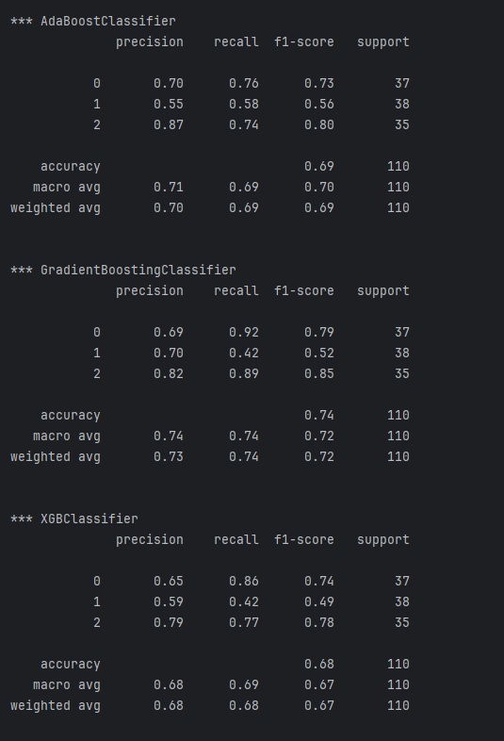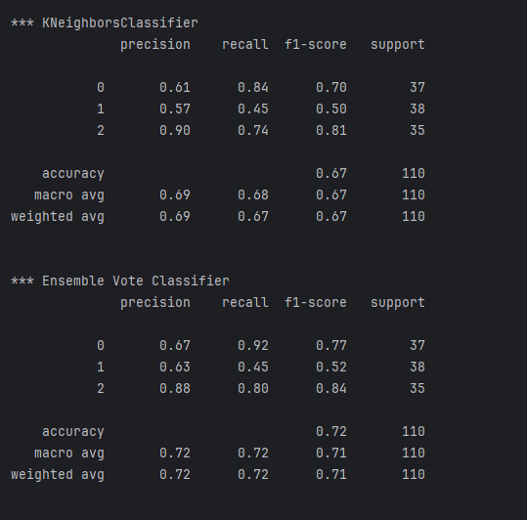
Run the model multiple times. Does the ensemble model generally tend to place as a top two model whether it is tied with another model or not?
yes it is otten competitive compared to both AdaBoost and GradientBoosting

Exercise 4 (2 marks)
Modify the solution to Exercise 3 to predict iris_type using iris_numeric.csv.
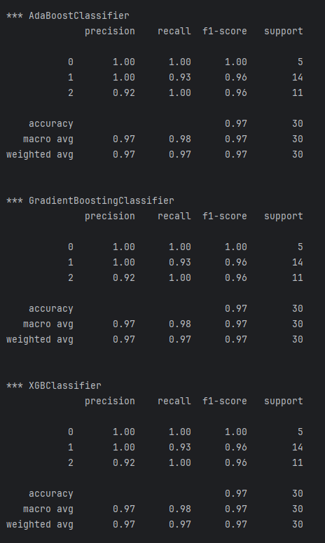
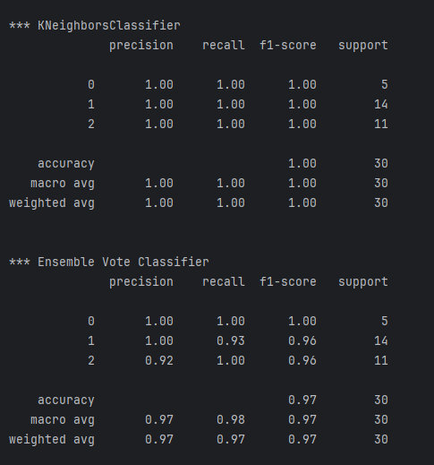

Voting Regressor
Similar to the EnsembleVoteClassifier, a VotingRegressor can be used for averaging numeric predictions for continuous targets. By default, the VotingRegressor averages predictions of multiple models like in Figure 1.

Figure 1: Averaging predictions of multiple models.
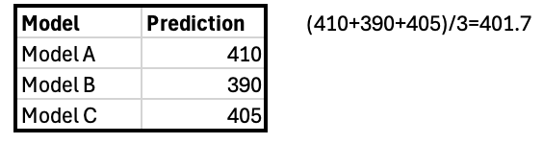
VotingRegressor also provides an option to weight better models more heavily to influence the outcome.
VotingRegressor(
estimators=[...],
weights=[0.2, 0.5, 0.3]
)

Example 5: Voting Regressor
This example demonstrates how to use the VotingRegressor to predict house prices from the California housing data set. With default averaging, the VotingRegressor usually will not be a top model but the variance/standard deviation will generally be lower.
RMSE over multiple runs
Ridge mean RMSE = 0.7264 | std = 0.0109
KNN mean RMSE = 0.6367 | std = 0.0105
RandomForest mean RMSE = 0.5024 | std = 0.0091
VotingRegressor mean RMSE = 0.5755 | std = 0.0086

Here is the code:
import numpy as np
import warnings
warnings.filterwarnings("ignore")

from sklearn.datasets import fetch_california_housing
from sklearn.model_selection import train_test_split
from sklearn.preprocessing import StandardScaler
from sklearn.metrics import mean_squared_error
from sklearn.linear_model import Ridge
from sklearn.neighbors import KNeighborsRegressor
from sklearn.ensemble import RandomForestRegressor, VotingRegressor

N_RUNS = 20
TEST_SIZE = 0.25

# Load data once
data = fetch_california_housing()
X, y = data.data, data.target

# Define base models
ridge = Ridge(alpha=1.0)
knn = KNeighborsRegressor(n_neighbors=15)

rf = RandomForestRegressor(
n_estimators=300,
)

vote = VotingRegressor(
estimators = [("ridge", ridge), ("knn", knn), ("rf", rf)]
)
models = {
"Ridge": ridge,
"KNN": knn,
"RandomForest": rf,
"VotingRegressor": vote # Place voting last in the list
}

# Storage for RMSEs
rmse_store = {name: [] for name in models}

# Multiple runs
for run in range(N_RUNS):
print("Run", run)
X_train, X_test, y_train, y_test = train_test_split(
X, y, test_size=TEST_SIZE
)

scaler = StandardScaler()
X_train_scaled = scaler.fit_transform(X_train)
X_test_scaled = scaler.transform(X_test)

for name, model in models.items():
model.fit(X_train_scaled, y_train)
preds = model.predict(X_test_scaled)
rmse = np.sqrt(mean_squared_error(y_test, preds))
rmse_store[name].append(rmse)

# Results
print("\nRMSE over multiple runs")
for name, rmses in rmse_store.items():
print(f"{name:15s} mean RMSE = {np.mean(rmses):.4f} | std = {np.std(rmses):.4f}")

Exercise 5 (2 mark)
Modify the weights in Example 5 and ensure they sum to 1. Weight the random forest more heavily. Compare output before and after weights

No weights  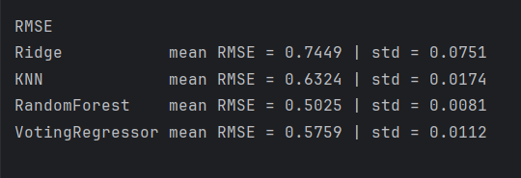 | With weights  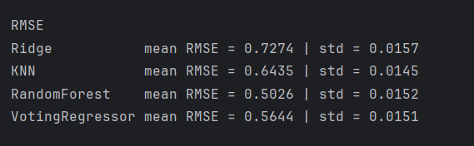

Exercise 6 (2 marks)
Add a model of your choosing and adjust the weights so the VotingRegressor relies more heavily on the better performing models. Show the updated definition for the vote object here:
ridge = Ridge(alpha=1.0)
knn = KNeighborsRegressor(n_neighbors=15)
rf = RandomForestRegressor(n_estimators=300)
grad_boost = GradientBoostingRegressor(n_estimators=300)
vote = VotingRegressor(estimators=[('ridge', ridge),
('knn', knn),
('rf', rf),
('gb', grad_boost)],
weights=[0.2, 0.2, 0.2, 0.4])

Show the updated models dictionary object here:
models = {
'Ridge': ridge,
'KNN': knn,
'RandomForest': rf,
'GradientBoosting': grad_boost,
'VotingRegressor': vote
}

Show sample output after making the requested changes for this exercise:
no weight
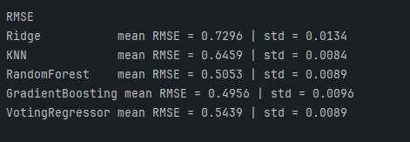

weighted:
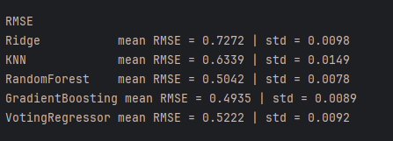

Stacked Models
A stacked model builds a model with the output from multiple models. Stacking can be applied to a combine the outputs from a wide variety of predictive models. Often, stacking helps to improve accuracy.

Stacking Regression

Example 6: Stacking Regression
This example shows how to implement stacking with outputs from the following combination of regressors:

- ElasticNet
- DecisionTreeRegressor
- SVR
- AdaBoostRegressor
- BaggingRegressor
- RandomForestRegressor
- ExtraTreesRegressor

The output when running this program shows that our super learner is competitive when compared to most models.
** Evaluate Base Models **
RMSE:123799.119 ElasticNet
RMSE:352456.005 SVR
RMSE:188327.974 DecisionTreeRegressor
RMSE:155919.974 AdaBoostRegressor
RMSE:136916.041 RandomForestRegressor
RMSE:131182.792 ExtraTreesRegressor

** Evaluate Stacked Model **
RMSE:104680.594 LinearRegression

Here is the code:
from sklearn.linear_model import LinearRegression
import warnings
warnings.filterwarnings('ignore')
from sklearn.linear_model import ElasticNet
from sklearn.preprocessing import StandardScaler
from sklearn.tree import DecisionTreeRegressor
from sklearn.svm import SVR
from sklearn.ensemble import AdaBoostRegressor
from sklearn.ensemble import RandomForestRegressor
from sklearn.ensemble import ExtraTreesRegressor
from sklearn.metrics import mean_squared_error
from sklearn.model_selection import train_test_split
import numpy as np
import pandas as pd

# Show all columns.
pd.set_option('display.max_columns', None)
pd.set_option('display.width', 1000)

# Prep data.
CSV_DATA = "USA_Housing.csv"
dataset = pd.read_csv(getPath() + CSV_DATA)
print(dataset.head())
X = dataset[['Avg. Area Income','Avg. Area House Age', 'Avg. Area Number of Rooms',\
'Avg. Area Number of Bedrooms', "Area Population"]].values
y = dataset['Price']

def getUnfitModels():
models = list()
models.append(ElasticNet())
models.append(SVR(gamma='scale'))
models.append(DecisionTreeRegressor())
models.append(AdaBoostRegressor())
models.append(RandomForestRegressor(n_estimators=200))
models.append(ExtraTreesRegressor(n_estimators=200))
return models

def evaluateModel(y_test, predictions, model):
mse = mean_squared_error(y_test, predictions)
rmse = round(np.sqrt(mse),3)
print(" RMSE:" + str(rmse) + " " + model.__class__.__name__)

def fitBaseModels(X_train, y_train, X_test, models):
dfPredictions = pd.DataFrame()

# Fit base model and store its predictions in dataframe.
for i in range(0, len(models)):
models[i].fit(X_train, y_train)
predictions = models[i].predict(X_test)
colName = str(i)
# Add base model predictions to column of data frame.
dfPredictions[colName] = predictions
return dfPredictions, models

def fitStackedModel(X, y):
model = LinearRegression()
model.fit(X, y)
return model

# Split data into train, test and validation sets.
X_train, X_temp, y_train, y_temp = train_test_split(X, y, test_size=0.70)
X_test, X_val, y_test, y_val = train_test_split(X_temp, y_temp, test_size=0.50)
scaler = StandardScaler()
X_train = scaler.fit_transform(X_train)
X_test = scaler.transform(X_test)
X_val = scaler.transform(X_val)

# Get base models.
unfitModels = getUnfitModels()

# Fit base and stacked models.
dfPredictions, models = fitBaseModels(X_train, y_train, X_val, unfitModels)
stackedModel = fitStackedModel(dfPredictions, y_val)

# Evaluate base models with validation data.
print("\n** Evaluate Base Models **")
dfValidationPredictions = pd.DataFrame()
for i in range(0, len(models)):
predictions = models[i].predict(X_test)
colName = str(i)
dfValidationPredictions[colName] = predictions
evaluateModel(y_test, predictions, models[i])

# Evaluate stacked model with validation data.
stackedPredictions = stackedModel.predict(dfValidationPredictions)
print("\n** Evaluate Stacked Model **")
evaluateModel(y_test, stackedPredictions, stackedModel)

Exercise 7 (3 marks)
Show a screenshot of the data frame that is used for input that is used to fit the stacked model in this exercise. Please make it reader-friendly by whatever means you feel is appropriate.
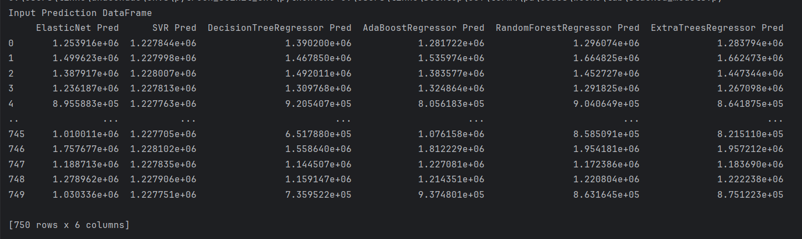

Explain what the columns of the data frame referenced above within this exercise represent.
Each column contains the predictions for that column model from the validation set.

Exercise 8 (3 marks)
Replace the code that retrieves the data in Example 6 with the following code which imports and prepares the wine quality data set. Make any other adjustments as required.
PATH = "/Users/pm/Desktop/DayDocs/data/"
CSV_DATA = "winequality.csv"
dataset = pd.read_csv(PATH + CSV_DATA)
X = dataset[['fixed acidity', 'volatile acidity', 'citric acid', 'residual sugar',
'chlorides', 'free sulfur dioxide', 'total sulfur dioxide', 'density',
'pH', 'sulphates','alcohol']].values
y = dataset['quality']

Run the code after making the changes. Show the output here:
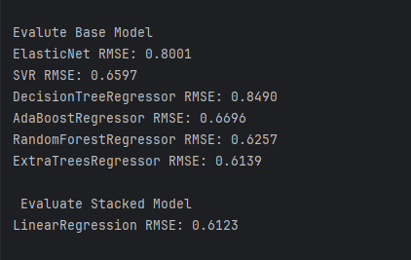

What model appears to perform the best and explain why you made that choice.
Stacked model has best performance with the lowest RMSE.

Stacking Classification

Example 7: Stacking for Classification
This example shows how to implement stacking for classification.
** Evaluate Base Models **
*** LogisticRegression
precision recall f1-score support
0 0.64 1.00 0.78 89
1 0.00 0.00 0.00 51

*** DecisionTreeClassifier
precision recall f1-score support
0 0.84 0.88 0.86 89
1 0.77 0.71 0.73 51

*** AdaBoostClassifier
precision recall f1-score support
0 0.80 0.89 0.84 89
1 0.76 0.61 0.67 51

*** RandomForestClassifier
precision recall f1-score support
0 0.84 0.88 0.86 89
1 0.77 0.71 0.73 51

** Evaluate Stacked Model **
*** LogisticRegression
precision recall f1-score support
0 0.83 0.88 0.85 89
1 0.76 0.69 0.72 51

Here is the code:
from sklearn.linear_model import LogisticRegression
from sklearn.tree import DecisionTreeClassifier
from sklearn.ensemble import AdaBoostClassifier
from sklearn.ensemble import RandomForestClassifier
from sklearn.metrics import classification_report
from sklearn.model_selection import train_test_split
import numpy as np
import pandas as pd

# Show all columns.
pd.set_option('display.max_columns', None)
pd.set_option('display.width', 1000)

# Prepare the data.
PATH = "/Users/pm/Desktop/DayDocs/data/"
CSV_DATA = "Social_Network_Ads.csv"

df = pd.read_csv(PATH + CSV_DATA)
df = pd.get_dummies(df,columns=['Gender'])
del df['User ID']

X = df.copy()
del X['Purchased']
y = df['Purchased']

def getUnfitModels():
models = list()
models.append(LogisticRegression())
models.append(DecisionTreeClassifier())
models.append(AdaBoostClassifier())
models.append(RandomForestClassifier(n_estimators=10))
return models

def evaluateModel(y_test, predictions, model):
print("\n*** " + model.__class__.__name__)
report = classification_report(y_test, predictions)
print(report)

def fitBaseModels(X_train, y_train, X_test, models):
dfPredictions = pd.DataFrame()

# Fit base model and store its predictions in dataframe.
for i in range(0, len(models)):
models[i].fit(X_train, y_train)
predictions = models[i].predict(X_test)
colName = str(i)
dfPredictions[colName] = predictions
return dfPredictions, models

def fitStackedModel(X, y):
model = LogisticRegression()
model.fit(X, y)
return model

# Split data into train, test and validation sets.
X_train, X_temp, y_train, y_temp = train_test_split(X, y, test_size=0.70)
X_test, X_val, y_test, y_val = train_test_split(X_temp, y_temp, test_size=0.50)

# Get base models.
unfitModels = getUnfitModels()

# Fit base and stacked models.
dfPredictions, models = fitBaseModels(X_train, y_train, X_val, unfitModels)
stackedModel = fitStackedModel(dfPredictions, y_val)

# Evaluate base models with validation data.
print("\n** Evaluate Base Models **")
dfValidationPredictions = pd.DataFrame()
for i in range(0, len(models)):
predictions = models[i].predict(X_test)
colName = str(i)
dfValidationPredictions[colName] = predictions
evaluateModel(y_test, predictions, models[i])

# Evaluate stacked model with validation data.
stackedPredictions = stackedModel.predict(dfValidationPredictions)
print("\n** Evaluate Stacked Model **")
evaluateModel(y_test, stackedPredictions, stackedModel)

Exercise 9 (3 marks)
Show a screenshot of the data frame that is used for input that is used to fit the stacked model in this exercise. Please make it reader-friendly by whatever means you feel is appropriate.
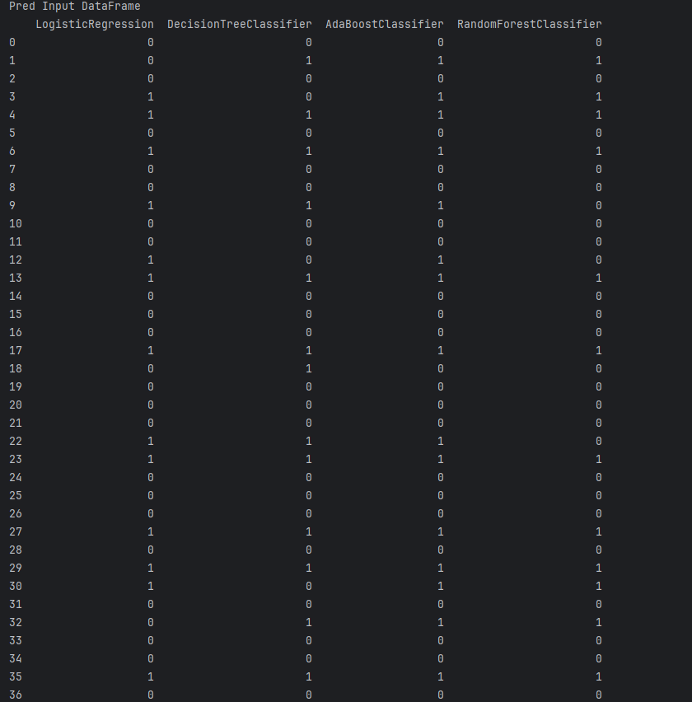

Explain what the columns of the data frame referenced above within this exercise represent.
Each column is a prediction column for the respective model on the fitted validated dataset.

Exercise 10 (3 marks)
Replace the code that retrieves the data in Example 7 with the following code which imports and prepares the iris data set. Make any other adjustments as required.
# Get the housing data
df = pd.read_csv('/Users/pm/Downloads/iris_numeric.csv')

dict_map = {'Iris-setosa':0,'Iris-versicolor':1, 'Iris-virginica':2}
df['target'] = df['iris_type'].map(dict_map)

y = df['target']
X = df.copy()
del X['target']
del X['iris_type']

Run the code after making the changes. Show the output here:
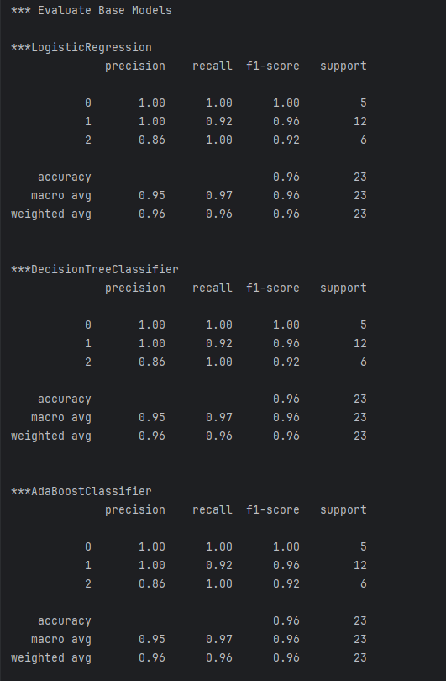
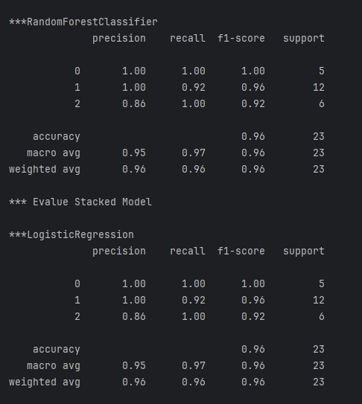

What model appears to perform the best and explain why you made that choice.
there is no obvious choice because the performance metrics for each run depends on the splits, and the dataset is not large enough to show clear edge for any one model.

Exercise 11 (3 marks)
Fill in the blanks:
a) A VotingRegressor combines predictions by taking the _mean_________ of the individual model outputs.
b) In a bagged model, each base learner is trained on a __smaller with replacement________ sample of the training data.
c) In stacking, the input features for the meta-learner are the __predictions________ of the base models.
d) Bagged models tend to reduce ___variance_______ and stacked models tend to improve ___accuracy______.

