Table of Contents
Saving and Loading State 6
state_dict 6
pth format 6
Loading the Model to Make a Prediction 6
Loading the Model for More Training 6
Regression with PyTorch 7
Creating a Custom Loss Function 11
Vanishing Gradients 12
Sigmoid activation 12
ReLU activation 12
Dying ReLU 17
Leaky ReLU 18

Example 1: Saving the Model and Viewing Metrics
This code is actually based on the last example in the previous lesson. It will be used for displaying metrics and for demonstrating how to save and load a model.

import copy
import numpy as np
import pandas as pd
import torch
import torch.nn as nn
import torch.optim as optim
from sklearn.model_selection import train_test_split
from sklearn.preprocessing import OneHotEncoder, StandardScaler

from get_path import getPath

def getTensors():
# read data and apply one-hot encoding
PATH = getPath()
data = pd.read_csv(PATH + "iris_alpha.csv")
y = data['iris_type']
X = data
del X['iris_type']

y = pd.get_dummies(y, dtype=int)

# keep as NumPy arrays for now
X = X.values.astype(np.float32)
y = y.values.astype(np.float32)

# split (still NumPy)
X_train, X_temp, y_train, y_temp = train_test_split(
X, y, train_size=0.7, shuffle=True
)
X_val, X_test, y_val, y_test = train_test_split(
X_temp, y_temp, train_size=0.7, shuffle=True
)

# scale (fit only on training data)
scaler = StandardScaler()
X_train = scaler.fit_transform(X_train)
X_val = scaler.transform(X_val)
X_test = scaler.transform(X_test)

# convert once to torch tensors
X_train = torch.tensor(X_train, dtype=torch.float32)
X_val = torch.tensor(X_val, dtype=torch.float32)
X_test = torch.tensor(X_test, dtype=torch.float32)
y_train = torch.tensor(y_train, dtype=torch.float32)
y_val = torch.tensor(y_val, dtype=torch.float32)
y_test = torch.tensor(y_test, dtype=torch.float32)
return X_train, X_val, X_test, y_train, y_val, y_test

class Multiclass(nn.Module):
def __init__(self):
super().__init__()
self.hidden = nn.Linear(4, 8)
self.act = nn.ReLU()
self.output = nn.Linear(8, 3)

def forward(self, x):
x = self.act(self.hidden(x))
x = self.output(x)
return x

def trainingLoop(model, optimizer, X_train, y_train, X_val, y_val):
loss_fn = nn.CrossEntropyLoss()
best_weights = None
best_acc = - np.inf
train_loss_hist = []
train_acc_hist = []
val_loss_hist = []
val_acc_hist = []

# training loop
for epoch in range(N_EPOCHS):
# shuffle training indices each epoch
perm = torch.randperm(len(X_train))

epoch_loss = []
epoch_acc = []

# set model in training mode and run through each batch
model.train()

for i in range(BATCHES_PER_EPOCH):
# Get random indicies from perm
start = i * BATCH_SIZE
idx = perm[start:start + BATCH_SIZE]
X_batch = X_train[idx]
y_batch = y_train[idx]

# forward pass
y_pred = model(X_batch)
loss = loss_fn(y_pred, y_batch)

# backward pass
optimizer.zero_grad()
loss.backward()

# update weights
optimizer.step()

# compute and store metrics
acc = (torch.argmax(y_pred, 1) == torch.argmax(y_batch, 1)).float().mean()
epoch_loss.append(float(loss))
epoch_acc.append(float(acc))

# set model in evaluation mode and run through the test set
model.eval() # dropout disabled, all neurons used.
with torch.no_grad(): # do not compute gradients
y_pred = model(X_val)
ce = loss_fn(y_pred, y_val)
acc = (torch.argmax(y_pred, 1) == torch.argmax(y_val, 1)).float().mean()

ce = float(ce)
acc = float(acc)
train_loss_hist.append(np.mean(epoch_loss))
train_acc_hist.append(np.mean(epoch_acc))
val_loss_hist.append(ce)
val_acc_hist.append(acc)

if acc > best_acc:
best_acc = acc
best_weights = copy.deepcopy(model.state_dict()) # make copy of weights.

print(f"Epoch {epoch} validation: Cross-entropy={ce:.2f},"
f"Accuracy={acc*100:.1f}%")
return model, best_weights

X_train, X_val, X_test, y_train, y_val, y_test = getTensors()

# prepare model and training parameters
N_EPOCHS = 200
BATCH_SIZE = 5
BATCHES_PER_EPOCH = len(X_train) // BATCH_SIZE

# define model and optimizer and start training
model = Multiclass()
optimizer = optim.Adam(model.parameters(), lr=0.001)
model, best_weights = trainingLoop(model, optimizer, X_train, y_train, X_val, y_val)

Exercise 1 (2 marks)
Explain why model.train() and model.eval() are used every epoch. Why is this necessary?
model.train() is used to set model to training mode which tells Pytorch to track and update weights and biases based on gradient calculations based on how batch_size is set.
model.eval() is used when evaluating the model per epoch telling Pytorch to not make updates to weights and biases.

Example 2: Loading and evaluating the model
This code loads the best weights and makes predictions for evaluation with the test data. To evaluate the model with familiar methods from sci-kit learn it is necessary to convert the Torch tensors a scikit friendly format.

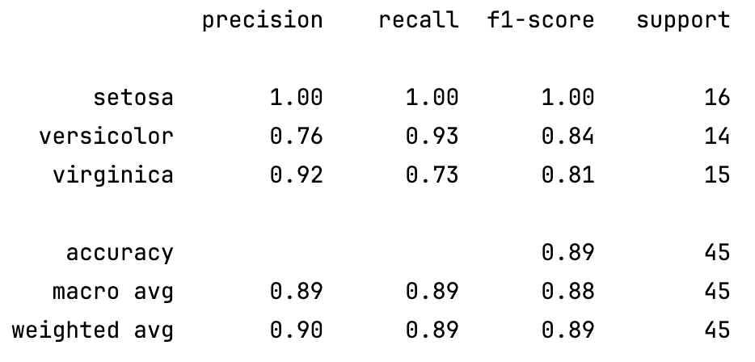
This code can be added to the end of Example 1 to show the classification report.
from sklearn.metrics import classification_report

def showClassificationReport(y_true, y_pred):
print(classification_report(
y_true,
y_pred,
target_names=["setosa", "versicolor", "virginica"]
))

model.load_state_dict(best_weights)
model.eval()
with torch.no_grad():
logits = model(X_test)
y_pred = torch.argmax(logits, dim=1).numpy()
y_true = torch.argmax(y_test, dim=1).numpy()
showClassificationReport(y_true, y_pred)

Exercise 2 (1 mark)
Why is torch.no_grad() used in Example 2?
to stop gradients from being calculated

Example 3: Displaying the state dictionary.
This example demonstrates how to display the weights of the Pytorch model. This code can be added at the end of Example 2 which is after load_state_dict() is called:
import pprint
pp = pprint.PrettyPrinter(indent=4)
pp.pprint(model.state_dict())

The output from this will look something like the following even though the numbers will be different:
OrderedDict([ ( 'hidden.weight',
tensor([[ 0.2754, -0.0486, 0.3669, 1.3396],
[ 0.0421, 0.1830, -0.3690, -0.8881],
[-0.5867, -0.4347, -0.2239, -0.6619],
[-0.4507, 0.1658, -0.9159, -1.0407],
[-0.2681, 0.5152, 0.6901, 0.1125],
[ 0.1534, -0.7932, 1.0474, 0.8622],
[ 0.2991, -0.5950, 0.6885, -0.2204],
[ 0.2746, -0.8409, 0.0704, 0.5904]])),
( 'hidden.bias',
tensor([-0.1409, 1.3778, 0.5866, 0.1143, 0.1486, 0.3217, 1.1685, 1.1044])),
( 'output.weight',
tensor([[-0.7935, 0.3427, 0.2292, 0.7023, -0.0380, -0.4716, -0.8331, -0.8546],
[-0.7159, 0.2533, 0.2111, -0.6991, -0.5675, 0.1086, 0.2957, 0.3308],
[ 0.6478, -0.9503, -0.9054, -0.4151, 0.1897, 0.4768, -0.0078, 0.2302]])),
('output.bias', tensor([ 0.0331, 0.2389, -0.2649]))])

Exercise 3 (2 marks)
What are the dimensions for hidden.weight and hidden.bias? What do these numbers represent?
weights: (4, 8), biases: (8,) -> 4 neuron for features in and 8 neurons out for hidden layer

What are the dimensions for output.weight and output.bias? What do these numbers represent?
weights: (3, 8), biases: (3) -> 8 neurons in and 3 output neurons

Saving and Loading State
The recommended way to save a PyTorch model is to save the states rather than the model. When the weights are saved, the saved states can be loaded later either for inference or for continued training.

state_dict
The state dictionary stores all trainable and non-trainable parameters of the model.

pth format
The pth file format is recommended for storing state since it can store a wide variety of information about the model. The pth format is actually an archive of pickle files.

Loading the Model to Make a Prediction
Example 4: Saving model states and loading model states for inference
This code can be added to Example 3 to save all trainable parameters (weights, biases) as a plain Python dictionary of tensors. This code does not save the architecture or training code.
# Save model
torch.save(model.state_dict(), "iris-model.pth")

# Create new model and load states
newmodel = Multiclass()
newmodel.load_state_dict(torch.load("iris-model.pth"))

# test with new model using copied tensor
y_pred = newmodel(X_test)
y_pred = torch.argmax(y_pred, 1)
y_pred = torch.argmax(logits, dim=1).numpy()
y_test = torch.argmax(y_test, dim=1).numpy()
showClassificationReport(y_test, y_pred)

Loading the Model for More Training
Example 5: Loading for more training.
The code in this example can be added to Example 2 to save the trainable parameters (weights, biases) as well as the optimizer. Then the model parameters can be loaded with the optimizer for more training.

NOTE: You may have to run the program several times or tweak N_EPOCHS to achieve the
desired result which should show that the model improves with additional training.
After first training round:  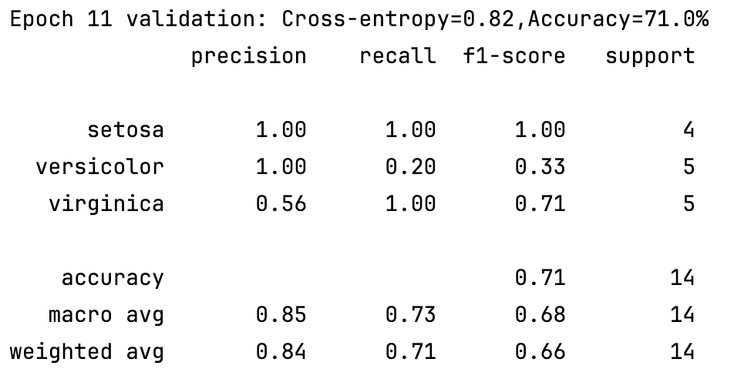 | After second training round:  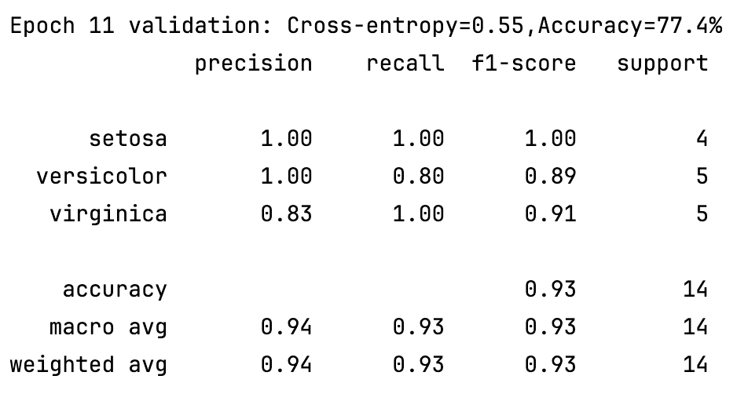

To observe improvements from continued training, lower the total epochs:
N_EPOCHS = 12

Then add this code to trainable parameters and optimizer and to resume training.
# recommended to also save optimizer with same momentum/Adam state
torch.save({
"model": model.state_dict(),
"optim": optimizer.state_dict()
}, "checkpoint.pth")
ckpt = torch.load("checkpoint.pth")
newmodel = Multiclass()
newmodel.load_state_dict(ckpt["model"])

optimizer = optim.Adam(newmodel.parameters(), lr=0.001)
optimizer.load_state_dict(ckpt["optim"])
newmodel, best_weights = trainingLoop(newmodel, optimizer, X_train, y_train, X_val, y_val)

newmodel.eval()
with torch.no_grad():
logits2 = newmodel(X_test)
y_pred2 = torch.argmax(logits2, dim=1).cpu().numpy()
y_true2 = torch.argmax(y_test, dim=1).cpu().numpy()
showClassificationReport(y_true2, y_pred2)

Regression with PyTorch

Example 6: Regression with PyTorch
This example demonstrates how to perform PyTorch regression to predict continuous values.

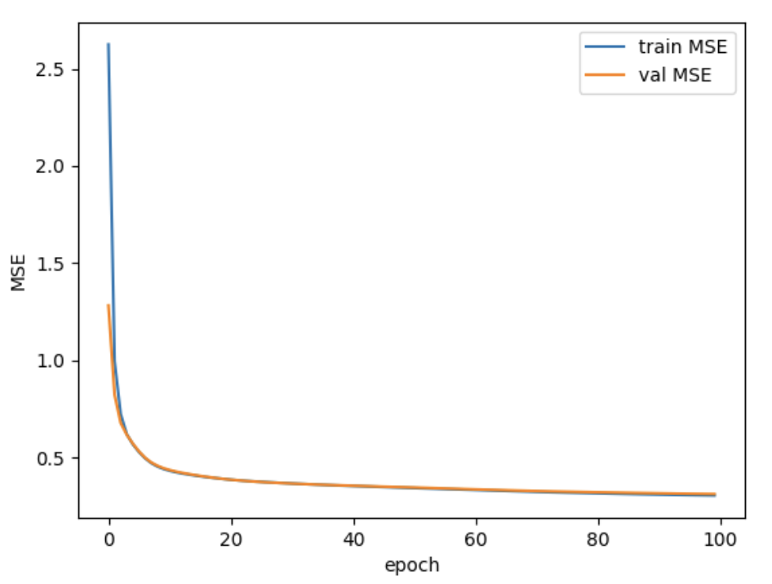
Here is the code:
import copy
import matplotlib.pyplot as plt
import numpy as np
import torch
import torch.nn as nn
import torch.optim as optim
from sklearn.model_selection import train_test_split
from sklearn.datasets import fetch_california_housing
from sklearn.preprocessing import StandardScaler

# Read data
data = fetch_california_housing()
X, y = data.data, data.target

# train-test split for model evaluation
X_train_raw, X_test_raw, y_train_raw, y_test = train_test_split(
X, y, train_size=0.7, shuffle=True, random_state=42
)

# NEW: split training into train/val
X_train_raw, X_val_raw, y_train_raw, y_val = train_test_split(
X_train_raw, y_train_raw, test_size=0.2, shuffle=True, random_state=42
)

# Standardizing data (fit ONLY on training)
scaler = StandardScaler()
scaler.fit(X_train_raw)
X_train = scaler.transform(X_train_raw)
X_val = scaler.transform(X_val_raw)
X_test = scaler.transform(X_test_raw)

# Convert to 2D PyTorch tensors
X_train = torch.tensor(X_train, dtype=torch.float32)
y_train = torch.tensor(y_train_raw, dtype=torch.float32).reshape(-1, 1)

X_val = torch.tensor(X_val, dtype=torch.float32)
y_val = torch.tensor(y_val, dtype=torch.float32).reshape(-1, 1)

X_test = torch.tensor(X_test, dtype=torch.float32)
y_test = torch.tensor(y_test, dtype=torch.float32).reshape(-1, 1)

# Define the model
model = nn.Sequential(
nn.Linear(8, 24),
nn.ReLU(),
nn.Linear(24, 12),
nn.ReLU(),
nn.Linear(12, 6),
nn.ReLU(),
nn.Linear(6, 1)
)

# loss function and optimizer
loss_fn = nn.MSELoss()
optimizer = optim.Adam(model.parameters(), lr=0.0001)

n_epochs = 100
batch_size = 10
batch_start = torch.arange(0, len(X_train), batch_size)

# Hold the best model (based on VALIDATION, not test)
best_val_mse = np.inf
best_weights = None

train_history = []
val_history = []

for epoch in range(n_epochs):
model.train()
epoch_losses = []

# shuffle row indices each epoch
perm = torch.randperm(len(X_train))

# iterate in batches over the shuffled indices
for start in range(0, len(X_train), batch_size):
idx = perm[start:start + batch_size]

X_batch = X_train[idx]
y_batch = y_train[idx]

y_pred = model(X_batch)
loss = loss_fn(y_pred, y_batch)

optimizer.zero_grad() # clear old gradients
loss.backward() # compute new gradients (∂loss/∂weights)
optimizer.step() # update model’s parameters using new gradients.

epoch_losses.append(float(loss))

# end-of-epoch: evaluate on validation set
model.eval()
with torch.no_grad():
val_pred = model(X_val)
val_mse = float(loss_fn(val_pred, y_val))

train_mse = float(np.mean(epoch_losses))
train_history.append(train_mse)
val_history.append(val_mse)

if val_mse < best_val_mse:
best_val_mse = val_mse
best_weights = copy.deepcopy(model.state_dict())

print(f"Epoch {epoch:3d} | train MSE={train_mse:.4f} | val MSE={val_mse:.4f}")

# Restore best model (based on validation)
model.load_state_dict(best_weights)

# Final test evaluation (done once)
model.eval()
with torch.no_grad():
test_pred = model(X_test)
test_mse = float(loss_fn(test_pred, y_test))

print("\nBest VAL MSE: %.4f | RMSE: %.4f" % (best_val_mse, np.sqrt(best_val_mse)))
print("Final TEST MSE: %.4f | RMSE: %.4f" % (test_mse, np.sqrt(test_mse)))

# Plot validation loss (and train for reference)
plt.plot(train_history, label="train MSE")
plt.plot(val_history, label="val MSE")
plt.xlabel("epoch")
plt.ylabel("MSE")
plt.legend()
plt.show()

# Inference examples (use the raw test rows, scaled)
model.eval()
with torch.no_grad():
for i in range(5):
X_sample = X_test_raw[i:i+1]
X_sample = scaler.transform(X_sample)
X_sample = torch.tensor(X_sample, dtype=torch.float32)
y_pred = model(X_sample)
print(f"{X_test_raw[i]} : {y_pred[0].numpy()} (expected {y_test[i].numpy()})")

Exercise 4 (3 marks)
Show the code needed to save the trainable parameters of the model in Example 6. Also show how to load and make prediction with the loaded model and the test data. Show the RMSE that results. Show the code here:
torch.save({
'model': model.state_dict(),
'optim': optimizer.state_dict()
}, 'reg_model.pth')
print('='*100)
print(f'\nLoading Saved Model')
state_dict = torch.load('reg_model.pth')
new_model = get_model()
new_model.load_state_dict(state_dict['model'])
optimizer = optim.Adam(new_model.parameters(), lr=1e-4)
optimizer.load_state_dict(state_dict['optim'])
new_model.eval()
with torch.inference_mode():
y_pred = new_model(X_test)
rmse_test = loss_fn(y_pred, y_test)
print(f'\nLoaded Model RMSE: {rmse_test:.4f}')

Show a screenshot which displays your code of this exercise and the output from running it here:
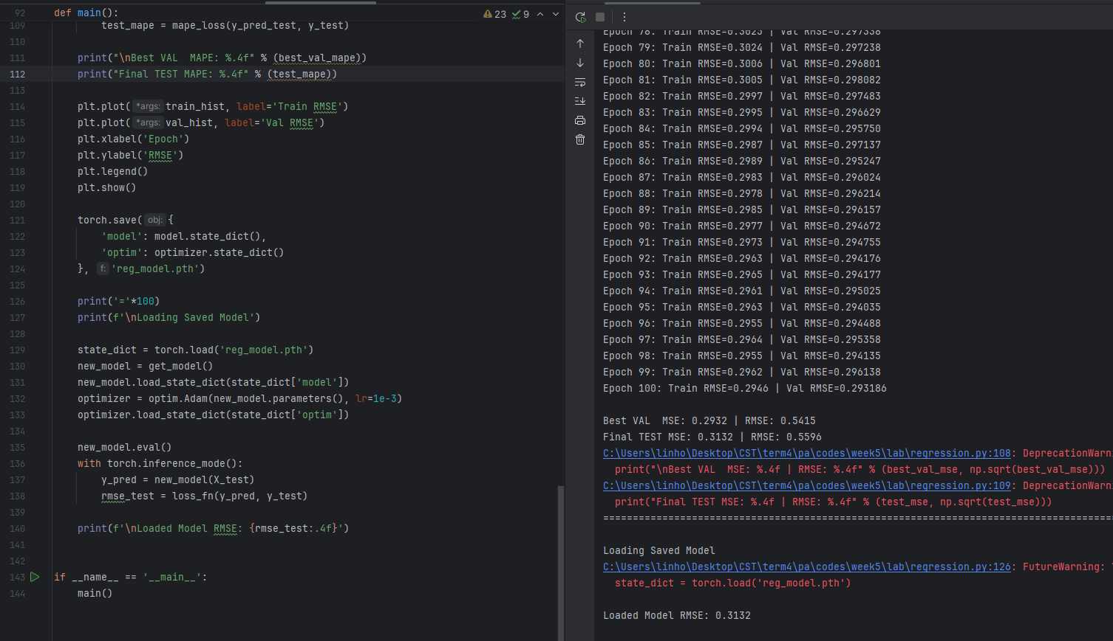

Creating a Custom Loss Function

In Example 1, a PyTorch CrossEntropyLoss() function was used for multi class predictions. In Example 6, an nn.MSELoss() function was used for regression. Prior to this lesson, a BCELoss() was function was used for a binary prediction with a PyTorch neural network.

Example 7: Creating a custom loss function
This example demonstrates how to implement a custom loss function. This example is based on Chapter 15: Loss Functions in PyTorch Models by Dr. Jason Brownlee. PyTorch does not provide all possible metrics such as mean average percentage error (MAPE):

MAPE = $\frac{1}{m}\sum_{i=1}^{m}{|\frac{\hat{y_{i}}-y_{i}}{y_{i}}|}$

For the California housing set, it might make more sense to have a loss function which compares percent price differences between actual and predicted values. To build this example, replace the loss_fn definition in Example 6 with this custom loss function:

def loss_fn(output, target):
# MAPE loss
return torch.mean(torch.abs((target - output) / target))

Exercise 5 (2 marks)
Change the output in Example 7 to show MAPE rather than MSE. Show a screenshot of the last few epochs that are printed to your console after changing the code to implement the loss function for Example 7.
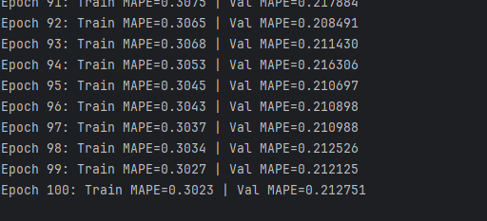
Also print the best validation MAPE and final test MAPE once the training loop is finished and show this in the same screenshot.
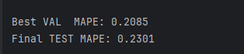

Vanishing Gradients
Backpropagation updates weights using the derivative of the activation function. If that derivative is very small, gradients shrink as they move backward through the layers and the learning stalls.

Sigmoid activation
The sigmoid function derivative quickly approaches zero for larger negative and larger positive numbers. Because of this, gradients quickly become unable to update neuron weights and biases during back propagation.

Figure 1 shows that the maximum derivative for sigmoid is 0.25. If each layer multiplies gradients by ≤ 0.25, then in a eight-layer network the updates to the initial layer quickly approach zero. ${0.25}^{8}$ = 0.00001526.

ReLU activation
For the rectified linear unit, for active neurons the derivative of the ReLU is 1. So instead of multiplying by 0.25 repeatedly, you multiply by 1. As a result, gradients pass backward unchanged so weight and bias updates can continue to occur.

Figure 1: Comparing Activation Functions and Their Derivatives
Sigmoid & Sigmoid Derivative  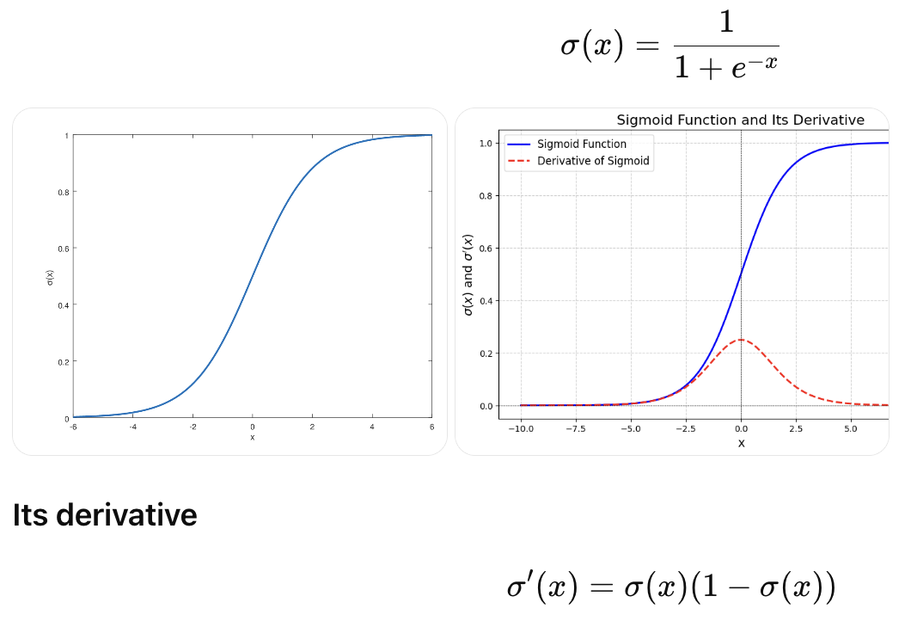 | ReLU & ReLU derivative  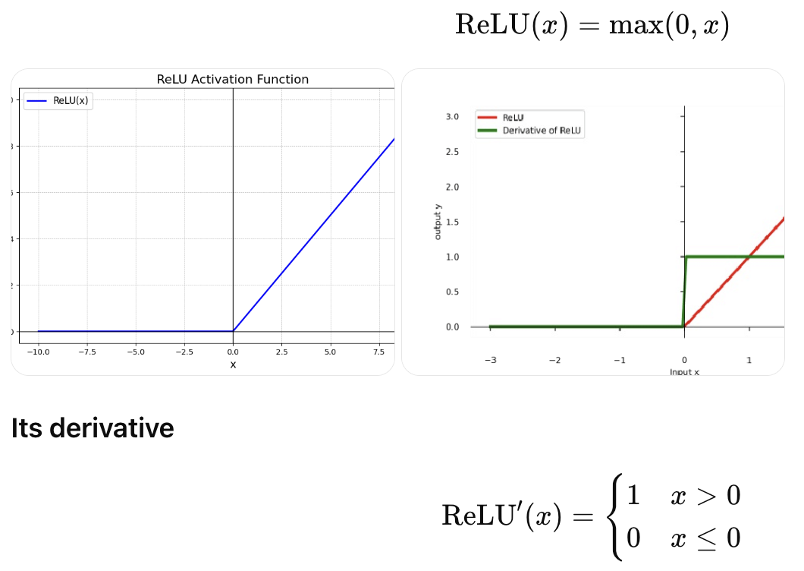

Mathematically,

z = wx + b # Applying weights and bias of the neuron.
a = f(z) # Apply activation function.
L = loss(a) # Calculate loss with output of activation function.

The gradient needed by optimizer.step() is:

$\frac{dL}{dw}$ = $\frac{dL}{da}∙\frac{da}{dz}∙\frac{dz}{dw}$ # $\frac{da}{dz}$ is the derivative of the activation function.

Example 8: Comparing gradients
This example demonstrates compare gradients diminish when a sigmoid and ReLU activation function are used. The example is based on Dr. Jason Brownlee’s example presented in Chapter 14 of Deep Learning with PyTorch.

The example starts with data set that is created with the make_circles() function from sklearn. The circles data set demonstrates that the activation function helps to solve a non-linear classification problem. In other words, the model needs to distinguish between blue and orange groups.
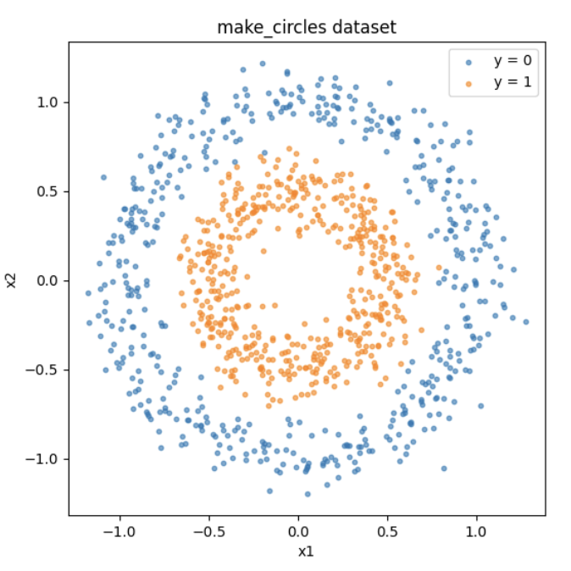
To keep this example simple, robust validation and training methods have been left aside.

When running the code with ReLU, we can see that a high amount of accuracy is achieved after 300 epochs (see the left plot in Figure 2). We also see healthy gradient values fluctuating within a general range for each layer (see the right plot in Figure 2).

Figure 2: ReLU activation function model loss and accuracy (left) and gradients (right).
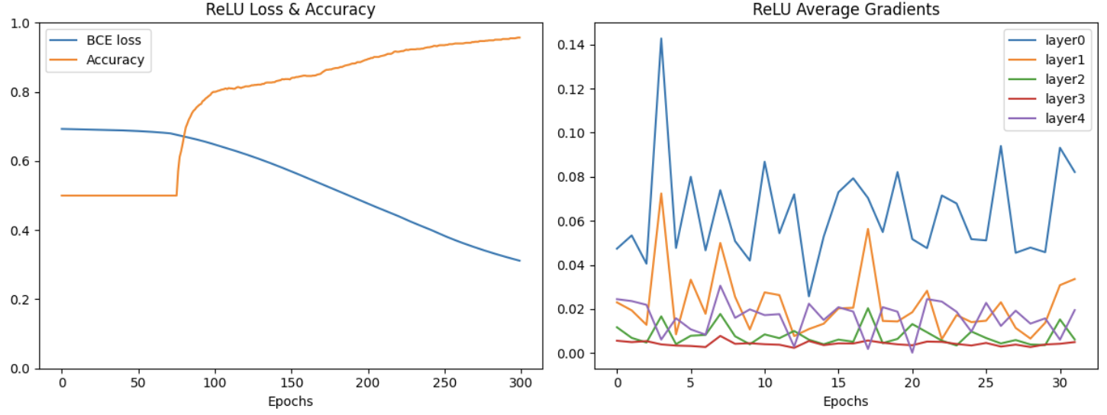

After 300 epochs the accuracy approaches 95.7%.

Epoch 249: BCE=0.3852, Accuracy=93.50%
Epoch 259: BCE=0.3674, Accuracy=94.00%
Epoch 269: BCE=0.3516, Accuracy=94.40%
Epoch 279: BCE=0.3370, Accuracy=94.90%
Epoch 289: BCE=0.3238, Accuracy=95.30%
Epoch 299: BCE=0.3116, Accuracy=95.70%

When a sigmoid activation function is used, the gradients in early layers rapidly diminish, leading to the vanishing gradient problem (see Figure 3). As a result, the network struggles to learn because weight updates in the early layers become extremely small, causing training to stall.

Figure 3: Sigmoid activation function model loss and accuracy (left) and gradients (right).
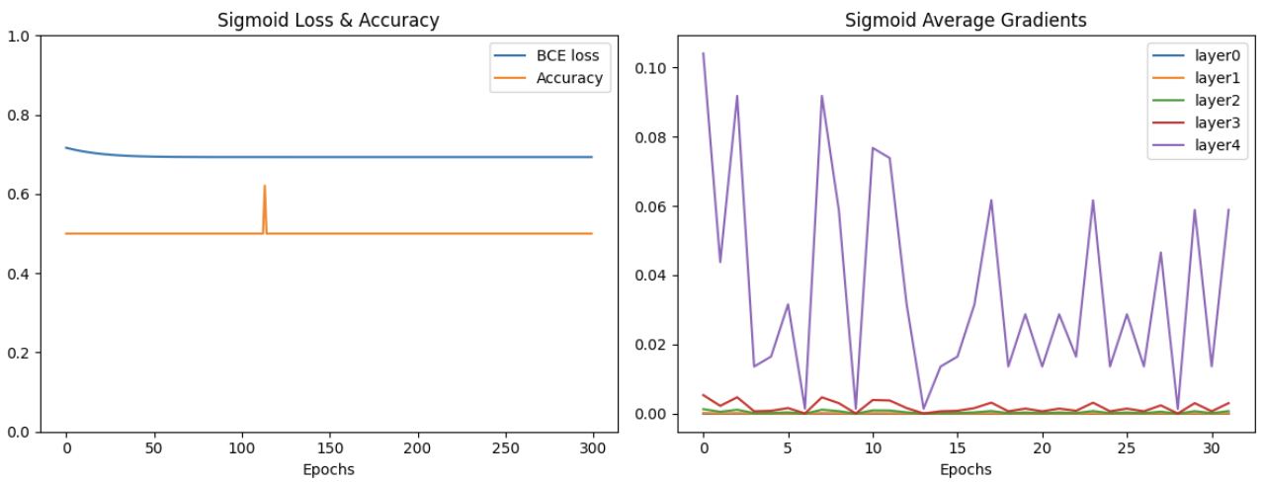
After 300 epochs, the total accuracy is no better than a random guess with an accuracy of 50%.

Epoch 279: BCE=0.6932, Accuracy=50.00%
Epoch 289: BCE=0.6931, Accuracy=50.00%
Epoch 299: BCE=0.6931, Accuracy=50.00%

This initial code runs using the ReLU activation function.
import matplotlib.pyplot as plt
import torch
import torch.nn as nn
import torch.optim as optim
from sklearn.datasets import make_circles

def visualizeData(X, y):
# convert tensors to numpy for plotting
X_np = X.numpy()
y_np = y.numpy().ravel()

# mask by class - generate true/false according to y=0 or 1.
mask0 = y_np == 0
mask1 = y_np == 1

plt.figure(figsize=(6, 6))

# Show 1st and 2nd columns in X. Color according to y value.
plt.scatter(X_np[mask0, 0], X_np[mask0, 1], s=10, label="y = 0", alpha=0.6)
plt.scatter(X_np[mask1, 0], X_np[mask1, 1], s=10, label="y = 1", alpha=0.6)

plt.xlabel("x1")
plt.ylabel("x2")
plt.title("make_circles dataset")
plt.legend()
plt.axis("equal")
plt.show()

def getData():
X, y = make_circles(n_samples=1000, factor=0.5, noise=0.1)

X = torch.tensor(X, dtype=torch.float32)
y = torch.tensor(y.reshape(-1, 1), dtype=torch.float32)
visualizeData(X, y)
return X, y

class Model(nn.Module):
def __init__(self, activation=nn.ReLU):
super().__init__()
self.layer0 = nn.Linear(2,5)
self.act0 = activation()
self.layer1 = nn.Linear(5,5)
self.act1 = activation()
self.layer2 = nn.Linear(5,5)
self.act2 = activation()
self.layer3 = nn.Linear(5,5)
self.act3 = activation()
self.layer4 = nn.Linear(5,1)
self.act4 = nn.Sigmoid()

def forward(self, x):
x = self.act0(self.layer0(x))
x = self.act1(self.layer1(x))
x = self.act2(self.layer2(x))
x = self.act3(self.layer3(x))
x = self.act4(self.layer4(x))
return x

def train_loop(model, X, y, n_epochs=300, batch_size=32):
loss_fn = nn.BCELoss()
optimizer = optim.Adam(model.parameters(), lr=0.0001)
batch_start = torch.arange(0, len(X), batch_size)

bce_hist = []
acc_hist = []
grad_hist = [[],[],[],[],[]]

for epoch in range(n_epochs):
# train model with optimizer
model.train()
layer_grad = [[],[],[],[],[]]
for start in batch_start:
X_batch = X[start:start+batch_size]
y_batch = y[start:start+batch_size]
y_pred = model(X_batch)
loss = loss_fn(y_pred, y_batch)
optimizer.zero_grad()
loss.backward()
optimizer.step()
# collect mean absolute value of gradients
layers = [model.layer0, model.layer1, model.layer2, model.layer3,
model.layer4]
for n,layer in enumerate(layers):
mean_grad = float(layer.weight.grad.abs().mean())
layer_grad[n].append(mean_grad)
# evaluate BCE and accuracy at end of each epoch
model.eval()
with torch.no_grad():
y_pred = model(X)
bce = float(loss_fn(y_pred, y))
acc = float((y_pred.round() == y).float().mean())
bce_hist.append(bce)
acc_hist.append(acc)
for n in range(len(layer_grad)):
grads = layer_grad[n] # gradients for layer n
total = sum(grads) # sum of gradients
count = len(grads) # number of gradients
avg_grad = total / count # average gradient
grad_hist[n].append(avg_grad) # store history

# print metrics every 10 epochs
if epoch % 10 == 9:
print("Epoch %d: BCE=%.4f, Accuracy=%.2f%%" % (epoch, bce, acc*100))
return bce_hist, acc_hist, layer_grad

def plotAverageGradients(loss_hist, acc_hist, grad_hist, title):
plt.figure(figsize=(12, 5))

# left plot: loss & accuracy
plt.subplot(1, 2, 1)
plt.plot(loss_hist, label="BCE loss")
plt.plot(acc_hist, label="Accuracy")
plt.xlabel("Epochs")
plt.ylim(0, 1)
plt.title(title + " Loss & Accuracy")
plt.legend()

# right plot: gradients
plt.subplot(1, 2, 2)
n_layers = len(grad_hist)

for n in range(n_layers):
grads = grad_hist[n]
label = "layer" + str(n)
plt.plot(grads, label=label)

plt.xlabel("Epochs")

plt.legend()

plt.suptitle(str(activation))
plt.title(title + " Average Gradients")
plt.tight_layout()
plt.show()

X, y = getData()

activation = nn.ReLU
model = Model(activation=activation)
bce_hist, acc_hist, grad_hist = train_loop(model, X, y)
plotAverageGradients(bce_hist, acc_hist, grad_hist , "ReLU")

To observe the under performance of a sigmoid function in a deep network, replace the highlighted code above with:
activation = nn.Sigmoid

Dying ReLU

A problem with ReLU is some neuron’s will die.
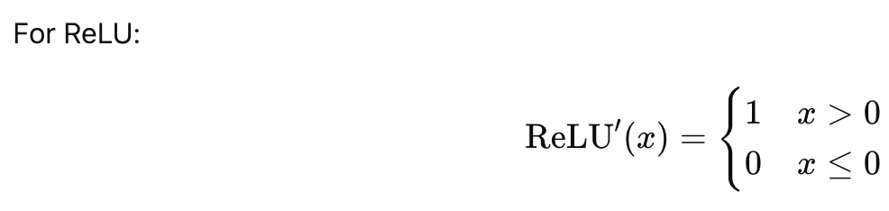
Because of this design, if a neuron’s input is below zero, the output is 0 and the weights are never updated during back propagation.

Leaky ReLU
The Leaky ReLU was designed to eliminate this problem of the dying ReLU by including a small negative slope on the left.
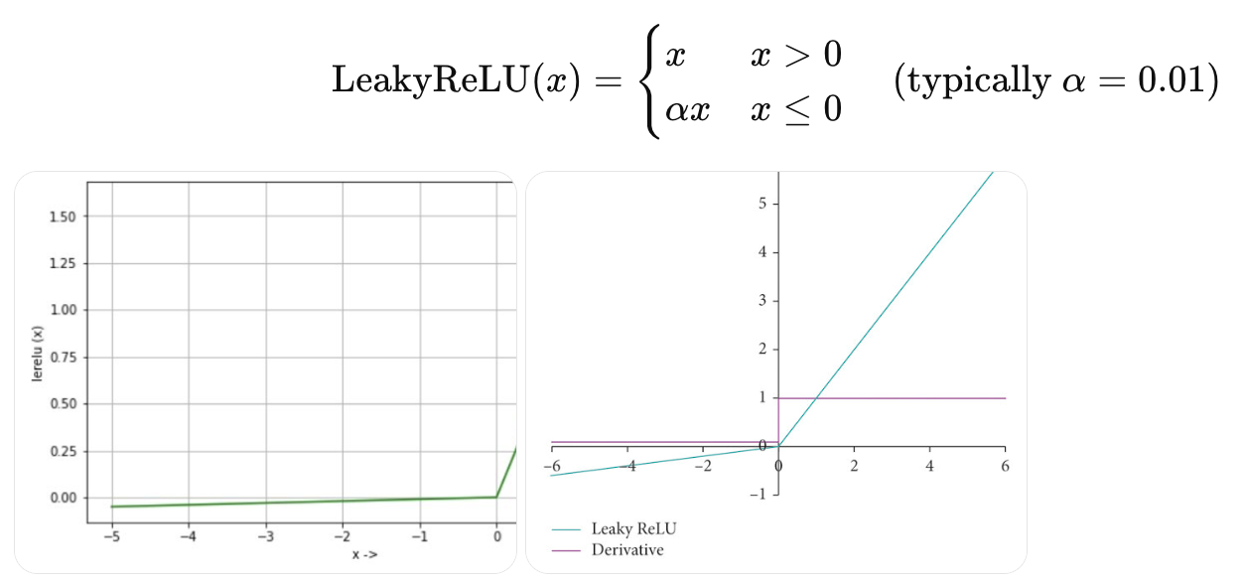

The innovation made by the leaky ReLU can make a positive difference. However, the original ReLU continues to be the more popular activation function due to its’ higher degree of reliability. Even though ReLU faces some limitation for back propagation, enough neuron’s usually survive for the model to keep learning during training when a ReLU activation function is used.

Exercise 6 (2 marks)
Set the activation=nn.LeakyReLU. Show the loss and accuracy plots for LeakyReLU. Clearly label the plots as being for LeakyReLU to get the mark.
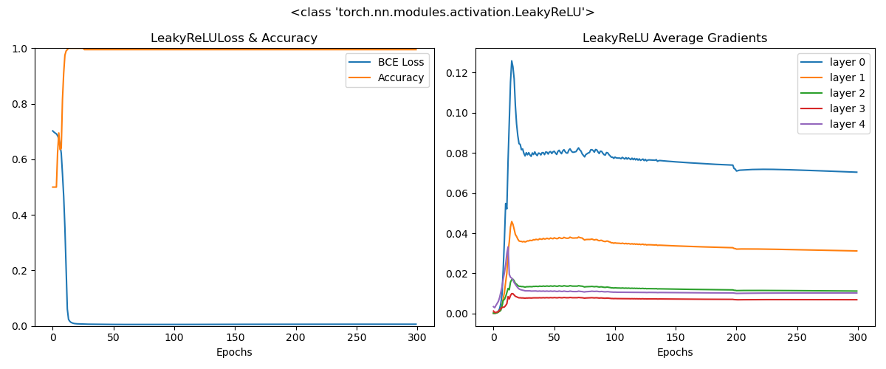
How do the results compare with the Sigmoid function.
There is virtually no difference since the dataset is too small and model is too simplistic to test on a more complex or larger dataset

