Table of Contents
Overcoming Memory Issues 1
Hyperparameter Terminology 1
Epoch 1
Batch Size 1
Loss Functions 2
Activation Functions 2
Sigmoid Activation Function 2
Tanh Activation Function 2
ReLU (Rectified Linear Unit) Activation Function 3
Leaky ReLU Activation Function 3
Softmax Activation Function 3
Optimizers 3
Updating the Gradient 7
Evaluating with Test Data 7
Monitoring Loss and Accuracy 9
Multi-class Prediction 14
Multi-class Prediction with the Cross Entropy Loss Function 18

Overcoming Memory Issues
When working with networks or any data set in this course, if you experience memory issues, some strategies to cope are consider cutting the data into a half or even to a third of the size. The goal for this course, when covering neural networks, is not to create the best artificial neural network but rather to gain a decent understanding to use them.

Hyperparameter Terminology
Artificial neural networks have many parameters that need to be configured. This section will introduce some of the basic hyperparameter terms.

Epoch
An epoch is an iteration of all sample data through the network.

Batch Size
The batch size is the number of samples that are processed before the model is updated. Batch size can range from 1 up to the number of samples. Figure 1 compares the advantages and disadvantages of small versus full sample batch sizes.

Figure 1: Comparing Small and Large Batch Sizes
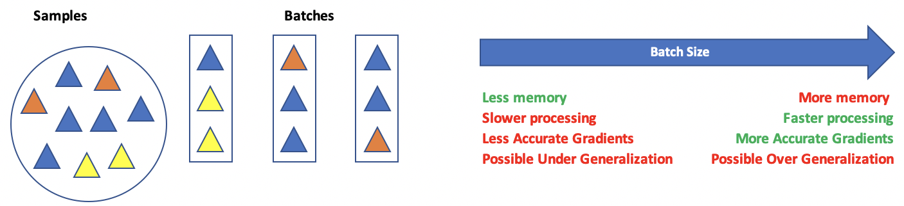

Loss Functions
Loss functions help to measure the difference between actual and predicted results. There are many loss function algorithms. Here are some common loss function options:

- nn.MSELoss(): (Regression)
- nn.CrossEntropyLoss(): (Classification)
- nn.BCELoss(): (Binary cross-entropy loss for binary classification)

The loss function is actually not part of the model. It works with the model to calculate a distance between actual and predicted values.

Activation Functions
Activation functions transform the output of a neuron before it is sent to the next layer. Nonlinear activation functions enable complex nonlinear fits.

Sigmoid Activation Function
Nonlinear functions like the sigmoid function keeps values between 0 and 1.

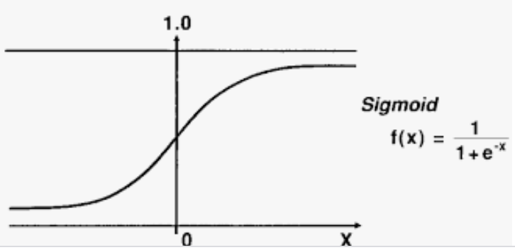

Vanishing Gradient Problem
The sigmoid function can lead to a vanishing gradient because its slope becomes very small when inputs are very positive or very negative. During backpropagation, these tiny gradients get multiplied across many layers backwards, quickly shrinking toward zero. As a result, earlier layers stop learning.

Tanh Activation Function
With a tanh function, the outputs are centered about zero. Otherwise, the advantages and disadvantages are similar to the sigmoid function.
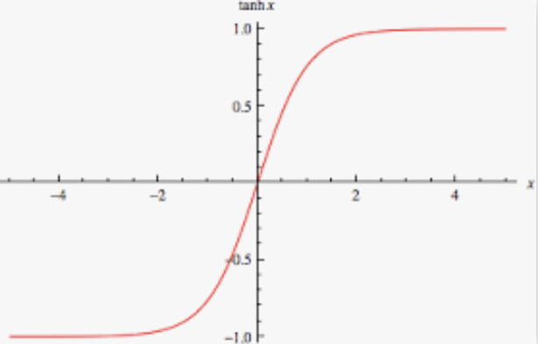

ReLU (Rectified Linear Unit) Activation Function
The ReLU is non-linear and computationally efficient function. ReLU helps to avoid vanishing gradients and therefore has enabled deeper networks compared to prior to this innovation.

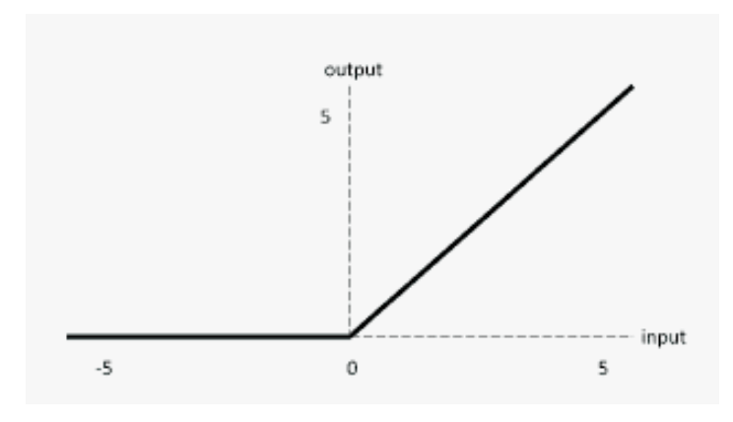

The Dying ReLU problem
When inputs approach zero, or are negative, the gradient of the ReLU function becomes zero, the neuron cannot perform backpropagation and cannot learn when this happens. Fortunately, often enough neurons survive for the network to continue learning.

Leaky ReLU Activation Function
The Leaky ReLU (LReLU or LReL) modifies the ReLU function to allow small negative values when the input is less than zero. This prevents dying the ReLU problem. The Leaky ReLU has a small positive slope in the negative area, so it enables backpropagation, even for negative input values. Results are not consistent though since the leaky ReLU does not provide consistent predictions for negative input values.
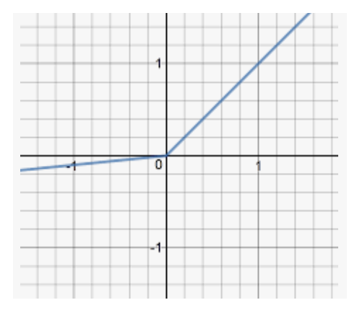 | LeakyReLU allows a small gradient when a neuron is not active.  f(x) = alpha * x if x < 0  f(x) = x if x >= 0

Softmax Activation Function
Softmax is often used with output neurons. Softmax gives the probability of the input value being in a specific class. Softmax is good for classifying outputs in many categories and continuous values.

Optimizers
Optimizers provide an algorithm to adjust learnable parameters such as weights and bias to reduce losses in the network. This is a list of some common optimizers:

- torch.optim.Adam(): The Adam algorithm (adaptive moment estimation)
- torch.optim.NAdam(): The Adam algorithm with Nesterov momentum
- torch.optim.SGD(): Stochastic gradient descent
- torch.optim.RMSprop(): The RMSprop algorithm

Example 1: Simple PyTorch Network
This example demonstrates how to create the following multi-layer feed forward network. The network neurons are shown in Figure 2. While not displayed in the diagram, each neuron is connected to each neuron ahead of it (but I did not draw the connections to save time).

Figure 2: Feedforward Network
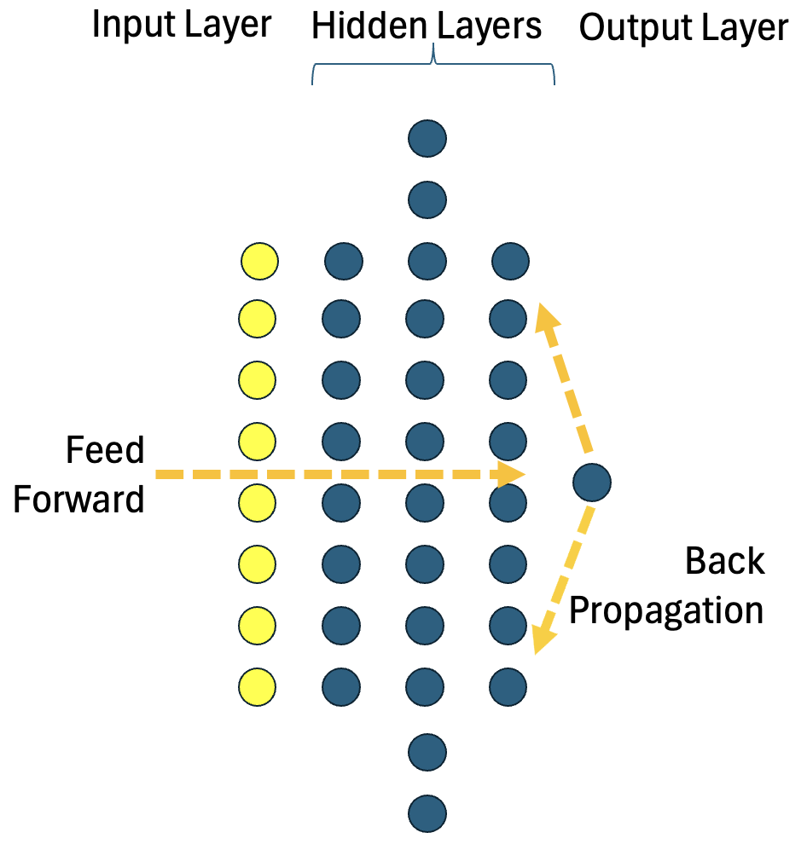
The code snippet below defines the network described by Figure 2.
model = nn.Sequential(
nn.Linear(8, 12), # Hidden layer. Linear means y=Wx+b
nn.ReLU(), # Non-linear activation function.
nn.Linear(12, 8),
nn.ReLU(),
nn.Linear(8, 1),
nn.Sigmoid()
)

Here is the complete example. The training is broken out into crude steps to help illustrate training features:
import numpy as np
import pandas as pd
import torch
import torch.nn as nn
import torch.optim as optim
from sklearn.model_selection import train_test_split
from sklearn.preprocessing import StandardScaler
from get_path import getPath

# Load dataset
file = "alt_diabetes.csv"
PATH = getPath()
df = pd.read_csv(PATH + file)

X = df[
[
"historical_factor",
"glucose_level",
"diastolic_bp",
"skin_fold_thickness",
"insulin_level",
"body_mass_index",
"family_history_score",
"age_years"
]
].to_numpy(dtype=np.float32)
y = df["diabetes"].to_numpy(dtype=np.float32)

# Define model
model = nn.Sequential(
# Linear() creates fully connected (dense) layer of a neural network.
nn.Linear(8, 12), # Linear means y=Wx+b
nn.ReLU(), # Non-linear activation function helps enable deeper learning.
nn.Linear(12, 8),
nn.ReLU(),
nn.Linear(8, 1),
nn.Sigmoid()
)

# Stratified split
X_train, X_test, y_train, y_test = train_test_split(
X, y,
test_size=0.20,
stratify=y, # keeping same proportion of y.
random_state=42
)

# PART B
scaler = StandardScaler() # Generally always scale with neural networks
X_train = scaler.fit_transform(X_train)
X_test = scaler.transform(X_test)

# PyTorch wants the torch tensor format (vector arrays / matrices)
# Formatting is awkward and frustrating but manageable
X_train = torch.tensor(X_train, dtype=torch.float32)
X_test = torch.tensor(X_test, dtype=torch.float32)

y_train = torch.tensor(y_train, dtype=torch.float32).reshape(-1, 1)
y_test = torch.tensor(y_test, dtype=torch.float32).reshape(-1, 1)

loss_fn = nn.BCELoss()# Binary loss.
optimizer = optim.Adam(model.parameters(), lr=0.001)

# Train ONLY on training data
n_epochs = 100
batch_size = 10

for epoch in range(n_epochs):
print("** EPOCH #: " + str(epoch))

for i in range(0, len(X_train), batch_size):
Xbatch = X_train[i:i + batch_size] # Select batch samples.
ybatch = y_train[i:i + batch_size] # Select batch samples.

print("Batch x: " + str(i))
y_pred = model(Xbatch) # Forward pass.
loss = loss_fn(y_pred, ybatch) # Calculate losses.

optimizer.zero_grad() # Clear gradients.
loss.backward() # Back propagate.
# Compute gradients of loss w.r.t. model weights.
optimizer.step() # Update weights using gradients.

# Evaluate on test set
model.eval()
with torch.no_grad():
y_test_pred = model(X_test)

test_accuracy = (y_test_pred.round() == y_test).float().mean()
print(f"Test Accuracy: {test_accuracy:.3f}")

Exercise 1 (1 mark)
How many times does back propagation occur during one epoch? Why?
len(X_train) / batch_size as seen in the code above inside the loop in which each step = batch_size and where loss.backward() is called
Exercise 2 (1 mark)
What instruction triggers an update of weights starting from the output layer back to the first hidden layer?
optimizer.step()
Exercise 3 (1 mark)
What does the following line of code do?

optimizer = optim.Adam(model.parameters(), lr=0.001)

A. It defines a loss function that measures the error between predictions and targets.
B. It initializes the Adam optimizer to update the model’s trainable parameters using a learning rate of 0.001.
C. It performs one training step by adjusting the model weights automatically.
D. It freezes the model parameters so they are not updated during training.

Updating the Gradient
The gradient says how much to update weights and bias and in which direction. The gradient is the slope (derivative) of the loss function with respect to each weight (see Figure 3).

Figure 3: Calculating derivative of loss function with respect to a specific weight.
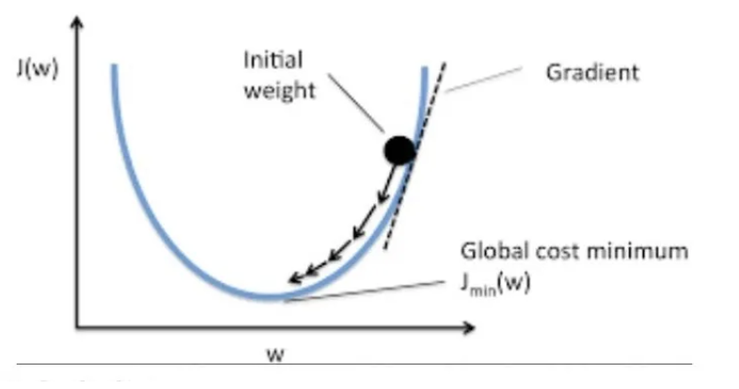

Evaluating with Test Data
You will also notice in Example 1 this code performs an evaluation with the test data.
with torch.no_grad():
y_test_pred = model(X_test)

When making predictions, torch.no_grad() tells PyTorch to feed the test data through the trained network without computing gradients, so the weights and biases are not updated.

Exercise 4 (1 mark)
In Example 1, how many features are received by the input layer?
8

Exercise 5 (1 mark)
A screenshot of the Threads & Variables window while halted after X is converted to a Tensor shows the following data:
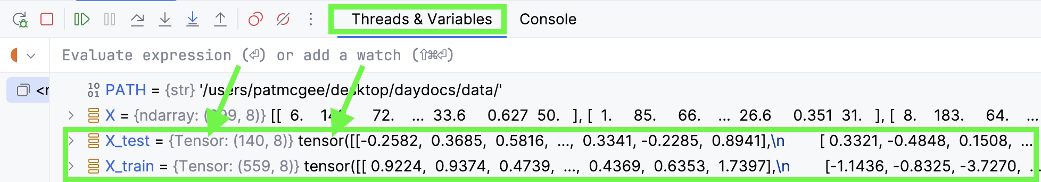
Show a screenshot of the tensors in the Threads & Variables display (while halted) for y_train and y_test after they are converted to tensor format.
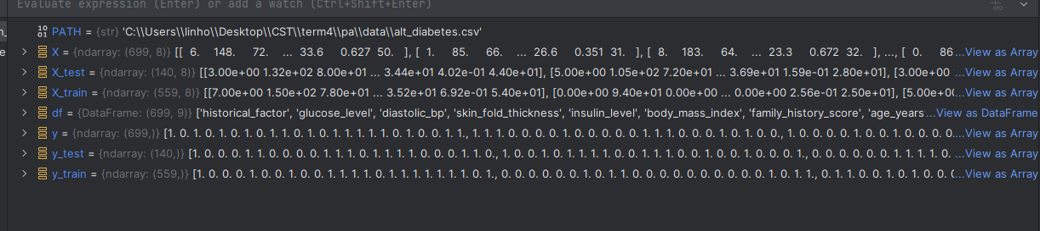

Exercise 6 (2 marks)
Complete the following table by observing Example 1.
Total samples pass through the network each epoch. | len(X_train)
Total batches per epoch. | len(X_train) / batch_size
Total samples per batch. | 10

Exercise 7 (1 mark)
What is a gradient?
it’s a tensor containing the vectors of partial derivatives of outputs of output layers with respect to their inputs, weights, and biases from the input layers, determining how much each of these factor influences the outputs.

Exercise 8 (1 mark)
When is torch.no_grad() used?
when evaluating the model performance on a test dataset, to avoid gradient calculation and updates made to weights and biases.

Exercise 9 (1 mark)
Modify the model definition in Example 1 by adding another layer between the second hidden layer and the output layer. Test your code to ensure that it can still run. Show the new model definition here:
model = nn.Sequential(
nn.Linear(8, 12),
nn.ReLU(),
nn.Linear(12, 12),
nn.ReLU(),
nn.Linear(12, 8),
nn.ReLU(),
nn.Linear(8, 1),
nn.Sigmoid()
)

Exercise 10 (1 mark)
Modify the last two hidden layers in Exercise 9 so that each has 120 neurons. Show the new model definition here and be sure that it works:
model = nn.Sequential(
nn.Linear(8, 12),
nn.ReLU(),
nn.Linear(12, 120),
nn.ReLU(),
nn.Linear(120, 120),
nn.ReLU(),
nn.Linear(120, 1),
nn.Sigmoid()
)

Example 2: Using nn.Module to define the computational graph.
This example shows how to declare the same network as in Example 1. However, this time the base class for PyTorch neural network models, nn.Module, is used to help set up the computational graph definition. The modification enables further easy customization through PyTorch if desired. To build this example, replace the model definition in Example 1 with this version:
# nn.Module is the base class for all neural network models.
class AltDiabetesClassifier(nn.Module):
def __init__(self):
super().__init__()
self.hidden1 = nn.Linear(8, 12)
self.act1 = nn.ReLU()
self.hidden2 = nn.Linear(12, 8)
self.act2 = nn.ReLU()
self.output = nn.Linear(8, 1)
self.act_output = nn.Sigmoid()

def forward(self, x):
x = self.act1(self.hidden1(x))
x = self.act2(self.hidden2(x))
x = self.act_output(self.output(x))
return x

model = AltDiabetesClassifier()

Exercise 11 (1 mark)
In your own words, explain the role of this line of code:

x = self.act1(self.hidden1(x))
calculates the activation output using the output of the previous hidden layer which takes x as input tensor.

Exercise 12 (2 marks)
Modify Example 2 to refit it so it can work with the fluDiagnosis.csv data set. The following screenshot shows x after the data has passed through the network. At the end, x is a single column wide.
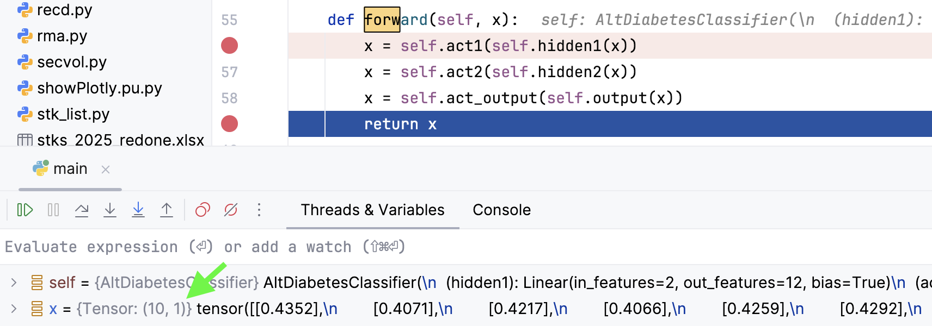

Show a full screenshot of this window while halted at x when x has just been fed to the network (at the very start inside the forward() function). Be sure to show the initial breakpoint while halted and also show x with a two-column tensor in the Threads & Variables window.
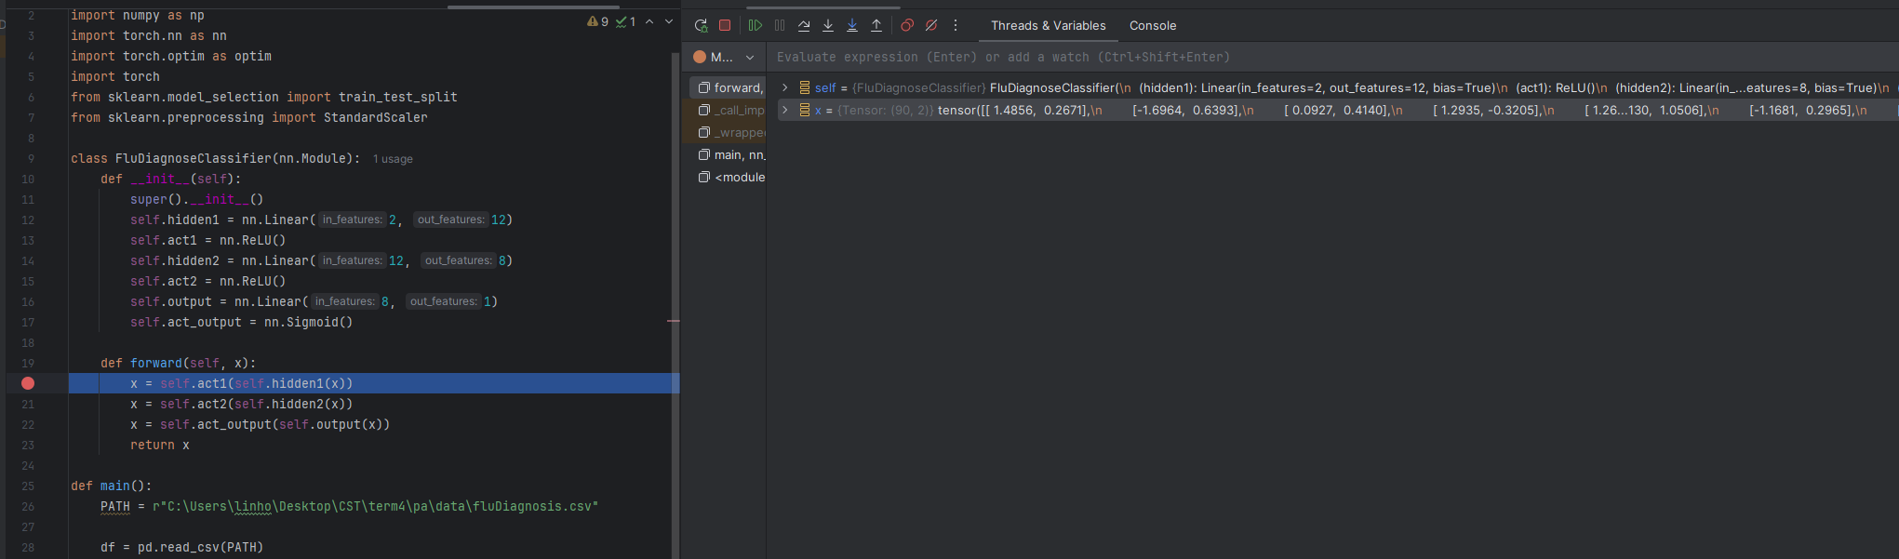
Show another full screenshot of this window while halted at x when x has just left the first activation function. Be sure to show the new breakpoint and also show x with the new tensor just before it enters the second hidden layer.
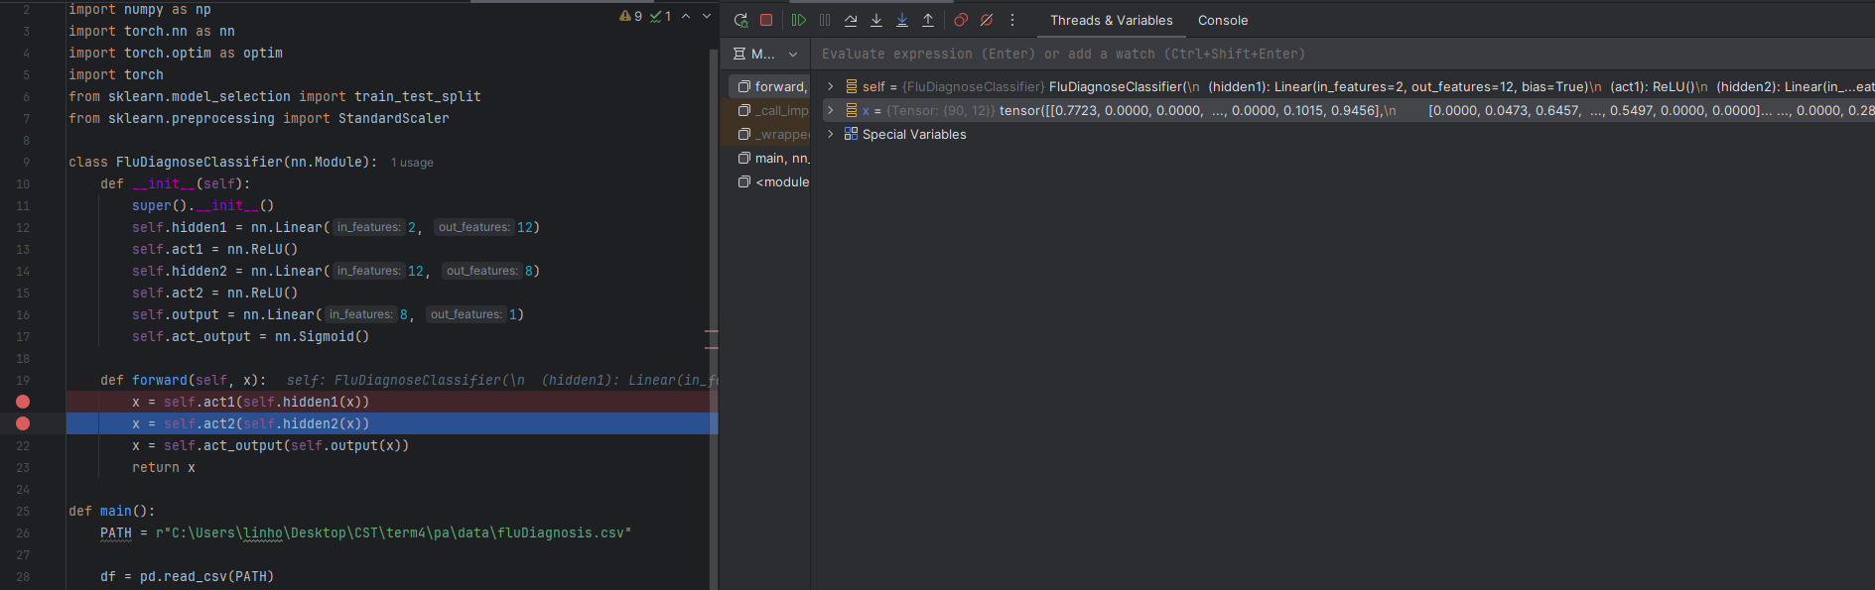

Monitoring Loss and Accuracy
The data sets used in the examples so far with neural networks are small so the model training has been fast and easy. Training larger models can take hours or even days so you will want to ensure that losses are declining as training progresses. For classification models you will often also want to know that accuracy is improving. Real-time logging of losses and accuracy during training can help with monitoring long training sessions.

Visualizations of loss and accuracy curves also help to evaluate the effectiveness of models. You will usually notice that test loss during evaluation with unseen data is slightly higher.
Figure 4: Loss curve comparison
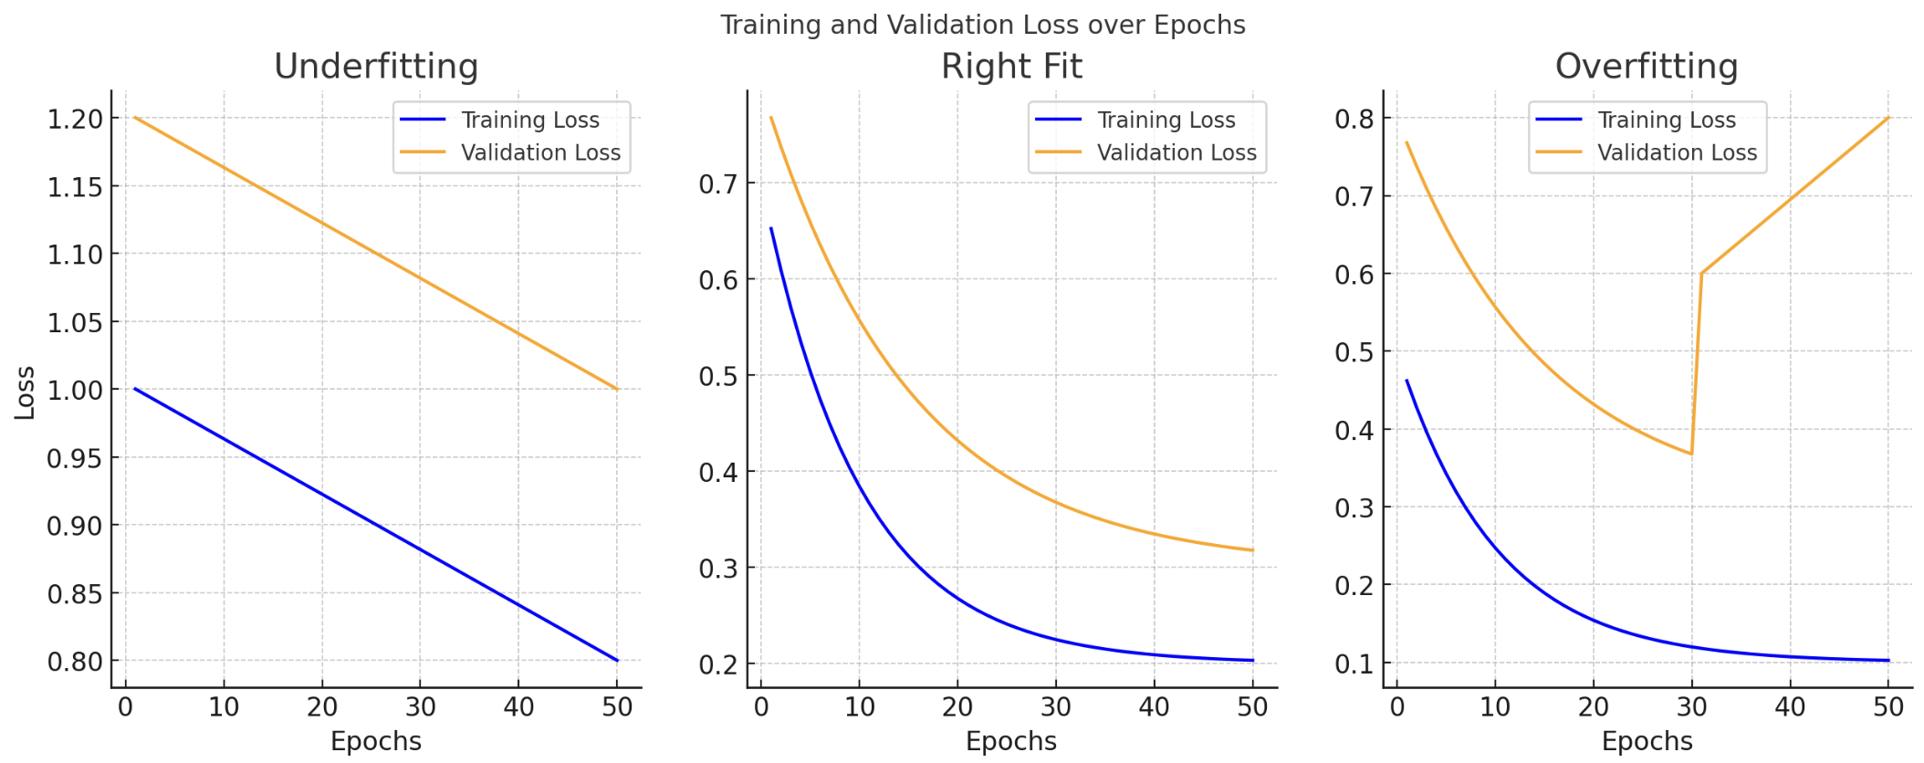
For classification models, accuracy curves can also help to reveal where the model stops or fails to learn (refer to Figure 5).

Figure 5: Accuracy curve comparison.
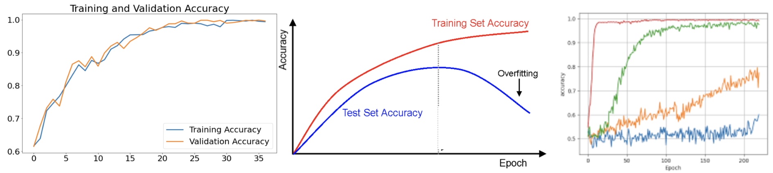
Exercise 13 (1 mark)
When examining the plot which shows underfitting in Figure 4, how could batch size possibly be adjusted to help improve results?
increasing batch size gives model more data to learn from that can improve its learning of pattern on a larger size of data.
When examining the plot which shows underfitting in Figure 4, how could the total epochs possibly be adjusted to help improve results?
increasing the number of epochs also gives model more opportunities to learn more underlying patterns that it may not be able to with fewer epochs
When examining the plot which shows underfitting in Figure 4, how could the learning rate possibly be adjusted to help improve results?
too small learning rate can lead to underfitting as the model is not able to make significant updates to its weights and biases because the steps it takes towards global minimum are too small or it can get stuck in a local minimum, thus increasing the learning rate can help improve this. However, too large learning rate can also result in underfitting or unstable performance because it may result in exploding gradient which then causes model to not be able to learn and generalize at all.

Exercise 14 (1 mark)
If overfitting is occurring like in the middle diagram of Figure 5, what two changes can be made to help prevent overfitting?
We can adjust learning rate, either increasing or decreasing proportionally. Another approach is reduce the number of epochs to stop models from memorizing patterns from training dataset.

Example 3: Visualization
This example offers a quick introduction to loss and accuracy visualizations with PyTorch. This crude implementation shows a quick way to track average loss and accuracy per epoch during training and validation. A more effective automated approach will be discussed later.

The output reveals favourable trends for declining losses and improving accuracy.
Figure 6: Loss and accuracy plots for Example 3.
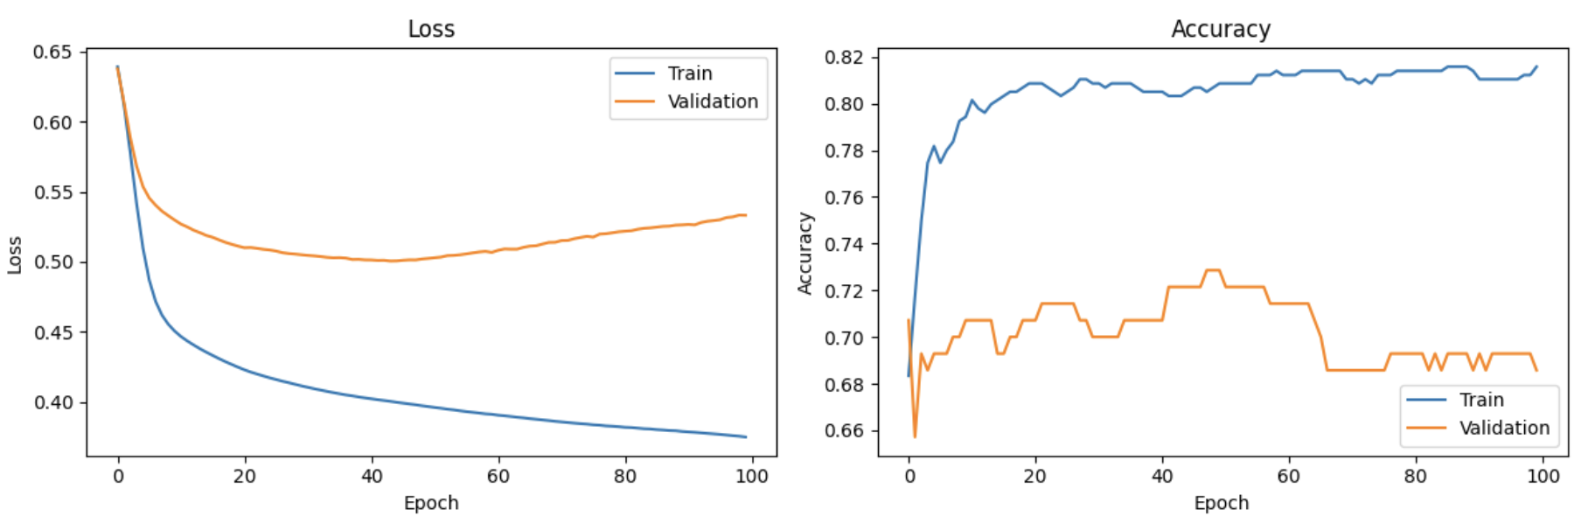

The logged data shows average losses and accuracy for each epoch. The output is important since it indicates that losses are declining and accuracy is improving while the model is learning.
Epoch 001 | loss=0.6653 | acc=0.651 | val_loss=0.6477 | val_acc=0.652
Epoch 002 | loss=0.6487 | acc=0.655 | val_loss=0.6264 | val_acc=0.652
Epoch 003 | loss=0.6304 | acc=0.655 | val_loss=0.6010 | val_acc=0.652
…
…
Epoch 098 | loss=0.3728 | acc=0.817 | val_loss=0.4619 | val_acc=0.804
Epoch 099 | loss=0.3722 | acc=0.819 | val_loss=0.4626 | val_acc=0.804
Epoch 100 | loss=0.3716 | acc=0.819 | val_loss=0.4632 | val_acc=0.804

Replace Part B in Example 2 where the training loop begins with the following code. You will notice that a third dataset called has been created this time. The validation set will be used in the cross fold loop to perform validation each fold. The test set will be used after the training loop.
# Creating validation set for cross fold.
X_train, X_val, y_train, y_val = train_test_split(
X_train, y_train, test_size=0.2, stratify=y_train, random_state=42
)

scaler = StandardScaler()
X_train = scaler.fit_transform(X_train)
X_val = scaler.transform(X_val)
X_test = scaler.transform(X_test)

# Convert to torch tensors (vector arrays / matrices)
X_train = torch.tensor(X_train, dtype=torch.float32)
X_val = torch.tensor(X_val, dtype=torch.float32)
X_test = torch.tensor(X_test, dtype=torch.float32)

y_train = torch.tensor(y_train, dtype=torch.float32).reshape(-1, 1)
y_val = torch.tensor(y_val, dtype=torch.float32).reshape(-1, 1)
y_test = torch.tensor(y_test, dtype=torch.float32).reshape(-1, 1)

loss_fn = nn.BCELoss()
optimizer = optim.Adam(model.parameters(), lr=0.001)

# Train ONLY on training data
n_epochs = 100
batch_size = 10

train_losses = []
train_accuracies = []

val_losses = []
val_accuracies = []

for epoch in range(n_epochs):
model.train()

epoch_loss = 0.0
correct = 0
total_samples = 0

for i in range(0, len(X_train), batch_size):
Xbatch = X_train[i:i + batch_size]
ybatch = y_train[i:i + batch_size]

y_pred = model(Xbatch)
loss = loss_fn(y_pred, ybatch)

optimizer.zero_grad()
loss.backward()
optimizer.step()

epoch_loss += loss.item() * Xbatch.size(0)

preds = (y_pred >= 0.5).float()
correct += (preds == ybatch).sum().item()
total_samples += ybatch.size(0)

avg_loss = epoch_loss / total_samples
train_acc = correct / total_samples

train_losses.append(avg_loss)
train_accuracies.append(train_acc)

# Evaluate on validation set each fold.
model.eval()
with torch.no_grad():
y_val_prob = model(X_val)
val_loss = loss_fn(y_val_prob, y_val).item()
y_val_pred = (y_val_prob >= 0.5).float()
val_acc = (y_val_pred == y_val).float().mean().item()

val_losses.append(val_loss)
val_accuracies.append(val_acc)

print(
f"Epoch {epoch+1:03d} | "
f"loss={avg_loss:.4f} | acc={train_acc:.3f} | "
f"val_loss={val_loss:.4f} | val_acc={val_acc:.3f}"
)

# Final TEST evaluation on holdout
model.eval()
with torch.no_grad():
y_test_prob = model(X_test)
test_loss = loss_fn(y_test_prob, y_test).item()
y_test_pred = (y_test_prob >= 0.5).float()
test_acc = (y_test_pred == y_test).float().mean().item()

print("\n*** Final Test Set (evaluated once) ***")
print(f"Test Loss: {test_loss:.4f}")
print(f"Test Acc: {test_acc:.3f}")

import matplotlib.pyplot as plt
plt.figure(figsize=(12, 4))

# Loss curve
plt.subplot(1, 2, 1)
plt.plot(train_losses, label="Train")
plt.plot(val_losses, label="Validation")
plt.xlabel("Epoch")
plt.ylabel("Loss")
plt.title("Loss")
plt.legend()

# Accuracy curve
plt.subplot(1, 2, 2)
plt.plot(train_accuracies, label="Train")
plt.plot(val_accuracies, label="Validation")
plt.xlabel("Epoch")
plt.ylabel("Accuracy")
plt.title("Accuracy")
plt.legend()

plt.tight_layout()
plt.show()

Exercise 15 (1 mark)
Example 3 evaluates the model on the test set within the training loop. How is this different than Example 1? What is the advantage of evaluating the model with the test set in training loop?
It helps to know if the model is learning or not by observing its validation score so that we can adjust hyperparameters earlier or to stop training and make adjustment.

Exercise 16 (2 marks)
Change the number of epochs in Example 3 to 10. What happens to accuracy?
Test Evaluation
Test Loss: 0.4951
Test Acc: 0.7143

both loss and accuracy actually improves
Show the loss and accuracy plot before the change in this exercise.
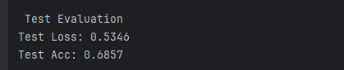
Show the loss and accuracy plot after the change in this exercise.
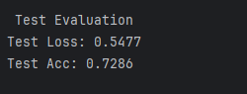nide

Multi-class Prediction
Example 4: Multiclass Prediction
This example builds demonstrates an ANN that is designed to classify Iris flowers into one of three possible groups. Figure 7 shows the basic structure of the network.

Figure 7: Feed forward network for predicting Iris flower type: setosa, virginica, versicolor.
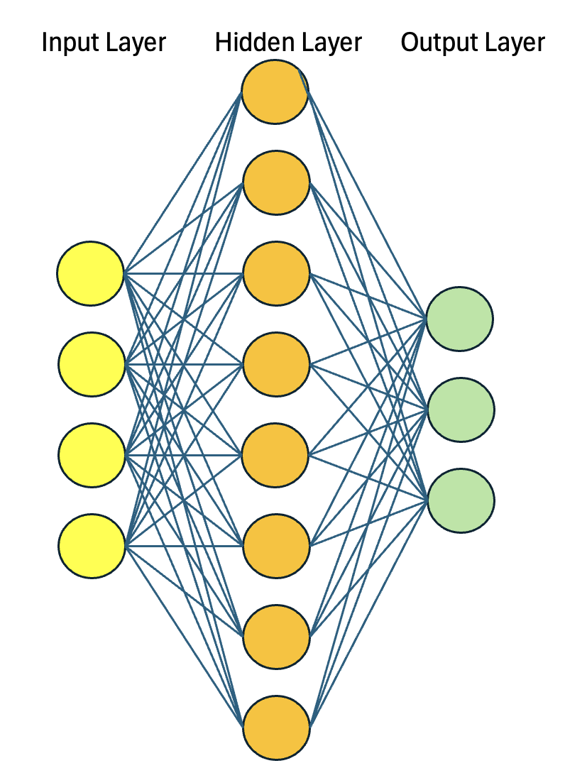

import copy

import matplotlib.pyplot as plt
import numpy as np
import pandas as pd
import torch
import torch.nn as nn
import torch.optim as optim
from sklearn.model_selection import train_test_split
from sklearn.preprocessing import OneHotEncoder, StandardScaler # (not used, kept to avoid changes)

# read data and apply one-hot encoding
PATH = getPath()
data = pd.read_csv(PATH + "iris_alpha.csv")
y = data['iris_type']
X = data
del X['iris_type']

y = pd.get_dummies(y, dtype=int)

# keep as NumPy arrays for now
X = X.values.astype(np.float32)
y = y.values.astype(np.float32)

# split (still NumPy)
X_train, X_test, y_train, y_test = train_test_split(
X, y, train_size=0.7, shuffle=True
)

# scale (fit ONLY on training data)
scaler = StandardScaler()
X_train = scaler.fit_transform(X_train)
X_test = scaler.transform(X_test)

# convert ONCE to torch tensors
X_train = torch.tensor(X_train, dtype=torch.float32)
X_test = torch.tensor(X_test, dtype=torch.float32)
y_train = torch.tensor(y_train, dtype=torch.float32)
y_test = torch.tensor(y_test, dtype=torch.float32)

class Multiclass(nn.Module):
def __init__(self):
super().__init__()
self.hidden = nn.Linear(4, 8)
self.act = nn.ReLU()
self.output = nn.Linear(8, 3)

def forward(self, x):
x = self.act(self.hidden(x))
x = self.output(x)
return x

# loss metric and optimizer
model = Multiclass()
loss_fn = nn.CrossEntropyLoss()
optimizer = optim.Adam(model.parameters(), lr=0.001)

# prepare model and training parameters
n_epochs = 200
batch_size = 5
batches_per_epoch = len(X_train) // batch_size

best_acc = - np.inf # init to negative infinity
best_weights = None
train_loss_hist = []
train_acc_hist = []
test_loss_hist = []
test_acc_hist = []

# training loop
for epoch in range(n_epochs):
# shuffle training indices each epoch
# Creates random permutation of integers with each integer appearing only once.
perm = torch.randperm(len(X_train))

epoch_loss = []
epoch_acc = []

# set model in training mode and run through each batch
model.train()

for i in range(batches_per_epoch):
# Get random indicies from perm
start = i * batch_size
idx = perm[start:start + batch_size]
X_batch = X_train[idx]
y_batch = y_train[idx]

# forward pass
y_pred = model(X_batch)
loss = loss_fn(y_pred, y_batch)

# backward pass
optimizer.zero_grad()
loss.backward()

# update weights
optimizer.step()

# compute and store metrics
acc = (torch.argmax(y_pred, 1) == torch.argmax(y_batch, 1)).float().mean()
epoch_loss.append(float(loss))
epoch_acc.append(float(acc))

# set model in evaluation mode and run through the test set
model.eval()
with torch.no_grad():
y_pred = model(X_test)
ce = loss_fn(y_pred, y_test)
acc = (torch.argmax(y_pred, 1) == torch.argmax(y_test, 1)).float().mean()

ce = float(ce)
acc = float(acc)
train_loss_hist.append(np.mean(epoch_loss))
train_acc_hist.append(np.mean(epoch_acc))
test_loss_hist.append(ce)
test_acc_hist.append(acc)

if acc > best_acc:
best_acc = acc
best_weights = copy.deepcopy(model.state_dict())

print(f"Epoch {epoch} validation: Cross-entropy={ce:.2f}, Accuracy={acc*100:.1f}%")

# Restore best model
model.load_state_dict(best_weights)

# Plot the loss and accuracy
plt.plot(train_loss_hist, label="train")
plt.plot(test_loss_hist, label="test")
plt.xlabel("epochs")
plt.ylabel("cross entropy")
plt.legend()
plt.show()

plt.plot(train_acc_hist, label="train")
plt.plot(test_acc_hist, label="test")
plt.xlabel("epochs")
plt.ylabel("accuracy")
plt.legend()
plt.show()

Multi-class Prediction with the Cross Entropy Loss Function
PyTorch’s nn.CrossEntropyLoss() function can be used to calculate the loss for each prediction made by a multi class predictive model like in Example 4.

Example 5: CrossEntropyLoss calculation
This example provides a simplified view of how the CrossEntropyLoss() function works.

To begin, predictions are made as logits. Logits are untreated raw numbers. The predicted class is indicated by the largest logit which is the first logit in this case:
logits = torch.tensor([[2.0, 1.0, 0.1]])

A softmax calculation converts the logits to unnormalized probabilities:

Softmax(2) = $\frac{e^{z_{i}}}{\sum{e^{z_{j}}}}$ = $\frac{e^{2}}{e^{2}+ e^{1}+ e^{0.1}}$ = np.exp(2)/(np.exp(2)+np.exp(1) + np.exp(0.1))

Softmax(2.0)= 0.6590011388859679
Softmax(1.0)= 0.4170299470424652
Softmax(0.1)= 0.09856589040931818

PyTorch’s CrossEntropyLoss() function also applies a log function to the softmax output to help provide stable back propagation:

Log(softmax(0)) = print(np.log(0.6590011388859679)) = -0.4170300162778335

Log softmax calculations for all three logits can be automated with log_softmax():
import torch
import torch.nn.functional as F
import numpy as np

logits = torch.tensor([[2.0, 1.0, 0.1]])
log_probs = F.log_softmax(logits, dim=1)
print("log_probs: ", log_probs)

The logit at index 0 is largest so the predicted class is 0. The log probability for the first element is -0.4170.
log_probs: tensor([[-0.4170, -1.4170, -2.3170]])

The log probability output can easily be validated since the sum of the $e^{\log{probabilities}}=1$. This code;
print("Sum of log probabilities: ", torch.exp(log_probs).sum(dim=1))
Outputs: tensor([1.0000]

Since the first class has been selected, the loss is calculated by negating the log probability:
Cross entropy loss = -1 * log_prob = -1 * -0.4170 = 0.4170

The following code uses the CrossEntropyLoss() function to automatically generate the same loss value of 0.4170:
targets = torch.tensor([0])
import torch.nn as nn
loss_fn = nn.CrossEntropyLoss()
loss = loss_fn(logits, targets)
print(loss.item())

Cross-entropy metrics have a negative sign because log(x) approaches negative infinity as
x approaches to zero. We want a higher loss when the probability approaches 0 and a lower loss
when the probability approaches 1.

Figure 8: Log(x) left. Loss –(log(x)) right.
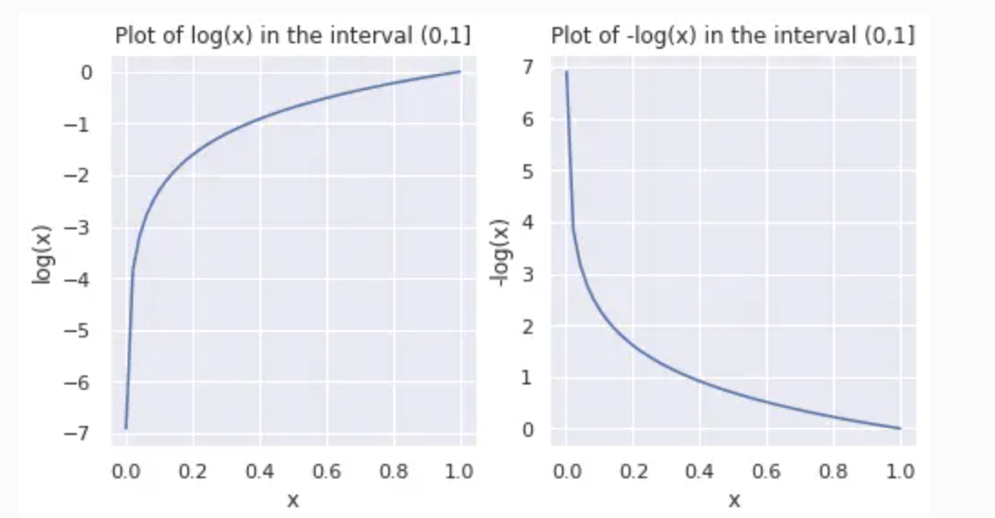
This plot is taken from https://www.pinecone.io/learn/cross-entropy-loss/

Exercise 17 (2 marks)
Given the following predictions in logit form:

[1.5, 2.5, -0.9]

Show the manual softmax (unnormalized probability) calculation either by hand or in code for the predicted class.
import numpy as np
logits = [1.5, 2.5, -0.9]
sm_output = [(np.exp(i) / sum(np.exp(logits))).item() for i in logits]
print(sm_output)

[0.26253611375660585, 0.7136471473388385, 0.02381673890455566]
Show the log of the softmax calculation by hand or in code from the step above.
log_output = [np.log(x).item() for x in sm_output]
print(f'Log Output: {log_output}')
Log Output: [-1.3373666301975569, -0.33736663019755686, -3.737366630197557]
Calculate the loss for the predicted value by negating the log probability. Show the result.
neg_log_likelihood = -1 * np.array(log_output)
print(neg_log_likelihood)

[1.33736663 0.33736663 3.73736663]
Show a screenshot of CrossEntropyLoss() function after it runs in the IDE and the loss value that it outputs for this exercise.
0.4170299470424652

Exercise 18 (1 mark)
Set a breakpoint at the end of the forward() function in Example 4 as shown below:
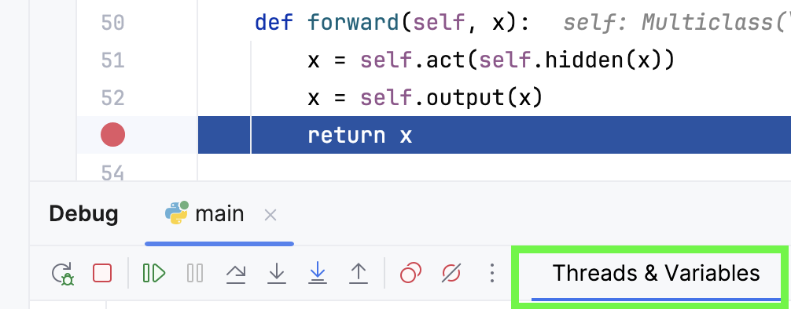
While halted, show a screenshot of the tensor for x as it displays in the Threads and Variables window.
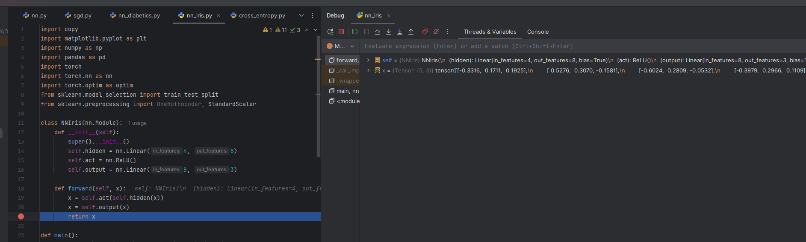
Do the logits for x in each individual array sum to 1?
no
What is the difference between a logit and a probability?
logits are raw output values calculated by an activation function, ie Linear layer in this example which is not standard. Whereas, probability is output of softmax function which sums to 1,

