Table of Contents
Cross Validation with Skorch 1
Grid Searching Network Layers 3
Grid Searching the Activation Function 5
Momentum 6
Tuning Optimizer Parameters 6
Initializing Weights 8
Weight Constraint 8
Configuring Number of Neurons 9
Tips for Tuning Neural Networks 10
General Approach to Hyperparameter Tuning 10
MLPClassifier and MLPRegressor from Scikit-learn 13
Limitations of MLPClassifier and MLPRegressor 13
MLPClassifier 13
GridSearchCV with MLPClassifier 17
MLPRegressor 18

Cross Validation with Skorch
Example 1: Cross Validation with Skorch
This example demonstrates how to implement cross validation with a kfold loop. Having the kfold loop helps for tracking additional statistics during each pass through the loop.
import numpy as np
import pandas as pd
import torch
import torch.nn as nn
from sklearn.metrics import accuracy_score
from sklearn.preprocessing import LabelEncoder, StandardScaler
from skorch import NeuralNetBinaryClassifier
from sklearn.model_selection import StratifiedKFold, cross_val_score

from get_path import getPath

# Read data
data = pd.read_csv(getPath() + "sonar.csv", header=None)
X = data.iloc[:, 0:60]
y = data.iloc[:, 60]

# Binary encoding of labels
encoder = LabelEncoder()
encoder.fit(y)
y = encoder.transform(y)

# Convert to 2D PyTorch tensors
X = torch.tensor(X.values, dtype=torch.float32)
y = torch.tensor(y, dtype=torch.float32)

# Define the model
class SonarClassifier(nn.Module):
def __init__(self):
super().__init__()
self.layer1 = nn.Linear(60, 60)
self.act1 = nn.ReLU()
self.layer2 = nn.Linear(60, 60)
self.act2 = nn.ReLU()
self.layer3 = nn.Linear(60, 60)
self.act3 = nn.ReLU()
self.output = nn.Linear(60, 1)

def forward(self, x):
x = self.act1(self.layer1(x))
x = self.act2(self.layer2(x))
x = self.act3(self.layer3(x))
x = self.output(x)
return x

# create the skorch wrapper
model = NeuralNetBinaryClassifier(
SonarClassifier,
criterion=torch.nn.BCEWithLogitsLoss,
optimizer=torch.optim.Adam,
lr=0.0001,
max_epochs=150,
batch_size=10,
verbose=False
)

kfold = StratifiedKFold(n_splits=5, shuffle=True, random_state=42)
fold_accuracies = []

fold = 1
for train_idx, test_idx in kfold.split(X, y):
X_train, X_test = X[train_idx], X[test_idx]
y_train, y_test = y[train_idx], y[test_idx]
scaler = StandardScaler() # Scaling is usually required for ANN’s.
X_train = scaler.fit_transform(X_train).astype(np.float32)
X_test = scaler.transform(X_test).astype(np.float32)

# IMPORTANT: create a fresh model for each fold
model = NeuralNetBinaryClassifier(
SonarClassifier,
criterion=torch.nn.BCEWithLogitsLoss,
optimizer=torch.optim.Adam,
lr=0.0001,
max_epochs=150,
batch_size=10,
verbose=False
)

# Fit on this fold
model.fit(X_train, y_train)

# Predict on this fold
y_pred = model.predict(X_test)

# Compute accuracy
acc = accuracy_score(y_test, y_pred)
fold_accuracies.append(acc)

print(f"Fold {fold} accuracy: {acc:.4f}")
fold += 1

# Summary
fold_accuracies = np.array(fold_accuracies)
print("\n** Cross-validation results")
print("Mean accuracy: %.3f" % fold_accuracies.mean())
print("Std accuracy: %.3f" % fold_accuracies.std())

Grid Searching Network Layers
Example 2: Grid Searching Network Layers
The highlighted code in this example relates to code that grid searches the total number of layers.
import pandas as pd
import torch
import torch.nn as nn
from sklearn.preprocessing import LabelEncoder, StandardScaler
from skorch import NeuralNetBinaryClassifier
from sklearn.model_selection import GridSearchCV

from get_path import getPath
from scratch import scaler

# Read data
data = pd.read_csv(getPath()+ "sonar.csv", header=None)
X = data.iloc[:, 0:60]
y = data.iloc[:, 60]

# Binary encoding of labels
encoder = LabelEncoder()
encoder.fit(y)
y = encoder.transform(y)

scaler = StandardScaler()
scaler.fit(X)
X = scaler.transform(X)

# Convert to 2D PyTorch tensors
X = torch.tensor(X, dtype=torch.float32)
y = torch.tensor(y, dtype=torch.float32)

# Define the model
class SonarClassifier(nn.Module):
def __init__(self, n_layers=3):
super().__init__()
self.layers = nn.ModuleList()
self.acts = nn.ModuleList()

for i in range(n_layers):
self.layers.append(nn.Linear(60, 60))
self.acts.append(nn.ReLU())

self.output = nn.Linear(60, 1) # Add output layer at end.

def forward(self, x):
for i in range(len(self.layers)):
x = self.acts[i](self.layers[i](x))
x = self.output(x)
return x

model = NeuralNetBinaryClassifier(
SonarClassifier,
criterion=torch.nn.BCEWithLogitsLoss,
optimizer=torch.optim.Adam,
lr=0.0001,
max_epochs=150,
batch_size=10,
verbose=False
)
param_grid = {
'module__n_layers': [1, 3, 5],
'lr': [0.1, 0.01, 0.001, 0.0001],
'max_epochs': [100, 150],}

grid_search = GridSearchCV(model, param_grid, scoring='accuracy', verbose=2, cv=3)
result = grid_search.fit(X, y)

print("Best: %f using %s" % (result.best_score_, result.best_params_))
means = result.cv_results_['mean_test_score']
stds = result.cv_results_['std_test_score']
params = result.cv_results_['params']
for mean, stdev, param in zip(means, stds, params):
print("%f (%f) with: %r" % (mean, stdev, param))

Exercise 1 (1 mark)
Why is n_layers prefixed with module__ when it is defined in param_grid?
this tells Scikitlearn to pass the search params to the Pytorch model defined inheriting from Pytorch nn.Module, not its internal params

Grid Searching the Activation Function
Example 3: Grid searching the activation function
This code performs a search of the activation function. Note that the activation function must be initialized so activation() is used when it is appended for each layer.
class SonarClassifier(nn.Module):
def __init__(self, n_layers=3, activation=nn.Tanh()):
super().__init__()
self.layers = nn.ModuleList()
self.acts = nn.ModuleList()

for i in range(n_layers):
self.layers.append(nn.Linear(60, 60))
self.acts.append(activation()) # Must instantiate activation function.
self.output = nn.Linear(60, 1)

def forward(self, x):
for i in range(len(self.layers)):
x = self.acts[i](self.layers[i](x))
x = self.output(x)
return x
The param_grid shows several different activation functions that can be used.
param_grid = { 'module__n_layers': [1, 3],
'lr': [0.1, 0.01, 0.001],
'max_epochs': [100, 150],
'module__activation': [nn.Identity, nn.ReLU, nn.ELU, nn.ReLU6,
nn.GELU, nn.Softplus, nn.Softsign]}

Momentum
Momentum controls how much of the previous update direction is carried forward into the next step. Low momentum values (for example, 0.1 to 0.5) mean that past updates have only a small influence on the current step, making the optimizer more reactive to recent gradients but also causing its movement to be noisier and less smooth. In contrast, high momentum values (such as 0.9 to 0.99) give strong weight to previous updates, which helps produce smoother and faster progress in directions that remain consistent over time. However, if the momentum is too high, this added inertia can cause the optimizer to overshoot the optimal solution.



Tuning Optimizer Parameters
Example 4: Tuning Learning Rate and Momentum parameters
Learning rate and momentum are optimizer parameters so note that the grid items are prefixed with:
optimizer__

This is the output:
Best: 0.703863 using {'optimizer__lr': 0.001, 'optimizer__momentum': 0.2}
0.678112 (0.021884) with: {'optimizer__lr': 0.001, 'optimizer__momentum': 0.0}
0.703863 (0.018543) with: {'optimizer__lr': 0.001, 'optimizer__momentum': 0.2}
0.679542 (0.026302) with: {'optimizer__lr': 0.001, 'optimizer__momentum': 0.4}

import numpy as np
import pandas as pd
import torch
import torch.nn as nn
import torch.optim as optim
from skorch import NeuralNetClassifier
from sklearn.model_selection import GridSearchCV

from get_path import getPath

dataset = pd.read_csv(getPath() + 'alt_diabetes.csv')

X = dataset.iloc[:, 0:8] # first 8 columns
y = dataset.iloc[:, 8] # 9th column (diabetes)

X = torch.tensor(X.values, dtype=torch.float32)
y = torch.tensor(y.values, dtype=torch.float32).reshape(-1, 1)

# PyTorch classifier
class DiabetesClassifier(nn.Module):
def __init__(self):
super().__init__()
self.layer = nn.Linear(8, 12)
self.act = nn.ReLU()
self.output = nn.Linear(12, 1)
self.prob = nn.Sigmoid()

def forward(self, x):
x = self.act(self.layer(x))
x = self.prob(self.output(x))
return x

# create model with skorch
model = NeuralNetClassifier(
DiabetesClassifier,
criterion=nn.BCELoss,
optimizer=optim.SGD,
max_epochs=100,
batch_size=10,
verbose=False
)

# define the grid search parameters
param_grid = {
'optimizer__lr': [0.001, 0.01, 0.1, 0.2, 0.3],
'optimizer__momentum': [0.0, 0.2, 0.4, 0.6, 0.8, 0.9],
}
grid = GridSearchCV(estimator=model, param_grid=param_grid, n_jobs=-1, cv=3,
verbose=2)
grid_result = grid.fit(X, y)

# summarize results
print("Best: %f using %s" % (grid_result.best_score_, grid_result.best_params_))
means = grid_result.cv_results_['mean_test_score']
stds = grid_result.cv_results_['std_test_score']
params = grid_result.cv_results_['params']
for mean, stdev, param in zip(means, stds, params):
print("%f (%f) with: %r" % (mean, stdev, param))

Initializing Weights
When you train a neural network using gradient descent, the initial neuron weights can sometimes make a difference. If the weights are too small, the activations shrink as they pass through the network, the gradients become tiny, and learning becomes very slow or can even stop. If the weights are too large, the gradients can explode and training becomes unstable. If all the weights start out the same, such as all zeros, the neurons behave identically and the network cannot learn different features. Good weight initialization aims to avoid these problems by keeping the variance of activations and gradients roughly constant through the layers of the network.

Example 5: Initializing Weights
These changes can be made to Example 4 to enable a grid search of weights:
class DiabetesClassifier(nn.Module):
def __init__(self, weight_init=init.xavier_uniform_ ):
super().__init__()
self.layer = nn.Linear(8, 12)
self.act = nn.ReLU()
self.output = nn.Linear(12, 1)
self.prob = nn.Sigmoid()
weight_init(self.layer.weight)
weight_init(self.output.weight)

This param_grid shows multiple selections for weight initialization algorithms:
'module__weight_init': [init.uniform_, init.normal_, init.zeros_,
init.xavier_normal_, init.xavier_uniform_,
init.kaiming_normal_, init.kaiming_uniform_]

Weight Constraint
A weight constraint limits how large the weights can be as gradient descent updates them. Without constraints, weights can grow too large, which can cause unstable training and overfitting. By constraining the weights, such as clipping them to a maximum norm or forcing them to stay within a certain range you keep the model’s parameters in a reasonable scale.

Example 6: Setting the Weight Constraint
These changes can be made to Example 4 to enable a grid search of weight constraint options:
class DiabetesClassifier(nn.Module):
def __init__(self, weight_constraint=1.0):
super().__init__()
self.layer = nn.Linear(8, 12)
self.act = nn.ReLU()

self.output = nn.Linear(12, 1)
self.prob = nn.Sigmoid()
self.weight_constraint = weight_constraint
# manually init weights
init.kaiming_uniform_(self.layer.weight)
init.kaiming_uniform_(self.output.weight)

def forward(self, x):
# maxnorm weight before actual forward pass
with torch.no_grad():
norm = self.layer.weight.norm(2, dim=0, keepdim=True) \
.clamp(min=self.weight_constraint / 2)
desired = torch.clamp(norm, max=self.weight_constraint)
self.layer.weight *= (desired / norm)
# actual forward pass
x = self.act(self.layer(x))

x = self.prob(self.output(x))
return x

Here is the param grid:
param_grid = {
'module__weight_constraint': [1.0, 2.0, 3.0, 4.0, 5.0], }

Configuring Number of Neurons
Example 7: Configuring the number of neurons
This example shows how the number of neurons per layer can be searched. Of course more detailed per layer searching can be implemented but this code can be integrated with Example 4 as a general approach.
# PyTorch classifier
class DiabetesClassifier(nn.Module):
def __init__(self, n_neurons=12):
super().__init__()
self.layer = nn.Linear(8, n_neurons)
self.act = nn.ReLU()
self.output = nn.Linear(n_neurons, 1)
self.prob = nn.Sigmoid()
self.weight_constraint = 2.0

# manually init weights
init.kaiming_uniform_(self.layer.weight)
init.kaiming_uniform_(self.output.weight)

def forward(self, x):
# apply max-norm constraint (no grads needed for this part)
with torch.no_grad():
w = self.layer.weight
norm = w.norm(2, dim=0, keepdim=True).clamp(min=1e-12)
desired = norm.clamp(max=self.weight_constraint)
w.mul_(desired / norm)

# actual forward pass (WITH grads)
x = self.act(self.layer(x))
x = self.prob(self.output(x))
return x

This parameter grid includes neuron choices that can be searched:
# define the grid search parameters
param_grid = {
'module__n_neurons': [1, 5, 10, 15, 20, 25, 30]
}

Tips for Tuning Neural Networks
When tuning a neural network’s hyperparameters, it’s important to think beyond just finding one “best” setting. Using cross-validation with more folds (such as 5 or 10 instead of 3) can give more reliable and stable performance estimates. Rather than only looking at the top score, examine the full grid of results to spot patterns and understand how different choices affect performance, even though this takes more time. To speed up early experimentation, you can also train on a smaller subset of your data to get a sense of which directions are promising. Finally, it’s usually best to begin with a broad, coarse search over parameters and then narrow down to a finer search once you’ve identified the most promising regions.

General Approach to Hyperparameter Tuning
Hyperparameter tuning is often the most challenging part of building machine learning models. Even for experienced practitioners, it can be difficult because there are many interacting choices, the search space can contain many local optima that are not truly optimal, and training models can be time-consuming. In practice, the number of possible configurations can quickly grow into the millions, and their effects are rarely linear or easy to predict.
Although the process is described here in a roughly sequential way, hyperparameter tuning is almost always iterative. You will typically settle on “good-enough” settings at each stage and revisit earlier decisions as you learn more about how the model behaves. Whenever possible, loss and accuracy curves should be used to visualize training and validation performance (noting that accuracy plots are not applicable to linear regression).
A commonly recommended tuning workflow is:
- Start with a simple regression or classification model to better understand the target variable and the difficulty of the problem.
- Begin with stochastic gradient descent to tune the learning rate and momentum, watching the validation loss and accuracy. Momentum can sometimes help smooth a noisy or jagged loss curve.
  - Learning rates often fall in the range of about 0.001 to 0.1, though these are not strict limits.
  - Momentum typically ranges between 0 and 0.99 and adds a fraction of the previous update to the current one to reduce oscillations.
- Choose the number of neurons for a single hidden layer. If needed, adjust the learning rate, momentum, and number of epochs while monitoring validation performance.
- Tune the number of layers, again revisiting the learning rate, momentum, and epochs as necessary and checking validation results.
- Finally, experiment with the batch size, making further small adjustments to the learning rate, momentum, and epochs if required.
Example 8: Baseline Classification Model
This example creates a baseline model which can be compared with an artificial neural network that you build in the exercises that follow.

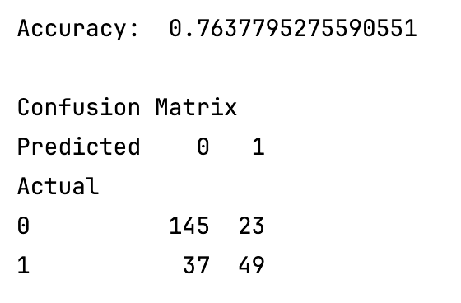
import pandas as pd
from sklearn.model_selection import train_test_split

from get_path import getPath

PATH = getPath()
from sklearn.linear_model import LogisticRegression
from sklearn import metrics
import numpy as np

# load the dataset
df = pd.read_csv(PATH + 'fluDiagnosis.csv', sep=',')
# split into input (X) and output (y) variables

X = df[['A','B']]
y = df[['Diagnosed']]

# Split into train and test data sets.
X_train, X_test, y_train, y_test = train_test_split( X, y, test_size=0.33)

# Perform logistic regression.
logisticModel = LogisticRegression(fit_intercept=True, random_state = 0,
solver='liblinear')
logisticModel.fit(X_train,y_train)
y_pred=logisticModel.predict(X_test)

# Show model coefficients and intercept.
print("\nModel Coefficients: ")
print("\nIntercept: ")
print(logisticModel.intercept_)

print(logisticModel.coef_)

# Show confusion matrix and accuracy scores.
confusion_matrix = pd.crosstab(np.array(y_test['Diagnosed']), y_pred,
rownames=['Actual'],
colnames=['Predicted'])

print('\nAccuracy: ',metrics.accuracy_score(y_test, y_pred))
print("\nConfusion Matrix")
print(confusion_matrix)

Exercise 2 (4 marks)
Following the guidelines listed under a general approach to hyperparameter tuning, modify Example 8 so that it becomes an artificial neural network which uses scorch and a stochastic gradient descent optimizer. Scaling the data is usually recommended for artificial neural networks so implement scaling.

Here is a code hint to help you get started:
dataset = pd.read_csv(getPath() + 'fluDiagnosis.csv')
X = dataset[['A', 'B']].to_numpy(dtype=np.float32)
y = dataset['Diagnosed'].to_numpy().astype(np.float32).reshape(-1, 1)

scaler = StandardScaler()
X = scaler.fit_transform(X) # Data should usually be scaled with ANN.

Example 4 offers a good code sample to begin with since it uses SGD and searches for compatible learning rate and momentum hyperparameters. Run this several times fine tune the grid as much as reasonably possible. The data set is small so the results will fluctuate. Show a screenshot of the final learning rate, momentum and number of neurons that appears in the console when running your grid search here:

Exercise 3 (4 mark)
Next, tune the number of layers, again revisiting the learning rate, momentum, and epochs as necessary. Show a screenshot which displays the best model output in the browser. It should definitely beat 0.76 accuracy and can easily beat 0.80 accuracy if done correctly. The screenshot should show

Best: using {'max_epochs': , 'module__num_layers': , 'module__num_neurons': ,
'optimizer__lr': , 'optimizer__momentum': }

Exercise 4 (4 marks)
Finally, experiment with the batch_size, making further small adjustments to the learning rate, momentum, and epochs if required. Show a screenshot of the output which should show the following values:
Best: using {'batch_size': , 'max_epochs':, 'module__num_layers': ,
'module__num_neurons': , 'optimizer__lr': , 'optimizer__momentum': }

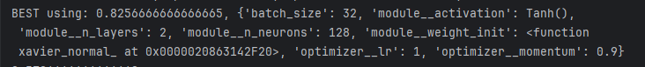

Note: The model should consistently beat 0.80 accuracy if done correctly. I could generally obtain 0.85 with my own basic experiments.

MLPClassifier and MLPRegressor from Scikit-learn
The MLPClassifier and MLPRegressor machine learning classes from scikit-learn offer a simple and fast way to generate neural networks while hiding the details. MLP stands for multi-layer perceptron which essentially is a sequential neural network with back propagation. These classes are designed for easy use in the sklearn ecosystem rather than large-scale deep learning. They are great for working with tabular data, for quickly determining acceptable metric baselines for models and parameters, and for conducting simple experiments to better understand the parameters.

Limitations of MLPClassifier and MLPRegressor
MLPClassifier and MLPRegressor only support basic MLPs using fully connected layers. They run on the CPU with no GPU support and offers limited customization. You can’t easily change the training loop or define custom layers, and it doesn’t support architectures like CNNs, RNNs, or Transformers. Because of these limitations, MLPClassifier and MLPRegressor are not intended for large-scale or complex deep learning projects.

MLPClassifier
model = MLPClassifier(
activation='relu', # Activation function for hidden layers.

alpha=0.0001, # L2 regularization strength (weight decay).
# Higher = more regularization to reduce overfitting.

batch_size='auto', # Number of samples per mini-batch.
# 'auto' lets sklearn choose min(200, n_samples).

beta_1=0.9, # Exponential decay rate for 1st moment Adam estimate.
# Controls how much past gradients influence update.

beta_2=0.999, # Exponential decay rate for 2nd moment Adam estimate.
# How past squared gradients influence update.

early_stopping=False, # True stops train when val score stops improving.
# When False, stops train at max_iter or convergence.

epsilon=1e-08, # Small constant in Adam avoids division by zero.

hidden_layer_sizes=(100,),# Architecture of the network.
# (100,) means one hidden layer with 100 neurons.
# (50,50) means 2 hidden layers with 50 neurons each.

learning_rate='constant', # Learning rate schedule.

learning_rate_init=0.001, # Initial learning rate for weight updates.
# Smaller = more stable but slower training.

max_fun=15000, # Only used for solver='lbfgs'.
# Maximum number of loss function calls.

max_iter=2000, # Maximum number of training iterations (epochs).

momentum=0.9, # Momentum factor for SGD (used only if solver='sgd').
# Helps smooth updates and speed up convergence.

n_iter_no_change=10, # Number of iterations with no improvement to wait
# before stopping (used with early_stopping=True).

nesterovs_momentum=True, # (only for solver='sgd').
# Slightly smarter version of momentum.

power_t=0.5, # For inverse scaling learning rate (used if learning_rate='invscaling').

random_state=None, # Seed for reproducibility.
# Set to an integer to get same results every run.

shuffle=True, # Whether to shuffle samples each epoch.
# Usually True to improve training stability.

solver='adam', # Optimization algorithm.
# 'adam' is a good default for most problems.

tol=0.0001, # Tolerance for optimization.
# Train stops when loss improvement is < tol value.

validation_fraction=0.1, # Fraction of training data used as validation set
# (only used if early_stopping=True).

verbose=False, # If True, prints progress messages during training.

warm_start=False # If True, continues training from previous fit call.
# If False, each fit() starts from scratch.
)

Example 9: MLPClassifier
In this example, the MLPClassifier is initialized without any parameters. The results show a reasonable learning rate and decent metrics (results will vary from run to run):

Figure 1: Loss Plot for MLPClassifier
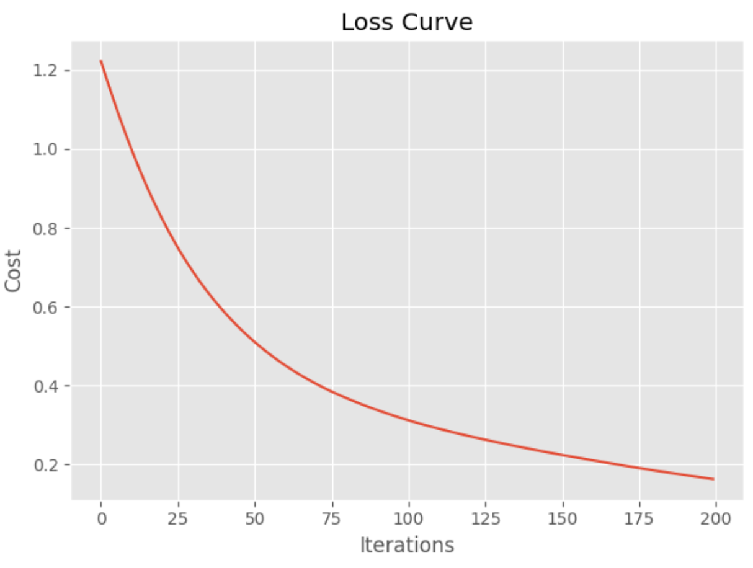
precision recall f1-score support
0 1.00 0.93 0.96 14
1 0.86 0.86 0.86 14
2 0.89 0.94 0.91 17
The default model often is very competitive with grid searched models. When the model is fitted, the parameters of the model can be displayed with the get_params() function.
print(model.get_params())
These are the parameters that were chosen for the default instantiation.
{'activation': 'relu', 'alpha': 0.0001, 'batch_size': 'auto', 'beta_1': 0.9, 'beta_2': 0.999, 'early_stopping': False, 'epsilon': 1e-08, 'hidden_layer_sizes': (100,), 'learning_rate': 'constant', 'learning_rate_init': 0.001, 'max_fun': 15000, 'max_iter': 200, 'momentum': 0.9, 'n_iter_no_change': 10, 'nesterovs_momentum': True, 'power_t': 0.5, 'random_state': None, 'shuffle': True, 'solver': 'adam', 'tol': 0.0001, 'validation_fraction': 0.1, 'verbose': False, 'warm_start': False}

Here is the code for the example:
from sklearn import metrics
from sklearn.neural_network import MLPClassifier
from sklearn.model_selection import train_test_split, GridSearchCV
import matplotlib.pyplot as plt
from sklearn.preprocessing import StandardScaler
import pandas as pd
plt.style.use('ggplot')

# Create numeric target for iris type.
dataset = pd.read_csv(getPath() + 'iris_numeric.csv')
dataset.iris_type = pd.Categorical(dataset.iris_type)

# Prepare x and y.
dataset['flowertype'] = dataset.iris_type.cat.codes
del dataset['iris_type']
y = dataset['flowertype']
X = dataset
del X['flowertype']

# Split X and y.
X_train, X_test, y_train, y_test = train_test_split(X,
y, test_size=0.30)
# Scale X and Y.
scX=StandardScaler()
scalerX = scX.fit(X_train)
trainX_scaled = scalerX.transform(X_train)
testX_scaled = scalerX.transform(X_test)

# Create and fit model.
model = MLPClassifier()
model.fit(trainX_scaled, y_train)
print(model.get_params()) # Show model parameters.

# Evaluate model.
predicted_y = model.predict(testX_scaled)
print(metrics.classification_report(y_test, predicted_y))
print(metrics.confusion_matrix(y_test, predicted_y))

def showLosses(model):
plt.plot(model.loss_curve_)
plt.title("Loss Curve")
plt.xlabel('Iterations')
plt.ylabel('Cost')
plt.show()
showLosses(model)

GridSearchCV with MLPClassifier

Example 10: Grid searching the MLPClassifier
This example shows how to fine tune and ideally improve the MLPClassifier by grid searching different parameters. The custom classification report shows good results.
precision recall f1-score support
0 1.00 1.00 1.00 14
1 1.00 0.93 0.96 14
2 0.94 1.00 0.97 17

To build this example, add the following code to Example 9. Note, the max_iter parameter specifies the number of epochs. When grid searching you will see warnings when the algorithm does not reach an optimum. My understanding is that it is not possible to eliminate these warnings because the algorithm is grid searching with a fixed set of iteration options.

We are only grid searching a subset of parameters so often the model that is built with a default initialization in Example 9 will do better.
parameters={
'solver': ['adam', 'sgd'],
'learning_rate': ['constant', 'adaptive', 'invscaling'],
'hidden_layer_sizes': [(200,200), (300,200), (150,150)],
'activation': ["logistic", "relu", "tanh"]
}
model2 = GridSearchCV(estimator=model, param_grid=parameters,
scoring='accuracy', # average='macro'),
n_jobs=-1, cv=4, verbose=1,
return_train_score=False)

model2.fit(trainX_scaled, y_train)
print("Best parameters: ")
print(model2.best_params_)
y_pred = model2.predict(testX_scaled)

print("Report with grid: ")
print(metrics.classification_report(y_test, y_pred))
print(metrics.confusion_matrix(y_test, y_pred))
showLosses(model2.best_estimator_)

Exercise 5 (2 marks)
Run the code in Example 10. Show a screenshot which displays the parameters for the best model and be sure to include the hidden_layer_sizes in the screenshot.
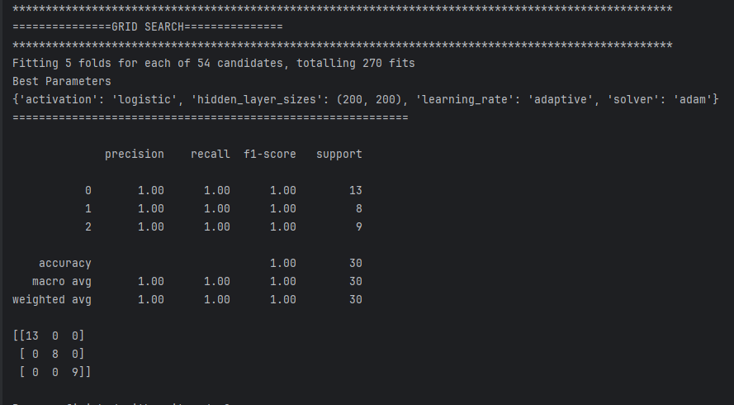

Explain what the hidden_layer_sizes parameter means (do not over think this).
it is the number of neurons for the number of hidden layers which is the number of values specified

MLPRegressor
The MLPRegressor is the regressor version of the simplified MLP family from scikit-learn.

Example 11: MLP Regressor
This code fits a model for predicting house prices and evaluates a default MLPRegressor object without specifying any parameters. The results are quite good for the data set provided.
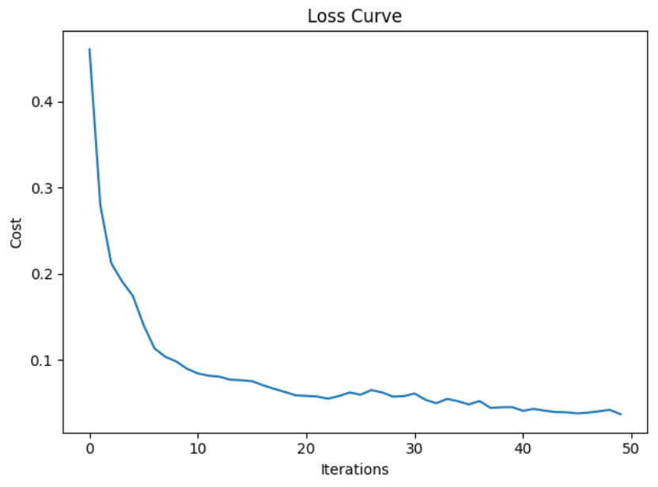
RMSE: 3.8574

import pandas as pd
import numpy as np

import matplotlib.pyplot as plt
from sklearn.model_selection import train_test_split
from sklearn.preprocessing import StandardScaler
from sklearn.neural_network import MLPRegressor
from sklearn import metrics
import warnings

from get_path import getPath

warnings.filterwarnings(action='once')

CSV_DATA = "housing.data"
df = pd.read_csv(getPath() + CSV_DATA, header=None)

# Show all columns.
pd.set_option('display.max_columns', None)

# Increase number of columns that display on one line.
pd.set_option('display.width', 1000)

print(df.head())
print(df.tail())
print(df.describe())

dataset = df.values

# split into input (X) and output (Y) variables
X = dataset[:,0:13]
y = dataset[:,13]

trainX, temp_X, trainY, temp_y = train_test_split(X, y, train_size = 0.7)
valX, testX, valY, testY = train_test_split(temp_X, temp_y, train_size = 0.5)

# Scale X and Y.
scX = StandardScaler()
scalerX = scX.fit(trainX)
trainX_scaled = scalerX.transform(trainX)
valX_scaled = scalerX.transform(valX)
testX_scaled = scalerX.transform(testX)

scY=StandardScaler()
trainY_scaled = scY.fit_transform(np.array(trainY).reshape(-1,1))
testY_scaled = scY.transform(np.array(testY).reshape(-1,1))
valY_scaled = scY.transform(np.array(valY).reshape(-1,1))

# Build basic multilayer perceptron.
model1 = MLPRegressor(
# 3 hidden layers with 150 neurons, 100, and 50.
hidden_layer_sizes = (150,100,50),
max_iter = 50, # epochs
activation = 'relu',
solver = 'adam', # optimizer
verbose=1)
model1.fit(trainX_scaled, trainY_scaled)

def showLosses(model):
plt.plot(model.loss_curve_)
plt.title("Loss Curve")
plt.xlabel('Iterations')
plt.ylabel('Cost')
plt.show()

def evaluateModel(model, testX_scaled, testY_scaled, scY):
showLosses(model)
scaledPredictions = model.predict(testX_scaled)
y_pred = scY.inverse_transform(
np.array(scaledPredictions).reshape(-1,1))
mse = metrics.mean_squared_error(testY_scaled, y_pred)
rmse = np.sqrt(mse)
print("RMSE: " + str(rmse))

evaluateModel(model1, valX_scaled, valY, scY)

Example 12: Grid Searching the MLP Regressor
This example shows how to grid search the MLP Regressor parameters of the model from Example 11. It turns out that the base model tends to do a good job of fitting a neural network.
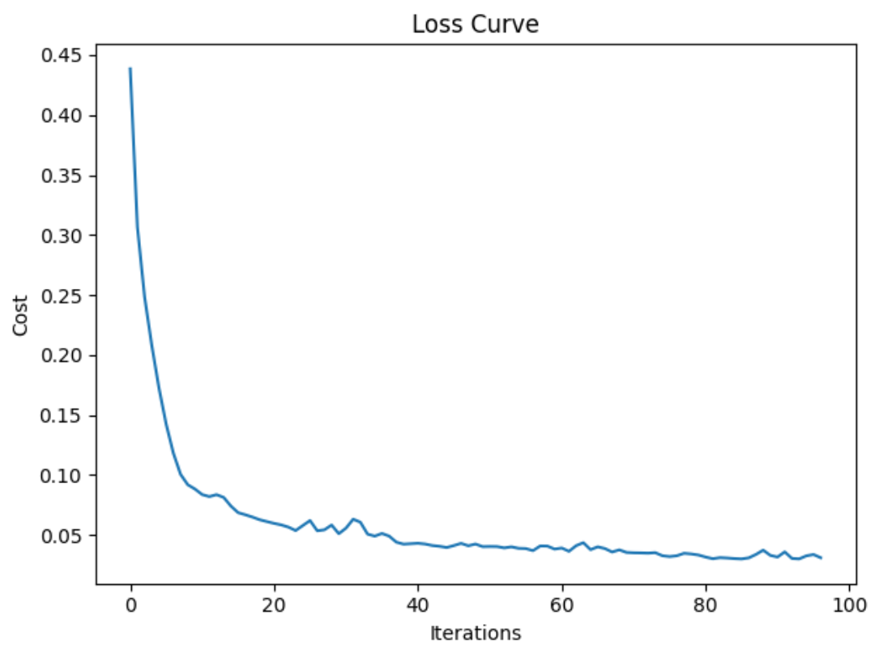

Sometimes, but not always, the grid search will find a better fit.

RMSE: 3.268

To build this example, add the following code to the end of Example 11.
# here is the new part.
param_grid = {
'hidden_layer_sizes': [(150,100,50), (120,80,40), (100,50,30)],
'max_iter': [50, 100],
'activation': ['tanh', 'relu'],
'solver': ['sgd', 'adam'],
'alpha': [0.0001, 0.05],
'learning_rate': ['constant','adaptive'],
}
from sklearn.model_selection import GridSearchCV

# n_jobs=-1 means use all processors.
# Run print(metrics.get_scorer_names()) for scoring choices.
model2 = MLPRegressor()
gridModel = GridSearchCV(model2, param_grid, n_jobs= -1, cv=10,

scoring='neg_mean_squared_error')
gridModel.fit(trainX_scaled, trainY_scaled)

print("Best parameters")
print(gridModel.best_params_)
evaluateModel(gridModel.best_estimator_, valX_scaled, valY, scY)
# Evaluate both models with test (unseen) data.
print("\n*** Base model with test data: ")
evaluateModel(model1, testX_scaled, testY, scY)
print(model1.get_params())
print("\n*** Grid searched model with test data: ")
evaluateModel(gridModel.best_estimator_, testX_scaled, testY, scY)
print(gridModel.get_params())

Exercise 7 (2 marks)
Advanced parameter settings for learning rate provide algorithms for slowing down the learning rate as the model approaches an optimum. The scikit-learn model enables an adjusting learning rate with the ‘adaptive’ setting.
'learning_rate': ['constant','adaptive'],

Starting with Example 12, add an option to the grid search to include a range of starting learning rates. Then change the grid search so it uses a random search instead.
'learning_rate_init': [0.0001, 0.001, 0.005, 0.01, 0.1, 0.2]

Show your code here after making the changes:
import pandas as pd
import numpy as np
import matplotlib.pyplot as plt
from sklearn.model_selection import train_test_split, RandomizedSearchCV
from sklearn.preprocessing import StandardScaler
from sklearn.neural_network import MLPRegressor
from sklearn.metrics import mean_squared_error
from sklearn.model_selection import GridSearchCV
def preprocess_data(path):
df = pd.read_csv(path, header=None)
X = df.iloc[:, 0:13].values
y = df.iloc[:, 13].values
X_train, X_test, y_train, y_test = train_test_split(
X, y, test_size=0.2
)
scaler_X = StandardScaler()
X_train_scaled = scaler_X.fit_transform(X_train)
X_test_scaled = scaler_X.transform(X_test)
scaler_y = StandardScaler()
y_train_scaled = scaler_y.fit_transform(np.array(y_train).reshape(-1, 1))
y_test_scaled = scaler_y.transform(np.array(y_test).reshape(-1, 1))
return X_train_scaled, X_test_scaled, \
y_train_scaled.ravel(), y_test_scaled.ravel(), y_test, scaler_y
def build_and_evaluate_model(X_train, X_test,
y_train, y_test, scaler_y):
model = MLPRegressor(
hidden_layer_sizes=(150, 100, 50),
max_iter=1000,
activation='relu',
solver='adam',
verbose=1
)
model.fit(X_train, y_train)
y_pred_scaled = model.predict(X_test)
y_pred = scaler_y.inverse_transform(np.array(y_pred_scaled).reshape(-1, 1))
rmse = np.sqrt(mean_squared_error(y_test, y_pred))
print(f'RMSE: {rmse:.4f}')
return model
def draw_plot(model):
plt.plot(model.loss_curve_)
plt.title('Loss Curve')
plt.xlabel('Iterations')
plt.ylabel('Loss')
plt.show()
def random_search(model, X_train, X_test, y_train, y_test, scaler_y):
param_grid = {
'hidden_layer_sizes': [(150, 100, 50), (120, 80, 40), (128, 64, 64)],
'activation': ['tanh', 'relu'],
'solver': ['sgd', 'adam'],
'alpha': [0.001, 0.05, 0.1, 0.0001],
'learning_rate': ['constant', 'adaptive']
}
grid = RandomizedSearchCV(model,
param_distributions=param_grid,
n_jobs=-1, cv=10,
scoring='neg_mean_squared_error')
grid.fit(X_train, y_train)
print('Best Parameters')
print(grid.best_params_)
print('\nEvaluate RandomizedSearchCV Model')
y_pred_scaled = grid.predict(X_test)
y_pred = scaler_y.inverse_transform(np.array(y_pred_scaled).reshape(-1, 1))
rmse = np.sqrt(mean_squared_error(y_test, y_pred))
print(f'RMSE: {rmse:.4f}')
return grid.best_estimator_
def main():
PATH = r"C:\Users\linho\Desktop\CST\term4\pa\data\housing.data"
X_train, X_test, y_train, y_test, y_test_orig, scaler_y = \
preprocess_data(PATH)
model = build_and_evaluate_model(X_train, X_test, y_train,
y_test_orig, scaler_y)
draw_plot(model)
print('='*100)
print('GRID SEARCHING...............')
gs_model = random_search(model, X_train, X_test, y_train,
y_test_orig, scaler_y)
draw_plot(gs_model)
if __name__ == '__main__':
main()

Run the random search after making the changes. Show a screenshot of the best model here.
