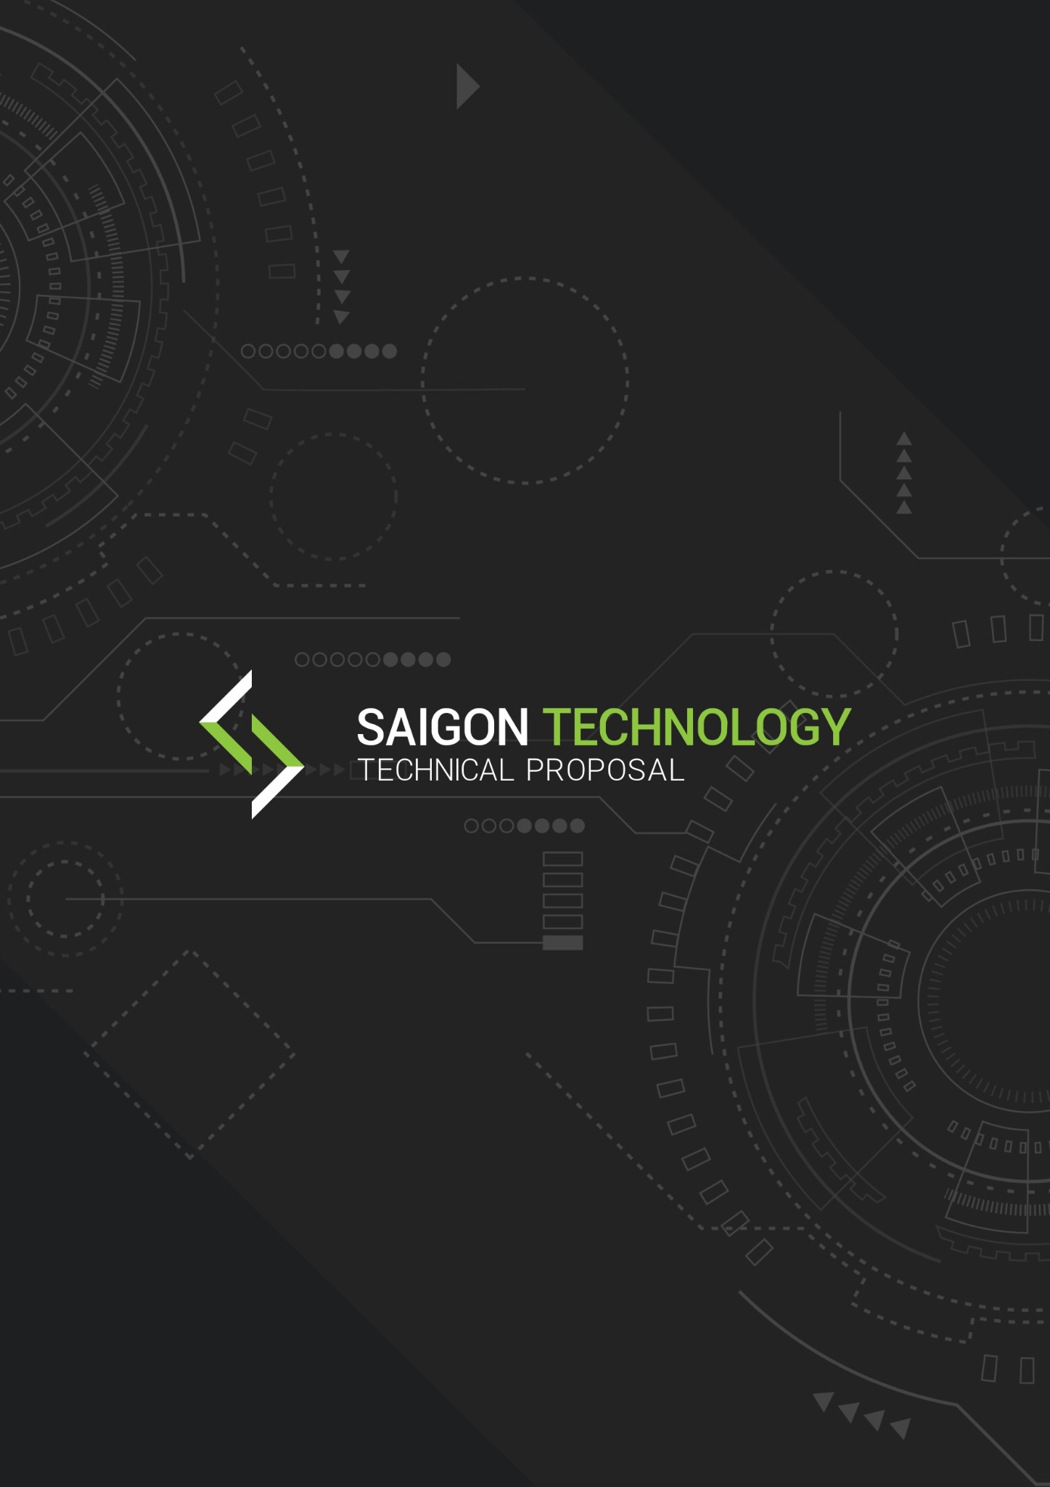

Technical Proposal - High Level
for {{PROJECT_TITLE}} - {{CLIENT_NAME}}
{{VERSION}} - {{PROPOSAL_DATE}}

ISSUED TO | ISSUED FROM
{{CLIENT_NAME}}  Project Sponsor  {{CLIENT_CONTACT_EMAIL}} | Saigon Technology Solutions  Project Coordinator  Project Coordinator  delivery@saigontechnology.com

Content

INTRODUCTION ?
Executive Summary ?
Problems & Solutions ?
Purpose ?
PROPOSED TECHNOLOGY ?
System Overview ?
2.1.1 System Context ?
2.1.2 AWS Reference Architecture ?
2.1.3 {{VENDOR_PARTNER_NAME}} Integration: Anti-Corruption Layer ?
2.1.4 Booking Saga: Idempotent Orchestration ?
2.1.5 Public API Hub ?
Technology Stack ?
Back-end ?
Front-end ?
Database ?
Server & Hosting ?
Mobile App Strategy ?
PROPOSED DEVELOPMENT MANAGEMENT ?
Management Methodology (Optional) ?
Development Flow ?
3.2.1 CI / CD Pipeline ?
Branch Model ?
Development Environment ?
Quality Assurance ?
Testing Workflow ?
Testing Scope ?
Testing Process ?
CASE STUDY ?
5. SUMMARY ?

INTRODUCTION

Executive Summary
{{EXECUTIVE_SUMMARY}}

Problems & Solutions
{{PROBLEMS_AND_SOLUTIONS}}

Purpose
{{PURPOSE}}

PROPOSED TECHNOLOGY

System Overview
{{SYSTEM_OVERVIEW_INTRO}}

2.1.1 System Context

Technology Stack

Back-end
{{TECHSTACK_BACKEND}}

Front-end
{{TECHSTACK_FRONTEND}}

Database
{{TECHSTACK_DATABASE}}

Server & Hosting
{{TECHSTACK_SERVER_HOSTING}}

{{TECHSTACK_DATA}}

{{TECHSTACK_AI}}

Mobile App Strategy

PROPOSED DEVELOPMENT MANAGEMENT

Management Methodology (Optional)

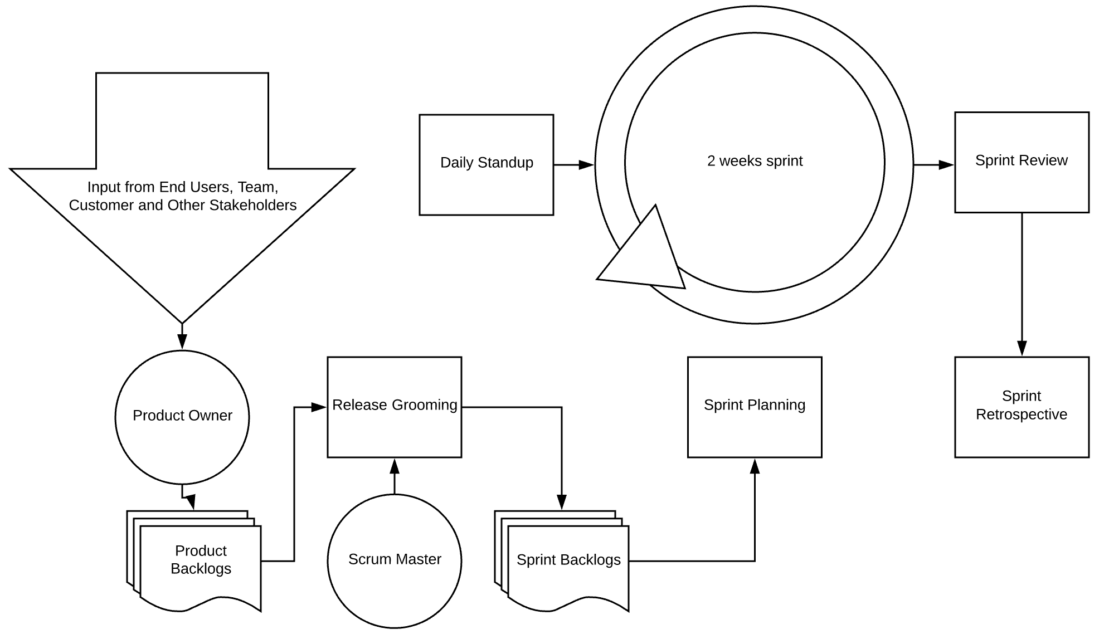
Figure 1: Agile Methodology

● Sprint length: 2 week sprint
● Scrum role:
○ Product Owner (Client Project Manager)
○ Scrum Master (Service Provider Project Manager)
○ Development Team
○ Tester
● Project Roadmap:
○ Product Owner, Scrum Master to define the project roadmap and the target for each phase.
● Product Backlog:
○ Scrum master, Product Owner to get raw requirements from Client then transfer them to User Story.
● Release Grooming:
○ Scrum Master, Development Team to breakdown User Story to Epic and Task.
Following the project roadmap, first define the sprint goal of this iteration, then select a list of user stories / epic / tasks to form the Sprint Backlog for the coming sprint which could fulfill the sprint goal.
● Sprint Planning:
○ Scrum Master, Development Team to review the current tasks, then estimate (Story Point) and arrangements for the workload based on the Sprint Backlog list.
○ Story Point is a scale of 1-13: 1 is very easy, 13 is very difficult.
○ Each sprint, the Development Team should allocate at least 15-20% for coding review and customer feedback/bugs.
○ All questions need to be asked in this state.
● Sprint Backlog:
○ Will be completed by the Development Team.
○ During development time, change requests or bugs may be added by the Product Owner. Scrum Master to review the sprint scope, discuss with the Development Team and extend the current sprint if needed.
● Daily Standup:
○ Within the Sprint, a Daily Scrum Meeting is required and each of the meetings is time-boxed in about 15 minutes.
Everyone needs to interact face-to-face with all members to share what they did yesterday and commit to what they want to achieve today. Questions about obstacles or unresolved issues could be raised also.
● Sprint Review:
○ When all tickets in Sprint Backlog are completed, Scrum Master conducts a Sprint Review Meeting. The product owner and the customer must participate.
○ Every member of the Scrum Team will demonstrate to them the working software they have completed and this meeting is very important and must not be canceled.
● Sprint Retrospective:
Start at the end of each sprint. During the retrospective, the team self-identifies elements of the process that did or did not work during the sprint, along with potential solutions. Retrospectives typically last 90 minutes and are there to help us incorporate continuous improvement into the team culture and into Sprint cadence.

Development Flow
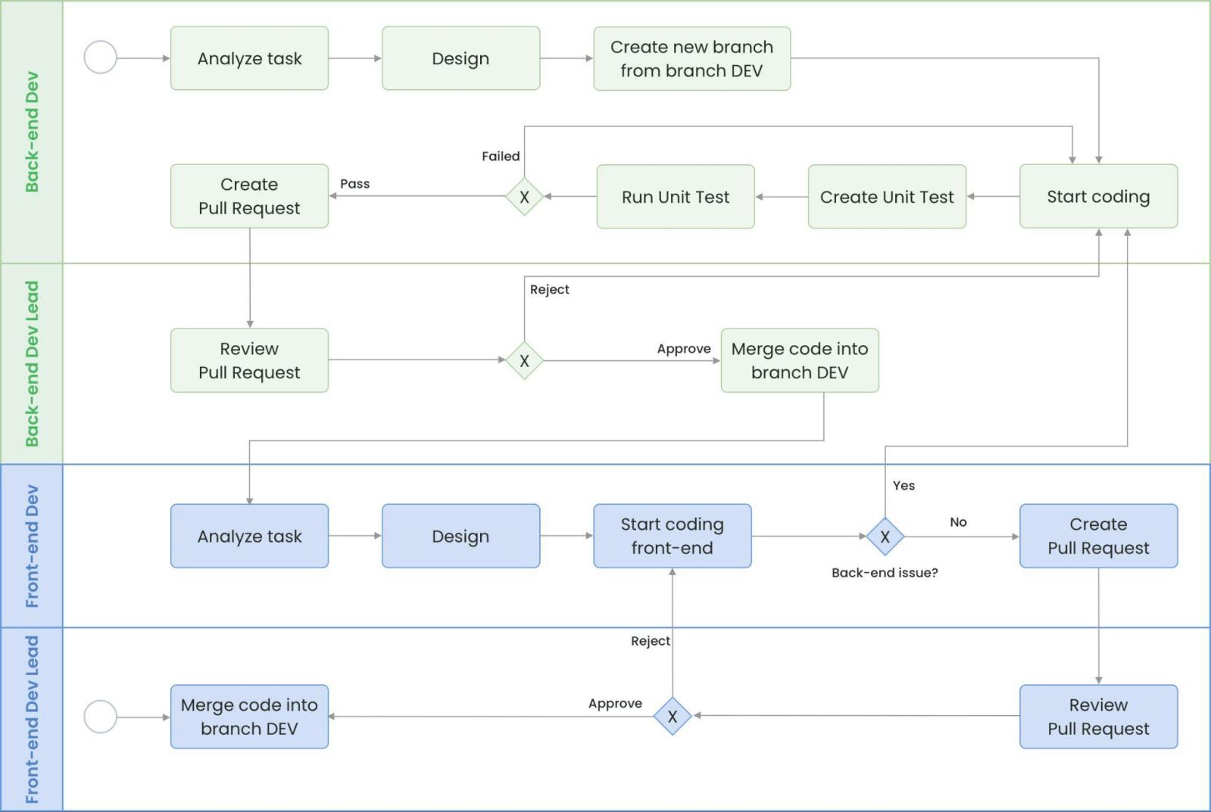

3.2.1 CI / CD Pipeline
Every change reaches production through an automated pipeline that gates merges on quality and security and applies changes via a GitOps controller. The same pipeline produces the artifacts and manifests for all environments, so Dev, QA, Staging, UAT and Production are always reachable from a Git commit, fully auditable and reversible. Specific tooling (CI runner, security scanners, GitOps controller) is selected during detailed design and recorded in the low-level design document.
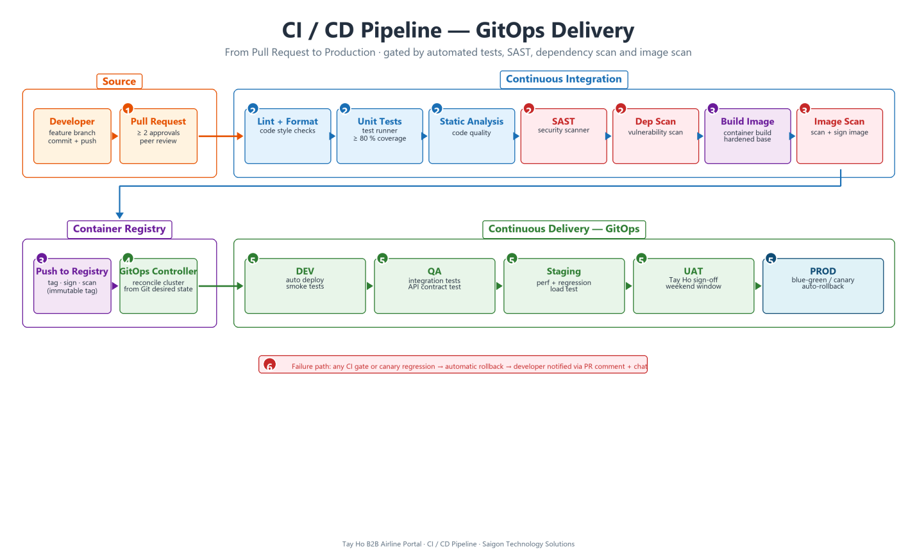
Figure 1: CI / CD Pipeline (GitOps Delivery)

1. Pull Request: requires at least two approvals (one from the Tech Lead for cross-cutting changes). No direct commits to main or develop.
2. CI quality gates: run on every PR, covering lint, unit tests with ≥ 80 % coverage on changed code, static analysis, SAST and dependency vulnerability scan. A failing gate blocks the merge.
3. Container build, scan and push: a hardened distroless base image is built, scanned for vulnerabilities and signed before being pushed to the container registry with an immutable tag.
4. GitOps controller: watches the Git desired-state and reconciles the cluster; the cluster is never modified by the CI step directly. This gives every deployment a Git commit as its identity.
5. CD environments promoted in order: DEV (auto on merge) → QA (integration + API contract tests) → Staging (performance + regression load test) → UAT ({{CLIENT_NAME}} sign-off on a weekend window) → Production (blue-green / canary with automatic rollback on regression).
6. Failure path: any failed CI gate or production canary regression triggers an automatic rollback and notifies the developer via chat and a PR comment, keeping mean-time-to-recovery measured in minutes.

Phase | Description | Person in-charge
Analyze Task | Developer picks up a task from the Sprint backlog and start analyze the task:  ● Read tickets and clarify with BA, PM/PC or Client all unclear requirements.  ● Review current project source code (if any) to understand the current context.  ● List out all possible test cases. | Developer
Design | Design solution for the task:  ● Define class design, database design, class diagrams and sequence diagrams (if required).  ● Discuss with Back-end Dev Lead about this solution to finalize the design.  ● Define a smaller task list to track progress. | Developer
Start Coding | Start coding based on agreed design. | Developer
Unit Test | ● Create unit tests if required.  ● Execute unit tests and fix any defects found.  Note: The unit test is not in this scope of work. | Developer
Pull Request | Create a pull-request and resolve all conflicts to be reviewed by the Dev Lead and team members. | Developer
Review & Merge Code | Review source code in the pull request based on the style guide or coding convention of the project (must create one for the project).  ● Comment on blocks of code having issues and suggest ideas to fix.  ● Taking note to share this as a lesson learned for other developers if necessary.  Merge feature branch into branch DEV. | Leader/Tech Lead

Branch Model

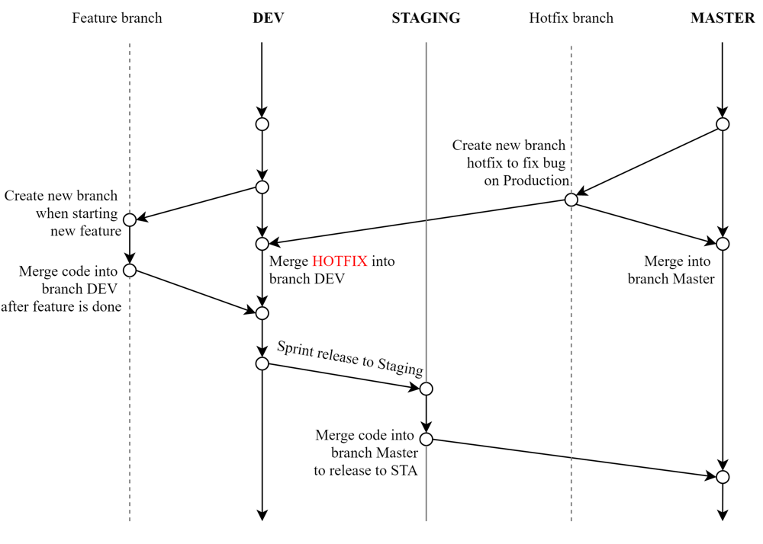
Figure 1: Branching Model

Branch | Purpose
master | ● Store the stable source code.  ● To release to STA/DEMO and PROD.  ● To fix a bug on PROD, the developer needs to create a new hotfix branch from PROD, fix the bug then release it to STA/DEMO to verify
dev | ● Store the latest source code.  ● To release to QA Environment.  ● To integrate and merge the feature code.  ● To fix a bug on QA Environment, the developer needs to create a new hotfix branch from DEV, fix the bug then release it to QA Environment again to verify.
feature | ● Store the feature/hotfix source code.  ● For feature, Developer to create a new feature branch with name DevName_TaskName_TaskID_Date when start developing any feature.  ● For hotfix, the Developer creates a new hotfix branch with the name DevName_Hotfix_TaskID_Date when they start fixing any bug.

Development Environment
Figure 1: Development Workflow

Environment | Purpose
Local | An environment for developers to develop features, do self testing
Development | An environment for developers to integrate FE and BE code and self test full features. Developers can invite testers/product owners to review features to ask for early feedback.
Testing/Staging | A testing environment for tester/product owner to do integration testing and verify all issues before demo.
UAT/Pre-Production | A full copy of production for product owner to demo application to client or do full workflow testing before rollout the new version to production.
Live/Production | Before releasing any version, a full backup of production needs to be prepared. After release, the smoke testing is required. Only some people in the white list IP can access the system and do the smoke testing.

Quality Assurance

Testing Workflow

Saigon Technology recommends the adoption of the Basic Testing workflow across multiple testing levels, including unit testing, integration testing, system testing, and user acceptance testing. This approach entails the utilization of appropriate testing tools and frameworks tailored to each testing type, thereby ensuring the overall quality of the application.
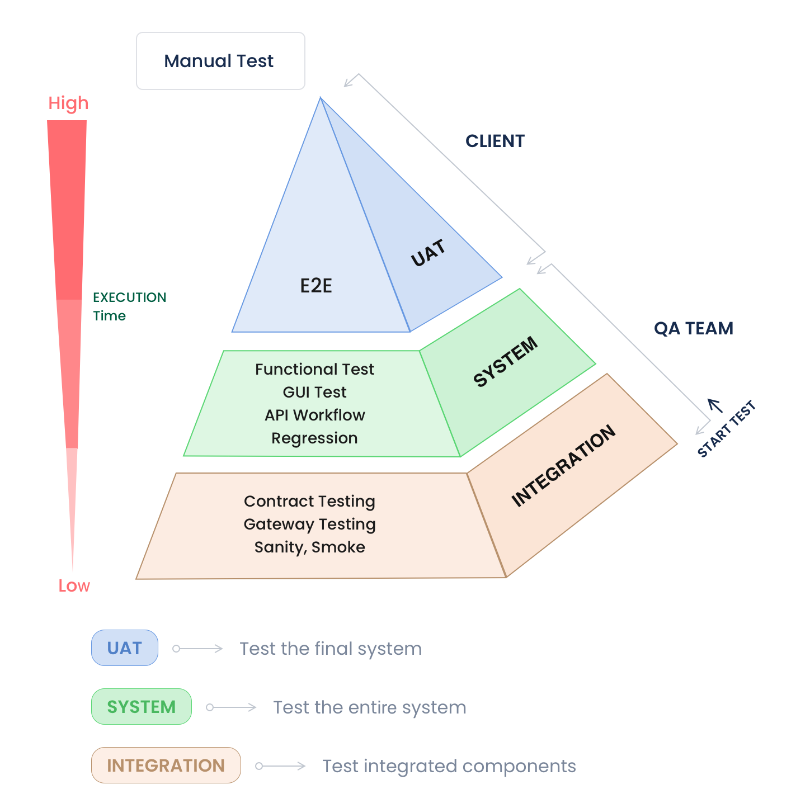
Figure 1: Basic Testing Workflow

Testing Scope
Testing to be involved within respective milestones of the development process are shall include:
Testing | Responsibility
Functionality Testing | QC
UI Testing | Client
Integration Testing | QC
Regression Testing | QC
User Acceptance Testing (test cases as per user stories) | Client

● For each user story acceptance criteria are defined.
● For further quality assurance, system architecture documentation as well as source code inline documentation is mandatory.
● For the testing schedule, please allow two (2) days for client testing for each stage. These days shall be Saturday and Sunday so that feedback can be provided by Monday morning.

Testing Process
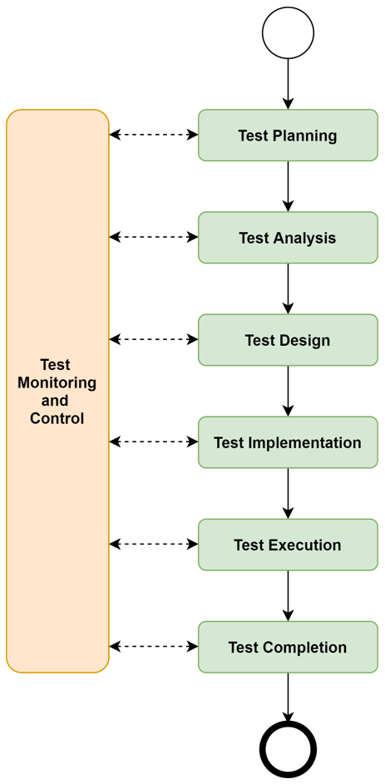
Figure 1: Testing Process

● Test Planning: define a strategy, planning that include testing scope, objectives, resources, tools, techniques and schedule for the testing.
● Test Analysis: analyzes project’s requirements and specifications to identify testable features, objectives of the testing.
● Test Design: design scenarios, high level cases, data, environment, and the techniques based on different expectations are analyzed.
● Test Implementation: develop test cases details, and test scripts (if any) based on the scenarios, high level cases.
● Test Execution: execute tests based on the test cases detailed, test scripts by comparing the actual behaviors against the expectation. Defects, issues are also identified and logged for tracking during this phase.
● Test Completion: generate final reports, summarize the testing activities, results and any remaining issues, then send to stake holders for release approval or send back to the development team for fixing.

CASE STUDY
We are pleased to present a relevant case study that demonstrates our ability to deliver a high-performance, multi-stakeholder B2B platform comparable to FruPro, a multi-stakeholder B2B platform we delivered for a similar engagement.this link

SUMMARY
{{SUMMARY_BODY}}

