AI / RAG Architecture
A retrieval-augmented AI architecture: a user request is orchestrated, dispatched to the model providers, and grounded with context retrieved from the vector store before the answer is returned.
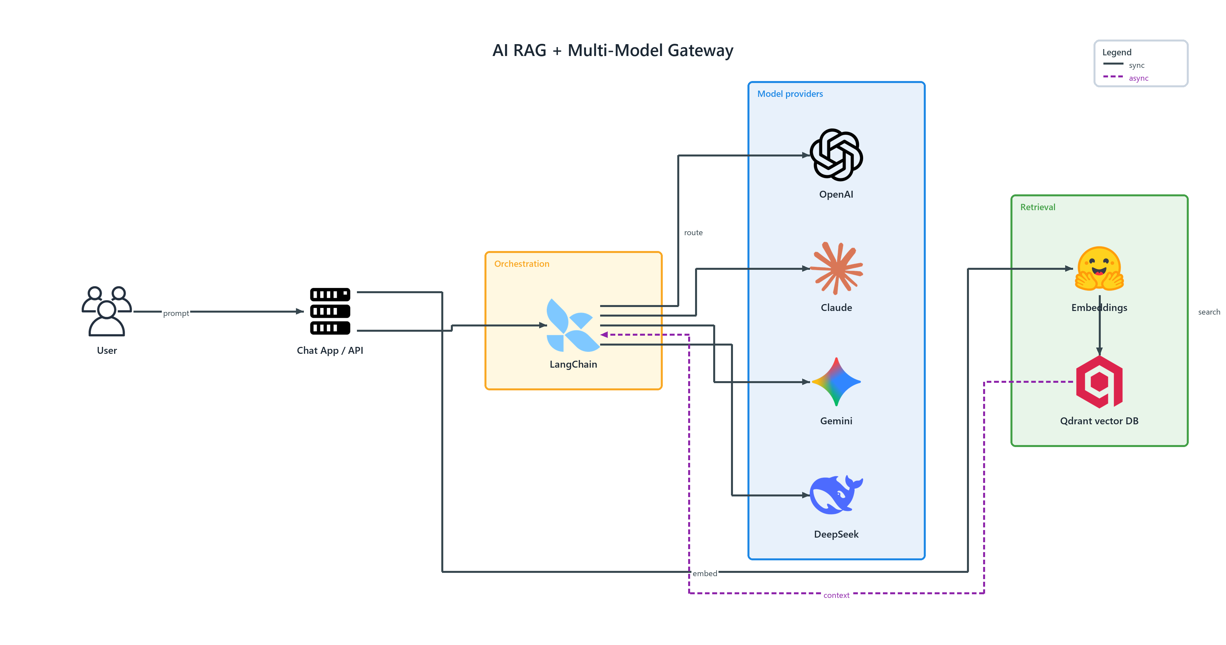
Figure 1: AI / RAG Architecture — AI RAG + Multi-Model Gateway
- User — users (ONPREM); prompt to Chat App / API
- Chat App / API — server (ONPREM); connects to LangChain, embed to Embeddings
- LangChain — langchain (AI) in Orchestration; route to OpenAI, connects to Claude, connects to Gemini, connects to DeepSeek
- OpenAI — openai (AI) in Model providers
- Claude — claude (AI) in Model providers
- Gemini — gemini (AI) in Model providers
- DeepSeek — deepseek (AI) in Model providers
- Embeddings — huggingface (AI) in Retrieval; search to Qdrant vector DB
- Qdrant vector DB — qdrant (AI) in Retrieval; publishes context to LangChain

