Cloud Reference Architecture
A cloud reference architecture in which inbound traffic terminates at Route 53, CloudFront, AWS WAF, ALB and NAT GW x2, is served by EKS services, and state is held in Aurora primary, Aurora replica, ElastiCache and OpenSearch. Asynchronous, event-driven work flows through Amazon MSK and SQS + DLQ. The estate sits inside VPC 10.0.0.0/16, with security & observability (IAM, KMS, Secrets Mgr, CloudWatch and S3 backup) applied across every tier.
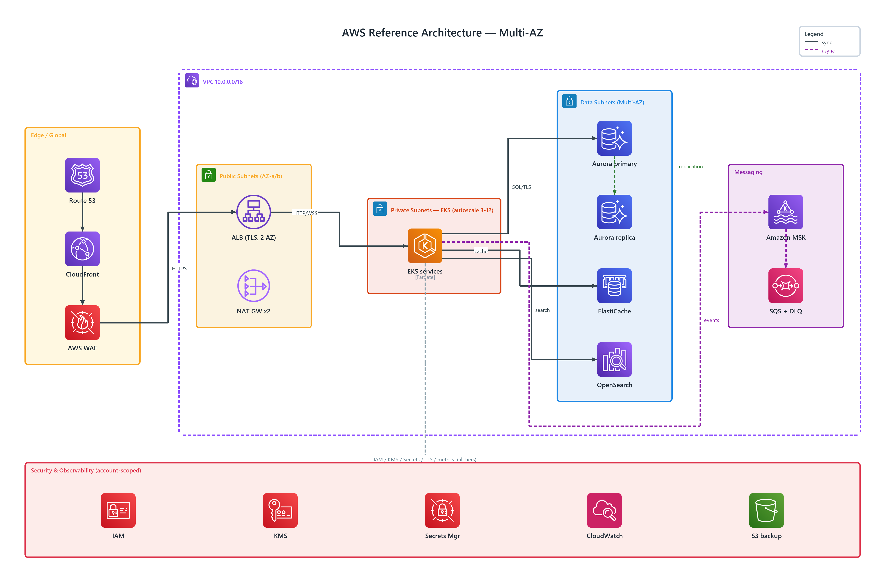
Figure 1: AWS Reference Architecture — Multi-AZ
- VPC 10.0.0.0/16 — transparent, dashed network boundary, badged vpc (AWS) spanning the tiers it encloses
- Route 53 — route 53 (AWS) in Edge / Global; connects to CloudFront
- CloudFront — cloudfront (AWS) in Edge / Global; connects to AWS WAF
- AWS WAF — waf (AWS) in Edge / Global; HTTPS to ALB (TLS, 2 AZ)
- ALB (TLS, 2 AZ) — elb application load balancer (AWS) in Public Subnets; HTTP/WSS to EKS services
- NAT GW x2 — nat gateway (AWS) in Public Subnets
- EKS services — elastic kubernetes service (AWS), Fargate in Private Subnets — EKS; SQL/TLS to Aurora primary, cache to ElastiCache, search to OpenSearch, publishes events to Amazon MSK
- Aurora primary — aurora (AWS) in Data Subnets; publishes replication to Aurora replica
- Aurora replica — aurora (AWS) in Data Subnets
- ElastiCache — elasticache (AWS) in Data Subnets
- OpenSearch — amazon opensearch service (AWS) in Data Subnets
- Amazon MSK — managed streaming for kafka (AWS) in Messaging; streams events to SQS + DLQ
- SQS + DLQ — simple queue service (AWS) in Messaging
- Security & Observability — cross-cutting services (IAM, KMS, Secrets Mgr, CloudWatch, S3 backup) applied to every tier — IAM / KMS / Secrets / TLS / metrics (all tiers)

