Cloud Reference Architecture
A cloud reference architecture in which inbound traffic terminates at Front Door + WAF and App Gateway, is served by Internal LB and AKS pools, and state is held in Azure SQL, Cache for Redis and Blob Storage. Asynchronous, event-driven work flows through Service Bus. The estate sits inside VNet 10.1.0.0/16, with shared services (Entra ID, Key Vault and Monitor) applied across every tier.
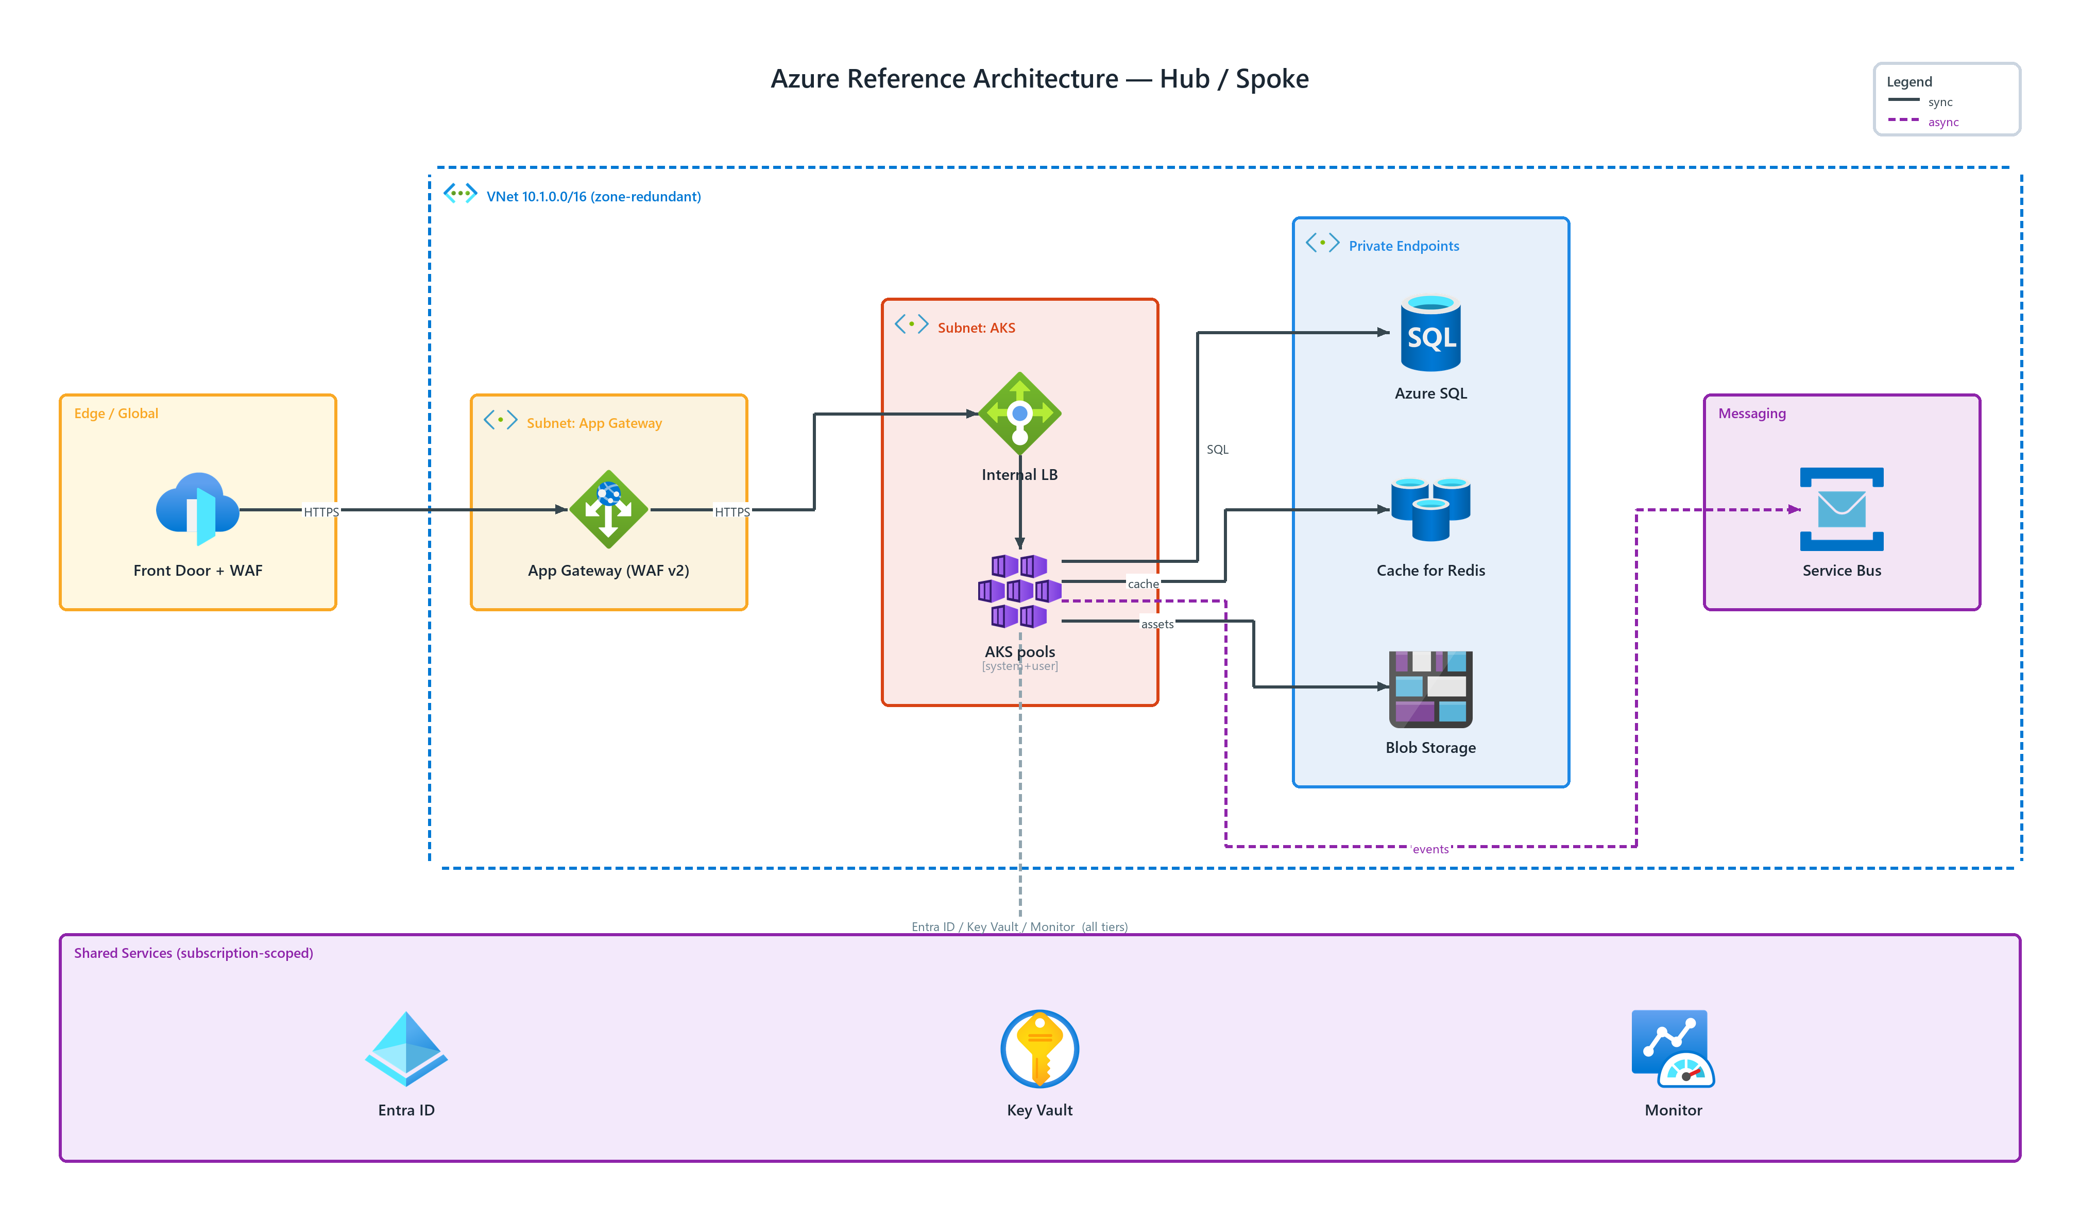
Figure 1: Azure Reference Architecture — Hub / Spoke
- VNet 10.1.0.0/16 (zone-redundant) — transparent, dashed network boundary, badged virtual networks (AZURE) spanning the tiers it encloses
- Front Door + WAF — front doors (AZURE) in Edge / Global; HTTPS to App Gateway (WAF v2)
- App Gateway (WAF v2) — application gateway (AZURE) in Subnet: App Gateway; HTTPS to Internal LB
- Internal LB — load balancers (AZURE) in Subnet: AKS; connects to AKS pools
- AKS pools — kubernetes services (AZURE), system+user in Subnet: AKS; SQL to Azure SQL, cache to Cache for Redis, assets to Blob Storage, publishes events to Service Bus
- Azure SQL — sql database (AZURE) in Private Endpoints
- Cache for Redis — cache redis (AZURE) in Private Endpoints
- Blob Storage — blob storage (AZURE) in Private Endpoints
- Service Bus — service bus (AZURE) in Messaging
- Shared Services — cross-cutting services (Entra ID, Key Vault, Monitor) applied to every tier — Entra ID / Key Vault / Monitor (all tiers)

