BPMN Process
BPMN — Order Fulfilment traces the flow through 7 activities — Order received, Validate order, In stock?, Reserve stock, … — and the 7 transitions between them.
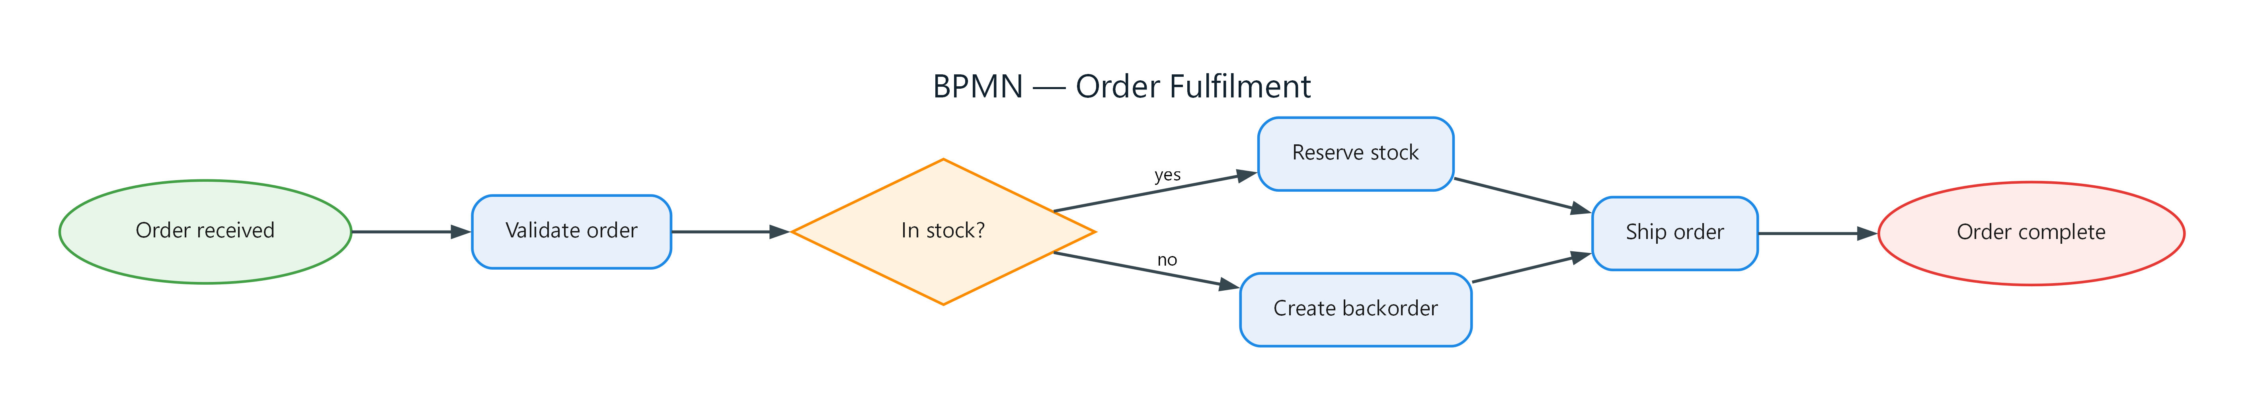
Figure 1: BPMN — Order Fulfilment
- Order received — start; connects to Validate order
- Validate order — task; connects to In stock?
- In stock? — gateway; connects to Reserve stock (yes), Create backorder (no)
- Reserve stock — task; connects to Ship order
- Create backorder — task; connects to Ship order
- Ship order — task; connects to Order complete
- Order complete — end

