C4 Container Diagram
A C4 container diagram in which the workload runs on API, and state is held in Database. The estate sits inside Internet Banking System.
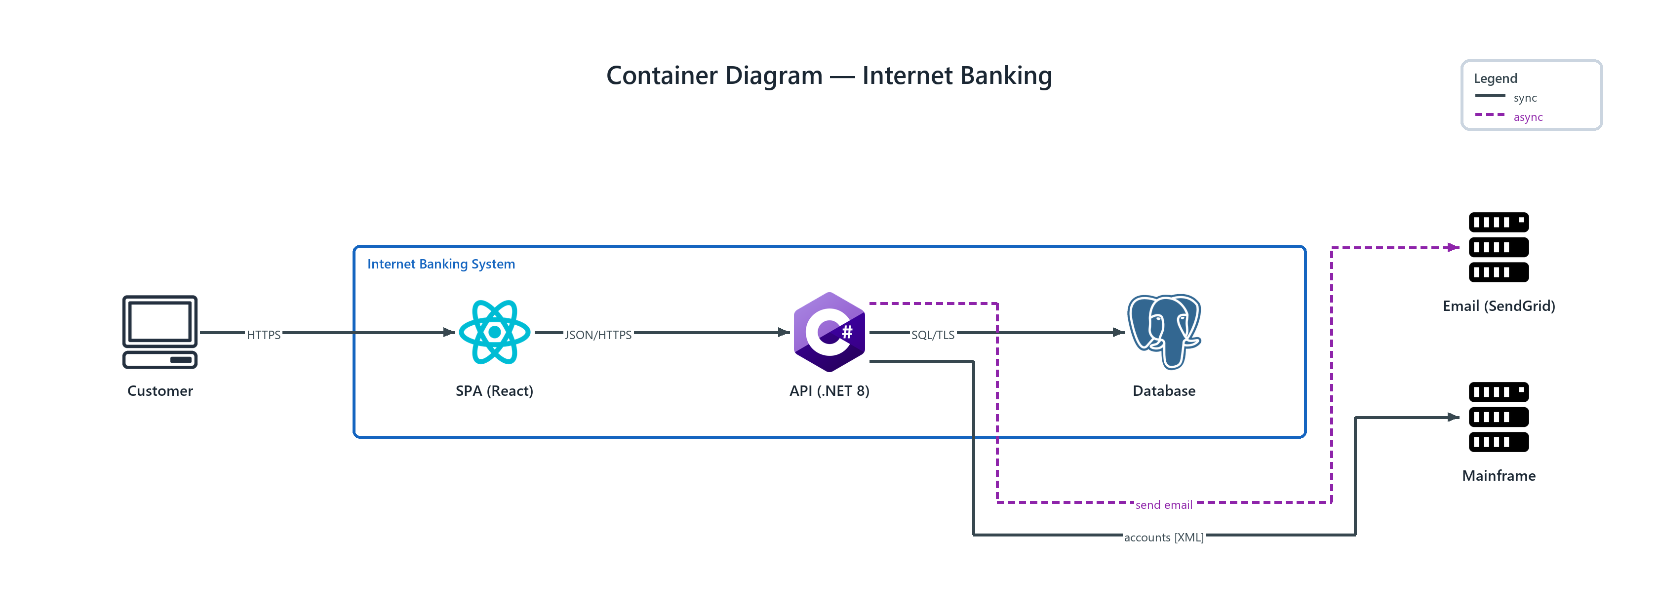
Figure 1: Container Diagram — Internet Banking
- Internet Banking System — network boundary spanning the tiers it encloses
- Customer — client (ONPREM); HTTPS to SPA (React)
- SPA (React) — react (PROGRAMMING); JSON/HTTPS to API (.NET 8)
- API (.NET 8) — csharp (PROGRAMMING); SQL/TLS to Database, publishes send email to Email (SendGrid), accounts [XML] to Mainframe
- Database — postgresql (ONPREM)
- Email (SendGrid) — server (ONPREM)
- Mainframe — server (ONPREM)

