C4 Diagram
System Context — Internet Banking models 4 elements — Customer, Internet Banking, Email System and Mainframe Banking — and the 3 relationships that connect them.
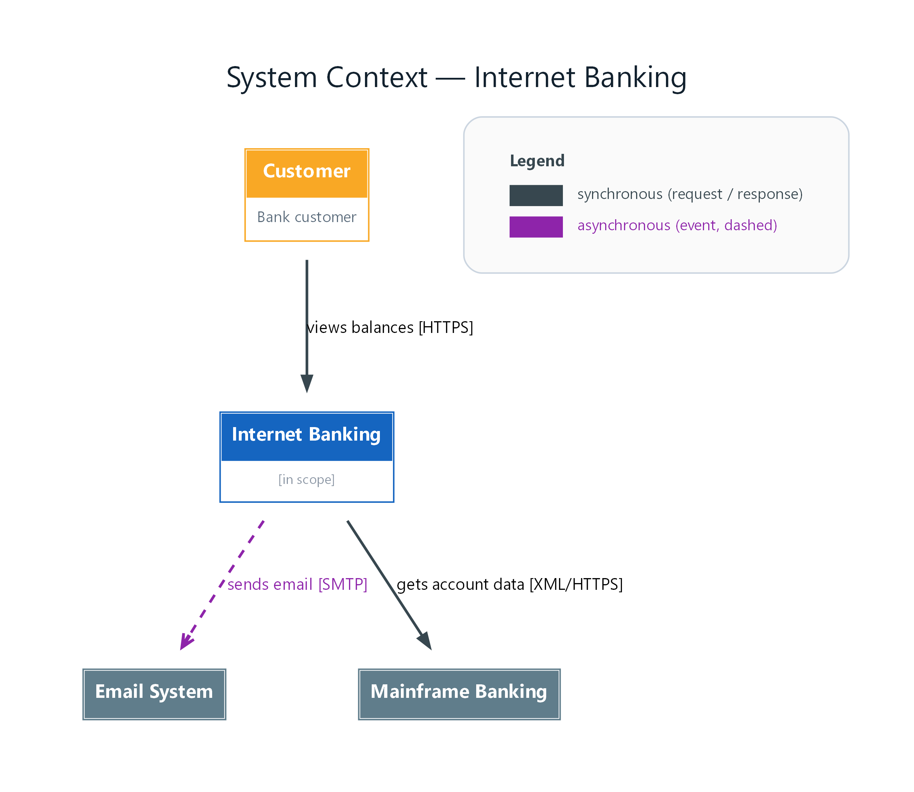
Figure 1: System Context — Internet Banking
- Customer — person; Bank customer; connects to Internet Banking (views balances [HTTPS])
- Internet Banking — system; in scope; connects to Email System (sends email [SMTP]), Mainframe Banking (gets account data [XML/HTTPS])
- Email System — external
- Mainframe Banking — external

