CI/CD Pipeline
A CI/CD pipeline that runs left to right through Source → CI → Registry → CD → Runtime, carrying a change from the first stage to the last.
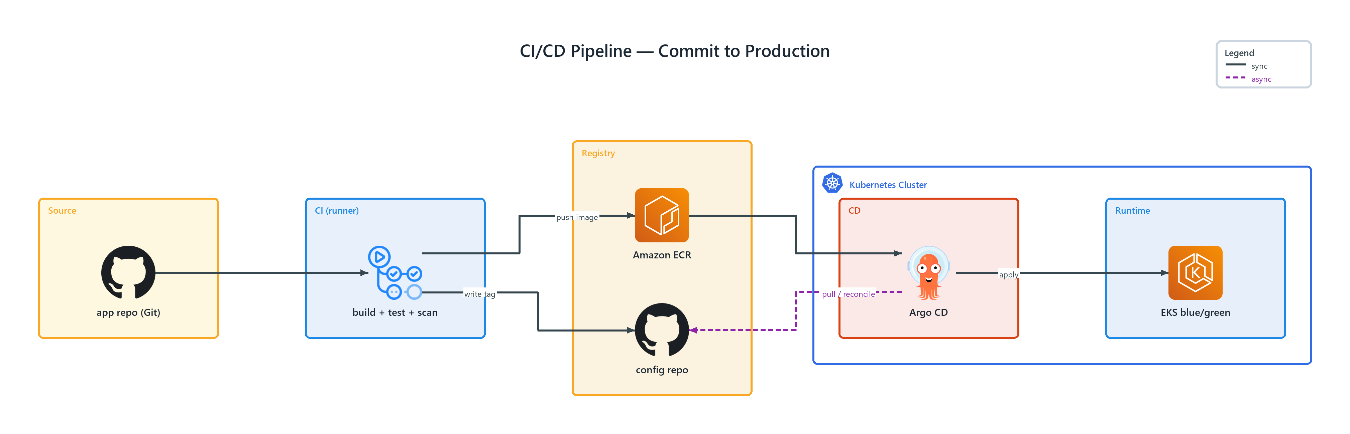
Figure 1: CI/CD Pipeline — Commit to Production
- Kubernetes Cluster — network boundary, badged k8s (K8S) spanning the tiers it encloses
- app repo (Git) — github (ONPREM) in Source; connects to build + test + scan
- build + test + scan — github actions (ONPREM) in CI; push image to Amazon ECR, write tag to config repo
- Amazon ECR — ec2 container registry (AWS) in Registry; connects to Argo CD
- config repo — github (ONPREM) in Registry
- Argo CD — argocd (ONPREM) in CD; publishes pull / reconcile to config repo, apply to EKS blue/green
- EKS blue/green — elastic kubernetes service (AWS) in Runtime

