UML Class Diagram
Class Diagram — Domain Model models 4 classes — Animal, Dog, Cat and Owner — and the 3 relationships that connect them.
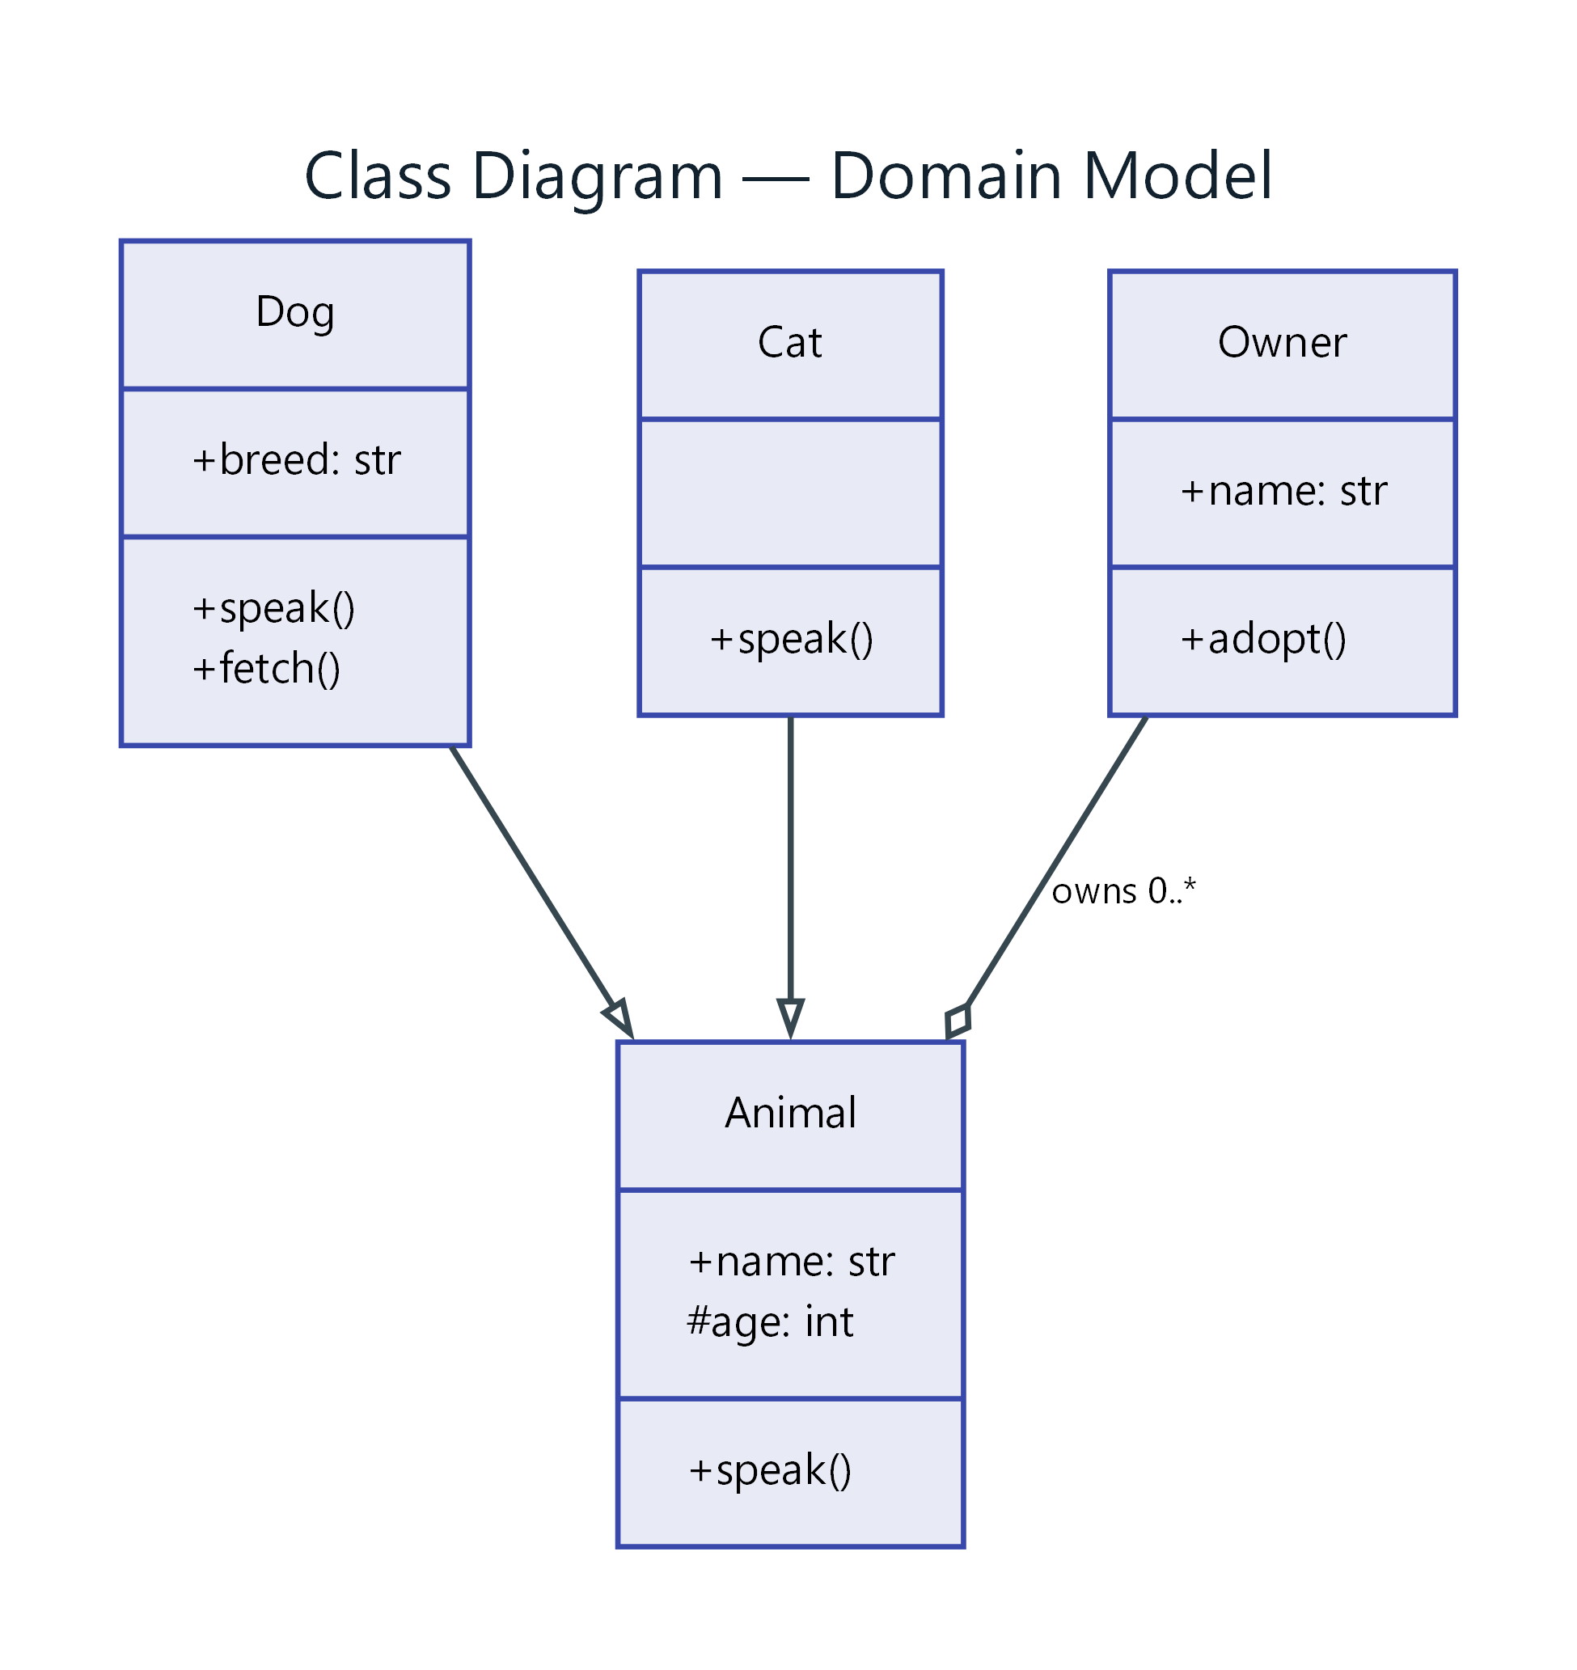
Figure 1: Class Diagram — Domain Model
- Animal — class; fields: +name: str, #age: int; methods: +speak()
- Dog — class; fields: +breed: str; methods: +speak(), +fetch(); connects to Animal
- Cat — class; methods: +speak(); connects to Animal
- Owner — class; fields: +name: str; methods: +adopt(); connects to Animal (owns 0..*)

