Data Pipeline
A data pipeline that runs left to right through Source → Ingest → Transform → Lake / Warehouse → Serve, carrying a change from the first stage to the last.
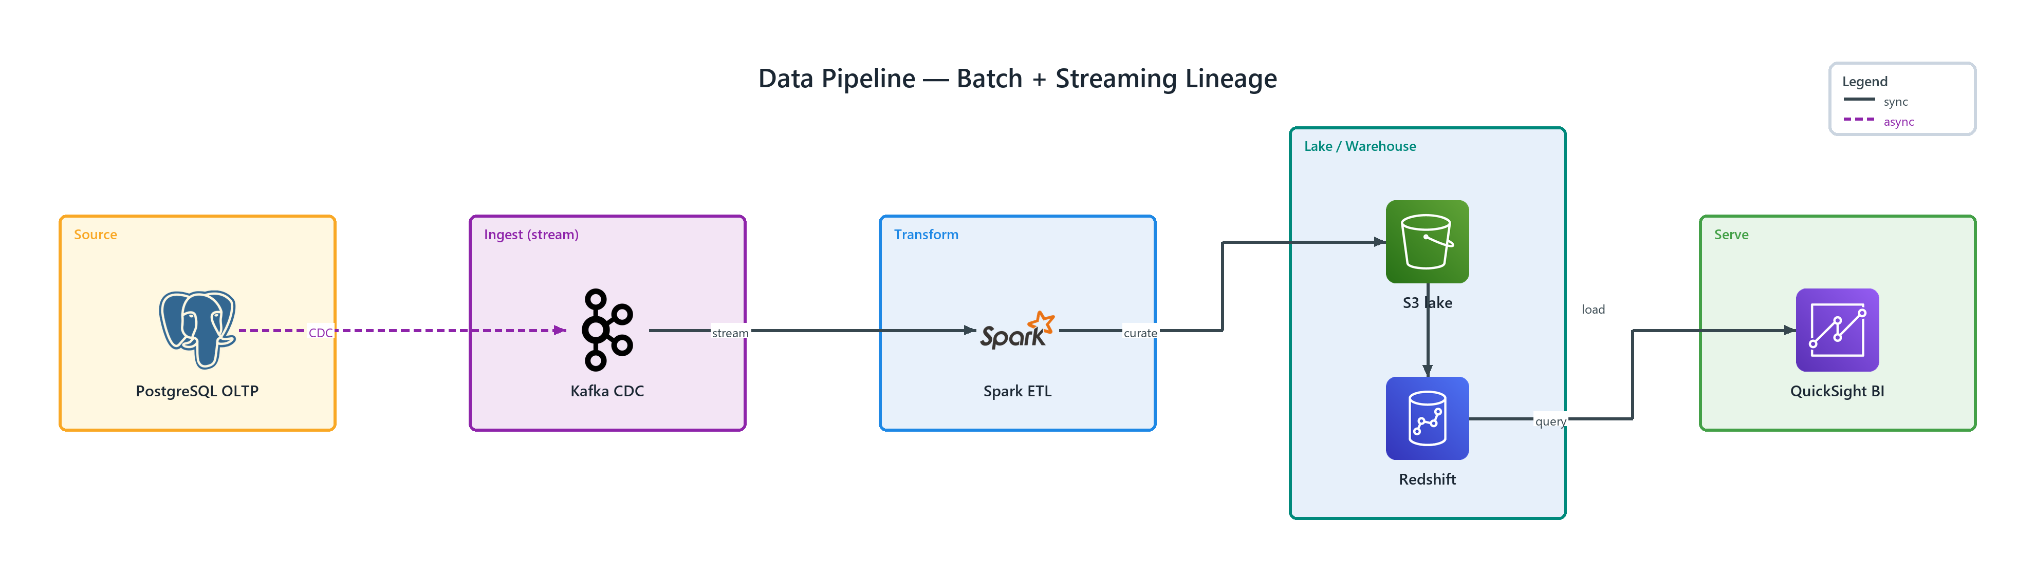
Figure 1: Data Pipeline — Batch + Streaming Lineage
- PostgreSQL OLTP — postgresql (ONPREM) in Source; publishes CDC to Kafka CDC
- Kafka CDC — kafka (ONPREM) in Ingest; stream to Spark ETL
- Spark ETL — spark (ONPREM) in Transform; curate to S3 lake
- S3 lake — simple storage service (AWS) in Lake / Warehouse; load to Redshift
- Redshift — redshift (AWS) in Lake / Warehouse; query to QuickSight BI
- QuickSight BI — quicksight (AWS) in Serve

