Flowchart
Decision Tree — Loan Approval traces the flow through 6 steps — Credit score > 700?, Income > 50k?, Has collateral?, Approve, … — and the 6 transitions between them.
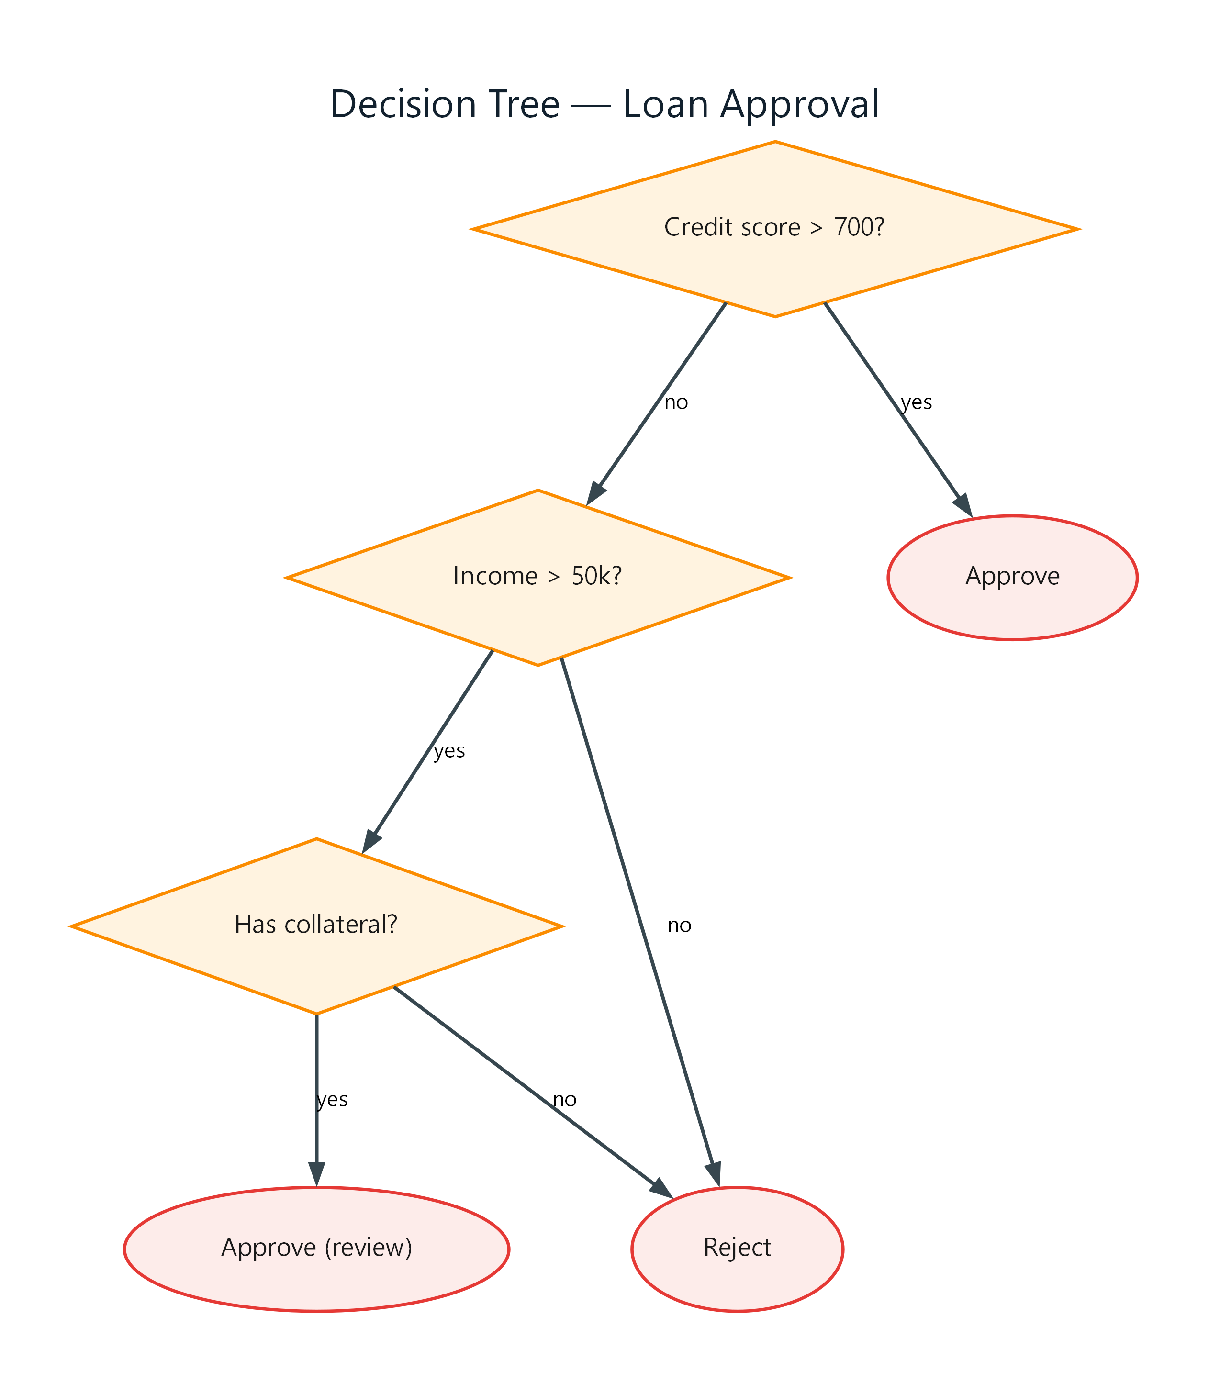
Figure 1: Decision Tree — Loan Approval
- Credit score > 700? — decision; connects to Approve (yes), Income > 50k? (no)
- Income > 50k? — decision; connects to Has collateral? (yes), Reject (no)
- Has collateral? — decision; connects to Approve (review) (yes), Reject (no)
- Approve — end
- Approve (review) — end
- Reject — end

