Data-Flow Diagram
Data Flow Diagram — Order Processing (L1) traces the flow through 5 processes and stores — Customer, 1. Validate Order, 2. Fulfil Order, Orders, … — and the 4 transitions between them.
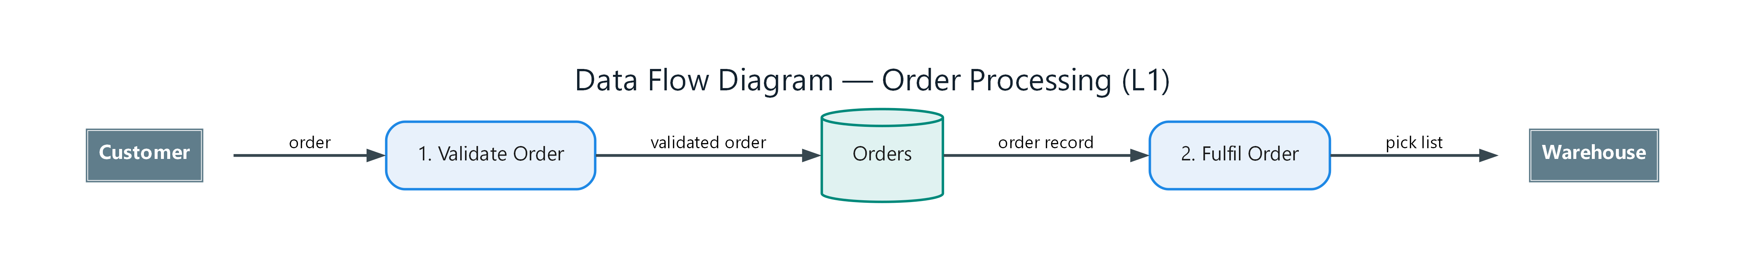
Figure 1: Data Flow Diagram — Order Processing (L1)
- Customer — external; connects to 1. Validate Order (order)
- 1. Validate Order — process; connects to Orders (validated order)
- 2. Fulfil Order — process; connects to Warehouse (pick list)
- Orders — datastore; connects to 2. Fulfil Order (order record)
- Warehouse — external

