Container Composition
A container composition in which the workload runs on api :3000 and web :80, and state is held in postgres and redis. Asynchronous, event-driven work flows through worker and RabbitMQ.
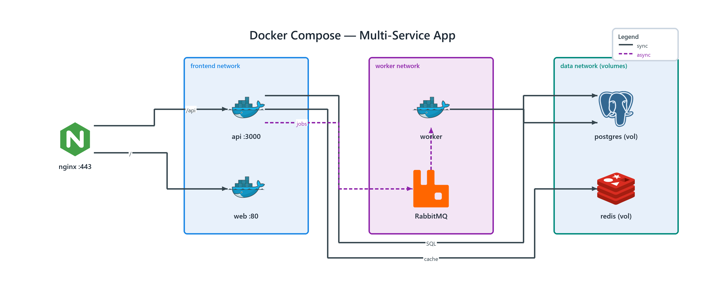
Figure 1: Docker Compose — Multi-Service App
- nginx :443 — nginx (ONPREM); /api to api :3000, / to web :80
- api :3000 — docker (ONPREM) in frontend network; SQL to postgres (vol), cache to redis (vol), publishes jobs to RabbitMQ
- web :80 — docker (ONPREM) in frontend network
- worker — docker (ONPREM) in worker network; connects to postgres (vol)
- RabbitMQ — rabbitmq (ONPREM) in worker network; streams events to worker
- postgres (vol) — postgresql (ONPREM) in data network
- redis (vol) — redis (ONPREM) in data network

