Entity-Relationship Diagram
ERD — Shop Data Model models 4 entities — User, Order, OrderItem and Product — and the 3 relationships that connect them.
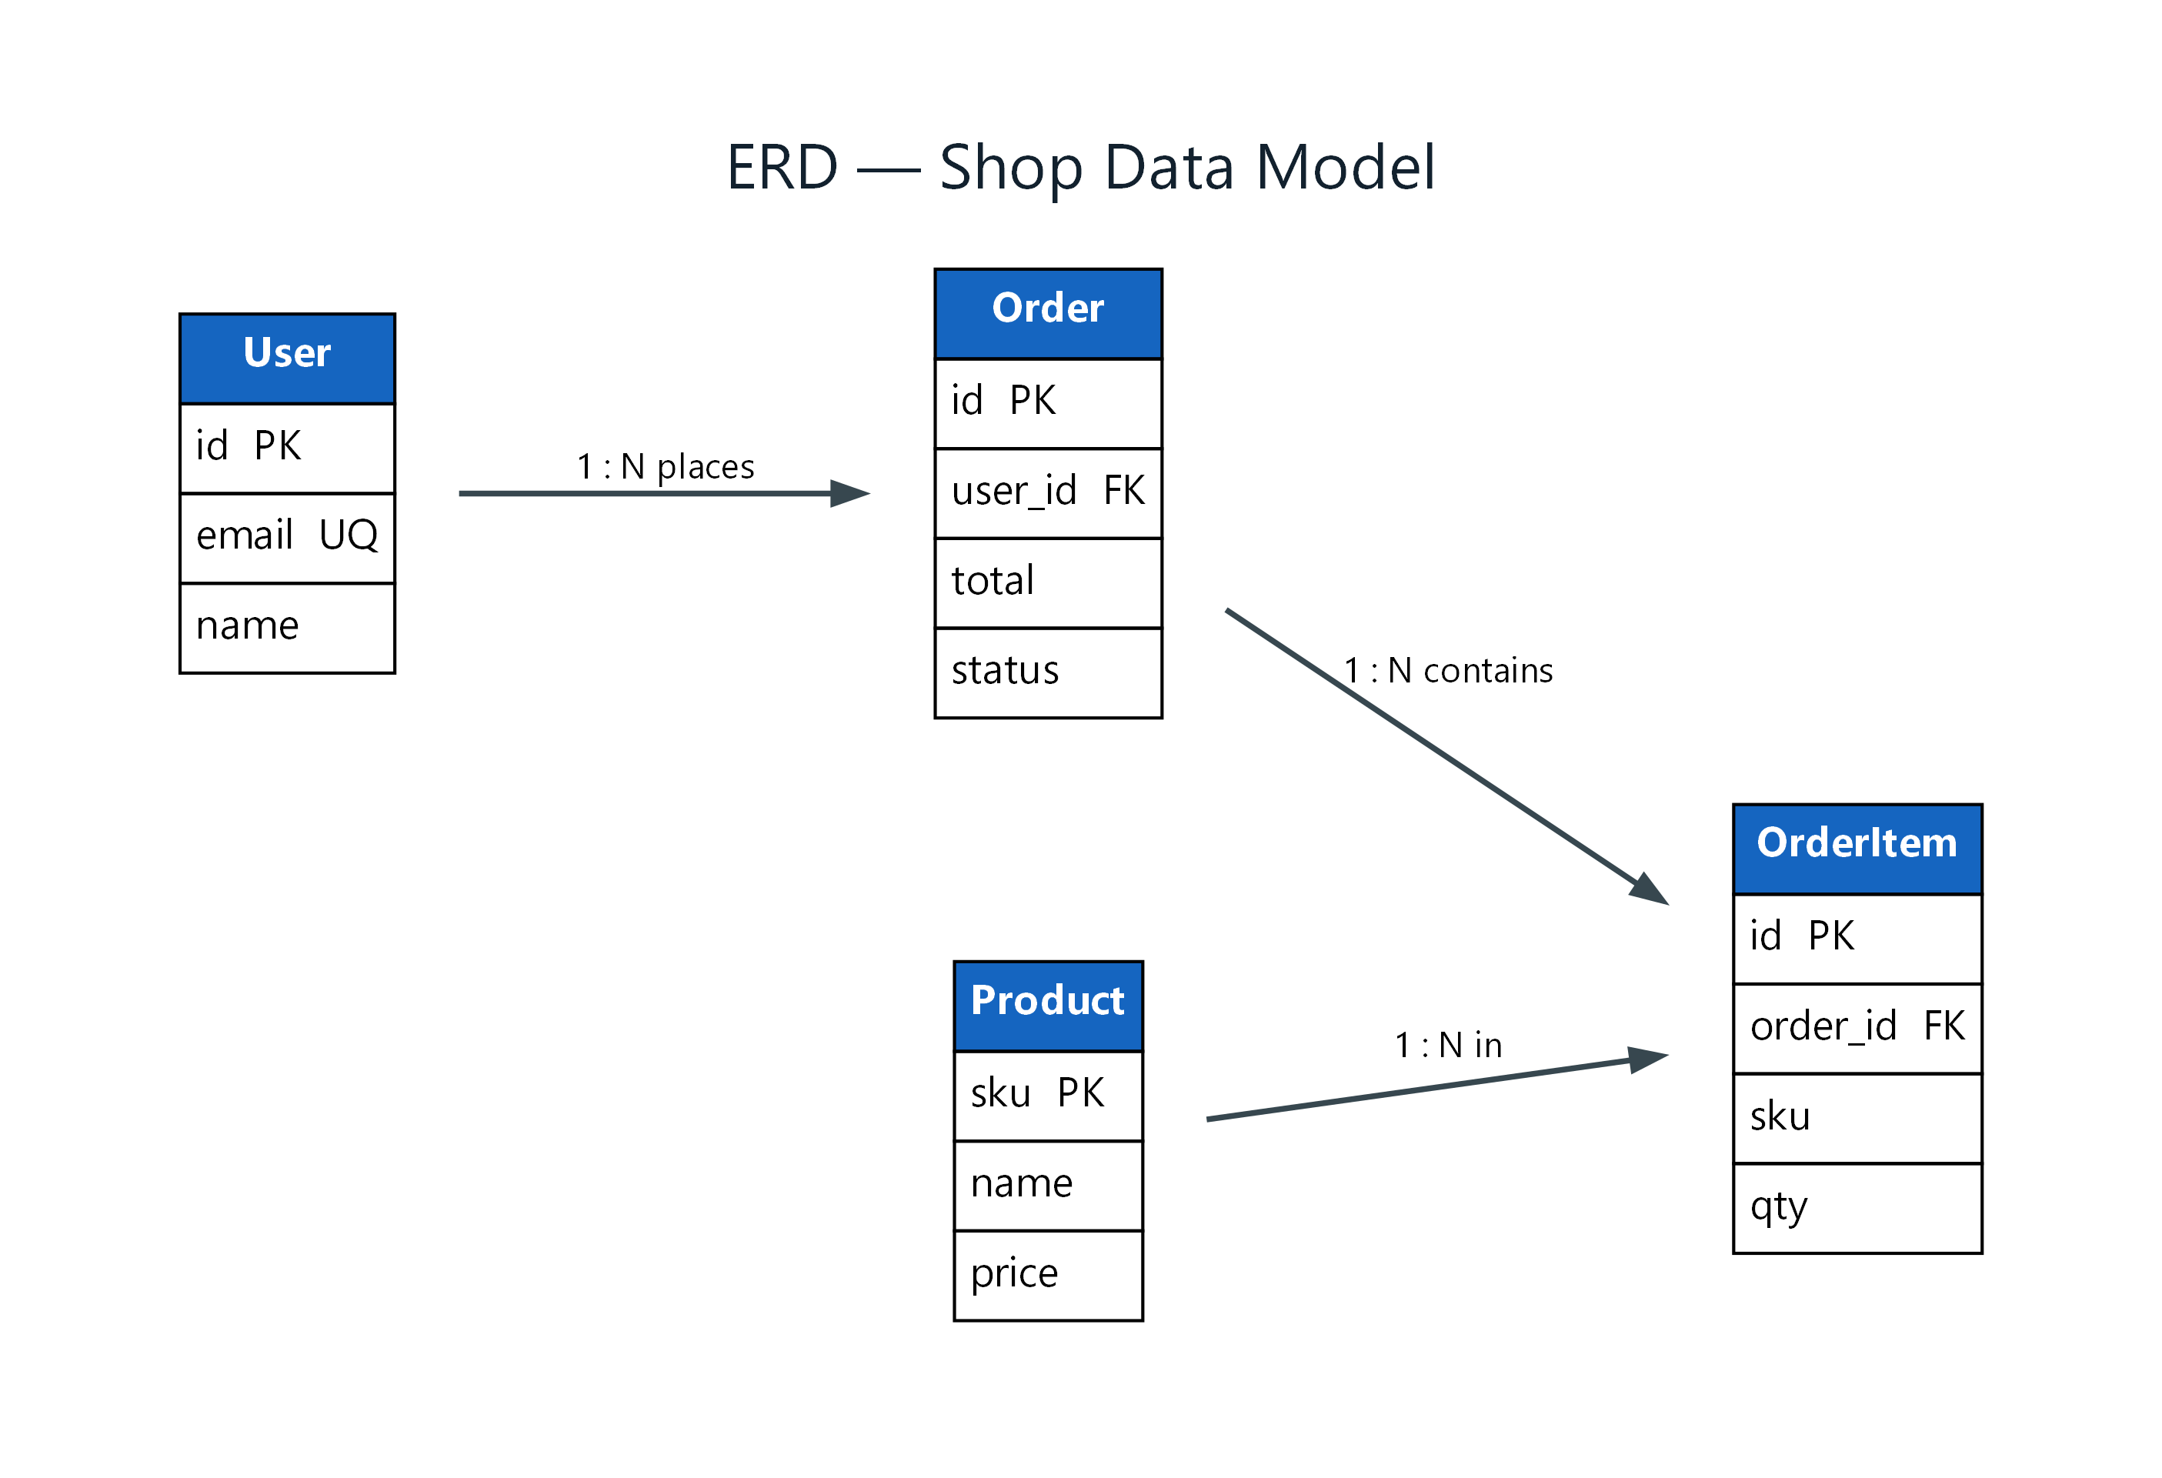
Figure 1: ERD — Shop Data Model
- User — entity; attributes: id PK, email UQ, name; connects to Order (1 : N places)
- Order — entity; attributes: id PK, user_id FK, total, status; connects to OrderItem (1 : N contains)
- OrderItem — entity; attributes: id PK, order_id FK, sku, qty
- Product — entity; attributes: sku PK, name, price; connects to OrderItem (1 : N in)

