Cloud Reference Architecture
A cloud reference architecture in which inbound traffic terminates at Cloud DNS, Cloud CDN, Cloud Armor and Global external LB, is served by Cloud Run and GKE regional, and state is held in Cloud SQL primary, read replica and Memorystore. Asynchronous, event-driven work flows through Pub/Sub. The estate sits inside VPC, with shared services (Cloud IAM, Cloud KMS, Cloud Ops and Cloud Storage) applied across every tier.
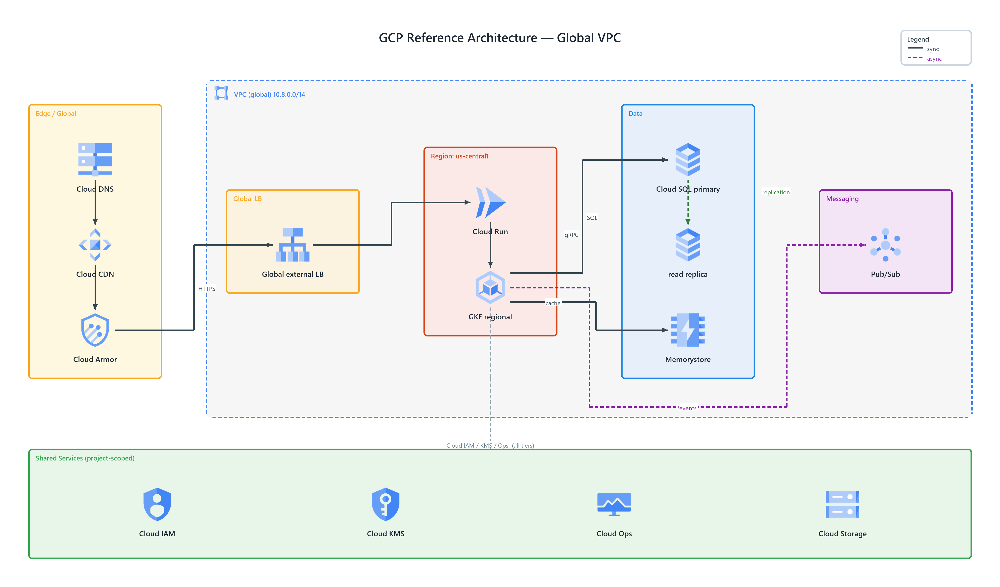
Figure 1: GCP Reference Architecture — Global VPC
- VPC (global) 10.8.0.0/14 — transparent, dashed network boundary, badged virtual private cloud (GCP) spanning the tiers it encloses
- Cloud DNS — dns (GCP) in Edge / Global; connects to Cloud CDN
- Cloud CDN — cdn (GCP) in Edge / Global; connects to Cloud Armor
- Cloud Armor — armor (GCP) in Edge / Global; HTTPS to Global external LB
- Global external LB — load balancing (GCP) in Global LB; connects to Cloud Run
- Cloud Run — run (GCP) in Region: us-central1; gRPC to GKE regional
- GKE regional — kubernetes engine (GCP) in Region: us-central1; SQL to Cloud SQL primary, cache to Memorystore, publishes events to Pub/Sub
- Cloud SQL primary — sql (GCP) in Data; publishes replication to read replica
- read replica — sql (GCP) in Data
- Memorystore — memorystore (GCP) in Data
- Pub/Sub — pubsub (GCP) in Messaging
- Shared Services — cross-cutting services (Cloud IAM, Cloud KMS, Cloud Ops, Cloud Storage) applied to every tier — Cloud IAM / KMS / Ops (all tiers)

