GitOps Delivery Flow
A GitOps delivery flow that runs left to right through Source → CI → Registry → Kubernetes Cluster, carrying a change from the first stage to the last.
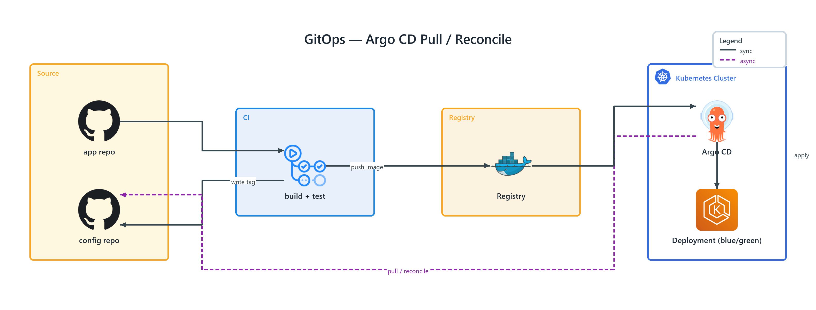
Figure 1: GitOps — Argo CD Pull / Reconcile
- app repo — github (ONPREM) in Source; connects to build + test
- config repo — github (ONPREM) in Source
- build + test — github actions (ONPREM) in CI; push image to Registry, write tag to config repo
- Registry — docker (ONPREM) in Registry; connects to Argo CD
- Argo CD — argocd (ONPREM) in Kubernetes Cluster; publishes pull / reconcile to config repo, apply to Deployment (blue/green)
- Deployment (blue/green) — elastic kubernetes service (AWS) in Kubernetes Cluster

