Kubernetes Topology
A Kubernetes topology in which inbound traffic terminates at Ingress, is served by Service, Pod x3 and HPA, and state is held in db, PVC and PV. The estate sits inside Kubernetes Cluster — Namespace: app, with control plane (kube-apiserver, etcd, ConfigMap and Secret) applied across every tier.
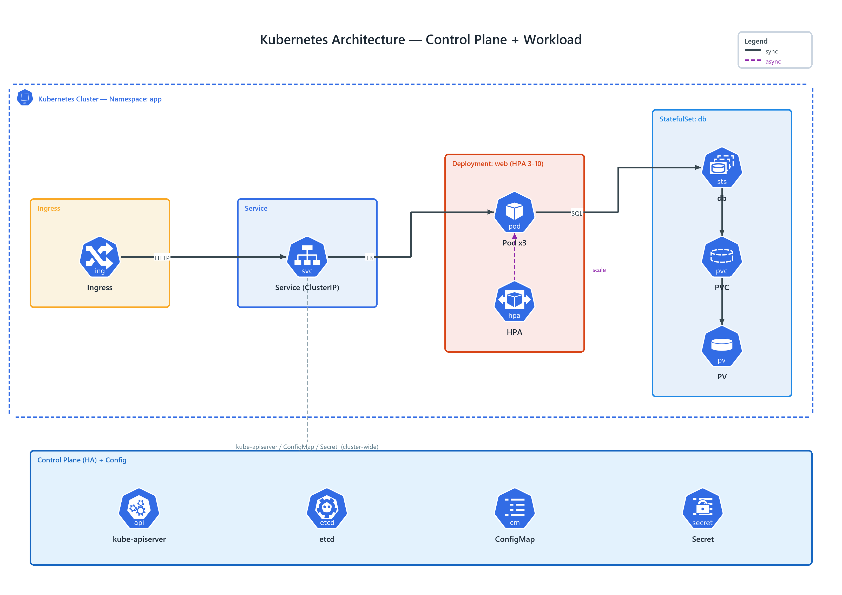
Figure 1: Kubernetes Architecture — Control Plane + Workload
- Kubernetes Cluster — Namespace: app — transparent, dashed network boundary, badged ns (K8S) spanning the tiers it encloses
- Ingress — ing (K8S) in Ingress; HTTP to Service (ClusterIP)
- Service (ClusterIP) — svc (K8S) in Service; LB to Pod x3
- Pod x3 — pod (K8S) in Deployment: web; SQL to db
- HPA — hpa (K8S) in Deployment: web; publishes scale to Pod x3
- db — sts (K8S) in StatefulSet: db; connects to PVC
- PVC — pvc (K8S) in StatefulSet: db; connects to PV
- PV — pv (K8S) in StatefulSet: db
- Control Plane — cross-cutting services (kube-apiserver, etcd, ConfigMap, Secret) applied to every tier — kube-apiserver / ConfigMap / Secret (cluster-wide)

