Microservices Decomposition
A microservices decomposition into Users Context, Orders Context and Payments Context, each context owning its own service and datastore and integrating with the others over synchronous APIs and asynchronous events.
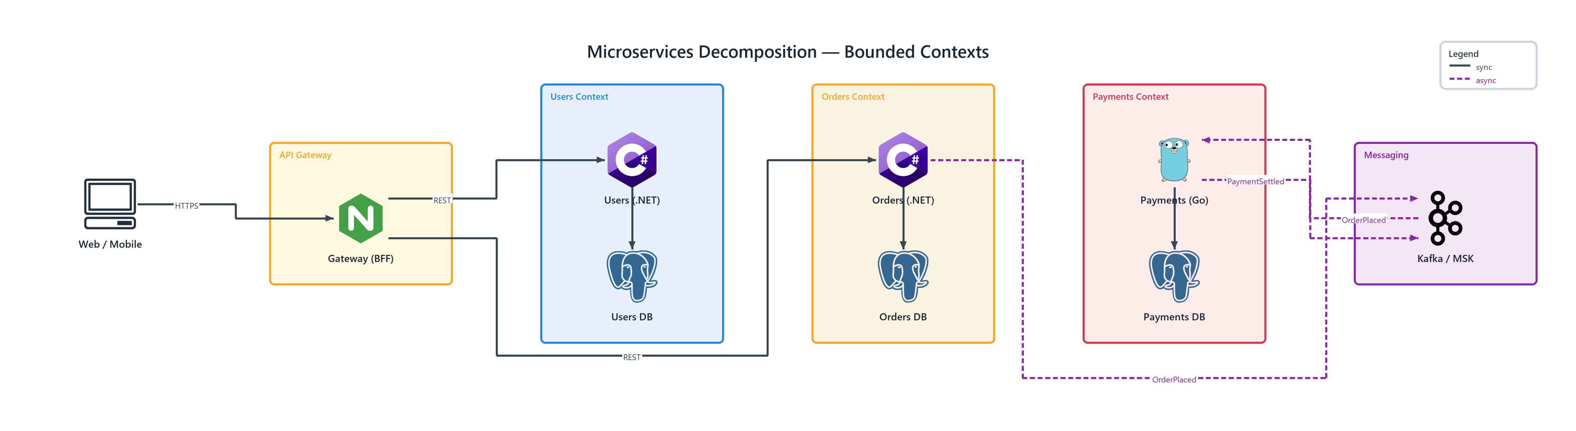
Figure 1: Microservices Decomposition — Bounded Contexts
- Web / Mobile — client (ONPREM); HTTPS to Gateway (BFF)
- Gateway (BFF) — nginx (ONPREM) in API Gateway; REST to Users (.NET), REST to Orders (.NET)
- Users (.NET) — csharp (PROGRAMMING) in Users Context; connects to Users DB
- Users DB — postgresql (ONPREM) in Users Context
- Orders (.NET) — csharp (PROGRAMMING) in Orders Context; connects to Orders DB, publishes OrderPlaced to Kafka / MSK
- Orders DB — postgresql (ONPREM) in Orders Context
- Payments (Go) — go (PROGRAMMING) in Payments Context; connects to Payments DB, publishes PaymentSettled to Kafka / MSK
- Payments DB — postgresql (ONPREM) in Payments Context
- Kafka / MSK — kafka (ONPREM) in Messaging; publishes OrderPlaced to Payments (Go)

