Mind Map
Mind Map — Product Launch models 11 branches — Product Launch, Marketing, Engineering, Sales, … — and the 10 relationships that connect them.
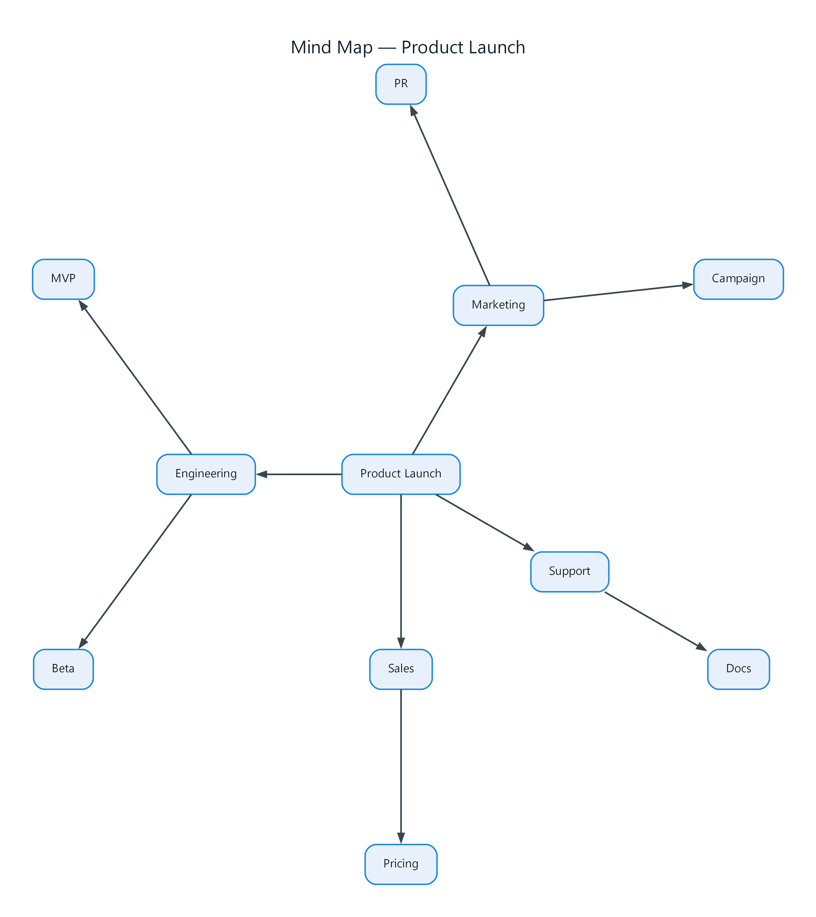
Figure 1: Mind Map — Product Launch
- Product Launch — process; connects to Marketing, Engineering, Sales, Support
- Marketing — process; connects to Campaign, PR
- Engineering — process; connects to MVP, Beta
- Sales — process; connects to Pricing
- Support — process; connects to Docs
- Campaign — process
- PR — process
- MVP — process
- Beta — process
- Pricing — process
- Docs — process

