Network Topology
Network Topology — DMZ + LAN models 6 nodes — Internet, Perimeter Firewall, Load Balancer, Web 1, … — and the 6 relationships that connect them.
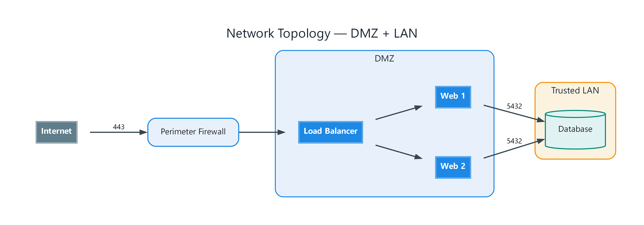
Figure 1: Network Topology — DMZ + LAN
- Internet — external; connects to Perimeter Firewall (443)
- Perimeter Firewall — process; connects to Load Balancer
- Load Balancer — service; connects to Web 1, Web 2
- Web 1 — service; connects to Database (5432)
- Web 2 — service; connects to Database (5432)
- Database — datastore
- DMZ — grouping: lb, w1, w2
- Trusted LAN — grouping: db

