UML Sequence Diagram
OAuth 2.0 Login — Authorization Code Flow traces how User, Web App, OAuth Provider and Backend API collaborate, exchanging 8 messages in time order.
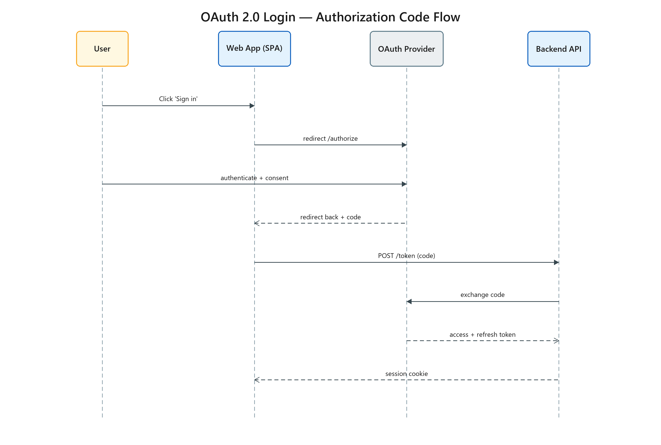
Figure 1: OAuth 2.0 Login — Authorization Code Flow
- User — actor
- Web App (SPA) — participant
- OAuth Provider — external
- Backend API — participant
- Step 1 — User → Web App (SPA): Click 'Sign in' (sync)
- Step 2 — Web App (SPA) → OAuth Provider: redirect /authorize (sync)
- Step 3 — User → OAuth Provider: authenticate + consent (sync)
- Step 4 — OAuth Provider → Web App (SPA): redirect back + code (return)
- Step 5 — Web App (SPA) → Backend API: POST /token (code) (sync)
- Step 6 — Backend API → OAuth Provider: exchange code (sync)
- Step 7 — OAuth Provider → Backend API: access + refresh token (return)
- Step 8 — Backend API → Web App (SPA): session cookie (return)

